OTC REST API Guide

T-Systems International

Version 0.1

Last revised 2016.02.07

**Draft**

- Internal -

Contents

T-Systems International 1

Metadata of Document 3

Joint Underwriting (optional) 3

Proof of Releases 3

Valid Documents 4

Change History 4

Short Description 4

1 Introduction 5

2 Preconditions 5

2.1 Access 5

3 Service Overview 5

4 OTC CLI Interface 5

5 OTC CLI Functionality 6

5.1 IAM Features 6

5.1.1 Generate IAM Token Based on Username and Password 6

5.2 ECS features 6

5.2.1 List ECS instances 6

5.2.2 Create ECS instances 6

5.2.3 Create Multiple ECS instances with default parameters 7

5.2.4 Create multiple ECS instances with custom parameters 7

5.2.5 Create ECS instances with file injection 7

5.2.6 List cloud images 8

5.2.7 Start-Stop-Restart instances 8

5.3 S3 Features 8

5.3.1 Create Bucket 8

5.3.2 List Bucket 9

5.3.3 List files in Specific Bucket 9

5.3.4 Get File Content 9

5.3.5 Upload Content 9

5.4 VPC features 9

5.4.1 List Virtual Private Clouds 9

5.4.2 Create New Virtual Private Clouds 9

5.4.3 List Subnets of VPC 9

5.4.4 Create Subnet 9

5.4.5 List Security Groups 10

5.4.6 Create Security Group 10

5.4.7 List Security Group Rule 10

5.4.8 Create Security Group Rule 10

5.4.9 List flavors 10

6 Obtaining a Project ID 10

7 AK and SK Generation 11

Imprint

|  |  |  |
| --- | --- | --- |
| Publisher | | |
| T-Systems International GmbH  PIA | | |
|  |  |  |
| Filename | Document Number | Document Designation |
| API-Guide-REST_vXX.docx |  | OTC API document |
|  |  |  |
| Version | Stand | Status |
| 0.3 | 08.01.2016 | DRAFT |
|  |  |  |
| Author | Content Reviewed by | Released by |
| Zsolt Nagy | - | Zsolt Nagy |
| Budapest, 06.02.2016 | Budapest, -.01.2016 | Budapest,07.02.2016 |
|  |  |  |
| Contact | Phone / Fax | E-Mail |
| Zsolt Nagy | +205800369 | [Z.Nagy@t-systems.com](mailto:Z.Nagy@t-systems.com) |
|  |  |  |

Metadata of Document

|  |  |
| --- | --- |
| Title of document | API-Guide-REST_v01.docx |
| Scope | CSS |
| Kind of Document | API-Guide-REST_v01.docx |
| Privacy | Internal |
| Publishing Organisation | PIA |
| Owner of Document | Kurt Garloff, Wenner, Sebastian, |
| Author | Zsolt Nagy |
| Process | INM, CHM, PRM, |
| Language | EN |
| Review Interval | 1 year |
| Preserve Period | 1 year |

Joint Underwriting (optional)

|  |  |  |  |
| --- | --- | --- | --- |
| Scope | Name | Date |  |
|  |  |  |  |
|  |  |  |  |
|  |  |  |  |
|  |  |  |  |
|  |  |  |  |

Proof of Releases

By signing, this document is released as a mandatory instruction for employees.  
Preceding versions are invalid from its release date on.

|  |  |  |  |
| --- | --- | --- | --- |
|  | Coordinated (Author) | formal checked (Editor) | released (Owner) |
| Name |  |  |  |
| Date |  |  |  |

Valid Documents

|  |  |
| --- | --- |
| File Name | Remarks |
|  |  |
|  |  |
|  |  |

Change History

|  |  |  |  |
| --- | --- | --- | --- |
| Version | Date | Author | Changes / Remarks |
| 0.1 | 06.02.2016. | Zsolt Nagy | Creation |
|  |  |  |  |
|  |  |  |  |
|  |  |  |  |
|  |  |  |  |
|  |  |  |  |
|  |  |  |  |
|  |  |  |  |
|  |  |  |  |
|  |  |  |  |

Short Description

This documentation contains how you can add new user to the Open Telecom Cloud.

# Introduction

This document describes how should use OTC API via Huawei REST interface.

# Preconditions

## Access

HTTPS access to OTC machines.

# Service Overview

This service based on a Huawei Cloud API interfaces. Detailed description available in following documents.

**Huawei API interface documents:**

* Auto Scaling API Reference 20160115 01.pdf
* Cloud Eye Service API Reference 20160115 01.pdf
* Elastic Cloud Server API Reference 20160115 01.pdf
* Elastic Load Balance API Reference 20160115 01.pdf
* Elastic Volume Service API Reference 20160115 01.pdf
* Identity and Access Management API Reference 2016-1-11 01 .pdf
* Image Management Service API Reference 20160115 01.pdf
* Object Storage Service API Reference 2016-01-15 01.pdf
* OpenStack API Reference 20160115 01.pdf
* Virtual Private Cloud API Reference 20160115 01.pdf
* Volume Backup Service API Reference 20160115 01.pdf

# OTC CLI Interface

Purposes of the OTC Tool to manage OTC via command line similar way than AWS with AWS cli tools . OTC Cli provides common interface to operation team and external DEVOPS to manage their cloud services.

# OTC CLI Functionality

## Configuration functions

### User configuration

**Command:**

otc configure

**Output:**

Enter a Project ID:

XXX65e2724ebbb504abXXXXXXXX

Enter a Access Key:

XXXXXVNOMK0UXXXX

Enter a Secret Key:

XXXXlQ7nNvBXXXXXXXXXXXXXXXXXXXXXX

### Proxy Configuration

**Command:**

otc configure-proxy

**Output:**

Enter a proxy host:

qhub03.hu.t-internal.com

Enter a proxy port:

3128

## IAM Features

URL: <https://iam.eu-de.otc.t-systems.com/v3/auth/tokens>

### Generate IAM Token Based on Username and Password

**JSON Request:**

{

"auth": {

"identity": {

"methods": [

"password"

],

"password": {

"user": {

"name": "'"$USERNAME"'",

"password": "'"$PASSWORD"'",

"domain": {

"name": "'"$USERNAME"'"

}

}

}

},

"scope": {

"project": {

"id": "'"$PROJECT_ID"'"

}

}

}

}

**Command:**

otc iam token

**Output:**

generated token.

## ECS features

### List ECS instances

**Command:**

otc ecs describe-instances

**Output:**

+------------------------------------+-----------------------+

|id |name |

+------------------------------------+-----------------------+

|f1c2d1e0-36fb-443e-ac18-eab70706235c|instancename |

|b6c602b1-06d0-4bdb-b764-5d43b47abc14|ecs-3dce |

|097da903-ab95-44f3-bb5d-5fc08dfb6cc3|ecs-8e83 |

+------------------------------------+-----------------------+

### Create ECS instances

**Command:**

otc ecs run-instances --count [number of instances] --admin-pass [amin password of running instance] --instance-type [instance flavour] --instance-name [name of the instance] --image-name [image name] --subnet-name [subnet name] --vpc-name [vpc of instance] --security-group-name [security group] --key-name [SSH key] –file[1-5] [target file=source file]

**Example:**

otc ecs run-instances --count 1 --admin-pass testpass123! --instance-type computev1-1 --instance-name instancename --image-name Community-CentOS-7.0-x86_64-2015-0 --subnet-name testsubnet --vpc-name testvpc --security-group-name testsecgroup --key-name testsshkeypair --file1 /otc/target=/otc/soruce

#### File Injection

Could inject max 5 file with following parameter:

* -- file[1-5] /targetdir/targetfile =/sourcedir/sourcefile

**JSON Request:**

{

"server": {

"availability_zone": "eu-de-01",

"name": "'"$INSTANCE_NAME"'",

"imageRef": "'"$IMAGE_ID"'",

"root_volume": {

"volumetype": "SATA"

},

"flavorRef": "'"$INSTANCE_TYPE"'",

"vpcid": "'"$VPCID"'",

"security_groups": [

{

"id": "'"$SECUGROUP"'"

}

],

"nics": [

{

"subnet_id": "'"$SUBNETID"'"

}

],

"adminPass": "'"$ADMINPASS"'",

"count": '"$NUMCOUNT"',

"},": {

"__vnc_keymap": "de"

}

}

}

### List cloud images

**URL:**

<https://ims.eu-de.otc.t-systems.com/v2/images>

**Command:**

otc ecs describe-images

**Example:**

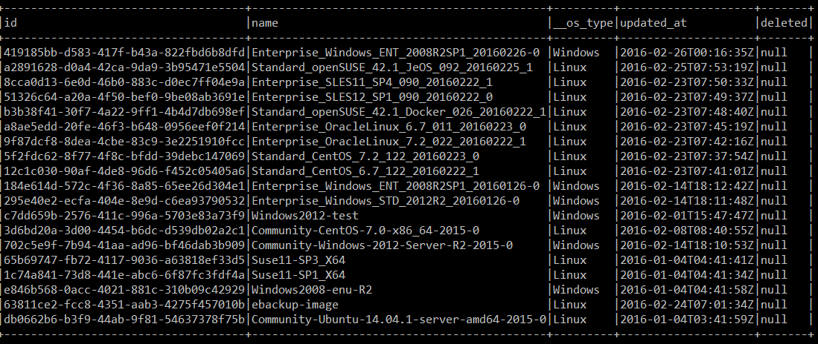

### Start-Stop-Restart instances

**URL:**

<https://ecs.eu-de.otc.t-systems.com/v1/$PROJECT_ID/cloudservers/action>

**Command:**

otc ecs reboot-instances [instance-id]

otc ecs stop-instances [instance-id]

otc ecs start-instances [instance-id]

**Example:**

otc ecs stop-instances b6c602b1-06d0-4bdb-b764-5d43b47XXXXX

{"job_id":"2c9eb2c1532f8bed015332895bXXXX"}

**JSON request:**

{

"'"$ECSACTION"'":

{

"type":"'"$ECSACTIONTYPE"'",

"servers": [ { "id": "'"$ECSACTIONSERVERID"'" }]

}

}'

## S3 Features

### Create Bucket

**Command:**

otc s3api create-bucket [bucketname]

**Example:**

otc s3 create-bucket mybucket

Bucket created: my-bucket

### List Bucket

otc s3 list

+----------+--------+--------------------------------+

|Bucketname|Owner |Owner Id |

+----------+--------+--------------------------------+

|newbucket |MYUSER |XXXXXXXXXXXXXXXX890c9a1673718c2b|

|otccli |MYUSER |XXXXXXXXXXXXXXXX890c9a1673718c2b|

+----------+--------+--------------------------------+

### List files in Specific Bucket

**Command:**

otc s3 list mybucket/

**Example**

otc s3 list mybucket/

+------------------------+--------+

|File | Size|

+------------------------+--------+

|setup_2016.02.29.exe |37153967|

|setup_2016.02.29.zip |37658811|

|setup_2016.02.29_new.zip|37658759|

+------------------------+--------+

totalItems: 3 totalSize: 112471537

### Get File Content

s3api get-object --bucket [bucket-name] --key [object-name]

### Upload Content

otc s3 cp [local-filename] s3://[bucket-name]/[objectname]

## VPC features

### List Virtual Private Clouds

URL: <https://vpc.eu-de.otc.t-systems.com/v1/$PROJECT_ID/vpcs>

**Command:**

otc vpc list

**Example:**

otc vpc list

+------------------------------------+-----------+------+--------------+

|id |name |status|cidr |

+------------------------------------+-----------+------+--------------+

|a86336d6-6467-XXX5-9df1-4bdca1dbXXXX|myvpc |OK |10.0.0.0/8 |

|ec317f48-3719-XXX0-bef8-4f86daaXXXXX|default-vpc|OK |192.168.0.0/16|

+------------------------------------+-----------+------+--------------+

### Create New Virtual Private Clouds

**Command:**

otc ecs create-vpc --vpc-name [vpcname] --cidr [ciddr]

**Example:**

otc ecs create-vpc --vpc-name testvpc --cidr 10.0.0.0/8

### List Subnets of VPC

**URL:** <https://vpc.eu-de.otc.t-systems.com/v1/$PROJECT_ID/subnets>

**Command:**

otc ecs describe-subnets

**Example:**



### Create Subnet

otc subnet create --subnet-name subnetname --cidr cidr --gateway-ip gateway --primary-dns primary-dns --secondary-dns sec-dns --availability-zone az --vpc-name vpc-name

Example:

otc subnet create --subnet-name testsubnet --cidr 10.0.2.0/8 --gateway-ip 10.0.0.2 --primary-dns 217.150.148.148 --secondary-dns 195.244.235.14 --availability-zone eu-de-01 --vpc-name testvpc

### List Security Groups

**URL:** <https://vpc.eu-de.otc.t-systems.com/v1/$PROJECT_ID/security-groups>

**Command:**

otc ecs describe-security-groups

**Output:**

+-------------------------------+---------------------------+-------------------------+

|id |name |vpc_id |

+-------------------------------+---------------------------+-------------------------+

|437549af-5350-4edb-b41d8b1d20c9|default |a86336d6-6467-4045-db7155|

|bcb07057-c84f-4c71-d391ed901c04|testsecgroup |a86336d6-6467-4045-db7155|

|d08659b9-a0b7-4276-8cde863cbd85|default |default |

|e4c694e1-f69e-4776-03f3cfe3c663|default |ec317f48-3719-4d90-a8985f|

+-------------------------------+---------------------------+-------------------------+

### Create Security Group

**Command:**

otc ecs securitecs y-group create –group-name [security-group name] --vpc-name [vpcname ]

**Example:**

otc security-group create –group-name testsecgroup --vpc-name testvpc

### Create Security Group Rule

**Command:**

otc ecs authorize-security-group-[ingress|egress] --security-group-name gorupname --protocol protocol --ethertype IPv4-IPv6 --portmin portstart –portmax portend

**Example:**

otc ecs authorize-security-group-ingress --security-group-name testsecgroup --protocol tcp --ethertype IPv4 --portmin 80 --portmax 80

### List flavors

**URL:** <https://ecs.eu-de.otc.t-systems.com/v1/$PROJECT_ID/cloudservers/flavors>

**Command:**

otc ecs describe-flavors

# Obtaining a Project ID

A project ID (the project ID can be project_id or tenant_id because project_id has the same meaning as tenant_id in this document)

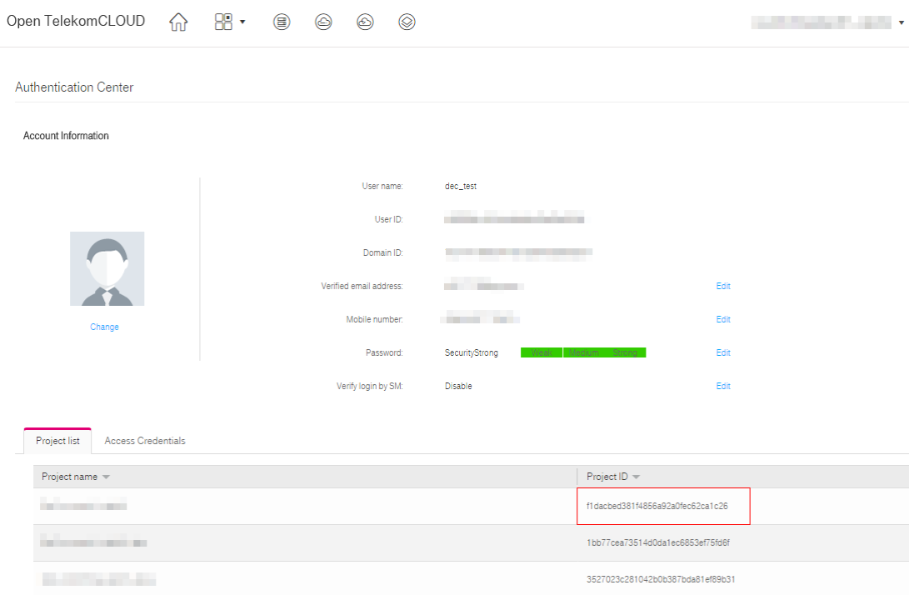

# AK and SK Generation

Sign up and log in to the management console, and click Authentication Center in the upper right corner of the page.

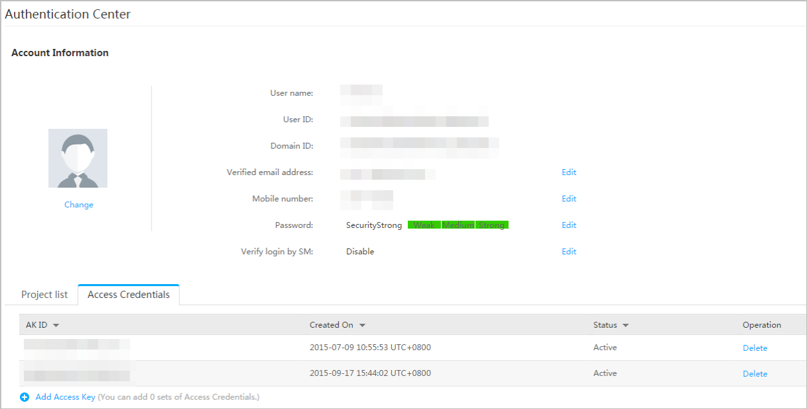

Click Add Access Key, and the Add Access Key page is displayed

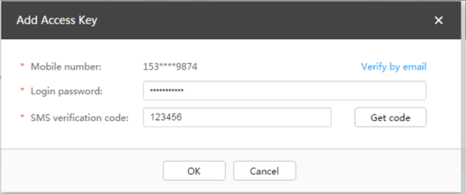

Enter the password ( YOUR PASSWORD ) and the short message verification code, and click OK to download the access key (CSV file) and keep the key secure.