

**AFFILIATED TO**



**A PROJECT REPORT ON**

**CMS-Based Blogging System**

SUBMITTED IN FULFILLMENT OF THE AWARD OF THE DEGREE OF

**BACHELOR OF TECHNOLOGY (2014-18)**

**UNDER THE GUIDANCE OF: SUBMITTED BY:**

**Prof. Dipankar Hazra**, Sourav Adak (Roll - 27500114017)

Head of Department & Project Supervisor, Sourav Das (Roll - 27500114018)

OmDayal Group of Institutions, Uluberia Sk. Asfaque Hossain (Roll - 27500114016)

**BONAFIDE CERTIFICATE**

This is to certify that this project report titled “**CMS-Based Blogging System**” is the bonafide work of,

Sourav Adak (Roll - 27500114017)

Sourav Das (Roll - 27500114018)

Sk. Asfaque Hossain (Roll - 27500114016)

, who carried out the project work under my guidance and supervision.

……………………………………

**Prof. Dipankar Hazra**

Head of Department & Project Supervisor

Computer Science and Engineering

OmDayal Group of Institutions, Uluberia,

Howrah- 711316.

**ACKNOWLEDGEMENT**

The satisfaction that accompanies the successful completion of any task would being complete without the mention of people whose ceaseless and support made it possible. We express our deepest thanks and gratitude to Mr. Dipankar Hazra, our project supervisor and Head of Department for the ceaseless guidance, timely advice and all his constructive suggestions that provided us with constant flow of motivation. He has taken the pains to go through our work and make necessary corrections as and when needed. The guidance was extremely valuable and has had a significant impact on the quality of this report. I would also like to thank the users involved throughout the development for their participation and the enthusiasm they showed for this project. We express our sincere thanks to our friends who have helped us in various problems throughout the making of this project.

**Project Submitted By: Signatures:**

1. Sourav Adak ………………………........
2. Sourav Das ………………………........
3. Sk. Asfaque Hossain ………………………........

**Project Supervisor:**

Mr. Dipankar Hazra

Head of Department

Computer Science and Engineering

OmDayal Group of Institutions, Uluberia,

Howrah- 711316.

**Signature of Project Supervisor:**

…………………………………………….

**ABSTRACT**

The main purpose of a Content Management System is to make it easy for even a novice computer user to maintain and manage a site. There are many CMSs available in the market but are not user-friendly. Both Drupal and Joomla have a very bloated and confusing administration. This is because both these packages have many advanced features in addition to the normal basic content management features. For example, polls providing the capabilities to capture votes on different topics in the form of multiple-choice questions, or news feeds, which provide syndicated content (RSS, RDF, and Atom feeds). This makes the CMS complex and difficult to use. Inevitably though, that CMS is going to be a little more complex to maintain. If the website requires complex features, the best thing to do is to hide these complex features. A good user interface should make most common tasks the most prominent and hide rare tasks so that they do not get in the way. Drupal's administration interface is confusing and not user friendly. Joomla's administration usability and learning curve is better than Drupal's, but not enough to provide a noticeable advantage to the end-user over Drupal. WordPress has a much better and very intuitive administration design, which makes it easier to learn. It includes features such as drag and drop, resulting in the generation of code without technical intervention. It would be more correct to describe such products as 'website builders' than Web Content Management Systems. The main feature that is not seen in most of today’s complex CMSs is intuitive and user-friendly website administration. Hence, we’ve built this simple CMS which has a very easy-to-use UI for an end-user and has collaborative multiple user support, powerful user feedback section and active reader engagement in the form of likes, comments, social media shares etc.

**TABLE OF CONTENTS**

1. **Introduction Page**
   1. **Project Overview…………………………………………………………………… 6**
   2. **Purpose…………………………………………………………………………………. 6**
   3. **Project Definition………………………………………………………………….. 7**
2. **Background Reading**
   1. **CMS…………………………………………………………………………………..…. 8-9**
   2. **Blogs……………………………………………………………………………………. 10**
3. **Tools**
   1. **HTML……………………………………………………………………………………. 11**
   2. **CSS………………………………………………………………………………………. 11**
   3. **jQuery………………………………………………………………………………….. 12**
   4. **Bootstrap……………………………………………………………………………… 12**
   5. **PHP…………………………………………………………………………..………….. 13**
   6. **MySQL………………………………………………………………………………….. 13**
4. **System Analysis**
   1. **Feasibility Study…………………………………………………………………… 14**
   2. **Existing System…………………………………………………………………….. 15**
   3. **Proposed System………………………………………………………………….. 15**
   4. **Tools & Technologies used……………………………..………………….....16**
5. **Diagram**

**3.1 Data-flow Diagram………………………………………………………………… 17-18**

**3.2 Use-case Diagram………………………………………………………............ 19**

1. **Input / Output Design……………………………………………………………….. 20-29**
2. **Testing………………………………………………………………………………………. 30-31**
3. **Conclusion………………………………………………………………………............ 32**
4. **References………………………………………………………………………………… 33**

**1. INTRODUCTION**

**1.1 Project Overview :-**

This project is designed in such a way that it allows extensive reader engagement in the form of blog comments and social media shares, likes, and follows and latest technological content posts. This system also supports content creation and manipulation by multiple users such that each user is authorized to access specific sections as per their user role and contribution towards this system.

**1.2 Purpose :-**

The main purpose of this project is to have a user-friendly content administration interface that includes most common CMS functions appropriate for small and simple websites, so that a novice user can manage the website content. A user having less coding knowledge can easily add, edit and format the website’s content using the rich text editor integrated in the Simple CMS engine without having to deal with the HTML and CSS code. Our CMS provides an easy and efficient way of engaging end-user for actively participating and contributing to this educational blogging system, where they can stay updated with the latest technological trends and at the same time provide valuable feedback to help develop the system better, bug-fixes (if any), innovative idea spreading, provide better service and relevant content with time. This system also supports content creation and manipulation by multiple users such that each user is authorized to access specific sections as per their user role and contribution towards this system. So, that each reader would get equal opportunity to grow, innovate, contribute to our blogging system.

**1.3 Project Definition :-**

There are a number of custom CMS-frameworks available out there like WordPress, Joomla, Drupal, Plone, Open CMS, TYPO3 etc. using which a complete CMS can be developed but all of these frameworks have a steep learning curve and so it’s difficult for an end-user to understand the modules. It requires more advanced coding knowledge when it comes to customizing. Hence, we’ve built a simple CMS with easy-to-use UI for end-user, powerful user feedback, multiple user support, effective post content.

Here is the list of the key features of the system :-

* Better access control of CMS section for an admin and a subscriber.
* Faster page refresh and load.
* Better post content and user feedback section in the form of comments.
* Image compression without compromising quality.
* Regular content updating, quality checks and bug fixes.
* Password encryption using crypt() and blowfish algorithm.
* Implemented SQL INJECTION prevention techniques.

**2. BACKGROUND READING**

**2.1 Content Management System (CMS) :-**

A content management system (CMS) manages the creation and modification of digital content. It typically supports multiple users in a collaborative environment. CMS features vary widely. Most CMSs include Web-based publishing, format management, history editing and version control, indexing, search, and retrieval. By their nature, content management systems support the separation of content and preparation. A web content management system (WCM or WCMS) is a CMS designed to support the management of the content of Web pages. Most popular CMSs are also WCMSs. Web content includes text and embedded graphics, photos, video, audio, maps, and program code (e.g., for applications) that displays content or interacts with the user.

Such a content management system (CMS) typically has two major components:

* A content management application (CMA) is the front-end user interface that allows a user, even with limited expertise, to add, modify, and remove content from a website without the intervention of a webmaster.
* A content delivery application (CDA) compiles that information and updates the website.

CMS come in all shapes and sizes and can manage anything a team of individuals is working on. From managing simple static website content, to allowing collaborative documentation across the Internet (wiki), CMSs perform many functions.

CMS packages can generally be classified into four categories:

* Enterprise CMS
* Web CMS
* Open Source CMS
* Commercial CMS

Open source content management systems are free in many ways. A user can do what he/she wishes with the product and the code behind it, extending and integrating it as they see fit. There’s no license cost for the software, and anyone can download and install them on a web server without cost, though it is likely they will have to pay for the server or pay someone to install the system.

**These are top 12 open source content management software systems :-**

* Drupal
* Acquia
* Squarespace
* HubSpot
* Joomla
* Sitecore
* Box
* Brightcove
* Pantheon.iO
* Kentico
* Blue Pen Articles
* Pyro CMS

Joomla, Drupal and WordPress are the most popular Open Source CMS being used today. Drupal has a steep learning curve and so it’s difficult for a first-time developer to understand the modules. It requires more advanced coding knowledge when it comes to customizing. Joomla has a better user interface than Drupal for newcomers. It is quite simple to add and edit pages. The design layer is almost the same as Drupal as they both do not have a lot of design templates. So, the issue is that most of the Joomla sites will look the same. WordPress is the perfect solution for small blogging websites as it has simple and user-friendly interface. There are a lot of great design templates available for the websites.

**2.2 Blogs :-**

A blog is a discussion or informational website published on the World Wide Web consisting of discrete, often informal diary-style text entries. Posts are typically displayed in reverse chronological order, so that the most recent post appears first, at the top of the web page. The appearance of blogs changed over time, and nowadays blogs include different items. But, most blogs include some standard features and structure.

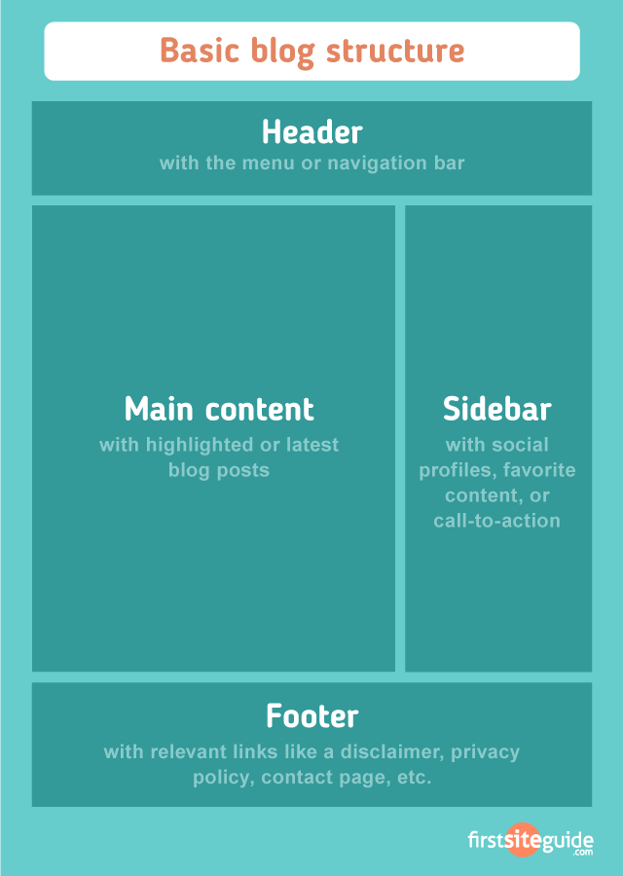

**3. TOOLS**

**3.1 HTML :-**

HTML stands for Hyper Text Markup Language. A markup language is a language that annotates text in a way that is syntactically distinguishable so that the computer can manipulate it. It is a set of markup tags used to describe web pages. The tags are what separate normal text from HTML code. They are the words between the <angle-brackets>. Different tags will perform different functions, like rendering images or tables. It is a combination of words and symbols which give instructions on how the document will be presented. The tags themselves don’t appear when you view your page through a browser, but their effects do. Markup is what HTML tags do to the text inside them. They mark it as a certain type of text (italicized text, for example). HTML documents contain HTML tags and plain text. The content on a HTML page will be static. In order to change the content, the editor needs to have some knowledge about HTML and change the content accordingly.

**3.2 CSS :-**

CSS stands for Cascading Style Sheets. It is used to control the style and layout of multiple web pages all at once. Styles define how to display HTML elements. CSS overrides the browser’s default settings for interpreting how tags should be displayed, letting you use any HTML element indicated by an opening and closing tag to apply style attributes defined either locally or in a stylesheet. External Style Sheets can save a lot of work. They are stored in CSS files. Stylesheets contain rules, composed of selectors and declarations that define how styles will be applied. The selector (a redefined HTML element, class name, or ID name) is the link

between the HTML document and the style. There are two different kinds of selectors: types (HTML element tags) and attributes (such as class and ID names).

**3.3 jQuery :-**

jQuery is a fast and concise JavaScript Library that simplifies HTML document traversing, event handling, animating, and Ajax interactions for rapid web development. jQuery is designed to change the way JavaScript is written. Therefore, jQuery greatly simplifies JavaScript programming. The modular approach to the jQuery library allows the creation of powerful dynamic web pages and web applications. jQuery includes the following features:

• DOM traversal and modification

• DOM manipulation based on CSS selectors that uses node elements name and node elements attributes (id and class) as criteria to build selectors

• Events

• Effects and animations

• Ajax

• Extensibility through plug-ins

• Cross-browser support

**3.4 Bootstrap :-**

Bootstrap is an open source toolkit for developing with HTML, CSS, and JS. Quickly prototype your ideas or build your entire app with our Sass variables and mixings, responsive grid system, extensive prebuilt components, and powerful plugins built on jQuery.

* Bootstrap is a free front-end framework for faster and easier web development
* Bootstrap includes HTML and CSS based design templates for typography, forms, buttons, tables, navigation, modals, image carousels and many other, as well as optional JavaScript plugins
* Bootstrap also gives you the ability to easily create responsive designs

**3.5 PHP :-**

What is PHP ??

* PHP is an acronym for "PHP: Hypertext Preprocessor"
* PHP is a widely-used, open source scripting language
* PHP scripts are executed on the server

What is a PHP file ??

* PHP files can contain text, HTML, CSS, JavaScript, and PHP code
* PHP code are executed on the server, and the result is returned to the browser as plain HTML
* PHP files have extension ".php".

What can PHP do ??

* PHP can generate dynamic page content
* PHP can create, open, read, write, delete, and close files on the server
* PHP can collect form data
* PHP can send and receive cookies
* PHP can add, delete, modify data in your database
* PHP can be used to control user-access
* PHP can encrypt data

With PHP you are not limited to output HTML. You can output images, PDF files, and even Flash movies. You can also output any text, such as XHTML and XML.

**3.6 MySQL :-**

MySQL is the most popular Open Source Relational SQL Database Management System. MySQL is one of the best RDBMS being used for developing various web-based software applications.

.

**4. SYSTEM ANALYSIS**

**4.1 Feasibility Study:**

The feasibility study is an evaluation and analysis of the potential of a proposed project which is based on extensive investigation and research to support the process of decision making. Depending on the results of the initial investigation the survey is now expanded to a more detailed feasibility study.

|  |
| --- |
| **Technical Feasibility** |
| It specifies whether the proposed solution to the project is possible to be implemented using available hardware and software. To build this software we stretched our coding efforts to the Php and gained knowledge of MySQL. And our team is competent in that. |
| **Social Feasibility** |
| All end-user can use and can contribute to this blogging system irrespective of any educational background. Technical knowledge is not mandatory. |
| **Market Research** |
| Market research says that this system would be useful for the almost every user as it could seamlessly help them for their modern and busy lifestyle, keeping them updated with latest educational and technological trends and also help them to participate actively in the form of comments, likes, social media shares, etc. |
| **Economic Feasibility** |
| This defines the cost effectiveness of the project. This project being a part of academic project, we’ve tried to minimize the overall cost. We’ve been successful in doing so. |
| **Alternate Solution** |
| Could be a mobile app but that would not be as efficient as of this system. |

**4.2 Existing System:**

The main purpose of a Content Management System is to make it easy for even a novice computer user to maintain and manage a site.There are a number of custom CMS-frameworks available out there like WordPress, Joomla, Drupal, Plone, Open CMS, TYPO3 etc. using which a complete CMS can be developed but all of these frameworks have a steep learning curve and so it’s difficult for an end-user to understand the modules. It requires more advanced coding knowledge when it comes to customizing. Both Drupal and Joomla have a very bloated and confusing administration. This is because both these packages have many advanced features in addition to the normal basic content management features. So, there is an utmost need to build a simple CMS that should be user-friendly.

**4.3 Proposed System:**

Our simple CMS has a user-friendly content administration interface that includes most common CMS functions appropriate for small and simple websites, so that a novice user can manage the website content. A user having less coding knowledge can easily add, edit and format the website’s content using the rich text editor integrated in the Simple CMS engine without having to deal with the HTML and CSS code. Our CMS provides an easy and efficient way of engaging end-user for actively participating and contributing to this educational blogging system, where they can stay updated with the latest technological trends and at the same time provide valuable feedback to help develop the system better, bug-fixes (if any), innovative idea spreading, provide better service and relevant content with time. This system also supports content creation and manipulation by multiple users such that each user is authorized to access specific sections as per their user role and contribution towards this system. So, that each reader would get equal opportunity to grow, innovate, contribute to our blogging system.

**4.4 Tools and Technologies used:**

|  |  |
| --- | --- |
| **Frontend Design** | **HTML5, CSS3, BOOTSTRAP4** |
| **Client-side Scripting** | **JQUERY** |
| **Server-side Scripting** | **PHP** |
| **Database** | **MYSQL** |
| **Development Tools** | **BRACKETS, XAAMP** |

For using this CMS there is no specific hardware / software requirements. End-user can use any O.S. and any web browser for using the blogging system, it is cross-browser checked and platform independent.

**5. DIAGRAMS**

**5.1 Data Flow Diagrams:**

Following shows various levels of DFD for the CMS user.

**5.1.1 DFD(level-0):**

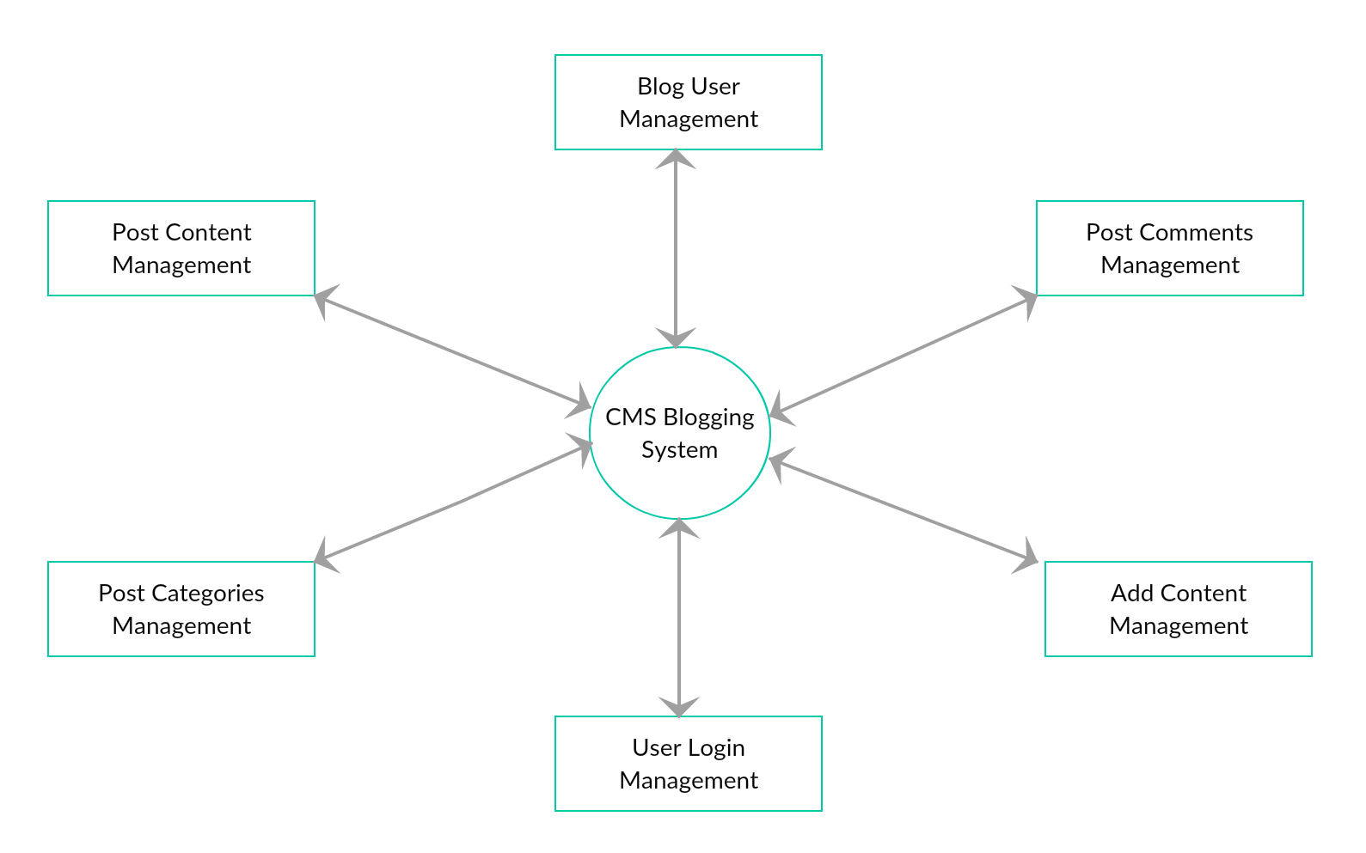

**5.1.2 DFD(level-1):**

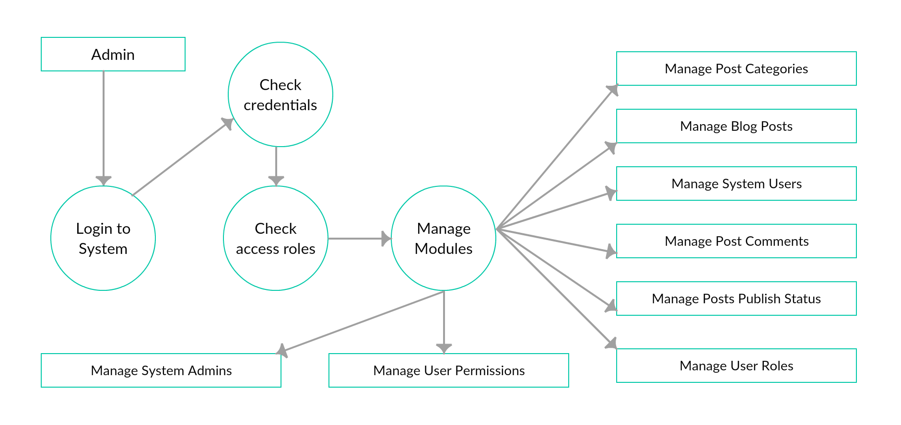

**5.2 Use Case Diagrams:**

Following shows the use cases for different CMS users.

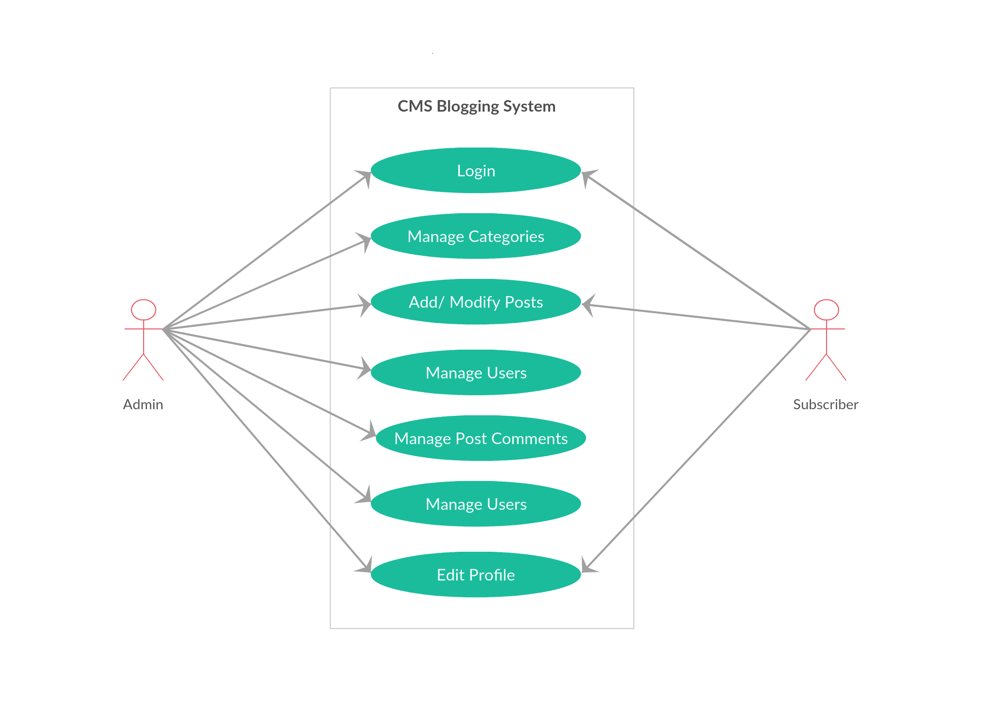

**7. Input / Output Design**

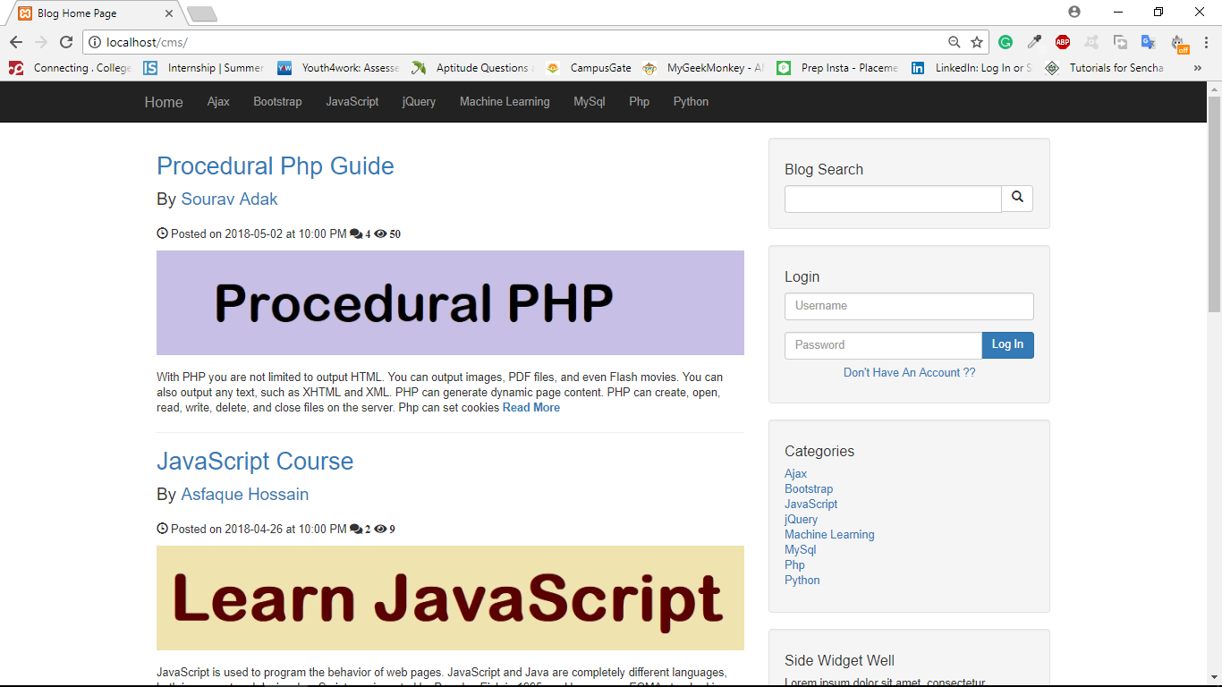

**This is the Blog Home Page.**

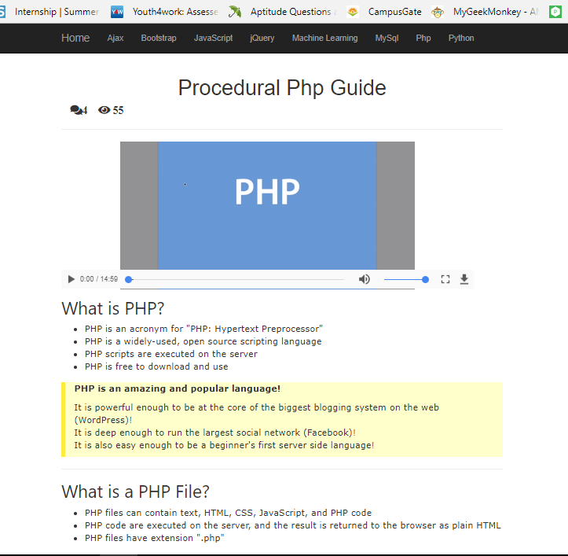

**This is the page specific to a clicked post.**

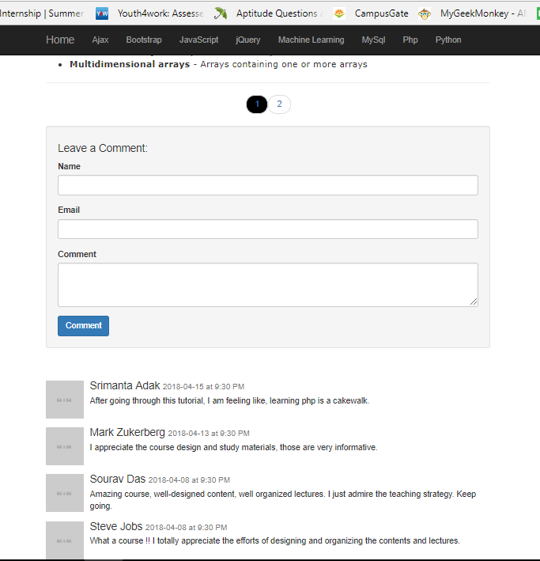

**This the Reader-Feedback / Comments section for a particular post.**

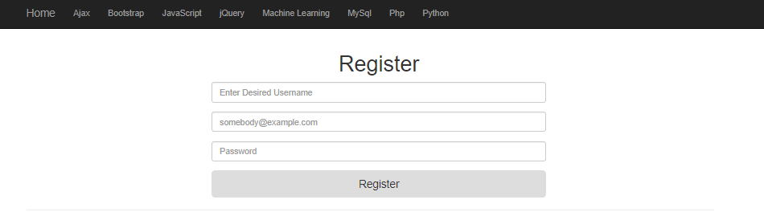 **This is the Registration section for new User.**

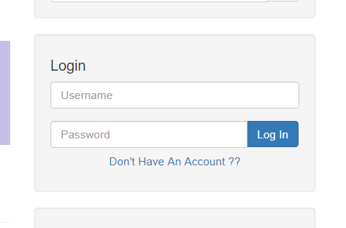

**This is the login section for Admin and Subscriber.**

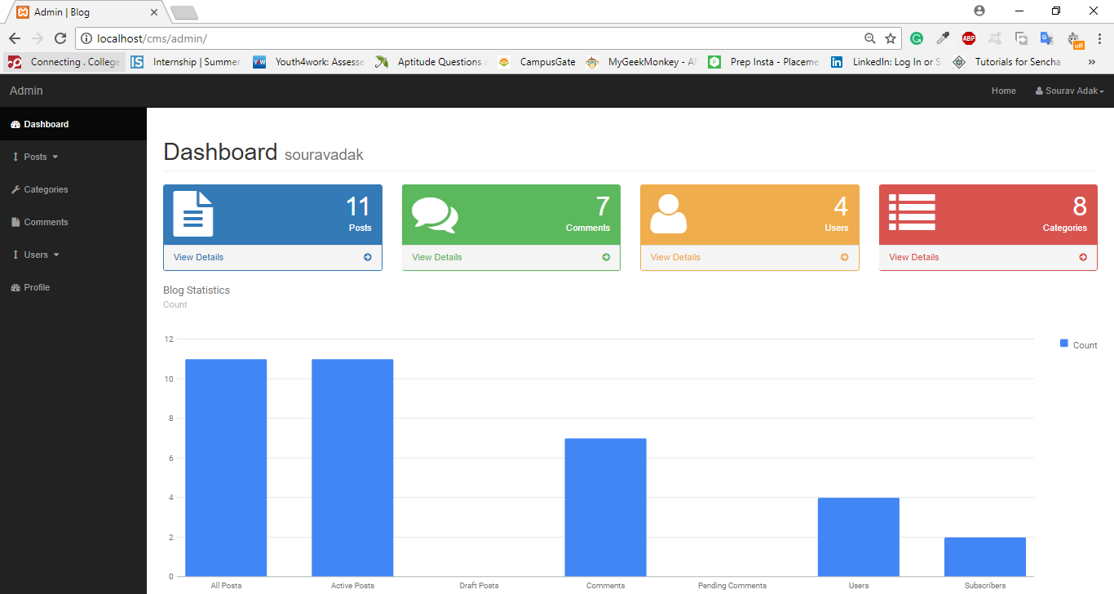

**Admin Dashboard. After login, admin would be redirected to this page.**

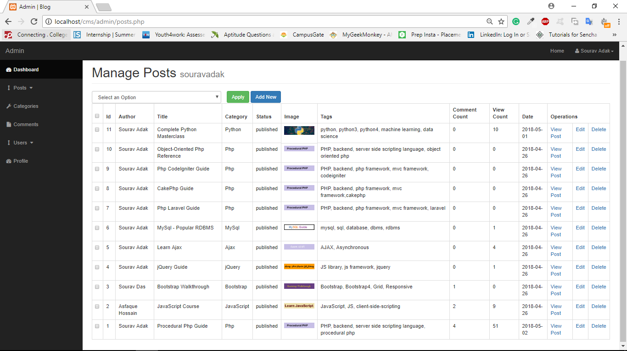

**Posts Database Management Page.**

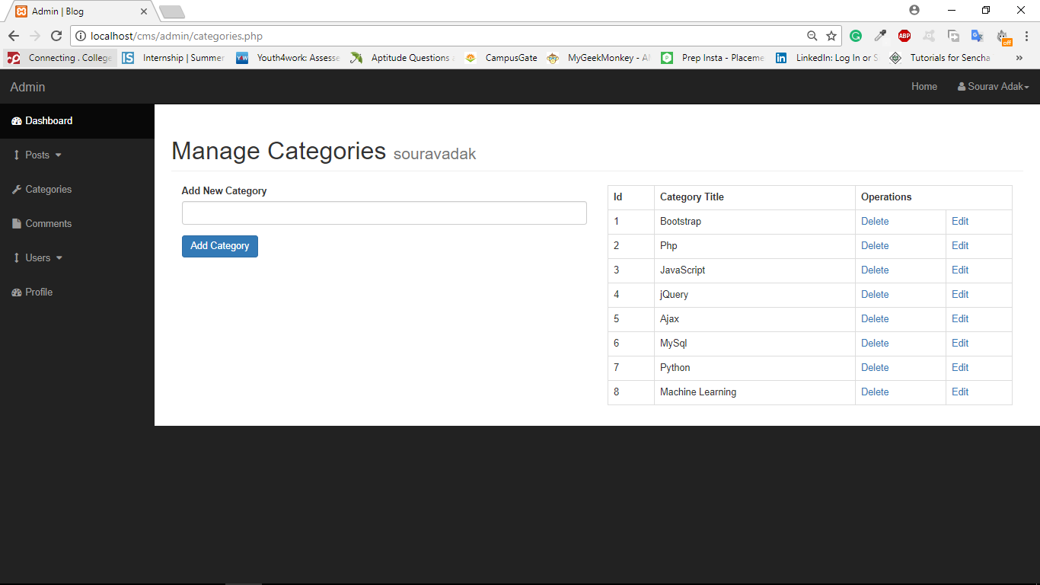

**Manage Post Categories Page.**

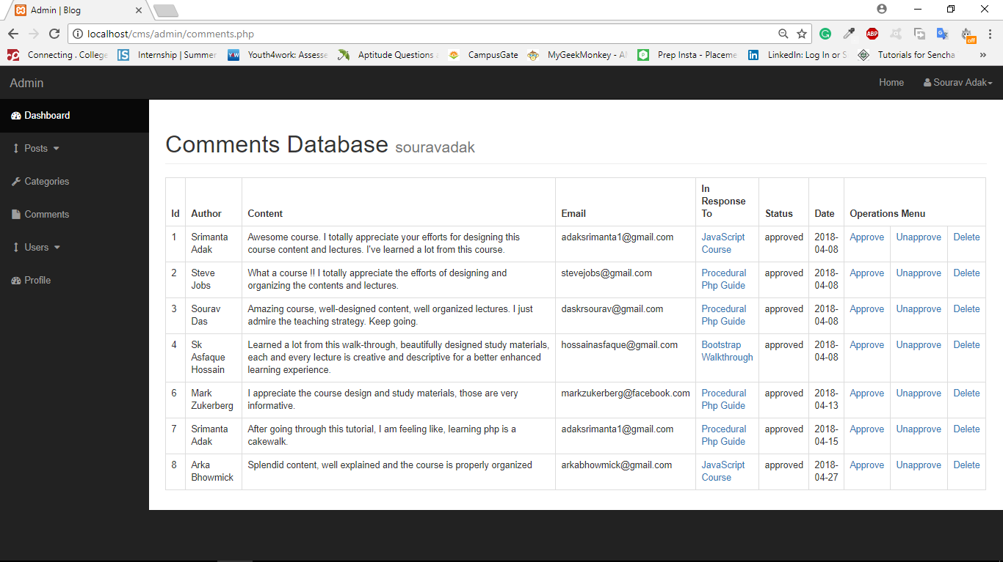

**Manage Post Comment Database Page.**

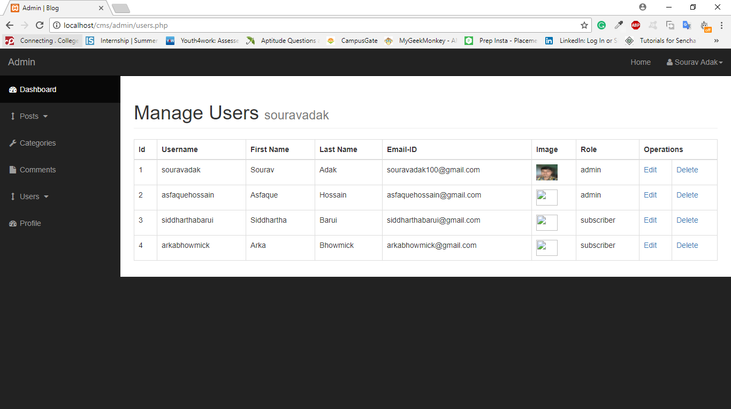

**Manage Blog Users Database.**

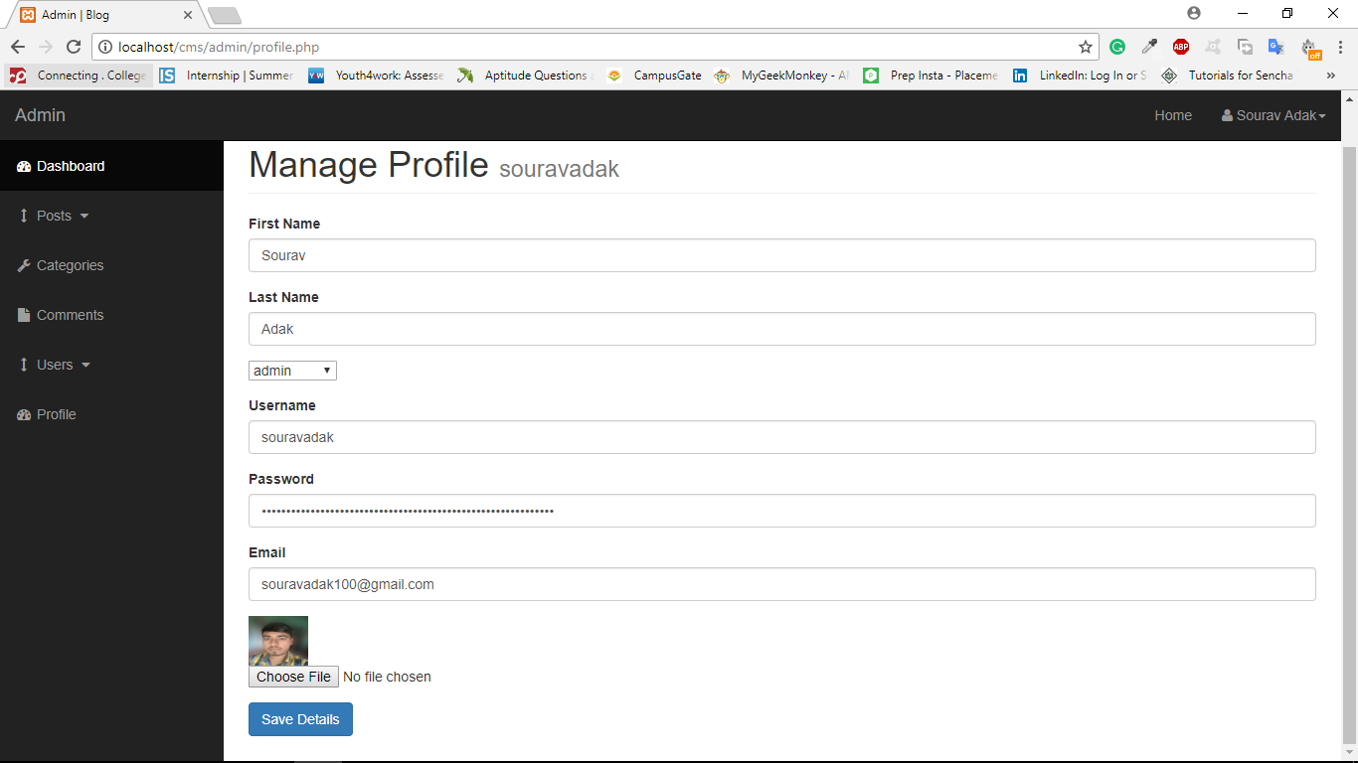

**Edit Profile Information Page.**

**7. Testing**

Testing is one of the most important phases of the software development life cycle(SDLC). Testing can expose most of the defects existing in the present system. And therefore, provides way of reducing defects in a system. Testing is done in various level to ensure the quality of the software. The user tests the system to verify that the system function is specified. Once the verification is complete, the system is ready to use by the end users.

To fulfill this objective, a series of testing steps :- unit testing, validation testing and system testing are planned and executed. Unit and integration testing concentrated on testing the functionality of a module. This is done one at a time and the modules are incorporated into the overall program structure.

**Types of software testing:**

There are five software testing phases each with a certain type of test associated with it.

|  |  |  |
| --- | --- | --- |
| Phase | Guiding Document | Test type |
| Development phase | Technical design | Unit testing |
| System and Integration Phase | Functional design | System testing and Integration testing |
| User acceptance phase | Business requirements | User acceptance testing |
| Implementation phase | Business case | Product verification test |
| Regression Testing applies to all Phases | | |

**7.1 Unit Testing:**

|  |  |  |  |  |  |
| --- | --- | --- | --- | --- | --- |
| Sr. No. | Test Cases | Data Input | Expected Output | Actual Output | Pass/ Fail |
| 1 | Registration module | Enter user details | If user already exists then alert that message else registered successfully | If user already exists then alert that message else registered successfully | Pass |
| 2 | Login module | Enter username and password | Login successful | Login successful | Pass |
| 3 | Edit profile module | Complete your profile information | When clicked update, profile information is successfully updated | When clicked update, profile information is successfully updated | Pass |
| 4 | Add post module | Add a new post | New post showed up in the blog home page as the latest post. | New post showed up in the blog home page as the latest post. | Pass |
| 5 | Manage posts module | Edit/Delete a Post | The post info is changed or the post is removed from the blog home page | The post info is changed or the post is removed from the blog home page | Pass |
| 6 | Add comment module | Add a comment on a post | The comment goes to admin for approval | The comment goes to admin for approval | Pass |

**8. Conclusion**

Depending on the requirements and the budget, CMS required for a system can either be built from scratch or one can use an existing open source or commercial product. The key feature to keep in mind while building a Web based CMS is intuitive and user-friendly administration. It should include important CMS functions like separation of layout and content, formatting the content with “WYSIWYG” editor and managing the workflow for the content approval before it is published to the users. I have successfully implemented the Simple CMS for an educational blogging system.

The primary features of Simple CMS are:

(1) easily editable content,

(2) templates (default/auto),

(3) user authentication, and

(4) workflow management.

The administration interface is relatively simple. It features one navigation bar that has different tabs for respective functions, such as Manage Pages, Manage Users, Manage Stylesheets, Configure homepage and Audit trial report. It has a workflow which will only allow the publishing of the new content when it is approved by the administrator. It has defined users and roles for users to add, delete or update content within the website. Each user can modify data according to his access rights. Only admin can assign roles to users and has full control over each user and his activity. The user can easily integrate a new template, which is basically the HTML and CSS files, into this application. Once it is integrated, the user can easily format and edit the page content using the rich text editor without having to deal with the HTML or the CSS code. Thus, this project will be useful to the users with less technical expertise, allowing them to easily manage the content of their page.

**9. References**

* <https://www.tutorialspoint.com>
* <https://www.w3schools.com/>
* <https://www.wikihow.com/>
* <http://www.codecademy.com/>
* <https://developer.mozilla.org/en-US/docs/Web/Tutorials>
* <https://tutsplus.com/>
* <https://www.udemy.com/>
* <https://en.wikipedia.org/>
* https://www.lynda.com/