Ramdeobaba University, Nagpur
Department of Computer Science and Engineering
Session: 2025-26

Subject: Design and Analysis of Algorithms (DAA) Lab Project
III Semester
LAB PROJECT REPORT

Ananya Gupta A5-B4-57
Khushi Rathi A5-B4-56
Bhoomi Rathi A5-B2-33

GITHUB link of Project repo : https://github.com/28rathib/DAA_LA_2_MINIMUM_NETWORK_COST_BUILDER

TITLE: Minimum Cost Network Builder(Greedy Algorithm)

Objectives:
• To design and implement a Minimum Cost Network Builder that connects all nodes with minimum total cost.
• To apply Kruskal’s Algorithm for constructing a Minimum Spanning Tree (MST).
• To use Union-Find (Disjoint Set Union) data structure for efficient cycle detection.
• To visualize the network with included edges and total cost.
• To develop an educational tool demonstrating MST construction and network optimization.

Introduction:
In network design and graph theory, building a connected network with minimal total cost is a fundamental problem. A spanning tree connects all vertices in a graph using exactly V − 1 edges, and a minimum spanning tree (MST) minimizes the total edge weights.

This project implements Kruskal’s Algorithm, which selects the smallest possible edges in increasing order of weight, ensuring no cycles are formed. The Union-Find data structure helps efficiently track connected components and detect cycles. The result is visualized graphically, showing how nodes are connected in the Minimum Cost Network.

Algorithms/Technique used:

1.Greedy Algorithm
Kruskal's Algorithm is a greedy algorithm: at each step it chooses the lowest-cost edge that does not create a cycle, eventually producing a minimum spanning tree.

2. Kruskal’s Algorithm (Stepwise)
Input: A connected, undirected graph G = (V, E) with weights on edges.
Step 1: Create an empty list MST to store the edges of the minimum spanning tree.
Step 2: Sort all edges in E in non-decreasing order of their weights.
Step 3: Initialize a Union-Find structure with each vertex in its own set.
Step 4: For each edge (u, v) taken from the sorted list in order:
a) Use Find(u) and Find(v) to determine the set representatives of u and v.
b) If Find(u) != Find(v), then add edge (u, v) to MST and perform Union(u, v).
c) If Find(u) == Find(v), skip the edge to avoid creating a cycle.
Step 5: Stop when MST contains exactly |V| - 1 edges or when all edges have been processed.
Output: MST contains the edges of a minimum spanning tree and its total cost is the sum of their weights.

3. Union-Find (Disjoint Set Union)
Union-Find efficiently manages groups of connected vertices using two main operations:
• Find(x): Returns the root parent of element x.
• Union(x, y): Merges the sets containing x and y.

It ensures that no cycles are formed when edges are added to the MST.
Optimization Techniques:
- Path Compression: Flattens the tree to speed up the find operation.
- Union by Rank: Keeps the tree shallow by attaching the smaller tree under the larger one.

4. Visualization Technique:
The visualization of network connection paths is achieved using a force-directed graph layout implemented through the NetworkX library in Python (using the spring_layout function). This technique represents each substation as a node and each selected edge (from Kruskal’s MST) as a connection line. The total cost of the network is computed by summing the weights of all edges included in the MST.

Time Complexity and its explanation:

Operation | Complexity | Explanation
Sorting Edges | O(E log E) | Sorting all edges by weight.
Union-Find Ops | O(E α(V)) | α(V) is the inverse Ackermann function (≈ constant).
Total | O(E log E)

Results:

Sample Input taken:
Vertices (Substations): A, B, C, D

Edges (Connections with Cost):
From To Cost
A B 10
A C 6
B C 5
B D 15
C D 4

Expected Output:
C -- D (4)
B -- C (5)
A -- C (6)
Total Minimum Cost = 15

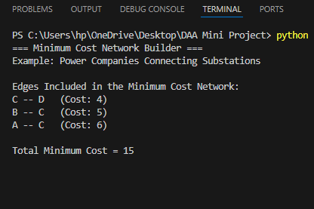

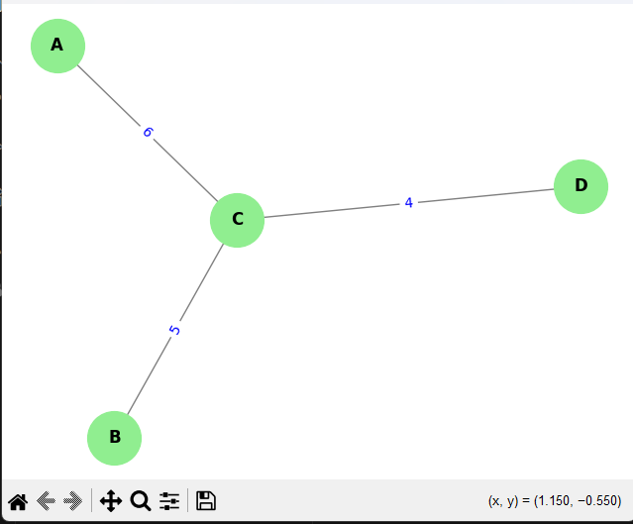

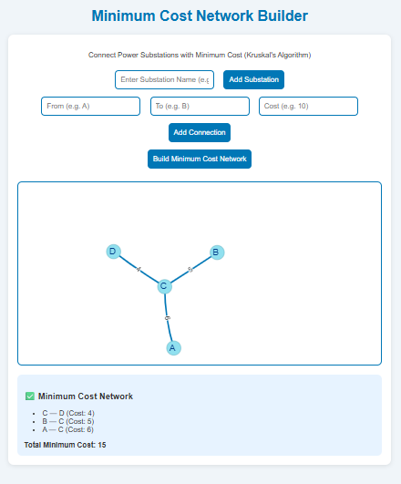

Conclusion and future scope:
Conclusion:
The Minimum Cost Network Builder project successfully demonstrates the use of Kruskal’s Algorithm and Union-Find for efficient network design. The visualization component enhances understanding of MST construction, showing how minimal connections achieve full connectivity.

Future Scope:
1. Integrate Prim’s Algorithm for comparison.
2. Support real-time dynamic edge updates.
3. Extend visualization with interactive GUI.
4. Apply to real-world networks like communication, transport, and power grids.
5. Include performance analysis charts comparing different MST algorithms.

