**Network Specifications**

3 nodes

2 hop communication

source & sink can communicate only via intermediate node

1 packet being sent from source to sink

Packet interval is 10 seconds in case of multiple packets

Packet size is 1000 bytes

Wifi Phy Mode - DsssRate1Mbps

Wifi Standard - WIFI_PHY_STANDARD_80211b

Pcap Data Link Type - DLT_IEEE802_11

Propogation Delay Model - ConstantSpeedPropagationDelayModel

Propogation Loss Model - FriisPropagationLossModel

Wifi Remote Station Manager - ConstantRateWifiManager

Wifi Mac - AdhocWifiMac

Mobility Model - ConstantPositionMobilityModel [No Mobility]

Routing Protocol - AODV

Transport Layer Protocol - UDP

Pcap Tracing is enabled.

NetAnim Code is added.

Source  
node 2  
[ip: 10.1.1.3; mac: 00:00:00:00:00:03]

Position (450,0,0)

Intermediate  
node 1   
[ip: 10.1.1.2; mac: 00:00:00:00:00:02]

Position (200,0,0)

Sink  
node 0   
[ip: 10.1.1.1; mac: 00:00:00:00:00:01]

Position (0,0,0)

**Power calculations using the Friis Propagation Model:**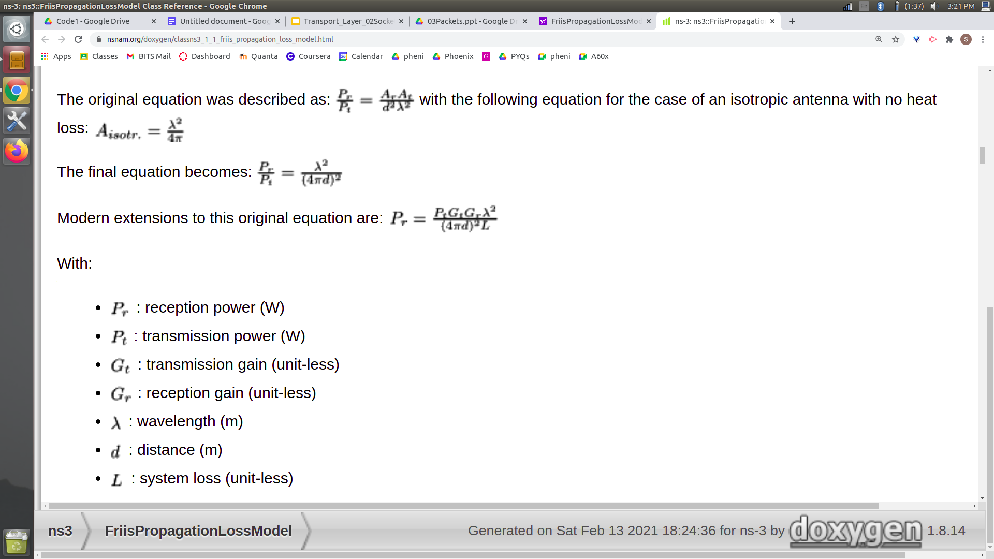

Source:<https://www.nsnam.org/doxygen/classns3_1_1_friis_propagation_loss_model.html>

f =15e+09 (default value of frequency)

λ =C/f = 299792458/(5.15e+09) = 0.058212127767

Gt =1

Gr =1 (No gain)

L =1 (No system losses)

Pt = 33dBm = 1.99526W

Max distance b/w nodes(d) = 255m

Thus, using the above values we can compute minimum energy required for receiving data:

$Pr = Pt*Gt*Gr*λ*λ÷((4*3.14*d)^{2}*L) =6.60693e-10 W =-61.8dBm$

Thus,

Energy of transmission: 33

Minimum energy required for receiving signal: -61.8