Contemporary Arts | 4th Quarter

WW4: Mixed Media Art Analysis

April 6 2022

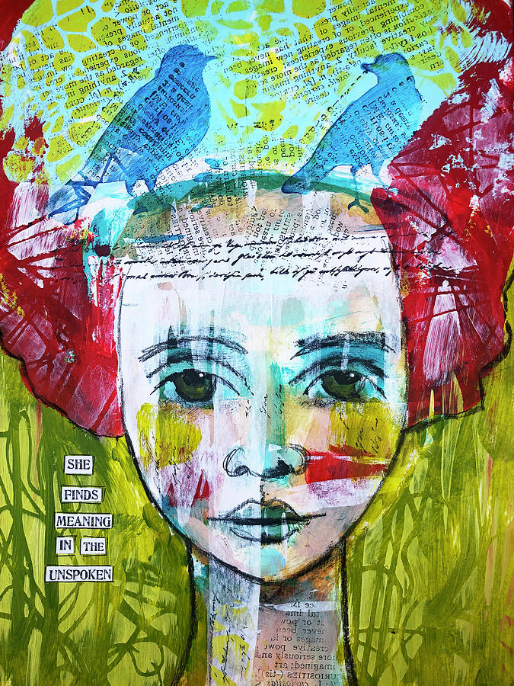

Title: **Meaning in the Unspoken**

Artist: **Lyn Colwell**

1. **What category does the art fall under? How can you tell?**

The art falls under the category of painting, and I can tell so as the way the piece is colored suggests that it is done with a paint brush.

1. **Turn your attention to the piece as a whole. Take a few minutes to look at the artwork in its entirety and answer the following questions.**
   1. **How does the artist use color? Are there stark contrasts or is it blended? Are there symbolic meanings behind the color choices?**

The artist uses a variety of colors for the piece, and there is a clear contrast on where there needs to be emphasis. I have been looking at it for a while, but I can’t see a symbolic meaning behind the color choices.

* 1. **Are the forms in the piece realistic or abstract? Are they fully one style or do they mix the two?**

The forms in the piece are both realistic with the face of the girl, but abstract with the other symbolisms in the piece. The artist used one style throughout the artwork.

1. **Based on the information above, write a paragraph about this artwork.**

The artwork shows a woman’s head with figures of two birds in her head. Beside her head is a written text that says “She finds meaning in the unspoken”, the unspoken being the figures in her head that can’t speak.

1. **What questions would you ask the artist about the artwork?**
   1. What inspired you to make the artwork?
   2. How did you make the artwork?
   3. How did you achieve the art style in your artwork?