General Physics 2 | 4th Quarter

PT1: Virtual Lab – EM Waves

March 28 2022

Wavelengths

1. Gamma Rays

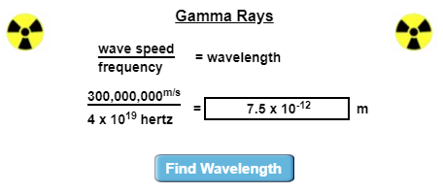

1. X-Rays

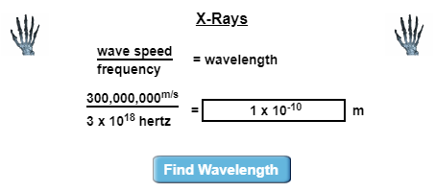

1. Ultraviolet Radiation

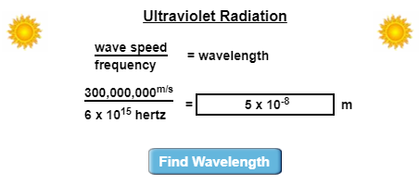

1. Visible Light

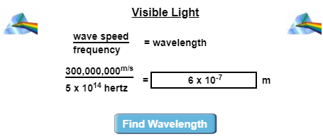

1. Infrared Radiation

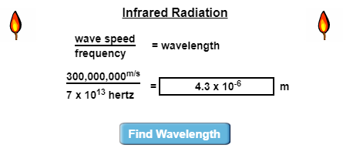

1. Microwaves



1. Radio Waves

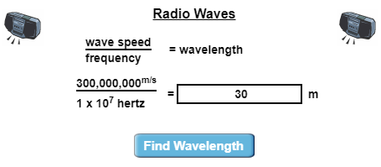

Electromagnetic Spectrum

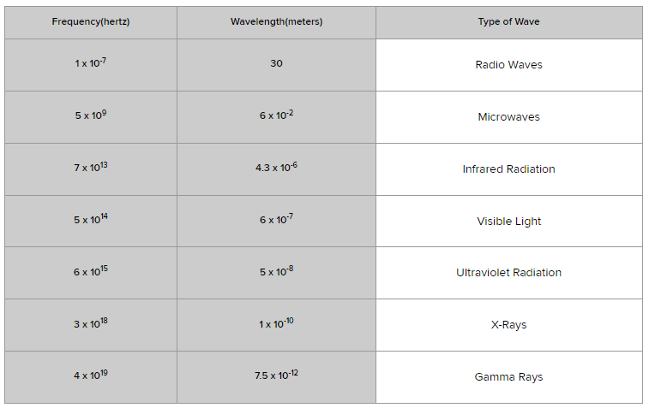

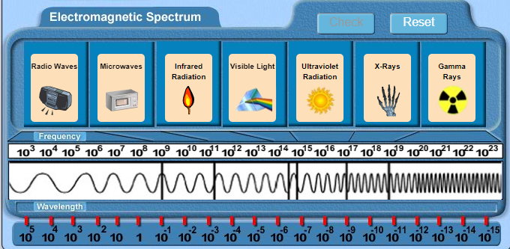

Journal

1. **As you move from left to right on the electromagnetic spectrum, what happens to frequency? What happens to wavelength?**

The frequency increases and the wavelength decreases.

1. **Arrange the following types of electromagnetic waves in order by wavelength, from longest to shortest:**
2. Radio waves
3. Microwaves
4. Infrared Radiation
5. Visible Light
6. Ultraviolet Radiation
7. X-Rays
8. Gamma Rays
9. **What kinds of EM waves have the lowest frequencies? What kinds have the highest frequencies?**

Radio waves, microwaves, and infrared waves have the lowest frequencies. Gamma rays, X-rays, and ultraviolet waves have the highest frequencies.

1. **Which type of EM wave has more energy, an ultraviolet wave or an infrared wave? How can you tell this by looking at the electromagnetic spectrum?**

An ultraviolet wave has more energy due to its higher frequency than the infrared wave.

1. **In terms of wavelength and frequency, what is the difference between a radio wave and an X-ray?**

A radio wave has longer wavelengths, but shorter frequencies. While an x-ray has higher frequencies, and shorter wavelengths.

1. **Based on your results, which type of EM wave do you think is more dangerous, a low-frequency wave or a high-frequency wave? Why?**

Based on the results, a high-frequency wave is way more susceptible to danger than a low-frequency one because of the energy it emits. It is known that gamma rays or x-rays are bad for body cells, as they can kill these cells.