General Physics 2 | 4th Quarter

WW1: Magnetic Force, Magnetic Field, Right Hand Rule

March 3 2022

1. Problem Solving
   1. A current flows west through a long wire. A magnetic field of is directed out of the page. What is the magnitude and direction of the magnetic force acting on a wire?
   2. A proton moves south with a speed of . A magnetic field is directed west. Determine the magnitude and direction of the magnetic force acting on a proton.
2. Right Hand Rule
   1. 1. 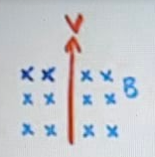

West /

* + 1. 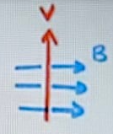

Into the page (North) /

* + 1. 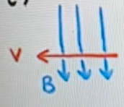

Out of the page (South) /

* + 1. 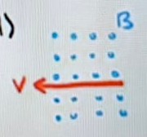

Upwards /

* 1. 1. 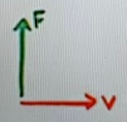

Into the page (North) /

* + 1. 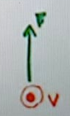

East /