Media Info Literacy | 4th Quarter

WW1

Date

Title: As You Like It – Eve MV

URL: https://youtu.be/nROvY9uiYYk

Thumbnail:

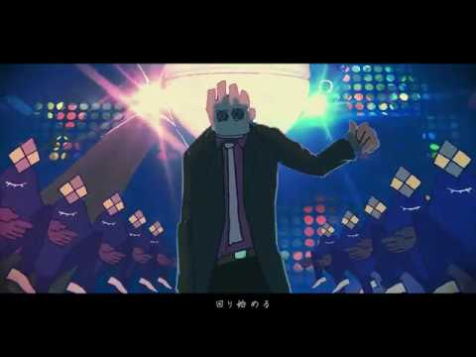

**How was this video created?**

This video was created with the use of technology and the technique called animation. Animation is a type video that has been around for quite a while now, and this video used it as animation is very popular in Japan, the country of origin of the artists, and Japan itself is popular for animation.

**What materials were used?**

To create the video, animators were hired that had crews to work on different parts of the animation, such as the background, the storyboard, keyframing, inking, coloring, so on and so forth. Most of the process of animation were made in the computer, only the concept art making, storyboarding, and etc. are done on paper sometimes, but it rarely seen nowadays.

**What decisions were made to make it entertaining or attention-grabbing?**

Decisions such as the timing of the movements, the design of the characters, the narrative of the video, and many more details are what made the video entertaining and attention-grabbing, apart from the upbeat and energetic music.

**What was included?**

The video included glimpses of the story which was enough to tell it. There were also a lot of visualizations that were abstract and in sync with the beat of the music turning out as a satisfying eye candy.

**What was excluded?**

As far as I can tell, the video contained everything it needed to communicate the message and the story the song was trying to tell.