General Physics 2 | 3rd Quarter
WW4: Series-Parallel Circuits
February 9 2022

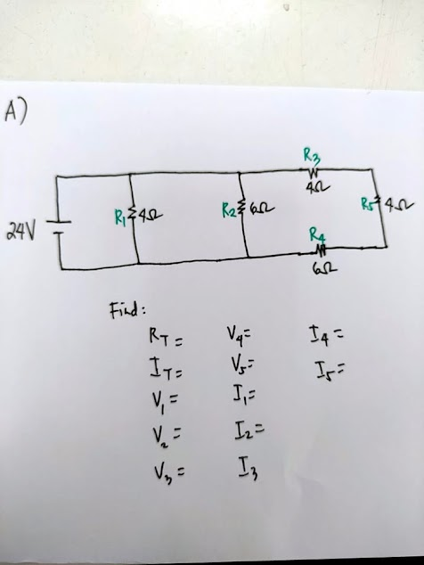
- Given:

Find:

- ✓

Solution:

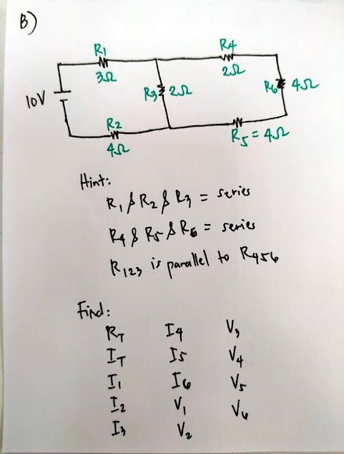

- Given:

