Inquiries, Investigation & Immersion | 3rd Quarter
Conceptual Framework
February 23 2022

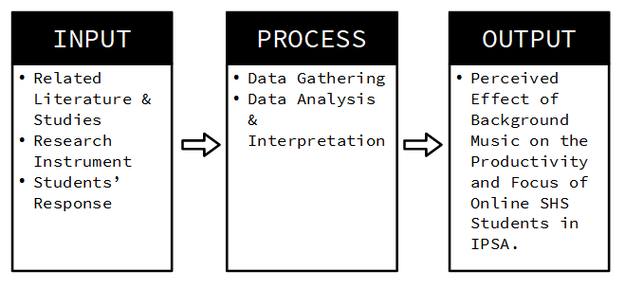
Conceptual Framework
As seen in the figure presented above, the researcher requires a review of the related literature, the students’ response to the research instrument, for the researcher to conduct this study.

