Contemporary Phil. Arts | 3rd Quarter
PT1: MODERN OR CONTEMPORARY?
January 3 2022

Modern Art
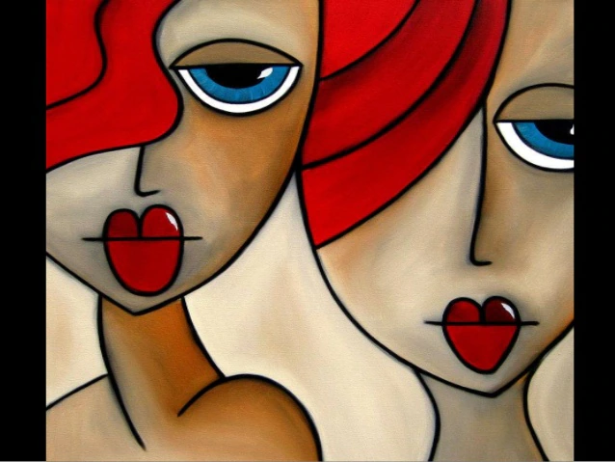

Contemporary Art
