PE & Health 4 | 3rd Quarter
WW3: Aquatic Activities
January 27 2022

- According to our presentation there are three systems of our body that can be developed in various swimming activities. Name the following and give a concrete example each.
Various swimming activities can develop three essential systems of our body. One of the systems is the respiratory system, humans currently can’t breathe underwater, and so swimming can help train the lungs under water pressure. The muscular system can also be developed because in swimming, essential muscles are used in order to move underwater. Water pressure not only affects the air in the lungs, but our blood as well, and so it develops the endurance of circulatory system and allow proper circulation of the blood.
- Besides swimming, give other Aquatic Activities that you want to try after the pandemic. Do research, post a photo, and describe your chosen activity. You may include the gear to use and its benefits.
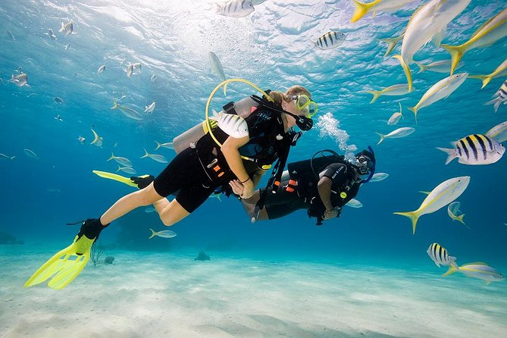
Probably even during the pandemic, I’d like to try scuba diving. Scuba diving is underwater diving where the divers use a breathing equipment to go and stay longer in deeper waters. The word scuba is an acronym itself for ‘self-contained underwater breathing apparatus’.

