

SENIOR HIGH SCHOOL DEPARTMENT



Badron, Ahmad G.

Grade 11 – STEM 2

Second Semester, SY 2020 – 2021


What is a portfolio?
A portfolio is a showcase of all students’ work, it is a collection of work that students keep, reflect on and share with their parents. There will be four (4) areas that are evident.

1) Learner Profile
Reflect on student’s experiences in an online class and how these demonstrate MELCs.
2) Academic Progress
Reflect on student’s work and development or progress in his/her different subjects.
3) Reflection On Learning (ROL)
Reflection on student’s skills and the acquisition of MELCs.
4) Inquiry
Demonstrate the inquiry cycle across the curriculum (Inquiry, Action, and Reflection).

Why do students keep a portfolio?
The portfolio will help you in four ways:
1. You can reflect on your learning throughout the semester
2. You can organize the evidence of your work in a variety of areas.
3. You can share your accomplishments with your family and others.
4. You will use this as a final Performance Task in all your subjects every end of semester.

What type of work does a student put in the portfolio?
You include written works, performance tasks, essays, artworks, researches, certificates you earn from participating webinars or activities. If the work/project is too large to fit in your Portfolio, a photo may be attached to a paper that describes the work/project. Be sure the date is on all your work and don’t forget to complete the Assessment to Learning reflection for every work.

Who will grade the portfolio?
The student will self-assess the portfolio by using the student checklist at the end of every semester. The teacher will also evaluate it as a requirement for completing the semester.

Organization of the Portfolio

Table of Contents
1. Cover Page
2. IPSA Vision and Mission Statement.
3. Personal Page
4. Written works with ROL/Learning experiences in every subject.
7. Performance Tasks with ROL/Learning experiences in every subjects.
8. Other works (e.g. essays, art works, researches) with ROL/Learning experiences in every subjects.
9. End of Semester Reflection


IPSA VISION and MISSION STATEMENTS

VISION STATEMENT

International Philippine School in Al Khobar (IPSA) is a leading Filipino community school: pro-God, dynamic and
responsive to the needs of the learners
and the community.

MISSION STATEMENT

International Philippine School in Al Khobar (IPSA)
is committed to providing value-focused,
research-based, service-driven and
innovative education.



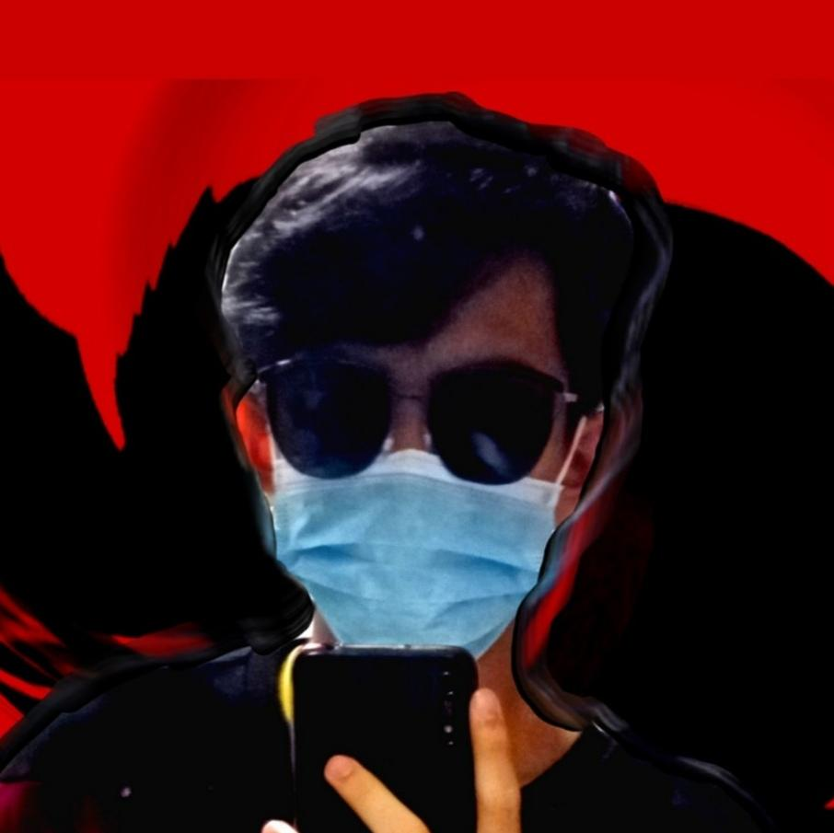
Personal Page

I am Ahmad Badron, and I may or may not consider myself an ambivert. And by that, I mean that I get very noisy with people I’ve known for long enough, and very silent around people I may know, but not too close to. I am a 5’7” (or 169 cm), 16 year old Filipino guy, born on a Tuesday, June 29, 2004 in Dammam Maternity Hospital, KSA. When I’ve got nothing to do, like nothing at all, I think about anything I can think of, and I brainstorm on it and come up with thoughts about the topic. So now you know about what goes in my head, when stationary. I’d say I am emotionally stable as a person. But kind of not too. I tend to overthink things, especially my friendships and relationships with people, which is a bad thing to do.

Currently, I am reading War and Peace, by Leo Tolstoy, and I’m not sure if I’m ever gonna finish it. First of all because it has 2000+ pages, and second that matters is that I’m not that ‘reader’ -ish of a person. So I’m not sure how this read is gonna go. I have played Lawn Tennis ever since I was young enough to be able to carry a racket in both my hands. And I still play it to this day. I like a lot of challenges, and thinking, so I try programming challenges that help me make algorithms that are actually useful in the long run. Mention the fact I also program. So far, the languages I have learned and have been able to program on are C++, Python, JavaScript, and Java. HTML and CSS aren’t programming languages, mind you.

Reading & Writing
Written Works
3rd Quarter
- Written Work 1
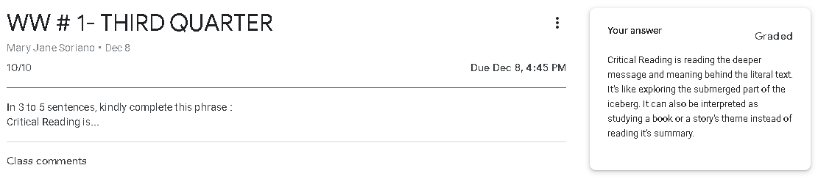
- Written Work 2
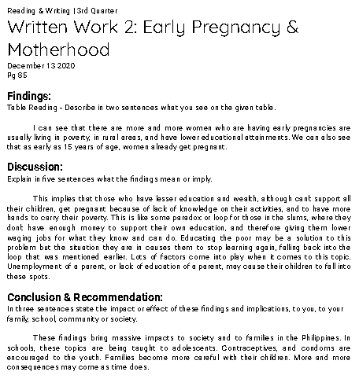

- Written Work 3 (Group): Circle Chat
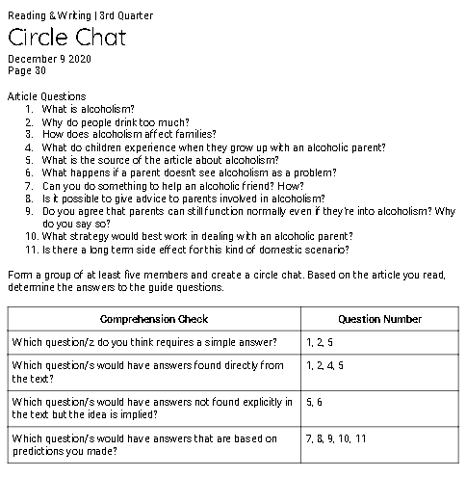
- Written Work 4 (Group): Unified or Not?
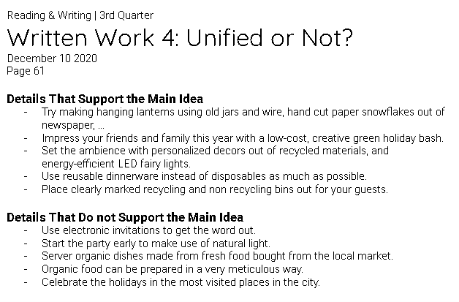

- Written Work 5 (Group): Odd One Out!

- Written Work 6 (Group): Revision through Cohesion
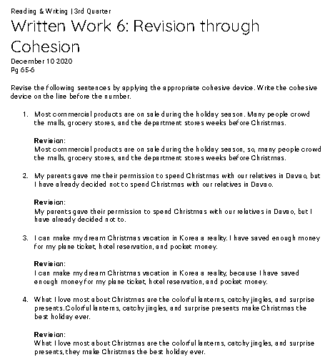

4th Quarter
- Written Work 1
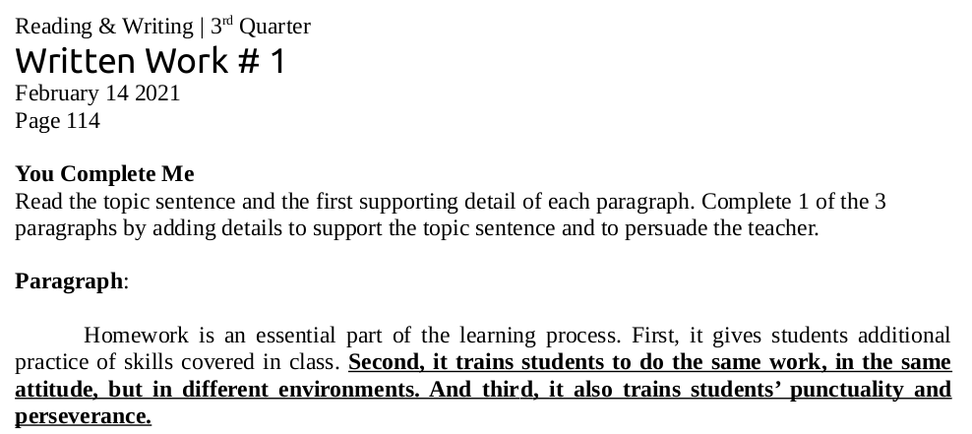
- Written Work 2
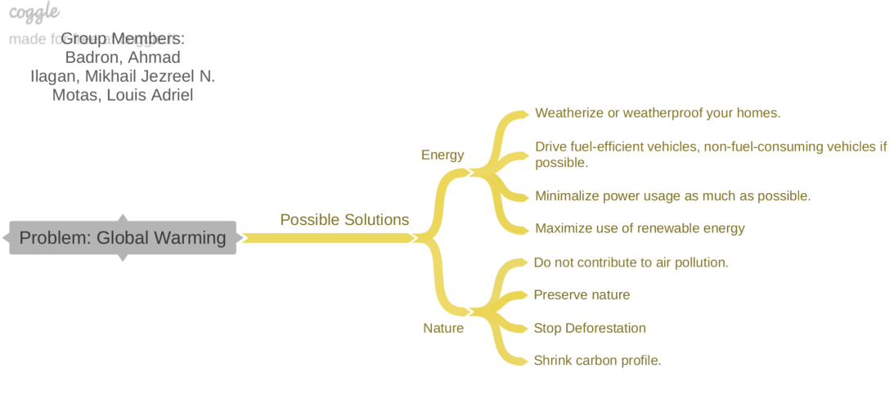
- Written Work 3: Critique / Review
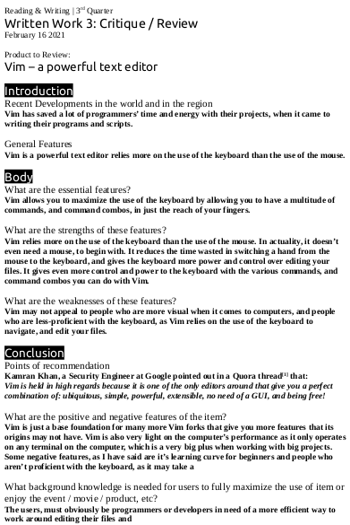

REFLECTION ON LEARNING
What are the Written Works?
3rd Quarter
- Written Work 1 – 10/10
- Written Work 2 – 10/10
- Written Work 3: Circle Chat – 10/10
- Written Work 4: Unified or Not? – 10/10
- Written Work 5: Odd One Out! – 10/10
- Written Work 6: Revision through Cohesion – 12/12

4th Quarter
- Written Work 1 – /15
- Written Work 2 – /15
- Written Work 3 – /15

Explain what exactly you were required to do in these written works?
3rd Quarter
- We were asked to continue this phrase: “Critical Reading is … ” in a short answer.
- We looked at a table of data about early pregnancy and motherhood, and we were asked to reflect and give our findings based on the data. We wrote our output in paragraph form.
- We listed down different types of questions based on the article we just read and the questions that came along with it. We did this activity with a group.
- We picked out the sentences that didn’t support the main topic, and those that support the main topic.
- We underlined the sentences that were out of order or sequence to evaluate the paragraph’s coherence. We did this activity with a partner.
- We revised sentences that didn’t feel right with cohesive devices, and we did it as a group.

4th Quarter
- In this written work, we completed a paragraph and filled in supporting details to complete the idea.
- In this written work, we made a graphic organizer with our select group mates, that was about a problem or a topic we chose.
- In this written work, we made a proper review of a product. I chose to review Vim, which isn’t really product, but an open-source text editor.

What information was the most interesting/surprising to you?
3rd Quarter
- I was amused by the concept of critical reading, because I was aware of it but I wasn’t aware about it being a concept.
- I was surprised to see that my expectations for the results weren’t what they turned out to be. I expected that the reckless teenagers would be more prone to early pregnancy, but it turned out that the 20-year-olds were more prone to pregnancy than the younger ages.
- Questions can be put into different classifications, and with that, you have an idea on how to efficiently answer the questions.
- Reading a paragraph without unity feels weird. The bits of the paragraph that don’t really point to the main idea distract the reader and causes them to lose grip of the main idea.
- My reaction to this was pretty much the same with the last activity, but this time, we get the satisfaction of revising the wronged paragraph using cohesive devices.
- Sentences can be easily fixed with just simple words such as “because”, and you can make the sentence be read smoothly without any doubt in it.

4th Quarter
- I learned in this written work, that with proper research, and sequence of ideas, a single sentence’s idea can be completed with the supporting details that’ll come after it.
- I learned and solidified the fact for myself that two heads are better than one, because me and my group mates came up with a lot of ideas, and even ideas that I myself couldn’t think of.
- It was fun to review a product that I really like and use, and maybe a bit of bias was mixed into the critique, but anyway, it was a fun activity.

Which of the written works you did well? Why?
3rd Quarter
I’d say I have done well in much of the tasks given to us, despite missing the first day of classes. Because I participated, took my time, and kept up with the activities as much as possible.

4th Quarter
I did well with all the activities. Because I was able to catch up

In what written work do you need to improve? How?
3rd Quarter
I want to work on my motivation to read long passages. I have very bad attentiveness and I get hooked by my environment quickly. I need to work on focusing in class and focusing on what I’m doing.

4th Quarter
The only thing I have to work on is the punctuality.

Performance Tasks
3rd Quarter
- Mini Performance Task 1: Revising through Cohesion
- Mini Performance Task 2

4th Quarter
- Mini Performance Task 1
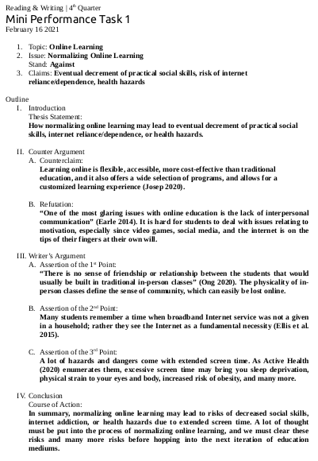
- Mini Performance Task 2
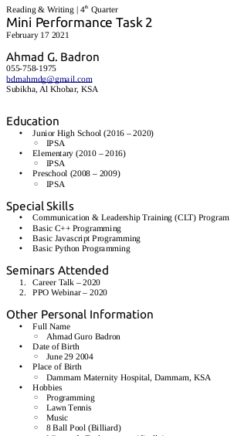

- Mini Performance Task 2 Part 2
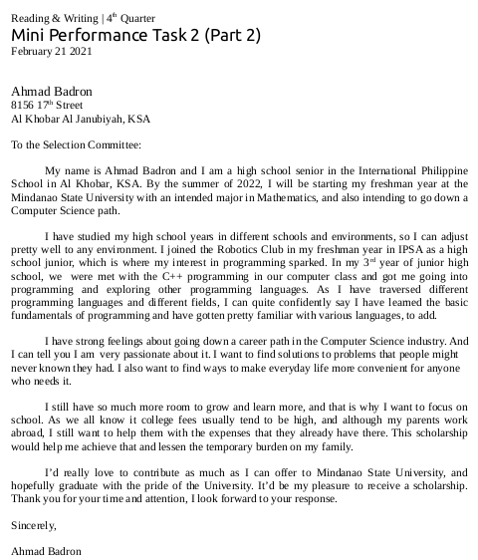

REFLECTION ON LEARNING
What are the Performance Tasks??
3rd Quarter
- Mini Performance Task 1: Revising through Cohesion - 15/15
- Mini Performance Task 2: Comparing & Contrasting -15/15

4th Quarter
- Mini Performance Task 1 – /25
- Mini Performance Task 2 – /20
- Mini Performance Task 2 Part 2 – /20

Explain what exactly you were required to do in this Performance Task?
3rd Quarter
- We were told to revise a paragraph using cohesive devices.
- We were asked to compare and contrast two subjects in an essay form.

4th Quarter
- In this mini performance task, we wrote a position paper. I chose the topic “Online Learning” having a stand against normalizing it.
- In this mini performance task, we made a resume.
- In this mini performance task, we made scholarship application letter, basing the details off the resume we made in the last mini performance task.

How may the skills that you have developed in this Performance Task be of help to you in your future career?
3rd Quarter
- Cohesive devices are very useful when revising sentences and making the ideas flow smoothly as the reader reads it.
- Having different ways to compare two topics is very handy, especially having two ways expressing your thoughts.

4th Quarter
- Position papers are like the scripts for asynchronous debates for me. I learned in this activity how to express my stand and opinions on topics in a more formal manner.
- Resumes are key items in the hustle for finding jobs, which is what we will get into hopefully after or during college.
- Learning how to write a scholarship application letter is going to be very helpful, to me and my family. Because I am looking forward to applying for a scholarship when I come home to the Philippines for college.

Which of the Performance Tasks you did well? Why?
3rd Quarter
I’d rather lean towards doing well in the first mini peta. Because I clearly understood the topic well among the others. I also did well in mini peta 2, because I had a good understanding of the activity and the topic.

4th Quarter
I did well in all as well, because I was in pace with the lessons.

In what Performance Task do you need to improve? How?
3rd Quarter
I’d gladly say I did well with most of the activities, it’s just that I feel like I was a bit tight on time, so I need to be more punctual.

4th Quarter
I need to improve in being more comprehensive in most of my writings, because I lack details, explanation and reason when I write out my ideas.

PE & Health
Written Works
3rd Quarter
- Written Work 1
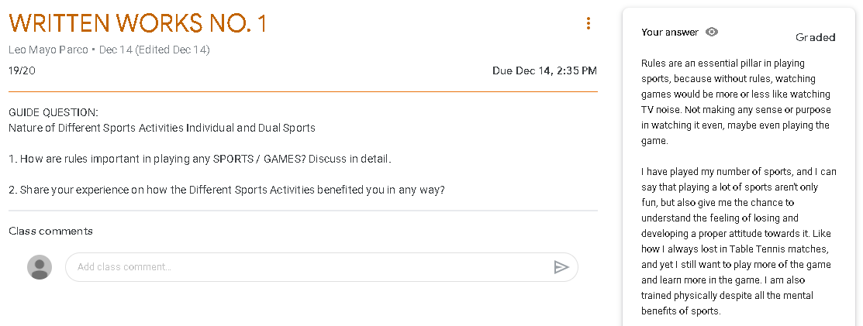
- Written Work 2
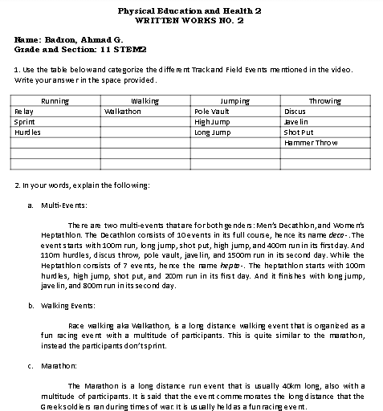

- Written Work 3
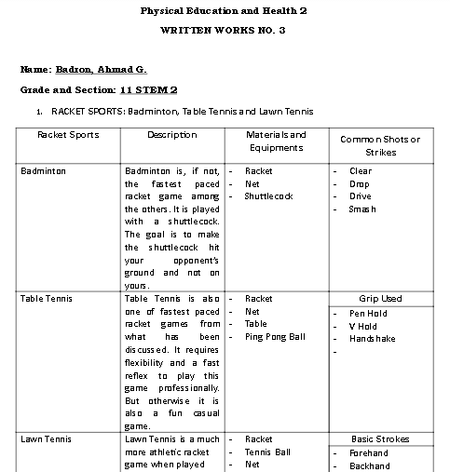

4th Quarter
- Written Work 1
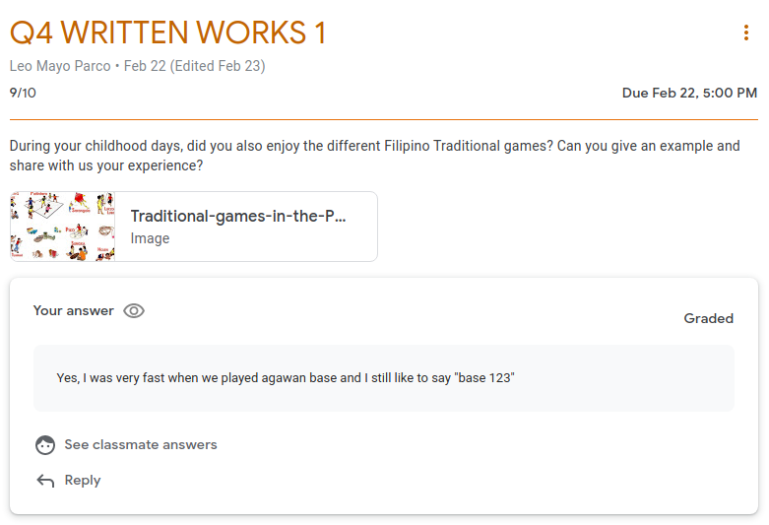

- Written Work 2
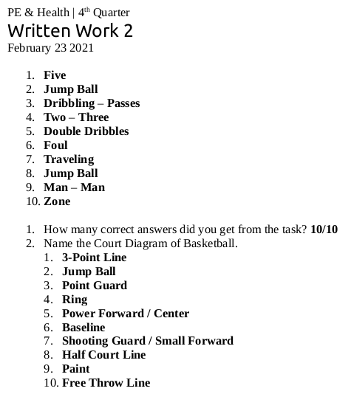
- Written Work 3
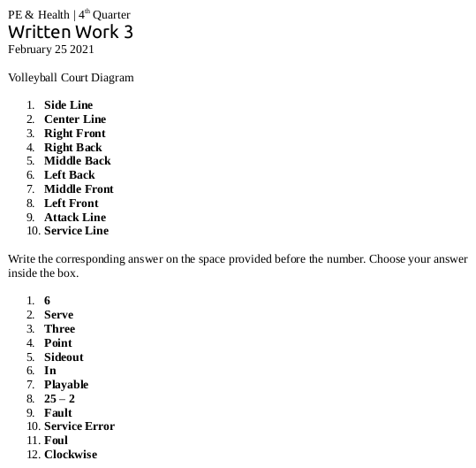

REFLECTION ON LEARNING
What are the Written Works?
3rd Quarter
- Written Work 1 - 19/20
- Written Work 2 - 22/25
- Written Work 3 - 29/30

4th Quarter
- Written Work 1 – 9/10
- Written Work 2 – 20/20
- Written Work 3 – 19/20

Explain what exactly you were required to do in these written works?
3rd Quarter
- We were asked two simple questions about sports, its rules, and how it benefited us in any way.
- We filled in tables about athletic sports, a topic we recently just studied. We also assessed our knowledge of the said topic through defining and explaining three words related to the topic.
- We filled in tables about the respective racket games we studied about. We were also asked to describe Pickleball and where it originated.

4th Quarter
- In this written work, we shared our experiences about traditional games we played as children.
- In this written work, we answered fill-in-the-blanks questions about Basketball and some identification about the Basketball court.
- In this written work, we did the same thing last task, but about Volleyball this time.

What information was the most interesting/surprising to you?
3rd Quarter
- Sports as a topic itself got me hooked to it. I look forward to the lessons.
- I was very interested in how the professional athletes who play the game have so much stamina, I wish I had a talent like theirs.
- When it comes to my main sport, lawn tennis, I’m not that much of a geek. But this made me feel like one. I also always thought that table tennis was the fastest paced racket game out there, until I realized how badminton is professionally played.

4th Quarter
- Now that I think about it, the games we used to play as children were very competitive. I was and am of the people who were very small and nimble so I had some advantage in the games me and my friends used to play.
- I got more familiar than I already was with the game of Basketball through this activity.
- I also got more familiar about the game of Volleyball through this activity and lesson. I really enjoy watching and playing the game of volleyball.

Which of the written works you did well? Why?
3rd Quarter
I would come to an agreement with myself that I have done well in all of the written works, since most of the required tasks were just revolving around the same topic we just have discussed.

4th Quarter
I’d say I did well in all the tasks given to us because I did my best in all of them, that is if I decide whether I did well or not.

In what written work do you need to improve? How?
3rd Quarter
I do think that I don’t any much negative productivity this quarter, and I’m proud of that. I’m also proud to say I have to keep it up.

4th Quarter
So far, I didn’t any problems in the written works side of the tasks given to us, and I’d give myself a clap for achieving this this quarter. I would really love to continue this productivity next year, with all subjects as well.

Performance Tasks
3rd Quarter
- Performance Task 1
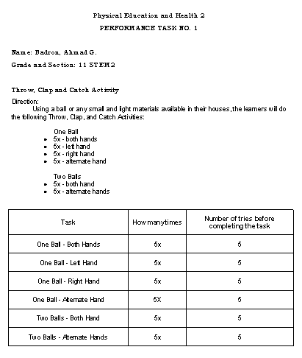

- Performance Task 2
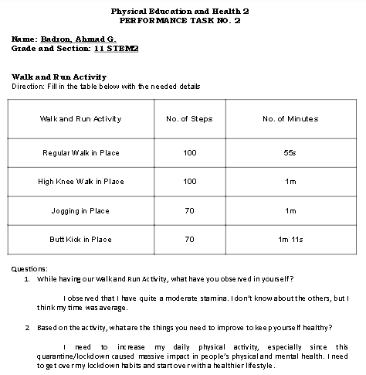
- Performance Task 3
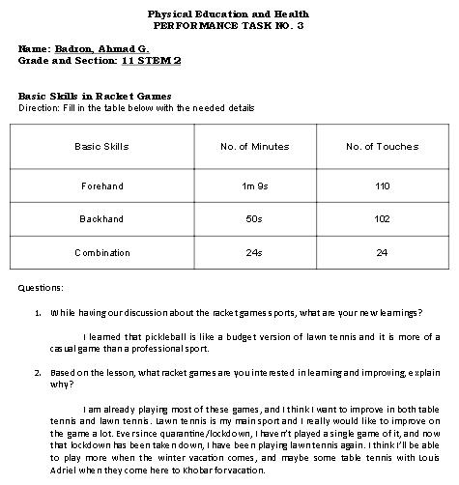

- Performance Task 4
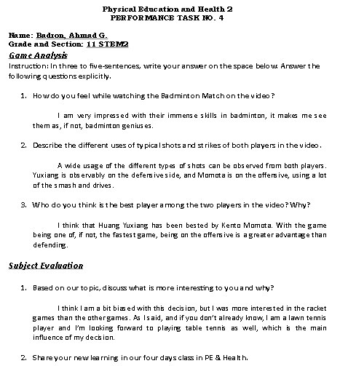

4th Quarter
- Performance Task 1
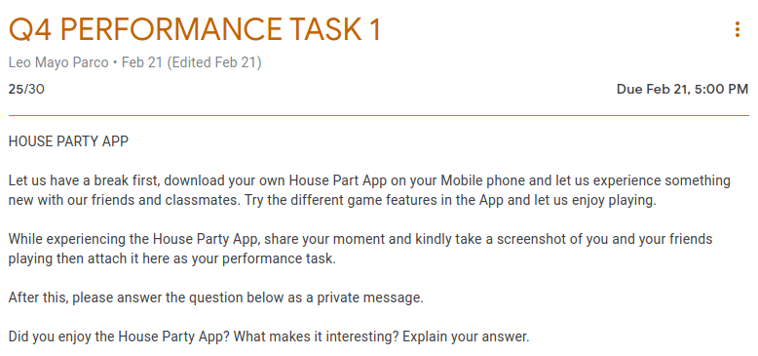

- Performance Task 2
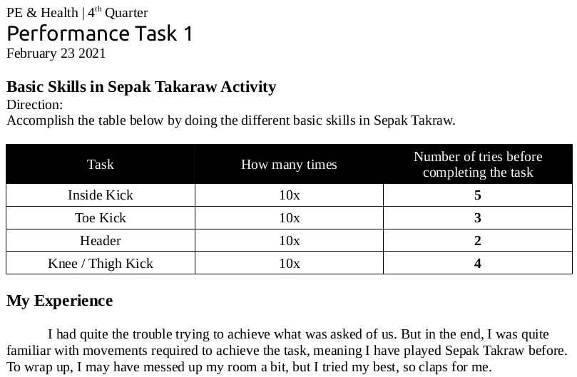
- Performance Task 3
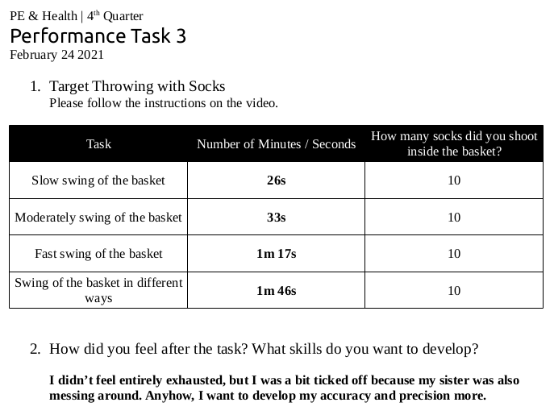
- Performance Task 4
https://drive.google.com/open?id=1ikbNPZK7Yq4aoLiHa2GndTxsLfICt90n&authuser=1

REFLECTION ON LEARNING
What are the Performance Tasks??
3rd Quarter
- Performance Task 1 - 25/30
- Performance Task 2 - 29/30
- Performance Task 3 - 29/30
- Performance Task 4 - 30/30

4th Quarter
- Performance Task 1 – 25/30
- Performance Task 2 – 39/40
- Performance Task 3 – 49/50
- Performance Task 4 – /30

Explain what exactly you were required to do in this Performance Task?
3rd Quarter
- In this performance task, we provided ourselves a small ball, or any material in its shape in the case there isn’t a ball. Then we threw the ball in the air, clapped our hands, and caught the ball again. We had to do this 5 times for certain circumstances.
- In this performance task, we measured the time it took for us to walk, and jog in different paces and variations.
- In this performance task, we provided ourselves a racket and a ball, makeshifts if not available. We measured how much we could do forehands, and backhands, and measured the time it took for us as well.
- In our final performance task, we watched a video of two professional badminton players going at it with each other. We were asked to reflect and give our insights on the clip of the match. We also gave our opinion on the subject in its course of 4 days.

4th Quarter
- In this performance task, we used the house party app to play with our friends using the games built into the app.
- In this performance task, we tried the different skills needed to play Sepak Takraw, and filled the data from our attempts into a table.
- In this performance task, we played basketball with socks and clothes baskets. We also chugged the data from our runs into a table for the output.
- In this performance task, we made a video that would demonstrate a certain skill in volleyball.

How may the skills that you have developed in this Performance Task be of help to you in your future career?
3rd Quarter
- Hand-eye coordination is a serious thing in any field of competitive sports, and I think I just found a way to measure my hand-eye coordination with this activity.
- Our legs are being used in our daily life indoor or outdoor, and since legs can be used in athletic professions, I think this can also be a measuring tool for when someone is planning on an athletic career.
- As a lawn tennis player, I have been through this in my training stages, but I can still use this same technique for when I teach lawn tennis to younglings.
- Game analysis are key factors when growing to be an iconic and strong athlete. Whether analysing your games, or analysing games of pros, it is always your advantage if you study where you went wrong, what you can do right, and etc.

4th Quarter
- This activity was fun because we found new ways to recreate and entertain ourselves with friends. It’s not that me and my friends haven’t played since lock-down, but since the school year is coming to an end, we’re getting new ideas to try.
- I was quite familiar with Sepak Takraw already, because I used to play Takyang, which is like sepak takraw but with something like a shuttlecock, when I was in Grade 6 in the Philippines. So this activity was fun to me as well, because I really enjoyed takyang in the Philippines.
- I really like basketball, it’s just that I don’t have the enough stamina to play the game. This activity made me feel a bit better that have quite a decent shooting skill, with socks and baskets at least.
- I really enjoyed this activity a lot, since I have also played and enjoyed volleyball in last year’s Intramurals. It gives me that flush of adrenaline and energy in a time like this pandemic.

Which of the Performance Tasks you did well? Why?
3rd Quarter
As with my response in the written works, I am proud to say I am content with my performance in all of the given tasks.

4th Quarter
I also did well in all of the performance tasks asked of us, and I hope I carry on this productivity as far as I can go.

In what Performance Task do you need to improve? How?
3rd Quarter
And as I have previously mentioned, I am proud and satisfied with my products and in my opinion, there’s still room for improvement.

4th Quarter
I believe I have done my best and there’s nothing much to point out, aside from the fact that my punctuality in activities are inconsistent.

Disaster Readiness & Risk Reduction
Written Works
3rd Quarter
- Activity 1
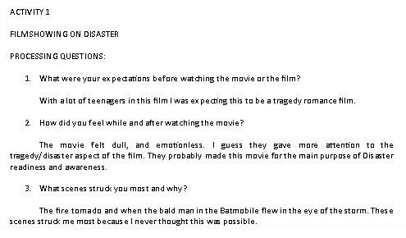
- Activity 2
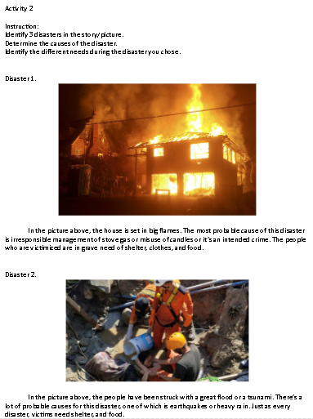

- Activity 3
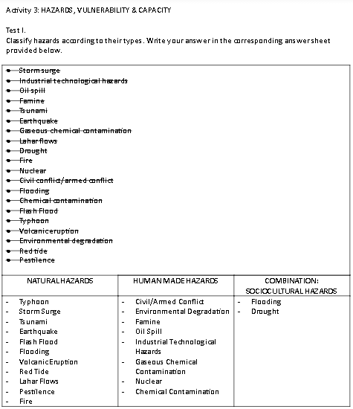
- Written Work: Potential Earthquake Hazards
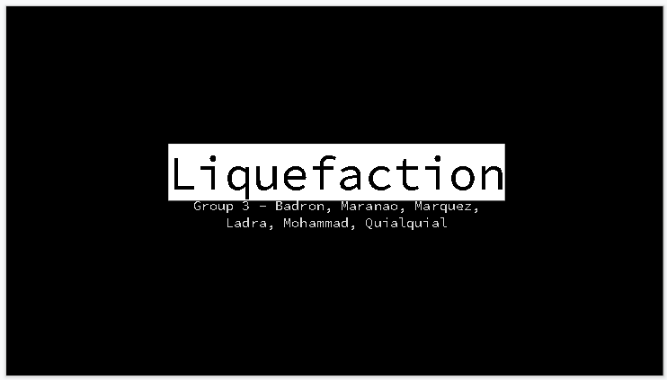

- Written Work: Erupt-A-Word
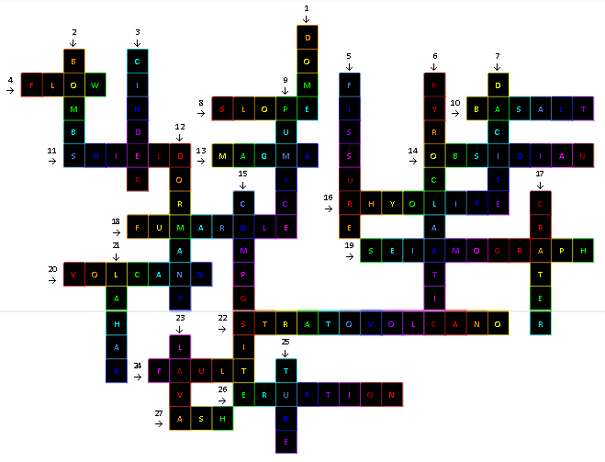

4th Quarter
- Written Work 1
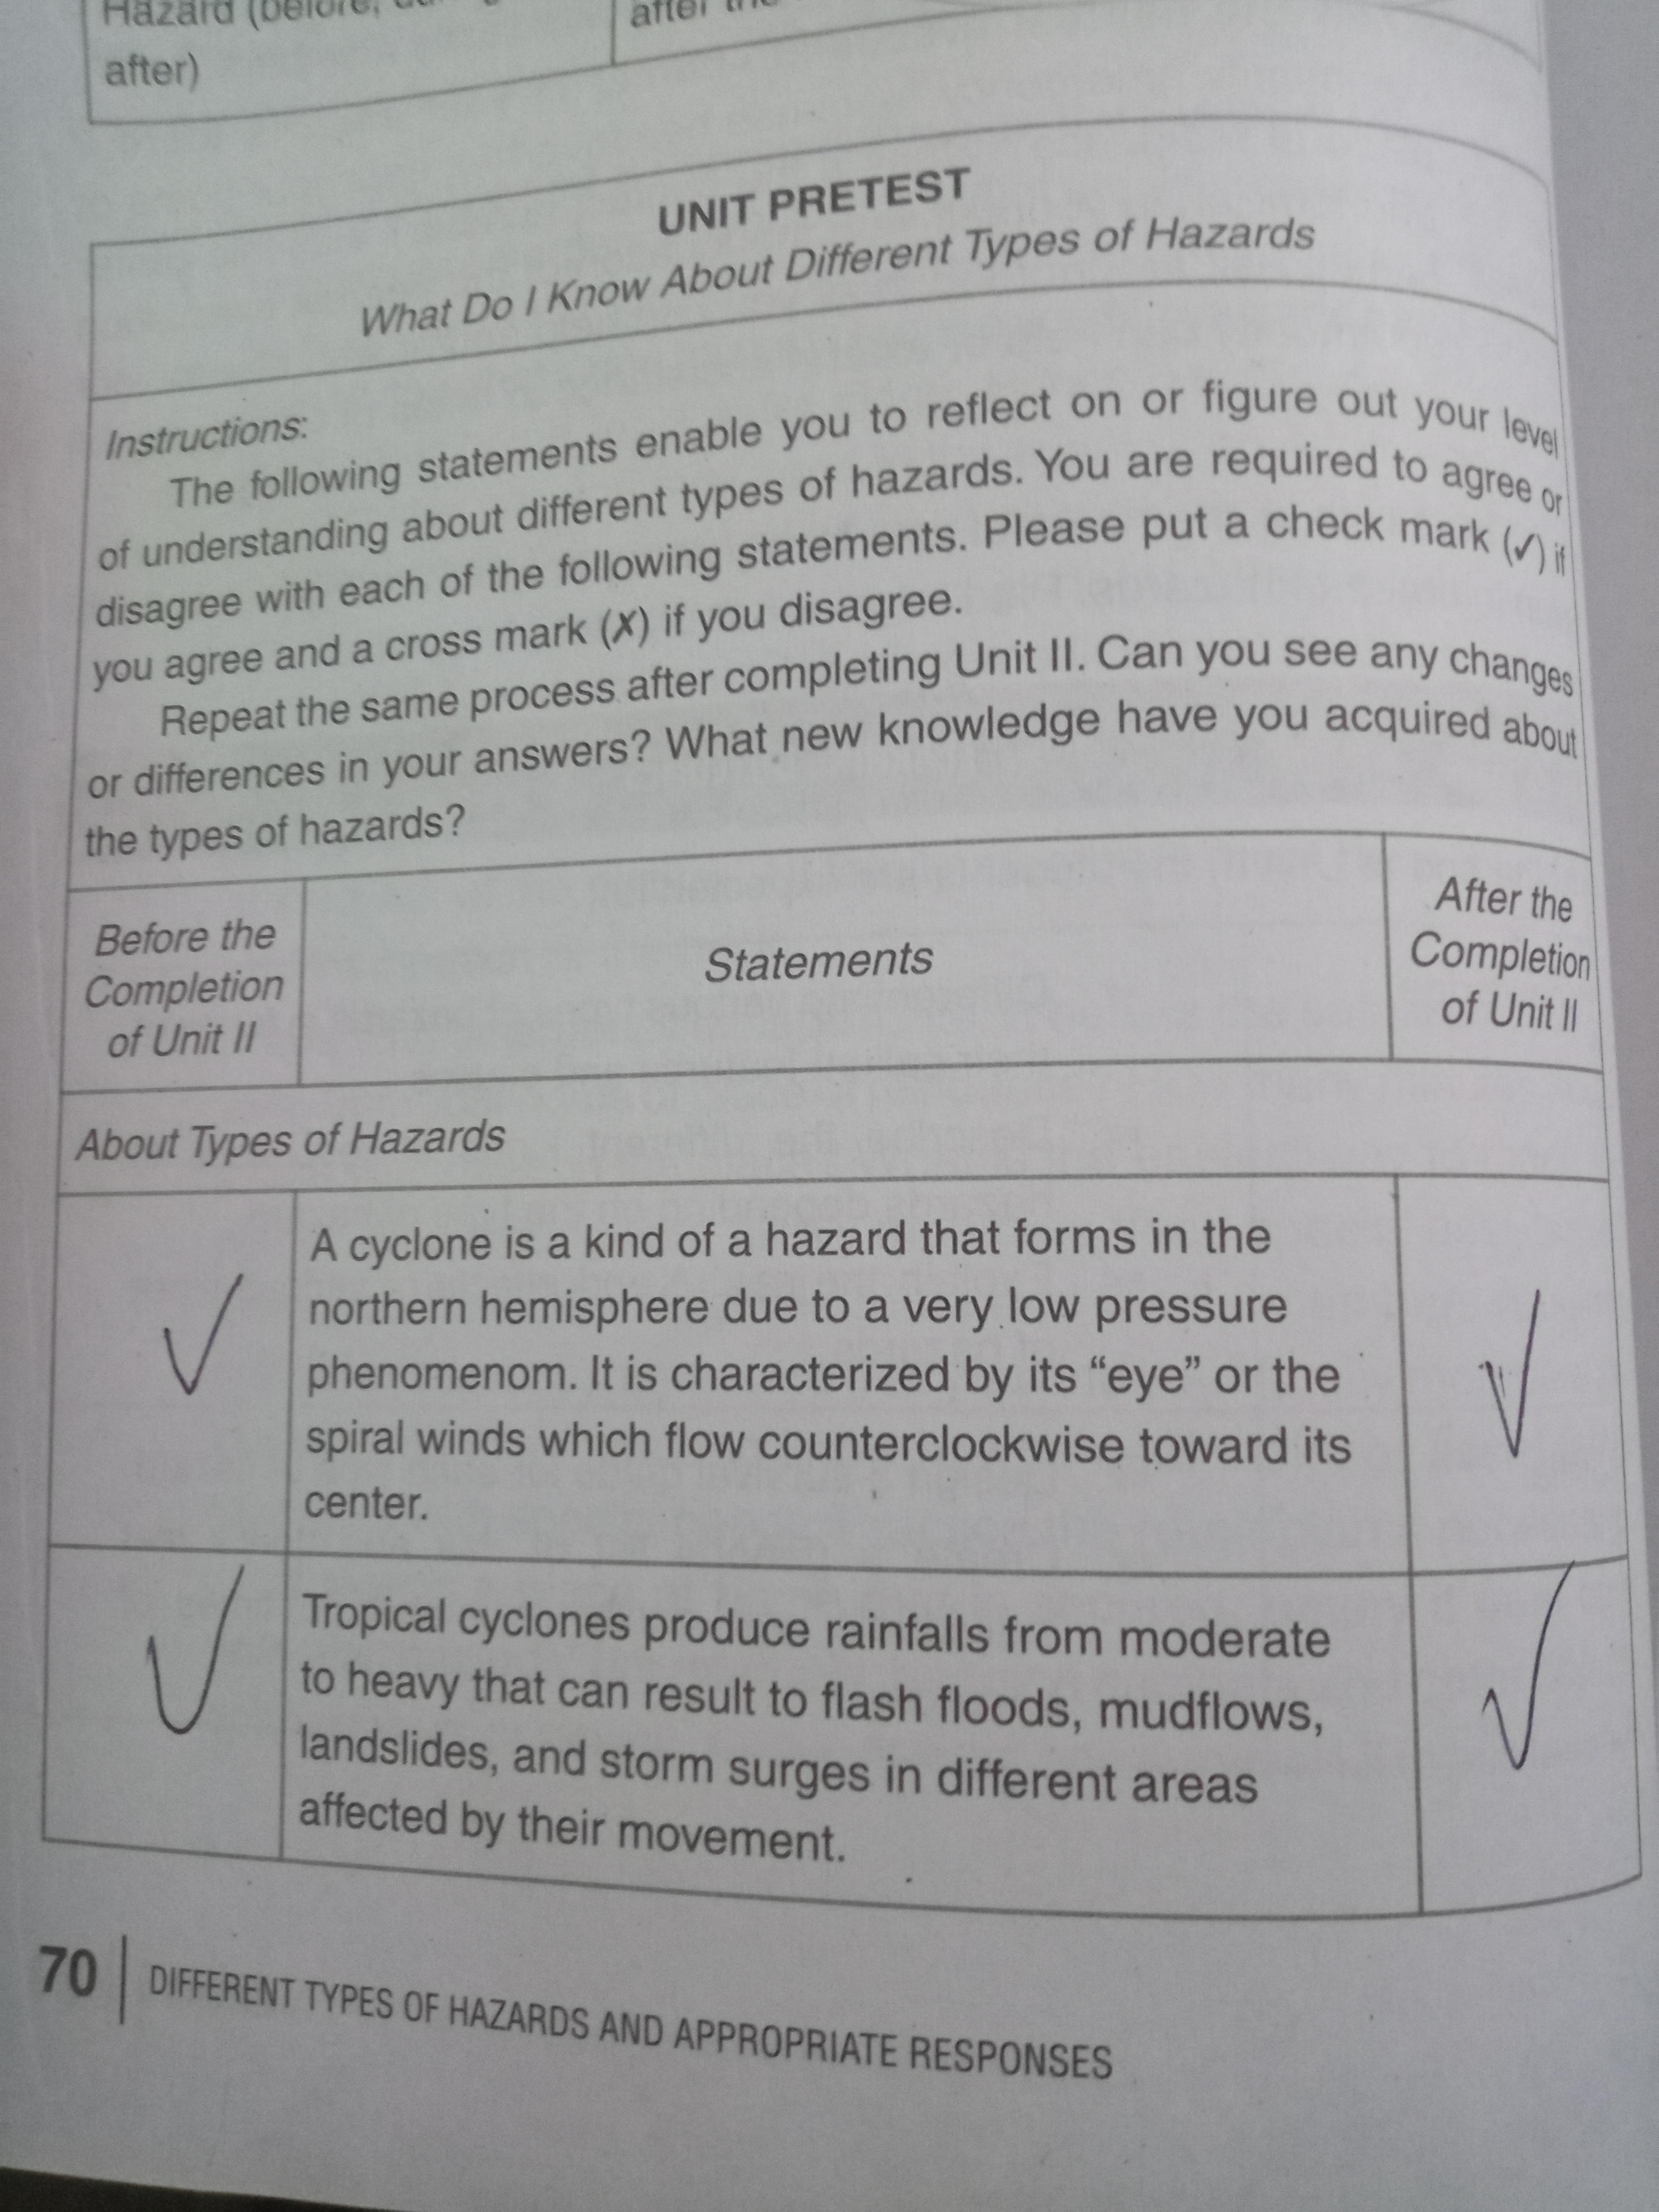
- Written Work 2
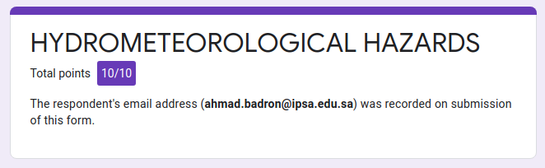
- Written Work 3
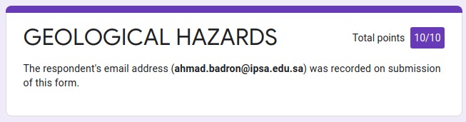
- Written Work 4
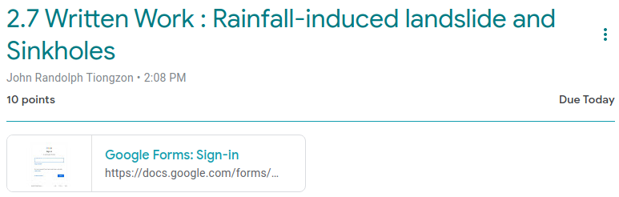
- Written Work 5
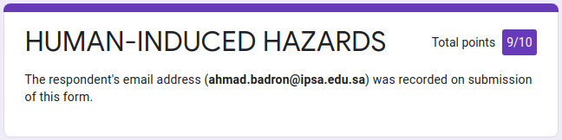
- Written Work 6
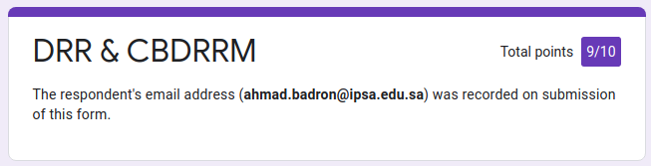

REFLECTION ON LEARNING
What are the Written Works?
3rd Quarter
- Activity 1 - 30/30
- Activity 2 - 15/15
- Activity 3 - /30
- Written Work: Potential Earthquake Hazards - 20/20
- Written Work: Erupt-A-Word - /27

4th Quarter
- Written Work 1 – 10/10
- Written Work 2 – 10/10
- Written Work 3 – 10/10
- Written Work 4 – 10/10
- Written Work 5 – 9/10
- Written Work 6 – 9/10

Explain what exactly you were required to do in these written works?
3rd Quarter
- In this activity, we watched an hour-long tragedy movie concerning disaster readiness and awareness. Then we were asked to reflect on the events in the movie.
- In this activity, we were split into breakout rooms. Then we picked out pictures that we could tell stories we could relate it to. Then in a Google Docs file, we picked out 3 images to explain the situation/disaster that occured to them.
- In this activity, we sorted different kinds of hazards into 3 categories. Then we identified different words related to disaster readiness, hazards, and etc.
- In this written work, we were grouped into breakout rooms. Each group was assigned a potential earthquake hazard. My group was assigned to Liquefaction or Soil Liquefaction. Later, our group’s assigned reporter explained and discussed our accumulated information to the class.
- In this written work, we were given two hyperlinks to pages that contained information for a crossword we had to fill in.

4th Quarter
- In this written work, we did a pre-unit activity in Page 70-71 of the book.
- In this written work, we answered a Google Form about Hydro meteorological Hazards.
- In this written work, we answered a Google Form about Geological Hazards.
- In this written work, we answered a Google Form about Rainfall-induced Landslides, and Sinkholes.
- In this written work, we answered a Google Form about Human-induced hazards.
- In this written work, we answered a Google Form about the DRR and CBDRM.

What information was the most interesting/surprising to you?
3rd Quarter
- I’m quite surprised that although people have been taught disaster drills, especially students, almost all their lives, they still gave a number of casualties to the tornadoes.
- I’ve come to realize that no matter what we do, disasters will always bring casualties to the table, and there’s no way around it. But what we do know is that we can prevent a larger and greater number of casualties and unfortunes.
- Being able to classify different hazards is one step towards preventing/preparing for it. Learning about them thoroughly is an even larger one.
- Now is the only time I learned about Soil Liquefaction, I never knew that the solid ground that I know can be as unstable as liquid water.
- I was so interested in the different types of lava. I never learned about it until now.

4th Quarter
- I have discovered in this written work about my correct hunches and misconceptions.
- This was a very useful since the Philippines was a typhoon-prone country.
- This topic was also a useful topic to learn since we have been hearing about the probabilities of ‘The Big One’ in the Philippines, which is what they expect to be a big earthquake.
- I only learned about sinkholes in this lesson only, and never before. And I really was surprised by how deep (pun intended) the DRRR subject can get.
- I realized how we can cause disasters ourselves to the communities that we ourselves live in.
- I learned about the DRR and CBDRM in this lesson, which I never knew before.

Which of the written works you did well? Why?
3rd Quarter
I’d like to point out that I appreciated the second activity a lot. Sharing stories and experiences with people help share the lessons we might have pulled out from it. And me having experienced some tragedies for myself, it’s nice to open it up to people.

4th Quarter
I had fun this quarter, which is probably the driving force for me to do a great job this quarter.

In what written work do you need to improve? How?
3rd Quarter
I feel like I should’ve paid more attention to the movie we watched. That’s just the only doubt I have for myself this quarter.

4th Quarter
This time, I feel like I can do even more and even better, which is what I aim in the next year and in the coming subjects.

Performance Tasks
3rd Quarter
- Mini Performance Task: Hunt for Hazards
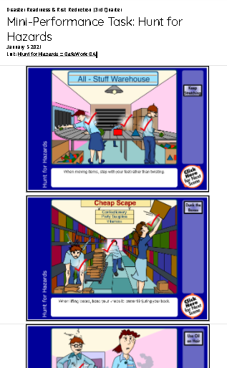
- Mini Performance Task 2: Tsunami
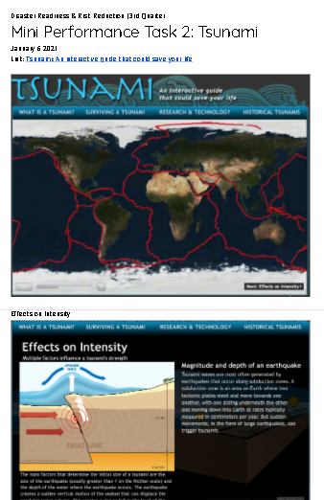

4th Quarter
- Mini Performance Task 1
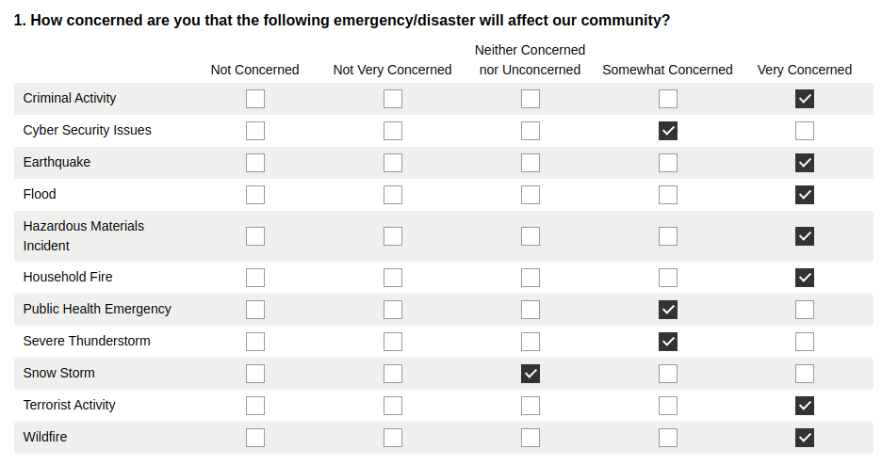
- Mini Performance Task 2
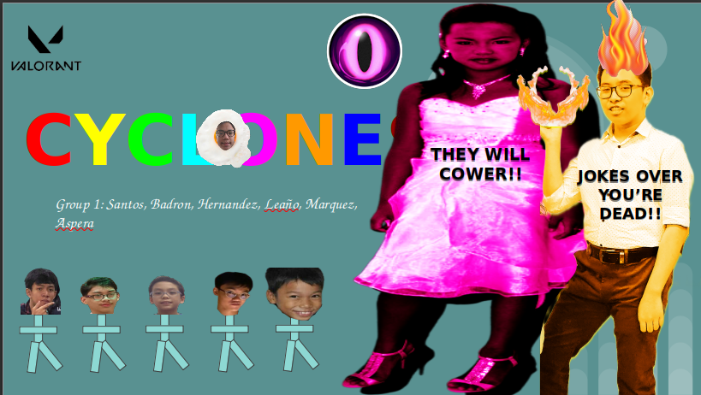
- Mini Performance Task 3
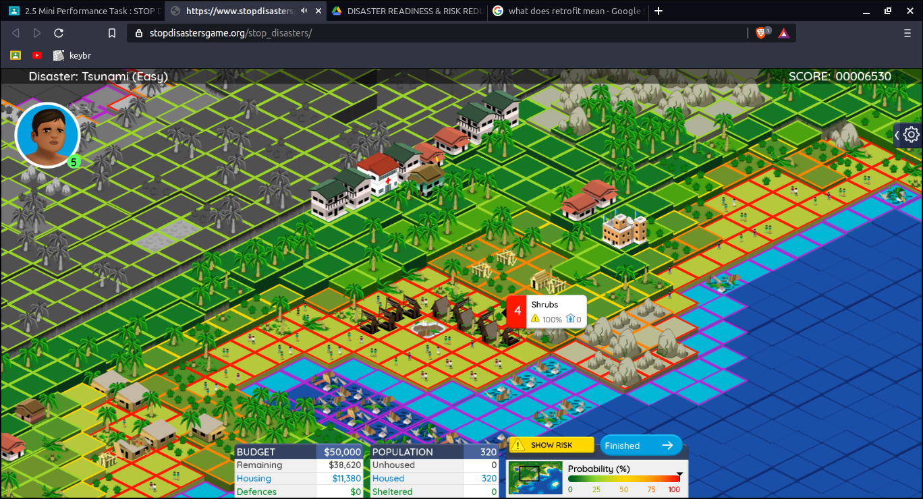

- Mini Performance Task 4
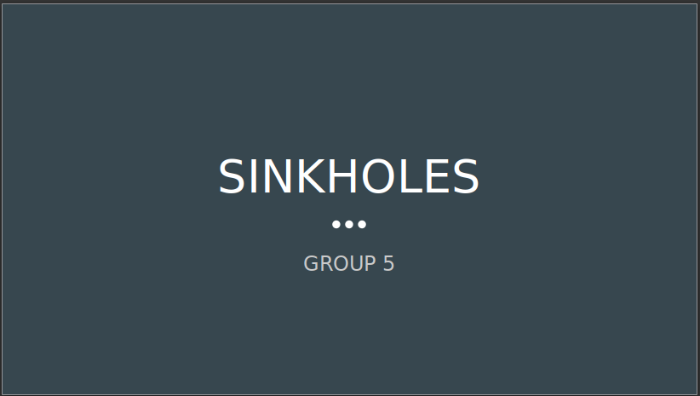
- Mini Performance Task 5
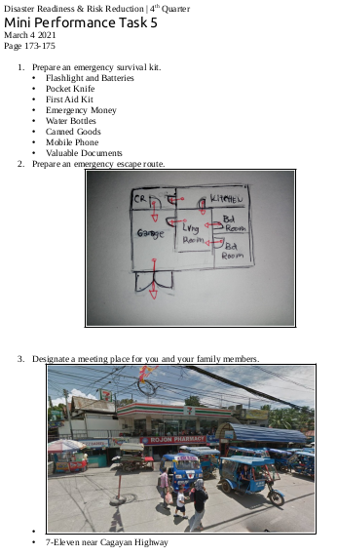

REFLECTION ON LEARNING
What are the Performance Tasks??
3rd Quarter
- Mini Performance Task: Hunt for Hazards - 50/50
- Mini Performance Task 2: Tsunami - /50

4th Quarter
- Mini Performance Task 1 – 50/50
- Mini Performance Task 2 – 50/50
- Mini Performance Task 3 – 100/100
- Mini Performance Task 4 – 50/50
- Mini Performance Task 5 – /50

Explain what exactly you were required to do in this Performance Task?
3rd Quarter
- In this performance task, we hopped on a flash animation. In the flash animation, we determined the most probable hazards in workspaces and everyday life as well, and dragged to it some possible solutions to them.
- In this performance task, We hopped on another flash animation where tsunamis were elaborately explained. A couple or more video footage of tsunamis were included in the flash animation as well. Then we had to screenshot every page of the flash animation and put it in a Docs file.

4th Quarter
- In this performance task, we answered a survey about our knowledge about the precautions before the strike of disasters.
- In this performance task, we were grouped up to make a presentation about a topic given to us regarding the different types of disasters. Our group was particularly assigned the topic ‘Cyclones’. And we were asked to report about what we had come up after the breakout room session.
- In this performance task, we played a management game about stopping disasters. The objectives of the game were more demanding as they wanted the player to prevent as much casualties and damages as possible, and to give the communities their specific needs, such as building schools, hospitals, or hotels.
- In this performance task, we were grouped up again to make a presentation and report about an assigned topic to us. We were assigned the topic, ‘Sinkholes’.
- In this performance task, we made an emergency survival plan for when disaster strikes our local communities in the Philippines.

How may the skills that you have developed in this Performance Task be of help to you in your future career?
3rd Quarter
- One way or another, everyone is still going to be having a job. And when working, hazards will always be present, since we’re not in a perfect ideal world. Learning about these hazards and studying how we can avoid them as much as possible beforehand will be a great advantage for when we set foot into the world of labor.
- I think being prepared for a tsunami beforehand is very helpful for when the real thing comes. Especially since the Philippines is part of the Pacific Ring of Fire where most seismic activities happen in the world.

4th Quarter
- I learned in this performance task that I lack in a lot of stuff when the time of emergency comes, and it made me realize that I need to prepare myself even more, if I want to save, not only myself, but also others.
- I learned about the different types of disasters in this activity, and I was able to distinguish a Typhoon from a Cyclone and from a Hurricane.
- I enjoyed this activity as it brought out my competitive spirit. What’s interesting is I’m not competing with anyone, I was just trying to protect a ‘community’ from the devastating hands of nature and calamity.
- I had time to understand the surroundings of our home in the Philippines through the help of my relatives in the Philippines. I was surprised about how I drew out the plan out of just details and the help of my family.

Which of the Performance Tasks you did well? Why?
3rd Quarter
I did well in all the performance tasks. They were all understandable and with the right motivation despite having the same class for a week straight.

4th Quarter
I did a good job this quarter, which I plan to expand into the incoming subjects and years.

In what Performance Task do you need to improve? How?
3rd Quarter
So far, good progress, keep it up for next quarter.

4th Quarter
I don’t have a task to criticize this quarter, and I’m proud of that. Like I said, I plan to expand make this productivity reach the next subjects and years.

Komunikasyon at Pananaliksik
Written Works
3rd Quarter
- Gawain 1

- Gawain 2

- Gawain 3

- Gawain 4

REFLECTION ON LEARNING
What are the Written Works?
3rd Quarter
- Gawain 1 - 20/20
- Gawain 2 - 20/20
- Gawain 3 - 13/16
- Gawain 4 - 10/10

Explain what exactly you were required to do in these written works?
3rd Quarter
- Sa gawaing ito, sinagutan namin ang pahina 146 B at ang pahina 151 Salok-Dunong.
- Sa gawaing ito, sinagutan namin ang pahina 158 A at ang pahina 163 Salok-Dunong.
- Sa gawaing ito, sinagutan namin ang pahina 172 B at ang pahina 177 Salok-Dunong.
- Sa gawaing ito, sinagutan namin ang pahina 191 Salok-Dunong.

What information was the most interesting/surprising to you?
3rd Quarter
- Natutunan kong marami pala tayong mga salitang ginagamit na hindi naman salita sa wika.
- Natutunan kong mas komplikado ang pakikipag-komunikasyon sa tao mula sa ating alam.
- Natutunan kong kasama rin ang mga di-berbal na kilos sa pakikipag-komunikasyon.
- Natuklasan kong pwede ko palang pahabain ang aking mga sanaysay gamit ng kakayahang diskorsal.

Which of the written works you did well? Why?
3rd Quarter
Nagawa ko lahat ng maigi dahil nasundan ko yung klase.

In what written work do you need to improve? How?
3rd Quarter
Siguro yung Gawain 3. Pero normal naman po magkamali, ‘di ko lang po ata napag-isipan ng maayos.

Performance Tasks
3rd Quarter
- Mini Performance Task: Pagsusuri ng Speech Act

REFLECTION ON LEARNING
What are the Performance Tasks?
3rd Quarter
- Mini Performance Task: Pagsusuri ng Speech Act -

Explain what exactly you were required to do in this Performance Task?
3rd Quarter
- Sa mini peta na ito, pinanood namin ang pelikula na “Guerrero” at kumuha ng mga linya mula sa pelikula. Sinuri din namin kung anong klaseng Speech Act ito.

How may the skills that you have developed in this Performance Task be of help to you in your future career?
3rd Quarter
- Makakatulong ito dahil ang araw-araw buhay sa mga susunod na taon ay magiging puno ng komunikasyon ng iba't ibang uri, kaya ito importante.

Which of the Performance Tasks you did well? Why?
3rd Quarter
Sa palagay ko, nagawa ko itong performance task nang maigi, dahil nakasabay nga ako sa discussion ng klase at naintindihan ko ang aralin.

In what Performance Task do you need to improve? How?
3rd Quarter
Tulad ng aking palagay kanina, nagawa ko nang maigi ang performance task na ito.

General Chemistry 2
Written Works
3rd Quarter
- WW1: Exercise Set 1
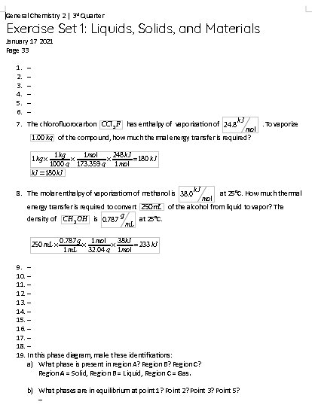
- WW2: Self Evaluation (Virtual Lab)
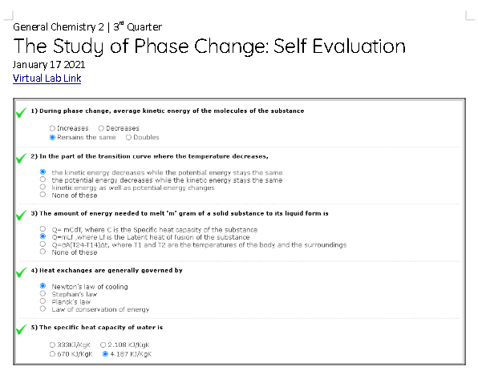
- WW3: Solutions Terminology
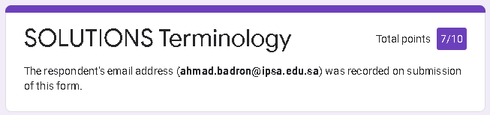

- WW4: Exercise Set 2
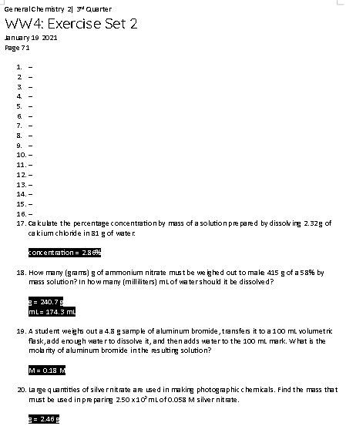
- WW5: Standard Enthalpy Formation & Hess' Law
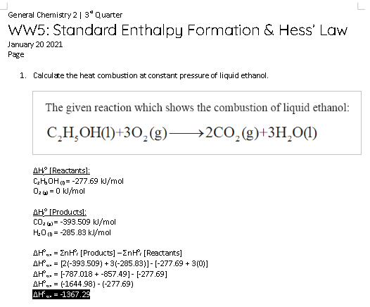

- WW6: Hess’ Law
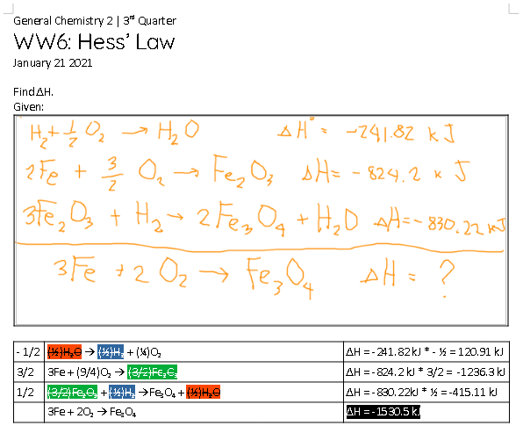

REFLECTION ON LEARNING
What are the Written Works?
3rd Quarter
- WW1: Exercise Set 1 - 13/20
- WW2: Self Evaluation (Virtual Lab) - 5/5
- WW3: Solutions Terminology - 7/10
- WW4: Exercise Set 2 - /100
- WW5: Standard Enthalpy Formation & Hess' Law - 10/10
- WW6: Hess’ Law - /10

Explain what exactly you were required to do in these written works?
3rd Quarter
- In this written work, we answered the exercise set on Page 33.
- In this written work we filled out the form on the Self Evaluation tab on the Virtual Lab activity.
- In this written work, we answered a Google Form about the terminologies in our recent lesson about solutions.
- In this written work, we answered the exercise set on Page 71.
- In this written work, we solved a problem about finding the heat of combustion of liquid ethanol.
- In this written work, we solved our way to finding the delta H of a given reaction, and we had to find through a number of steps.

What information was the most interesting/surprising to you?
3rd Quarter
- Everything in this written work and lesson itself was new to me, besides the concepts of moles and energy.
- I learned that Isaac Newton has made various studies on different fields of physics as well.
- I learned in this written work, and lesson about a previously studied topic which is solutions.
- I learned in this exercise set that a solution’s concentration isn’t just merely computed by dividing the solute mass to the solution mass.
- I realized that most of chemistry is just chemical information + scientific rules & laws + mathematics/algebra.
- This written work solidifies what I said about the previous written work, this written work showed how important the differences of the substances were like how Fe₂O₃ and Fe₃O₄ aren’t the same subtances.

Which of the written works you did well? Why?
3rd Quarter
I believe that I did an excellent job on Written Work 6, because I had the help of my classmates and, in turn, helped my classmates with this activity.

In what written work do you need to improve? How?
3rd Quarter
I didn’t perform well enough in Written Work 3, probably because I didn’t review what I just learned thoroughly. I should though next time.

Performance Tasks
3rd Quarter
- MPT: The Study of Phase Change (Virtual Lab)
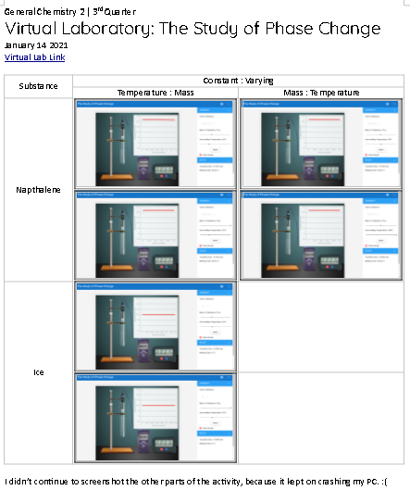
- MPT 2: Concentration
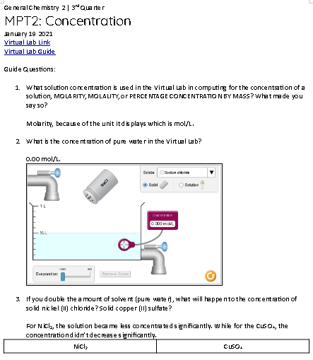

REFLECTION ON LEARNING
What are the Performance Tasks?
3rd Quarter
- MPT: The Study of Phase Change (Virtual Lab) - 50/50
- MPT 2: Concentration - 50/50

Explain what exactly you were required to do in this Performance Task?
3rd Quarter
- In this mini performance task, we recorded the data on the simulation of phase change on a website given to us.
- In this mini performance task, we recorded the data and came to conclusions on a simulation on a website given to us.

How may the skills that you have developed in this Performance Task be of help to you in your future career?
3rd Quarter
- This performance task emulated the process of experimentation despite being isolated in my own room.
- In addition to my previous answer, this performance task helped me understand some basic mechanics of how solutions work.

Which of the Performance Tasks you did well? Why?
3rd Quarter
I must say I did well in the Concentration MPT, because I really like the topic. Maybe because of the math that the lesson uses.

In what Performance Task do you need to improve? How?
3rd Quarter
I believe I did well in all the MPTs and that there isn’t anything more to answer to this question.

Practical Research 1
Written Works
3rd Quarter
- Task 1: Practical Research
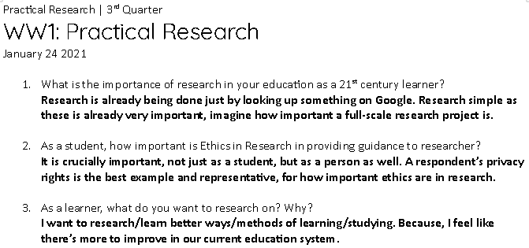
- Task 2: Qualitative Research Across Fields
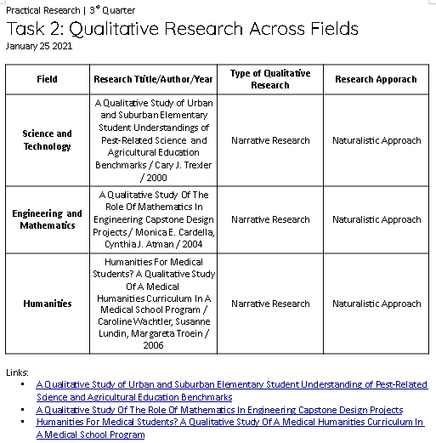
- Task 4: Statement of the Problem and Beneficiaries of Research Project
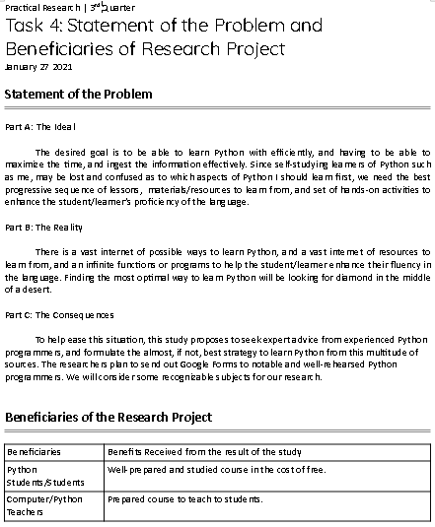
REFLECTION ON LEARNING
What are the Written Works?
3rd Quarter
- Task 1: Practical Research - 96/100
- Task 2: Qualitative Research Across Fields - /100
- Task 4: Statement of the Problem and Beneficiaries of Research Project - /100

Explain what exactly you were required to do in these written works?
3rd Quarter
- In this written work, we answered a set of 3 questions that asked us about
- In this written work, we filled in a table with the data it needed: a research article for the specified the field, and it had to be a qualitative study. We had to figure out its type of qualitative research, and its research approach.
- In this written work, we continued with the same topic as the last written work, and we made the statement of the problem, along with the beneficiary of the research project.

What information was the most interesting/surprising to you?
3rd Quarter
- This written work made me realize the importance and value of research, and it sparked my interest in researching different kinds of stuff.
- I learned that studies in the field of Science, Technology, Engineering, and Mathematics, don’t necessarily need to be quantitative studies. There are various types of qualitative studies in the said fields that are really unexpected when you first think of these fields.
- I always thought research papers are just made to be put out on the internet or something, but now I learned that research projects are directed towards the community, and it is put out there for a reason, which is to solve a problem, at the least.

Which of the written works you did well? Why?
3rd Quarter
I’m saying this unconfidently, but I’m just confident with how I did in Task 1. Just because I actually got a handle of what was happening in the written work.

In what written work do you need to improve? How?
3rd Quarter
I don’t have a written work in my mind that I did that bad on. But the closest written work to that bad is Task 4, in my opinion. Not just because of my punctuality, but also because of how I did in it.

Performance Tasks
3rd Quarter
- Task 3: Project Proposal and Purpose of Study
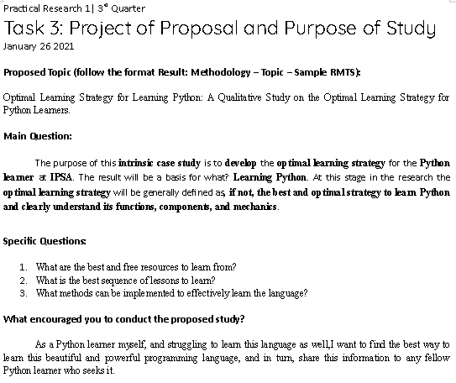
- Task 5: Research Framework and Scope and Limitations of the Study

REFLECTION ON LEARNING
What are the Performance Tasks??
3rd Quarter
- Task 3: Project Proposal and Purpose of Study – 98/100
- Task 5: Research Framework and Scope and Limitations of the Study -

Explain what exactly you were required to do in this Performance Task?
3rd Quarter
- In this performance task, ironically, we applied what we learned from the discussion and we chose a topic to make a project proposal, the main question, and the specific questions for the research topic.
- In this performance task, we drew out the IPO model for the same research topic we’ve been holding in Task 3 & 4. We also determined the scope and limitations for the study.

How may the skills that you have developed in this Performance Task be of help to you in your future career?
3rd Quarter
- I think I will only be able to use these skills in college when thesis stuff come in, but it’s still useful I guess.
- The skills I may acquire from this performance task will be useful, like I said before, in thesis and research in college or the coming years.

Which of the Performance Tasks you did well? Why?
3rd Quarter
I can only admit that I did well in Task 3. There’s no real reason to perform well, I just did a great job. I’m also hopeful

In what Performance Task do you need to improve? How?
3rd Quarter
Not much, I’m happy with my results. But there’s still room for growth and improvement, which will be in use in the next school quarter and years.

Basic Calculus
Written Works
3rd Quarter
- Activity 3.1: Graphs of Sine and Cosine Functions
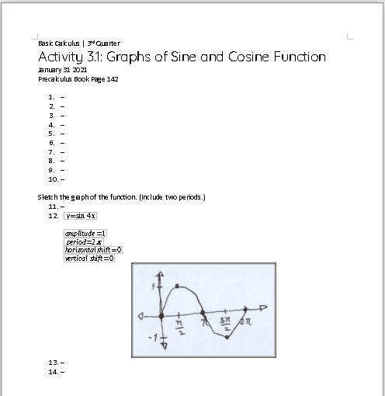
- Activity 3.2: Graphs of Inverse Trigonometric Functions
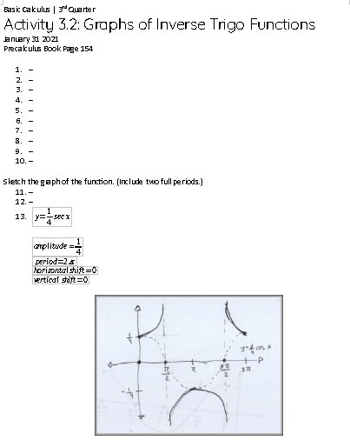
- Quiz 3.0: Graphs of Trigonometric Functions
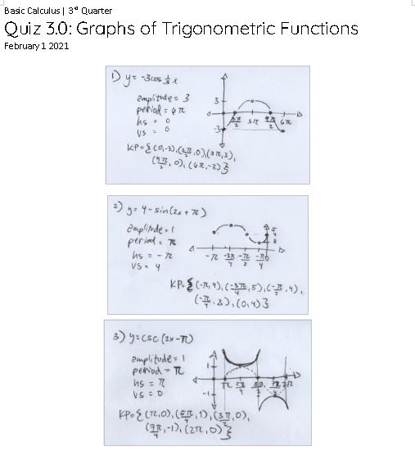

- Activity 3.3: Verifying Trigonometric Identities
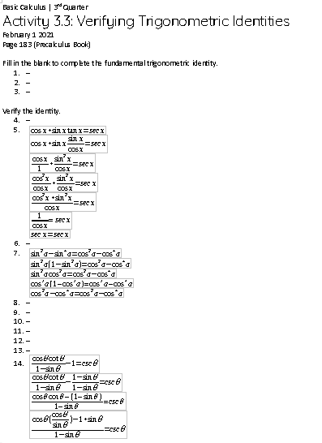
- Activity 3.4: Laws of Limits
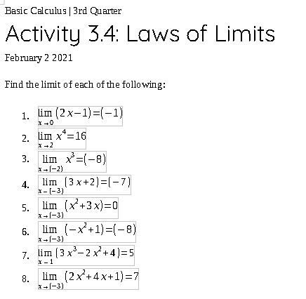
- Activity 3.5: One Sided Limits
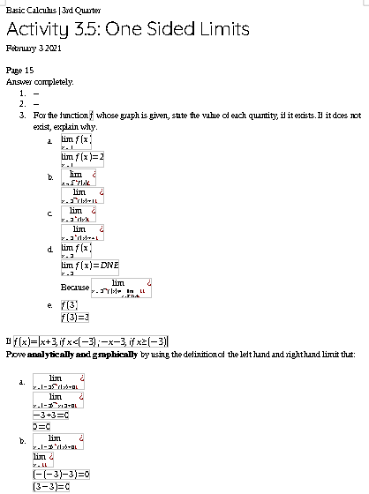

- Activity 3.6: Infinite Limits
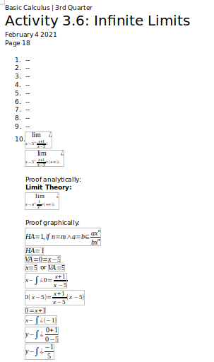

REFLECTION ON LEARNING
What are the Written Works?
3rd Quarter
- Activity 3.1: Graphs of Sine and Cosine Functions – 10/10
- Activity 3.2: Graphs of Inverse Trigonometric Functions – 10/10
- Quiz 3.0: Graphs of Trigonometric Functions – 15/15
- Activity 3.3: Verifying Trigonometric Identities – /15
- Activity 3.4: Laws of Limits – 8/8
- Activity 3.5: One Sided Limits – /15
- Activity 3.6: Infinite Limits – /10

Explain what exactly you were required to do in these written works?
3rd Quarter
- In this written work, we were asked to sketch the graphs of the sine and cosine function. We had to find the amplitude, period, and the 5 key points before we were able to sketch the graph in detail.
- In this written work, we were asked to sketch the graphs of the inverse of the sine and cosine function, the cosecant and secant respectively. We had to sketch the graph of the sine or cosine of the given problem and then we just had to invert the graph.
- In this quiz, we were asked to find the necessary points needed to sketch the graph of a given trigonometric function, then we sketched the graph of the given function. We were given 3 of these problems to solve.
- In this written work, we verified the identities of the given trigonometric functions. We needed to make the statement obvious enough to be true. This was achieved through various algebraic operations that were studied in the past, and with the knowledge of the trigonometric identities.
- In this written work, we had a quick seatwork on our recent topic, limits of functions. We were given 8 problems that we had to evaluate and find the limitations of.
- In this written work, we were given problems, related to left and right hand limits, or better known as one sided limits, one of which is in the exercise set in the Basic Calculus book and another given by ma’am Ilas.
- In this written work, we were tested to find the limits of rational functions which had infinite limits, and we had to prove it analytically and graphically.

What information was the most interesting/surprising to you?
3rd Quarter
- I’m pretty aware of basic trigonometric functions and their graphs, but I was very interested in learning more about it, which this lesson really helped me to. I will enjoy this lesson.
- Inverses of trigonometric functions are way more complicated, and I still feel like there’s more to know on how these functions work, because if sines and cosines go wavy, these inverted trigo functions go the other way.
- This quiz solidified our knowledge and understanding on the concept of and graphing trigonometric functions.
- It’s surprising how this trigonometric constants just loop back to each other. These concepts are very unique in the field of mathematics to me, the logics and the stars just line up perfectly, as the trigonometric identities do so too.
- Finding the limits of functions are fairly easy when we’re talking about linear functions here.
- I was very amazed by the mechanics of limits and how they work, it gets me interested in how and where they really shine the brightest.
- This was like a plot twist. Just when you thought that limits can also not exist, then you also learn that there can be infinite limits! What are the limits to Math’s wonders?

Which of the written works you did well? Why?
3rd Quarter
I’m proud to say that I did well in all works, but what I’m not proud of is how I only am confident in this subject.

In what written work do you need to improve? How?
3rd Quarter
There was a lot of confusion in Activity 3.6, which I need to improve on by practicing with problems like these.

Performance Tasks
3rd Quarter
- Mini Task 3.1: Trigonometric Identities (Group Activity)
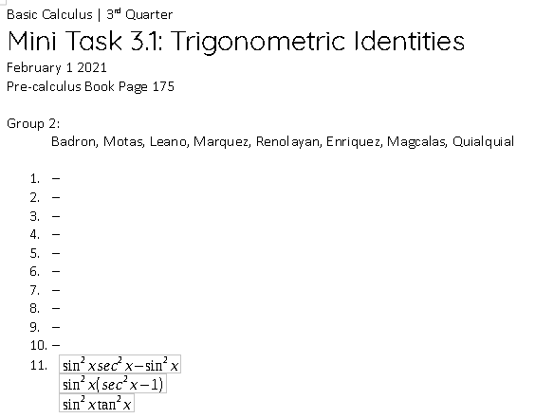
- Mini Task 3.2: Limits (Group Activity)
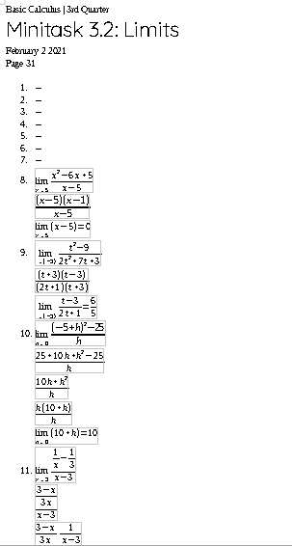
- PeTa: Trigonometric Functions and Limits

REFLECTION ON LEARNING
What are the Performance Tasks?
3rd Quarter
- Mini Task 3.1: Trigonometric Identities (Group Activity) – 10/10
- Mini Task 3.2: Limits (Group Activity) – /10
- PeTa: Trigonometric Functions and Limits – /30

Explain what exactly you were required to do in this Performance Task?
3rd Quarter
- In this mini task, we were grouped into a breakout room. We had to simplify given trigonometric functions.
- In this mini task, we were grouped into a breakout room in random, and we were asked to simplify a given function to be able to have a valid limit out of the function.
- In this PeTa, we did a Google Form on trigonometric functions and then we had to solve problems about limits, piecewise functions, and etc. on paper.

How may the skills that you have developed in this Performance Task be of help to you in your future career?
3rd Quarter
- I still can’t clearly see where limits are going to be useful in my future career, but all I know for now is it will.
- The future is fogged and I can’t see where this skill will take me. But it is being taught to us for a reason, so why not?
- As foggy as it was on Friday, where specifically I can use these skills I can’t determine. But it will come in handy at some point if not in the nearer future.

Which of the Performance Tasks you did well? Why?
3rd Quarter
For the most part, I did well in all, there was just some incosistency, but so far, so good.

In what Performance Task do you need to improve? How?
3rd Quarter
One thing I didn’t do well in these performance tasks was my punctuality, and proficiency in the topics especially in the final PeTa. So I have to work on finishing my work earlier, and more accurately.

Statistics and Probability
Written Works
3rd Quarter
- WW1: Random Variables (Group Activity)
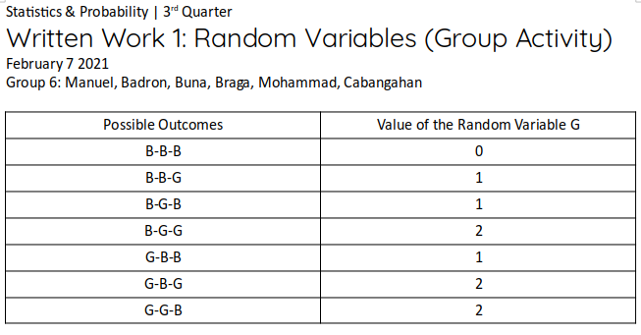
- WW2: Discrete Probability Distribution (Seatwork 1)
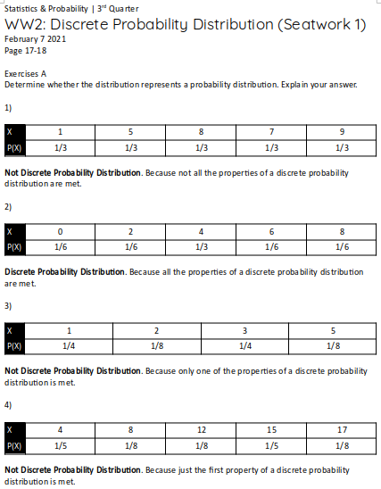

- WW3 (Group Activity)
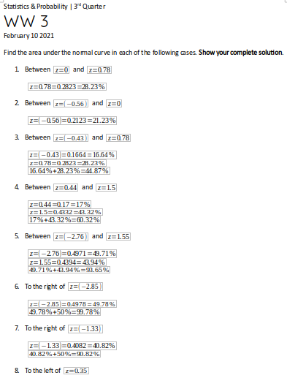
- WW4: Standard Scores (Seatwork 2)
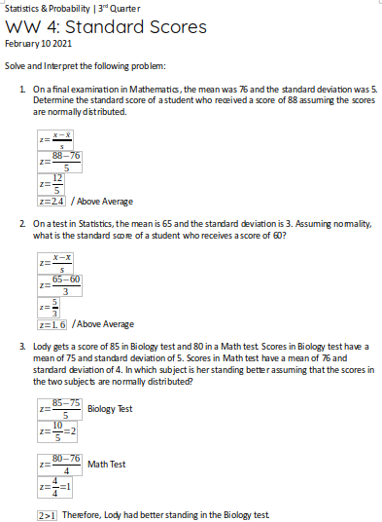
- WW5: Mean, Variance, and Standard Deviation of Sampling Distribution of the Sample Means

REFLECTION ON LEARNING
What are the Written Works?
3rd Quarter
- WW1: Random Variables – 20/20
- WW2: Discrete Probability Distribution (Seatwork 1) – 20/20
- WW3 (Group Activity) - 17/20
- WW4: Standard Scores (Seatwork 2) – 16/20
- WW5: Mean, Variance, and Standard Deviation of Sampling Distribution of the Sample Means – /50

Explain what exactly you were required to do in these written works?
3rd Quarter
- In this written work, we did an ‘Extension’ activity in page 9 of the book. We had to fill out a table of the different possibilities for what balls you can draw out of the box.
- In this written work, we filled out answers to questions in page 17-18 of the book.
- In this written work, we answered some problems given to us by Ma’am Shaima about standard scores, and the standard normal table.
- In this written work, we solved problems about standard scores but in more English sense.
- In this written work, we answered problems about finding the mean, and standard deviation of sampling distribution of the sample means.

What information was the most interesting/surprising to you?
3rd Quarter
- I was fairly familiar with combinations and sequences before, so it was fun to revisit this topic in another light.
- Discrete probability distribution is a new concept I learned and it is a very interesting concept, I’m gonna be honest.
- This activity was a bomb of questions and problems. It was fun to answer them all, one by one.
- This activity was also a good activity practice my skills in solving.
- This was, in all honesty, a bit of a heavy work, but I carried through, and we carried through. This activity helped me crank up my motivation standard.

Which of the written works you did well? Why?
3rd Quarter
I believe I did well in most of the written works, I have participated in the class properly, as every student should, and I did the written works in time as well.

In what written work do you need to improve? How?
3rd Quarter
I’d like to tell myself to keep this work up for the next quarter.

Performance Tasks
3rd Quarter
- MPT1: Mean, Variance, Standard Deviation
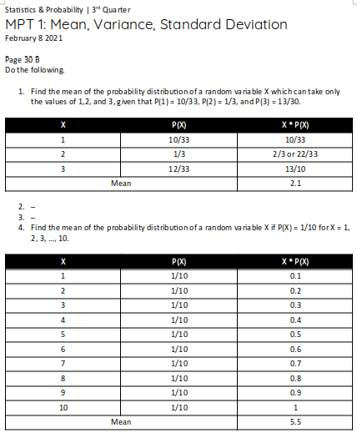

REFLECTION ON LEARNING
What are the Performance Tasks??
3rd Quarter
- MPT1: Mean, Variance, Standard Deviation – 30/30

Explain what exactly you were required to do in this Performance Task?
3rd Quarter
- In this mini-peta, we answered page 30 of the book, which had problems about finding mean, variance, and standard deviation.

How may the skills that you have developed in this Performance Task be of help to you in your future career?
3rd Quarter
- These topics are very useful in the field of research and data collecting, it helps give more precision and definition to researches.

Which of the Performance Tasks you did well? Why?
3rd Quarter
This is the only performance task I can do well in. But I also believe I really did well in this performance task because I studied well about this topic.

In what Performance Task do you need to improve? How?
3rd Quarter
Like in my response in my written works, I believe I can grow better for next quarter.

OTHER WORKS

WORK #1: (put the name of work here)

REFLECTION ON LEARNING
Explain what exactly you were required to do in this work?

How may the skills that you have developed in this work be of help to you in your future career?

WORK #2: (put the name of work here)

REFLECTION ON LEARNING
Explain what exactly you were required to do in this work?

How may the skills that you have developed in this work be of help to you in your future career?

WORK #3: (put the name of work here)

REFLECTION ON LEARNING
Explain what exactly you were required to do in this work?

How may the skills that you have developed in this work be of help to you in your future career?

WORK #4: (put the name of work here)

REFLECTION ON LEARNING
Explain what exactly you were required to do in this work?

How may the skills that you have developed in this work be of help to you in your future career?

CERTIFICATES

(put scanned copy or picture of your certificates here)

End of Semester Reflection

1. What helped you achieve or pass your subjects this semester? What prevented you from giving your best?

2. What is something you did really well or tried your best at during this semester?

3. What is something that you didn’t do as well as you could have or something that you would like to improve?

