Contemporary Arts | 3rd Quarter
Artist during American Colonial Period
February 2 2022

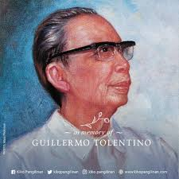

Guillermo Tolentino

Guillermo, born Guillermo Estrella Tolentino, was born on July 24 1890, in Malolos, Bulacan. Guillermo studied in the School of Fine Arts of the University of the Philippines during his college years. In 1915, he graduated with a degree of Fine Arts. He went to Europe and came back in 1925 to work as a professor at the University of the Philippines’ School of Fine Arts.

