Physical Education & Health 4 | 3rd Quarter
WW1: Choosing an Outdoor Recreational Activity
January 13 2022

Given a chance after this pandemic, what outdoor activity would you like to try? Why? Who do you like to be with? Research, surf the internet, read blogs. Copy and paste a picture then post it below and write something about it.

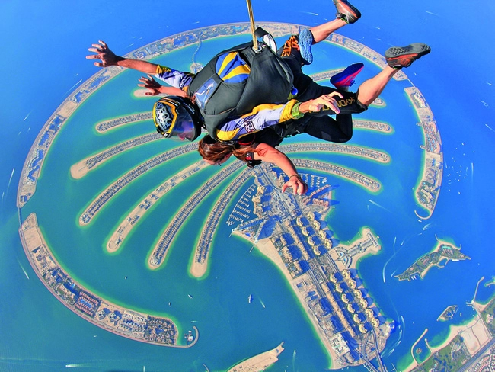

What? Why? Where? With whom? What benefits can I get from it? Write your description here:
I would like to try skydiving because I’m really afraid of heights and I’d like to try going head-on with my fears. Trembling, probably even crying, in fear up there, any of my closest friends can come with me. By skydiving, not only do I face my greatest fears, I can also break a record of how much my adrenaline will rise in a short amount of time.

WW2: Left a Trace

From your observation, whether first hand or from other sources (news, documentary shows, narrated by friends, etc.) which among the LEAVE NO TRACE 7 PRINCIPLES is usually NOT being observed in the Philippines? Explain your answer. You may copy and paste a news article or a personal picture to back up your explanation.

[Insert Picture]

_

