Contemporary Arts | 3rd Quarter
Artist during American Colonial Period
February 2 2022

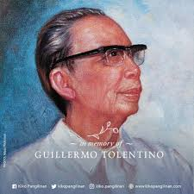

Guillermo Tolentino

Guillermo, born Guillermo Estrella Tolentino, was born on July 24 1890, in Malolos, Bulacan. Guillermo studied in the School of Fine Arts of the University of the Philippines during his college years. In 1915, he graduated with a degree of Fine Arts. He went to Europe and came back in 1925 to work as a professor at the University of the Philippines’ School of Fine Arts. Towards the end of his career as a professor, in 1955, he retired from his services in UP and returned to private practice. He received a notable National Artist recognition from Ferdinand Marcos in 1973. Tolentino died in his own residence in Quezon City the year later.

His Artworks & Sculptures

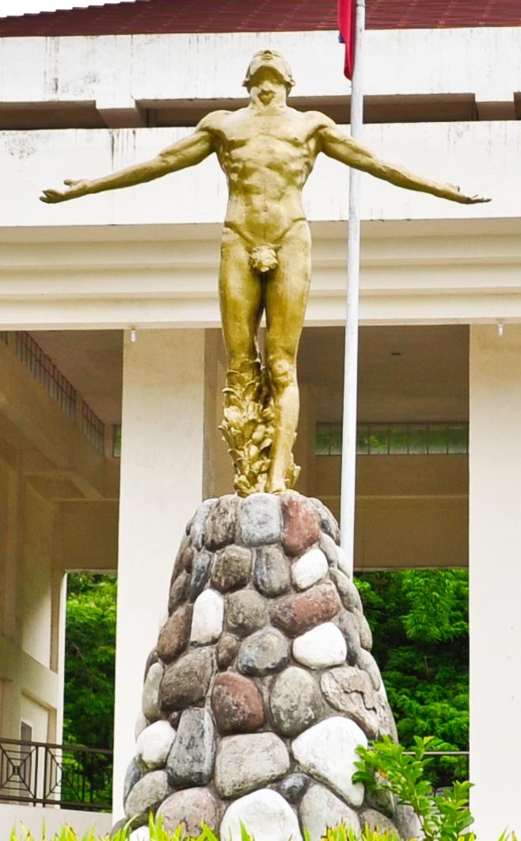

The Oblation is one of Guillermo’s most famous works. The Oblation is one of Guillermo's most famous works. The Oblation depicts a man facing skywards, with his arms stretched outwards, symbolizing selfless offering of oneself to his union.

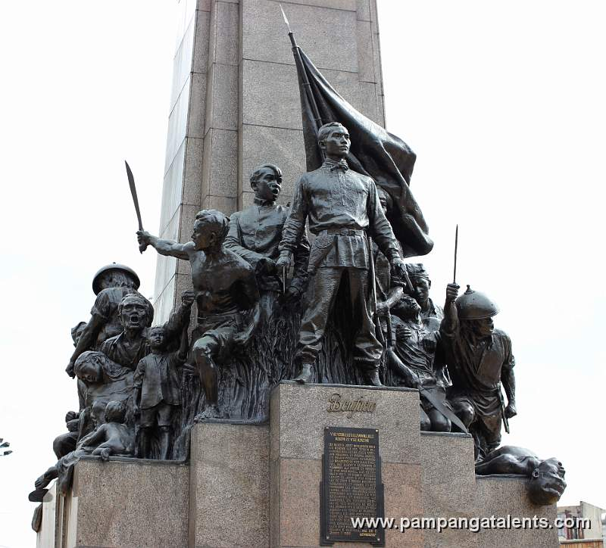

The Andres Bonifacio monument, also known as Monumento, is a memorial monument in Caloocan, Philippines to commemorate Philippine revolutionary Andres Bonifacio, the founder and Supremo of the Katipunan.

