**PERSONAL BLOG(travel blog)**

**Team members**

1. A.PRIYA SAKTHI
2. R.SHARMILA
3. R.SUJITHA
4. JAISHREE

**Layout:**

website layout needs to be built with all these elements in mind. It needs to be able to help you tell story, show off your pictures, and ensure your site looks great on mobile . site layout should be easy to view on any type of device. If you are looking for an easy way to create a great-looking site and add new posts, check out the Off sprout website builder and tools.

**Social Links:**

Social media is an important source of traffic for travel blogs. One website cites that on average, 13% of a travel blog’s traffic can come from social. Some travel obviously get more traffic from social. Others get less. It just depends how well you utilize social media. Regardless, you should make your content shareable for social. Let people Pin your content to Pinterest, and share on Facebook or Twitter.

**Links:**

Great travel blogs also have outbound links to third-party content. Often, travel blogs use affiliate links for related products and services. They also link to other relevant websites related to your blog posts. Linking out, aside from the referral revenue, is a great service for your readers, and can help you engage with other blogs or websites.

**Travel Blog Website Designs:**

Now, let’s dive in to our picks for the best travel blog website designs for inspiration.

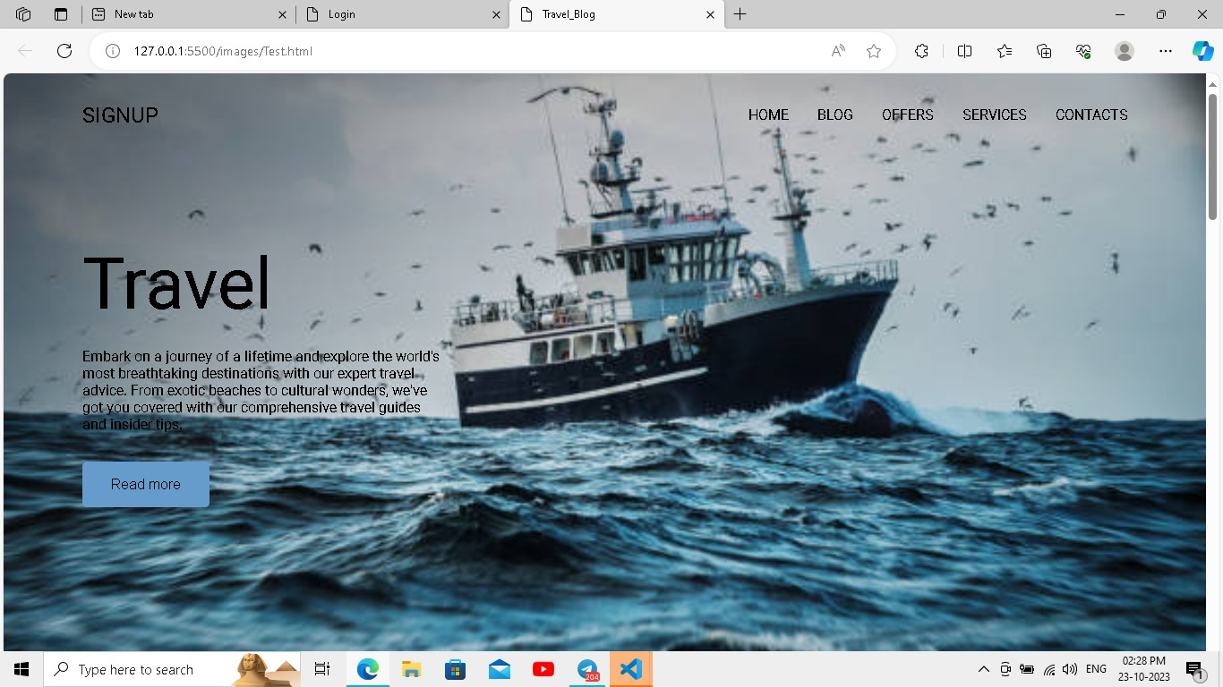**1.create a signup page :**

**2.Create a login page:**

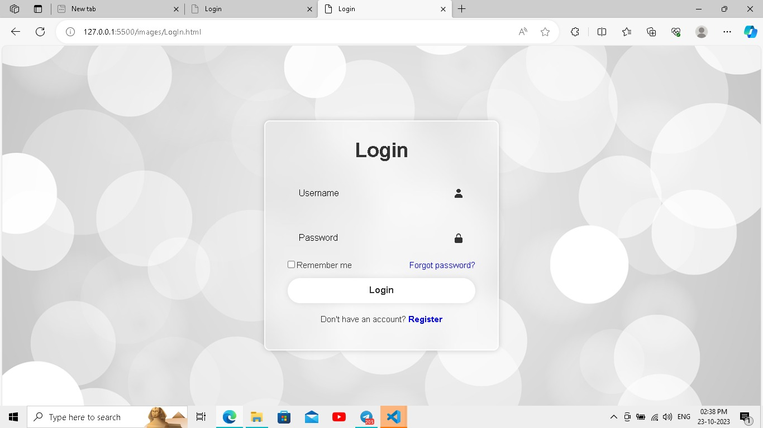

**Sidetracked:**

 Sidetracked is a travel magazine website with gorgeous photos, travel guides, interviews, and personal essays.

The site and each of its articles have simple yet elegant layouts. The interplay between the text essays and striking images is done very well .In each of the articles, you’ll see things like pull-quotes to the side, with images and content artfully arranged.

Scrolling through an article feels like you are almost reading a physical magazine. Here, similar to the Along Dusty Roads travel blog, you have a site that focuses on highlighting breathtaking images, along with text that helps tell the stories behind the photos .The layout lets the photos and text shine, and doesn’t get in the way.

**3.journey countries page design:**

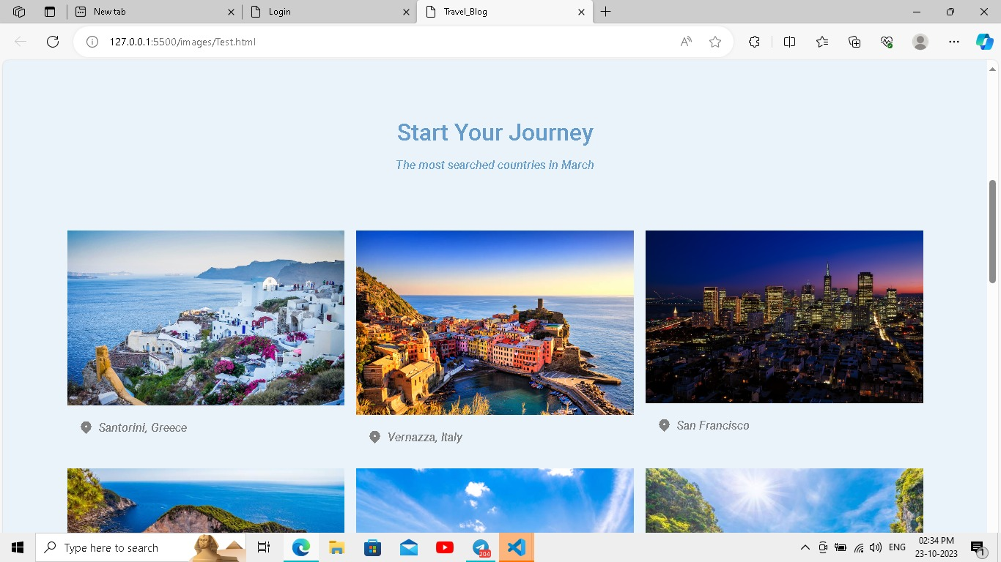

4.**In My page six country to travel:**

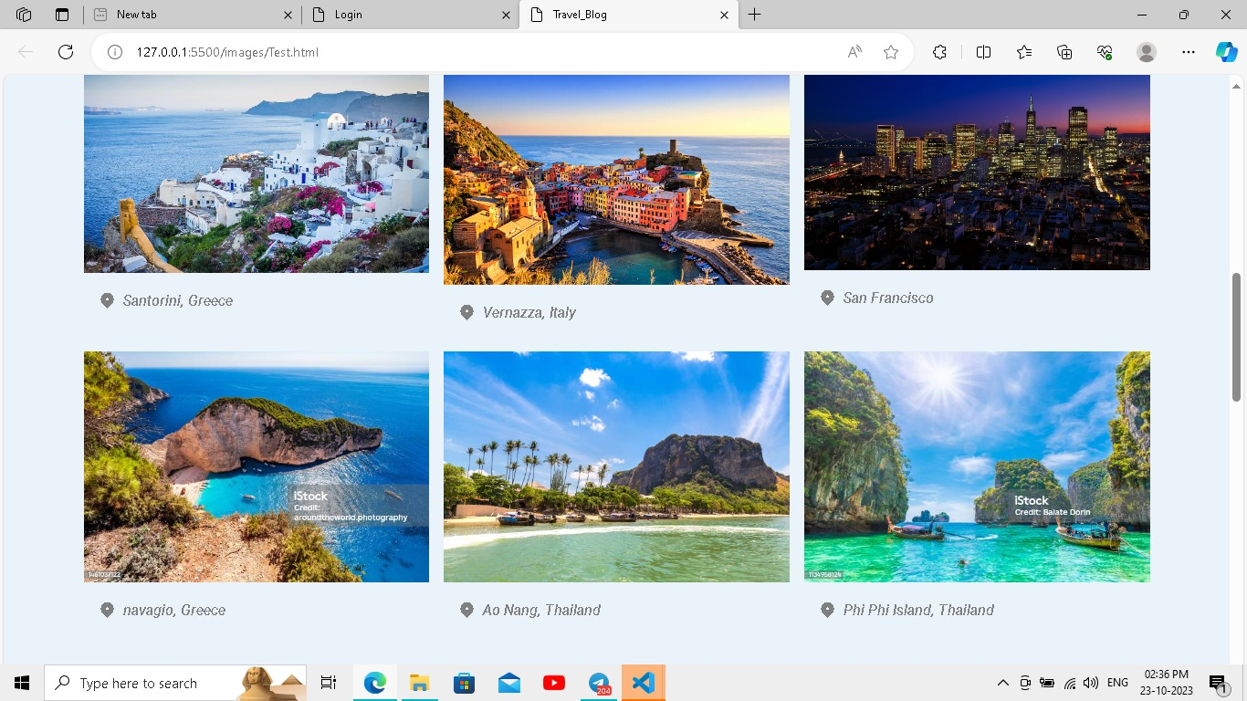

**5.Discount offer page:**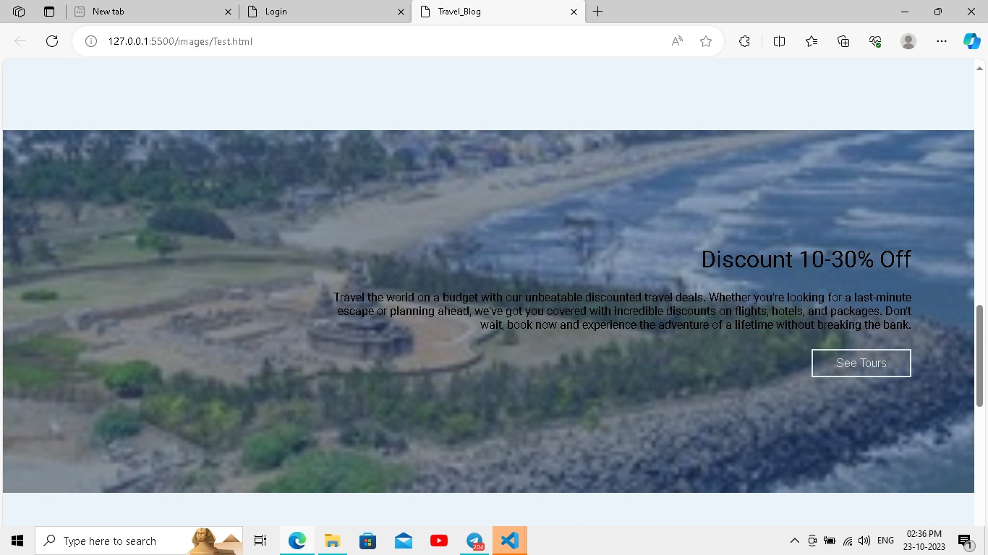

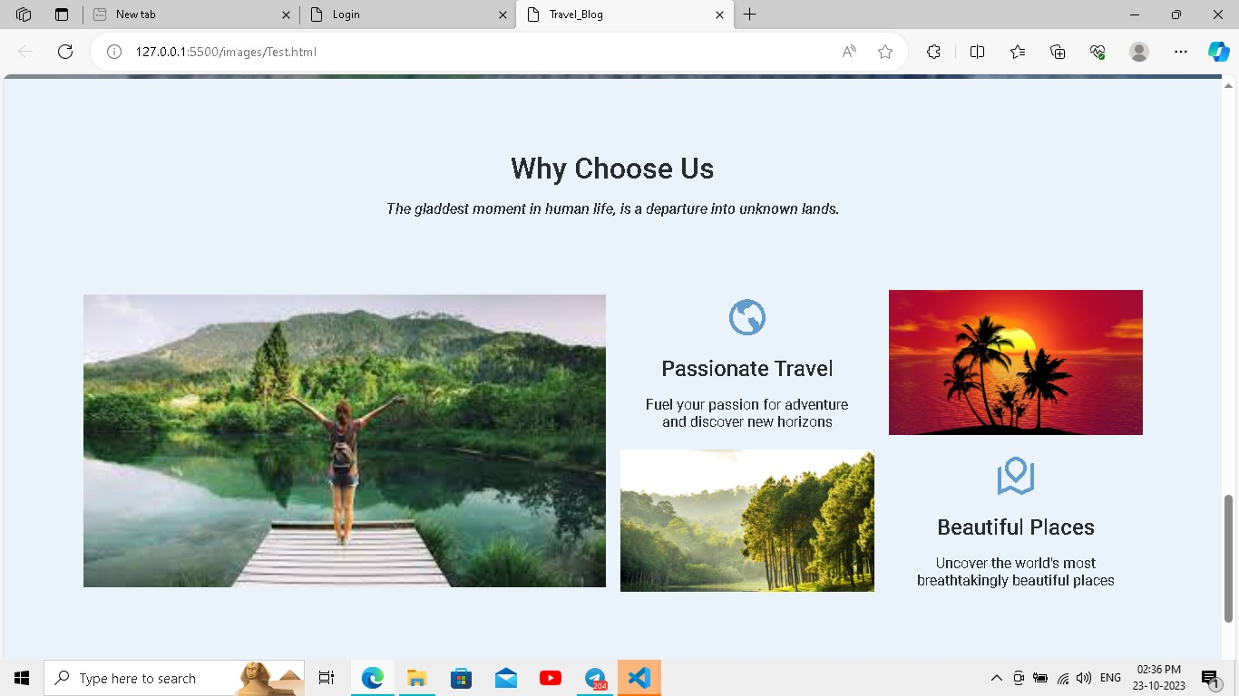**6.Destination page :**

**7.social icons page :**

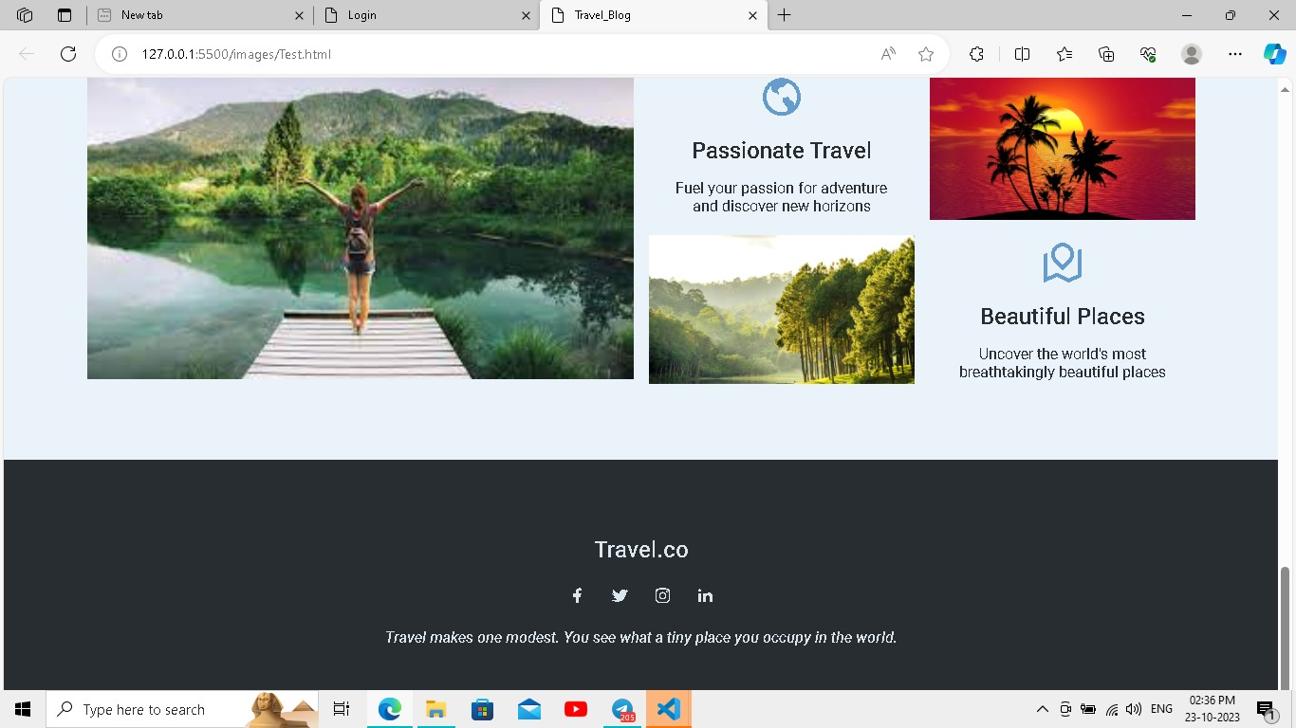

**Wrapping Up The Best Travel Blog Website Designs:**

Hope this provided you some serious design inspiration for next travel blog website design. We had a lot of fun reviewing these blogs. They made us want to get out, explore, and take better picture