**PERSONAL BLOG(TRAVEL BLOG)**

**TEAM MEMBERS**

1. **PRIYA SAKTHI A**
2. **SHARMILA R**
3. **SUJITHA R**
4. **JAISHREE R**

**PROJECT OBJECTIVES:**

In addition, keeping a travel blog will naturally give purpose to your life. Most importantly, you'll have the opportunity to memorialise your adventures. A method to remember the people you've met, the experiences you've had, and the locations you've visited while exploring the world.A travel blog is a great way to share your personal experiences with others and inspire them to explore new places and cultures.Travel Bloggers are freelance writers who travel around the world and put together stories about their experiences. Over 80% of travel planning is done through the internet and is growing. 33% of US travelers use travel blogs for travel advice. The majority of travel blogs are between 1-4 years old.

# **STEPS FOR DESIGN**

## 1. Pick your destination

2. Decide the duration of your trip

## 3. Book flights, train, or bus tickets, and accommodation

## 4. Plan the day-wise activities and course of action

## 5. Pack diligently and make all the necessary adjustments

**Website structure:**

Site structure or website architecture refers to how your website is designed or how various pages on your website are connected for excellent user experience. This is important not just from the user’s perspective but also for [search engine optimization](https://www.infidigit.com/blog/what-is-seo/).A website structure refers to the hierarchy, order and organization of your site’s pages, mapped out by a desired user experience. It connects all your web pages with a navigational system of menus, internal linking and content.

Along with your site’s [information architecture](https://www.wix.com/blog/information-architecture), website structure is an important [UX design](https://www.wix.com/blog/what-is-ux-design) factor that impacts a visitor’s user journey. But it’s also a way for you as the creator to plan your site's layout and content and determine where each element should sit. Especially when designing

website with multiple pages, the more attention you pay to your site’s structure at the start, the less surprises you’ll have later on.

**Elements are in a website structure?**

Defining a website structure ensures that visitors follow a logical [user journey](https://www.wix.com/blog/user-journey-mapping) when discovering information on your website. The structure must include all of the web pages on your site, a system of categories for organizing these and a means for visitors to navigate from one element to another. Your site’s structure should make sure the most important information is discoverable first, while inviting visitors to continue exploring the following elements:

* Categories and sub-categories
* Navigation
* Linking system

**Navigation**

Your [website’s navigation](https://www.wix.com/blog/website-navigation-tips) lays out its structure for visitors, acting as a map of directions to the content they need. In most cases, this starts with a website menu—which may be a classic header menu across the top or a more minimalistic hamburger menu.

Since the purpose of navigation is to guide visitors, your homepage should clearly display the pages and categories they’re looking for on your site. From there, sub-categories should also be discoverable, whether by using a drop-down menu or using another way to display links to sub-category pages. Additionally, you’ll want to be sure your site’s navigation drives visitors to other important web pages relating to your brand, such as an “About Us” page or a “Contact” page.

### 

### **Linking system**

Implementing a well-thought-out linking system ensures that your user moves through your site properly. Depending on the type of website structure you use, when [learning how to make your website](https://www.wix.com/blog/how-to-build-website-from-scratch-guide), there will be varying degrees to which the visitor relies on your linking system. In addition to links from your website’s menu, a structure can utilize the following kinds of links to elevate the user experience:

* **CTAs**, or calls-to-action, are strategically placed links that take visitors to a direct goal, encouraging them to make a move. Whether it's a link to “sign up” or “purchase,” CTAs are extremely helpful to visitors who have that specific goal on your site. Display them using bold text, enticing [microcopy](https://www.wix.com/blog/what-is-microcopy-ux) or a button design.
* **Internal links** refer to those links within a website that connect to other pages of the same site. Every site naturally has internal linking between its web pages, whether it's organized in the most optimal way for visitors is entirely up to you. Sometimes, businesses will group their pages into category “clusters,” using this as a guide. Having a system of internal linking also happens to be a strong SEO best practice. Since it is reflected in your sitemap, Google bots see the effort being made to provide visitors with the most relevant information in the right order.
* **Contextual links** bring the visitor to related content outside of your own site’s web pages, such as product pages from other businesses, blog posts, sources or news.

## **Importance of Website structure?**

## **A smooth user experience**

If your website is appealing and informative and has hassle-free navigation, users will want to spend more time on it, increasing the [dwell-time](https://www.infidigit.com/blog/dwell-time/) and decreasing the bounce time. This will, in turn, indicates to Google that your website is an excellent result to be displayed for a search query and can boost your rankings.

* **Good site structure can get you sitelinks**

[Sitelinks](https://www.infidigit.com/blog/sitelinks/) on a SERP show your website’s important pages. These are of a great [SEO](https://www.infidigit.com/seo-search-engine-optimization/) advantage and can improve [clickthrough rate](https://www.infidigit.com/blog/click-through-rate/), better your brand’s reputation and help you rank better on SERPs. Google awards sitelinks to websites with excellent site structure. Currently, you cannot add a sitelink on your own.

* **Improved Crawling**

A properly designed website structure with good [internal linking](https://www.infidigit.com/blog/internal-linking/) will help not only users but also crawlers that [crawl](https://www.infidigit.com/blog/crawling-and-indexing/) your website by letting them discover important pages.

* **Prevents from competing with your website**

Sometimes, you may have different blog posts written around the same topic. If your site is designed correctly, it can help you avoid having competing webpages and [keyword cannibalization](https://www.infidigit.com/blog/keyword-cannibalization/).

**How to approach your website structure**

Once you’re ready to design a website, decide whether you’ll use a top-down or bottom-up website structure to organize your content. While a top-down approach starts with outlining a hierarchy of categories based on your site’s general topics, a bottom-up approach starts with the least important sub-categories, working up to the more general categories and content.

If you’re starting with a template, you likely don’t need to think much about creating a website structure—just be on the lookout for one that suits your content. If you’re making a site from scratch, using [UX tools](https://www.wix.com/blog/ux-design-tools) for stages like wireframing and drafting your design’s architecture can be extremely helpful for kick-starting this process.

**Content creation:**

### 1. Come up with a list of topics

The first thing you need to start writing a travel blog is to make a list of topics you are interested in writing about. It’s okay if you can’t narrow down the list yet. Sometimes, broad topics can help you explore your options further. You can choose anything from sustainable travel to adventure destinations. No matter what theme you decide on, ensure you post high-quality photographs. Mentioned in the image above are a few travel blog ideas you can borrow.

### 2. Go into the details

While sharing your travel experience, it’s always better to be specific. Be clear about where and which places you visited, the specialties found there, and how you felt staying there. Some things to look for: neighborhoods visited, whom you traveled with, and hotels you stayed at.

### 3. Write about the locale

Talk about the behavior and type of people you met in a particular city, town, or village. Also, write about the quirks of that area, which you may recommend to your audience for sightseeing. For example, if you are writing about your travel experience to France, you should mention the Eiffel Tower and other sightseeing locations. In addition, you can add the names of the country’s famous cheeses, perfumes, wines, and other local specialties to your blog. You should also specify some offbeat places you visited and would like to recommend to others.

### 4. Find ideas and inspiration

Any creative work—writing an article or making a vlog—requires inspiration and innovative ideas. As they say, “Always a student, never a teacher.” You should always refer to other [travel blogs](https://www.peppercontent.io/blog/best-travel-blogs) to see how fellow travelers portray their experiences. You can even watch travel vlogs for further information and inspiration. You can even Google the best travel bloggers in the world. They can be storehouses of inspiration for you.

### 5. Ensure you share the most relevant experiences

Sharing your travel experience is good; however, you should never go off the topic or miss putting down the main ingredients of your blog. Always stick to the topic, and don’t share experiences that do not resonate with your audience. You must also take into consideration what traveling is like with pets and companions with special needs. Wherever applicable, include tips for traveling with such populations.

### 6. Create a structure

There needs to be a structure to your blog for enhanced readability. Although you can have subheads, blurbs, text blocks, and other elements, here is a broad outline you can follow:

### Introduction

Start by introducing the place. You can do so by giving a small overview of its culture or history. Highlight why it is travel-worthy and why you chose to go there, among other things.

### Body

This is where most of the interesting content goes in. Right from places to visit, events, and shopping opportunities to the interesting people you meet, the body is what should compel the reader to continue reading.

### Conclusion

When concluding, put together some key takeaways and points to remember. This will help your readers plan their trip smoothly.

### 7. Use a casual yet informative tone

You can make your travel blog sound a bit casual, but most of it should be covered with useful details and information. If you’re not too confident about writing about a particular place, consider including the opinion or views of someone who has traveled there. Here’s an example of a blog that is both informative and engaging.

### 8. Target a specific audience

When we ask you to target a specific audience, what we mean is that you should find people who may have similar travel preferences as you or those who would look forward to your content. This helps you build deeper connections with the travel community at large. Also, when targeting them, you should keep yourself up to date on recent travel trends.

### 9. Do your research

Before venturing into unknown territory, it is highly advisable to conduct thorough research. This exercise helps you get a sense of the people there, the culture, safety concerns (if any), and the weather at the time you’re visiting. Additionally, you may have traversed the breadth of a place, but it is still possible to miss out on some details that make it worth a visit. In such cases, too, research plays a crucial role.

However, not all sources on the net are reliable. A good number of them are either outdated, clickbait, or even something totally irrelevant. So, the next time you are out hunting for material, only pick the points that are published by reliable and reputable sources.

### 10. Use statistics

Sometimes, to make a case for a location, it is better to show numbers to your viewers. Provide them with statistical reports on how many people visit the site yearly and the usual period of their visit. An example could be, “Five million people come to visit this UNESCO World Heritage Site annually.”

### 11. Write exclusively for the reader

Sharing your travel experiences is undoubtedly a key component of your travel blog, but the whole article should not be just about what you did from morning to night. Your travel blog should be more about what you think the reader might like. The best way to do this is by sharing travel hacks or tips. You may mention how you felt being there, but keep in mind to keep it short. In the end, your priority should be to provide your audience with crucial information.

### 12. Publish interviews

When you travel to a new location, the best way to learn about its culture and people is by interacting with the local populace. You can chat about the destination and its culture with the people who reside there. This can give you deeper, more enriching insights into the place. You can also ask the interviewee to suggest some must-see places of interest.

### 13. Focus on some fun activities

Tourist sites without entertainment or activities are unidimensional, and not many people dig that. So, try to add locations that have fun activities, such as a national park that may have kayaking, skiing, or mountain climbing. Besides that, do not limit your travel blog only to adventurous activities. Sightseeing, birding, and a pleasant Photowalk count as entertainment too.

### 14. Help your audience sketch out an itinerary

Your travel blog is not all that useful if it can’t arouse wanderlust in the reader. However, evoking is not enough either. You need to hand-hold your reader through the travel planning process, should they decide to visit the place. You can arm them with key information, such as the following (note that the below-mentioned list is not exhaustive):

● Names and frequency of flights to and from the location

● How to get to the destination after landing

● Recommended staying options for all budgets

● Local foods to try out

● Places to visit

● Where to shop

● Things to do

● What to pack

### 15. Review the blog before posting it

After you have added the finishing touches to your article, ensure to proofread it before posting. Check if the travel blog has all the necessary information. This way, you would be able to determine if your article is good enough for the world to see.

Learning how to [write a travel blog](https://www.peppercontent.io/blog/write-a-travel-blog) takes patience, perseverance, courage, and support from the community. Travel blogging is no easy task and requires a ton of effort. However, if you put your sweat and blood into it, you are guaranteed to be successful. Hopefully, our advice will help you to get started with your travel blog, or if you have already started, then improve further.

# **Technical implementation**

1. Database

A database is a collection of information that is organized so that it can easily be accessed, managed, and updated. In this system, database plays the most important role in supporting all applications with data stored of all kinds of information. Furthermore, stored data is the source for data analysis tools such as data mining to get valued information and knowledge.

2. Hybrid positioning systems

Hybrid positioning systems are implemented for the purpose of identifying the location of a mobile device using several different positioning technologies. Mobile apps can provide current position information by using GPS module that is integrated in smart phones.

3. Rating and Ranking system

Our solution expands the boundary of the Rating and Ranking system from destination to users. In other words, users not only can rate destinations and attractions, but also can imply a rating and/or a few remarks on their group members if they were satisfied with the performance of any member in one travel plan. Of course, this rating and ranking actions could be anonymous and users can choose by themselves whether or not to display their ratings and rankings to other users. It is still noticeable that people who display good ratings, that is,with good reputations will become more popular in the community and other users will prefer travelling together with them in future.

4. Recommendation system

Recommendation will be generated through analysing the ‘rating’ and ‘preference’ comments that given by users about a destination.

5. User Interface (UI)

A well designed user interface can greatly improve the work efficiency, customer satisfaction while in the meantime reduce complaints and inquires and the cost of after-sales services. Therefore, user interface design is extremely important for products and services.

In this application, the structure of UI is organized by functions. As shown in the screenshots below, this websiteis categorized with functional columns, namely “Travel Journal”, “Photo Gallery”, “Video Sharing”, “Rating and Recommendation”, “Friends” and “My Travel Plan”. In addition, for the convenience of users,the booking of hotels, flights and other travel related services is provided in an independent section “G2gether super market”.

For smart phone application counterpart, the design is also function-oriented, which includes hotel info, flight info, train info, destination info, plan info, account info, etc. The pictures below display the design of our main UIs.

SCREENSHOT OF OUR WEBSITE:

**1.signup page :**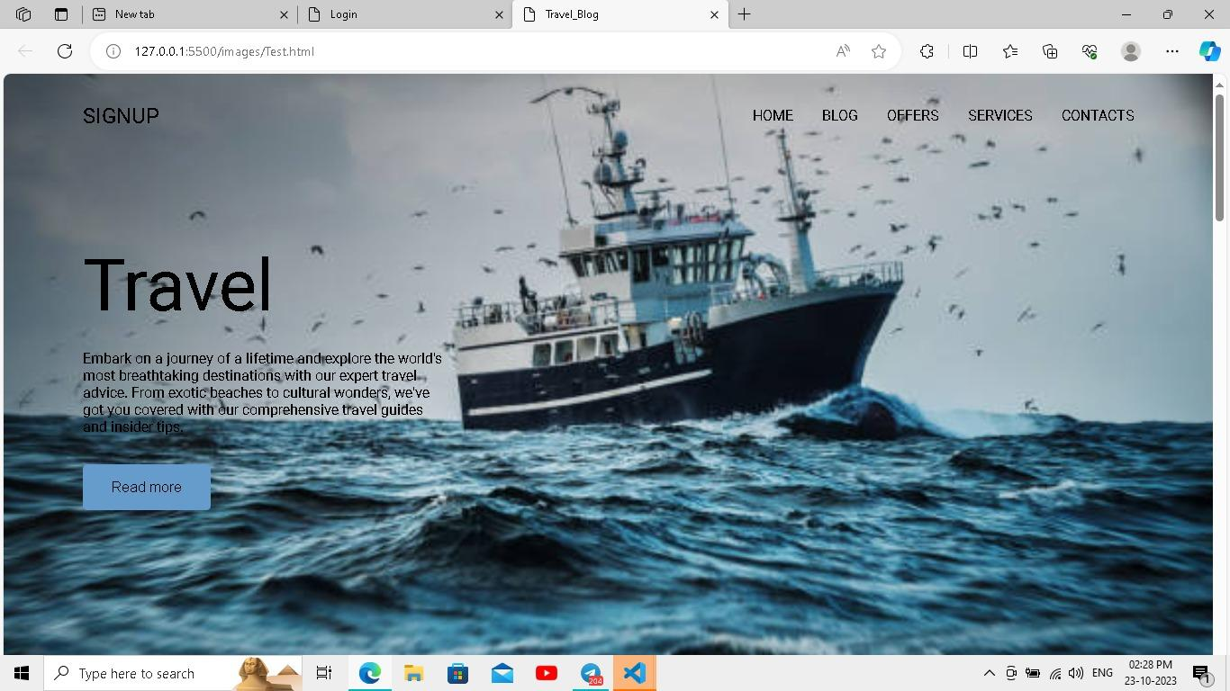

**2. login page:**

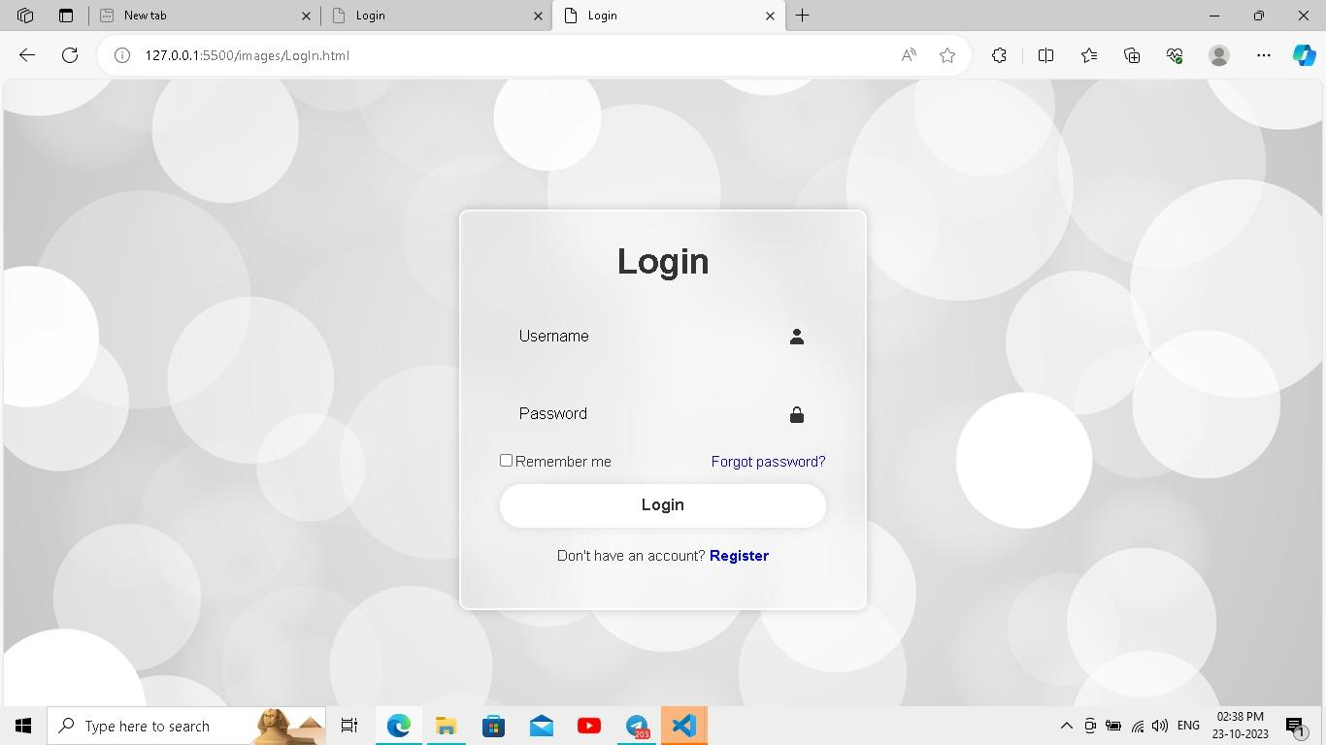

**3.journey countries page design:**

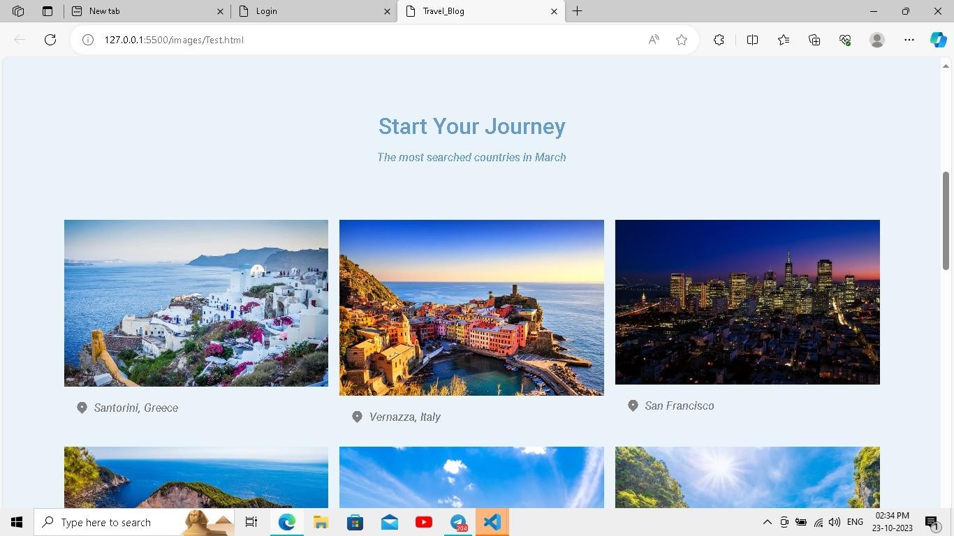

4.**In My page six country to travel:**

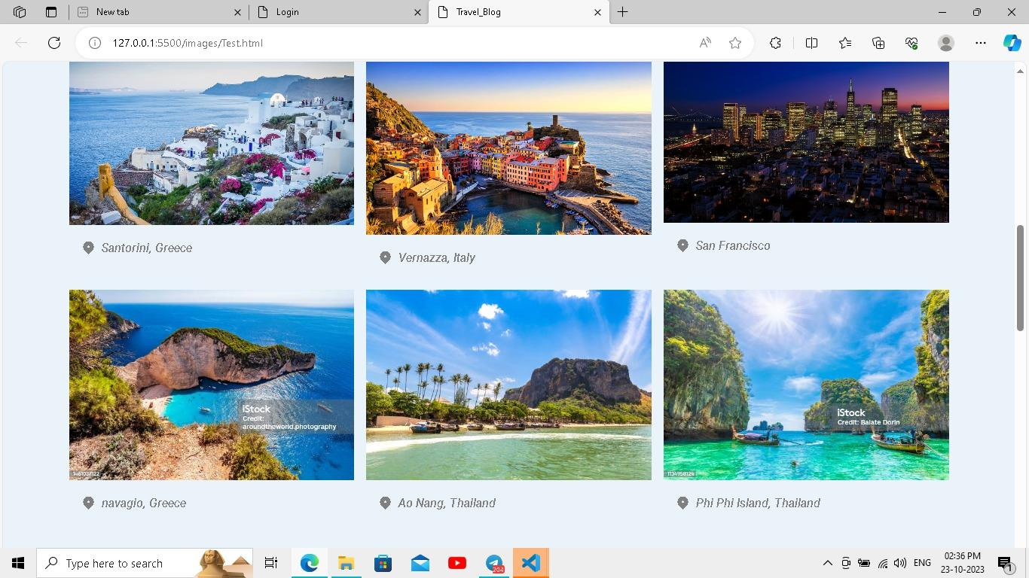

**5.Discount offer page:**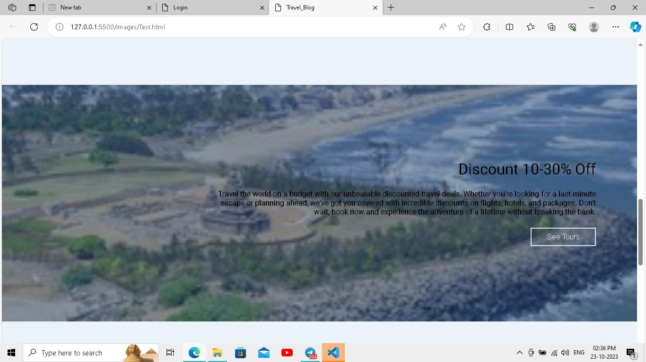

**6.Destination page :**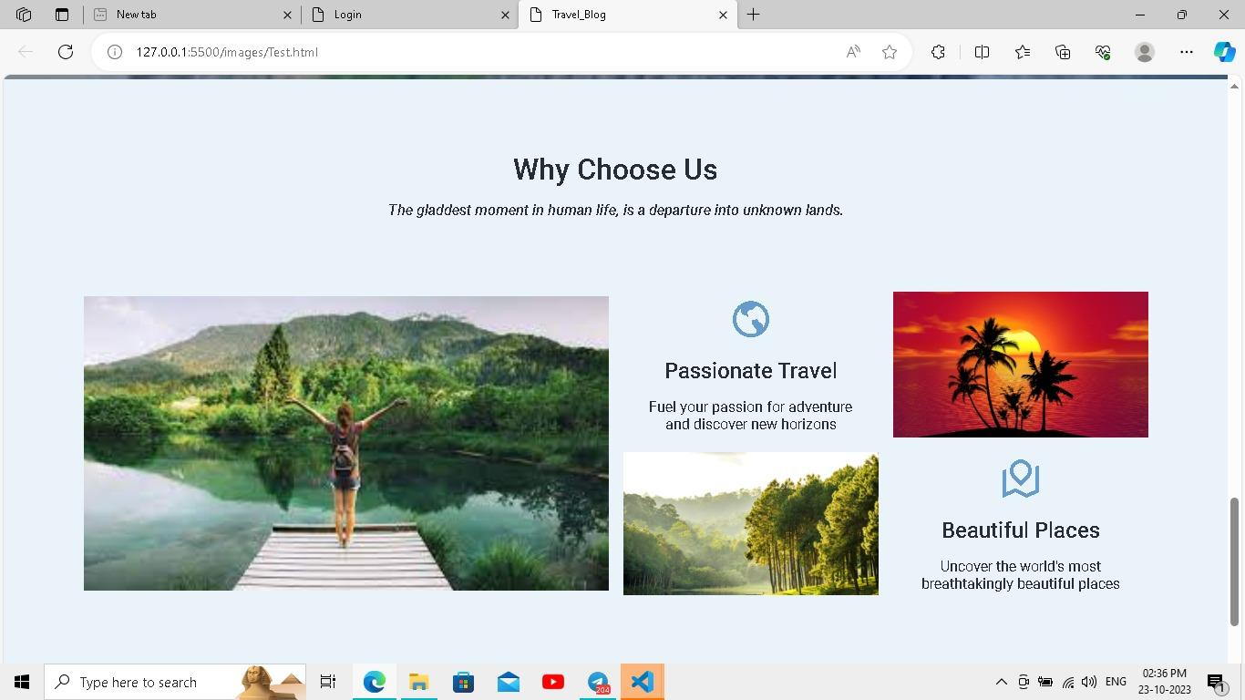

**7.social icons page :**

