**ASSIGNMENT 33.1**

**Write Java client API to perform following operations:**

**● Create the method name get record and use get class to retrieve one record at a time record from company table.**

**● Create the method name display and use scan class to display all records from company table.**

**Step 1: writing java code to get only names from the table ‘customer’**

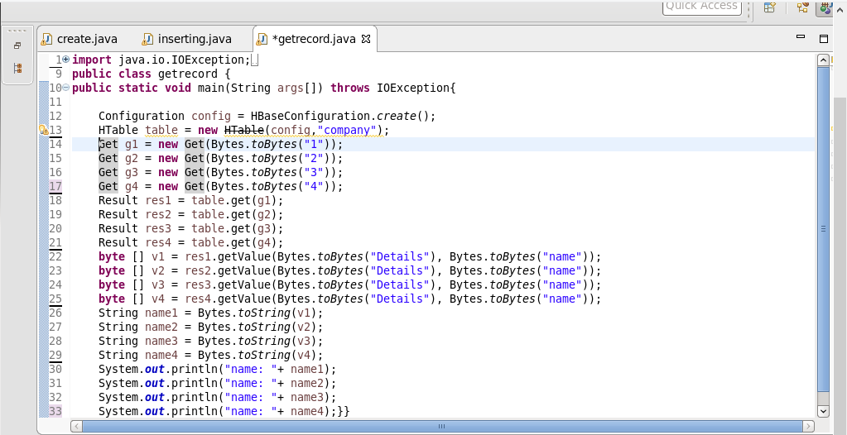

**Step 2: list of names from the table ‘customer’**

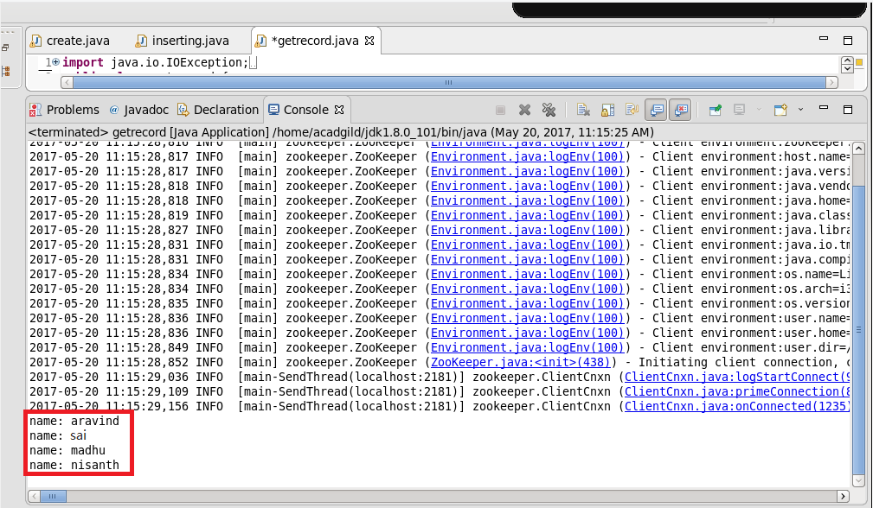

**Step 3: checking the contents of the table “company” using scan command**

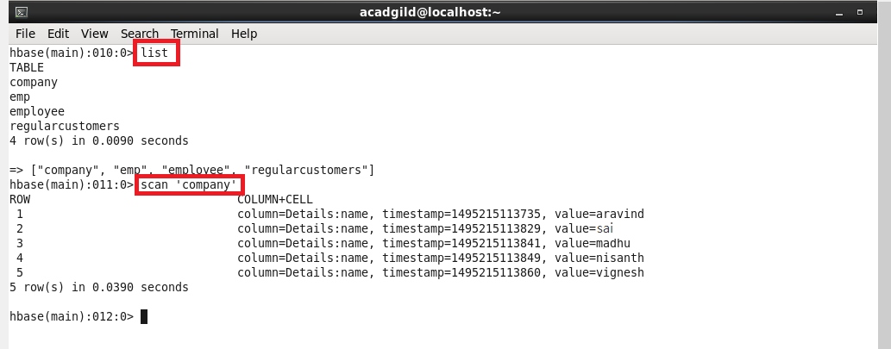

**-------------------------------------------------------------------------------------------------------------**

* **Create the method name display and use scan class to display all records from company table.**

**Step 1:**

**writing java code by using scan class to display all records from company table.**

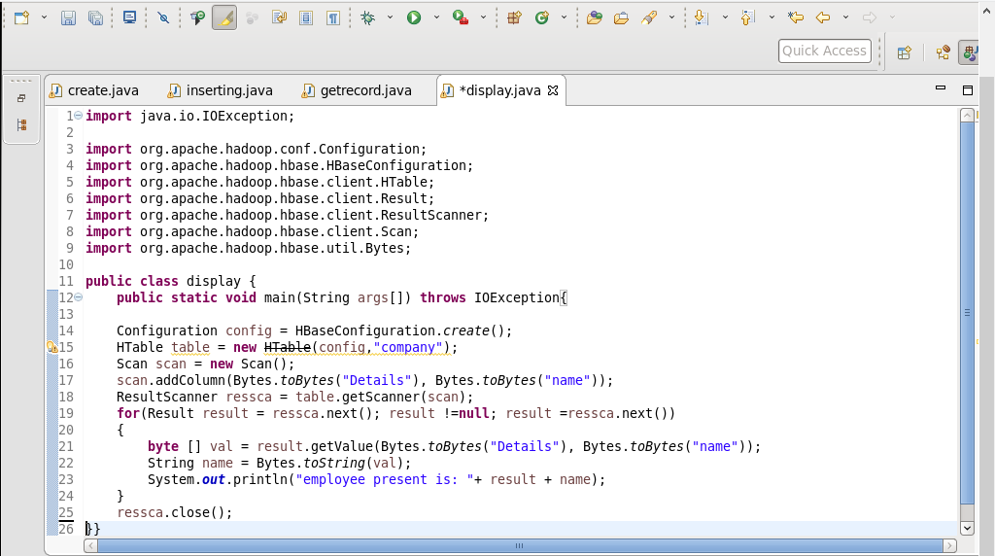

**Step 2: running java code(run as application) in eclipse**

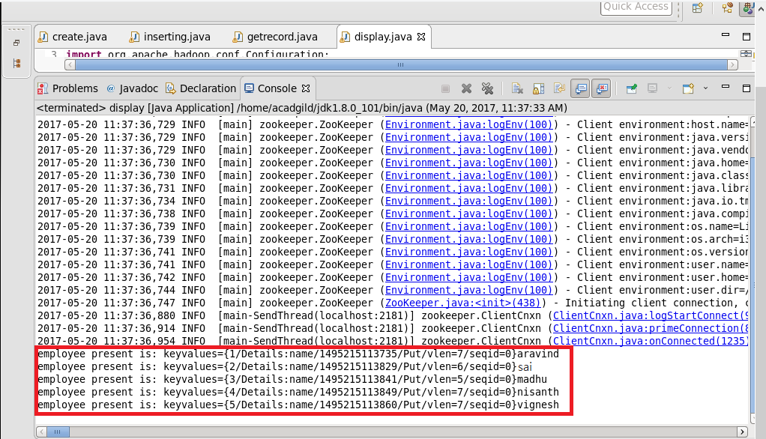

**Step 3: checking the contents of the table “company” using get command**

