Problem Statement

Explain the running modes of pig and integrate Tez with Hadoop and run a simple pig query using tez.

Dataset:

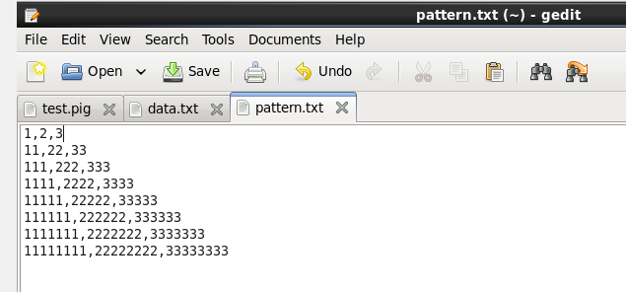

Pig script:

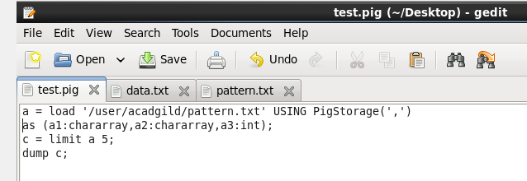

Running pig script using tez:

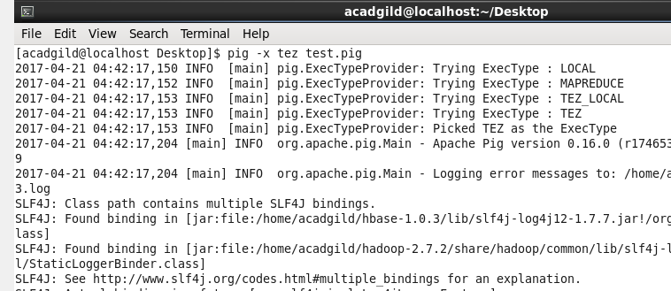

Output:

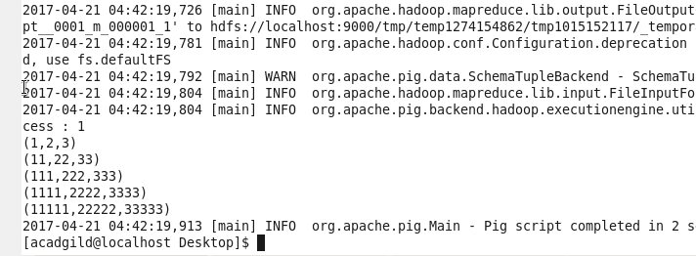

Q.Explain the running modes of pig:

**Execution Modes**

Pig has two execution modes or exectypes:

**Local Mode** – will run Pig in local mode.

* Will beaccessed only in a single machine.
* all files are installed and run using the local host and the file system.
* Specifying the local mode by using -x flag (pig -x local).
* Note: local mode will never support parallel mapper execution with Hadoop 0.20.x and 1.0.0.
* Because the Local Job Runner of Hadoop versions is not thread-safe.

**Mapreduce Mode** – will run the Pig in mapreduce mode.

* One need access to Hadoop cluster and HDFS installation.
* Mapreduce mode is a default mode.
* Thee will not be any need to specify it by making use of -x flag (pig OR pig -x mapreduce).
* One can run Pig in either mode by using the "pig" command (the bin/pig Perl script) or the "java" command (java -cp pig.jar ...).