**CDAC Mumbai PG-DAC AUGUST 24**

**Assignment No- 2**

1)Write a program that checks if a given year is a leap year or not using both if-else and switch-case.

Code:

IF-ELSE

class LeapYear

{

public static void main(String[] args)

{

int year = 1900;

if(year%4==0 && year%400==0 || year%100 !=0)

{

System.out.println(year + " is a leap year");

}

else

{

System.out.println(year + " is not a leap year");

}

}

}

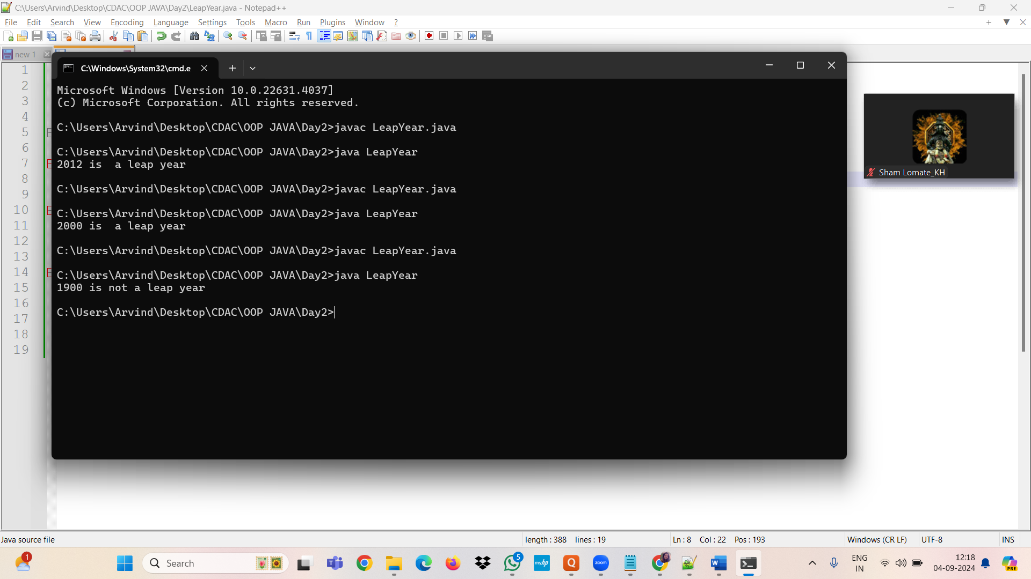

SWITCH case

Code:

class LeapYear

{

public static void main(String[] args)

{

int year = 2012;

switch(year%4)

{

case 0:

switch(year%400)

{

case 0:

System.out.println("leap year");

break;

default:

switch(year%100)

{

case 0:

System.out.println("not leap year");

break;

default:

System.out.println("");

}

}

System.out.println("leap year");

break;

default:

System.out.println("not leap year");

}

}

}

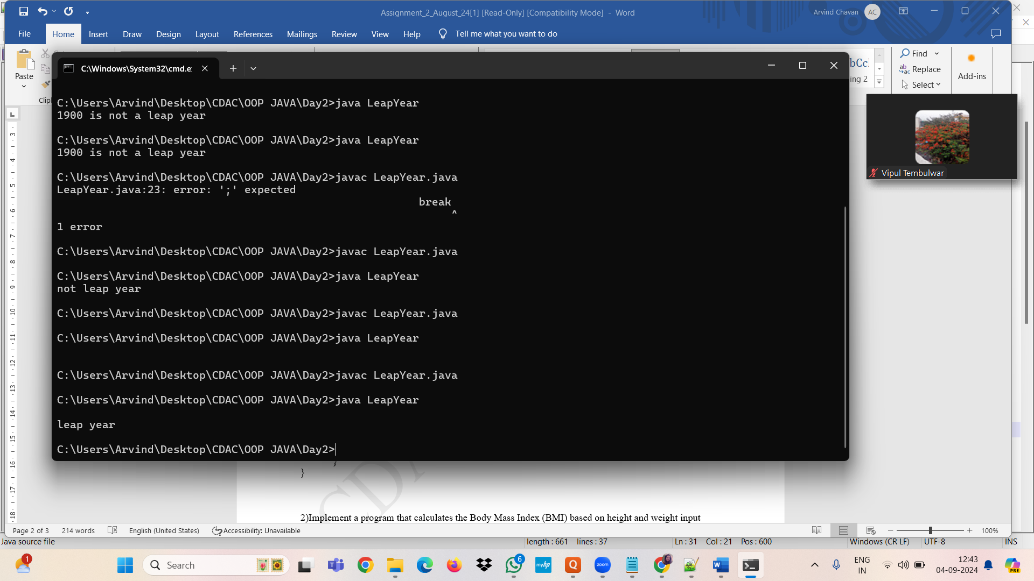

2)Implement a program that calculates the Body Mass Index (BMI) based on height and weight input using if-else to classify the BMI int categories (underweight, normal weight, overweight,etc).

Code:

// how to calculateBMI

// wieght/ height^2 = BMi

//16.0 - 18.5 underweight

//18.5 - 24.9 normal

//25.0 - 29.9- overweight

class BmiCal

{

public static void main(String[] args)

{

float weight = 75.8f;

float height = 1.59f;

float heightsq = height * height;

float bmi = weight/heightsq;

if(bmi>=16.0f && bmi<=18.0f)

{

System.out.println("underweight");

}

else if(bmi>=18.5f && bmi<=24.9f)

{

System.out.println("normal weight");

}

else if(bmi>=25.0f && bmi<=29.9f)

{

System.out.println("over weight");

}

else

{

System.out.println("obeseity is detected do excersise");

}

}

}

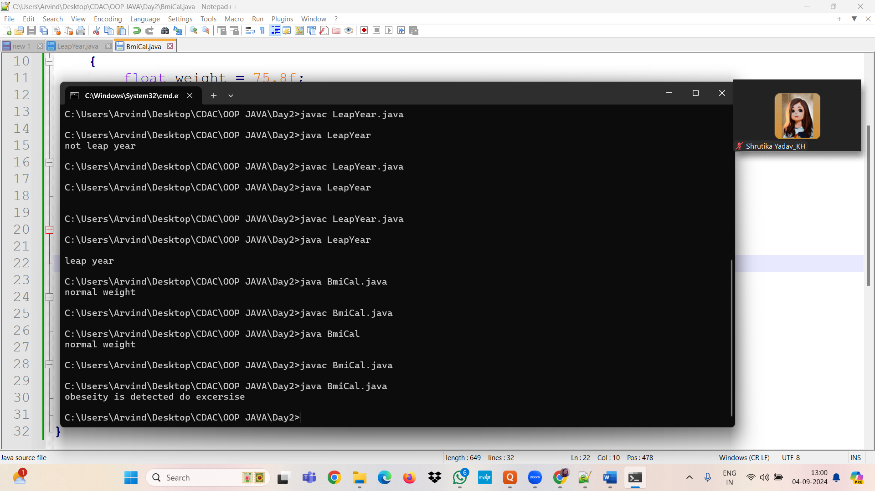

3)Write a program that checks if a person is eligible to vote based on their age.

Code:

class VoteEli

{

public static void main(String[] args)

{

int age = 17;

if(age>=18){

System.out.println("Mubarakho you can vote");

}

else{

System.out.println("na baba abhi umar nahi hai");

}

}

}

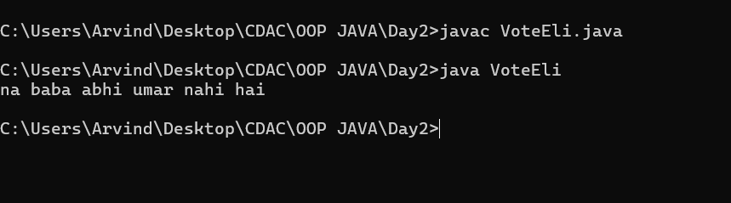

4)Write a program that takes a month (1-12) and prints the corresponding season (Winter, Spring, Summer, Autumn) using a switch case

Code:

5)Write a program that allows the user to select a shape (Circle, Square, Rectangle, Triangle) and then calculates the area based on user-provided dimensions using a switch case.