Question 1: Write a shell script that prints "Hello, World!" to the terminal.

cdac@LAPTOP-NV03GB24:~$ nano p5.sh

cdac@LAPTOP-NV03GB24:~$ bash p5.sh

Hello world

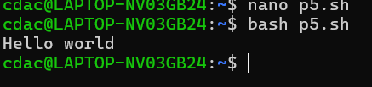

Question 2: Declare a variable named "name" and assign the value "CDAC Mumbai" to it. Print the value of the variable.

name="CDAC MUMBAI"

echo $name

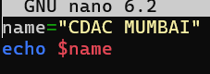

Question 3: Write a shell script that takes a number as input from the user and prints it.

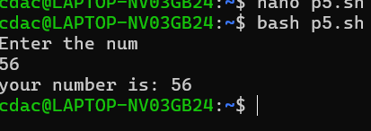

Question 4: Write a shell script that performs addition of two numbers (e.g., 5 and 3) and prints the result.

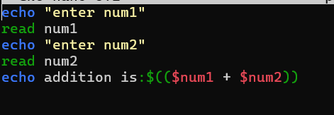

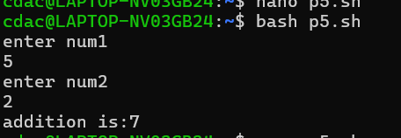

Question 5: Write a shell script that takes a number as input and prints "Even" if it is even, otherwise prints "Odd".

echo "Enter the Number"

read n

r=`expr $n % 2`

if [ $r -eq 0 ]

then

echo "$n is Even number"

else

echo "$n is Odd number"

fi

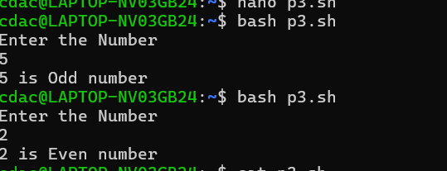

Q6 : Write a shell script that uses a for loop to print numbers from 1 to 5.

cdac@LAPTOP-NV03GB24:~$ nano p3.sh

cdac@LAPTOP-NV03GB24:~$ cat p3.sh

i=0

for i in 1 2 3 4 5

do

echo $i

done

cdac@LAPTOP-NV03GB24:~$ bash p3.sh

1

2

3

4

5

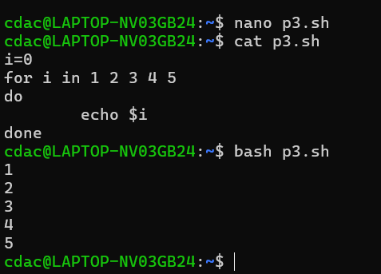

Question 7: Write a shell script that uses a while loop to print numbers from 1 to 5.

cdac@LAPTOP-NV03GB24:~$ nano p3.sh

cdac@LAPTOP-NV03GB24:~$ bash p3.sh

1

2

3

4

5

cdac@LAPTOP-NV03GB24:~$ cat p3.sh

i=1

while [ $i -le 5 ]

do

echo $i

i=`expr $i + 1`

done

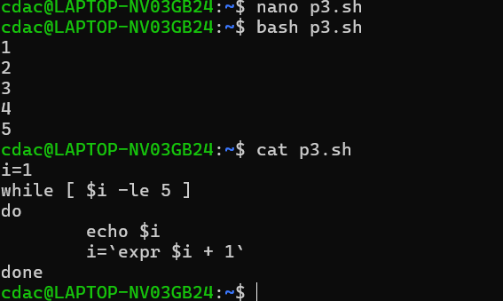

Question 8: Write a shell script that checks if a file named "file.txt" exists in the current directory. If it does, print "File exists", otherwise, print "File does not exist".

If [ -f “file1.txt”]

Then echo exist

Else echo not exist

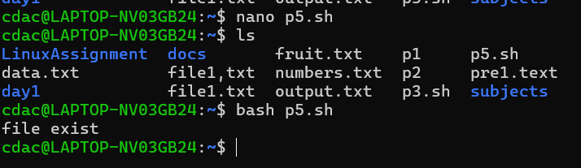

Question 9: Write a shell script that uses the if statement to check if a number is greater than 10 and prints a message accordingly.

echo enter the num

read n

if [ $n -gt 10 ]

then

echo greater than 10

else

echo less than 10

fi

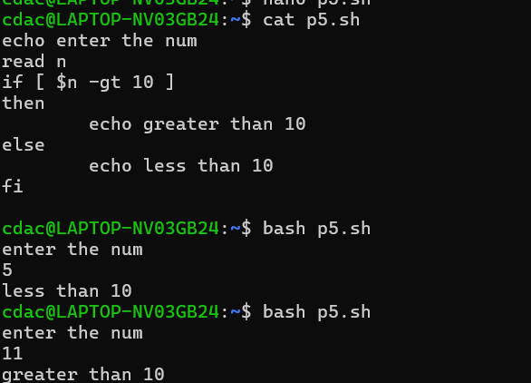

Question 10: Write a shell script that uses nested for loops to print a multiplication table for numbers from 1 to 5. The output should be formatted nicely, with each row representing a number and each column representing the multiplication result for that number.

for i in {1..5}

do

for j in {1..10}

do

res=$((i \* j))

echo "$i \* $j = $res"

done

echo "--------"

done

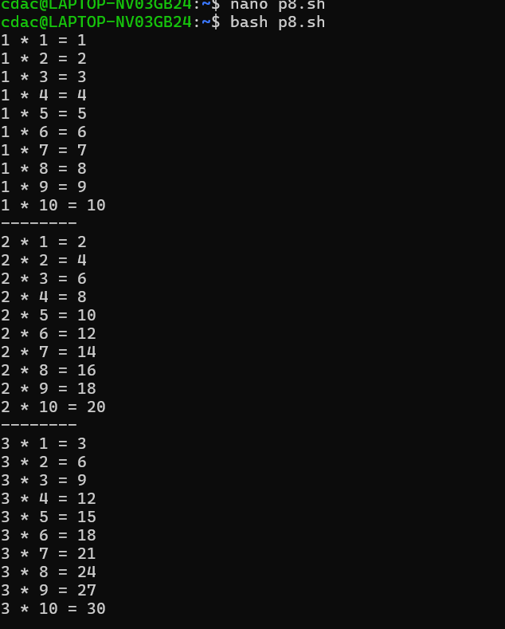

Question 11: Write a shell script that uses a while loop to read numbers from the user until the user enters a negative number. For each positive number entered, print its square. Use the break statement to exit the loop when a negative number is entered.

