Safety Incident Database & Equipment Database

2. Flowcharts

2.1 C - Safety Incident Database
Covers adding a new incident, viewing all incidents, searching, and filtering.
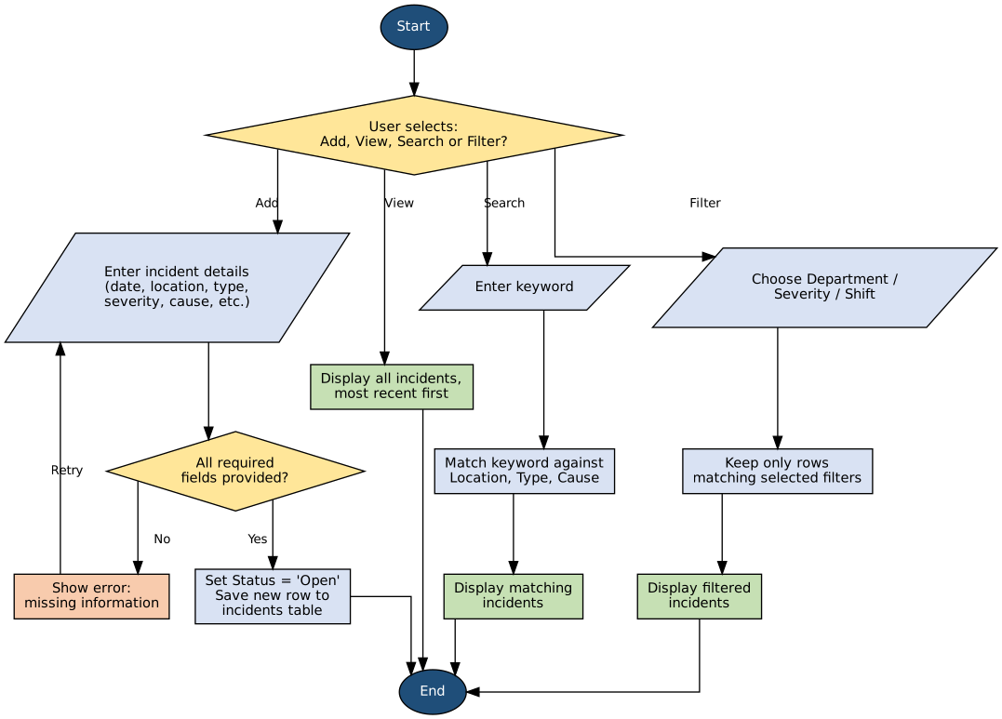
Figure 1: Safety Incident Database - add / view / search / filter flow

2.2 D - Equipment Database
Covers adding equipment, viewing all records, looking up one machine's full parameter set, and filtering.
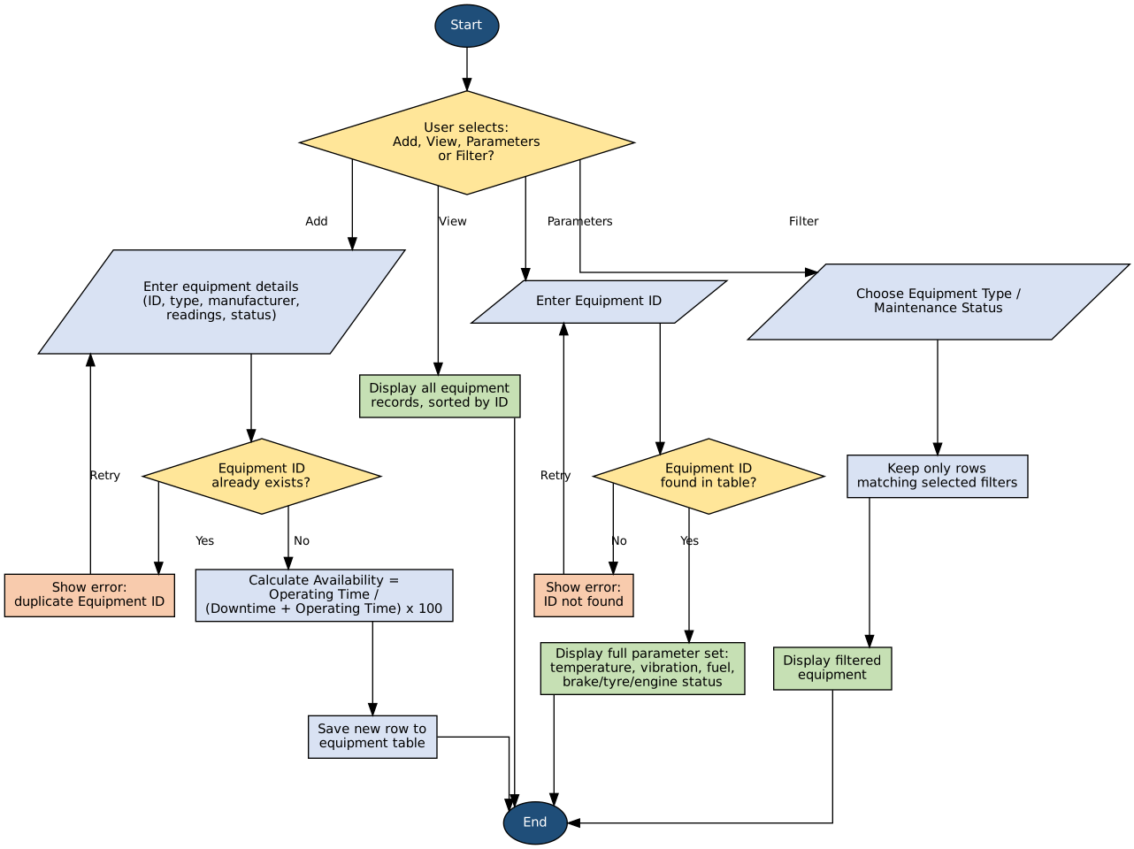
Figure 2: Equipment Database - add / view / parameters / filter flow

3. Pseudocode

3.1 Add Incident
BEGIN AddIncident(id, date, shift, location, department, type, severity, cause, action)
IF any required field is missing THEN
DISPLAY "missing information" error
RETURN to input
ENDIF
SET status = "Open"
APPEND new row to incidents table
RETURN updated table
END AddIncident

3.2 View / Search / Filter / Categorise / Count Incidents
BEGIN ViewIncidents(table)
SORT table by Date, most recent first
RETURN sorted table
END ViewIncidents

BEGIN SearchIncidents(table, keyword)
FOR each row in table
IF keyword found in Location OR Type OR Cause THEN
KEEP row
RETURN kept rows
END SearchIncidents

BEGIN FilterIncidents(table, department, severity, shift)
result = table
IF department given THEN result = rows WHERE Department == department
IF severity given THEN result = rows WHERE Severity == severity
IF shift given THEN result = rows WHERE Shift == shift
RETURN result
END FilterIncidents

BEGIN CategorizeIncidents(table)
GROUP rows by IncidentType and Severity
COUNT rows in each group
RETURN group counts, highest first
END CategorizeIncidents

BEGIN AnalyseIncidentTrends(table)
GROUP rows by calendar month
COUNT rows in each month
RETURN monthly counts
END AnalyseIncidentTrends

3.3 Add Equipment
BEGIN AddEquipment(id, type, manufacturer, operatingHours, downtime, ...)
IF id already exists in equipment table THEN
DISPLAY "duplicate Equipment ID" error
RETURN to input
ENDIF
SET availability = operatingHours / (operatingHours + downtime) * 100
APPEND new row to equipment table
RETURN updated table
END AddEquipment

3.4 View Records / Parameters / Filter Equipment
BEGIN ViewEquipmentRecords(table)
SORT table by EquipmentID
RETURN sorted table
END ViewEquipmentRecords

BEGIN GetEquipmentParameters(table, equipmentID)
IF equipmentID not found in table THEN
DISPLAY "ID not found" error
RETURN to input
ENDIF
RETURN full row of readings and status fields for that ID
END GetEquipmentParameters

BEGIN FilterEquipment(table, type, maintenanceStatus)
result = table
IF type given THEN result = rows WHERE EquipmentType == type
IF maintenanceStatus given THEN result = rows WHERE MaintenanceStatus == maintenanceStatus
RETURN result
END FilterEquipment

4. Python Code

4.2 C - Safety Incident Database Functions
add_incident, view_incidents, search_incidents, filter_incidents, categorize_incidents, count_incidents, analyse_incident_trends, and high_risk_departments.
import pandas as pd
from datetime import datetime

def add_incident(incidents_df, incident_id, date, shift, location, department,
incident_type, severity, lost_time_injury, cause, corrective_action):
"""Adds one new safety incident record to the incidents table."""
# Build the new row as a small dictionary first, so it is easy to read.
# pd.to_datetime() keeps the Date column as a proper date type.
new_row = {
"IncidentID": incident_id,
"Date": pd.to_datetime(date),
"Shift": shift,
"Location": location,
"Department": department,
"IncidentType": incident_type,
"Severity": severity,
"LostTimeInjury": lost_time_injury,
"Cause": cause,
"CorrectiveAction": corrective_action,
"Status": "Open", # every new incident starts as "Open"
}
# pd.concat is used instead of the old .append() method, which
# Pandas has removed in recent versions
new_row_df = pd.DataFrame([new_row])
updated_df = pd.concat([incidents_df, new_row_df], ignore_index=True)
updated_df["Date"] = pd.to_datetime(updated_df["Date"]) # keep the column as dates
return updated_df

def view_incidents(incidents_df):
"""Returns the full incidents table, sorted with the most recent incident first."""
return incidents_df.sort_values("Date", ascending=False)

def search_incidents(incidents_df, keyword):
"""Searches incidents for a keyword in Location, IncidentType or Cause."""
# Not case-sensitive, so convert everything to lower case first
keyword = keyword.lower()
# Check each of the three text columns for a match, then combine
# the three True/False results with "OR" (the | symbol)
mask = (
incidents_df["Location"].str.lower().str.contains(keyword, na=False) |
incidents_df["IncidentType"].str.lower().str.contains(keyword, na=False) |
incidents_df["Cause"].str.lower().str.contains(keyword, na=False)
)
return incidents_df[mask]

def filter_incidents(incidents_df, department=None, severity=None, shift=None):
"""Returns incidents matching the given Department/Severity/Shift filters."""
# Any filter left as None (or "All") is ignored
result = incidents_df.copy()
if department and department != "All":
result = result[result["Department"] == department]
if severity and severity != "All":
result = result[result["Severity"] == severity]
if shift and shift != "All":
result = result[result["Shift"] == shift]
return result

def categorize_incidents(incidents_df):
"""Groups incidents by type and severity, with a count for each group."""
# groupby + size() counts how many rows fall into each combination
grouped = (
incidents_df
.groupby(["IncidentType", "Severity"])
.size()
.reset_index(name="Count")
.sort_values("Count", ascending=False)
)
return grouped

def count_incidents(incidents_df, by="Department"):
"""Counts incidents grouped by a chosen column (e.g. Department, Shift)."""
# value_counts() automatically sorts from highest to lowest
return incidents_df[by].value_counts()

def analyse_incident_trends(incidents_df):
"""Summarises incident counts per month, to see if trends are rising or falling."""
# dt.to_period("M") groups every date into its calendar month
monthly_counts = incidents_df.groupby(
incidents_df["Date"].dt.to_period("M")
).size()
return monthly_counts

def high_risk_departments(incidents_df, severity_levels=("High", "Critical")):
"""Counts High/Critical incidents per department, highest first."""
# Keep only the rows with a high-risk severity, then count by department
high_risk = incidents_df[incidents_df["Severity"].isin(severity_levels)]
return high_risk["Department"].value_counts()

4.3 D - Equipment Database Functions
add_equipment, view_equipment_records, search_equipment, filter_equipment, get_equipment_parameters, categorize_equipment, count_equipment, and equipment_summary_stats.
def add_equipment(equipment_df, equipment_id, equipment_type, manufacturer,
operating_hours=0, temperature=25, vibration=0,
fuel_consumption=0, brake_status="OK", tyre_status="OK",
engine_status="OK", maintenance_status="Up to date",
downtime=0):
"""Adds one new piece of equipment to the equipment table."""
new_row = {
"EquipmentID": equipment_id,
"EquipmentType": equipment_type,
"Manufacturer": manufacturer,
"OperatingHours": operating_hours,
"Downtime": downtime,
"Temperature": temperature,
"Vibration": vibration,
"FuelConsumption": fuel_consumption,
"BrakeStatus": brake_status,
"TyreStatus": tyre_status,
"EngineStatus": engine_status,
"MaintenanceStatus": maintenance_status,
}
# Availability is calculated from operating hours and downtime
total_time = operating_hours + downtime
new_row["Availability"] = round((operating_hours / total_time) * 100, 1) if total_time > 0 else 0.0

new_row_df = pd.DataFrame([new_row])
updated_df = pd.concat([equipment_df, new_row_df], ignore_index=True)
return updated_df

def view_equipment_records(equipment_df):
"""Returns the full equipment table, sorted by EquipmentID."""
return equipment_df.sort_values("EquipmentID")

def search_equipment(equipment_df, keyword):
"""Searches equipment for a keyword in ID, EquipmentType or Manufacturer."""
keyword = keyword.lower()
mask = (
equipment_df["EquipmentID"].str.lower().str.contains(keyword, na=False) |
equipment_df["EquipmentType"].str.lower().str.contains(keyword, na=False) |
equipment_df["Manufacturer"].str.lower().str.contains(keyword, na=False)
)
return equipment_df[mask]

def filter_equipment(equipment_df, equipment_type=None, maintenance_status=None):
"""Returns equipment matching the given Type/Maintenance Status filters."""
result = equipment_df.copy()
if equipment_type and equipment_type != "All":
result = result[result["EquipmentType"] == equipment_type]
if maintenance_status and maintenance_status != "All":
result = result[result["MaintenanceStatus"] == maintenance_status]
return result

def get_equipment_parameters(equipment_df, equipment_id):
"""Returns the full parameter set (temperature, vibration, fuel, status fields) for one machine."""
# .loc finds the single row matching this EquipmentID
row = equipment_df.loc[equipment_df["EquipmentID"] == equipment_id]
if row.empty:
return None
return row.iloc[0].to_dict()

def categorize_equipment(equipment_df):
"""Groups equipment by type and maintenance status, with a count for each group."""
grouped = (
equipment_df
.groupby(["EquipmentType", "MaintenanceStatus"])
.size()
.reset_index(name="Count")
.sort_values("Count", ascending=False)
)
return grouped

def count_equipment(equipment_df, by="EquipmentType"):
"""Counts equipment grouped by a chosen column (e.g. Type, Manufacturer)."""
return equipment_df[by].value_counts()

def equipment_summary_stats(equipment_df):
"""Calculates average availability and identifies which equipment needs attention."""
# idxmax()/idxmin() find the row label with the highest/lowest value
worst_downtime = equipment_df["Downtime"].idxmax()
worst_vibration = equipment_df["Vibration"].idxmax()
worst_temperature = equipment_df["Temperature"].idxmax()
worst_availability = equipment_df["Availability"].idxmin()

summary = {
"average_availability": round(equipment_df["Availability"].mean(), 1),
"highest_downtime_equipment": equipment_df.loc[worst_downtime, "EquipmentID"],
"highest_vibration_equipment": equipment_df.loc[worst_vibration, "EquipmentID"],
"highest_temperature_equipment": equipment_df.loc[worst_temperature, "EquipmentID"],
"lowest_availability_equipment": equipment_df.loc[worst_availability, "EquipmentID"],
}
return summary

4.4 Test Section

if__ name__ == "__main__":

sample_incidents = pd.DataFrame({
"IncidentID": ["INC001", "INC002", "INC003"],
"Date": pd.to_datetime(["2026-02-10", "2026-03-05", "2026-03-20"]),
"Shift": ["Day", "Night", "Day"],
"Location": ["Shaft 1", "Plant", "Shaft 2"],
"Department": ["Mining", "Processing", "Mining"],
"IncidentType": ["Slip/Fall", "Fire", "Vehicle Collision"],
"Severity": ["Low", "Critical", "High"],
"LostTimeInjury": [False, True, False],
"Cause": ["Human Error", "Equipment Failure", "Human Error"],
"CorrectiveAction": ["Retrain staff", "Inspect wiring", "Review procedure"],
"Status": ["Closed", "Open", "Open"],
})

print("===== SAFETY INCIDENT DATABASE TEST =====")
sample_incidents = add_incident(
sample_incidents, "INC004", "2026-04-01", "Night", "Shaft 1", "Mining",
"Fire", "High", False, "Equipment Failure", "Inspect equipment"
)
print("\nAfter adding INC004:")
print(sample_incidents[["IncidentID", "IncidentType", "Status"]])

print("\nSearch results for 'fire':")
print(search_incidents(sample_incidents, "fire")[["IncidentID", "IncidentType"]])

print("\nFilter: Mining department only:")
print(filter_incidents(sample_incidents, department="Mining")[["IncidentID", "Department"]])

print("\nIncidents grouped by type and severity:")
print(categorize_incidents(sample_incidents))

print("\nIncident count by department:")
print(count_incidents(sample_incidents, by="Department"))

print("\nMonthly incident trend:")
print(analyse_incident_trends(sample_incidents))

print("\nHigh-risk departments:")
print(high_risk_departments(sample_incidents))

sample_equipment = pd.DataFrame({
"EquipmentID": ["EQ001", "EQ002", "EQ003"],
"EquipmentType": ["Haul Truck", "Loader", "Drill Rig"],
"Manufacturer": ["Caterpillar", "Komatsu", "Sandvik"],
"OperatingHours": [720, 650, 800],
"Downtime": [80, 40, 120],
"Temperature": [95, 70, 105],
"Vibration": [6.5, 3.2, 9.1],
"FuelConsumption": [150, 120, 100],
"BrakeStatus": ["OK", "OK", "OK"],
"TyreStatus": ["OK", "OK", "Fault"],
"EngineStatus": ["OK", "OK", "OK"],
"MaintenanceStatus": ["Due", "Up to date", "Overdue"],
})
sample_equipment["Availability"] = round(
sample_equipment["OperatingHours"] /
(sample_equipment["OperatingHours"] + sample_equipment["Downtime"]) * 100, 1
)

print("\n\n===== EQUIPMENT DATABASE TEST =====")
sample_equipment = add_equipment(
sample_equipment, "EQ004", "Excavator", "Epiroc",
operating_hours=500, downtime=20, temperature=75, vibration=4.0
)
print("\nAfter adding EQ004:")
print(sample_equipment[["EquipmentID", "EquipmentType", "Availability"]])

print("\nSearch results for 'sandvik':")
print(search_equipment(sample_equipment, "sandvik")[["EquipmentID", "Manufacturer"]])

print("\nFilter: Overdue maintenance only:")
print(filter_equipment(sample_equipment, maintenance_status="Overdue")[["EquipmentID", "MaintenanceStatus"]])

print("\nFull parameter set for EQ003:")
print(get_equipment_parameters(sample_equipment, "EQ003"))

print("\nEquipment grouped by type and maintenance status:")
print(categorize_equipment(sample_equipment))

print("\nEquipment count by type:")
print(count_equipment(sample_equipment, by="EquipmentType"))

print("\nSummary statistics:")
print(equipment_summary_stats(sample_equipment))

