BST
二叉查找树（Binary Search Tree，简称BST）是一棵二叉树，它的左子节点的值比父节点的值要小，右节点的值要比父节点的值大。它的高度决定了它的查找效率。

在理想的情况下，二叉查找树增删查改的时间复杂度为O(logN)（其中N为节点数），最坏的情况下为O(N)。

BST存在倾斜的问题
平衡的BST：
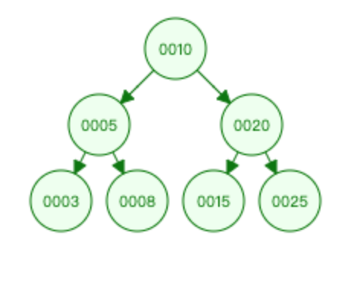

倾斜的BST:
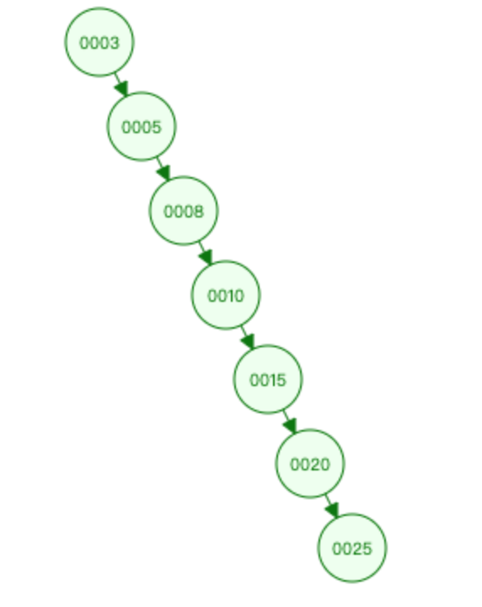

public class BstTest { static class Node { public String content; public Node parent; public Node left; public Node right; public Node(String content) { this.content = content; } } public Node root; // BST的查找操作 public Node search (String content) { Node r = root; while (r != null) { if (r.content.equals(content)) { return r; } else if (content.compareTo(r.content) > 1) { r = r.right; } else if (content.compareTo(r.content) <= 1) { r = r.left; } } return null; } // BST的插入操作 public void insert (String content) { Node newNode = new Node(content); Node r = root; Node parent = null; if (r == null) { root = newNode; return; } while (r != null) { parent = r; if (newNode.content.compareTo(r.content) > 1) { r = r.right; } else if (newNode.content.compareTo(r.content) < 1){ r = r.left; } else { r = r.left; } } if (parent.content.compareTo(newNode.content) > 1) { parent.left = newNode; newNode.parent = parent; } else { parent.right = newNode; newNode.parent = parent; } }}

