Report

K-means
1641469 Long Cheng

Introduction
This project implement the K-means approach

Dataset

data sources used
The data I used is download from: http://archive.ics.uci.edu/ml/datasets/Semeion+Handwritten+Digit, named Semeion Handwritten Digit. It has 1593 handwritten digits from around 80 persons were scanned, stretched in a rectangular box 16*16 in a gray scale of 256 values. Actually, when load this .data file in MATLAB, it a 1593*266 double matrix, each line is a hand-written digit sample, and the first 256 dimensions are a single pixel of a 16*16 image. The last 10 dimensions are the digit it presents.

2.2 main characteristics
Samples number | 1593
Resolution of each hand-written digit | 16*16
Range of value for each pixel | [0, 1]
Number of Attributes | 256
Associated Tasks | Classification

Data preprocessing operations
The data was already preprocessed by the owner in UCI Machine Learning Repository, we know that each image has RGB information, but this data only choose 256 gray scale. Furthermore, each pixel was scaled between 0 and 1 (setting to 0 every pixel whose value was under the value 127 of the grey scale (127 included) and setting to 1 each pixel whose ordinal value in the grey scale was over 127). So, all the image was scaled into a 16*16 binary square box, final 256 binary attributes.

Point out the label
The data we load in was a 1593*266 matrix, the excess 10 attributes show the real digit this sample present. We know that there are 10 digits, 10 attributes are suitable for this.
As a neural network, I have a size 10 output, I used [1,0,0,0,0,0,0,0,0,0] to present 0. Only one attribute is 1, others are all 0, the position of 1 present the digit. This is what I done in neural networks, but in data prepare, I convert them into an integer for easier way to understand.

Random extract testing data
From this data, we have 1593 records. In most way of machine learning, it’s a routine that we should choose some of same for testing, not in training. In this demo, the percentage of testing data I chose was 75%. 25% data was randomly elected for accuracy calculation (398 records).

Random initialize weight
For each theta, we initialize it in a range from [-epsilon, -epsilon], the epsilon I chose here is 0.12.

Structure of the neural networks

Structure
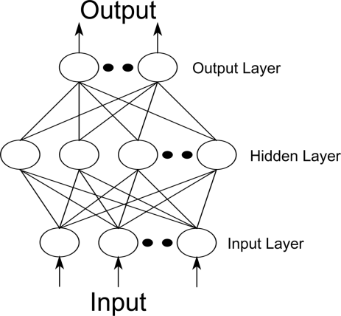
Like the structure in the right, the neural networks I implement in this demo have three layers: input layer, hidden layer and output layer, the size of them are 257, 201 and 10 respectively. The one more node in the input and hidden layer is a bias unit which output +1. In most neural networks, the hidden layer size is set near input size, so I chose 200 here.

4.2 Reason of this structure
As we mentioned above, we have 256 attributes and 10 output dimensions, the one more node in input and hidden layer is bias unit. The size of hidden layer is recommended integer times than input layer size, so I chose 200 here.

Prediction result

accuracy
After running this neural networks on testing data, about 50 iterations, the cost is decreased very slow, the accuracy I got for testing data was around 93% while almost 100% for the training data.

GUI
I also wrote a GUI to demo the result, randomly chose a sample in the dataset, it will show the digit image and calculate the result of my networks. The GUI shows below.
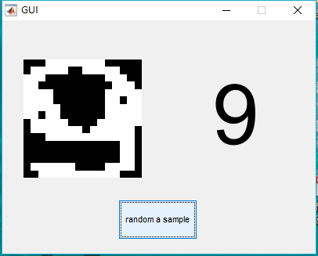

Possible improvements
For this small dataset, I can’t feel the time consumption, the accuracy is good enough now, but when the data comes bigger, it will need some methods to decrease the time. Maybe we can draw some features of these input images, make the input attribute smaller. What else, try different size of hidden layer may help the time consumption.

