Automatica 36 (2000) 1627}1638



非线性系统状态估计的新进展

Magnus N+rgaardª›*\**, Niels K. Poulsenª, Ole Ravnª

ª*Department of Mathematical Modelling, Bldg 321, Technical University of Denmark, 2800 Lyngby, Denmark*

ª*Department of Automation, Bldg. 326, Technical University of Denmark, 2800 Lyngby, Denmark*

Received 17 December 1998; received in "nal form 16 April 2000

*基于插值公式, 可以导出非线性系统的精确状态估计。此估计不需要导数信息, 这使得它们易于实现。*

摘要

基于多维插值公式的多项式逼近，导出了非线性系统的状态估计。结果表明，在一定的假设下，估计的性能优于基于泰勒近似估计。然而，由于不需要求导运算，执行起来明显更简单。因此，认为新的状态估计器可以替代已知的估计器，例如扩展卡尔曼滤波（EKF）及其高阶的变形。

*关键词：* 状态预估；非线性滤波器；插值算法；多变量多项式；扩展卡尔曼滤波器；参数预估

# 简介

当涉及到非线性状态预估时，没有单一的解决方案明显的优于其他策略。随着时间的推移，我们提出了一系列估计器，其中大多数是著名的卡尔曼滤波器的非线性扩展。因此，对于每一个具体的应用，必须基于最佳权衡多种属性例如估计精度、实现的难易程度、数值鲁棒性及计算量等进行选择。到目前为止，扩展卡尔曼滤波器（EKF）(Gelb, Kasper,Nash, Price & Sutherland, 1974; Maybeck, 1982; Lewis,1986)无疑是占统治地位的技术。EKF是基于“估计状态转移方程和量测方程的一阶泰勒逼近”。因此，滤波器的应用取决于假定所需的导数存在并且可以通过合理的方法获得。在许多情况下，泰勒线性化提供了一个不够精确的表达式，和明显的偏差、甚至协方差问题，通常是由于过于错略的近似引起的。一些估计技术可用，比EKF更复杂，例如：re-iteration，高阶滤波器和统计线性化(Gelb et al., 1974; Maybeck, 1982)。更先进的技术通常可以提高估计的准确度, 但它是以进一步复杂化的实现和增加计算负担为代价的。

本文提出了一种新的基于多项式逼近的非线性变换的估计，特别是斯特林插值公式的多维扩展。从概念上讲, 新滤波器的基本原理类似于 ekf 及其高阶变形。然而, 实现是相当不同的。与泰勒公式的对比, 在插值公式中不需要导数, 只有评价函数。这可以很容易地实现滤波器, 并能进行状态估计， 即使有奇异点的导数是未定义的。尽管实现的复杂性比基于泰勒的滤波器要复杂得多，但计算负担通常在大小上是可比的。此外, 在某些假设的估计误差分布, 新的滤波器提供了一个相近的, 甚至是优越的性能。

6This paper was not presented at any IFAC meeting. This paper was recommended for publication in revised form by Associate Editor R.K. Boel under the direction of Editor T. Basar.

*\** Corresponding author. Tel. #45-4525-35659; fax: #45-4588- 1295.

*E-mail address:* [pmn@iau.dtu.dk](mailto:pmn@iau.dtu.dk) (M. N+rgaard).

obtained with a reasonable e!ort. The Taylor lineariz- ation provides an insu$ciently accurate representation in many cases, and signi"cant bias, or even convergence problems, are commonly encountered due to the overly crude approximation. Several estimation techniques are available, which are more sophisticated than the EKF, e.g., re-iteration, higher-order "lters, and statistical lin- earization (Gelb et al., 1974; Maybeck, 1982). The more advanced techniques generally improve estimation accu- racy, but it happens at the expense of a further complica- tion in implementation and an increased computational burden.

In this paper we propose a new set of estimators which are based on polynomial approximations of the nonlin- ear transformations obtained with particular a multi- dimensional extension of Stirling's interpolation formula (Ste!ensen, 1927; FroK berg, 1970). Conceptually, the prin- ciple underlying the new "lters resembles that of the EKF and its higher-order relatives. The implementation is, however, quite di!erent. In contrast to Taylor's formula no derivatives are needed in the interpolation formula, only function evaluations. This accommodates easy im- plementation of the "lters and enables state estimation even when there are singular points in which the deriva- tives are unde"ned. Despite the fact that implementation is less complicated than for "lters based on Taylor

0005-1098/00/$ - see front matter Ø 2000 Elsevier Science Ltd. All rights reserved. PII: S 0 0 0 5 - 1 0 9 8 ( 0 0 ) 0 0 0 8 9 - 3

approximations, the computational burden will typically be comparable in size. Additionally, under certain assumptions on the distribution of the estimation errors, the new "lters provide a similar, or even superior, performance.

Recently, there have been interesting developments in derivative-free state estimation techniques (Julier & Uhl- mann, 1994; Julier, Uhlmann & Durrant-Whyte, 1995; Julier & Uhlmann, 1997; Schei, 1997). It is shown in the following that these "lters occur as special cases of "lters based on the interpolation formula. The "lter described in Schei (1997) corresponds to a suboptimal implementa- tion of the "lter derived using "rst-order approximations while the "lter proposed in Julier and Uhlmann (1994); Julier et al. (1995) has the same a priori state estimate and a related (but less accurate) covariance estimate as the "lter derived using second-order approximations. Due to these relationships we have found it natural to adopt some of the ideas on practical implementation suggested in Schei (1997). Furthermore, the analysis of the "lter performance is inspired by the approach taken in Julier and Uhlmann (1994).

The paper is organized as follows. First we introduce Stirling's interpolation formula and discuss under which circumstances it can provide more accurate approxima- tions than Taylor's formula. A multidimensional exten- sion of the interpolation formula is made, and it is discussed how it can be used for approximation of mean and covariance of stochastic variables generated by non-

A commonly used approximation is obtained by truncat- ing the series after a "nite number of terms. As more terms are included, a locally better approximation is

achieved since the remainder (the sum of higher-order terms) converges as *O*(|*x*!*x*¯ |*’+*¹) (this holds even when *f* is not analytic). The principle of the Taylor series is that

the approximation inherits still more characteristics of the true function in one particular point as the number of terms are increased. However, the assumption that *f* is analytic also implies that any desired accuracy can be achieved in an arbitrary region around the expansion point provided a su$cient number of terms are retained in the series. Nevertheless, it is generally advised to use a truncated series only in the proximity of the expansion point unless the remainder term has been properly analyzed.

Several *interpolation formulas* are available for deriving polynomial approximations that are to be used over an interval. Most of these do not require derivatives but are instead based on a "nite number of evaluations of the function. Usually it is therefore much simpler to derive approximations with these formulas. Several textbooks are available that deal with interpolation (e.g., Dahlquist

& Bjorck, 1974; Ste!ensen, 1927; FroK berg, 1970). In the following we will consider one particular formula, namely *Stirling*'*s* interpolation formula. Let the operators

& and µ perform the following operations (*h* denotes a selected *interval length*)

linear transformation of stochastic variables with known

mean and covariance. Based on the obtained results two

*h*

&*f* (*x*)"*f x*# !*f*

(

*h*

*x*! , (2)

new "lters are proposed. The DD1 "lter is based on "rst- order approximations and the DD2 "lter is based on

new "lters are demonstrated on a benchmark example.

2( (

2) (

*h*) (

2)

*h*))

second-order approximations. The performance of the

Readers only interested in the actual "lter implementa-

µ*f* (*x*)"

*f x*# #*f x*!

2 2

. (3)

tion may choose to skip Sections 2 and 3.

1

# Power series revisited

This section deals with polynomial approximations of arbitrary functions. In particular we will compare ap-

With these operators, Stirling's interpolation formula used around the point *x*"*x*¯ can be expressed as (FroK berg, 1970):

*f* (*x*)"*f* (*x*¯ #*ph*)"*f* (*x*¯ )#*p*µ&*f* (*x*¯ )

*p*\* *p*#1

]

proximations obtained with Taylor's formula, which commonly underlies "lters for nonlinear systems, with approximations obtained with an interpolation formula. Initially, functions of only one variable will be considered

#2! &\**f* (*x*¯ )#[

*p*\*(*p*\*!1)

µ&³*f* (*x*¯ )

3

*p*#2

while later the treatment is extended to multiple dimen- sions.

If the function *f* is analytic we can represent it by its

# 4! &ª*f* (*x*¯ )#[

5 ]µ&‘*f* (*x*¯ )#2. (4)

Taylor series expanded about some point, *x*"*x*

*f* ”(*x*¯ )

In this paper attention is restricted to "rst- and second-

order polynomial approximations. The formula (4) is in this case particularly simple

*f* (*x*)"*f* (*x*¯ )#*f* '(*x*¯ )(*x*!*x*¯ )#

*f* (³)(*x*¯ )

(*x*!*x*¯ )*

2!

*f* ”DD(*x*¯ )

# (*x*!*x*¯ )³#2. (1)

3!

*f* (*x*)+*f* (*x*¯ )#*f* 'DD(*x*¯ )(*x*!*x*¯ )# 2!

(*x*!*x*¯ )*, (5)

24234442342

3535345

where

*f* (*x*¯ #*h*)!*f* (*x*¯ !*h*)

'

By again restricting our attention to second-order poly- nomials we will let the multidimensional interpolation formula take the form

*f* (*x*¯ )" 2*h* ,

DD

*y*+*f* (*x*¯ )#*D*

*f*# 1 *D*I *

*f*. (10)

*f* (*x*¯ #*h*)#*f* (*x*¯ !*h*)!2*f* (*x*¯ )

ª*’* 2! ª*’*

*f* ”DD(*x*¯ )"

*h*\* . (6)

As the divided di!erence operators, *D*

, *D*I * , we will use

*’*

*’*

ª ª

One can be interpret (5) as a Taylor approximation with

1 *’*

ª*’ h*

(

*P P P*)

the derivatives replaced by central divided di!erences. To

assess the accuracy of the approximation it is useful to insert the full Taylor series (1) in place of *f* (*x*¯ #*h*) and

*D f*"

1

*

"

)

*P*"¹

*’*

A*x* µ &

*f* (*x*¯ ), (11)

*f* (*x*¯ !*h*).

*f* ”DD(*x*¯ )

*D*I ª*’*

*f h*\*(

*’*

"¹ "¹

)

*P*"¹

*’*

A*x*\**P* &\**P*

*f* (*x*¯ )#*f* 'DD(*x*¯ )(*x*!*x*¯ )#

(*x*!*x*¯ )*

2!

) ) A*xP* A*xfl* (µ*P*&*P*)(µ*fl*&*fl* ))*f* (*x*¯ ), (12)

*f* ”(*x*¯ )

*P fl*

*fl*\**P*

"*f* (*x*¯ )#*f* '(*x*¯ )(*x*!*x*¯ )#

(*x*!*x*¯ )*

2!

where &*P* has been introduced as the `partiala di!erence operator

#(*f* (³)(*x*¯ )*h*\*# (‘)(*x*¯ )*h*ª#2

)

(*x*!*x*¯ )

& *f* (*x*¯ )"*f*

*x*¯ # *e*

!*f x*¯ ! *e*

(13)

*f*

3! 5!

*h h*

*P* 2 *P* 2 *P*

(

)

(

)

#(*f* (ª)(*x*¯ )*h*\*# (ª)(*x*¯ )*h*ª#2

*f*

(*x*!*x*¯ )*. (7)

and *eP* is the *p*th unit vector. A similar extension was

4! 6! )

The "rst three terms on the right-hand side of (7) are independent of the interval length, *h*, and are recognized as the "rst three terms of the Taylor series expansion of *f*. The `remaindera term given by the di!erence between (7) and the second-order Taylor approximation is controlled by *h* and will in general di!er from the higher-order terms of the Taylor series expansion of *f*. The possibility of controlling the remainder term is what makes the inter- polation formula more attractive than Taylor approxi- mation for certain applications. A sensible choice of interval length can ensure that the remainder term in some sense will be close to the higher-order terms of the full Taylor series.

We will now proceed with the multidimensional case. Let *x* be a vector, *x* 3*R’*, and let *y*"*f* (*x*) be a vector

function. There are di!erent ways in which the interpola- tion formula can be extended to multiple dimensions, but

made to the average operator, µ.

The formula (10) is just one example of a multidimen- sional extension of the interpolation formula. To illus- trate how others can be derived, the following linear transformation of *x* is introduced:

*z*"*S*¯¹*x*, (14)

and the function *f*I is de"ned by

*f*I (*z*)O*f* (*Sz*)"*f* (*x*). (15)

While the Taylor approximation of *f*I is identical to that of *f*, it is obviously not the case that the multidimensional interpolation formula (10) yields the same results for *f* and *f*I . Since

2µ*P*&*P f*I (*z*¯ )"*f*I (*z*¯ #*heP* )!*f*I (*z*¯ !*heP* )

"*f* (*x*¯ #*hsP* )!*f* (*x*¯ !*hsP*), (16)

before addressing this recall "rst that the multidimen-

where *sP* denotes the *p*th column of *S*, *D*

*’ f* and *D*I \**’ f* will

sional Taylor series expansion of *f* about *x*"*x*¯ is given

clearly deviate from *D*

*² f*I and *D*I \**² f*I . ª ª

ª ª

by In the following section we are going to use the inter-

polation formula in a stochastic framework. In this case

* 1 a particularly useful choice of transformation matrix and

*y*"*f* (*x*¯ #A*x*)" ) *?*

*D*

*’*

*?*"º *i*! ª

*f*, (8)

interval length exists.

where the operator description employed by Julier and Uhlmann (1994) has been adopted

*?*

# Approximation of mean and covariance

Let *x* be a vector of stochastic variables for which the

ª*’* (

¹&*x*

*&*x*

&*x* ) |

expectation and covariance are available

*D? f*" A*x*

& #A*x*

¹

& &

#2#A*x’*

* *’*

*f* (*x*)

.

*’*"*’*

(9) *x*¯ "*E*[*x*], *P’*"*E*[(*x*!*x*¯ ) (*x*!*x*¯ )T]. (17)

We would now like to determine

cross-correlations *E*[A*z?*A*z!*]"0, *i*O*j*.

*y*¯ *T*O*E*[ *f* (*x*)], (18)

T

*P’* O*E*[( *f*I (*z*¯ )#*D*I ª*² f*I !*f*I (*z*¯ ))( *f*I (*z*¯ )#*D*

ª*² f*I !*f*I (*z*¯ ))T]

(*P’*)*T*O*E*[( *f* (*x*)!*y*¯ *T*)( *f* (*x*)!*y*¯ *T*)T], (19)

(*P’’*)*T* O*E*[(*x*!*x*¯ )( *f* (*x*)!*y*¯ *T*)T]. (20)

*’*

"*E* )

[(

*P*"¹

*’*

*’*

A*zP*µ*P*&*P f*I (*z*¯ ) )

)(

*P*"¹

A*zP*µ*P*&*P f*I (*z*)) ]

As *f* is nonlinear we cannot rely on being able to calculate the exact expectations. Instead it is customary to insert

"o* )

*P*"¹

(µ*P*&*P f*I (*z*¯ ))(µ*P*&*P f*I (*z*))T

a "rst- or second-order polynomial approximation in place of *f* before taking the expectations. In this section we will focus on estimates of the expectations obtained using the interpolation formula in (10) for approximation of *f*. Additionally, we shall "nd it particularly useful to work with a linear transformation of *x* as described above. The transformation matrix is selected as a square Cholesky factor of the covariance matrix (Schei, 1997):

*z*"*S*¯*’* ¹*x*, *P’*"*S’S*T*’* . (21)

This transformation is sometimes said to perform a *stochastic decoupling* of the variables in *x* as the ele- ments of *z* become mutually uncorrelated (and each with

1 *’*

" ) ( *f*I (*z*¯ #*heP* )!*f*I (*z*¯ !*heP*)) 4*h*\* *P*"¹

✕( *f*I (*z*¯ #*heP*)!*f*I (*z*¯ !*heP* ))T. (25)

We shall denote the *i*th moment of an arbitrary element

in A*z* by o*?*. As all elements are assumed to be equally distributed, their moments are obviously identical. As

discussed above, o*"1. Higher moments depend on the distribution of A*z*.

Recalling that *f*I (*z*¯ $*heP*)"*f* (*x*¯ $*hs’*›*P*), where *s’*›*P* is the *p*th column of the square Cholesky factor of the

covariance matrix *S’*, (25) can also be written

unity variance)

1

*P’*"

*’*

) ( *f* (*x*¯ #*hs’*›*P*)!*f* (*x*¯ !*hs’*›*P*))

*E*[(*z*!*E*[*z*])(*z*!*E*[*z*])T]"*I*. (22)

We shall in the following use a rather wide interpretation of the so-called Cholesky factorization. For any sym- metric matrix product *M*"*SS*T we will refer to *S* as

4*h*\* *P*"¹

✕( *f* (*x*¯ #*hs’*›*P*)!*f* (*x*¯ !*hs’*›*P*))T. (26)

An estimate of the cross-covariance matrix can be de- rived along the same lines

a *Cholesky factor*. Thus, the Cholesky factor need not be

square and triangular. However, most often a triangular

*P’’*O*E*[(*x*!*x*¯ )( *f*I (*z*¯ )#*D*

ª*² f*I !*f*I (*z*¯ ))T]

Cholesky factor is considered as computationally e$- cient methods are available for performing such factoriz-

"*E*[(*S’* A*z*)(*D*

*’*

[

ª*²f*I )T]

*’* T

(

ations.

In the following subsections we work with *f*I (*z*) directly as this is most convenient. A few assumptions on *f*I and

"*E* )

*P*"¹

[

*’*

*s’*›*P*A*zP* )

*P*"¹

A*zP* µ*P*&*P f*I (*z*)) ]

*z* will be invoked. *f*I must in principle be de"ned for all

*z*3*R’* and the elements of A*z*"*z*!*E*[A*z*] are assumed

"o* )

*P*"¹

*s’*›*P*(µ*P* &*P f*I (*z*))T]

to belong to the same (zero mean) distribution. In Section

3.2 it is additionally assumed that A*z* is Gaussian.

* 1. *A* x*rst-order approximation*

1 *’*

" ) *s’*›*P*( *f*I (*z*¯ #*heP*)!*f*I (*z*¯ !*heP* ))T, (27) 2*h P*"¹

which we can also write

First estimates of mean and covariance will be de- rived by replacing the function *f*I by a "rst-order appro-

1

*P’’*" *h*

2

*’*

)

*P*"¹

*s’*›*P*( *f* (*x*¯ # *hs’*›*P*)!*f* (*x*¯ ! *hs’*›*P*))T. (28)

ximation

*y*"*f*I (*z*¯ #A*z*)+*f*I (*z*¯ )#*D*I ª*² f*I . (23) As the expectation *E*[A*z*]"0 by de"nition, the expec-

tation of (23) is

It is not clear from the derivations how the interval

length, *h*, should be selected. The mean estimate is inde- pendent of the parameter while it has an obvious impact on the estimate of the covariance matrices. In N+rgaard, Poulsen and Ravn (2000), which contains analysis of the estimates, it is shown that the optimal setting of *h* is

*y*¯ O*E*[ *f*I (*z*¯ )#*D*

ª*² f*I ]"*f*I (*z*¯ )"*f* (*x*¯ ). (24)

dictated by the distribution of A*z*. It turns out that

*h*\* should equal the kurtosis of the distribution, *h*\*"oª.

An estimate of the covariance (19) is derived along the

same lines. As before, the "rst-order moments can be neglected since A*z* is zero mean. Moreover, the cross- terms evaluate to zero as *z* has been generated so that the

This choice is motivated by a comparison between a

Taylor expansion of the true mean and covariance and of

the estimated quantities. When *h*\*"oª, these series match well. For a Gaussian distribution oª"3o*"3.

* 1. *A second-order approximation*

More accurate estimates of mean and covariance of *f*I can be obtained with a limited extra e!ort by approxi- mating the function with a second-order polynomial de- rived with the interpolation formula

The second step was taken by using the fact that all odd-order moments cancel as the elements of A*z* are independent and the distribution is symmetric. The "rst term in (33) is recognized as the covariance based on a "rst-order approximation of *f*I and has already been dealt with. Let us instead take a closer look at the two remaining terms:

*y*+*f*I (*z*¯ )#*D*

*f*I #~~¹~~*D*I * *f*

ª*²* * ª*²*

1 *’*

*E*[*D*I *

ª

*²*

*f*I (*D*I *

ª

*²*

*f*I )T] is composed of three kinds of terms

"*f*I (*z*¯ ) *h*(

#

)

*P*"¹

A*zP*µ*P*&*P* )

*f*I (*z*¯ )

*E*[(A*z*\*&\**f*I ) (A*z*\*&* *f*I )T]"(&* *f*I ) (&* *f*I )To

, (34)

*? ? ? ?*

1 *’*

#

*? ?* ª

2*h*\*( )

*P*"¹

A*z*\**P*&\**P*

*E*[(A*z*\**?* &\**? f*I ) (A*z*\**!* &\**! f*I )T]"(&\**? f*I ) (&\**! f*I )To*, (35)

*’ ’ E*[(A*z* A*z* µ & µ &

*

"¹ "¹

*f*I )(A*z* A*z* µ & µ &

*f*I )T]

# ) )

A*zP*A*zfl*(µ*P*&*P*) (µ*fl*&*fl*))*f*I (*z*¯ ). (29)

*? ! ? ? ! !*

*? ! ? ? ! !*

*P fl*

*fl*\**P*

In order to obtain useful results the assumptions about

"(µ*?*&*?* µ*!*&*! f*I )(µ*?*&*?* µ*!*&*! f*I )To*. (36)

A*z* will now be slightly more restrictive as we demand

*E*[*D*I * *f*I ]*E*[*D*I *

*f*I ]T is composed of two kinds of terms

that it is Gaussian. Since A*z* is zero mean, and the elements are uncorrelated, the Gaussian assumption im- plies that the elements are independent and the distribu- tion is symmetric. The assumption is not needed for derivation of the mean estimate, but it is important when deriving the new covariance estimate.

By employing the approximation (29) the expectation of *f*I is estimated by

ª*²* ª*²*

*E*[A*z*\**?* &*? f*I ]*E*[A*z*\**?* &*? f*I ]T"(&\**? f*I ) (&\**? f*I )To*, (37)

*

*E*[A*z*\**?* &*? f*I ]*E*[A*z*\**!* &*! f*I ]T"(&\**? f*I ) (&\**! f*I )To*. (38) All of the above terms appear for ∀*i*,∀*j*, *i*O*j*.

*

The terms in (35) and (38) are identical and cancel

when subtracted. Additionally, we will discard the terms

containing cross-di!erences (36). This is done because

2(

1 *’*

)

*P*"¹

A*z*\**P*&\**P* )*f*I (*z*¯ )]

inclusion leads to an excessive increase in the number of computations as the number of such terms grows rapidly with the dimension of *z* and because four additional

"*f*I (*z*¯ ) o* *’*

#

)

&\**P f*I (*z*¯ )

evaluations of *f* are required for each element of *z*. The

*h*\*!*n*

"

2 *P*"¹

1

*f*I (*z*¯ )#

*’*

) ( *f*I (*z*¯ #*heP*)#*f*I (*z*¯ !*heP* )) (30)

reason for not considering the extra e!ort worthwhile is that we are unable to capture all fourth moments, any- way. This would require that *f* was approximated by

*h*\* 2*h*\**P*"¹

a third-order polynomial (this is further discussed in

*h*\*!*n*

"

1

*f* (*x*¯ )#

*’*

) *f* (*x*¯ #*hs’*›*P*)#*f* (*x*¯ !*hs’*›*P*). (31)

N+rgaard et al., 2000).

Thus, we arrive at the following covariance estimate:

*h*\* 2*h*\* *P*"¹

*’*

We will now proceed with a derivation of a covariance

estimate. First we observe that

*P’*"o* )

*P*"¹

(µ*P* &*P f*I (*z*¯ ))(µ*P* &*P f*I (*z*))T

(*P’*)*T*"*E*[(*y*!*y*¯ )(*y*!*y*¯ )T]

oª!o* *’*

"*E*[(*y*!*f*I (*z*¯ ))(*y*!*f*I (*z*¯ ))T]!*E*[*y*!*f*I (*z*¯ )]*E*[*y*!*f*I (*z*¯ )]T.

(32)

#

4

" o* *’*

* )

*P*"¹

(&\**P f*I (*z*¯ ))(&\**P f*I (*z*))T

The estimate can therefore be written

4*h*\* )

"¹

*P*

( *f*I (*z*¯ #*heP*)!*f*I (*z*¯ !*heP*))

*P’*O*E*[(*D*

*f*I #~~¹~~*D*I *

*f*I ) (*D*

*f*I #~~¹~~*D*I *

*f*I )T]

✕( *f*I (*z*¯ #*heP*)!*f*I (*z*¯ !*heP*))T

ª*²* * ª*²*

ª*²* * ª*²*

!*E*[*D*

*f*I #~~¹~~*D*I *

*f*I ]*E*[*D*

*f*I #~~¹~~*D*I *

*f*I ]T

oª!o* *’*

ª*²* * ª*²*

ª*²* * ª*²*

# * )

( *f*I (*z*¯ #*he* )#*f*I (*z*¯ !*he* )!2*f*I (*z*¯ ))

"*E*[*D*

*f*I (*D*

*f*I )T]#~~¹~~*E*[*D*I *

*f*I (*D*I *

*f*I )T]

4*h*ª

*P P*

*P*"¹

ª*²* ª*²*

ª ª*²* ª*²*

!~~¹~~*E*[*D*I *

*f*I ]*E*[*D*I *

*f*I ]T. (33)

✕( *f*I (*z*¯ #*he* )#*f*I (*z*¯ !*he* )!2*f*I (*z*¯ ))T. (39)

ª ª*²* ª*² P P*

*

Inserting that o*"1 and setting *h*\*"oª ("3 for a Gaussian distribution) gives

*’*

* 1. *Review of state estimation for nonlinear systems*

Consider the following general nonlinear model of

*P’*" ~~¹~~ )

ª*’*\*

[ *f* (*x*¯ #*hs*

*’*›*P*

)!*f* (*x*¯ !*hs’*›*P*)]

a dynamic system whose states are to be estimated

*P*"¹

✕[ *f* (*x*¯ #*hs’*›*P*)!*f* (*x*¯ !*hs’*›*P*)]T

*x’+*¹"*f* (*x’*, *u’* , *v’* ), (43)

*y* "*g*(*x* , *w* ). (44)

*’ ’ ’*

*’*

#*’*\*¯¹ )

ª*’*ª

*P*"¹

[ *f* (*x*¯ #*hs’*›*P*

)#*f* (*x*¯ !*hs’*›*P*

)!2*f* (*x*¯ )]

*v’* and *w’* are assumed i.i.d. and independent of current and past states, *v’*&(*v*¯ *’*, *Q*(*k*)), *w’*&(*w*¯ *’*, *R*(*k*)).

The state estimation principle commonly used for

✕[ *f* (*x*¯ #*hs’*›*P*)#*f* (*x*¯ !*hs’*›*P*)!2*f* (*x*¯ )]T. (40)

As

oª!o*"*E*[A*z*ª]!*E*[A*z*\*]*"<*ar*[A*z*\*]'0, (41)

*

oª5o* for all probability distributions. Therefore, we should always select *h*\*51. Obviously, this implies that

*

the covariance estimate will always be positive semide"nite. It is interesting to note that the second- order estimate does not require additional evaluations of

*f* compared to the covariance estimate based on the

nonlinear systems is brie#y outlined in the following. Detailed treatments of the topic can be found in Lewis (1986), Gelb et al. (1974) and Maybeck (1982). Ideally, we would like to determine the a priori state and covariance estimates (i.e., estimates in-between measurements) like in the Kalman "lter. That is, as the conditional expectations

*x*¯ *’*"*E*[*x’* |>*’*¯¹], (45)

*P*M (*k*)"*E*[(*x’* !*x*¯ *’*) (*x’*!*x*¯ *’*)T|>*’*¯¹], (46)

where >*’*¯¹ is a matrix containing the past measure-

º

*y*

"rst-order approximation. The extra computations are

ments >*’*¯¹"[ *y*

¹ 2 *y’*¯¹

]T.

entirely due to the second sum in (40).

The cross-covariance estimate, *P’’*, turns out to be the same as when the "rst-order approximation is employed

(28)

The a posteriori updating of the state estimate (i.e.,

estimate at a measurement) is usually restricted to be linear in the measurements for convenience. By selecting the update so that the (conditional) covariance of the estimation error is minimized, we obtain the following

*P’’*O*E*[(*S’*A*z*) (*D*

*f*I #~~¹~~*D*I *

*f*I )T]

(Lewis, 1986):

ª*²*

"*E*[(*S’*A*z*)(*D*

* ª*²*

*f*I )T]

*K* "*P*

(*k*)*P*¯¹(*k*), (47)

ª*² ’*

*’’ ’*

" 1 *’ x*( *’*"*x*¯ *’*#*K’*[*y’* !*y*¯ *’*], (48)

2*h* )

*P*

"¹

*s’*›*P*( *f* (*x*¯ #*hs’*›*P*)!*f* (*x*¯ !*hs’*›*P*))T. (42)

where

*y*¯ *’*"*E*[*y’*|>*’*¯¹], (49)

# State estimation for nonlinear systems

We have now arrived at the central issue of this paper, namely state estimation for nonlinear systems. Two new "lters will be suggested that are based on the previously derived polynomial approximations. The "lters are fun- damentally di!erent from "lters based on Taylor approx- imations in that the polynomial approximations underlying the new "lters take into account the uncer- tainty on the state estimate. The Taylor approximation underlying conventional "lter designs for nonlinear sys- tems, such as the EKF, depends only on the current state estimate. Additionally, the new "lters can generally be implemented more easily as no derivatives are required. The "rst "lter we derive is based on "rst-order poly- nomial approximations. This estimator is an improved version of the "lter presented in Schei (1997). Sub- sequently a more accurate "lter will be derived, which includes second-order terms. It turns out that this "lter has notable similarities with the *unscented* "lter described

in Julier and Uhlmann (1994) and Julier et al. (1995).

*P’’*(*k*)"*E*[(*x’* !*x*¯ *’*) (*y’*!*y*¯ *’*)T|>*’*¯¹], (50)

*P’*(*k*)"*E*[(*y’*!*y*¯ *’*) (*y’*!*y*¯ *’*)T|>*’*¯¹]. (51)

The corresponding update of the covariance matrix is

*P*K (*k*)"*E*[(*x’* !*x*( *’*)(*x’* !*x*( *’*)T|>*’*]"*P*M (*k*)!*K’P’’*(*k*)*K*T*’* .

(52)

As the various expectations in general are intractable, some kind of approximation is commonly used. E.g., it is well-known that the extended Kalman "lter is based on Taylor linearization of state transition and output equations (43), (44).

In the following subsections we will pursue the use of approximations obtained with the interpolation formula for derivation of state estimators for nonlinear systems.

* 1. *The DD1* x*lter*

In this section a generalized version of the nonlinear state estimation scheme suggested in Schei (1997) will be

described. The "lter is derived using the "rst-order ap- proximation presented in Section 3.1. Conceptually the "lter is much like the extended Kalman "lter. The di!er- ence is that matrices of divided di!erences replace matrix products of Jacobians and Cholesky factors of covariance matrices (Schei, 1997). The state update is therefore the same as in the EKF. The di!erence is alone found in the update of the various covariance matrices, which generally can be implemented more easily. We will use an approach much like the one suggested in Schei (1997). One of the particularly useful ideas provided in Schei (1997) is to directly update the Cholesky factors of the covariance matrices.

First we will introduce the following four square Cho- lesky factorizations

Introducing the vector *z* by stochastical decoupling of *x*y , *x*y "*S’*y *z*, it is not di$cult to see how the state estimation problem can be mapped into the treatment of the general

vector function *f*I (*z*) presented in Section 3.

For the a priori update of the state estimate we will use (24):

*x*¯ *’+*¹+*f*I (*z*¯ *’*)"*f* (*x*( *’*, *u’*, *v*¯ *’*). (57) which is the same as for the EKF.

As the basis of the covariance update we shall use (26). By application of the matrices de"ned in (54) the update can obviously be expressed as the following symmetric matrix product:

*P*M (*k*#1)"[*S*(*’*¹*’*( )(*k*) *S*(*’*¹*‘*)(*k*)][*S*(*’*¹*’*( )(*k*) *S*(*’*¹*‘*)(*k*)]T

(*’*¹*’*)(*k*) (*S*(*’*¹*’*)(*k*))T#*S*(*’*¹*‘*)(*k*) (*S*(*’*¹*‘*)(*k*))T. (58)

*Q*"*S‘S*T*‘* , *R*"*S* S*T*\**,

"*S*

(53)

*P*M "*S*M *’S*M T*’*, *P*K "*S*K *’ S*K T*’*.

The factorization of the noise covariance matrices *Q*, *R* can usually be made in advance. *S*M *’* and *S*K *’* are updated

directly during application of the "lter.

Let the *j*th column of *S*M *’* be denoted *s*¯ *’*›*!* and similarly for the other factors. Four matrices containing divided

di!erences are now de"ned by

*S*(*’*¹*’*( )(*k*)"{*S*(*’*¹*’*( )(*k*)(*?*›*!*)}"{( *f?*(*x*( *’* #*hs*( *’*›*!*, *u’*,*v*¯ *’*)

!*f?* (*x*( *’* !*hs*( *’*›*!*, *u’*,*v*¯ *’*))/2*h*},

*S*(*’*¹*‘*)(*k*)"{*S*(*’*¹*‘*)(*k*)(*?*›*!*)}"{( *f?*(*x*( *’*, *u’*,*v*¯ *’*#*hs‘*›*!*)

!*f?* (*x*( *’* , *u’*,*v*¯ *’* !*hs‘*›*!*))/2*h*},

*S*(*’*¹*’*¯ )(*k*)"{*S*(*’*¹*’*¯ )(*k*)(*?*›*!*)}"{(*g?*(*x*¯ *’* #*hs*¯ *’*›*!*,*w*¯ *’*)

!*g?*(*x*¯ *’*!*hs*¯ *’*›*!*,*w*¯ *’* ))/2*h*},

*S*(*’*¹*\**)(*k*)"{*S*(*’*¹*\**)(*k*)(*?*›*!*)}"{(*g?*(*x*¯ *’*,*w*¯ *’*#*hs\**›*!*)

!*g?*(*x*¯ *’*,*w*¯ *’* !*hs\**›*!*))/2*h*}. (54) The selection of interval length, *h*, was brie#y discussed in Section 3.2. More insights can be found in N+rgaard et al. (2000). Assuming that the estimation errors are Gaussian and unbiased, one should set *h*\*"3.

* + 1. *The a priori update*

To understand how the results from Section 3 can be applied in a state estimation context it is useful to think o! an *augmented state vector* consisting of state vector and process (or measurement) noise:

Due to the assumed independence of *v’* and *x’* , the update can be written as a sum of two matrix products.

It is well-known that a straightforward `text-booka implementation of the (extended) Kalman "lter results in numerical problems after a number of iterations as the e!ect of round-o! errors accumulate, thus making the covariance matrix asymmetric and non-positive de"nite. The usual remedy for this is to use a factored update. As the covariance update (58) is a sum of two quadratic terms, numerical problems of this kind should not occur with this update. Nevertheless, it is tempting to use a factored update anyway since the factor will be needed for the a posteriori update. Moreover, the (rectangular, nontriangular) Cholesky factor is immediately available as the following compound matrix:

*S*M *’*(*k*#1)"[*S*(*’*¹*’*( )(*k*) *S*(*’*¹*‘*)(*k*)]. (59)

For later use, the matrix must be transformed to a square Cholesky factor. This can be achieved through House- holder triangularization (Press, Flannery, Tevkolsky & Vetterling, 1988; Grewal & Andrews, 1993; Golub & van Loan, 1989).

* + 1. *The a posteriori update*

The a priori estimate of output and covariance matrix for the *output* estimation error is derived in a similar fashion. The output estimate is given by

*y*¯ *’*"*g*(*x*¯ *’*, *w*¯ *’*) (60)

and the compound matrix

*x*y "[*x*¯y #A*x*y ]"[*x*( #A*x*

. (55)

*S’*(*k*)"[*S*(*’*¹*’*¯ )(*k*) *S*(*’*¹*\**)(*k*)] (61)

*v*¯ #A*v* ]

As the process noise is assumed to be independent of the state, the (conditional) covariance of A*x*y is

is a Cholesky factor of the covariance of the output estimation error,

*P’*(*k*)"*S’*(*k*)*S’*(*k*)T. (62)

*P*K 0

*S*K *’* 0

*S*K *’* 0 T

As for *S*M *’*, *S’*(*k*) should be transformed to a quadratic

*P*K *’*y "[0 *Q*]"[0 *S* ][0 *S* ]

"*S*K *’*y *S*K T*’*y . (56)

matrix by Householder triangularization.

*‘ ‘*

For approximation of the cross-covariance of state and output estimation error we will use the result in (28)

*P’’*(*k*)"*S*M *’* (*k*) (*S*(*’*¹*’*¯ )(*k*))T. (63)

The Kalman gain can now be calculated according to (47)

*K’* "*P’’*(*k*)[*S’*(*k*)*S’* (*k*)T]¯¹. (64)

* 1. *The DD2* x*lter*

The DD2 "lter is obtained by using the estimates of mean and covariance derived in Section 3.2. First we shall de"ne four additional matrices containing divided di!erences

{*h*\*!1

and the state vector is updated according to (48)

*S*(*’*\**’*( )(*k*)"{

2*h*\*

(*f?*(*x*( *’* #*hs*( *’*›*!*, *u’*, *v*¯ *’*)

*x*( *’*"*x*¯ *’*#*K’*(*y’*!*y*¯ *’* ). (65)

The factorization of *P’* has deliberately been maintained

#*f?* (*x*( *’* !*hs*( *’*›*!*, *u’*,*v*¯ *’*)!2*f?*(*x*( *’* , *u’* , *v*¯ *’*))},

*h*\*!1

in (64) because it is useful in the practical computation of the gain. Since *S’* is triangular the equation

*S*(*’*\**‘*)(*k*)"{{

2*h*\*

( *f?*(*x*( *’*, *u’*, *v*¯ *’*#*hs‘*›*!*)

[*S’*(*k*)*S’*(*k*)T]*K’*"*P’’*(*k*) is easily solved using only

forward and back substitutions.

#*f?* (*x*( *’* , *u’*, *v*¯ *’*!*hs‘*›*!*)!2*f?* (*x*( *’*, *u’*, *v*¯ *’*))},

{*h*\*!1

The a posteriori covariance can be updated according to (52). However, as suggested in Schei (1997) one can

*S*(*’*\**’*¯ )(*k*)"{

2*h*\* (*g?*(*x*¯ *’*#*hs*¯ *’*›*!*, *w*¯ *’*)

also in this case update its Cholesky factor directly. As the following expressions are identical

#*g?*(*x*¯ *’*!*hs*¯ *’*›*!*, *w*¯ *’*)!2*g?* (*x*¯ *’* , *w*¯ *’*))},

*h*\*!1

*KP’K*T"*S*M *’*(*S*(*’*¹*’*))T*K*T

*S*(*’*\**\**)(*k*)"{{

2*h*\*

(*g?*(*x*¯ *’*,*w*¯ *’*#*hs\**›*!*)

"*KS*(*’*¹*’*)*S*T*’*

#*g* (*x* ,*w* !*hs*

)!2*g* (*x* ,*w* )) .

"*KS*(*’*¹*’*) (*S*(*’*¹*’*))T*K*T#*KS*(*’*¹*\**) (*S*(*’*¹*\**))T*K*T

*? ’ ’*

*\**›*!*

*? ’ ’* }

the a posteriori update can clearly be rewritten as

*P*K "*P*M !*KP’K*T

"*P*M !*KP’K*T!*KP’ K*T#*KP’ K*T

* 1. *The a priori update*

Proceeding as for the DD1 "lter, we can obtain an improved state estimate by using (31)

*h*\*!*n’* !*n‘*

"*S*M *’S*M T*’*!*S*M *’* (*S*(*’*¹*’*))T*K*T!*KS*(*’*¹*’*)*S*T*’*

#*KS*(*’*¹*’*)(*S*(*’*¹*’*))T*K*T#*KS*(*’*¹*\**)(*S*(*’*¹*\**))T*K*T

*x*¯ *’+*¹"

*h*\* *f* (*x*( *’*, *u’*, *v*¯ *’*) *’’*

"(*S*M *’*!*KS*(*’*¹*’*)) (*S*M *’*!*KS*(*’*¹*’*))T#*KS*(*’*¹*\**)(*KS*(*’*¹*\**))T (66)

implying that a square Cholesky factor of the covariance

# 1 )

2*h*\* *P*"¹

*f* (*x*

*’* #*hs*

*’*›*P*

, *u’*, *v’* )

matrix can be obtained by triangularization of the compound matrix

#

#*f* (*x*( *’*!*hs*( *’*›*P*, *u’*, *v*¯ *’*)

1 *’‘*

)

*f* (*x*( *’* , *u’*, *v*¯ *’*#*hs‘*›*P*)

*S*K *’*(*k*)"[*S*M *’*(*k*)!*K’S*(*’*¹*’*¯ )(*k*) *K’S*(*’*¹*\**)(*k*)]. (67)

The "lter equations are summarized in Table 1.

2*h*\* *P*"¹

# *f* (*x*( *’*, *u’*, *v*¯ *’*!*hs‘*›*P*), (68)

Table 1

Summary of "lter equations

Action DD1 "lter DD2 "lter

Initialization *x*¯ º, *S*M *’*(0) *x*N º, *S*M *’*(0)

*Divided di*+*erences S’*(¹*’*¯ ), *S*(*’*¹*\**)

*S’*(¹*’*¯ ), *S*(*’*¹*\**), *S’*(\**’*¯ ), *S*(*’*\**\**)

Output estimate *y*¯ *’* (60) (70)

Output covariance *S’*(*k*) Triangularize (61) Triangularize (71)

Cross-covariance *P’’*, Kalman gain *K’* (63), (64) (63), (64)

A posteriori states *x*( *’* (65) (65)

A posteriori covariance *S*K *’*(*k*) Triangularize (67) Triangularize (76)

Divided di!erences *S’*(¹*’*( ), *S*(*’*¹*‘*)

*S’*(¹*’*( ), *S*(*’*¹*‘*), *S’*(\**’*( ), *S’*(\**‘*)

A priori states *x*¯ *’+*¹ (57) (68)

A priori covariance *S*M *’*(*k*#1) Triangularize (59) Triangularize (69)

where *n’* denotes the dimension of the state vector and

A posteriori update of state vector

*n‘* denotes the dimension of process noise vector. It turns

*x* "*x*

#*K* (*y* !*y*

). (74)

out that this estimate of the mean is identical to the one proposed in Julier and Uhlmann (1994) and Julier et al. (1995). This is interesting as the approach used in these papers is quite di!erent from the one used here. The expression (68) is obviously more complex than the a priori state estimate used in the DD1 "lter (57). How- ever, it is important to note that no additional evalu- ations of *f* are required in comparison to the DD1 "lter. The values of *f* are the same as those used in the covariance estimate of the DD1 "lter.

In agreement with the covariance estimate in (26), a triangular Cholesky factor of the a priori covariance is obtained by Householder transformation of the follow- ing compound matrix

*S*M *’*(*k*#1)"[*S*(*’*¹*’*( )(*k*) *S*(*’*¹*‘*)(*k*) *S*(*’*\**’*( )(*k*) *S*(*’*\**‘*)(*k*)]. (69)

The covariance estimate corresponding to the symmetric matrix product *P*M "*S*M *’S*M T*’* is *not* the same as the one derived in Julier and Uhlmann (1994) and Julier et al.

(1995). In N+rgaard et al. (2000) it is shown how the covariance estimate of Julier & Uhlmann (1994) (which generally is less accurate than the one presented here) can be derived in a similar fashion as (69).

* 1. *The a posteriori update*

The a priori estimate of the output and its covariance is calculated in a similar fashion as for the states

*h*\*!*n’*!*n\**

*’ ’ ’ ’ ’*

The a posteriori update of the estimation error covariance has a few additional terms. Following the derivations in (66) we can write the covariance matrix

*P*K "(*S*M *’*!*KS*(*’*¹*’*)) (*S*M *’*!*KS*(*’*¹*’*))T#*KS*(*’*¹*\**)(*KS*(*’*¹*\**))T

# *KS*(*’*\**’*)(*KS*(*’*\**’*))T#*KS*(*’*\**\**)(*KS*(*’*\**\**))T (75)

which obviously has the Cholesky factor

*S*K *’*(*k*)"

[*S*M *’*(*k*)!*K’S*(*’*¹*’*)(*k*) *K’S*(*’*¹*\**)(*k*) *K’S*(*’*\**’*)(*k*) *K’S*(*’*\**\**)(*k*)].

(76)

The "lter equations are summarized in Table 1.

# Example

To demonstrate the performance of the new "lters they will be evaluated in this section on the vertically falling body example originating from Athans, Wishner and Bertolini (1968). The set-up, which is depicted in Fig. 1, is brie#y described below. The reader is referred to Athans et al. (1968) for a more detailed introduction to the problem. Several "lter designs have been evaluated on this example. In addition to Athans et al. (1968) see for example also Maybeck (1982) and Julier and Uhlmann (1994). The new "lters will be compared with the EKF and the (modi"ed Gaussian) second-order "lter, which

*y*¯ *’*"

# 1

*h*\* *g*(*x*¯ *’*, *w*¯ *’*)

*’’*

have both been implemented as described in Athans et al.

(1968).

The objective of the "lter is to estimate the altitude

2*h*\* )

*P*

"¹

*g*(*x*¯ *’* #*hs*¯ *’*›*P*, *w*¯ *’* )#*g*(*x*¯ *’*!*hs*¯ *’*›*P*, *w*¯ *’*)

*x* ), the downward velocity (*x*

), and a (constant) ballis-

tic parameter (*x*

(

*

³

¹

) of a vertically falling body. The fall of

1 *’\**

#

the body can be described by the two di!erential equa-

2*h*\* )

*g*(*x*¯ *’* , *w*¯ *’*#*hs\**›*P*)#*g*(*x*¯ *’*, *w*¯ *’*!*hs\**›*P*) (70)

tions (77) and (78). *x*

represents a ballistic coe$cient

and

*P*"¹

which we assume

³

unknown

and therefore wish to esti-

*S’*(*k*)"[*S*(*’*¹*’*¯ )(*k*) *S*(*’*¹*\**)(*k*) *S*(*’*\**’*¯ )(*k*) *S*(*’*\**\**)(*k*)], (71)

where *n\** is the dimension of the measurement noise vector.

It follows from the discussion in Section 3.2 and (42) that the a priori cross-covariance matrix is the same as for the DD1 "lter (63):

*P’’*(*k*)"*S*M *’* (*k*)*S’’*¯ (*k*)T. (72)

Kalman gain and a posteriori update of the state is carried out exactly as for the DD1 "lter:

*Kalman gain*:

*K’* "*P’’*(*k*)[*S’*(*k*)*S’* (*k*)T]¯¹. (73)

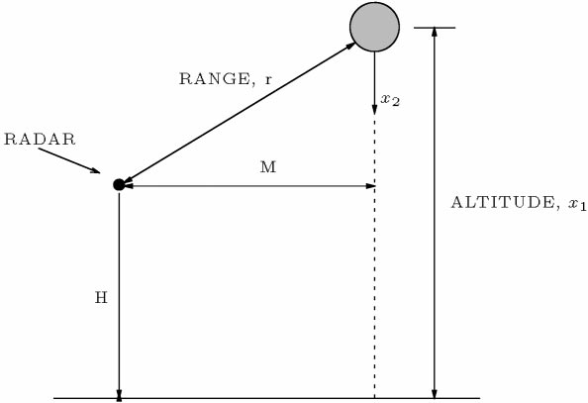

Fig. 1. Geometry of the vertically falling body problem.

mate simultaneously with the altitude and velocity of the body. The radar measures the range (*r*). The measure- ments appear with intervals of 1 second and are a!ected by additive white Gaussian noise.

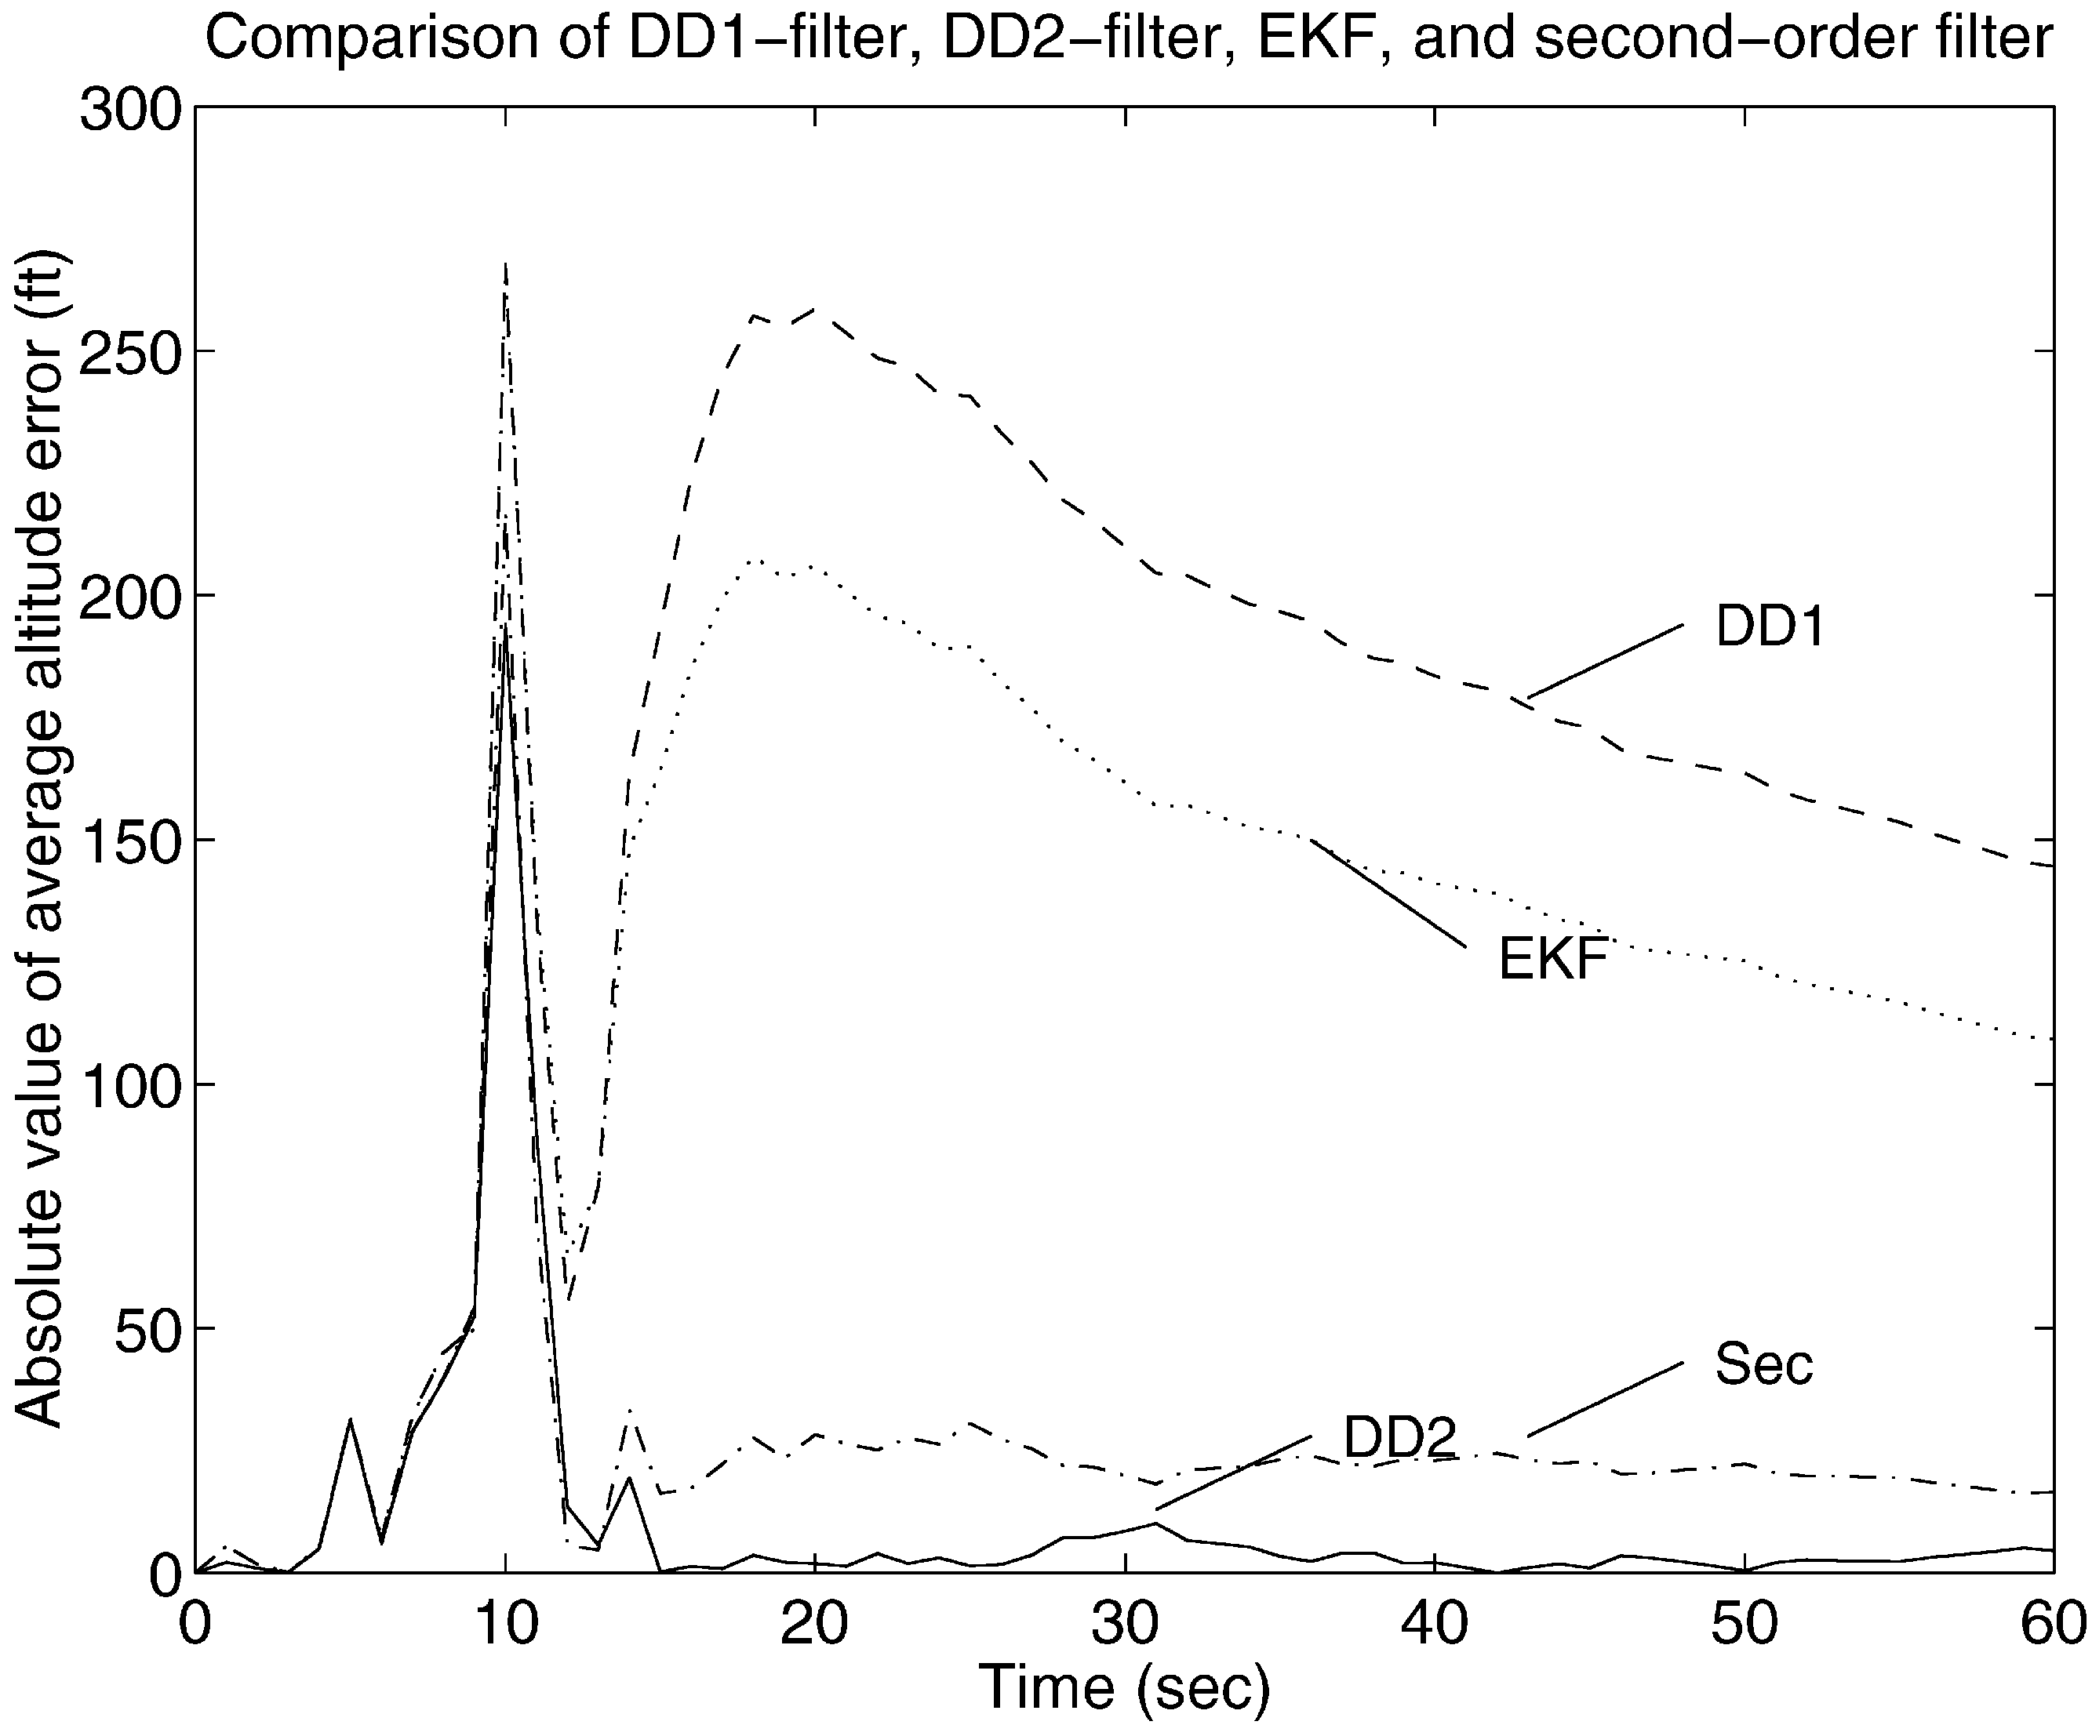

The model is the following:

*x*˙ ¹(*t*)"!*x*\* (*t*), (77)

*x*˙ *(*t*)"!e¯‘*’*¹ (*’*)*x*\*(*t*)\**x*³ (*t*), (78)

*x*³(*t*)"0, (79)

*y’*"*r’*#*w’*"{*M*\*#(*x*

¹›*’*

!*H*)*#*w’*. (80)

The model parameters are given by

*M*"100,000 ft,

*H*"100,000 ft,

y"5✕10¯‘,

*E*[*w*\**’* ]"10ª ft* (81)

and the initial state of the system is

Fig. 2. Absolute error in position estimate (50 run average).

*x*

¹›º

*x*

*›º

*x*

³›º

"300,000 ft,

"20,000 ft/s,

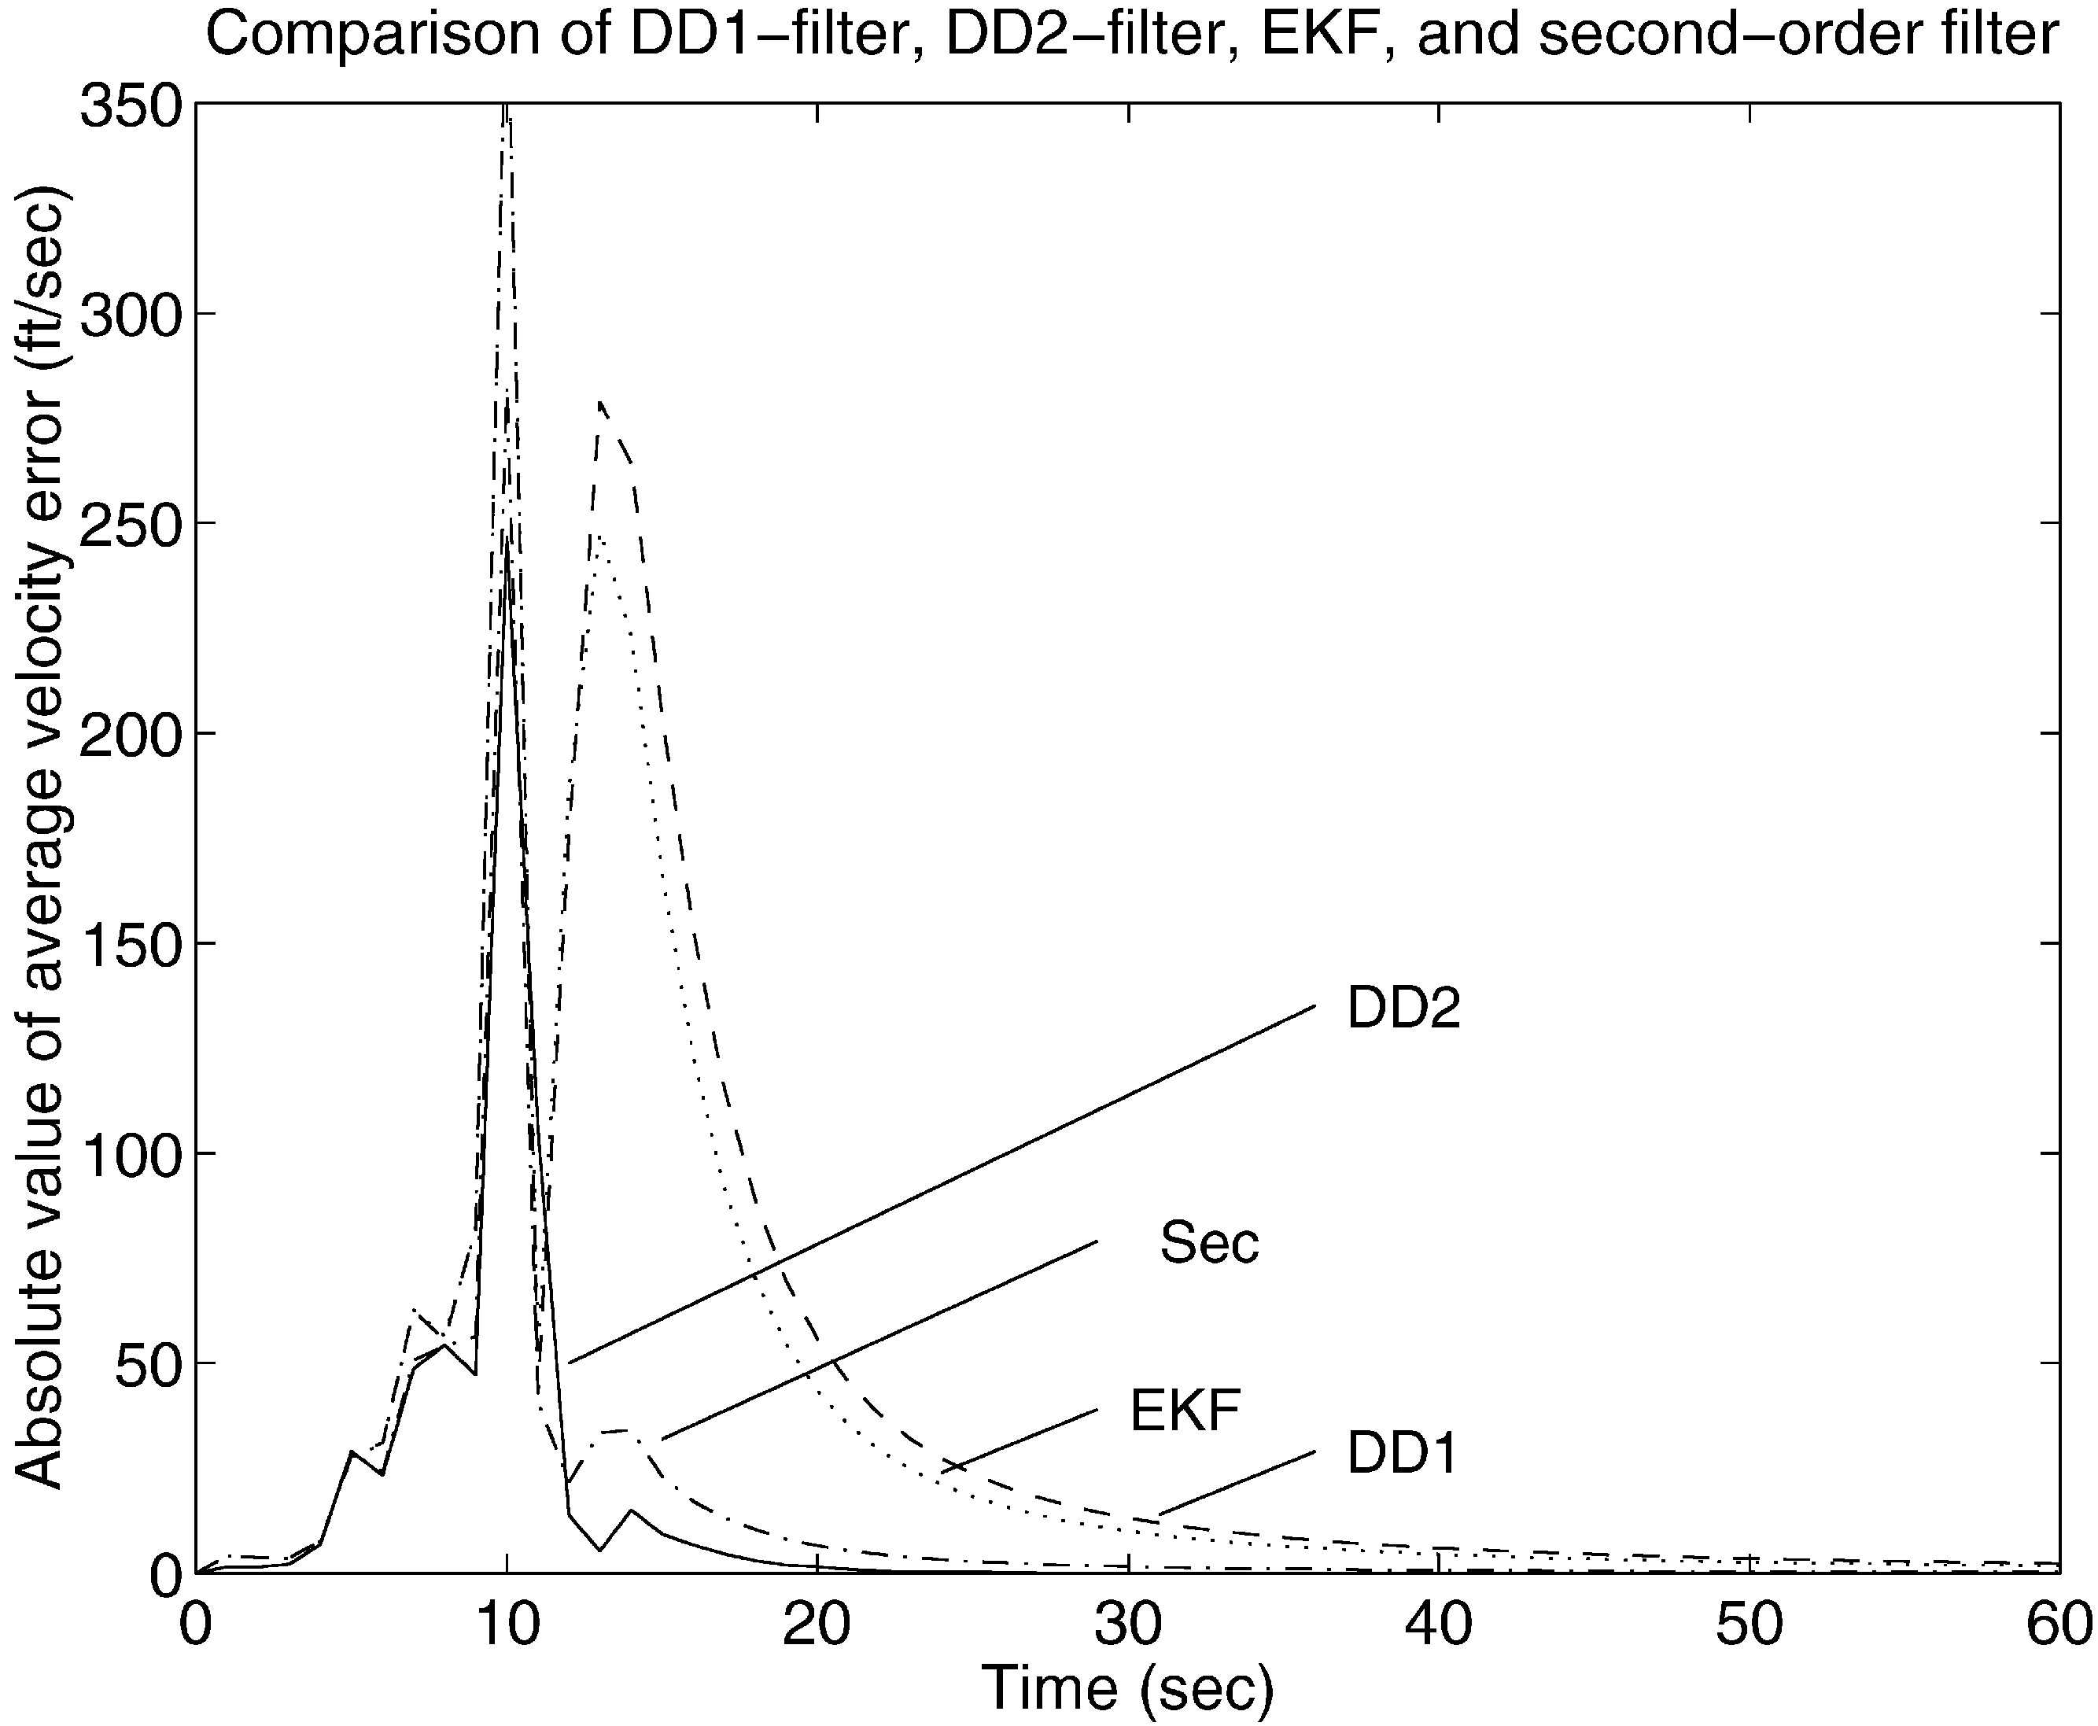

"10¯³. (82)

Due to the nature of the problem it is common practice to employ a continuous-discrete "lter implementation. The state equations (77)}(79) are integrated using a fourth-order Runge}Kutta method with 64 steps taken between each observation. It is straightforward to imple- ment continuous-discrete versions of the DD1 and DD2 "lters as there is no process noise. In Athans et al. (1968) the implementation of the EKF and the second-order "lter is described for the considered application.

In accordance with Athans et al. (1968) the following initialization of state estimates and covariance matrix is used

Fig. 3. Absolute error in velocity estimate (50 run average).

*x*¹›º *x*\*›º *x*³›º

"300,000 ft,

"20,000 ft/s,

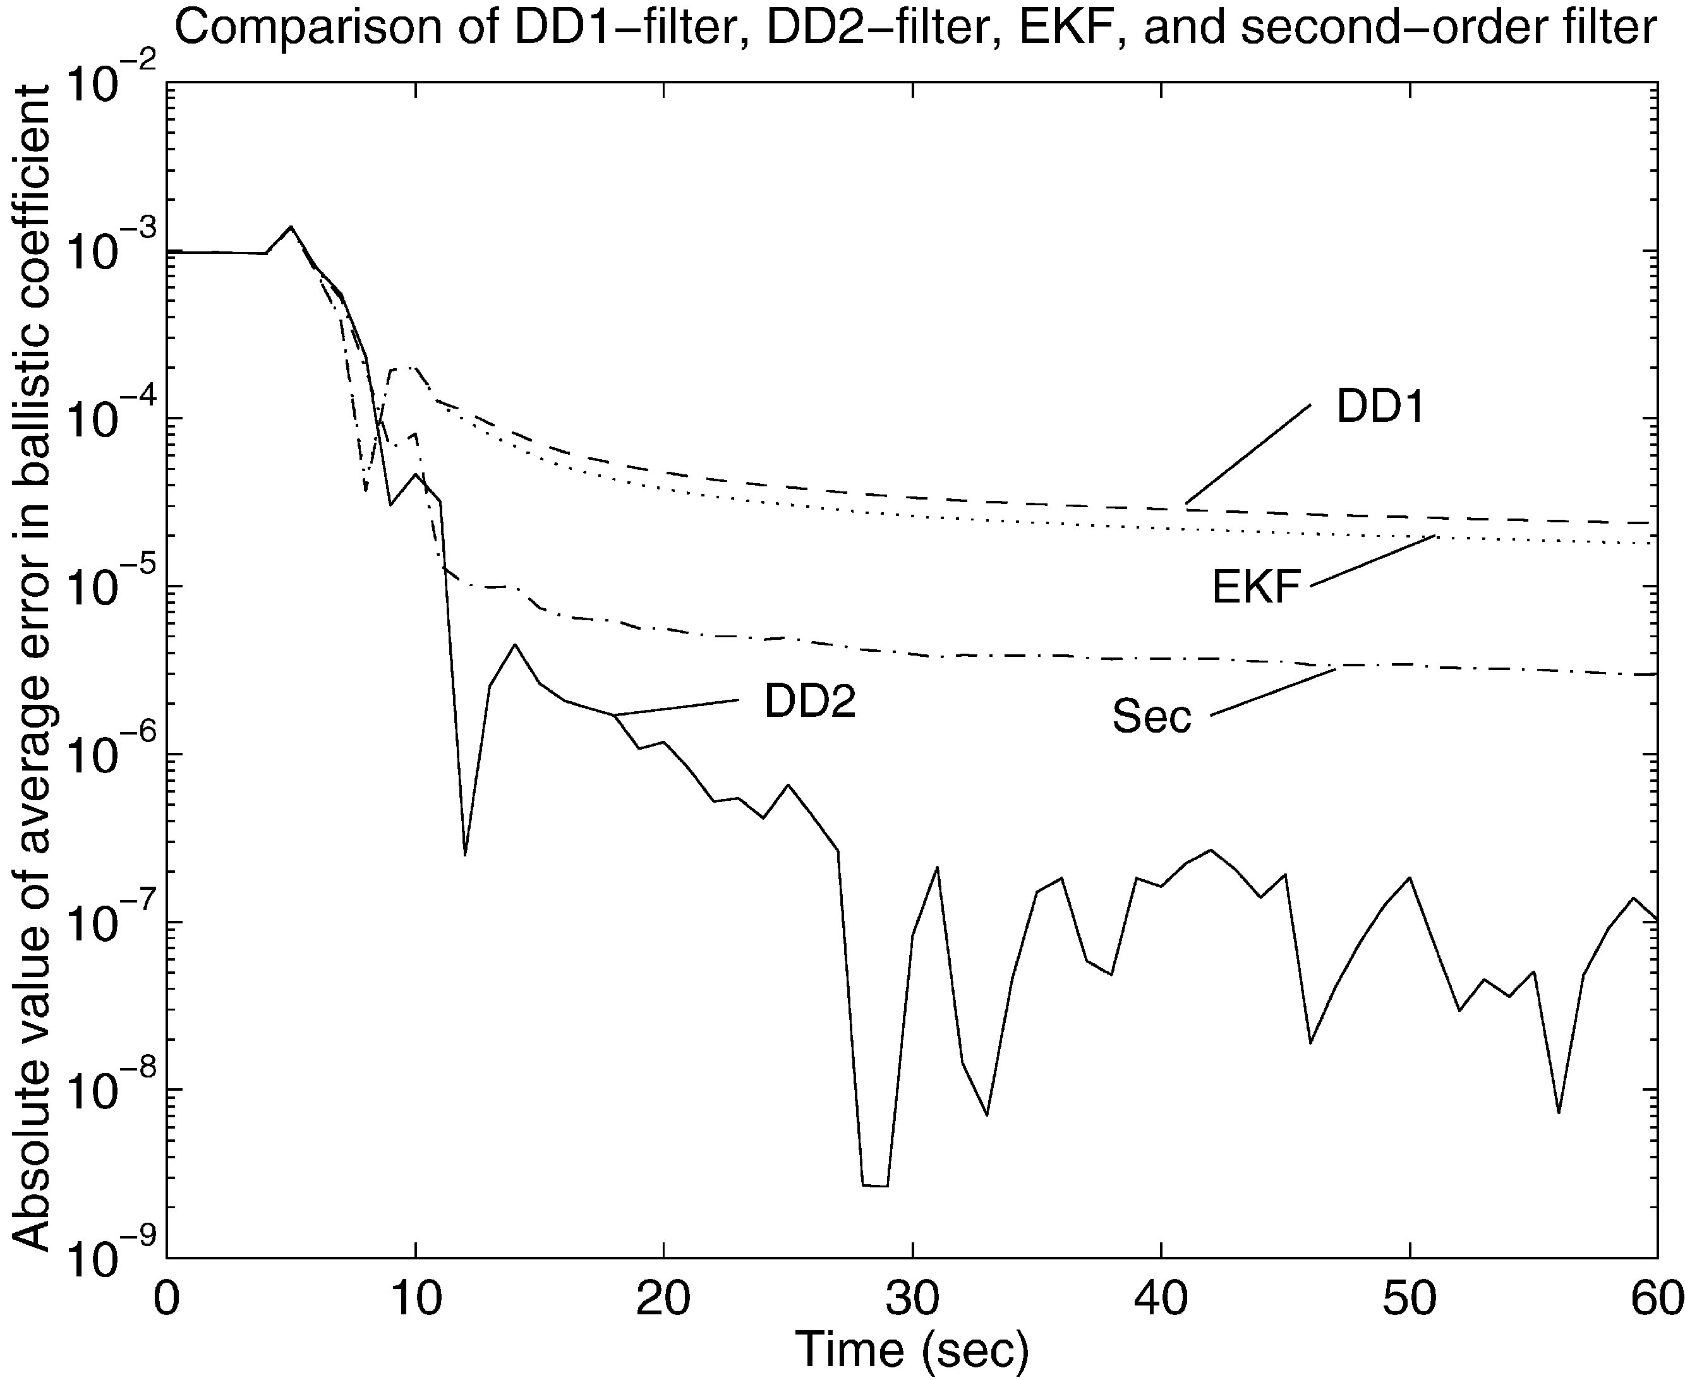

"3✕10¯‘, (83)

10ª 0 0

]

¯ª

0 0 10

. (84)

To enable a fair comparison of the estimates produced by each of the four "lters, the estimates are averaged across a Monte Carlo simulation consisting of 50 runs. Each run is carried out with a di!erent noise sample. The results of the Monte Carlo simulation are shown in Figs. 2}5.

Not surprisingly, Figs. 2}4 illustrate that the DD2 "lter exhibits a performance which is completely superior to the EKF and the DD1 "lter. Even more encouraging,

Fig. 4. Absolute error in estimate of ballistic coe$cient (50 run aver- age). The DD2 estimate may look #uctuating, but it should be noticed that the scale is logarithmic.

it also performs better than the second-order "lter. This is remarkable as implementation of the DD2 "lter is signi"cantly simpler than implementation of both EKF and second-order "lter.

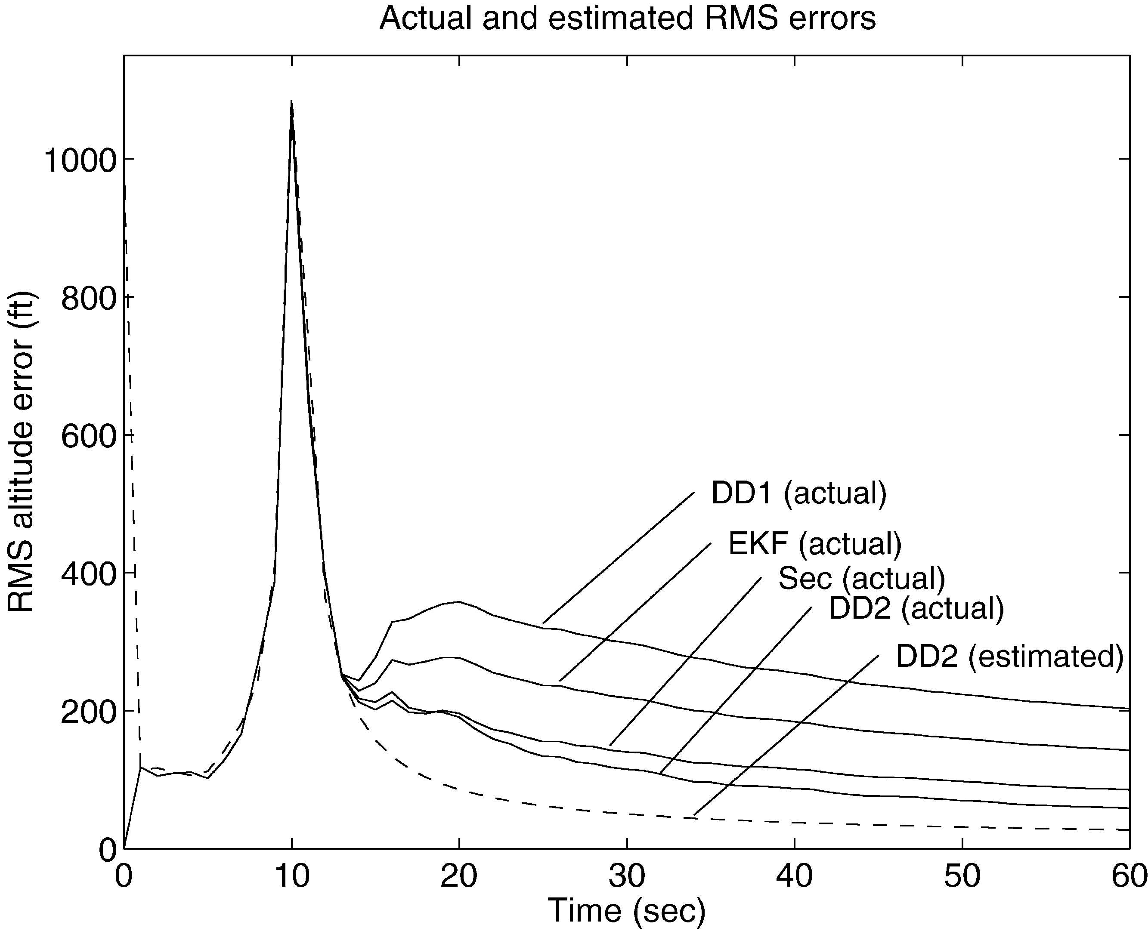

Fig. 5. `Actuala (50 run average) RMS altitude errors compared with the estimated RMS error, {*P*K ¹¹(*k*) for the DD2 "lter.

In this example it turns out that the performance of the DD1 "lter is slightly worse than for the EKF. The di!er- ence is, however, not dramatic and must be contributed to the fact that the assumptions on which the DD1 "lter was derived are partly violated. An analysis of empirical distribution of the estimation errors showed that the estimates produced by the EKF and the DD1 "lter have a non-negligible bias and the distribution of the errors is slightly asymmetric. On the other hand, the DD2 "lter produces nearly unbiased, Gaussian estimates.

Comparison with the study of the unscented "lter carried out in Julier and Uhlmann (1994) shows that the performances of the unscented "lter and the DD2 "lter are similar. This agrees well with our expectations as the a priori state estimate is the same and the "lters deviate only in the covariance estimate.

The RMS value of the altitude errors is shown in Fig. 5 for each of the four "lters. For comparison, the estimated

values {*P*K ¹¹ have also been plotted for the DD2 "lter. Note that the variation in the performance of the DD2

"lter is seemingly smaller than for the other "lters. For all "lters the actual estimation error variances exceed the variance estimates produced by the "lters. However, the estimated variance is closer to the actual variance for the DD2 estimates than for the other three "lters.

It should be mentioned that the simulation study also showed that there is little di!erence between the esti-

mates of {*P*K ¹¹ produced by the four "lters. This is why only the estimates produced by the DD2 "lter have been

plotted in Fig. 5.

# Conclusions

We have in this paper proposed two new "lters for nonlinear state estimation. Whereas "lters for nonlinear systems commonly are based on polynomial approxima-

tions obtained with Taylor's formula, the approxima- tions underlying the new "lters are obtained with a multi- variable extension of Stirling's interpolation formula. The "lters are simple to implement as no derivatives are needed, yet they provide excellent accuracy. The DD1 "lter is the simplest of the two "lters. It represents a slight improvement over the "lter suggested in Schei (1997). See N+rgaard et al., (2000) for further details. The most important contribution of the paper is the superior DD2 "lter. This "lter has the same a priori state estimate as the

`unscenteda "lter described in Julier and Uhlmann (1994) and Julier et al. (1995) but a better covariance estimate.

The characteristics of the "lters are brie#y summarized below:

. It can be shown (N+rgaard et al., 2000) that based on Gaussian assumptions, the accuracy of the DD1 "lter is slightly better than the EKF in the sense that the expected error of the estimates have a smaller upper bound. Moreover, the accuracy of the DD2 "lter is comparable or better than a Gaussian second-order "lter. As the polynomial approximations, on which the new "lters are based, utilize knowledge about the covariance of the state estimate, we expect that the new "lters will be particularly superior to conventional (Taylor approximation based) "lters for highly nonlin- ear systems, and systems with high noise levels.

. The implementation of the "lters is extremely simple as they do not require derivative information. Yet, the computational burden is relatively limited and will often be comparable to that of the EKF. As the user needs only provide models of dynamics and observa- tion process, the "lters are highly attractive in relation to implementation of `generica computer programs for nonlinear "ltering.

. The "lters are very useful for model calibration. It is straightforward to include a varying number of para- meters in the state vector for simultaneous state and parameter estimation. The user needs only initialize the parameter estimates and their variances and then run the "lter again.

. As it is not necessary to assume di!erentiability of the nonlinear mappings, the range of applications is wider than for the EKF, which requires that the Jacobians exist.

# Acknowledgements

This work was supported by the Danish Technical Research Council under contract no. 9502714.

# References

Athans, M., Wishner, R. P., & Bertolini, A. B. (1968). Suboptimal state estimation for continuous-time nonlinear systems from discrete

noisy measurements. *IEEE Transactions on Automatic Control*, *13*(5), 504}514.

Dahlquist, G., & BjoK rck, As . (1974). *Numerical methods*. Englewood

Cli!s, NJ: Prentice-Hall.

FroK berg, C. -E. (1970). *Introduction to numerical analysis*. Reading, MA: Addison-Wesley.

Gelb, A., Kasper, J. F., Nash, R. A., Price, C. F., & Sutherland, A. A. (1974). *Applied optimal estimation*. Cambridge, MA: MIT Press.

Golub, G. H., & van Loan, C. F. (1989). *Matrix computations*. Baltimore, MD: The Johns Hopkins University Press.

Grewal, M. S., & Andrews, A. P. (1993). *Kalman* x*ltering: Theory and practice*. Englewood Cli!s, NJ: Prentice Hall.

Julier, S. J., & Uhlmann, J. K. (1994). *A general method for approximating nonlinear transformations of probability distributions*. Technical re- port, Robotics Research Group, Department of Engineering Science, University of Oxford (Internet publication: [http://www.robots.ox.ac.uk/&siju/index.html).](http://www.robots.ox.ac.uk/%26siju/index.html))

Julier, S. J., & Uhlmann, J. K. (1997). A new extension of the Kalman "lter to nonlinear systems. *Proceedings of AeroSense*: *The 11th inter- national symposium on aerospace*/*defense sensing*, *simulation and controls, Orlando, FL*.

Julier, S. J., Uhlmann J. K., & Durrant-Whyte, H. F. (1995). A new approach for "ltering nonlinear systems. *Proceedings of the 1995 American control conference*, *Seattle*, *Washington* (pp. 1628} 1632).

Lewis, F. L. (1986). *Optimal estimation*. New York: Wiley.

Maybeck, P. S. (1982). *Stochastic models, estimation, and control,* Vol. 2, London: Academic Press.

N+rgaard, M., Poulsen, N. K., & Ravn, O. (2000). *Advances in deriva-*

*tive-free state estimation for nonlinear systems*. Technical Report, IMM-REP-1998-15, Department of Mathematical Modelling, DTU, revised April 2000.

Press, W. H., Flannery, B. P., Tevkolsky, S. A., & Vetterling, W. T. (1988). *Numerical recipes in C* } *The art of scienti*x*c computing*. Cambridge, UK: Cambridge University Press.

Schei, T. S. (1997). A "nite-di!erence method for linearization in nonlinear estimation algorithms. *Automatica*, *33*(11), 2051}2058.

Ste!ensen, J. F. (1927). *Interpolation*. Baltimore, MD: Williams & Wilkins.

**Magnus N**0**rgaard** was born in Copen- hagen, Denmark in 1968. He received the

M.S. and Ph.D. degrees in electrical engin- eering from the Technical University of Denmark (DTU) in 1992 and 1996, respec- tively. During 1996}1999 and 1999}2000 he has been working as an Assistant Re- search Professor at DTU. During most of 1999 he was working as Computer Scien- tist at NASA Ames Research Center, Cali- fornia. His current research interests include non-linear state estimation tech-



niques and sensor fusion systems for autonomous guided vehicles and system identi"cation and control with neural networks.

**Niels Kj**0**lstad Poulsen** was born in the central part of Sjvlland, Denmark in 1956. He received his M.Sc. and Ph.D. degrees in electrical engineering from The Institute of Mathematical Statistics and Operations Research (IMSOR), the Technical Univer- sity of Denmark, in 1981 and 1984, respec- tively. He has been employed at the Technical University of Denmark from 1984. Since 1990 as an Associate Professor at the Department of Mathematical Mod- elling. His primary research interests are



within stochastic control theory, system identi"cation and adaptive control.

**Ole Ravn** was born on Frederiksberg, De- nmark in 1959. He received his M.Sc. and Ph.D. degrees in electrical engineering from the Department of Automation at the Technical University of Denmark. He has been employed at the Technical University of Denmark from 1987, since 1991 as an Associate Professor at the Department of Automation. His primary research inter- ests are control of robots and autonomous systems, adaptive control and computer aided control engineering.

