 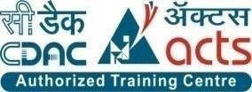

**INSTITUTE FOR**

**ADVANCED COMPUTING**

**AND SOFTWARE**

**DEVELOPMENT AKURDI,**

**PUNE**

Documentation On

**“E-RTO System”**

PG-DAC SEP 2021

*Submitted By:*

**Group No: 12**

# Aniket Jain (219021)

# Sidak Bhatia (219193)

**Mr. Prashant Karhale Mr.Chetan Pardeshi**

**Centre Coordinator Project Guide**

**Table of Contents**

1. **Introduction** ..............................................................................................................................3 Problem Statement......................................................................................................................3 Aim & Objectives........................................................................................................................3
2. **Overall Description**...................................................................................................................4 Proposed Methodology...............................................................................................................4

Operating Environment...............................................................................................................4

Design and Implementation Constraints......................................................................................4

1. **Requirements Specification**....................................................................................................6

External Interface Requirements................................................................................................6

1. **System Diagram**........................................................................................................................7

Sequence Diagram……………………………………………………………………………..8

Use Case Diagram .....................................................................................................................9

ER Diagram .............................................................................................................................10

**5. Table Structure**........................................................................................................................ 13

Users ........................................................................................................................................13

Learning ..................................................................................................................................13

Permanent ..............................................................................................................................13

app_id ......................................................................................................................................14

images……………..................................................................................................................14

**6.** **Conclusion**........................................................................................................................... 15

Future Scope ...................................................................................................................... 15

**7. References** ...........................................................................................................................16

**List of Figures**

Figure 1 Activity Diagram ...………………........................................................................................6

Figure 2 ADMIN Sequence Diagram ....................................................................................................7

Figure 3 CITIZEN Sequence Diagram ................................................................................................. 7

Figure 4 Use Case Diagram for both ADMIN and CITIZEN ............................................................. 8

Figure 5 Class Diagram ........................................................................................................................9

Figure 6 ER Diagram ........................................................................................................................10

Figure 6 ER Diagram ........................................................................................................................... 11

**1. INTRODUCTION**

**Introduction:**

The e-RTO System's aim is to automate the major processes in Regional Transport Offices. The Online RTO system provides citizens with 24/7 access to services like online registration for Learner's license & Permanent license. Admin can update application status and can also manage time slots for tests. The main motive of the system is to make the daily activities efficient and to provide fast response by storing and retrieving information & informing it to the users via Email.

**Problem Statement:**

Now a day’s many people are purchasing two wheelers, four wheelers etc. So the RTO employees having lot of work burden of making registration. License issue, transfer etc. which required lot of paper work. As a result people cannot get the things done in right time, which waste the time, energy. Similarly the vehicle owner sometimes forgets to carry the license at the time of enquiry. So to overcome these drawbacks we are developing an enhanced e-RTO Management System. Such like that we provide one type of environment which gives a user friendly means user can access and understand well. Administrator has the power to verify the data entered by the user, processing of data and provide appropriate solutions.

E-RTO Management system is an advanced system which is designed keeping in view to make the existing registration system easier and faster. It includes the entire registration procedure starting from the initial phase of entering till the results. It is more reliable, accurate time, saving and free from any misuse. The tedious jobs such as verifying all the records of the applicant, confirming all the personal details are furnished, submission of documents, driving license, registration details, etc. are done in the most convenient way to the administrator. Also security is being provided in the most proficient way.

**Aims and Objective:**

The aim is to build a user-friendly webpage where the citizens can apply for learner’s license, driving license. The webpage also provides provision for citizens to submit their complaints. Mainly, the website is used for issuing of license. An individual can apply for learning license and driving license online. Accordingly, slots and dates are generated for the respective test. The application received will be verified and approved by the RTO officials. The applicant can monitor the status of their application.

In other words, our E-RTO Management system portal has, following objectives:

* Simple database is maintained.
* Easy operations for the user and the admin of the system.
* User interfaces are user accommodating and attractive; it takes very less time for the operator to use the system.

**2. OVERALL DESCRIPTION**

**Proposed Methodology:**

The proposed system is aimed to automate the major processes in the Regional Transport Office. E-RTO Management System for different License Scope: “RTO Management System” is aimed to automate the major processes in Regional Transport Offices. The scope of Online RTO Management system includes a complete suite of portal to provide citizens with 24/7 access to services like Online Registration for Learner's license & permanent license, Examination and maintaining results, Management of time slots for driving tests. The main motive of the system is to make the daily activities efficient and providing fast response by storing and retrieving information & informing it to the users via SMS or E-Mail.

**OPERATING ENVIRONMENT:**

Server Side:

**Processor:** Intel® Xeon® processor 3500 series

**HDD:** Minimum 500GB Disk Space

**RAM:** Minimum 4GB

**OS:** Windows 10

**Database:** MySQL

Client Side (minimum requirement):

**Processor:** Intel Dual Core

**HDD:** Minimum 80GB Disk Space

**RAM:** Minimum 2GB

**OS:** Windows 7

**Design and Implementation Constraints:**

* The application will use ReactJs, Axios and CSS as main web technologies.
* HTTP protocol is used as communication protocol. FTP is used to upload the web application in live domain and the client can access it via HTTP protocol.
* Several types of validations make this web application a secured one and SQL Injections can also be prevented.
* Since E-RTO SYSTEM is a web-based application, internet connection must be established.

**3. REQUIREMENTS SPECIFICATION.**

**External Interface Requirements:**

User Interfaces:

* All the users will see the same page when they enter in this website. This page asks the users a username and a password.
* After being authenticated by correct username and password, user will be redirect to their corresponding profile where they can do various activities.
* The user interface will be simple and consistence, using terminology commonly understood by intended users of the system. The system will have simple interface, consistence with standard interface, to eliminate need for user training of infrequent users.

Hardware Interfaces:

* No extra hardware interfaces are needed.
* The system will use the standard hardware and data communication resources.

This includes, but not limited to, general network connection at the server/hosting site, network server and network management tools.

Application Interfaces:

**Web Browser:**

The system is a web-based application; clients need a modern web browser such as Mozilla Firebox, Internet Explorer, Opera, and Chrome. The computer must have an Internet connection in order to be able to access the system.

Communications Interfaces:

* This system uses communication resources which includes but not limited to, HTTP protocol for communication with the web browser and web server and TCP/IP network protocol with HTTP protocol.
* This application will communicate with the database that holds all the booking information. Users can contact with server side through HTTP protocol by means of a function that is called HTTP Service. This function allows the application to use the data retrieved by server to fulfil the request fired by the user.

**4. SYSTEM DIAGRAMS.**

* **Activity Diagram:**

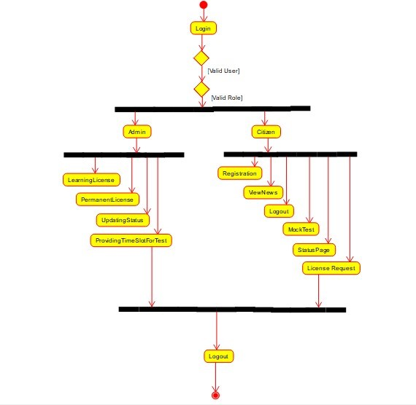

## Fig 1

## 

## **Sequence diagram:**

ADMIN Sequence:-

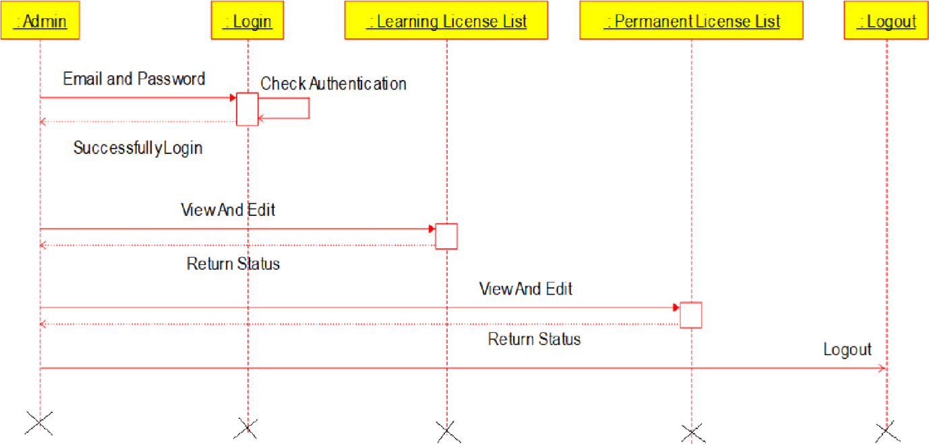

Fig 2

CITIZEN Sequence:

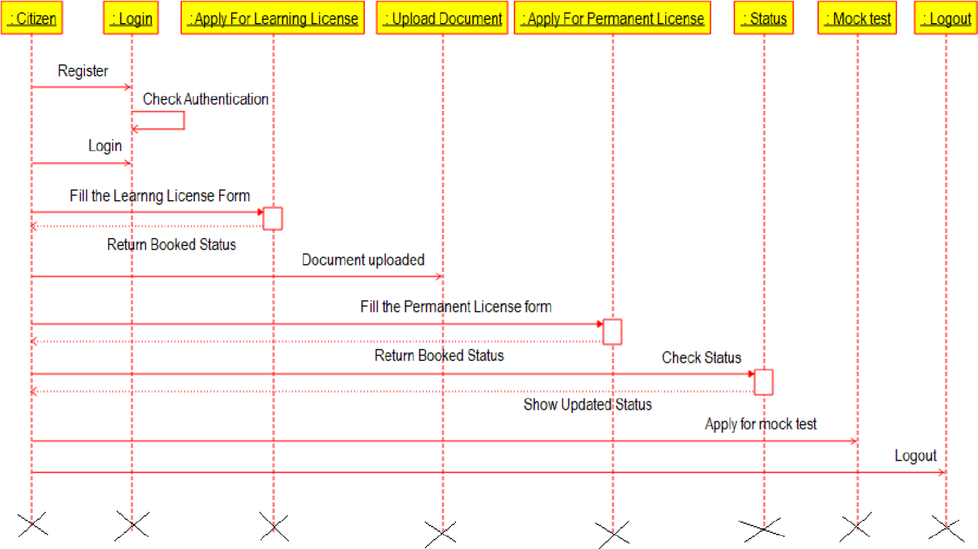

Fig.3

## **Use Case Diagrams:**

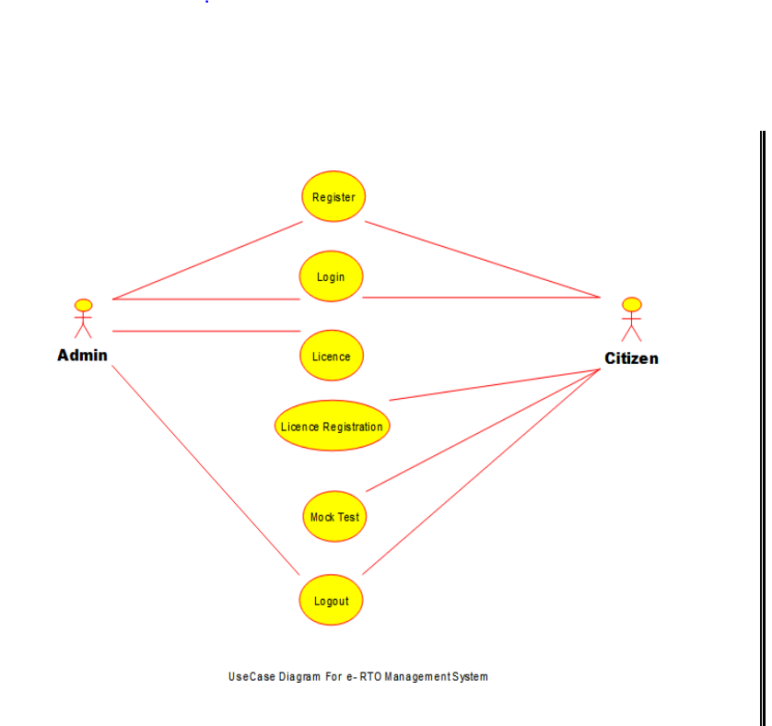

Fig.4

**Class-Diagram:**

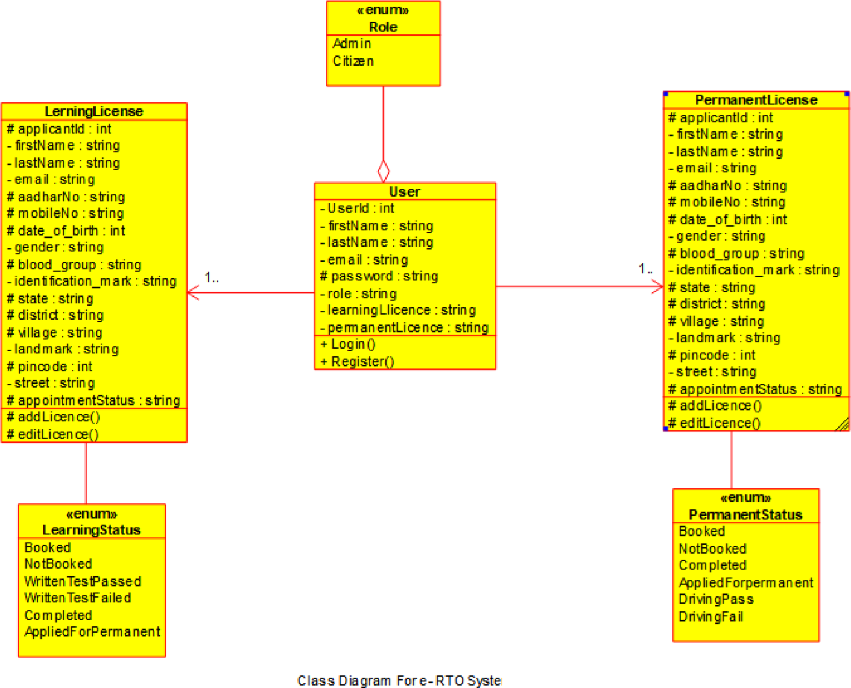

Fig.5

**ER-Diagram:**

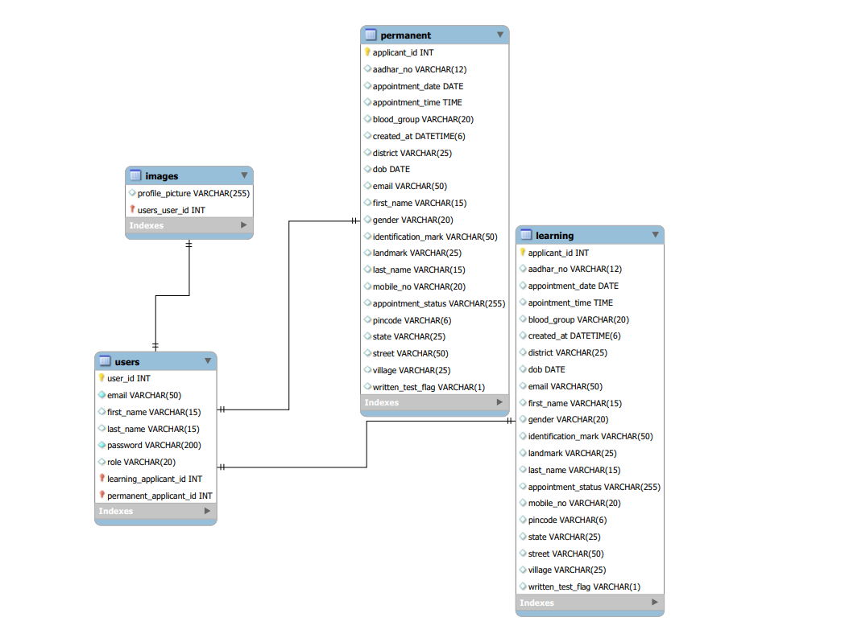

Fig.6

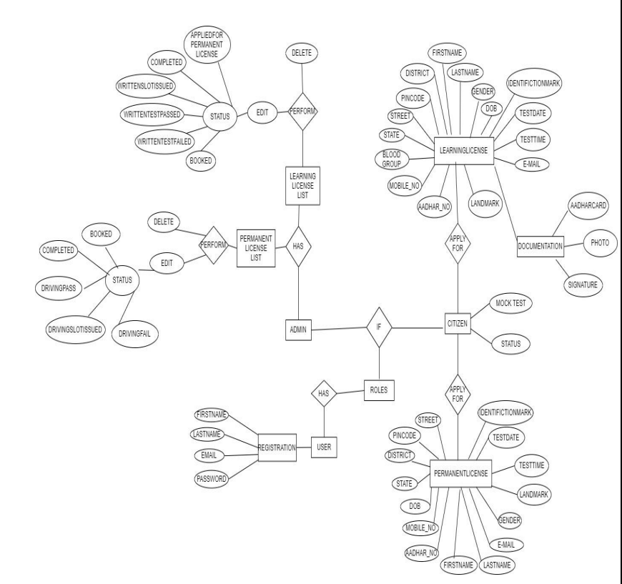

Fig 7

**5. TABLE STRUCTURE**

* Users:

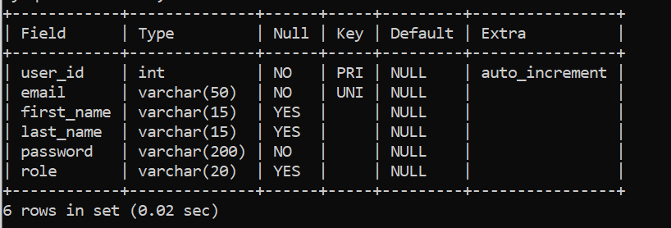

* learning:

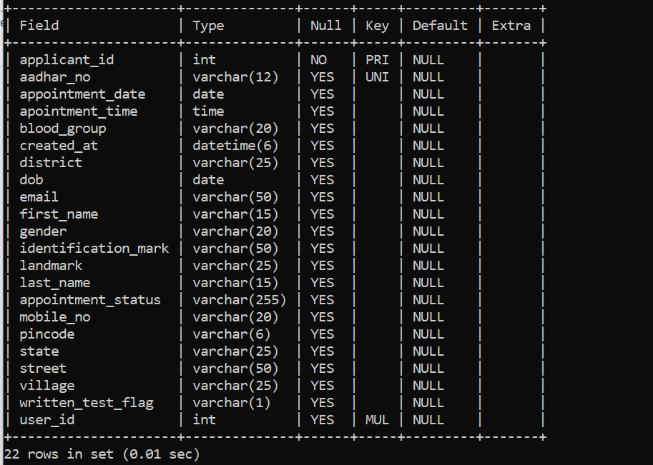

* permanent:

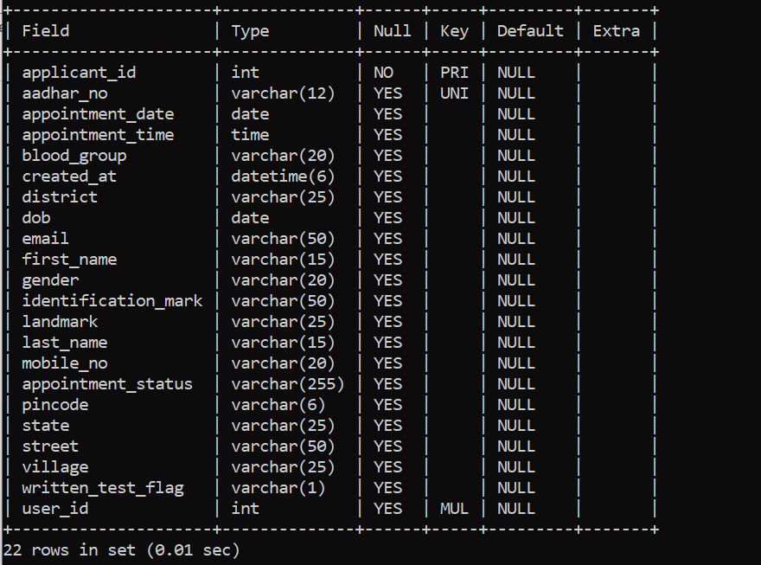

* app _id:

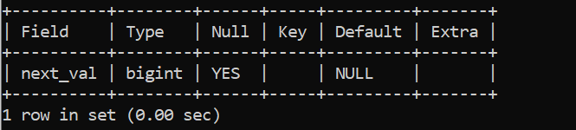

* images:

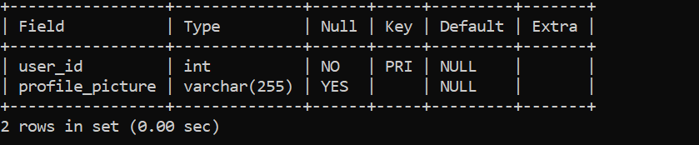

**6. CONCLUSION**

* The system generated only a limited number of reports. If more detailed reports are required the system can be directed Even though the system has well communication facility, it’s not enough.
* The mail service can be enhanced with features bcc, cc etc. The system has full security but the account information for the customer credit information.
* Improved communication, ease of access to RTO resources such as Registration forms etc , will help foster a stronger user relationship.
* e - RTO management will empower you to spend more time and effort developing your users’ lifelong learning license.
* In this e-RTO management complete global Module. (Any Where Any Time)
* In this system the main entity is Admin who has all the right.
* Here the main tasks of admin are update/delete registration, license.

## **Future Scope:**

This project can be enhanced further by adding some more features. The application is design in such a way that any further enhancements can be done with ease. The system has the capability for easy integration with other systems. New modules can be added to the existing system with less effort. In future a new function or procedure can be easily added in the system through these classes. Or even a new class can be added.

The software is flexible enough to be modified and implemented as per future requirements. We have tried our best to present this free and user–friendly website to Regional Offices.

1. **REFERENCES**

* **References:**
* [React Tutorial (w3schools.com)](https://www.w3schools.com/react/)
* [Learn Spring Boot | Baeldung](https://www.baeldung.com/spring-boot)
* [Spring Data JPA - Reference Documentation](https://docs.spring.io/spring-data/jpa/docs/current/reference/html/)
* [React – A JavaScript library for building user interfaces (reactjs.org)](https://reactjs.org/)
* Bootstrap · the most popular HTML, CSS, and JS library in the world. (getbootstrap.com)