**PROJECT REPORT**

**PROJECT NAME** :- Quiz-Game

**DEVELOPMENT** :- C Language.

**PROJECT BY** :- PRASANNA N BARIMANI

## TABLE OF CONTENTS

|  |  |  |
| --- | --- | --- |
| **S No.** | **Content** | **Page No.** |
| **1.** | Introduction | **3** |
| **2.** | Objective | **4** |
| **3.** | Requirements | **5** |
| **4.** | Flow chart | **6** |
|  |  |  |
| **5.** | Input and output Display | **7** |
| **6.** | Future scope | **8** |
| **7.** | Reference | **9** |

# INTRODUCTION

This is a complete and error-free **Quiz Game Mini Project in C** designed as a simple console application. In this project, a number of questions are asked, and the user is tested then declared as winner.

In quiz game, questions are chosen in such a a way that they cover all fields of a typical quiz contest. The user’s general knowledge is tested with quiz questions regarding science, technology, movies, sports, general health, geography and many more..

**Features:**

I have divided this mini project into many functions, and listed below:

* edit_score() – adds the current cash prize won to the previous one upon giving the right answer to a question.
* help() – help menu with game summary and rules.
* reset_score() – to reset the highest score/cash prize to default.
* show_record() – shows the highest cash prize won by a particular user
* show_score() – to view the highest score

**OBJECTIVE**

* In this quiz game mini project, you can store the user name, view the highest score secured by a user, and even reset the score. Additionally, to make the game look a little more interesting, it is divided into two rounds; user must pass the first round to reach the second one.
* Of the 2 rounds I mentioned above, the first is called the Warm-up Round; the second is the Challenge round. In the warm-up round, the user is asked a total of three simple questions and they must be able to answer at least two of them correctly to enter the next round. If the user is not capable of doing that, he is not permitted to proceed further.
* In the second and more interesting round of this quiz game in C, the user will be asked questions continuously, and for each right answer given, they will earn $100,000!
* The game ends when the user’s cash prize piles up to $1 million. For each question asked, there are 4 options, namely A, B, C and D. There are no negative markings, so the user’s accumulated cash money won’t be deducted for wrong answers to the questions.

**REQUIREMENTS**

**Software Requirement**

* Operating System : Windows
* Application Software: Code-Blocks/Visual Studio
* Language : C-Programming

#### Hardware Requirements Specification

#### Processor : Intel core i3 or i5

#### Hard Disk : 250GB

#### Ram : 2GB

**FLOW CHART**

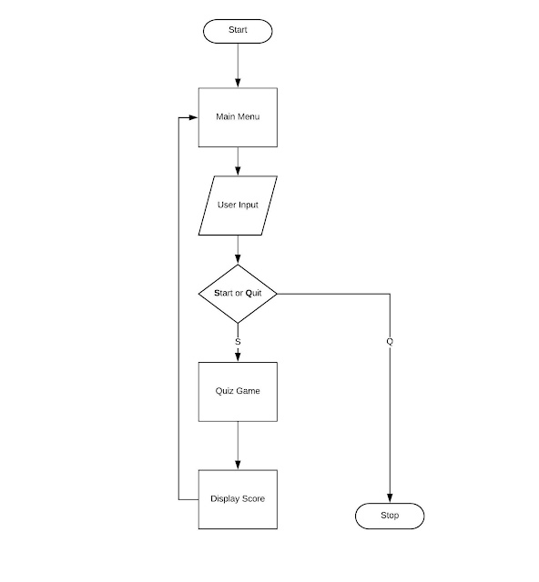

**INPUT AND OUTPUT DISPLAY**

**Welcome Screen**

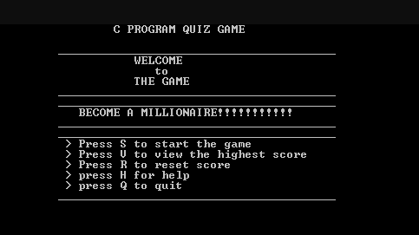

**Input**

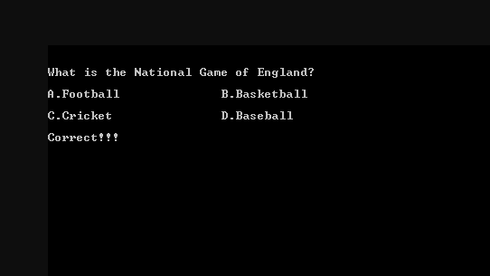

**Output**

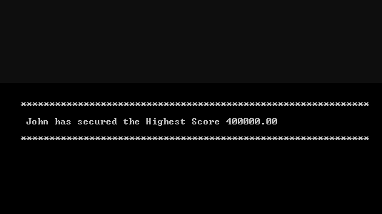

**Future Scope Of Project**

This Quiz Game project is used for mini quiz competitions at school level and it can also be used for organizations by updating the code.

**Reference**

* [www.youtube.com](http://www.youtube.com).