Sarah Thompson
Doug Brinkerhoff
Machine Learning
12/7/2019

Exploring Peak Shaving Using Time Series Forecasting on Univariate Data with Complex Seasonality
Abstract:
To explore the question of predicting peak energy usage at the University of Montana two forecasting techniques were used: STLM and TBATS. These models were chosen based on their ability to handle the complex seasonality displayed in the univarite energy data. Before forecasting, the length of the data was shortened, the average values for energy use (kwh) were created, and the seasonal patterns within the data were identified. Ultimately, the STLM model outperformed the TBATS model by correctly predicting the peak time and day during a week long forecast.
Introduction:
Graph 1: The kw energy use per quarter hour by The University of Montana
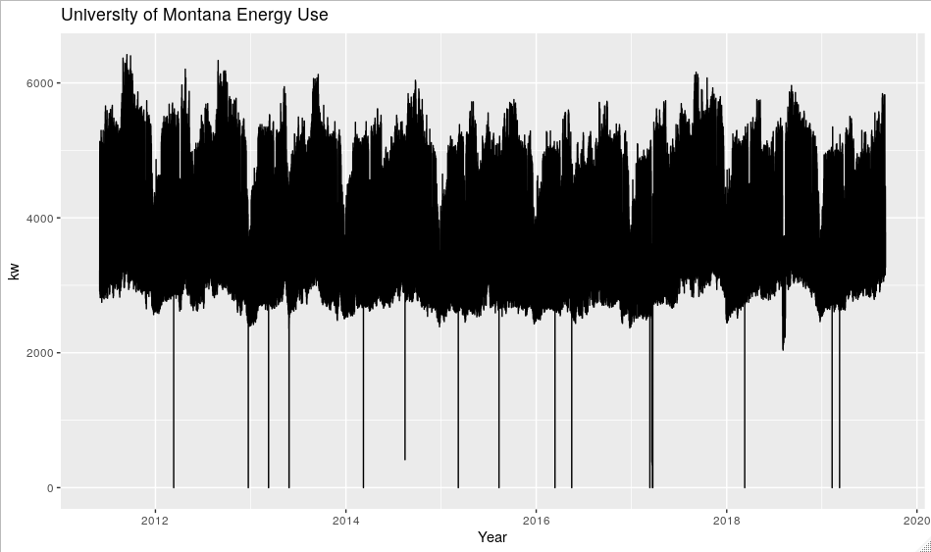
This project aims to help Brian Kerns from UM Facilities lower energy costs for the university by reducing a component of the univeristy’s energy bill. The question is simple, can we predict energy peaks throughout the month so as to keep the max kilowatts (kw) used below a certain threshold? Northwestern Energy charges the university not only for the total amount of energy used per month but also for the maximum amount used at any point in time throughout the month. Thus ‘peak shaving,’ or the process of reducing maximum amount used, would be a useful way to cut energy costs. Ultimately, this project will entail building a dashboard that streams energy data from the individual building meters, aggregates the data, and gives an estimate of the likelihood of peaking on a given day. To start, I wanted to build a forecast to predict the next week’s energy demand by hour.
Graph 1 shows the entire data set, which begins June 1, 2011 at 12:15am and ends September 2, 2019 at 7:45pm and contains kw energy demands in fifteen minutes intervals. Examining Graph 1 we see clear annual patterns and potentially some semi annual patterns of seasonality in the data. This is observed by the repetitious pattern of energy use dropping in January, peaking before summer break, dropping around summer break, and then peaking sometime before winter break. Graph 2 shows the data from January 2017, allowing an easier comparison of semi annual patterns. Zooming in further, Graph 3 displays one month of data, where we see weekly and daily seasonal patterns but not monthly.

Graph 2: The kw energy use per quarter hour by The University of Montana from Jan 2017-Sept 2019
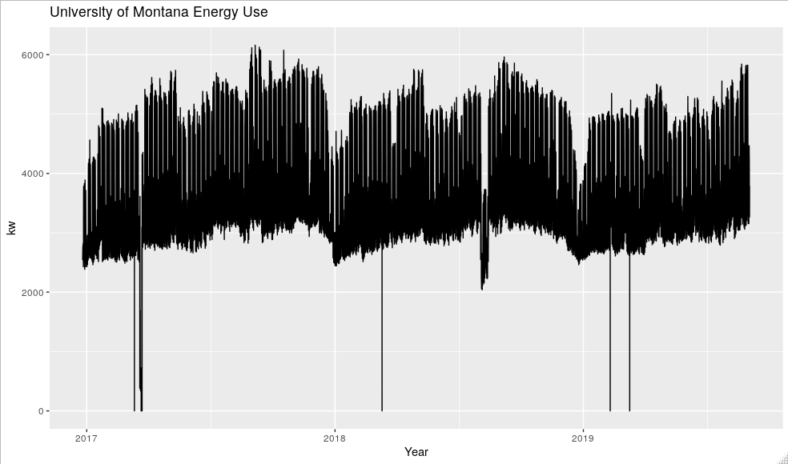

Graph 3: The kw energy use per quarter hour by The University of Montana during August 2019
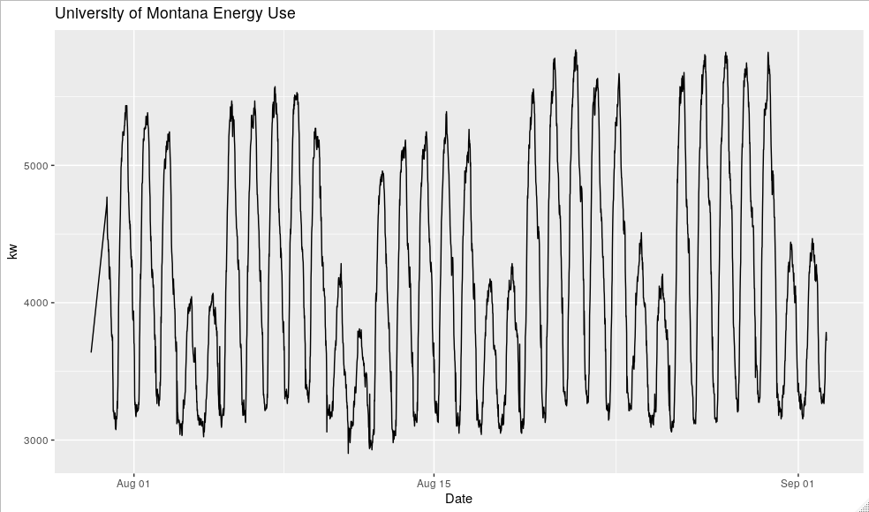
Methods:
Many forecasting techniques do not preform as well on very long times series such as this one, thus before moving forward the data set was shortened to a length of two years (Hyndman). Additionally, for this initial forecasting project, the data were rolled into mean kw per hour (kwh) intervals instead of fifteen minute intervals to improve forecasting speed. The only variable being used in these forecasts is kwh.
When dealing with complex seasonality, commonly used time series forecasting methods like ARIMA and ETS are no longer useful as they are designed to handle only one type of seasonality. As seen above, the kwh energy data contains several different types of seasonal patterns, prompting the use of the STLM and TBATS forecasting methods. The SLTM model, or “Seasonal and Trend decomposition using Loess” model splits the time series into three elements: seasonal, trend, and remainder (Hyndman). The model removes trend and then uses a Lowess smoother to find the seasonal elements. Next, it uses another smoother to remove the seasonal elements, and repeats these steps several times to improve the accuracy of its components (GmbH). In comparison, the TBATS model is a trigonometric exponential smoothing state space model that uses a Box-Cox transformation, trend and seasonal components, and ARMA errors (Naim). This model is completely automated and allows for seasonality to change slowly over time, which may be useful when dealing with the subtle changes of the academic calendar (Hyndman).
Two measures were used to compare the prediction accuracy of the models, the root mean squared error (RMSE) and the mean absolute percentage error (MAPE). Both involve measuring the distance between the model’s predicted value and observed value from the test set. The model with the lowest RMSE and MAPE is considered superior, see Figure 1 for the formulas (Naim).
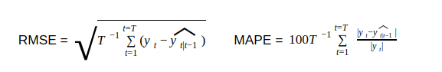
Figure 1: The formulas for RMSE and MAPE
Results:
Prior to forecasting with univariate data it is important to confirm that all of the seasonal components of the data are understood. Graph 4 shows the decomposition of the data with explicitly defined daily, weekly, and quarterly seasonal periods. The first graph shows the data, where the 2018 summer break dip in energy use stands out in the middle. Next is the trend, the visible pattern in the trend of the data suggests that more seasonal periods might be present in the data (Prastiwi). Seasonal24 is the daily seasonality pattern, Seasonal168 and Seasonal2190 are the weekly and quarterly seasonality patterns, respectively. The last graph is the remainder, that which is leftover after accounting for these seasonalities.
Graph 4: The decomposition of kwh data in hour intervals with daily, weekly, and quarterly seasonality
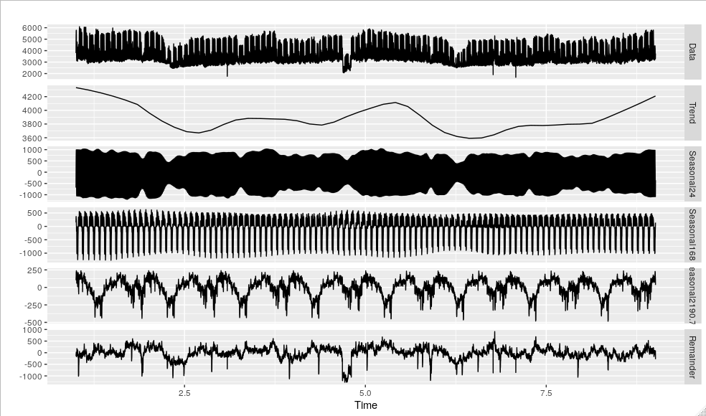
Graph 5 shows the addition of annual seasonality (Seasonal5762) and the desired trend graph for proceeding. The absence of a pattern in the trend graph signifies that we have captured all the levels of seasonality present in the univariate data.

Graph 5: The decomposition of kwh data in hour intervals with daily, weekly, quarterly, and annually seasonality
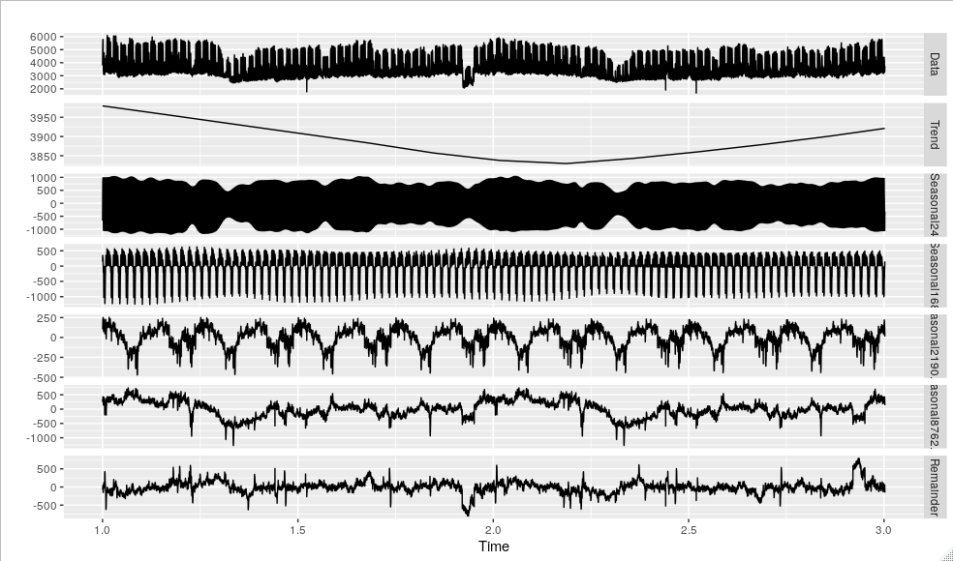
Prior to forecasting, test and training sets of the data must be created in order to compare the forecasting accuracy of the two models. A model is trained on the training set and forecasts over the test set, then the predictions of the forecast are compared to the values in the test set. For this project, the test set contains the last week of the data and the training set contains the last two years of data with the last week removed.
After using both forecasting methods we can compare the results and examine the predictions. Based on Figure 2 we see that the STLM forecast has a lower RMSE and MAPE, with Graph 6 corroborating these results.

 | RMSE | MAPE
STLM | 134.14 | 105.82
TBATS | 250.85 | 198.11
Figure 2: Forecasting accuracy metrics RMSE and MAPE
Graph 6 also shows the STLM model correctly predicting the peak day of the month. The test set contained the peak for the month of August on August 28th and the STLM model correctly predicted that this would be the peak day and around the same time of day the peak would occur. In comparison to the TBATS model, the STLM forecasting architecture is the clear winner for predicting peak energy use at the University of Montana.

Graph 6: Comparing STLM and TBATS Forecasting Models to test set
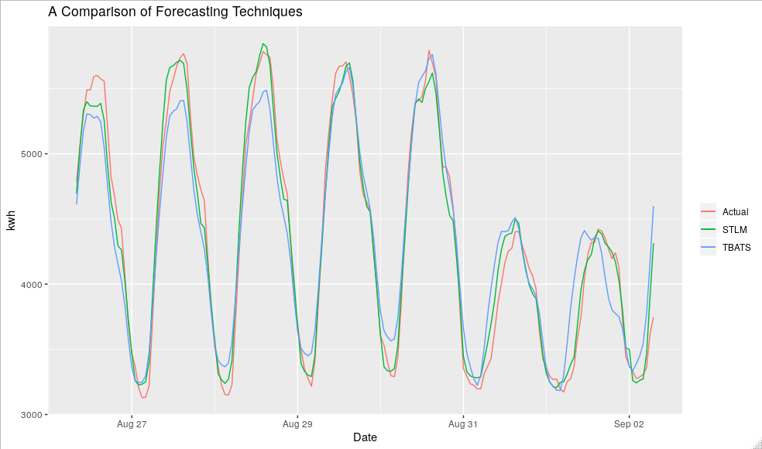
Discussion:
While the STLM model performed quite well, I remain unconvinced that it is the most precise method to answer the question being asked. Next, I will explore logistic regression, recurrent neural networks, and Long Short Term Memory (LSTM) to return a likelihood estimation of peaking on a given day. This will involve compiling additional variables like academic calendar, weather data, and lagged time. Currently, Uber is using LSTM architecture and a neural network to forecast extreme events like Christmas and New Years day. Their hope is to create a flexible forecasting framework that can be applied to many different cities and locations across the world (Laptev). This may be a helpful avenue because I will ultimately be working with data from all the buildings on campus, thus there may be need for many forecasts. Moving forward with a better understanding of the data and forecasting in general, there is ample research on the use of recurrent neural-networks and LSTM architecture for generating predictions.
Conclusions:
STLM and TBATS forecasting models were chosen to explore peak energy usage at the University of Montana due to their ability to handle univariate data with complex seasonality. In order to answer the question: Can we predict the peak in energy use? Seven years of energy (kw) data in fifteen minute intervals were cut down to two years of data in mean kwh intervals. After identifying the multiple levels of seasonality within the data, the STLM and TBATS forecasts were compared using RMSE and MAPE. Both metrics indicated that the STLM model outperformed the TBATS model, in fact the STLM architecture correctly identified the peak day and hour of the week. Despite the accuracy of the STLM forecasting method, I look forward to exploring other methods like recurrent neural-networks and LSTM to improve forecasting accuracy.
Citations:
GmbH, RapidMiner. “STL Decomposition (Time Series).” STL Decomposition - RapidMiner Documentation, https://docs.rapidminer.com/9.1/studio/operators/modeling/time_series/decomposition/stl_decomposition.html.

Hyndman, R.J., & Athanasopoulos, G. (2018) Forecasting: principles and practice, 2nd edition, OTexts: Melbourne, Australia. OTexts.com/fpp2. Accessed on 10 December 2019.

Laptev, Nikolay, et al. “Engineering Extreme Event Forecasting at Uber with Recurrent Neural Networks.” Uber Engineering Blog, 17 Jan. 2019, https://eng.uber.com/neural-networks/.

Naim, Iram, et al. “Effective Short-Term Forecasting for Daily Time Series with Complex Seasonal Patterns.” Procedia Computer Science, vol. 132, 2018, pp. 1832–1841., doi:10.1016/j.procs.2018.05.136.

Prastiwi, Ajeng. (2019) Forecasting Time Series with Multiple Seasonal, Rpubs. https://rpubs.com/AlgoritmaAcademy/multiseasonality. Accessed on 10 December 2019.

