**District Summary:**

From the below comparison, we conclude that the average score for both math and Reading hasn’t been affected – reason being rows with NaN values are not taken into consideration while calculating Mean. However, % Passing Math and % Passing Reading as well as % Overall Passing has dropped for Charter School Type after data correction because Thomas High School is a Charter School. No change in the District School Type.

Challenge:

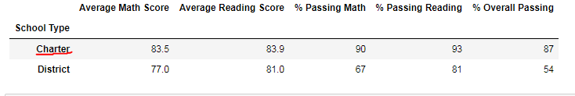

Original:

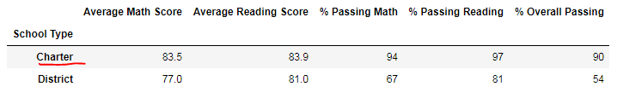

**School Summary:**

Thomas High School lost its 2nd position and has fallen to 8th position after the data was corrected for 9th Graders Math and Reading Scores

Challenge: 8th position

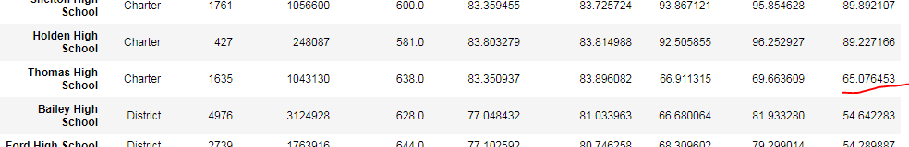

Original: 2nd position

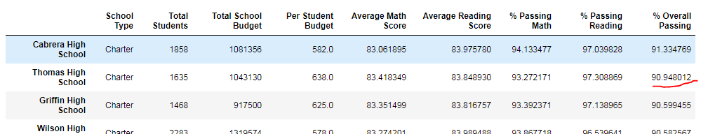

**By Grade:**

From the data screenshots below, we can say that the data for the 9th grade is now showing up as nan. There is no change in any other grade data

Math Reading

Challenge

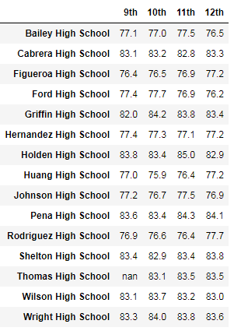

Original

Math Reading

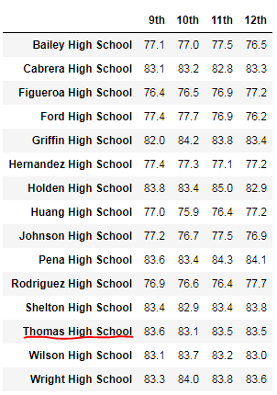 

**By School Spending:**

Thomas High School has a spending range of $630-$644 hence we see that the % Overall passing has dropped. Average is not affected after data correction to NaN but the % Passing Math and % Passing Reading have dropped as well.

Challenge

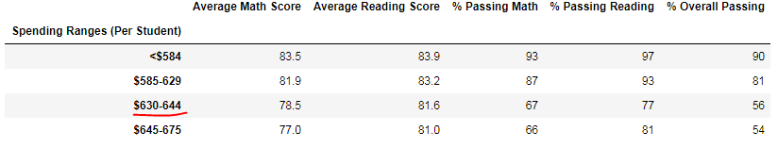

Original

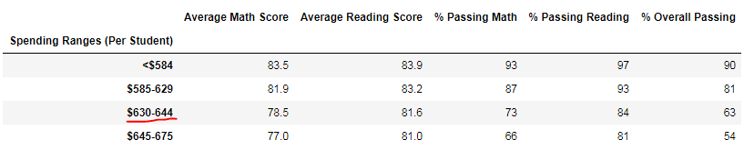

**Scores by School Size:**

Thomas High School is a medium sized school hence we see that the %Overall passing has dropped. Average is not affected after data correction to NaN but the % Passing Math and % Passing Reading have dropped as well.

Challenge

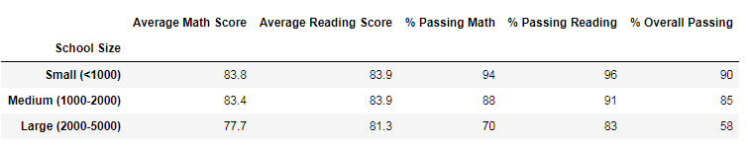

Original

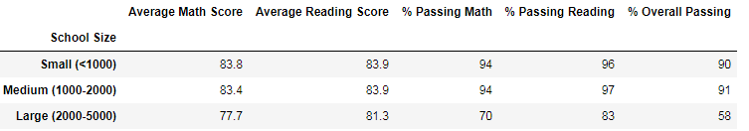

**Scores by School Type:**

From the below comparison, we conclude that the average score for both math and Reading hasn’t been affected – reason being rows with NaN values are not taken into consideration while calculating Mean. However, % Passing Math and % Passing Reading as well as % Overall Passing has dropped for Charter School Type after data correction because Thomas High School is a Charter School. No change in the District School Type.

Challenge:



Original:

