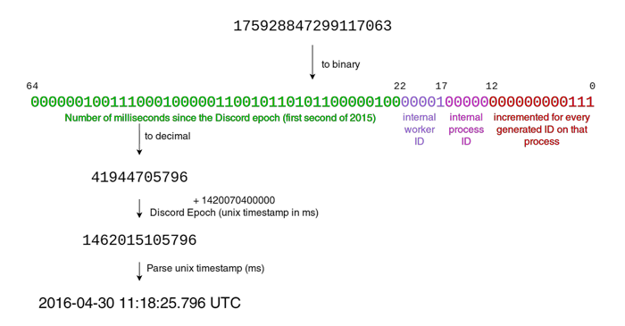
In Javascript: new Date((id / 4194304) + 1420070400000);

// function found on internet
function getCreationDate(id) {
return new Date((id / 4194304) + 1420070400000);
}
getCreationDate("insertId")

// my own function
const getTime = (id) => {
return ((Number(BigInt.asUintN(64, id) >> 22n)) + 1420070400000) / 1000 | 0
}
getTime("instertId")

Exemple: new Date((622716865428324353 / 4194304) + 1420070400000);

