Hi all,

I am developing an ESC (Ethercat Slave Controller) for an educational project. It will run in a harsh industrial environment (not automotive).

I have choose TPS560430YFQDBVRQ1 (among other reasons) because it is small and does not need external schottky diode.

In datasheet page 16 this link appears not to be working:

<https://webench.ti.com/wb5/WBTablet/PartDesigner/quickview.jsp?base_pn=TPS560430&origin=ODS&litsection=device_support>

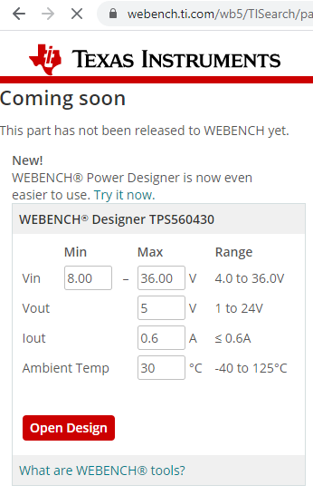

Not a problem, it is a new device. OK, I then follow instructions in page 15

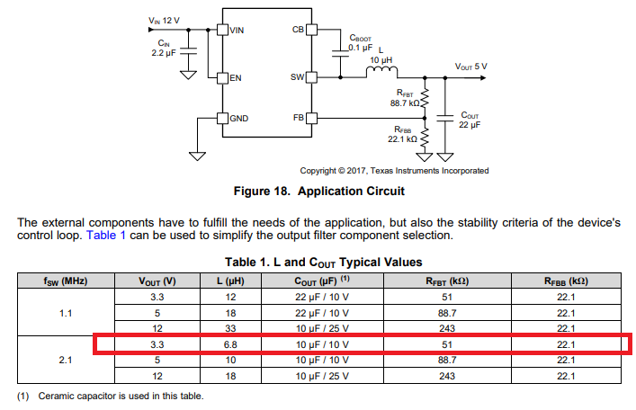

I have prototyped some boards and got them manufactured but I am putting parts by hand so have soldered only power circuit at the moment, then put a load of resistor 220 Ohm to a LED. With 12Vin so far so good. But it does not work with 24Vin.

So my question is (whether it is possible to answer it in this conditions) in regarding to capacitor and inductor size limiting, what values will do it for 24Vin, 3.3Vout at 300mA?

Helpdesk have suggested me this forum will be the right place to ask for help, because I am working from home (as everybody else, I guess) and I have not a scope at my bench right now.

Schematics

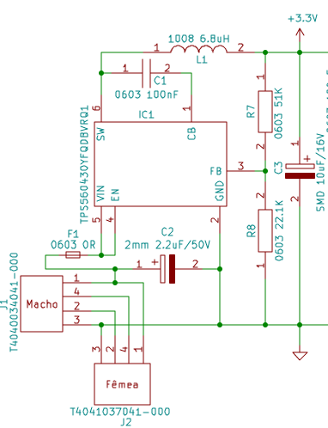

Board

