****Wildfire Risk and Burned Area Simulator

A Deep Learning Approach

Guilherme Polónia Rodrigues

*Orientador*

nome do orientador

*Coorientador*

Prof. Doctor José Brito

Dissertação apresentada  
ao Instituto Politécnico do Cávado e do Ave

para obtenção do Grau de Mestre em Engenharia Eletrónica e Computadores

*Este trabalho não inclui as críticas e sugestões feitas pelo Júri.*

março, 2020

(folha em branco)

****Wildfire Risk and Burned Area Simulator

A Deep Learning Approach

Guilherme Polónia Rodrigues

*Orientador*

Prof. Doctor José Brito

*Coorientador*

nome do coorientador (se aplicável)

Dissertação apresentada  
ao Instituto Politécnico do Cávado e do Ave

para obtenção do Grau de Mestre em Engenharia Eletrónica e de Computadores

*Este trabalho não inclui as críticas e sugestões feitas pelo Júri.*

março, 2020

Declaração

Nome: Guilherme Polónia Rodrigues

Endereço eletrónico: a16000@alunos.ipca.pt

Título da Dissertação: Wildfire Risk and Burned Area Simulator

Subtítulo da Dissertação: A Deep Learning Approach

Orientador: Prof. Doutor José Brito

Coorientador: Nome do Coorientador (SE APLICÁVEL)

Ano de conclusão: março, 2020

Designação do Curso de Mestrado: Mestrado em Engenharia Eletrónica e de Computadores

Nos exemplares das Dissertações /Projetos/ Relatórios de Estágio de mestrado ou de outros trabalhos entregues para prestação de Provas Públicas, e dos quais é obrigatoriamente enviado exemplares para depósito legal, deve constar uma das seguintes declarações:

É AUTORIZADA A REPRODUÇÃO INTEGRAL DESTA DISSERTAÇÃO/TRABALHO APENAS PARA EFEITOS DE INVESTIGAÇÃO, MEDIANTE DECLARAÇÃO ESCRITA DO INTERESSADO, QUE A TAL SE COMPROMETE;

É AUTORIZADA A REPRODUÇÃO PARCIAL DESTA DISSERTAÇÃO/TRABALHO (indicar, caso tal seja necessário, nº máximo de páginas, ilustrações, gráficos, etc.), APENAS PARA EFEITOS DE INVESTIGAÇÃO, MEDIANTE DECLARAÇÃO ESCRITA DO INTERESSADO, QUE A TAL SE COMPROMETE;

DE ACORDO COM A LEGISLAÇÃO EM VIGOR, NÃO É PERMITIDA A REPRODUÇÃO DE QUALQUER PARTE DESTA DISSERTAÇÃO/TRABALHO

Instituto Politécnico do Cávado e do Ave, ___/___/______

Assinatura: ________________________________________________

APOIOS

Nesta folha deve ser feita “alusão aos apoios financeiros sempre que isso acontecer”. Se não a utilizar, selecione desde o início do título desta secção até ao início do título da secção seguinte e remova tudo. (tecla Del Windows ou Shift + Del Mac)

Wildfire Risk and Burned Area Simulator

A Deep Learning Approach

RESUMO

O resumo deve ter entre 200 a 300 palavras no máximo. Esta secção deve ser traduzida para Inglês (ver secções seguintes). (Texto deve ser escrito a TIMES NEW ROMAN tamanho 10 pontos, espaçamento entre linhas 1,5).

O objetivo principal o resumo é informar o leitor sobre: a razão da investigação; como foi feita a investigação; os principais resultados e apresentar as principais conclusões.

No caso de o trabalho ser escrito numa só língua elimine o que vêm escrito na página da esquerda (nesta página) e introduza uma quebra de secção ou passe o texto para branco de forma a não ser impresso.

**Palavras-chave:** Indicar as palavras-chave separadas por vírgulas, até um máximo de 5 palavras-chave.

**WILDFIRE RISK AND BURNED AREA SIMULATOR**

**A DEEP LEARNING APPROACH**

ABSTRACT

The abstract should contain between 200 and 300 words maximum.

This section should be a translation of the Portuguese version of the Abstract (Resumo).

**Keywords:** Write a list of, at most, 5 keywords, comma separated

Agradecimentos

Esta secção é facultativa. Se não a utilizar, selecione desde o início do título desta secção até ao início do título da secção seguinte e remova tudo. (tecla Del Windows ou Shift + Del Mac)

Dedicatória

Esta secção é facultativa. Se não a utilizar, selecione desde o início do título desta secção até ao início do título da secção seguinte e remova tudo (tecla Del Windows ou Shift + Del Mac).

Se a utilizar, mude a cor do texto deste parágrafo e do título da secção para branco (de modo a que não sejam impressos, mas sejam colocados no índice) e coloque a dedicatória desejada no parágrafo seguinte.

*Substituir pelo texto da dedicatória*

Lista de Abreviaturas   
e/ou Siglas

DGT – Direção Geral de Território

EPSG - European Petroleum Survey Group – This group have systematized all Spatial Reference Systems (SRS), naming as ESPG codes. This means a given projection can be identified through EPSG pattern (Direção-Geral do Território, 2020).

ICNF – Instituto de Conservação da Natureza e Floresta

SNIG – Sistema Nacional de Informação Geográfica

WMS – Web Map Services

ÍNDICE

APOIOS I

RESUMO III

ABSTRACT V

Agradecimentos VII

Dedicatória IX

Lista de Abreviaturas e/ou Siglas XI

ÍNDICE XIII

Introdução 1

1. Exemplo de Capítulo/ secção de Nível 1 3

1.1 Exemplo de SubCapítulo/ seccção de Nível 2 3

1.1.1 Exemplo de outro subCapítulo/Secção de Nível 3 3

1.1.1.1 Exemplo de outro Subcapítulo/ Secção de Nível 4 3

1.1.1.1.1 Exemplo de outro Subcapítulo/Secção de Nível 5 3

1.1.1.1.2 Outro Subcapítulo/ Secção de Nível 5 3

1.2 Outro Subcapítulo/ Secção de Nível 2 3

2. Work developed 4

2.1 Analysis and data obtention 4

2.1.1 Shapefiles 4

2.1.2 Wep map services (wms) 5

2.2 Data Processing 7

2.2.1 Program Workflow 7

2.2.1.1 Interface 7

2.2.1.1.1 Interface Layout 7

2.2.1.1.2 Interface Operation 8

2.2.1.2 Shapefile Iteration Process 9

2.2.1.3 Images Generation using shape and WMS 9

3. Outro Exemplo Capítulo/Secção de nível 1 12

Conclusões 14

Referências Bibliográficas 16

Anexos 18

# Introdução

(Segundo o regulamento, esta secção/capítulo (introdução) deve conter “o enquadramento, a motivação para a escolha da problemática, objetivos do estudo, metodologia a ser seguida e a estrutura definida para este trabalho).

# Resume

The scourge of fires is an event that has been increasing in recent years throughout the world, particularly in Portugal.

In order to firefighters being capable of acting in a more efficient and quickly way, the current techniques used to combat fires should be improved. Being that said, the use of tools and techniques to predict the way fire is spread without endangering human lives, is an advantageous solution in many ways, particularly in terms of safety for the population and economically viable.

[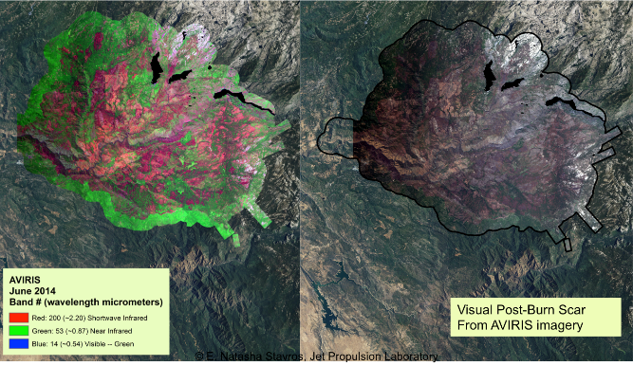](https://www.google.pt/url?sa=i&rct=j&q=&esrc=s&source=images&cd=&cad=rja&uact=8&ved=2ahUKEwj9lI-zqMDdAhWHy4UKHbWyA7wQjRx6BAgBEAU&url=https://www.nasa.gov/jpl/nasaforest-service-maps-aid-fire-recovery&psig=AOvVaw0w9vtmZC2_H9RVw7rDRiCs&ust=1537214412867643)[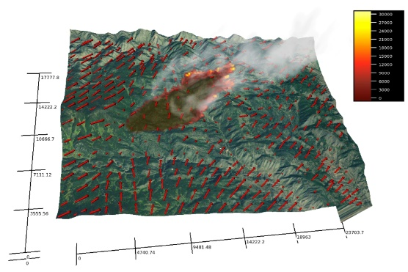](https://www.google.pt/url?sa=i&rct=j&q=&esrc=s&source=images&cd=&cad=rja&uact=8&ved=2ahUKEwiU75uLqMDdAhWpyIUKHYoZBoUQjRx6BAgBEAU&url=https://phys.org/news/2015-04-nasaforest-aid-recovery.html&psig=AOvVaw0w9vtmZC2_H9RVw7rDRiCs&ust=1537214412867643)Fig. 2 – Example of existing fire simulator - NASA/Forest Service Maps Aid Fire Recovery

The aim of this document is to present a proposal of fire risk and burned area simulator based on Machine Learning techniques, more precisely using a deep learning approach. We are willing to develop a solution capable to predict the places predict with highest fire risk as well as the burned area using data from previous fire events.

**Index Terms**— Fire, Fire Detection, Fire Prevention, Fire Risk, Fire Simulation, Fire Damage Assessment, Firefight Technics, Machine Learning, Deep Learning.

# Introduction

## Wildfire Risks and Consequences

In the last years, Portugal, Spain, Italy and Greece were the most severely affected countries in EU by forest fires. In 2016, these four countries account about 85% of the European burnt area. In the EU, in the year 2016 alone, more than 345.000 ha have burned in forest fires [36]. Portugal was particularly affected, with a staggering 161.000 ha of burnt area, roughly 45% of the EU burnt area in 2016, even though Portugal only has 2% of the EU area. In 2017, in continental Portugal alone, the burned area was around 540 000 hectares of forest (Fundação Francisco Manuel dos Santos, 2018), the equivalent of almost 650 000 football stadiums.

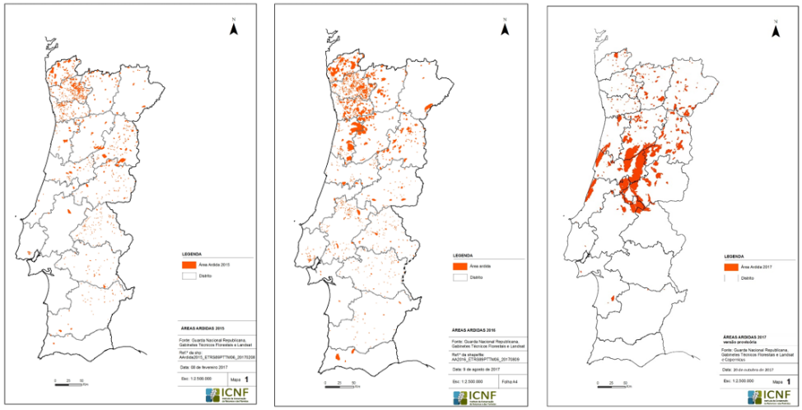

Fig 1 – Portugal burned area progression respectively in: 2015, 2016, 2017

According to [36], “by September 2017 wild fires have burned more than 700.000 ha of land in the EU” [36]. According to the 10th Provisional Report on Forest Fires 2017 [37] from the Portuguese Instituto de Conservação da Natureza e Florestas (ICNF), “between January 1st and October 31st of 2017” the burnt area already surpassed 440.000 ha of burnt area, making the 2017 fire season the worst since 1980, both in terms of property damage and loss of human life.

## Machine Learning vs Deep Learning

The usage of techniques that allow machines take decisions is not new, neither it is from this century. However, it has only begun to gain supporters and its use being spread when the technology evolved in such a way, that permitted it to be implemented on a large scale with relatively affordable costs.

In fact, the introduction of machine learning approaches in the scientific community begun with several AI (Artificial Intelligence) studies. Since then, and until the first machine learning algorithms emerged, there was significant progress. Which would continue and would later evolve into something "deeper" - the deep learning algorithms.

[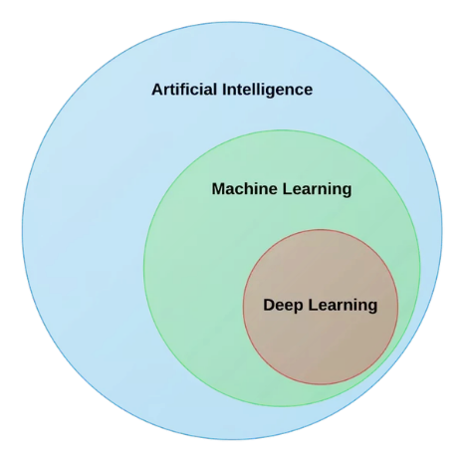](https://www.google.pt/url?sa=i&rct=j&q=&esrc=s&source=images&cd=&cad=rja&uact=8&ved=2ahUKEwjo3-eM4dndAhWxzYUKHdCmBnYQjRx6BAgBEAU&url=https://www.quora.com/What-is-the-key-difference-between-AI-machine-learning-and-deep-learning-What-are-some-real-life-examples&psig=AOvVaw0aJlkZAcP4k3frHafKdVCB&ust=1538088693175539)

Fig. 1. AI overview with its subsets.

The machine learning is characterized by AI techniques giving computers the ability to learn without being explicitly programmed to do so while deep-learning is a subset of machine learning which make the computation of multi-layer neural networks feasible [35], in other words, deep learning is the ability to enable the machine take decisions for its own.

[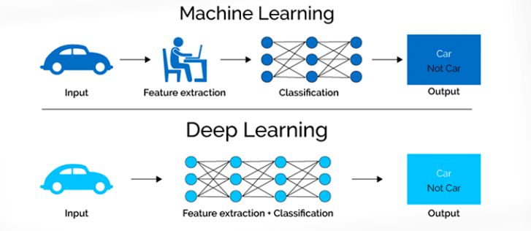](https://www.google.pt/url?sa=i&rct=j&q=&esrc=s&source=images&cd=&cad=rja&uact=8&ved=2ahUKEwiX9puR3dndAhXnzIUKHWdADccQjRx6BAgBEAU&url=http://blog.thinkwik.com/insights-of-the-machine-learning-and-the-deep-learning/&psig=AOvVaw3a--dWQN-8ZUvC4CjgZE--&ust=1538087561016201)

Fig. 2. Machine Learning and Deep Learning Comparison

## Artificial Intelligence Applied in Wildfires

Taking advantage of the latest techniques of machine learning, namely deep learning, one of the main objectives of this work is to design and develop an algorithm capable to learn, through information transmitted to it, and from there relearn and improve the process and decisions make in the future. This information can be taken from the history of fires and its known characteristics such as:

Topographic conditions:

Fire progression area along the time;

Terrain slope;

Water courses;

Vegetation Type;

Atmospheric Conditions:

Wind;

Humidity;

Temperature;

# State of Art

## Introduction

The shortage of effective ways to fight the fires, specially the wildfires, have been a constant during the years. This, together with territorial disorder and the obscure business that has on fire their source of income, led to the increasing number of fires and burned area during the last few decades.

These events have a huge impact in several areas: economy, natural ecosystems and greenhouse effect are some examples.

The economy, mainly the local one, is often dependent of the natural resources, and the fires tend to destroy all these resources. Besides this, the death of several animal species and the destruction of its habitat, has a huge impact on the natural ecosystem as well as on the amount of CO2 generated by the fires, resulting in a significant increase of green-house effect.

For these reasons, the study of wildfires fights and prevention that has been developed during the last years, is a very important step to reduce the number of fires as well as the burned area.

In this way, during the last years, several methods have been developed: UAV (Unmanned Aerial Vehicles) allow us to have an overview of the current scene and improve the way how to fight the fire more efficiently, but on the other hand it still has significant costs because is not a completely developed technology. Other approach which is increasing in popularity is WSN (Wireless Sensor Network). This strategy can achieve great results and help to find a fire in its beginning but because it needs to have sensors spread all over the territory, becomes difficult to maintain it and it is still a very expensive solution. On the other hand, prevention actions can also have a very good impact in avoid big fires, causing an easily firefighters’ intervention, however the prevention actions are worldwide known and rarely applied which means that it is hard to implement them, still more when we talk about big countries with a huge forest zone with very a few populations.

This take us to think on a different way to solve this calamity. Building a software tool capable to improve the accuracy and speed of the decisions taken during a fire.

In this way, use a software simulator can has several advantages over other firefight techniques, such as lower cost, lower maintenance, and safety.

## FIREFIGHT TECHNIQUES – OVERVIEW

### UAV (Unmanned Aerial Vehicles)

Known also as remotely piloted aircraft systems, these new platforms were developed to collect data [1]. Particularly in forest zones, these aircrafts have been studied and applied in way to be a reliable solution in wildfire fight.

In 1961, was experienced the first attempt of forest fires information gathering using a UAV by the United States Forest Services (USFS) Forest Fire Laboratory [2]. Since there, the UAV technology has been developed and began to integrate visual camera and an onboard imaging system to acquire forest fire images [3]. In fact, despite its known benefits such as low material and operational costs, flexible control of spatial and temporal resolution, high-intensity data collection, and absence of risk to crews [4], the application of this technology has been attracted worldwide attention due to the possibility of integration with remote sensing techniques [5] [6] [7] making it possible for UAV to reach a greater potential.

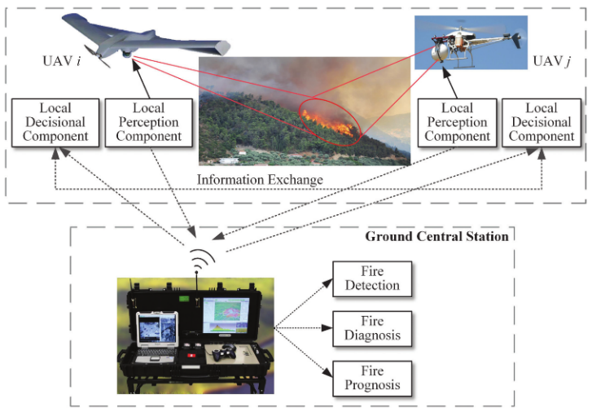

Fig. 3. Conceptual UAV-based forest fire monitoring, detection, and fighting system [6].

As illustrated in Fig. 3, the forest fire monitoring and detection mission is composed of three stages: fire search, fire confirmation, and fire observation [8]. Fire search is realized by a UAV’s fleet, making use of fire vision-based detection capabilities to detect the potential fire focus along the surveillance area [9]. When the alarm is received from one of the UAV’s, the ground central station asks to other UAV’s to confirm the detected alarm, and if there is a confirmation then begins the fire monitoring [9]. Here begins the fire observation stage by repositioning the UAV’s to synchronously obtain images and data of the detected fire from different points of view [10] [9].

Using a vision-based detection technique it is possible supply intuitive and real-time data, detect wide range objects, and make record conveniently [5]. IR (Infra-Red) cameras, generally, have better image quality, which allow us to extract better data from it. However, to reduce implementation costs and deliver more presentative information, it has been tried to develop image processing and computer vision techniques [5].

Vision-based systems fire detection make use of color, motion, and geometry features to obtain fire accurate characteristics results [11] [5].

Despite the advances of this technology, it stills need verification of UAV effectiveness in real forest fire fighting activities in future investigations [6] [5].

“Further investigation is needed on all aspects of their use, including suitable system platforms, remote sensing payloads and sensors, and algorithms for autonomous guidance, navigation, and control (GNC), as well as on using UAVs in combination with other remote sensing techniques” [6].

### Surveillance using Digital Cameras

The fire warning through image processing are quite common and spread all over the world. This is due to the demonstrated efficiency and the advanced development of this technology.

Therefore, we can distinguish the different types of detection sensors [12]:

(i) video-camera, sensitive to visible spectrum of smoke recognizable during the day and a fire recognizable at night;

(ii) infrared (IR), thermal imaging cameras based on the detection of heat flow of the fire;

(iii) IR spectrometers to identify the spectral characteristics of smoke;

(iv) light detection and ranging systems—LIDAR (detection of light and range) that measure laser rays reflected from the smoke particles.

In Table 1, on next page, is shown an overview of the main characteristics of the existing image-based detection systems.

Despite the different types of detection sensors used in terrestrial systems, all have the same general concept: the detection of smoke and fire glow [13]. For each image acquire by the camera the processing unit tracks the motion in images and checks how many pixels contain smoke or fire glow. Then the result is sent for another algorithm to decide whether to produce an alarm for the operator.

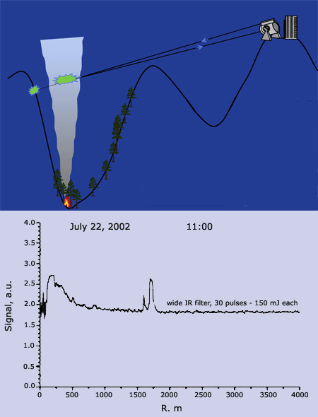

Fig. 4. Principal of Operation of LIDAR Technology (Naturlink - Informação Ambiental, S.A., 2018).

However, despite the good performance that can be achieved, to cover a large forest area it is necessary implement several infrastructures which means a high cost of implementation of this technology, making it almost unfeasible.

Table I

Image-Based Terrestrial Detection Systems Comparison [3]

|  |  |  |  |  |  |  |  |
| --- | --- | --- | --- | --- | --- | --- | --- |
| **Terrestrial Detection System** | **Sensor Technology** | **Sensor Movement** | **Detection Type** | **Detection Radius (Km)** | **Centralization** | **Communications** | **Price per unit** |
| **Bosque System** | Infra-Red and Visual Detection | Positioning System | Semi-automatic | 20 | Centralized and Decentralized | Connection via Radio | 250 K € |
| **BSDS** | Infra-Red Detection | Positioning System | Semi-automatic | 10 – 15 | Decentralized | Radio Connection via GSM | 200 K € |
| **ARTIS FIRE** | Visual Detection | Fixed | Semi-automatic | 10 | Decentralized | Radio Connection via computer network RTC or ISDN | Not Produced Anymore |
| **AWISS** | Infra-Red and Visual Detection | Positioning System | Semi-automatic | 10 | Decentralized | Connection via Radio | Unknown |
| **FIREHAWK** | Visual Detection | Positioning System | Semi-automatic | 3 – 5 | Centralized | Connection via Radio (microwaves) | Unknown |
| **CICLOPE** | Infra-Red and Visual Detection  LIDAR | Positioning System | Semi-automatic | 20 | Centralized | Private and Public Networks (Radio, Optical Fiber, GSM, GPRS, UMTS, PSTN, RDIS) | Unknown |
| **OBSERVA** | Visual Detection | Fixed | Manual | 10 | Centralized | 25 K € |
| **FIREWATCH** | Visual Detection | Fixed | Semi-automatic | 40 | Centralized and Decentralized | Private and Public Networks (Radio, Optical Fiber, Microwaves, Cable GSM, GPRS, UMTS, PSTN, RDIS) | 100 K € |
| **SRD (smoke detection system)** | Visual Detection | Positioning System | Manual | 20 | Decentralized | Cable Connection | Unknown |

### Machine Learning Approaches

Machine learning algorithms use an automatic inductive approach to recognize patterns in data. Once learned, pattern relationships are applied to other similar data to generate predictions for data-driven classification and regression problems [15].

Regarding wildfires, fire detection accuracy can also be improved by using machine learning techniques such as: Support Vector Machines (SVM), Artificial Neural Networks (ANN), Decision Trees (DT), Regression (REG), Clustering and Feed Forward Neural Network (FFNN) [16] [17]. To apply this, there are four steps for machine learning procedure to correlate the output and the input features: 1) Feature selection and output labeling, 2) Sample collection 3) Offline training and 4) Online classification [6] [18] [19].

These algorithms are usually applied in several methods such as or Wireless Sensors Networks Architectures Satellite Imagery or Fire Spread Simulators.

#### WSN (Wireless Sensor Networks)

Wireless Sensor Networks have been developed and mainly used in environments monitoring [13] [20]. Exterior environments, such as smart homes, tracking systems, military fields, agriculture or forests fields were a target of intense studies and applications in the last decade due to the huge improvements that they can obtain from it [20].

WSN is composed by several sensors/nodes connected through a network, capable of sense physical parameters such as the temperature, pressure and humidity, as well as chemical parameters such as carbon monoxide, carbon dioxide, and nitrogen dioxide [13]. These nodes are spread into the environments which cannot be reached easily and which most of the time are not reliable [21].

This technique has become attractive because it can deploy large number of small low-cost sensors, using a wireless communication, avoiding wires, provide real-time monitoring, and works on short communication links, resulting in a more accurate information with less delay provided [13] [20]. Making use of these features, it was developed the ZigBee Protocol. This protocol was built under IEEE 802.15.4, and emphasizes low battery consumption, suited for low data rates and small range communications.

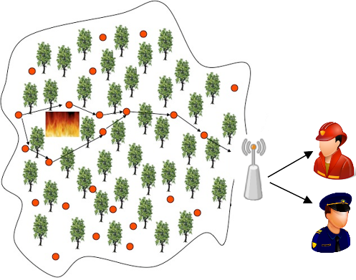

Fig. 5. Typical Wireless Sensor Network distribution nodes, representing a possible communication architecture during a wildfire. (Picture adapted [22])

To ensure the success of WSN technique, the algorithm behind the structure has a huge importance. How much precise and accurate the code is, how much effective the solution will be. Because of this, researches on WSN have been develop Machine Learning optimization algorithms [19].

However, these wireless networks still have some problems implementation concerning to power optimization and security [23].

Once the WSN’s nodes have limited battery it may lead a faster power supply drain, even though the recent sensor nodes are able to get the energy from the environment, when they are under adverse weather conditions it becomes harder. The other problem in WSN is security. All the nodes communicate through wireless medium, this means, any malicious nodes can interrupt the communication by injecting false information or stealing the information [24].

#### Satellite Imagery

Using machine learning algorithms, satellite imagery has been used along the years in multiple scenarios: ecological applications - detection of oil spills, social cases - tackle the case of poverty and environmental studies - spatially explicit predictions of species richness, biomass, and diversity of fish community [15].

Predicting natural hazards using satellites has begun in 2000, and it has changed the way natural disasters are being assessed [24]. If access to timely information is allowed, satellite images provides almost real-time data for forecaster to predict natural hazards, atmospheric interfering such as clouds, smoke and smog grounds distortions in the images retrieved [25].

Satellite active ﬁre data can be used to i) determine the ﬁre start and end dates, thus ﬁre event duration; ii) determine ignition location(s); and iii) evaluate temporal and spatial discrepancies between active ﬁre's observations and simulated ﬁre growth [26]. This method is quite useful to improve other fire fight techniques accuracy in a way to become possible increase the spread area prediction [26].

However, weather conditions are an important problem in these systems. Clouds and rain absorb parts of the frequency spectrum and reduce spectral resolution of satellite imagery which means that good images, and consequently good data quality, can be achieved if there were good weather conditions. So, the performance of this system changes very much. Satellites can monitor a large area, but the resolution of satellite imagery is low. A fire is detected when it has grown quite a lot, so real time detection cannot be provided [27] [28]. Moreover, these systems are very expensive. A satellite is usually designed to perform many diverse

functions (telecommunications, remote-sensing for broad features of the earth’s surface or the atmosphere, etc.) and it is not cost-effective to add to it the capability to detect forest fires [13].

#### Fire Spread Simulators

Develop a simulator capable to predict with the maximum of accuracy requires very hard work. Furthermore, when the simulation has several inconstant variables that are always changing in time, it becomes much more challenger to build a model capable to predict them. Concerning fire, conditioning factors such as weather, topography and fuel patterns along with socioeconomic conditions are all factors that contribute to the complexity and uncertainty of wildfire risk management [29].

Most of the existing simulators such as BEHAVE, FARSITE, FIRETEC [30] use two ways to calculate the fire area: Mathematic models - including empirical, semi-empirical and theoretical [31] - and/or the ellipse propagation model [15] [32] [33].

FIRSITE - Fire Area Simulator – is the most common used simulator for fire spread area prediction [26]. This simulator incorporates raster layers of topography and fuels, as well as weather data (temperature, precipitation, relative humidity, wind and cloud cover) and simulate the surface fire spread as an elliptical wave propagation based on the Huygens' principle to model the expansion of a polygonal fire front through time [26].

Also, the cellular automaton (CA) model, can be interesting in a certain point of view. The aim of this approach is based on the observed evolutions of recent forest fires and an optimization technique (i.e., Genetic Algorithm), a set of input parameters can be optimized and employed to simulate the spread of near future fires [34]. This technique mixes the learning capacity of the machine with statistical models to improve the capacity of feed the dynamical real-time data from sensors into simulation process and recursively adjust the system state estimation to improve accuracy of fire simulation results [34].

There is also WILDFIRE ANALYST, a fire simulator developed by Technosylva companie, but once is not an open source tool there is not much information about it.

Despite the continuous improvement of fire spread simulators, the results are quite fare from the real burned area [34] [26] propagation along time, whereby, it is necessary a readjustment of the used methods in a way that can be possible predict in a short time the development of the fire.

# PROPOSED APROACH

## Proposal Description

Until now, several techniques were approached in a way to better avoid, predict, and/or fight directly the wildfires. However, predict in real time the fire risk and fire spread based on variable conditions such as weather, topography or vegetation type, through deep learning techniques it is an underexplored strand that can produce very good results.

Conjugate these three variables into a single tool, make us much closer to obtain a real time indicator how fire can behave in any conditions. This can provide a very reliable and strong information that can be enormously useful in wildfire fight.

In this way, mapping and analyzing the land surface, in particular forest areas, can give us important information to develop tools capable to relate this important variant to fire spread in each moment.

As we see previously [26] [29], the topographic variable can have a significant impact in the way the flames spread. Making use of data taken before and after wildfire occur and the corresponding historical evolution of each fire, we must be able to translate a relation between topography and fire spread. This relation ca be made using a computer neural network trained to understand the pixel image differences helping in the construction of a correlation between both periods (before fire and after fire occur).

After this stage we will be able to introduce new variables in the model, in this case, the weather conditions. As we know, the weather can have a huge impact when we talk about fires, mainly wildfires. But it is also very important to understand how big this impact can be. If we know that water presence has a positive impact in flames fight, we also must know how factors like air moisture, temperature and wind, can influence the fire progression.

Finally, we aim to add one more factor to the learning network: the vegetation type.

Dense weald, and trees such as eucalyptus and pine are a fast-inflammable fuel, unlike for example, birches, oaks and chestnut trees known as "fire trees". For these reasons, it is easy to infer how important is to know what vegetation type is present on each place.

To realize this work, we will use a GIS map, an interactive spatial data infrastructure, which provides georeferenced cartography at a national scale, using data visualization tools. It contains extensive map coverage, including the ecological network; the soil, relief, water and natural and semi-natural vegetation datasets; and the land use suitability maps.

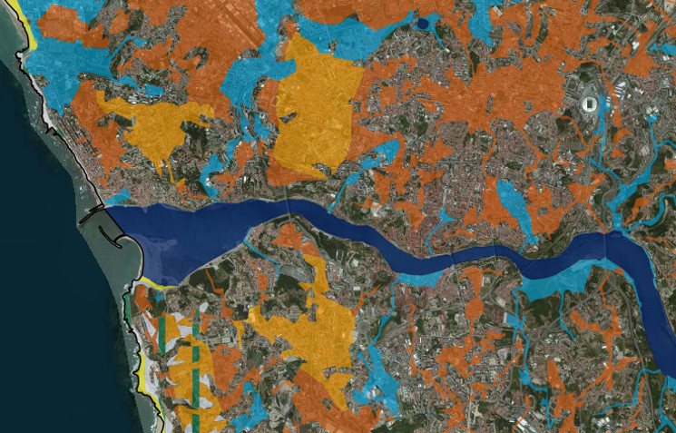

Fig 6. Land Morphology - EPIC WEBGIS PORTUGAL

# Exemplo de Capítulo/ secção de Nível 1

## Exemplo de SubCapítulo/ seccção de Nível 2

Note-se que as palavras de seccção nível 2 também são iniciadas com maiúsculas. As letras têm tamanho de 10 pontos e a Negrito.

### Exemplo de outro subCapítulo/Secção de Nível 3

Nas secções de nível 3 e inferior as palavras ainda são iniciadas por maiúsculas, com 10 pontos mas sem o Negrito.

#### Exemplo de outro Subcapítulo/ Secção de Nível 4

Este tipo de título deixa de ter só maiúsculas, 10 pontos e volta a estar em Negrito.

##### Exemplo de outro Subcapítulo/Secção de Nível 5

Neste tipo de secções o título distingue-se do Texto corrente meramente pela fonte e pelo itálico. É o menor nível da estrutura de segmentação.

##### Outro Subcapítulo/ Secção de Nível 5

Qualquer secção, se tiver subsecções, deve ter sempre duas ou mais, pois caso contrário, não faria sentido estar a seccionar.

## Outro Subcapítulo/ Secção de Nível 2

Non eram nescius, Brute, cum, quae summis ingeniis exquisitaque doctrina philosophi Graeco sermone tractavissent, ea Latinis litteris mandaremus, fore ut hic noster labor in varias reprehensiones incurreret. nam quibusdam, et iis quidem non admodum indoctis, totum hoc displicet philosophari. quidam autem non tam id reprehendunt, si remissius agatur, sed tantum studium tamque multam operam ponendam in eo non arbitrantur. erunt etiam, et ii quidem eruditi Graecis litteris, contemnentes Latinas, qui se dicant in Graecis legendis operam malle consumere. postremo aliquos futuros suspicor, qui me ad alias litteras vocent, genus hoc scribendi, etsi sit elegans, personae tamen et dignitatis esse negent.

Contra quos omnis dicendum breviter existimo. Quamquam philosophiae quidem vituperatoribus satis responsum est eo libro, quo a nobis philosophia defensa et collaudata est, cum esset accusata et vituperata ab Hortensio. qui liber cum et tibi probatus videretur et iis, quos ego posse iudicare arbitrarer, plura suscepi veritus ne movere hominum studia viderer, retinere non posse. Qui autem, si maxime hoc placeat, moderatius tamen id volunt fieri, difficilem quandam temperantiam postulant in eo, quod semel admissum coerceri reprimique non potest, ut propemodum iustioribus utamur illis, qui omnino avocent a philosophia, quam his, qui rebus infinitis modum constituant in reque eo meliore, quo maior sit, mediocritatem desiderent.

# Work developed

## 2.1 Analysis and data Gathering

To develop any kind of work related to neural networks or machine learning processes, it is necessary a solid and well-maintained database or datasets. These data must be studied and understood to avoid conflicts during the development or misunderstandings when interpreting the results.

This work was developed based on datasets supplied by ICNF (Instituto de Conservação da Natureza e Floresta), DGT (Direção Geral de Território) and SNIG services (Sistema Nacional de Informação Geográfica) in cooperation with Registo Nacional de Dados Geográficos - all these entities from Portugal.

From DGT it was obtained the shapefiles, important to know with best precision the shape of each burned area. In other hand, from DGT and SNIG it was used its web map services (WMS) to obtain the Land Occupation Map and Land Digital Model with 50m resolution for each shape area.

### 2.1.1 Shapefiles

The shapefiles were downloaded directly from ICNF website (http://www2.icnf.pt/portal/florestas/dfci/inc/mapas) and it makes available some data related to each fire occurred in the related years namely:

* **Fire Shape** – This shape is in fact a polygon made from a set of pair coordinates represented in *EPSG:3763*;
* **Fire Epicenter Coordinates** – All shapes have a fire ignition point. This point is indicated through a pair of coordinates (x,y) represented in *EPSG:3763* and it shows where the fire must have started.
* **Bounding Box Shape** – Through four (x,y) points, a bounding box of each shape is drawn and makes possible resize the image centered on shape.

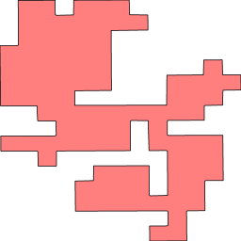

Figure - Bounding Box Delimitation

* **Other Data Present on Shape** – Beyond the previous described information, each shape has other descriptive information that can be useful or not depending what is intended to do. The table below shows the fields present on the files in 2017:

Table 1 - Fields present in shapefile with detailed information of each fire in 2017

|  |  |
| --- | --- |
| Shapefile Year | Available Fields |
| 2017 | Fire Information Management System Code, Source, Name, District, Burned Area Type, Year, Settlement Area, Bush Area, Agriculture Area, Total Area, Relight, Slash, False Alarm, Small Fire, Fire, Agricultural, Alert Date, Alert Hour, Local, Town Hall, Village, Alert Source, Epicenter Coordinates (x,y), Fire Cause Code, Fire Cause Description, Begin Date and Hour, End Date and Hour, Duration, Burned Area (ha/h), Fire Extinction Date, Fire Extinction Hour, First Intervention Day, First Intervention Time, Geographical System Information Area. |

### 2.1.2 Wep map services (wms)

The SNIG, has a set of several services available on <https://snig.dgterritorio.gov.pt/rndg/srv/por/catalog.search#/home>. These services allow download a portion or an entire map of Portugal including the isles (Açores and Madeira). On this work, the services made possible extract some maps according to each shape bounding box, namely the COS2018 and the altitude map.

These kind of services (wms) have two stages that must be performed in order to get the final map. First, it should be sent the url and its version and after that must be sent particular parameters in order to get back the intended map. The flow is explained in the figure below:

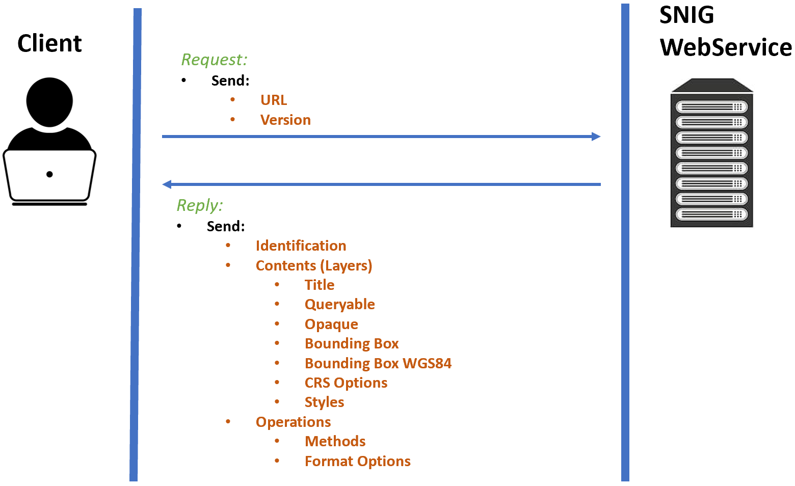

Figure 2 - First Stage: WMS Request Structure

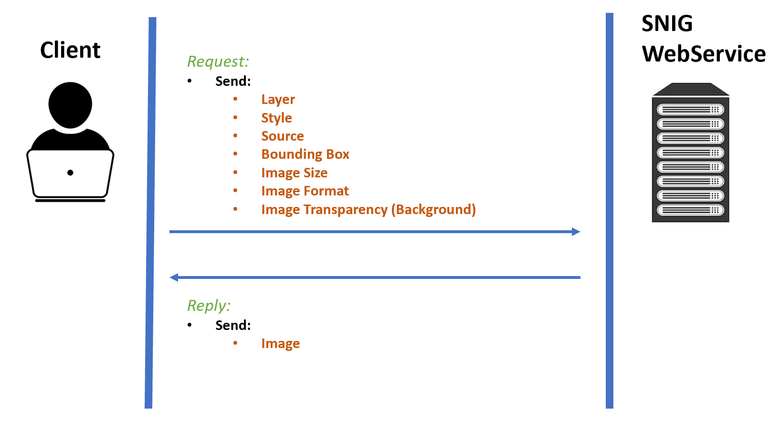

Figure 3 - Second Stage: WMS Image Request

On code side, these operations can be executed using ***owslib*** library for python. When using it, it must be imported ***WebMapService*** class. After this step it is possible to request any map available on the service as shown in the next figure:

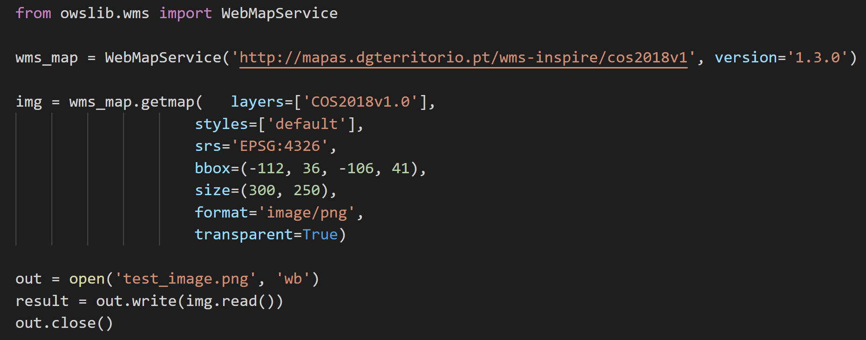

Figure 4 - Code snip invoking a WMS service and saving the returned image

## 2.2 Data Processing

During this work it was necessary develop a program to generate the images needed to train the neural network. To do so, it was used Visual Studio Code IDE to develop the program and Python 3.7.4 version as programming language. It was also necessary save the files generated during the development in a cloud repository, for this purpose it was made an integration between the Visual Studio Code and GitHub where it was created a repository folder only for final code releases.

### 2.2.1 Program Workflow

The program is composed by 3 parts: Interface, Shapefile Iteration Processing and Images Generation using shape and WMS.

The result is a folder tree where each shape match with a folder containing the corresponding COS image, shape image and altitude image.

#### 2.2.1.1 Interface

The interface of this program appears to become easier the interaction between the user and all program process.

##### 2.2.1.1.1 Interface Layout

The layout is composed by one label next to a button “*Load Shape File*” to get the path until the shapefile intended to be processed. Two radio buttons, one for processing shapefiles and other to generate the final images that will feed our neural network, and finally two buttons at the bottom to proceed with the process or to exit the application.

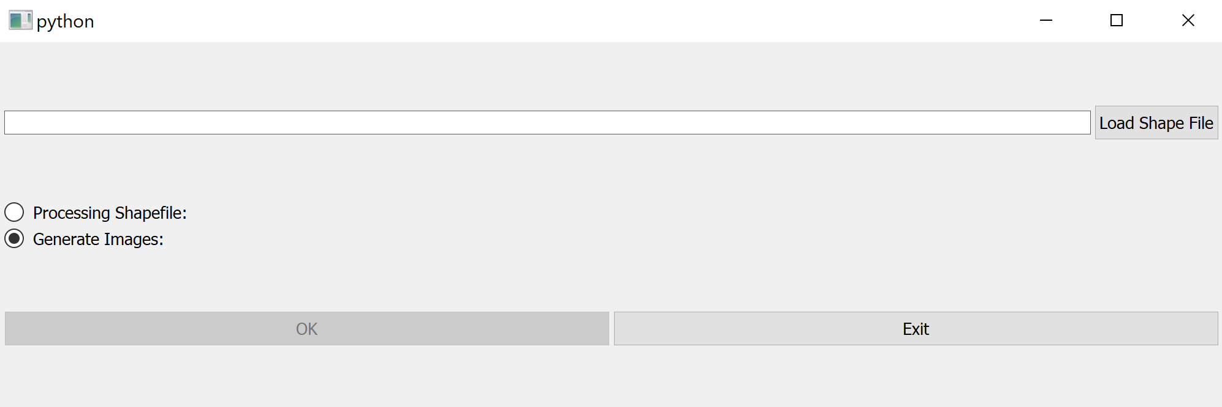

Figure 5 - Interface Application Layout when second radio button is checked (default behavior)

Additionally, in case the first button is checked, it appears also a second label next to button “*Select Save Path*” and two extra input labels bellow, which have the limits we want filter for our shapefile.

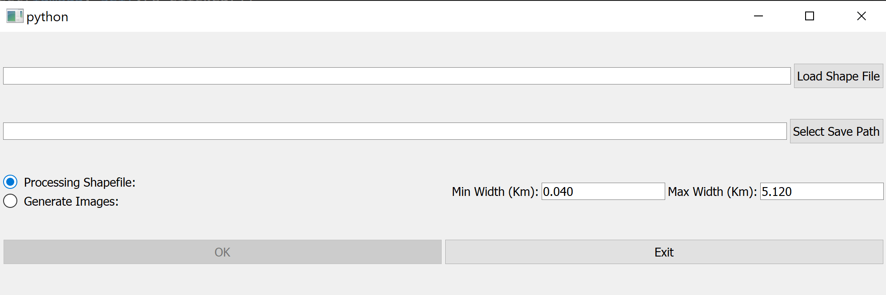

Figure 6 - Interface Application Layout when first radio button is checked

##### 2.2.1.1.2 Interface Operation

It is possible runs the interface in two ways: in Processing Shapefile mode or in Generate Images mode.

This happens because the program offers the possibility, in a first phase, to remove the shapes that should not be processed in the second phase, to avoid loss of processing time.

First phase is optional but, as it was said earlier, it can helps saving time to the next phase. It is performed always the first radio button is checked and consists of, from a first shapefile, remove all shapes where its width or height are lesser or bigger than the limits we define in the interface, generating a new shapefile.

When this phase is executed, to proceed, we must select the shapefile we want process using the first button “*Load Shape File*”. Here, a new window will open to let the user select the file. After this, the path will be automatically written on first input label. Then, must be chosed the folder where the new file will be saved on. Similarly, when “*Select Save Path*” button is clicked, it will also open a new window to help in the process and the final path will be automatically written on second input label. This process is illustrated in Figure 7.

By default, the new shapefile will be named as *new_file.shp* as well as the other obligatory files that are generated with this *.shp* file.

**Note:** The “*OK”* button will only be enabled when the path/paths are filled correctly

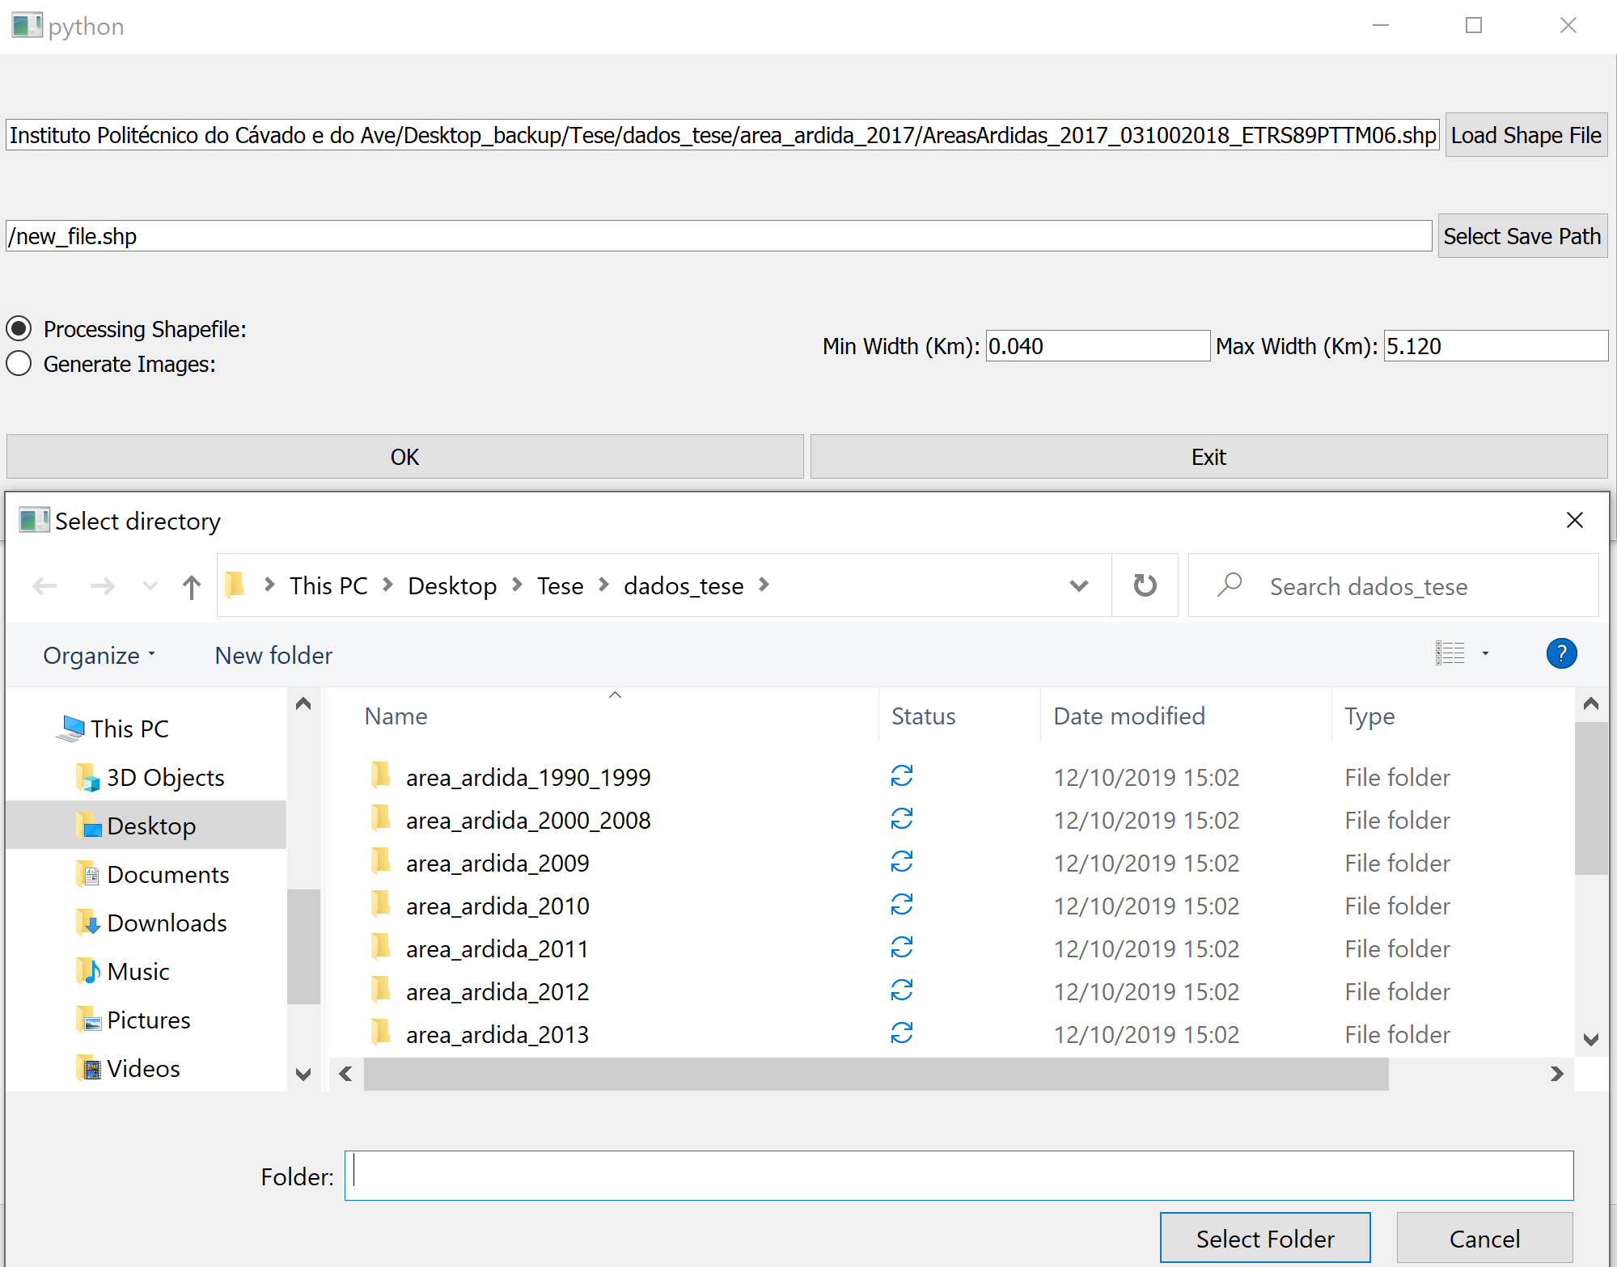

Figure 7 - Selecting folder process to save new shapefile

#### 2.2.1.2 Shapefile Iteration Process

This process allows to remove shapes not needed to images generation process.

After load the shapefile, this file is iterated shape by shape. Each iterated item presents several information such as the polygon points (allowing build the shape), the EPSG code reference, shape bounding box and fire occurrence data.

Using *Haversine* library for python and bounding box coordinates points, it is possible to estimate the approximate distance value (km) for each shape both in width and in height. From there, the shapes out of the range distances predefined initially in the interface, will not be added to the new shapefile. The next figure shows the flow:

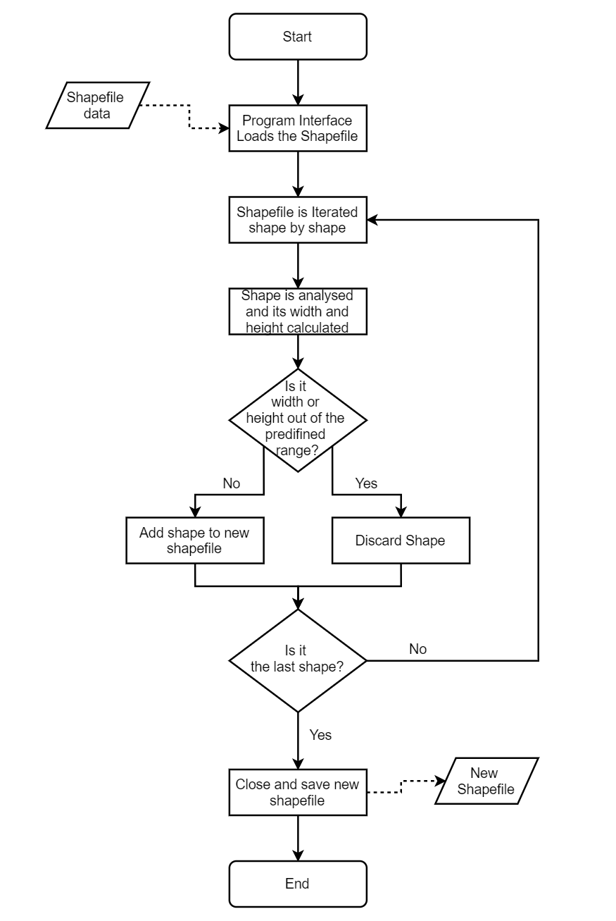

Figure 8 - Shapefile Iteration Process Workflow

#### 2.2.1.3 Images Generation using shape and WMS

The image generation process unfolds using a shapefile draw and wms request with the same coordinates. These two steps are developed inside the, iteration of the file generated on the previous stage. By each shape, it is possible draw the shapefile image and get the corresponding land cover letter image as well as extract some information as begin/end fire occurrence date and burned area, between others.

To get the desired image dimensions (256x256) it is necessary manipulate the image. Each iterated shape makes available its own boundary box. This box has a set of four coordinates (ESPG:3763) allowing calculate the box center point and then convert it to latitude/longitude coordinates (EPSG:4326).

Based on desired maximum width and height real values (in meters) image and python ***pyproj*** library, it is possible to calculate the new maximum coordinates values of final image. This way we ensure the output image resolution as desired.

# Outro Exemplo Capítulo/Secção de nível 1

Non eram nescius, Brute, cum, quae summis ingeniis exquisitaque doctrina philosophi Graeco sermone tractavissent, ea Latinis litteris mandaremus, fore ut hic noster labor in varias reprehensiones incurreret. nam quibusdam, et iis quidem non admodum indoctis, totum hoc displicet philosophari. quidam autem non tam id reprehendunt, si remissius agatur, sed tantum studium tamque multam operam ponendam in eo non arbitrantur. erunt etiam, et ii quidem eruditi Graecis litteris, contemnentes Latinas, qui se dicant in Graecis legendis operam malle consumere. postremo aliquos futuros suspicor, qui me ad alias litteras vocent, genus hoc scribendi, etsi sit elegans, personae tamen et dignitatis esse negent[1].

Contra quos omnis dicendum breviter existimo. Quamquam philosophiae quidem vituperatoribus satis responsum est eo libro, quo a nobis philosophia defensa et collaudata est, cum esset accusata et vituperata ab Hortensio. qui liber cum et tibi probatus videretur et iis, quos ego posse iudicare arbitrarer, plura suscepi veritus ne movere hominum studia viderer, retinere non posse.[2] Qui autem, si maxime hoc placeat, moderatius tamen id volunt fieri, difficilem quandam temperantiam postulant in eo, quod semel admissum coerceri reprimique non potest, ut propemodum iustioribus utamur illis, qui omnino avocent a philosophia, quam his, qui rebus infinitis modum constituant in reque eo meliore, quo maior sit, mediocritatem desiderent.

Sive enim ad sapientiam perveniri potest, non paranda nobis solum ea, sed fruenda etiam [sapientia] est; sive hoc difficile est, tamen nec modus est ullus investigandi veri, nisi inveneris, et quaerendi defatigatio turpis est, cum id, quod quaeritur, sit pulcherrimum. etenim si delectamur, cum scribimus, quis est tam invidus, qui ab eo nos abducat? sin laboramus, quis est, qui alienae modum statuat industriae? nam ut Terentianus Chremes non inhumanus, qui novum vicinum non vult 'fodere aut arare aut aliquid ferre denique' -- non enim illum ab industria, sed ab inliberali labore deterret --, sic isti curiosi, quos offendit noster minime nobis iniucundus labor.

Iis igitur est difficilius satis facere, qui se Latina scripta dicunt contemnere. in quibus hoc primum est in quo admirer, cur in gravissimis rebus non delectet eos sermo patrius, cum idem fabellas Latinas ad verbum e Graecis expressas non inviti legant. quis enim tam inimicus paene nomini Romano est, qui Ennii Medeam aut Antiopam Pacuvii spernat aut reiciat, quod se isdem Euripidis fabulis delectari dicat, Latinas litteras oderit?

Non eram nescius, Brute, cum, quae summis ingeniis exquisitaque doctrina philosophi Graeco sermone tractavissent, ea Latinis litteris mandaremus, fore ut hic noster labor in varias reprehensiones incurreret. nam quibusdam, et iis quidem non admodum indoctis, totum hoc displicet philosophari. quidam autem non tam id reprehendunt, si remissius agatur, sed tantum studium tamque multam operam ponendam in eo non arbitrantur. erunt etiam, et ii quidem eruditi Graecis litteris, contemnentes Latinas, qui se dicant in Graecis legendis operam malle consumere. postremo aliquos futuros suspicor, qui me ad alias litteras vocent, genus hoc scribendi, etsi sit elegans, personae tamen et dignitatis esse negent.

Iis igitur est difficilius satis facere, qui se Latina scripta dicunt contemnere. in quibus hoc primum est in quo admirer, cur in gravissimis rebus non delectet eos sermo patrius, cum idem fabellas Latinas ad verbum e Graecis expressas non inviti legant. quis enim tam inimicus paene nomini Romano est, qui Ennii Medeam aut Antiopam Pacuvii spernat aut reiciat, quod se isdem Euripidis fabulis delectari dicat, Latinas litteras oderit?

Conclusões

(Nesta secção é o local “onde se apresentam os aspetos centrais do trabalho, se relacionam os objetivos previamente enunciados com os resultados encontrados e se referem os contributos, constrangimentos e expectativas futuras”)

Referências Bibliográficas

(As referências bibliográficas devem seguir as normas APA de acordo com o regulamento em vigor.)

Anexos

(Após definir os anexos introduzindo nas páginas destinadas esse fim a informação pretendida deve colocar em cada uma das páginas uma descrição do anexo, utilizando o estilo **Anexos-IPCA**. Após ter todos os anexos prontos pode gerar um índice automático com base nessas descrições.)

1. Non eram nescius, Brute, cum
2. Graecis litteris, contemnentes Latinas