**Instructions for the 2BRobots SkyKontrol IoT controller**

The controller must be powered with regulated **12 VDC**. When the controller is operating normally, the green **READY** LED will remain on. It is possible that during the initialization sequence several LEDs turn on and off.

If the green **READY** LED starts blinking individually, it means that a firmware update is in progress, you should not interrupt this process since you could leave the controller unusable and it should be sent back for reprogramming.

The blue **WIFI** LED indicates the status of the Wi-Fi connection, when a connection is available, this LED will remain on. It may flash momentarily during data transmission, and it will also flash constantly during network scanning. When the controller is in Wi-Fi configuration mode, the green **READY** LED and the blue **WIFI** LED will flash consecutively.

The input of pulses from the coin acceptor (**CNT**) in the controller is of the open collector type. This means that the wallet must send a low logic signal (GND) every time it receives a coin and in a standby state it must be floating (no voltage). The pulses must have a minimum width of 10ms active and a separation of 5ms between pulses. This is a high-speed digital input, connecting unfiltered signals can cause erratic behavior.

Also this controller can block the coin acceptor through the **BLK** output, the output is open collector and when active sends a low logic signal (GND). As well as turn on the red **BLOCK** LED indicating it.

When the built-in output relay is activated the yellow **RELAY** LED will remain on.

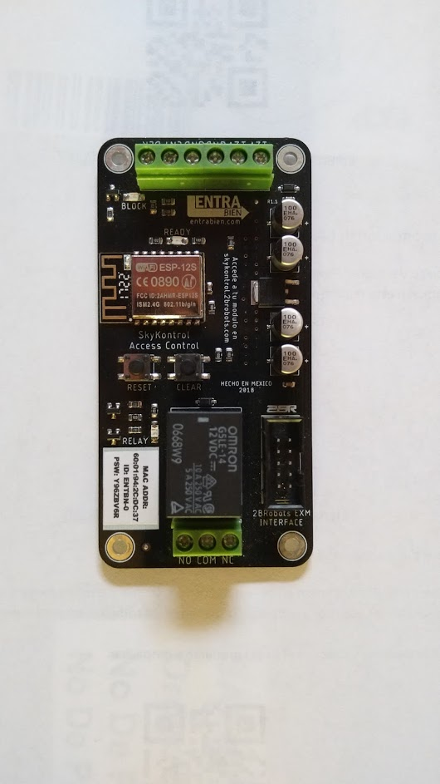

**How to modify the configuration:**

To modify parameters such as price, opening time and blocking, as well as consulting the history of events, you must enter the page [skykontrol.2brobots.com](http://skykontrol.2brobots.com)

You will be asked for the ID and Password, these are the ones that are written on the label of each controller. It is essential that you are connected to the internet for the configuration to take effect. It may take several minutes for the synchronization to occur, if you want the change to be instantaneous you can force it by pressing the **RESET** button.

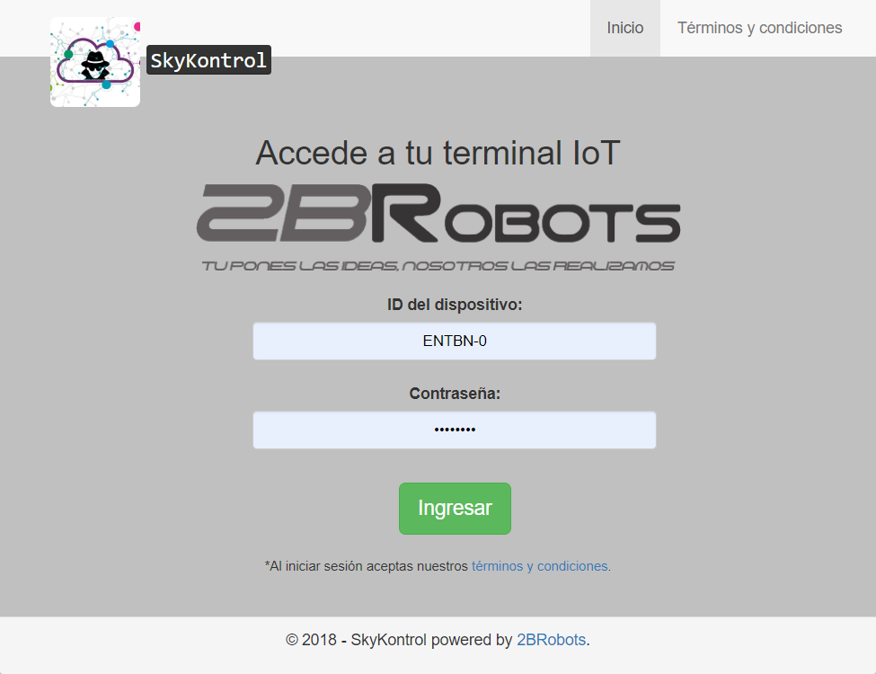

**Note**: If you have an official accessory connected to the EXM interface, you will see it on this platform, and you can configure it if required. For the platform to be updated you must turn on your controller with an internet connection and the accessory installed. Then login and you will see how the corresponding settings and notices appear. *Some accessories require additional configurations that are not shown on the platform, our technical advisors will help you.*

**How to connect the Wifi network:**

1. The first time you turn on the controller, it will start in Wi-Fi configuration mode. The **READY** and **WIFI** LED will flash consecutively. To access this mode later, press the **CLEAR** button, you will notice that the **READY** LED will flash once. Then press the **RESET** button.
2. 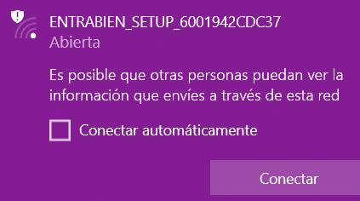Now use your computer, cell phone or tablet to access the Wi-Fi network “2BROBOTS_SETUP_macAddr” and connect to it.
3. Once connected, a window will open automatically asking you to choose a network in the list and enter your password. If it does not open automatically, enter the browser and enter the address “192.168.1.1”. If your network does not appear in the list, it means that it was not visible at the time of scanning or is not compatible.

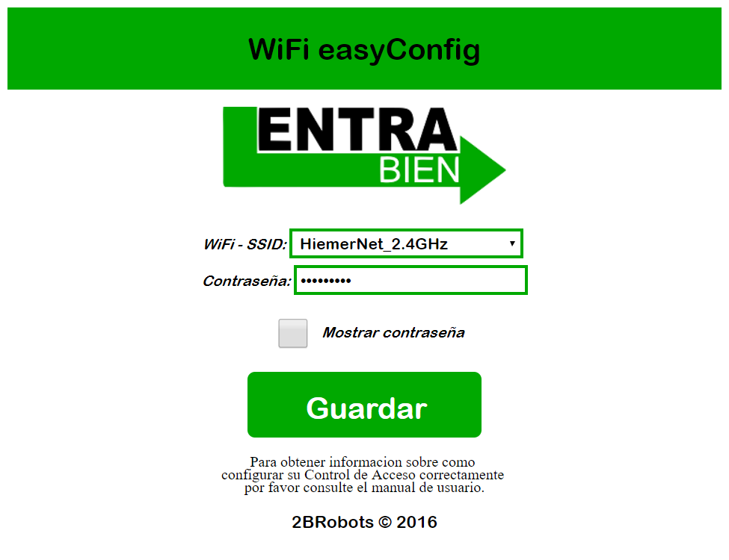

1. Once you have entered this information, click on Save. Next, you will be shown a screen with the settings you entered. To continue press the **RESET** button, the initialization sequence will begin and if everything is correct you will be connected to the Wifi network.

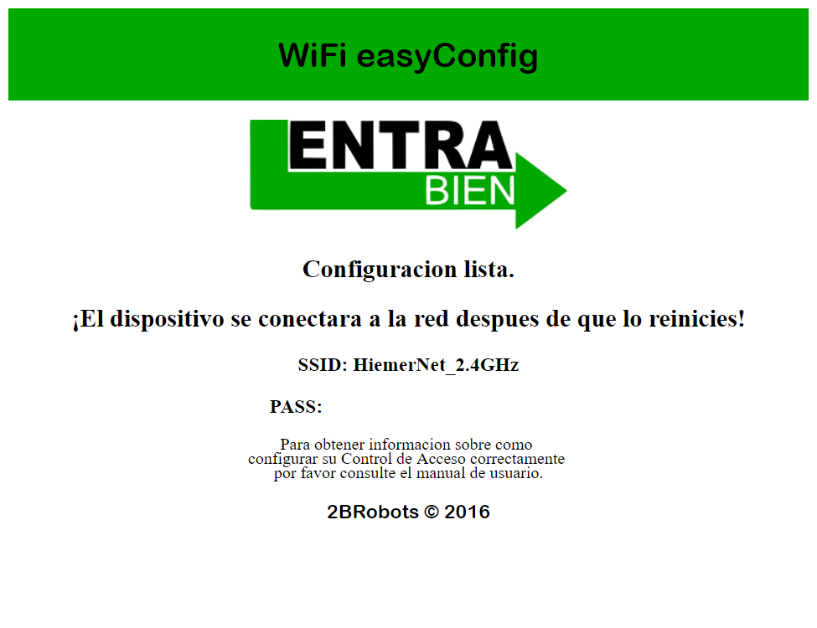

1. You need to enter a Wi-Fi network so that the controller can start working for the first time and download the configuration from the platform. If the network is subsequently unavailable it simply will not connect to it and will continue to function normally. The network access and configuration data are stored in the memory indefinitely, to clear them press the **CLEAR** button. If you do this you will have to reconfigure your controller, since at the time of restarting or turning it on again it will be in Wi-Fi configuration mode.

If for any reason you have any problem during this process you can always press the **RESET** button and try again from the beginning.

**Note:** Keeping your controller connected to the internet ensures that you can configure it at anytime from anywhere in the world, as well as log all events and be able to check them in the log. It also keeps you up to date with security and functionality updates.

*Any questions or if you need assistance contact us by email* ***hi@2brobots.com***