Touchstone 3: Visual Design and Responsive Layout
Name | Branden Bellfield
Course | Introduction to Web Development
Date | September 21, 2026
Selected Client | Client A: North Star Bakery

Section 1: GitHub Link
GitHub repository: https://github.com/2Booty/Touchstone-NSB-Sophia

Section 2: Design Explanation

Respond to each prompt below. Focus on explaining your design decisions.

Your responses should reference specific elements from your website. General descriptions without examples may receive reduced credit.

Note: Your design should use 2 to 4 colors and no more than 2 font families, applied consistently across all pages.

Client Alignment

Explain how your design choices support your selected client’s goals and audience. Include at least one specific example from your website.
I kept North Star Bakery simple and welcoming because it serves local customers and families. The brown headings and cream background fit the handmade bakery theme. On the home page, the cookie photo, price, and pickup link help visitors find the weekly item quickly. The contact page keeps the hours and address near the request form so customers can plan a visit.

Color Palette
List the 2 to 4 main colors you used (you may include hex codes). Explain how these colors support your client’s tone and ensure readability. Include one example of where you applied these colors.
I used cream (#faf6ef), brown (#654331), dark brown (#352b26), and white (#ffffff). Cream is the page background, while brown is used for headings, links, borders, and the button. Dark brown text is easy to read on the cream background, and white form fields stand out from the page. The request button uses white text on brown so its label is clear.

Typography

Identify the font or font pair you used. Explain how your choices support readability and create visual hierarchy. Include one example of how you used font size, weight, or style.
I used Georgia for headings and Arial for the rest of the text. Georgia gives the bakery headings a traditional look, while Arial keeps paragraphs and form labels easy to read. The main heading is 32px on phones and 40px on larger screens, while body text stays at 16px. Smaller section headings and bold form labels help visitors scan the page.

Responsive Design

Describe how your layout adapts across screen sizes. Include at least one specific example of a layout, spacing, or content change.
I started with a single-column layout for small screens. At 768px and wider, a media query changes the Flexbox layouts from columns to rows. For example, the home page cookie photo sits above its description on a phone and beside it on a desktop. The contact form and visiting information also sit side by side on larger screens, and the main top padding increases from 28px to 40px.

Design Challenge

Describe one design challenge you encountered. Explain how you addressed it and what change you made.
One challenge was changing the earlier desktop-first CSS into a mobile-first layout. I made the stacked layout the default and moved the row layouts into a min-width media query. I also used max-width: 100% on images and width: 100% on form fields so they fit their containers. I checked the pages at 320px, 375px, 768px, and 1280px and found no sideways scrolling.

Section 3: Submission Checklist
Done
Section 4: Screenshot
Include one screenshot of your website that demonstrates a design decision you described above.
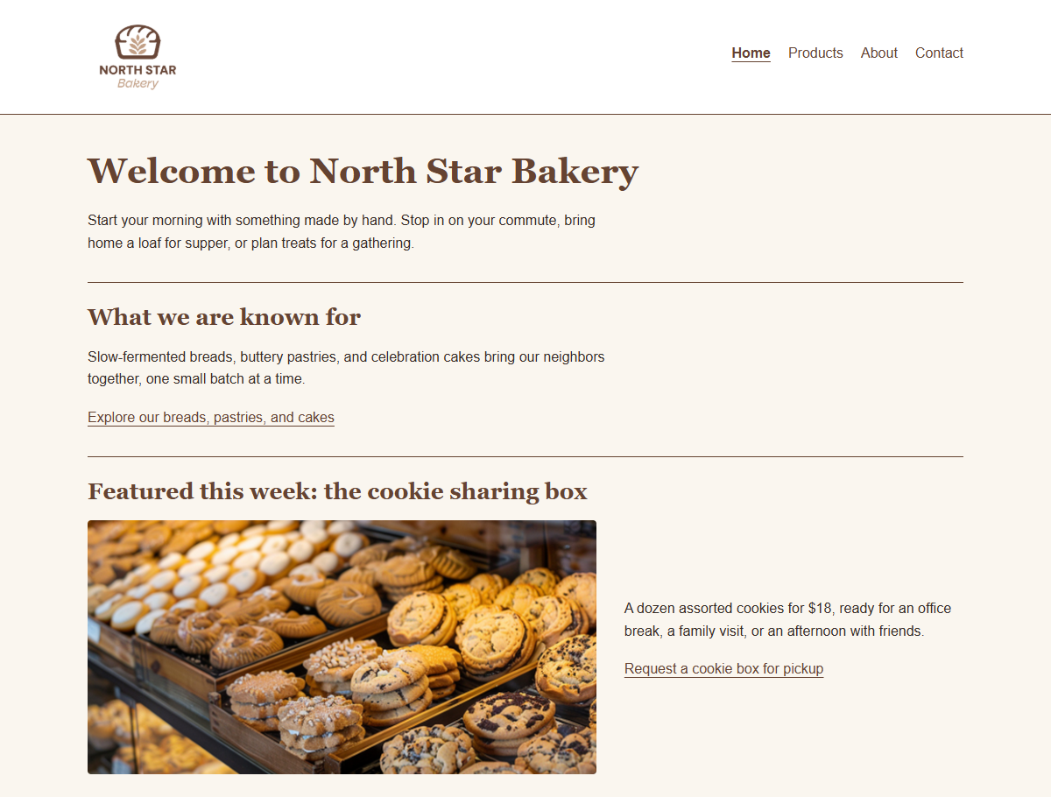
Home page at 1200px wide. The screenshot shows the cream and brown colors, Georgia headings, and the cookie photo beside the description after the 768px media query applies.

