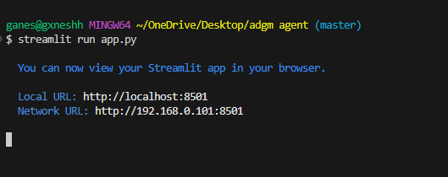

Run the given code on bash using this command and stream lit will  
 host the website in its server  
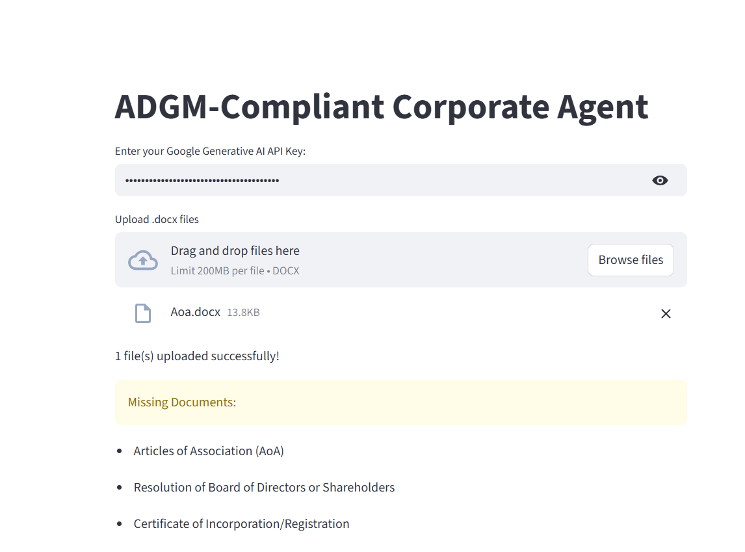 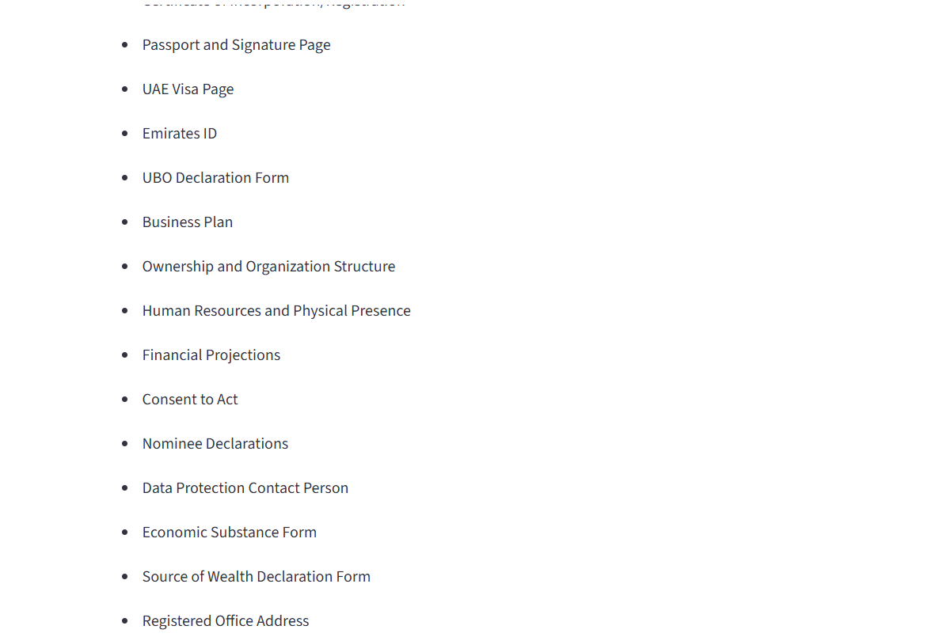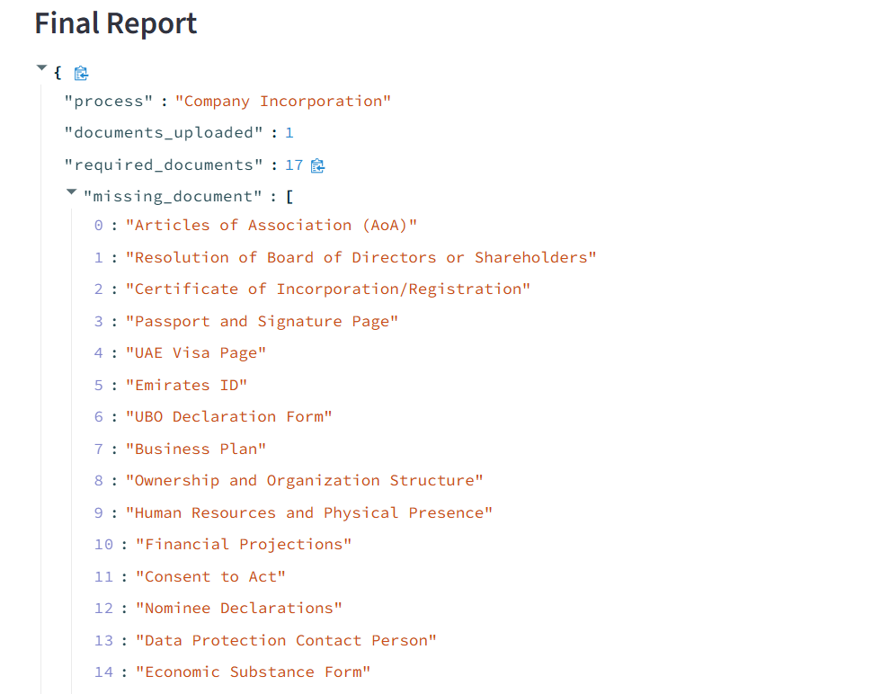

**Output**

{"process":"Company Incorporation",

"documents_uploaded":1,

"required_documents":17,

"missing_document":

["Articles of Association (AoA)",

"Resolution of Board of Directors or Shareholders",

"Certificate of Incorporation/Registration",

"Passport and Signature Page",

"UAE Visa Page","Emirates ID",

"UBO Declaration Form",

"Business Plan",

"Ownership and Organization Structure",

"Human Resources and Physical Presence",

"Financial Projections",

"Consent to Act",

"Nominee Declarations",

"Data Protection Contact Person",

"Economic Substance Form",

"Source of Wealth Declaration Form",

"Registered Office Address"],

"issues_found":[]}