**Text Editor**

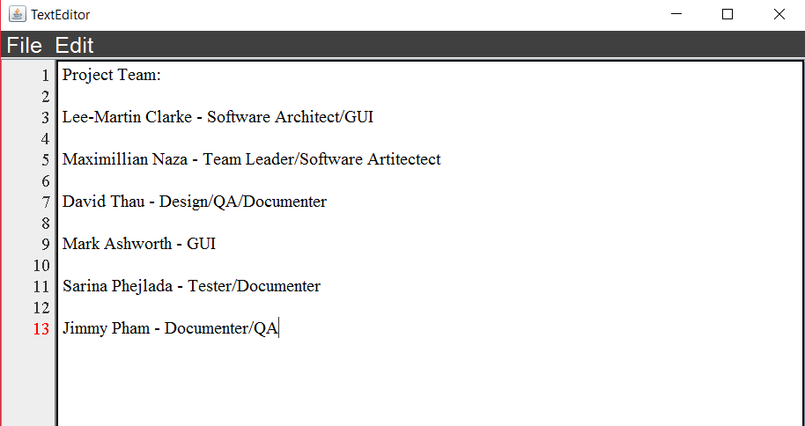

**Table of Contents**

**Class Diagram:****4**

**Functional Specification:****5**

File: 5

Edit: 5

New File: 5

Open: 5

Save As: 5

Cut: 5

Copy: 6

Paste: 6

Delete: 6

Select All: 6

**Test Cases:****6**

File: 6

Edit: 7

New: 7

Open: 7

Up One Level: 7

Desktop: 7

Create New Folder: 8

List: 8

Details: 8

File Name: 8

Save: 8

Save As: 9

Cut: 9

Copy: 9

Paste: 9

Delete: 9

Select All: 10

Customize: 10

**Deployment:****11**

**User Manual:****12**

File: 13

Create New File: 13

Opening Files: 13

Saving Files: 14

Edit: 14

Cutting Text: 15

Copying Text: 15

Pasting Text: 15

Delete: 15

Selecting All Text: 15

# 

# **Class Diagram:**

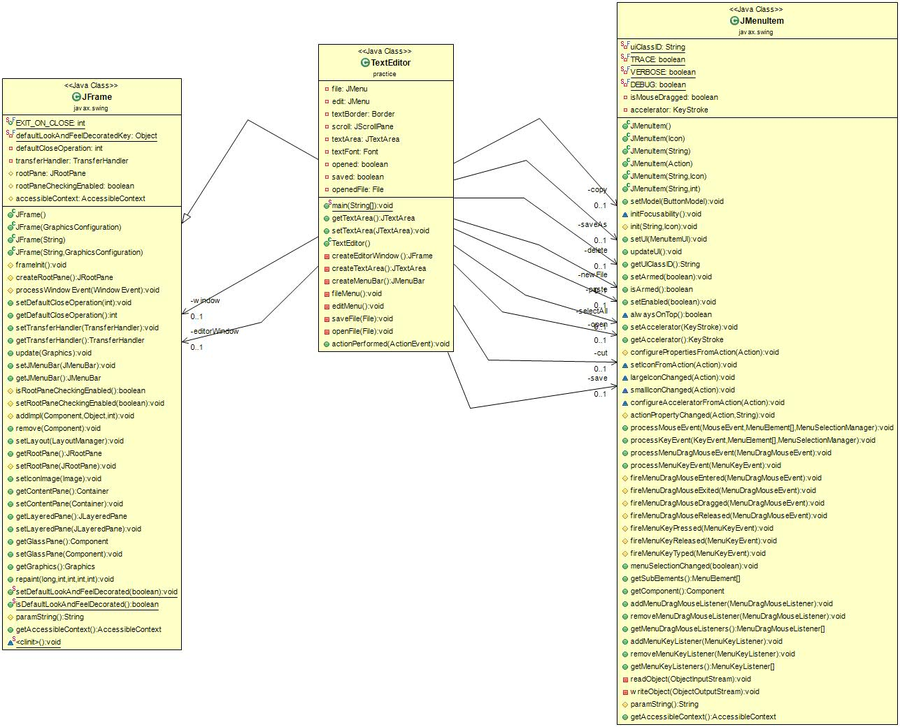

# **Functional Specification:**

This text editor contains 2 tabs each with separate functions.

## ***File:***

Upon clicking this tab on the text editor, you have the functions New File, Open, Save, and SaveAs that the user can select from.

## ***Edit:***

Upon clicking this tab on the text editor, you have the functions Save, SaveAs, Delete, SelectAll, Cut, Copy, and Paste that the user can select from.

## ***New File*:**

This button lets the user create a new file on the text editor and creates a blank document for the user to start editing.

## ***Open:***

This button allows the user to reopen a saved file from the desired location.

***Save:***

This button allows to user to save current new file or existing file. If the user is saving an existing file, a dialog box will appear and ask the user to confirm the user to save to the existing file. The dialog box will say “Replace Existing File?”.

## ***Save As:***

This button allows the user to name and save the document to a desired location.

## ***Cut:***

This button allows the user to remove the selected text from the current document.

## ***Copy:***

This button allows the user to replicate the selected text from the current document.

## ***Paste:***

This button allows the user to insert copied or cut text the user selected before from the current document.

## ***Delete Selected:***

This button will allow the user to delete the selected text from the current document.

## ***Select All:***

This button allows the user to select all text written within the current document opened.

**Customize:**

This button allows the user to change the background color and text color of the TextEditor. The user can choose the color of the background to be white, gray, black, red, yellow, green, blue, purple, and pink. This is the same for the text color.

# **Test Cases:**

## ***File:***

To test this function, the user clicked on the “File” tab and a drop-down opened displaying the options to open a new file, open an existing file, save the current file, and save the current file under a new name.

## ***Edit:***

To test this function, the user clicked on the “Edit” tab and a drop-down opened displaying the options to cut the selected text, copy the selected text, paste a previously copied or cut selection of text, delete a selection of text, and select all the text on the document.

## ***New:***

To test this function, the user opened the file tab and selected the “New” option. It opened a brand new document for the user to type in.

## ***Open:***

To test this function, the user opened the file tab and selected the “Open” option. A new window appeared on the screen displaying the user's “Documents” folder for the user to select an already saved text file to edit. After selecting the file, the user had to click the “Open” button at the bottom of the window for the document to open or the user could select cancel and continue using the already open file. The user was able to click a drop-down to pick a folder to look in other than “Documents”. Beside this drop down was a series of five buttons.

## ***Up One Level:***

The first button when hovered over said “Up One Level”, upon clicking this button the screen displayed the folder that held the current folder the user was looking at in that moment. For example, when the user clicked the open tab it automatically displayed the “Documents” folder. The user used the drop-down to select the “Desktop” folder. The user then clicked the “Up One Level” button and the window then displayed the “This PC” folder to pick a document to open.

## ***Desktop:***

The second button when hovered over said “Desktop”. When the user clicked this button, the window displayed the “Desktop” folder. It functioned as a shortcut to reach this folder rather than having the user search and select the “Desktop” folder in the drop-down.

## ***Create New Folder:***

The third button when hovered over said “Create New Folder”. When the user clicked this button, the user was able to create a new folder in the folder already displayed. It opened a new folder with the title highlighted in order to allow the user to name the newly created folder. After naming this new folder the user had to press enter to finalize this new folder. The user was able to open the newly created folder after initializing it.

## ***List:***

The fourth button when hovered over said “List”. When clicked it did nothing unless the user had previously clicked the fifth button labeled “Details”. This button is meant to display the files with only their titles.

## ***Details:***

The fifth button when hovered over said “Details”. When clicked it changed the way the user viewed the files. Instead of displaying only the file names it also displayed their size, item type, and date modified.

## ***File Name:***

This is a line displayed at the bottom of the open window that displays the name of the file clicked on to open. The user was also able to type the name of the file then select the open button rather than having to search for it first in their documents.

## ***Save:***

To test this function, the user opened the file tab and selected the “Save” option. The program saved the document to its existing file if the document was already given a save location. If the document was new and not previously saved before then it opened the same window displayed when the user selected the “Open” option; however, instead of selecting a file to open, the program allowed to user to select a location to save and name the file.

## ***Save As:***

To test this function, the user opened the file tab and selected the “Save As” option. The program opened the same window displayed when the user selected the “Open” option. Instead of selecting a file to open, the user was able to select the location and name of the new file being saved.

## ***Cut:***

To test this function, the user typed a sample amount of text into the document first. Next, the user highlighted the desired amount of text to be cut from the document. Then, the user opened the edit tab and selected the “Cut” option. The program then removed the highlighted text from the document.

## ***Copy:***

To test this function, the user typed a sample amount of text into the document first. Next, the user highlighted the desired amount of text to be copied from the document. Then, the user opened the edit tab and selected the “Copy” option. The program then saved the highlighted amount of text to be reused later.

## ***Paste:***

To test this function, the user having already used the cut or copy option on the document opened the edit tab and selected the “Paste” option. The document then retyped the text that had previously been copied or cut. If both options were used, it used the text that was most recently affected. The text was pasted where the flashing text indicator was last at while selecting the paste option.

## ***Delete Selected:***

To test this function, the user typed a sample amount of text into the document first. The user highlighted a selected amount of text then pressed the delete function and it closed the entire program without prompting the user if they wanted to save their document. The program was changed so the next time the user tested the program it deleted the highlighted text without copying the deleted text to be saved anywhere else. It no longer closed the entire program.

## ***Select All:***

To test this function, the user typed a sample amount of text into the document first. The user then opened the edit tab and selected the “Select All” option. The program then highlighted all the text that the user had typed into the document indicating that it was selected for action.

## ***Customize:***

To test this function, the user typed a sample amount of text into the document first. The user then opened the file tab and select “Customize”. A box opened showing dropdown functions for the background color, text color, and color scheme. To test the background color, the user hit the dropdown under the “Background Color” title which gave a list of 8 different colors. Each color when selected changed the background of the text editor to the color stated in the dropdown. To test the text color, the user hit the dropdown under the “Text Color” title which gave a list of the same 8 colors. Each color when selected changed the color of the text in the text editor that the user had typed. To test the color scheme, the user hit the dropdown under the Color Scheme title which gave a list of Programming Languages. Each language, when selected is supposed to change the color of keywords (ie. words such as “for” & “int” etc.) according to words most used in that programming language. This feature is incomplete in that it prepares for the colors to be changed but doesn't actually change the textcolor of the key words.

# 

# **Deployment:**

1. The first step in running this program on your computer is to download Java JDK and an IDE that supports java. You can do this by going to <https://ninite.com/> and checking the two boxes under Developer Tools. Then just click dowload. This should give you everything you need to run our text editor.

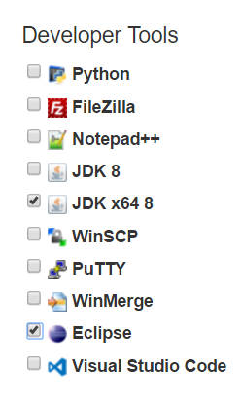

2) Once the IDE is installed, open command prompt.

3) Locate the path of the java file. For example: C:\Users\user\Documents\data structures\TextEditor\src

4) Then type cd (your file path). Then press enter

5) Type javac TextEditor.java. Then press enter

6) Finally type java TextEditor. The program should open up the window to the TextEditor

# **User Manual:**

This text editor was created using the Java IDE to be used as a very basic text editor to simply open, edit, and save text documents. As a result, there contains only 2 menu options: ***File*** and ***Edit***.

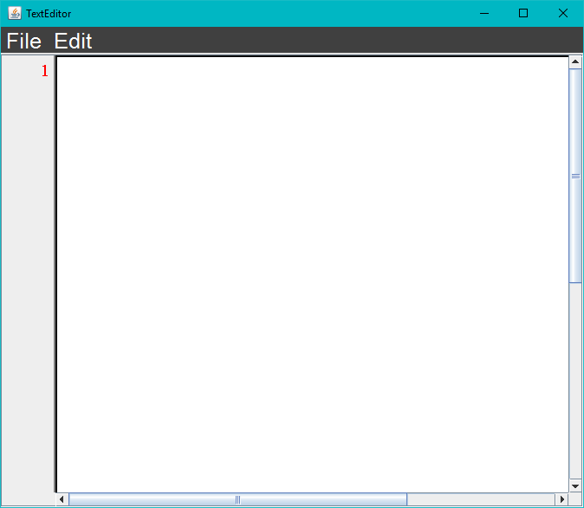

## ***File***:

In the File menu, you are able to access 5 different functions as described in the **Functional Specification** and **Test Cases** sections. We are able to create new files, open files, save files, and save files as.

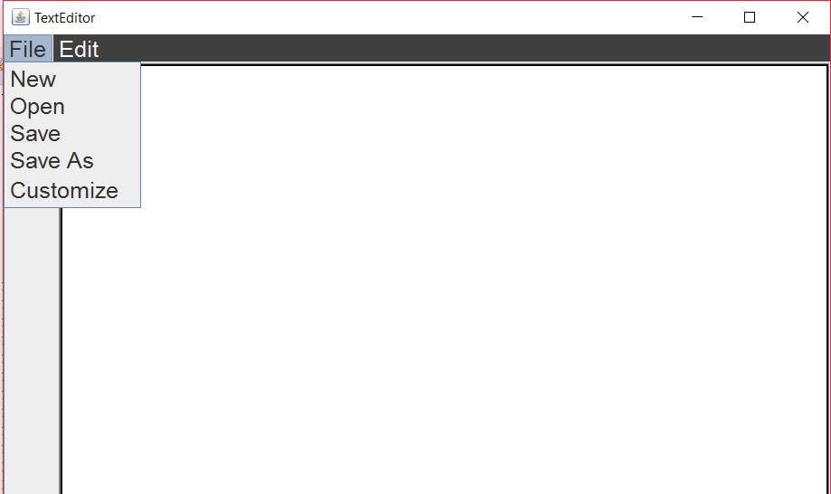

## ***Create New File:***

To create a new file, simply click on the option called “New” from the File menu and a new file will be created. Note that clicking on New will not overwrite whatever the user has already started editing.

## ***Opening Files:***

To open a file saved on your computer, click on the “Open” option from the File menu. This should open up a command window to allow the user to search for their files within their desktop and PC folders. Once you find your desired file, double-click on the .txt document and the file will open up on the text editor.

## ***Saving Files:***

The process of saving a file is very similar to opening a file. There are two ways to save a file, ***Save*** or ***Save As.*** To save a file, scroll through the File menu and click on the “Save” option. This will open up a command window to allow the user to save the file with whatever name they desire. Ex. hello.txt. After naming the file, you are able to save the file in any desired location in your directory. When editing a previously created file, the ***Save*** function will automatically save any changes made in the file without prompted to name the file and save the file location again. Using the Save As function however, allows the user to always prompt the command window to allow the user to either change the name of the file or overwrite a file with the same name.

## ***Edit:***

In the Edit menu, you are able to access 4 different functions as described in the **Functional Specification** and **Test Cases** sections. In this menu, we are able to cut, copy, paste, delete, and select all text.

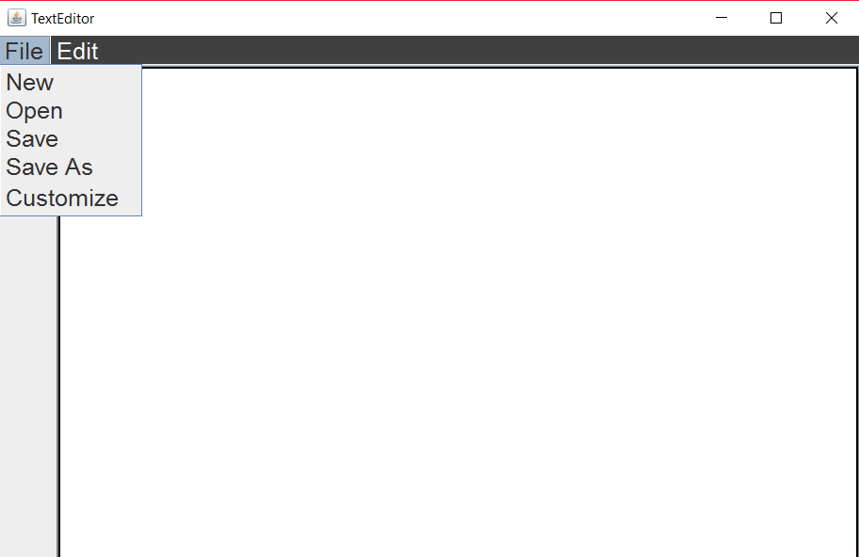

## ***Cutting Text:***

Like all text editors, cutting text involves removing selected text. To do this, first you must highlight the text you want to cut, then go to the Edit menu and choose the “Cut” option. This will remove the selected text.

## ***Copying Text:***

To copy, first highlight the selected text and go to the Edit menu where you can then choose the “Copy” option. Once you have copied the selected text, the next time you paste something will be the selected text that you have copied.

## ***Pasting Text:***

In order to paste any text, the user must have already have copied text before using the paste function. Once you have copied text that you want to paste, go to the Edit menu and choose the “Paste” option. This will print out the selected text that you have copied beforehand.

## ***Delete:***

This option will let the user select specific line(s) of text and delete them from the document. This function, will then replace the selected text with ““.

## ***Selecting All Text:***

There are two ways to select text in the text editor. You can either manually highlight all the text using the cursor or you can use the menu option in Edit to automatically select all text. To do this, go to the Edit menu and choose “Select All” which will proceed to select all of the text written in the current file.