Responsive

DEADLINE: 10.03.2022

FOLDER STRUCTURE
FE_HW1/*  └─ task/**  └─ FE_HW1.docx**  └─ examples/**  └─ desktop.png**  └─ mobile.png**  └─ tablet.png**  └─ homework/*  └─ img/*  └─ contact_image.jpg *  └─ lady.jpg *  └─ logo.png *  └─ pricing_bg.jpg *  └─ services_bg.jpg *  └─ tools.png *  └─ icons/*  └─ cardiology.jpg  └─ dentistry.jpg  └─ laboratory.jpg  └─ oftalmology.jpg  └─ pediatrics.jpg  └─ radiology.jpg  └─ css/*  └─ styles.css*  └─ index.html* | * - required  ** - restricted (no need to submit)

TASK
In this homework, you should create a web page and provide styles for specific screen resolutions as shown in the pictures (pixel perfect is not required):
- examples/desktop.png - shows how the page should look like on 1280px
- examples/tablet.png - shows how the page should look like on 768px
- examples/mobile.png - shows how the page should look like on 414px
Requirements:
- The @media query breakpoints that are used in the example:
- Mobile: < 768px
- Tablet: minimal width is 768px
- Desktop minimal width is 1280px

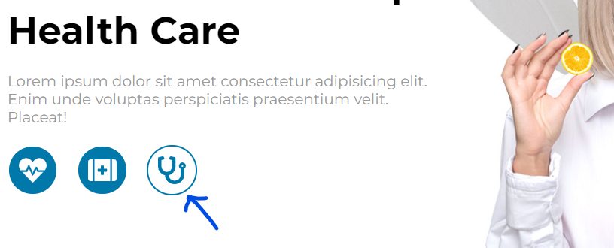
- All links and buttons should have hover effect (see screenshots below)
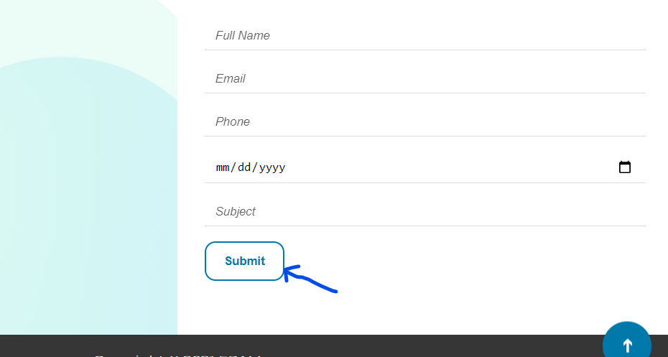
- Navigation menu should be fixed during the page scroll.
- Click on any of menu items should move you smoothly to the appropriate section on the page. Logo should move you to the top, the same for the “Up” button (should be also fixed)
- Form should include date picker and dropdown with autocomplete function.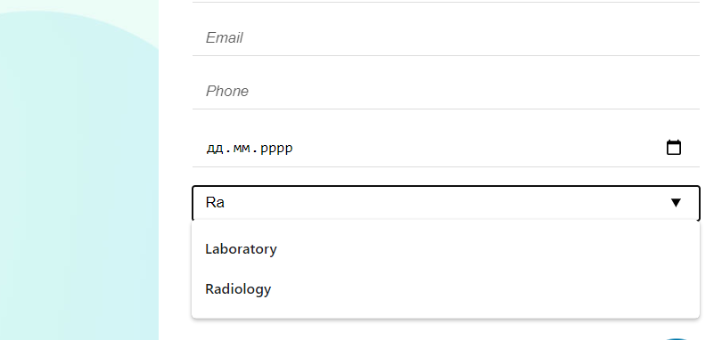

RESTRICTIONS
- Please use pure CSS only, without any preprocessors;
- For icons use FontAwesome (you can download icon in SVG format)
- Don’t use any 3rd party tools or libs (e.g. Bootstrap);
- Use only styles.css file for your CSS code without splitting it;
- Usage of JavaScript is forbidden;
- Adding task/ and examples/ folders is forbidden. Do not push it to repository (only homework/ folder should be pushed);
- No requirements for browser support (should work properly in Google Chrome last version).

BEFORE SUBMIT
- Verify that all functionality is implemented according to requirements;
- Format your code (remove redundant spaces, lines of code etc.);
- Add only related to your code, valid comments;
- Validate in https://validator.w3.org/ and https://jigsaw.w3.org/css-validator/ ;
- Make sure your GitHub folder structure meets the required one (without task and examples folders)

SUBMIT
- The FE_HW1 branch should be uploaded to GitHub repository “FE_2025”, the main branch should stay empty

USEFUL LINKS
- https://developer.mozilla.org/en-US/docs/Web/CSS/position
- https://developer.mozilla.org/en-US/docs/Web/CSS/@media
- https://css-tricks.com/snippets/css/a-guide-to-flexbox/
- https://css-tricks.com/snippets/css/complete-guide-grid/

