BagBag:
A User guide.

Supervisor: Sir Murtaza
Batch: 2601C
Group: BagBag
Noel Enosh Khan | 1726401
Rehan Ali | 1726408
Sohnia Bashir | 1724157
Javeria | 1724152

Table of Contents
1. Introduction
2. Purpose
3. Scope
4. Home Page
5. Navigation Bar
6. Hero Slider
7. Product Page
8. Product Categories
9. Search Feature
10. Wishlist & Shopping Cart
11. Technologies Used
12. Future Enhancements
14. Conclusion

Introduction
Global Luxury is a modern e-commerce website developed to showcase premium handbags and luxury accessories. The website focuses on providing an elegant shopping experience through a clean user interface, attractive product displays, and smooth navigation.
The project was created using HTML, CSS, and JavaScript. It demonstrates how a luxury brand can present its products online in a professional way. The design emphasizes simplicity, high-quality visuals, and user-friendly interaction, making it suitable for customers interested in premium fashion products.

Purpose
The main purpose of this project is to build a modern online shopping website where users can browse luxury bags easily. The website aims to provide an attractive interface that highlights featured products while keeping navigation simple and responsive.
It also serves as an educational project to demonstrate front-end web development skills.

Scope
The website includes a homepage, product listing page, search functionality, wishlist icons, shopping cart icons, and responsive layouts. The project can later be expanded by adding user accounts, online payments, order tracking, and an admin dashboard.

Home Page
The homepage is designed to create a strong first impression. It contains a luxury hero banner with a promotional heading, navigation bar, logo, and a 'Shop Collection' button. The full-screen banner immediately attracts the user's attention and encourages them to explore the collection.

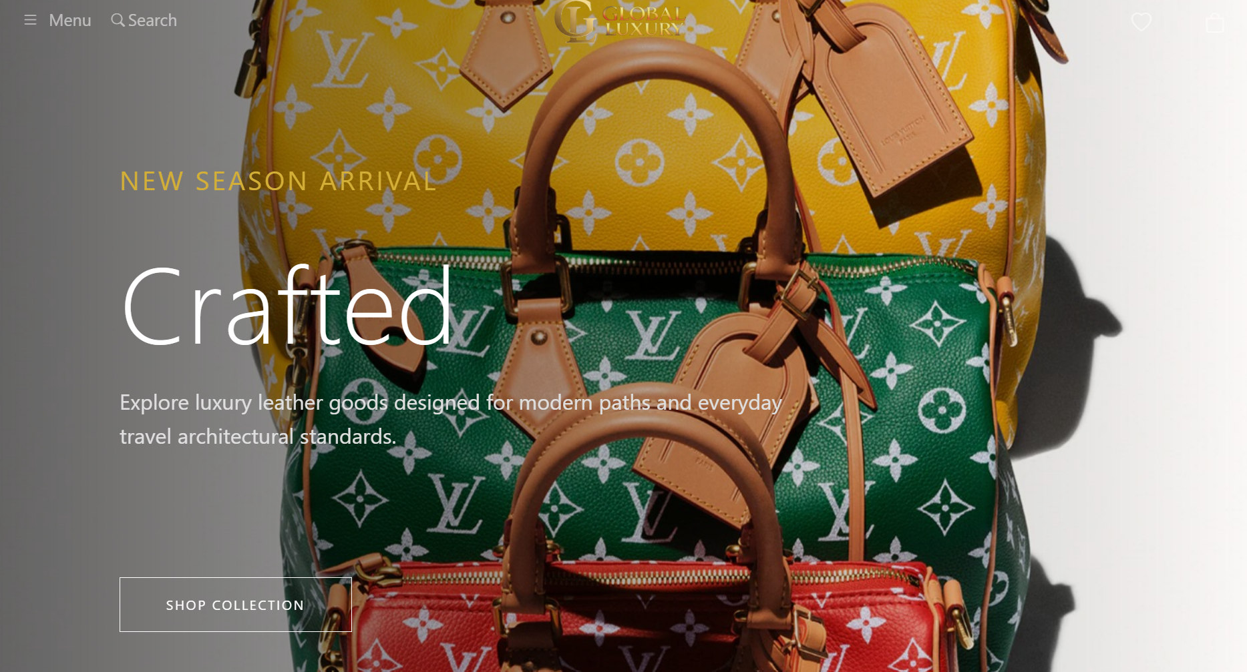

Navigation Bar
The navigation bar is positioned at the top of the page and provides quick access to different parts of the website. It includes a menu button, search option, company logo, wishlist icon, and shopping cart icon. The layout remains clean and balanced to match the luxury theme.
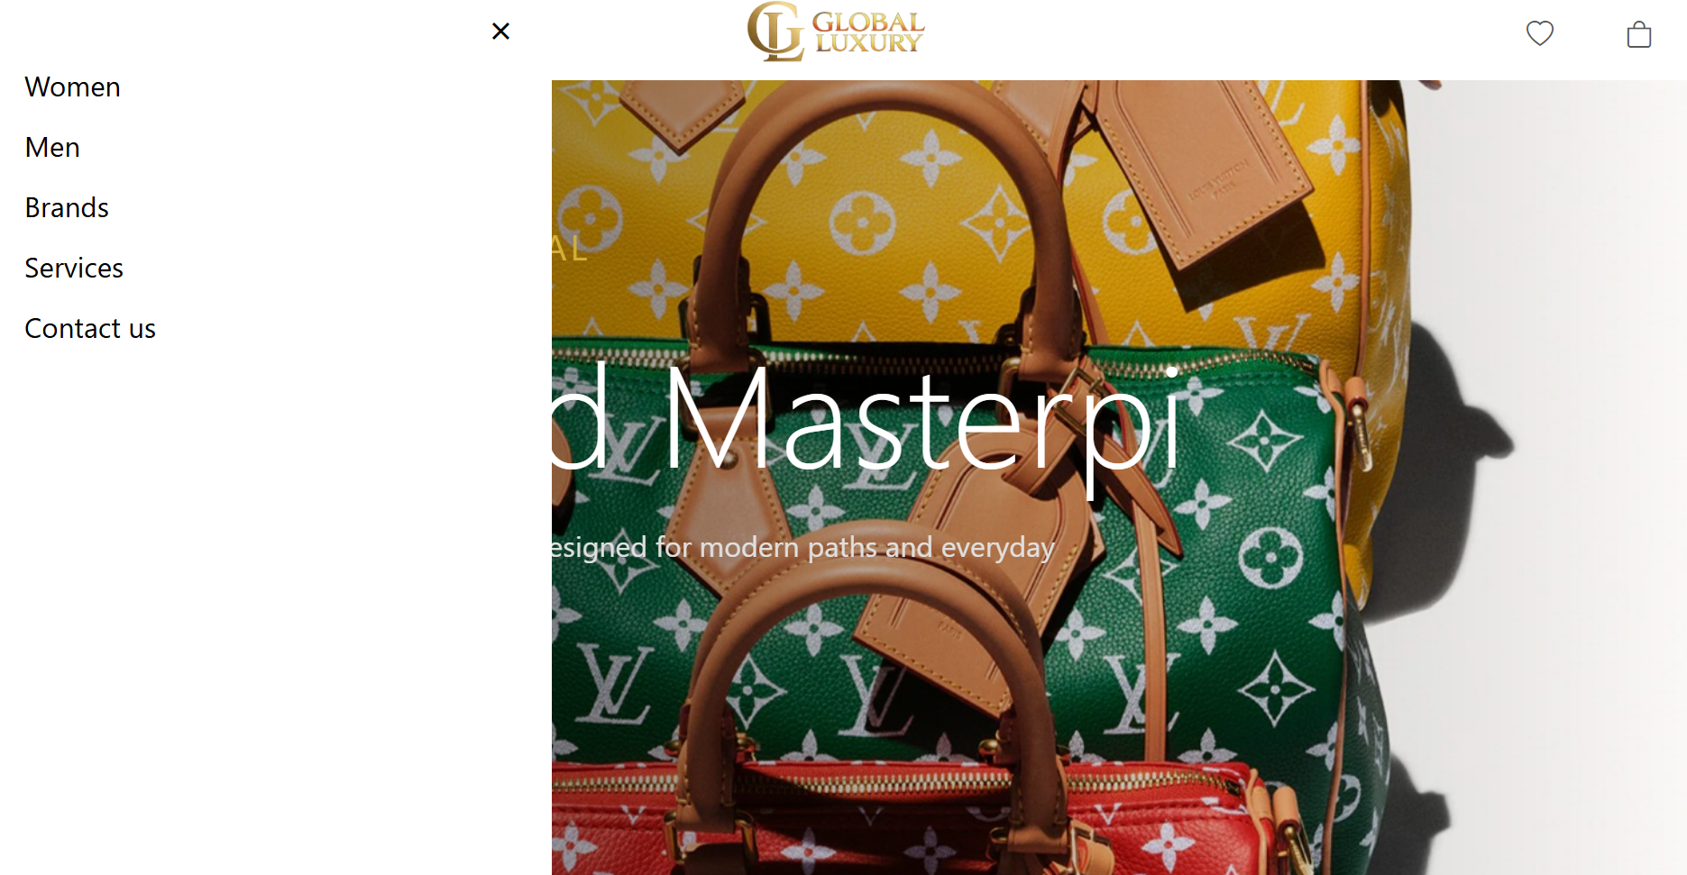

Hero Slider
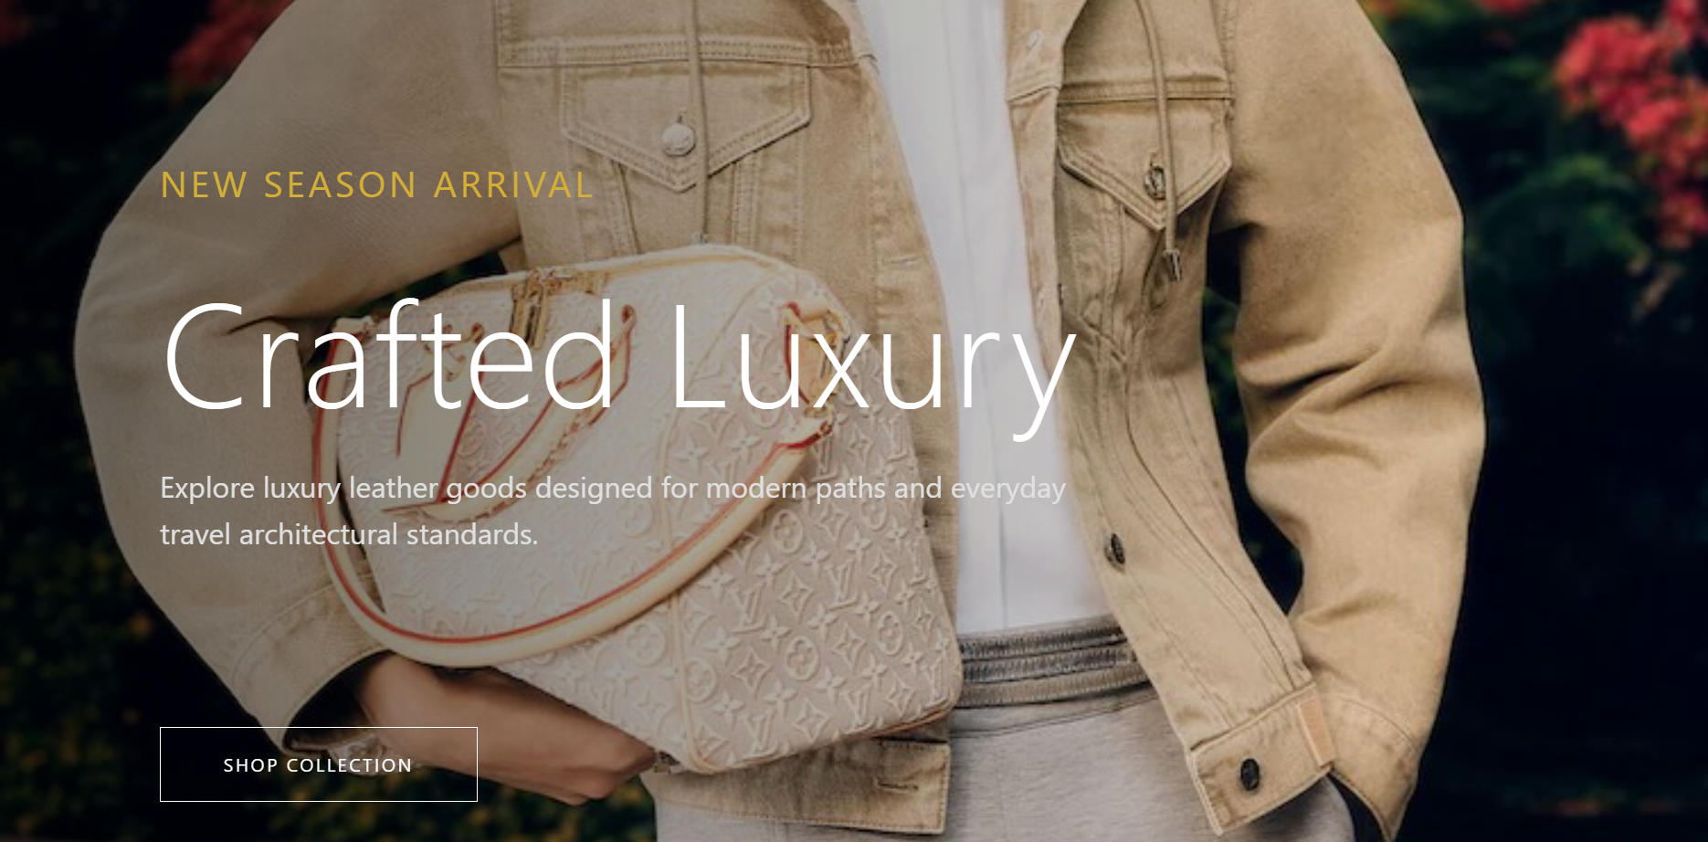
The hero section acts as the main attraction of the homepage. Large background images, promotional text, and elegant typography create a premium look. The slider can be expanded to automatically rotate multiple featured products in the future.

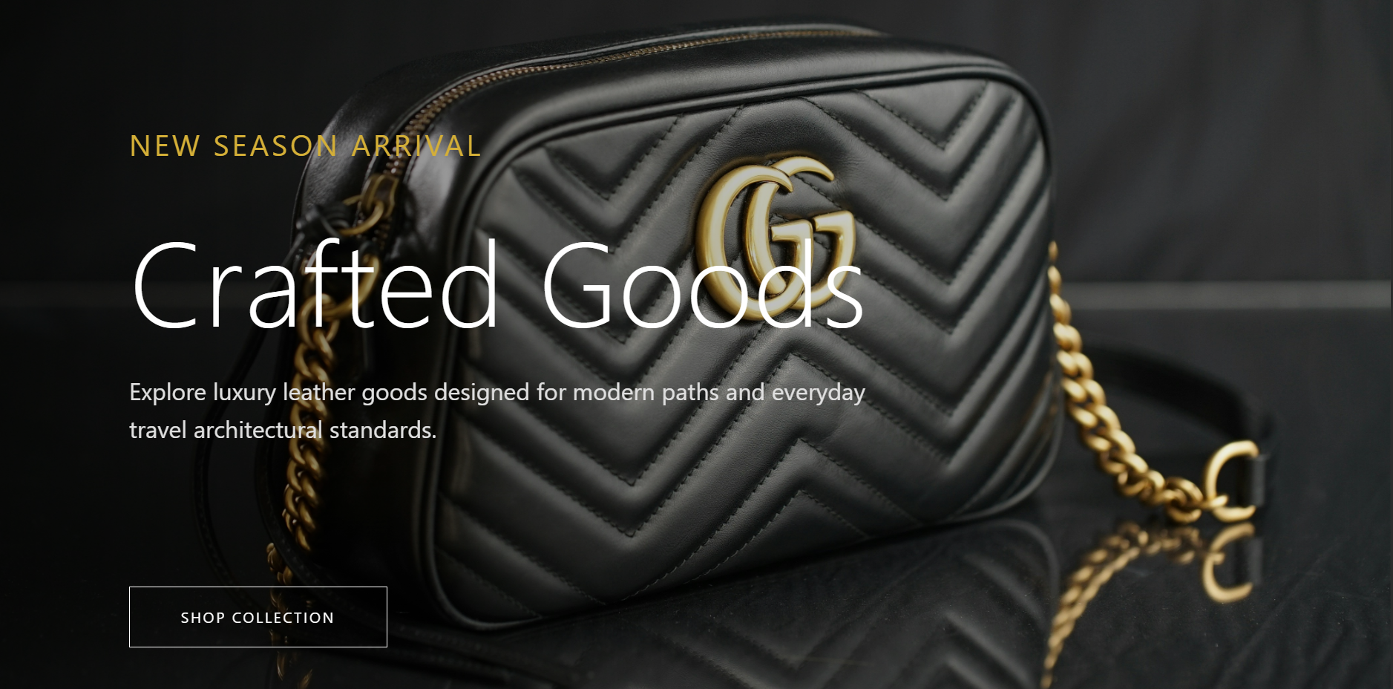

Product Page
The products page displays handbags in a responsive grid layout. Each product card contains a product image, product name, short description, and a wishlist icon. The design allows users to browse products quickly while maintaining a modern appearance.

Product Categories
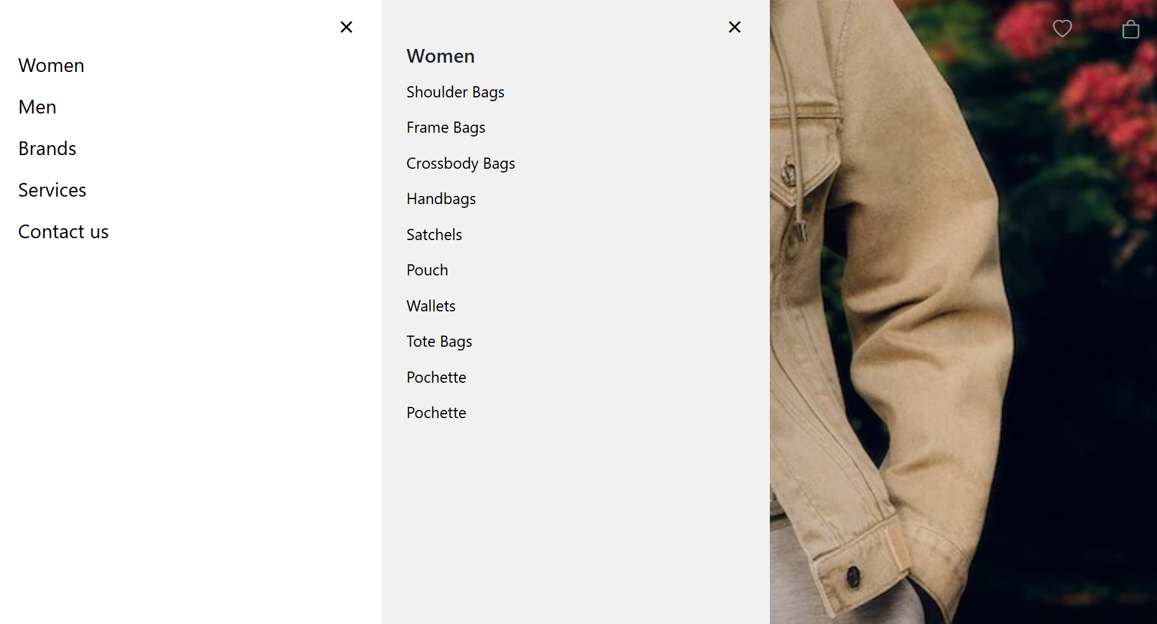
Products are arranged in to categories by type such as Tote Bags, Handbags, Shoulder Bags, Crossbody Bags, Luxury Collection, and Travel Bags. Categories make it easier for customers to find products according to their preferences.
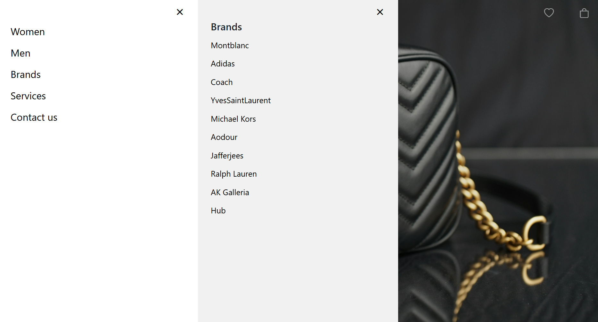
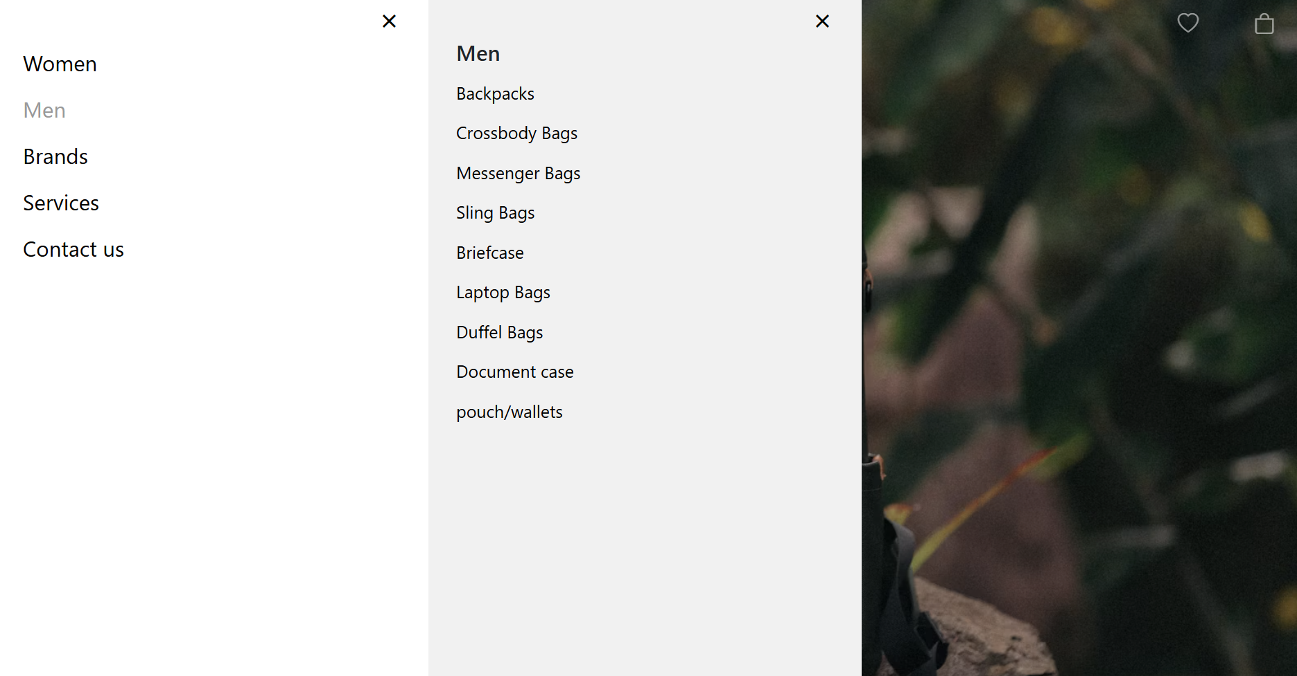

Search Feature
A search bar is provided at the top of the products page to help users locate products efficiently. This improves user experience by reducing the time required to browse through multiple products.
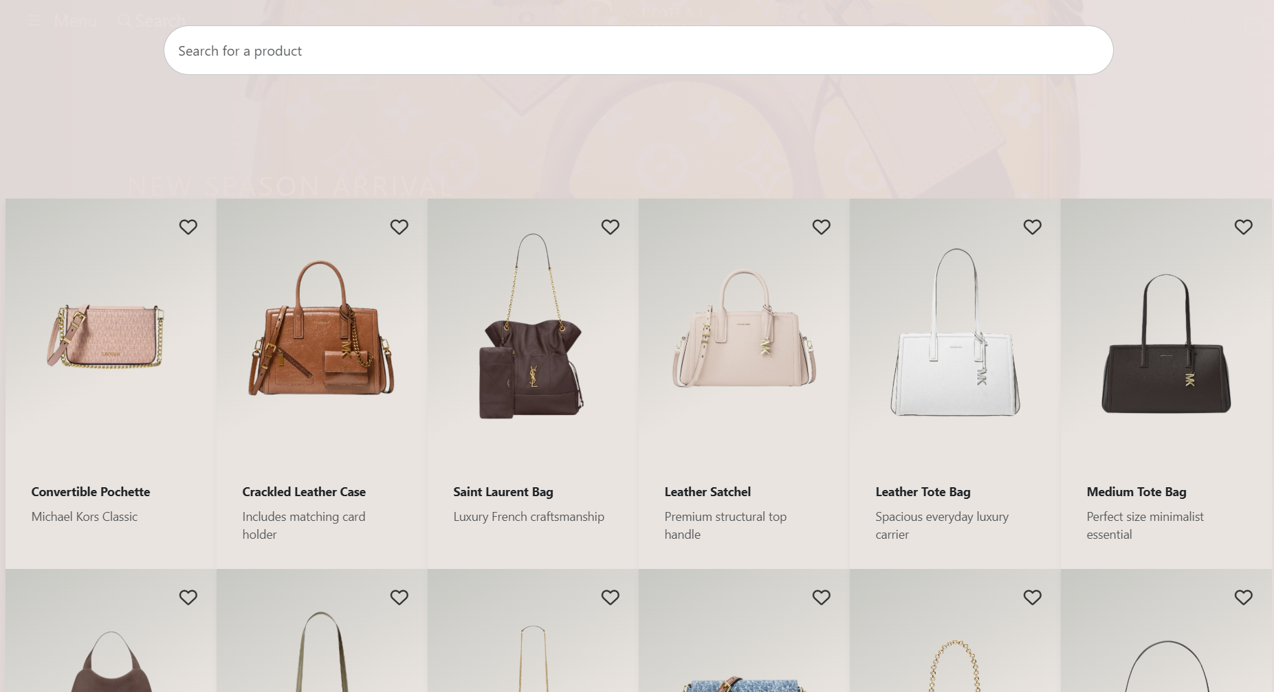

Wishlist & Shopping Cart
The wishlist feature allows customers to save products for future purchase, while the shopping cart stores selected products before checkout. These features improve convenience and are essential for modern e-commerce websites.

Technologies Used
• HTML5 for page structure.
• CSS3 for styling and responsive layouts.
• JavaScript for interactive features.
• Visual Studio Code as the development environment.
These technologies together create a fast and visually appealing website.

Future Enhancements
Future improvements may include user registration, login system, payment gateway integration, product filtering, customer reviews, dark mode, and order tracking. These additions would transform the project into a complete online shopping platform.

Conclusion
The Global Luxury Bags website successfully demonstrates the fundamentals of modern web development. It combines attractive design, responsive layouts, and practical shopping features to create a professional luxury shopping experience. The project also provides a strong foundation for adding advanced e-commerce functionality in the future.

