Engineering clinics- Building a robot

Introduction

This project is intended to be a starting point for us to understand about and build robots. This robot is an example of an Assistant bot which aims to make life easier for us. The functional robot is supposed to do things like:

- Talk to the user. Greet them.
- Turning lights on or off intelligently, based on a light sensor.
- Help carry things from one place to another.
- Wipe the floor.
- Picking up magnetic substances with an electromagnetic arm.
- Doing simple math and displaying on the screen.

A brief explanation of the functioning of the robot:

- The robot will be semi-autonomous. It will be primarily be run by a Bluetooth interface, but it also has the ability to respond to human speech.
- When the surrounding light fades away the photo-sensitive sensor detects that to turn the lamps mounted on its head with the information from a light sensor. The lamps can work like study lamps or guide lamps.
- It has an electromagnetic arm controlled by servos mounted on a rotating base and can be used to carry magnetic materials.
- Bicycle chain rings in the form of wheels are mounted to tracks (belts) so that it can move easily on smooth and rough surfaces and also have stability.
- Sponge, brush and sprinklers are fixed at the base for wiping the floors.
- It has a drawer for carrying things, which can be opened and closed.
- It uses a basic speech recognition ability to recognize human speech and follow their commands.
- It can perform simple mathematical computations based on speech and display results on a TFT screen.
- It has a 360 degree rotating base helping direct lights in every direction and also helping the arms move.
- A solar panel is used to store energy.

Participants

The project is a part of Engineering clinics in VIT-AP for Fall 2017 Semester. The project is being guided by Prof. Hari Seetha, Department of Computer Science.

The students working on the project are:

Sl. | Name | VIT AP registration No. | Email ID: | Branch
1. | Dedipyaman Das | 17BCE7080 | dedipyaman.das@vitap.ac.in | CSE
2. | Pujitha Pinninti | 17BCD7058 | pujitha.pinninti@vitap.ac.in | CSE DA
3. | Kamrun Nisa | 17BCD7046 | kamrunnisa@vitap.ac.in | CSE DA
4. | Niket Chandil | 17BEE7015 | chandil.niket@vitap.ac.in | EEE
5. | Amartya Raj Saha | 17BME7056 | amartya.saha@vitap.ac.in | Mechanical

Components

- Lights:
  - Light sensor
  - Study Lamp
  - Headlights
  - Li-ion Battery

- Interaction
  - TFT Screen
  - Speech Recognition Module
  - Speakers

- Cleaning
  - Servo
  - Brush
  - Shower
  - Sponge

- Carrying
  - Tray

- Movement
  - Bicycle chain
  - Chain ring
  - Screw and bolts
  - PVC pipes

A detailed estimated expenditure is mentioned in the corresponding table.

Rough design

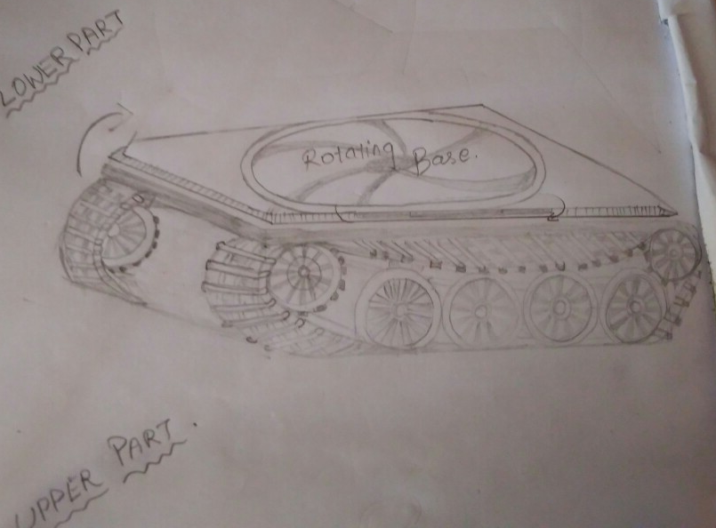

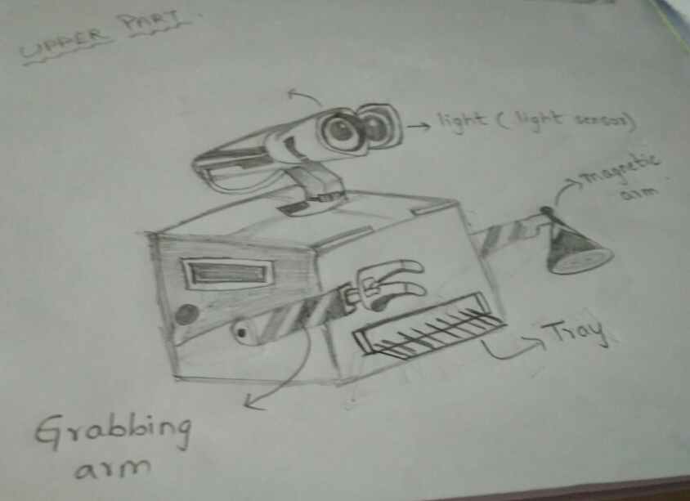

Estimated expenditure

 | Component Name | Component Type | Quantity | Price | Total
1 | Arduino Mega 2560 r3 Microcontroller Board ATmega2560 With Usb Cable | Microcontroller | 1 | 1099 | 1099
2 | HW 9V Batteries | Primary power Source | 6 | 15 | 90
3 | SLAEX039 L293D Motor Shield for Arduino | Motor Driver Shield | 1 | 285 | 285
4 | 12Volt DC Motor(Multipurpose Brushed Motor for DIY applications PCB Drill) | Primary wheel Motor | 4 | 199 | 796
5 | 8 V DC Motor | Secondary Wheel Motor | 2 | 80 | 160
6 | LDR Light Sensor Module(Photosensitive) Based on LM393 for Arduino | Light Sensor | 1 | 159 | 159
7 | 3mm LED Light Emitting Diodes Electronic 1/4 W Resistors | Lights | 20 | 3 | 60
8 | Bluetooth Transceiver Module with TTL Outputs-HC05 | Bluetooth Module | 1 | 298 | 298
9 | Dusting brush | Sprinkler (Cleansing) | 1 | 20 | 20
10 | Shower | Cleansing Part | 1 | 50 | 50
11 | Sponge | Cleansing Part | 1 | 20 | 20
12 | Servo | Arm movements | 1 | 195 | 195
13 | TFT screen | Display | 1 | 530 | 530
14 | Electromagnet | Magnetic object holder | 1 | 630 | 630
15 | Mechanical arm | Arm | 2 | 699 | 1398
16 | Lithium rechargeable battery | Secondary Power Source | 1 | 399 | 399
17 | Tray | Carrying block | 1 | 50 | 50
18 | Speakers | Audio Out | 1 | 80 | 80
19 | Cycle chain | Track Chain | 1 | 250 | 250
20 | PVC pipe | Track chain support | 1 | 425 | 425
21 | Chain ring | Wheels | 12 | 100 | 1200
22 | Screw and bolts | Track connector | 200 | 2 | 400
 |  |  |  | Estimated total: | Rs. 8594

References

The following websites were helpful to figure out a design of this project:

- instructables.com
- howstuffworks.com
- youtube.com
- amazon.in

