ACTS OVERLAP THEOLOGY SERIES
BOOK 1
The Full Framework
The Complete Integrated Doctrine of the Acts Overlap Model
Two Programs. One Overlap. One Boundary. One Mystery. One Kingdom.
Alexander S. Marien

The Acts Overlap Theology Series
Acts Overlap Theology Series: Book 1 — The Full Framework
Acts Overlap Theology Series: Book 2 — The Diagnostic Manual (Planned)
Acts Overlap Theology Series: Book 3 — Dispensational Diagnostics (Planned)
Acts Overlap Theology Series: Book 4 — The Pauline Revelation (Planned)
Acts Overlap Theology Series: Book 5 — Israel’s Prophetic Program (Planned)
The Full Framework
The Complete Integrated Doctrine of the Acts Overlap Model
Acts Overlap Theology Series, Book 1
Copyright © 2026 Alexander S. Marien
Published by Zay-Marie Press
First Edition, 2026
Paperback ISBN: 979-8-9978856-0-1
Hardback ISBN: 979-8-9978856-1-8
EPUB ISBN: 979-8-9978856-2-5
All rights reserved. No part of this publication may be reproduced, distributed, or transmitted in any form or by any means, including photocopying, recording, or other electronic or mechanical methods, without the prior written permission of the publisher, except in the case of brief quotations embodied in critical reviews and certain other noncommercial uses permitted by copyright law.
Unless otherwise indicated, all Scripture quotations are taken from the Holy Bible, New Living Translation, copyright © 1996, 2004, 2015 by Tyndale House Ministries. All rights reserved.

Series Preface
The Acts Overlap Theology Series is planned as a five-volume doctrinal system built around a single, central thesis: two distinct divine programs — Israel’s Prophecy Program and the Body of Christ’s Mystery Program — operate concurrently during Acts 9–28, and this overlap, properly understood, resolves the interpretive tensions that run throughout the book of Acts.
Book 1 — The Full Framework is the doctrinal backbone of the series. Its twenty-one chapters and appendices (A–U) constitute the canonical statement of the Acts Overlap Model. Every definition, chart, diagram, and doctrinal boundary introduced here is intended to govern the later volumes, which are planned to reference, extract from, expand, and summarize this book rather than establish competing versions of its material.
Planned: Book 2 — The Diagnostic Manual will distill the framework of Book 1 into an introductory, quick-reference guide to help readers apply the system’s categories, boundaries, and interpretive rules in real-time analysis.
Planned: Book 3 — Dispensational Diagnostics will expand the Seven Diagnostic Lenses introduced in Book 1 into a full interpretive handbook, with advanced case studies and detailed examples of how the Acts Overlap Model resolves exegetical tensions.
Planned: Book 4 — The Pauline Revelation will develop the Body of Christ’s Mystery Program in exegetical depth, tracing its doctrinal contours, dispensational distinctives, and canonical implications.
Planned: Book 5 — Israel’s Prophetic Program will develop Israel’s Prophecy Program with equal exegetical rigor, tracing its prophetic structure, covenantal foundations, and eschatological trajectory.
Together, the five volumes are intended to form a unified theological system: Book 1 establishes the framework, Book 2 will equip the reader to use it, Book 3 will expand its diagnostic power, and Books 4 and 5 will develop the two programs that define the Acts Overlap itself.

Table of Contents
The Acts Overlap Theology Series ii
Series Preface iv
Table of Contents v
Chapter 1: The Prophetic Foundation 1
Chapter 2: The Mystery Revealed 14
Chapter 3: The Two Programs 23
Chapter 4: The Overlap Begins (Acts 9) 33
Chapter 5: Paul’s Heavenly Apostleship 42
Chapter 6: Peter’s Circumcision Apostleship 50
Chapter 7: The Jerusalem Council 57
Chapter 8: Signs and Wonders During the Overlap 64
Chapter 9: Local Jewish Rejection and the National Verdict 70
Chapter 10: Gentile Inclusion 77
Chapter 11: The Pauline Churches 85
Chapter 12: The Two Commissions 92
Chapter 13: The Two Destinies 98
Chapter 14: The Two Baptisms 104
Chapter 15: The Two Justifications 110
Chapter 16: The Two Ecclesiologies 116
Chapter 17: The Two Eschatologies 123
Chapter 18: The Acts 28 Crisis 130
Chapter 19: The Judicial Blinding 136
Chapter 20: The Overlap Ends 143
Chapter 21: The Mystery Program Alone 149
Appendix A: Acts Timeline 156
Appendix B: Two Programs Chart 162
Appendix C: Acts Overlap Diagram 165
Appendix D: Signs & Wonders Diagnostic 168
Appendix E: Paul vs. Peter Authority Map 171
Appendix F: Dispensational Glossary 175
Appendix G: Baptisms Comparison 182
Appendix H: Justification Comparison 185
Appendix I: Ecclesiology Comparison 188
Appendix J: Eschatology Comparison 191
Appendix K: Commission Comparison 193
Appendix L: Audience Diagnostic Worksheets 195
Appendix M: Pauline Epistles Timeline 199
Appendix N: Local Jewish Rejection and the National Verdict Chart 202
Appendix O: Acts 28 Judicial Blinding Analysis 204
Appendix P: Teaching Modules 209
Appendix Q: Diagnostic Lenses Reference Sheets 214
Appendix R: Overlap Flowchart 217
Appendix S: Program Separation Map 221
Appendix T: Hermeneutical Rules for Acts 224
Appendix U: How This Architecture Resolves the Historical Confusions 227
Selected Bibliography 231

Chapter 1: The Prophetic Foundation
“So when the apostles were with Jesus, they kept asking him, ‘Lord, has the time come for you to free Israel and restore our kingdom?’” — Acts 1:6 (NLT)

Introduction: Why We Begin Before Acts Begins
Every misreading of the book of Acts begins the same way: by opening to chapter 1 as though the story starts there. It does not. The apostles who stood on the Mount of Olives asking Jesus about the restoration of Israel’s kingdom were not improvising a question. They were finishing a sentence that God had begun some two thousand years earlier, in a pagan city called Ur, when He called a man named Abram out of his father’s house and promised him a nation, a land, and a blessing that would one day reach the whole earth.
The Acts Overlap Model stands or falls on a single conviction stated plainly here at the outset: Acts does not open a new story. It continues an old one — the prophetic, covenantal, national story of Israel’s kingdom — and only later, without displacing that story, does God begin telling a second one that no prophet had ever announced. Before we can see the Mystery revealed directly to Paul and subsequently made known by the Spirit to the New Testament apostles and prophets associated with his ministry — not the Twelve as Prophecy apostles (chapter 2) — with any clarity, and before we can trace how the two programs run alongside one another during the Acts Overlap of Acts 9–28, we have to understand what was already fully in motion when Acts begins. This chapter lays that foundation: the Abrahamic, Davidic, and New Covenants; the prophetic expectation they created; and the unbroken continuity of that expectation from the Old Testament through John the Baptist, through Jesus, through the Twelve, and into the opening chapters of Acts itself.
This is not background material to be skimmed before the “real” argument starts. It is the argument’s starting premise. If Israel’s Prophecy Program was still fully in force and fully unresolved when Acts 1 opens — covenantally grounded, prophetically promised, and offered again by the apostles themselves — then everything that follows in this book depends on taking that fact seriously rather than reading it away.

The Abrahamic Covenant: The Root of the Prophetic Promise
The starting point of Israel’s prophetic identity is not Sinai. It is Genesis 12, where the Lord speaks to Abram with no prior condition attached and no law yet given:
“Leave your native country, your relatives, and your father’s family, and go to the land that I will show you. I will make you into a great nation. I will bless you and make you famous, and you will be a blessing to others. I will bless those who bless you and curse those who treat you with contempt. All the families on earth will be blessed through you.” (Genesis 12:1–3, NLT)
Three promises are embedded in these three verses, and each one becomes load-bearing for the rest of the prophetic storyline: a nation (“I will make you into a great nation”), a land (“go to the land that I will show you”), and a blessing that ultimately reaches beyond Abram’s own household (“all the families on earth will be blessed through you”). The nation and the land promises are Israel-specific and irrevocable; the blessing promise is the seed of a Gentile hope, but notice carefully how it arrives — through Abram’s family, not apart from it. Genesis 12 does not envision two separate peoples receiving two separate blessings. It envisions the whole earth blessed through the one covenant nation.
Three chapters later, the land promise is formalized with unusual solemnity. In the covenant ceremony of Genesis 15, God alone — represented by the smoking firepot and flaming torch — passes between the divided animal pieces while Abram sleeps (Genesis 15:12–17). This is a self-maledictory oath, and Abram is not a covenant partner obligated to hold up his end; he is a spectator to a promise God binds only Himself to keep. The content of that promise is geographic and specific:
“I have given this land to your descendants, all the way from the border of Egypt to the great Euphrates River — the land now occupied by the Kenites, Kenizzites, Kadmonites, Hittites, Perizzites, Rephaites, Amorites, Canaanites, Girgashites, and Jebusites.” (Genesis 15:18–21, NLT)
The verb tense matters: “I have given,” not “I will consider giving if you obey.” This is the pattern that distinguishes the Abrahamic covenant from the Mosaic covenant that comes later at Sinai. Sinai is bilateral and conditional — blessing and cursing hinge on Israel’s obedience (Deuteronomy 28). Abraham’s covenant is unilateral and unconditional — God obligates Himself alone. This distinction is not a technicality; it is the reason Israel’s prophetic destiny survives Israel’s repeated national failure throughout the Old Testament, and it is the reason — as we will see throughout this book — that Israel’s covenant standing survives even the judicial blinding of Acts 28. A conditional covenant broken by disobedience ends. An unconditional covenant broken by disobedience is delayed, disciplined, or paused — but not annulled.
Acts 28 marks the national judicial suspension of Israel’s Prophecy Program, not the exclusion of individual Jews from salvation. Israel no longer stands as the nationally operative prophetic instrument in the present administration, but Jewish individuals remain fully reachable by Paul’s gospel and may be incorporated into the one Body of Christ by faith on the same basis as Gentiles. This suspension neither cancels Israel’s covenants and future prophetic destiny nor asserts that every Jewish individual is spiritually incapable of believing. National suspension does not mean individual spiritual impossibility: Israel is set aside nationally, but Jews are not barred individually.
The Body of Christ is not under the Mosaic covenant or Israel’s Law administration but under grace. This freedom from the Mosaic Law does not remove moral accountability. Pauline revelation establishes the ethical instruction appropriate to the Mystery administration, and many moral truths found in the Mosaic Law are reaffirmed there. Their present authority for the Body rests upon Pauline instruction under grace rather than upon covenantal subjection to Israel’s Law. Freedom from the Mosaic Law is not freedom from righteousness. Repeated moral content does not establish identical programmatic jurisdiction.
Genesis 17 makes the permanence explicit, using the word every subsequent prophet will lean on:
“I will confirm my covenant with you and your descendants after you, from generation to generation. This is the everlasting covenant: I will always be your God and the God of your descendants after you. And I will give the entire land of Canaan, where you now live as a foreigner, to you and your descendants. It will be their possession forever, and I will be their God.” (Genesis 17:7–8, NLT)
Everlasting. Forever. These are not the terms of a covenant awaiting cancellation. They are the terms of a covenant awaiting fulfillment — and fulfillment, within the logic of Scripture’s own storyline, requires an earthly kingdom, a covenant nation still standing, and a King. That King is the subject of the next covenant.

The Davidic Covenant: The Throne of the Coming King
If the Abrahamic covenant supplies the nation and the land, the Davidic covenant supplies the throne. In 2 Samuel 7, after David expresses his desire to build God a permanent house, the prophet Nathan delivers a reversal: it is not David who will build God a house, but God who will build David a house — a dynasty, a throne, and a kingdom that outlasts David’s own lifetime by an order of magnitude no ordinary succession could explain:
“For when you die and are buried with your ancestors, I will raise up one of your descendants, your own offspring, and I will make his kingdom strong. He is the one who will build a house — a temple — for my name. And I will secure his royal throne forever. I will be his father, and he will be my son. If he sins, I will correct and discipline him with the rod, like any father would do. But my favor will not be taken from him as I took it from Saul, whom I removed from your sight. Your house and your kingdom will continue before me for all time, and your throne will be secure forever.” (2 Samuel 7:12–16, NLT)
Solomon fulfills the immediate, near-term sense of this promise — he is David’s descendant, and he builds the temple. But the passage will not stay contained within Solomon’s reign. “I will secure his royal throne forever” and “your throne will be secure forever” outrun any single human king, including Solomon, whose own unfaithfulness (1 Kings 11) makes plain that the ultimate referent of this promise cannot be merely dynastic continuity by ordinary succession. The prophets who follow read Nathan’s oracle exactly this way: as a promise of a coming, permanent, righteous King from David’s line, ruling an actual kingdom, on an actual throne, on the earth.
Isaiah states it in language too textured and too specific to spiritualize into a merely inward or “spiritual” reign:
“For a child is born to us, a son is given to us. The government will rest on his shoulders. And he will be called: Wonderful Counselor, Mighty God, Everlasting Father, Prince of Peace. His government and its peace will never end. He will rule with fairness and justice from the throne of his ancestor David for all eternity. The passionate commitment of the Lord of Heaven’s Armies will make this happen!” (Isaiah 9:6–7, NLT)
“The government will rest on his shoulders.” “the throne of his ancestor David.” This is not poetic vagueness about an ethereal reign someday, somewhere. It is the picture of an actual governmental order, headquartered in connection with David’s own throne, administered by a divine King. Daniel’s vision of “someone like a son of man” adds the international, universal scope this kingdom will eventually possess:
“As my vision continued that night, I saw someone like a son of man coming with the clouds of heaven. He approached the Ancient One and was led into his presence. He was given authority, honor, and sovereignty over all the nations of the world, so that people of every race and nation and language would obey him. His rule is eternal — it will never end. His kingdom will never be destroyed.” (Daniel 7:13–14, NLT)
Hold Isaiah 9 and Daniel 7 together and the prophetic picture sharpens: a Davidic King, ruling an earthly, political, universal kingdom, whose reign never ends. This is Israel’s prophetic hope in its fullest Old Testament expression — and it is the hope that every Gospel writer, every one of the Twelve, and Paul’s own kinsmen according to the flesh carried into the first century unmodified. Nothing in the intertestamental centuries diluted it. If anything, under Roman occupation, it sharpened into an urgent, immediate expectation.
Prophecy and Mystery contain distinct divinely appointed messages, audiences, commissions, requirements, hopes, and destinies. Their distinction does not mean competing Saviors: both programs belong to the one God and are centered on the same Lord Jesus Christ. Salvation is always by faith and never by merit, but the content of faith is what God revealed within each program, and this book states no single saving ground common to both (chapter 15). The distinction runs through revelation, audience, commission, required response, hope, and destiny.

The New Covenant — For Israel
The third covenant undergirding the prophetic program is the New Covenant of Jeremiah 31, and this is the covenant most frequently misapplied in contemporary teaching, so precision here matters more than anywhere else in this chapter. Jeremiah is explicit about whom this covenant is made with:
“‘The day is coming,’ says the Lord, ‘when I will make a new covenant with the people of Israel and Judah. This covenant will not be like the one I made with their ancestors when I took them by the hand and brought them out of the land of Egypt. They broke that covenant, though I loved them as a husband loves his wife,’ says the Lord. ‘But this is the new covenant I will make with the people of Israel after those days,’ says the Lord. ‘I will put my instructions deep within them, and I will write them on their hearts. I will be their God, and they will be my people. And they will not need to teach their neighbors, nor will they need to teach their relatives, saying, “You should know the Lord.” For everyone, from the least to the greatest, will know me already,’ says the Lord. ‘And I will forgive their wickedness, and I will never again remember their sins.’” (Jeremiah 31:31–34, NLT)
Read the covenant formula twice over: “a new covenant with the people of Israel and Judah” (v. 31); “the new covenant I will make with the people of Israel” (v. 33). This covenant is national, ethnic, and Israel-specific in its stated recipients. Its content — an internalized law, a permanently secured relationship (“I will be their God, and they will be my people”), universal covenant-knowledge within the nation, and comprehensive forgiveness of national sin — describes the spiritual condition of Israel in the coming kingdom, not the formation of a separate, non-national, non-covenantal Body made up of Jew and Gentile without distinction.
This distinction is essential for the Acts Overlap Model and will be developed at length in chapters 2, 3, and 15. For now, the point to fix firmly in mind is this: the Body of Christ’s Mystery Program is explicitly, repeatedly described in the framework this series follows as non-covenantal — it is not the New Covenant relocated, reassigned, or reinterpreted onto a new people. The New Covenant belongs to Israel’s Prophecy Program. It is one more thread — alongside the Abrahamic land and nation promise and the Davidic throne promise — in the single covenantal rope that constitutes Israel’s prophetic hope. Whatever benefits Gentiles in the Mystery Program come to experience by grace through Paul’s gospel, they do not come to them by absorption into a covenant God explicitly made “with the people of Israel and Judah.” Keeping this boundary clean here, in chapter 1, is what will make chapters 14 through 17 — on the two baptisms, the two justifications, the two ecclesiologies, and the two eschatologies — coherent later.
The Body of Christ receives every spiritual blessing necessary to its heavenly calling through the finished work of Christ, but this does not place the Body under Israel’s national covenants or make it the covenant nation. Israel’s covenants belong to Israel’s Prophecy Program and guarantee the fulfillment of God’s promises to that nation. The Mystery Program is grounded in God’s previously hidden purpose revealed through Paul and must not be converted into an extension or spiritualization of Israel’s covenant program. Participation in a blessing does not by itself establish covenant identity. Spiritual benefit through Christ does not equal incorporation into Israel’s national covenant program.

The Kingdom Announced: John, Jesus, and the Twelve
By the time the Gospels open, this three-stranded covenantal hope — nation and land from Abraham, throne from David, internalized covenant blessing from Jeremiah’s New Covenant — has produced a single, sharply focused expectation among first-century Jews: the coming of the promised King and the establishment of His kingdom, on earth, for Israel. This is not a peripheral theme the Gospel writers introduce quietly. It is the headline. John the Baptist opens his ministry with it:
“In those days John the Baptist came to the Judean wilderness and began preaching. His message was, ‘Repent of your sins and turn to God, for the Kingdom of Heaven is near.’” (Matthew 3:1–2, NLT)
Jesus takes up the identical message, in the identical words, the moment His own public ministry begins:
“From then on Jesus began to preach, ‘Repent of your sins and turn to God, for the Kingdom of Heaven is near.’” (Matthew 4:17, NLT)
And when Jesus commissions the Twelve for their first ministry assignment, He restricts both their audience and their message along exactly these covenantal lines:
“Jesus sent out the twelve apostles with these instructions: ‘Don’t go to the Gentiles or the Samaritans, but only to the people of Israel — God’s lost sheep. Go and announce to them that the Kingdom of Heaven is near.’” (Matthew 10:5–7, NLT)
Run this moment through the diagnostic method this series will use throughout (developed fully in chapter 3 and in the planned Book 3): the audience is explicitly, deliberately Israel alone — Gentiles and Samaritans are named and excluded by Jesus Himself. The message is the kingdom, not the cross, not the Mystery, not the Body of Christ — none of which have been revealed yet. The commission is what this series will later call the Kingdom Commission’s forerunner: a proclamation to the covenant nation that its covenanted King and covenanted kingdom are at hand. Every lens returns the same reading. This is Israel’s Prophecy Program in its pre-cross, pre-Acts, fully operative form — continuous with Abraham, continuous with David, continuous with Jeremiah’s New Covenant, and not yet touched by anything Paul will later call a message “kept secret for centuries and generations past” (Colossians 1:26, NLT).
This continuity matters because it establishes the default condition of the created biblical world as Acts opens. Nothing has changed it yet. The King has been rejected and crucified, yes — but rejection is not replacement, and the resurrection reopens rather than cancels the kingdom offer, as the next two passages make unmistakably clear.

The Kingdom Question Persists at Pentecost’s Doorstep
Acts 1 opens during the forty days after the resurrection, with the risen Christ still instructing His apostles “about the Kingdom of God” (Acts 1:3). Given everything traced above, their question in verse 6 should not surprise us and should not be treated — as it too often is in non-dispensational readings — as evidence of the apostles’ confusion, spiritual immaturity, or misunderstanding of Jesus’ “true,” reinterpreted, purely spiritual mission:
“So when the apostles were with Jesus, they kept asking him, ‘Lord, has the time come for you to free Israel and restore our kingdom?’” (Acts 1:6, NLT)
Notice precisely what Jesus does not say in reply. He does not correct the premise of the question. He does not say, “You misunderstand — there is no future national kingdom for Israel; the kingdom is now internal, spiritual, and universal.” Had that been the truth requiring correction, this is the moment to correct it — after three years of the apostles’ training, forty days of post-resurrection instruction on the kingdom specifically, and immediately before the ascension, with nothing left to lose by speaking plainly. Instead:
“He replied, ‘The Father alone has the authority to set those dates and times, and they are not for you to know. But you will receive power when the Holy Spirit comes upon you. And you will be my witnesses, telling people about me everywhere — in Jerusalem, throughout Judea, in Samaria, and to the ends of the earth.’” (Acts 1:7–8, NLT)
Jesus corrects the timing question, not the content question. The restoration of Israel’s kingdom remains a live, future, unrevoked reality — its date simply belongs to the Father’s own authority, not to apostolic curiosity. What Jesus adds instead is a task for the interim: empowered witness, expanding geographically outward from Jerusalem. That outward geographic expansion — Jerusalem, Judea, Samaria, “to the ends of the earth” — will itself become, in chapters 4 through 10 of this book, one of the visible seams along which the overlap between the two programs becomes traceable. But the kingdom hope itself is left standing, untouched, fully intact, as Acts begins.

Peter’s Offer: The Kingdom Still on the Table
If Acts 1:6–8 leaves any doubt that Israel’s Prophecy Program is still fully in force as Acts opens, Peter’s own sermon at Solomon’s Colonnade removes it. Following Pentecost and the healing of the lame man at the temple gate, and preaching to a Jewish crowd inside the temple precincts, Peter offers Israel something categorically prophetic:
“Now repent of your sins and turn to God, so that your sins may be wiped away. Then times of refreshment will come from the presence of the Lord, and he will again send you Jesus, your appointed Messiah. For he must remain in heaven until the time for the final restoration of all things, as God promised long ago through his holy prophets.” (Acts 3:19–21, NLT)
Every phrase in this passage belongs to the vocabulary of Israel’s prophetic hope, not to the vocabulary of the Mystery that Paul will later describe as hidden from the prophets entirely (Ephesians 3:5). “Times of refreshment,” “final restoration of all things,” and — decisively — “as God promised long ago through his holy prophets” locate Peter’s offer squarely within the Abrahamic-Davidic-Jeremiah covenant stream traced earlier in this chapter. Peter is not preaching the Body of Christ. He could not be; it has not been revealed yet, and will not be until Paul’s calling in Acts 9 (chapter 4). Peter is preaching a genuinely conditional offer: national repentance, extended to the covenant nation specifically, with the reappearance of the “appointed Messiah” and the “final restoration of all things” held out as the consequence of that repentance. This is Israel’s Prophecy Program, continuing to operate exactly as it operated under John the Baptist and under Jesus — offered again, this time by the apostle to whom Jesus gave “the keys of the Kingdom of Heaven” (Matthew 16:19), to the same covenant nation, on the same covenantal terms.
Paul identifies the church of the Mystery Program as the Body of Christ. In Ephesians 5, he uses the husband-wife relationship to illustrate Christ’s sacrificial love, headship, and union with His Body; the analogy should not be converted into a programmatic identity-title that makes the Body of Christ the prophetic Bride. Analogy does not equal identity. Marriage imagery applied illustratively to Christ and His Body does not erase the Prophecy–Mystery distinction or transfer Israel’s prophetic bridal identity to the Body of Christ.
This is the condition of affairs as Acts 1–3 closes: fully prophetic, fully covenantal, fully national, fully continuous with everything traced from Genesis 12 forward. Nothing new has yet entered the story. That changes in Acts 9 — but not by cancellation of what came before. As chapter 2 will show, when the Mystery is revealed to Paul, it does not retire Israel’s Prophecy Program; it begins running alongside it. The overlap this whole series is built to explain cannot be seen clearly until this foundation — the one this chapter has laid — is firmly in place first.

Applying the Seven Diagnostic Lenses: A Working Example
Before moving forward, it is worth pausing to model the interpretive method that the planned Book 3 will expand into a full handbook, applying it here to the very passages just studied. This is the method by which every passage in Acts and the epistles will be tested throughout this series:
- Audience — Who is being addressed? In Acts 1:6–8 and 3:19–21: Jewish apostles and a Jewish temple crowd. Israel, exclusively.
- Apostolic Authority — Whose commission governs the passage? Peter’s, operating under the authority given to the Twelve (Matthew 16:19; 19:28).
- Covenant — Is covenantal language present? Yes: “as God promised long ago through his holy prophets” invokes the Abrahamic-Davidic-Jeremiah covenant stream directly.
- Sign-Gift — Are miraculous signs present? Yes, prominently: the healing of the lame man (Acts 3:1–10) precedes and authenticates Peter’s sermon, in continuity with the sign-authenticated ministry pattern of the Gospels.
- Commission — Which commission is operative? The kingdom-proclamation commission continuous with Matthew 10 and the Kingdom Commission of Matthew 28:18–20 — not the Pauline Commission, which has not yet been given.
- Eschatology — Which destiny is in view? Earthly: “final restoration of all things,” a returning Messiah, a kingdom restored to Israel.
- Dispensation — Which economy governs the passage? Israel’s Prophecy Program — law fulfilled in Christ, kingdom offered to Israel, not yet the administration of grace that Paul will later call “the dispensation of the grace of God” (Ephesians 3:2, KJV; cf. NLT “the special responsibility of extending his grace to you Gentiles”).
The cessation of the prophetic sign-gift of healing does not mean that God has ceased to heal. God remains sovereign and may answer prayer according to His will. What is no longer operative in the present Mystery administration is the programmatic sign-authentication authority by which miraculous healing functions as a validating sign connected with Israel’s prophetic program. God’s sovereign ability to heal does not equal a continuing apostolic gift of healing, and prayer for the sick does not equal possession of sign-healing authority. Believers may pray for healing while submitting the outcome to God’s sovereign wisdom without claiming a present Kingdom sign commission guaranteeing miraculous healing through an authorized human healer.
All Scripture concerning prayer is profitable, but individual prayer promises must be interpreted according to their audience, commission, programmatic setting, and immediate context. Kingdom promises of guaranteed sign-related or circumstance-altering answers must not automatically be transferred as unconditional guarantees to the Body of Christ. Pauline revelation provides the controlling doctrinal pattern for prayer in the present Mystery administration. A biblical promise addressed to another program remains true Scripture without automatically becoming a direct programmatic promise to the Body of Christ. The Mystery believer prays confidently to God without claiming promises belonging specifically to Israel’s Kingdom administration. Believers may ask God for healing while submitting the outcome to His sovereign wisdom rather than claiming a Kingdom sign-promise as an unconditional guarantee.
Run through all seven lenses, Acts 1–3 returns a single, unambiguous diagnostic profile: this is Israel’s Prophecy Program, operating exactly as it operated before the cross, now continuing after the resurrection with no cancellation and no modification. Holding this profile clearly in view is what will make the diagnostic shift beginning in Acts 9 — the subject of chapter 4 — visible for what it actually is: not a correction of what came before, but the addition of something entirely new alongside it.

Chapter Summary
Israel’s prophetic hope was not invented in Acts and did not originate with John the Baptist. It runs in an unbroken covenantal line from Abraham (nation, land, and a blessing mediated through that nation) through David (an eternal throne and a coming King) through Jeremiah (an internalized, unbreakable covenant relationship for “the people of Israel and Judah”) into the ministries of John, Jesus, and the Twelve, all of whom preached the identical, undiluted message: the Kingdom of Heaven is near, and it is offered to Israel. That offer is still open, unmodified and uncancelled, as Acts begins. The apostles’ question in Acts 1:6 is not corrected but only deferred in its timing. Peter’s sermon in Acts 3 renews the same national offer on the same covenantal terms. This is the foundation the entire Acts Overlap Model rests on: before there can be an overlap between two programs, there must first be one program, already fully in motion, into which a second, previously unrevealed program will be introduced. That introduction is the subject of chapter 2.

Key Terms
Abrahamic Covenant — The unconditional covenant (Genesis 12, 15, 17) promising Abraham’s descendants a nation, a land, and a mediating blessing to the world.
Davidic Covenant — The covenant (2 Samuel 7) promising David an eternal dynasty, throne, and kingdom, fulfilled ultimately in the Messiah.
New Covenant (Israel’s) — The covenant (Jeremiah 31:31–34) made explicitly “with the people of Israel and Judah,” promising an internalized law and a permanently secured national relationship with God; not to be confused with the non-covenantal Mystery Program (see chapter 2).
Kingdom of Heaven — The earthly, Davidic, prophetic kingdom announced by John, Jesus, and the Twelve, offered to Israel.
Restoration of All Things — Peter’s Acts 3:21 description of the prophesied future in which the kingdom promises to Israel reach their fulfillment.

Reflection and Teaching Questions
- Why is it significant that the Abrahamic covenant is unconditional while the Mosaic covenant is conditional? How does this distinction protect Israel’s future kingdom hope from being nullified by Israel’s national disobedience?
- In Acts 1:7–8, Jesus corrects the apostles’ timing question but not the content of their kingdom expectation. What is the exegetical significance of what Jesus does not say?
- Using the Seven Diagnostic Lenses modeled in this chapter, walk through Matthew 10:5–7 on your own. What audience, commission, and eschatology does the passage return?
- Why does the framework of this series insist that Jeremiah’s New Covenant belongs to Israel’s Prophecy Program rather than to the Body of Christ’s Mystery Program? What is at stake theologically in keeping that boundary clean?

Diagram: The Prophetic Line
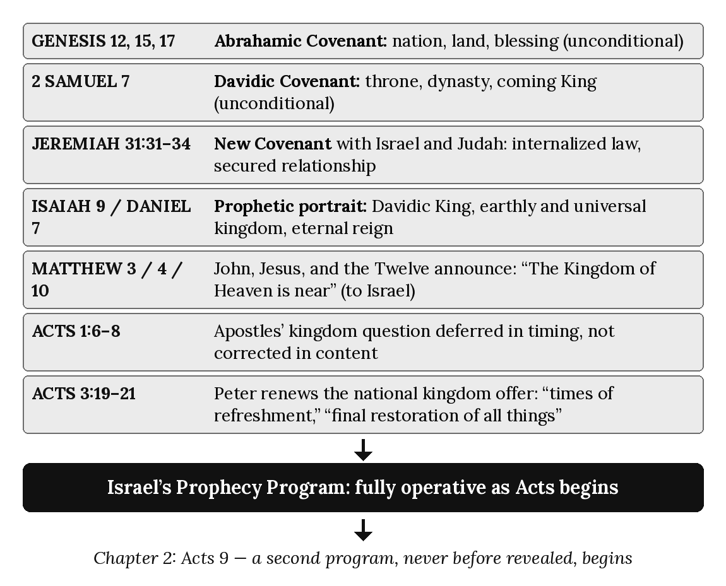

Chapter 2: The Mystery Revealed
“This message was kept secret for centuries and generations past, but now it has been revealed to God’s people.” — Colossians 1:26 (NLT)

Introduction: A Second Story Begins
Chapter 1 established a single, controlling fact about the world Acts opens into: Israel’s Prophecy Program was already fully in motion, covenantally grounded in Abraham, David, and Jeremiah’s New Covenant, and still being offered — unmodified, uncancelled — by Peter himself in Acts 3. Nothing in the first eight chapters of Acts introduces anything genuinely new to that storyline. The apostles preach the kingdom. The Twelve perform the same category of signs Jesus performed. The audience is Israel. The covenant categories are Israel’s covenant categories. The prophetic line runs unbroken from Genesis 12 to Acts 8.
Then Saul of Tarsus is converted on the road to Damascus, and something enters the biblical storyline that had never been there before — not partially, not in shadow form, not in type, but in the fullest sense of the word Paul himself insists on using for it: a mystery. This chapter examines what that word means, what content Paul says was revealed to him, on what basis he claims to have received it, and why — critically for everything that follows in this book — the arrival of this second program does not retire the first one traced in chapter 1. Acts 9 (treated fully in chapter 4) is where this revelation breaks into the narrative. This chapter asks a prior question: what, exactly, was revealed?

What “Mystery” Means in Paul’s Vocabulary
The English word “mystery” invites the wrong picture. In ordinary usage a mystery is a puzzle — an unsolved question awaiting a clever answer. That is not what Paul means when he uses the Greek term mystērion. In Paul’s vocabulary, a mystery is a sacred secret: something real, definite, and fully formed in the mind and purpose of God, that has been deliberately withheld from all previous revelation and is now, at a specific point in redemptive history, disclosed for the first time. The mystery is not solved. It is unveiled.
Three of Paul’s own descriptions of this disclosure use language of concealment so emphatic that it cannot be softened into a merely fuller explanation of something Israel’s prophets had already partly seen. Paul writes to the Romans that his gospel has “revealed his plan for you Gentiles, a plan kept secret from the beginning of time” (Romans 16:25, NLT). He tells the Colossians that his message “was kept secret for centuries and generations past, but now it has been revealed to God’s people” (Colossians 1:26, NLT). And he tells the Ephesians that he was chosen “to explain to everyone this mysterious plan that God, the Creator of all things, had kept secret from the beginning” (Ephesians 3:9, NLT).
Hold these three descriptions against the material surveyed in chapter 1. The Abrahamic, Davidic, and New Covenant promises were not kept secret from the beginning — they were spoken aloud, in public, to named recipients, recorded in Scripture, and repeated by prophet after prophet for two millennia. That entire body of material is, by definition, prophesied — announced in advance, however partially understood, so that its eventual fulfillment could be recognized when it came (compare 1 Peter 1:10–12, where the prophets themselves searched to understand what they had already been given to write). The mystery Paul describes belongs to an entirely different category. It was not prophesied in shadow and later clarified. It was, in Paul’s own repeated words, kept secret — hidden, unspoken, unknown to the very prophets whose writings form the whole substance of chapter 1’s foundation. This distinction is the hinge on which the entire Acts Overlap Model turns: two programs, one prophesied for two thousand years and one deliberately concealed for the same span, entering the biblical storyline through two different apostolic channels, at two different times, to two different audiences — and, as chapters 3 and 4 will show, running alongside each other rather than replacing one another.

Paul’s Testimony: A Revelation With No Human Source
Paul is not content to let his gospel’s origin remain ambiguous. Writing to the Galatians — a letter whose entire argument depends on establishing his apostolic independence from Jerusalem — he states the source of his message in terms that exclude every ordinary channel of religious instruction:
“Dear brothers and sisters, I want you to understand that the gospel message I preach is not based on mere human reasoning. I received my message from no human source, and no one taught me. Instead, I received it by direct revelation from Jesus Christ.” (Galatians 1:11–12, NLT)
Read carefully, Paul rules out three possible sources in succession — human reasoning, human transmission (“no human source”), and human instruction (“no one taught me”) — before naming the actual source: “direct revelation from Jesus Christ.” This is a striking claim for a man who, by the time he writes Galatians, has had years of contact with Peter, James, and the Jerusalem apostles (Galatians 1:18–19; 2:1–2). He is not claiming ignorance of their teaching. He is claiming that his gospel — the content of the mystery specifically — did not originate there. Whatever continuity exists between Paul’s message and the kingdom message of the Twelve (and chapter 6 will show there is real continuity in the person and work of Christ himself), the mystery’s content is, on Paul’s own sworn testimony, underived from the Twelve’s apostolic deposit.

Given to Paul Personally
This claim of direct, personal reception is not confined to Galatians. It recurs, in nearly identical first-person language, everywhere Paul discusses the mystery. To the Ephesians:
“When I think of all this, I, Paul, a prisoner of Christ Jesus for the benefit of you Gentiles . . . assuming, by the way, that you know God gave me the special responsibility of extending his grace to you Gentiles. As I briefly wrote earlier, God himself revealed his mysterious plan to me.” (Ephesians 3:1–3, NLT)
And to the Colossians:
“God has given me the responsibility of serving his church by proclaiming his entire message to you. This message was kept secret for centuries and generations past, but now it has been revealed to God’s people.” (Colossians 1:25–26, NLT)
Notice the pattern across all three letters: “I received my message... by direct revelation from Jesus Christ” (Galatians 1:12); “God himself revealed his mysterious plan to me” (Ephesians 3:3); “God has given me the responsibility... this message was kept secret... but now it has been revealed” (Colossians 1:25–26). In each case the verb of revelation is anchored to Paul’s own person, in the first person singular, as the recipient through whom the church subsequently comes to know what was previously hidden. Paul does not describe himself as one among several who happened to receive this material. He describes himself as its conduit.

Addressing Ephesians 3:5: “His Holy Apostles and Prophets”
A careful reader of Ephesians 3 will notice a phrase that appears, at first glance, to require further clarification concerning Paul’s unique role as the direct recipient and governing steward of the Mystery.
“God did not reveal it to previous generations, but now by his Spirit he has revealed it to his holy apostles and prophets.” (Ephesians 3:5, NLT)
This verse deserves direct engagement rather than silent omission, because the diagnostic method this series teaches (chapters 3 and following) is only credible if it is applied to passages that create friction, not only to those that confirm the thesis cleanly. Two observations resolve the apparent tension. First, verses 2–3 identify the original point of direct disclosure: the mystery was revealed personally and directly to Paul by revelation. Second, verse 5 describes subsequent Spirit-mediated disclosure: what was revealed directly to Paul was then made known by the Spirit to New Testament apostles and prophets associated with his ministry. This does not make the Twelve, in their capacity as Israel’s Prophecy apostles, joint original recipients, administrators, or stewards of Paul’s distinctive Mystery commission. The distinction is therefore between unique direct reception and subsequent Spirit-mediated disclosure. Paul remains the distinctive apostle and steward of the Mystery, while its truth does not remain his private possession.

The Content of the Mystery: The One New Man
Having established how the mystery was revealed and to whom, we turn to what it actually contains. Paul’s clearest statement of its substance comes in Ephesians 2, immediately before the passage on revelation examined above:
“For Christ himself has brought peace to us. He united Jews and Gentiles into one people when, in his own body on the cross, he broke down the wall of hostility that separated us. He did this by ending the system of law with its commandments and regulations. He made peace between Jews and Gentiles by creating in himself one new people from the two groups. Together as one body, Christ reconciled both groups to God by means of his death on the cross, and our hostility toward each other was put to death.” (Ephesians 2:14–16, NLT)
This is worth reading against chapter 1’s material with real precision, because it is easy to mistake this passage for a description of Gentiles being grafted into Israel’s existing covenant blessings — and that is not what the text says. Paul does not describe Jew and Gentile as two groups where one (Israel) retains its prior covenant identity while the other (Gentiles) is added to it. He describes the creation of “one new people from the two groups” — a third entity, distinct from either constituent group as previously defined, formed by dissolving the very legal and covenantal categories (“the system of law with its commandments and regulations”) that had structured the distinction between them. This is the theological content behind this series’ term “the one new man”: not Israel enlarged to include Gentiles, but Jew and Gentile together forming a wholly new body with no covenantal precedent in the material surveyed in chapter 1.

The Threefold “Fellow” in Ephesians 3:6
Paul’s own summary of the mystery’s content, two verses after naming it a mystery, repays close attention at the level of individual words:
“And this is God’s plan: Both Gentiles and Jews who believe the Good News share equally in the riches inherited by God’s children. Both are part of the same body, and both enjoy the promise of blessings because they belong to Christ Jesus.” (Ephesians 3:6, NLT)
The NLT’s “share equally,” “part of the same,” and “enjoy the promise” each render a Greek compound built on the prefix syn- (“with,” “together”; the prefix takes the forms syn-, syg-, sys-, and sym- by sound): believing Gentiles are synklēronoma — fellow-heirs, jointly inheriting; syssōma — fellow-members of one body; and symmetocha — fellow-partakers, jointly sharing the same promise. Syssōma appears nowhere else in the New Testament, and the other two are rare, so Paul appears to be coining or nearly coining technical vocabulary suited to a genuinely new theological reality — a reality for which the existing covenantal vocabulary surveyed in chapter 1 (heir of promise, people of God, covenant partner) was not built to describe, because it presupposed Israel’s own separate covenantal identity as the frame of reference. Paul’s threefold “fellow” describes something that vocabulary cannot: Jew and Gentile as equal, undifferentiated co-participants in a single new reality, with neither serving as the base category into which the other is added.
Romans 16 confirms both the newness and the universal scope of this disclosure:
“Now all glory to God, who is able to make you strong, just as my Good News says. This message about Jesus Christ has revealed his plan for you Gentiles, a plan kept secret from the beginning of time. But now as the prophets foretold and as the eternal God has commanded, this message is made known to all Gentiles everywhere, so that they too might believe and obey him.” (Romans 16:25–26, NLT)
The phrase “as the prophets foretold” in verse 26 requires the same care given to Ephesians 3:5 above: it describes the prophets’ witness to the fact that God would one day act toward the Gentiles in grace and mercy (a theme genuinely present in the Old Testament — see, for example, Isaiah 49:6), not a claim that the specific content of the one new man — Jew and Gentile fused into a single new body, the church, with no distinction — was itself disclosed in the Old Testament. The prophets foretold that blessing would come to the Gentiles; they did not foretell the mystery — the specific mechanism, timing, and shape of the one new man — because, as Paul says without qualification twice in the same short span (Romans 16:25; Ephesians 3:9), that plan was “kept secret from the beginning.”

Hidden From the Prophets, Not Merely From Men
It is worth pausing on how sweeping Paul’s language of concealment actually is, because contemporary readers sometimes soften it into merely saying the mystery had gone unnoticed or underemphasized by careful readers of the Old Testament. That is not what “kept secret from the beginning of time” (Romans 16:25) or “kept secret for centuries and generations past” (Colossians 1:26) or “kept secret from the beginning” (Ephesians 3:9) can reasonably mean. This is concealment by God’s own design, not oversight by Israel’s prophets. The prophets did not fail to notice the one new man; it was not there for them to notice, because — on Paul’s own repeated testimony — it had not yet been given. This is precisely why chapter 1’s covenantal material (Abrahamic land and nation, Davidic throne, Jeremiah’s New Covenant “with the people of Israel and Judah”) contains no reference, anywhere, to a body formed of Jew and Gentile without covenantal distinction, no reference to a heavenly rather than earthly destiny for that body, and no reference to Gentiles entering blessing apart from Israel’s own national restoration. Those omissions are not accidents of incomplete prophecy. They are the necessary shape of a genuine mystery — content that could not have been derived from, anticipated by, or read out of material that predates its disclosure, because it was deliberately withheld from that material until the appointed moment of Paul’s own commissioning.

Why the Mystery Doesn’t Cancel the Kingdom
It would be a natural but mistaken inference to conclude, from everything traced above, that the arrival of this new revelation retires the Prophecy Program described in chapter 1. Nothing in the texts examined in this chapter says so, and the Lord’s own words to Ananias about Paul, at the very moment of Paul’s commissioning, say the opposite:
“But the Lord said, ‘Go, for Saul is my chosen instrument to take my message to the Gentiles and to kings, as well as to the people of Israel. And I will show him how much he must suffer for my name’s sake.’” (Acts 9:15–16, NLT)
Paul’s commission is explicitly threefold in its audience — “the Gentiles and... kings, as well as... the people of Israel” — and nowhere in this description, or anywhere else in Acts 9 (examined fully in chapter 4), does the text indicate that Peter’s ministry, the Twelve’s apostleship, or the kingdom offer traced in chapter 1 has been withdrawn. What begins in Acts 9 is additive, not substitutionary. A second, previously unrevealed program is introduced into a narrative in which the first program — covenantal, national, prophetic, still being offered by Peter as recently as Acts 3 — continues operating in full force. This is the overlap this whole series is built to explain, and chapter 3 will lay out both programs side by side, in full, before chapter 4 traces the precise moment — Acts 9 — where the second program enters the story.

Applying the Seven Diagnostic Lenses: Ephesians 3:1–9
- Audience — Gentiles specifically named as beneficiaries (“for the benefit of you Gentiles,” v. 1; “extending his grace to you Gentiles,” v. 2), though the mystery’s content includes Jew and Gentile united (v. 6).
- Apostolic Authority — Paul’s distinct apostleship; the passage’s entire argument depends on his personal, singular commissioning (“God gave me,” v. 2; “revealed... to me,” v. 3).
- Covenant — Non-covenantal; no covenant is invoked, cited, or fulfilled. The content is “kept secret,” not covenantally promised.
- Sign-Gift — Absent from the passage; Paul’s authority rests on revelation, not on an accompanying sign given at this moment.
- Commission — The Pauline Commission: “I was chosen to explain to everyone this mysterious plan” (v. 9) — a distinct commissioning from the Kingdom Commission of Matthew 28 and the kingdom-proclamation mandate of Acts 3.
- Eschatology — Heavenly and universal (“both are part of the same body,” v. 6) rather than the earthly, national restoration language of Acts 3:19–21.
- Dispensation — The administration of grace: “by God’s grace and mighty power, I have been given the privilege of serving him” (v. 7), consistent with Paul’s own description of “the special responsibility of extending his grace” given to him (cf. Ephesians 3:2, NLT).
Every lens returns the same diagnostic profile: this is not Israel’s Prophecy Program continuing under new management. It is a distinct, non-covenantal, Paul-mediated disclosure, addressed to a mixed but Gentile-emphasized audience, structured by an entirely different apostolic authority, commission, destiny, and dispensational administration than the material examined in chapter 1.

Chapter Summary
The mystery Paul describes in Galatians, Ephesians, Colossians, and Romans is not a fuller explanation of Israel’s prophetic hope; it is a previously undisclosed divine purpose, kept secret across the span of Old Testament revelation and first entrusted directly to Paul through his commissioning by the risen Christ and progressively unfolded through subsequent revelation. Its content is the one new man — Jew and Gentile united into a single new body, reconciled to God together, with the legal distinctions that structured the old covenant order set aside. Paul is the unique direct recipient and distinctive steward of this revelation; it is subsequently made known by the Spirit to New Testament apostles and prophets associated with his ministry, not independently disclosed to the Twelve as Prophecy apostles. And critically, nothing about this disclosure cancels what chapter 1 established: Israel’s Prophecy Program continues in force, governed by the Twelve, even as this second program begins. Chapter 3 now sets these two programs side by side.

Key Terms
Mystery (mystērion) — A sacred secret: content deliberately hidden throughout previous revelation and disclosed for the first time at a specific point in redemptive history, as distinct from prophecy, which announces in advance what will later be recognized as fulfilled.
The One New Man — The body created when Christ, through the cross, united believing Jew and Gentile into a single new people distinct from either group’s prior covenantal identity (Ephesians 2:14–16).
Direct Revelation — Paul’s own description of how he received the mystery: “not based on mere human reasoning... from no human source... by direct revelation from Jesus Christ” (Galatians 1:11–12).
Dispensation of Grace — Paul’s term for the administration under which the mystery operates, distinct from the kingdom-offer administration described in chapter 1 (cf. Ephesians 3:2).

Reflection and Teaching Questions
- Why does the distinction between “prophesied in advance” and “kept secret from the beginning” matter for how we interpret Old Testament silence about the church? What would it mean to get this distinction backward?
- How does the framework in this chapter handle Ephesians 3:5’s reference to “his holy apostles and prophets”? Do you find the distinction between original reception and shared subsequent knowledge persuasive? Why or why not?
- Ephesians 2:14–16 describes “one new people from the two groups” rather than Gentiles being added to Israel’s existing covenant identity. Why does this distinction matter for keeping Israel’s program and the Body of Christ’s program doctrinally separate?
- Acts 9:15 describes Paul’s commission as including “the Gentiles and... kings, as well as... the people of Israel.” How does this shape our expectation for what we should find as we read the Acts Overlap in the chapters ahead?

Diagram: Two Revelations Compared
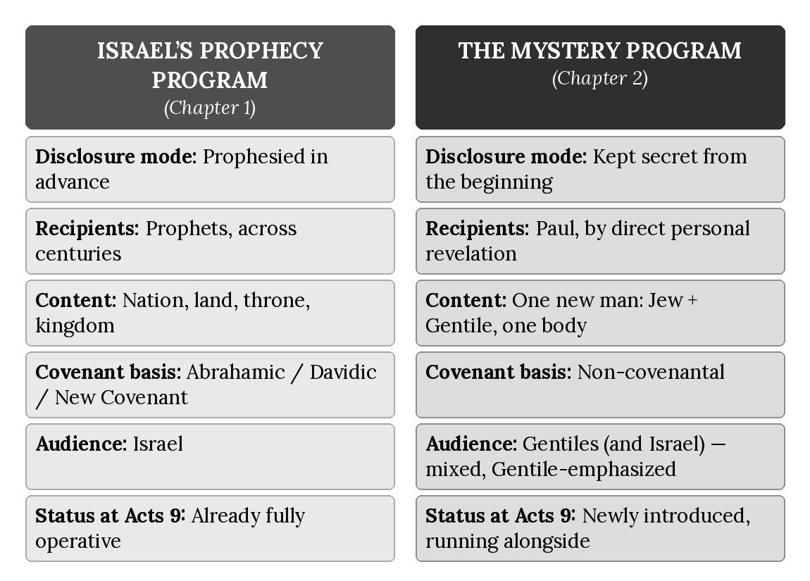

Chapter 3: The Two Programs
“Instead, they saw that God had given me the responsibility of preaching the Good News to the Gentiles, just as he had given Peter the responsibility of preaching to the Jews.” — Galatians 2:7 (NLT)

Introduction: Naming What Chapters 1 and 2 Established
Chapter 1 traced Israel’s Prophecy Program from Abraham to Peter’s sermon at Solomon’s Colonnade: covenantal, earthly, national, governed by the Twelve, and still fully in force as Acts opens. Chapter 2 traced the Mystery Program from its point of disclosure: non-covenantal, heavenly in destiny, universal in scope, revealed through Paul, and — critically — additive rather than substitutionary. Neither chapter has yet placed these two realities side by side as a single, formal system. That is the task of this chapter, and it is the reason this book is titled what it is. The Acts Overlap Model is not a claim that Acts contains scattered tensions best explained away individually, passage by passage, with whatever harmonization seems convenient at the moment. It is a claim that two distinct, identifiable, consistently patterned divine programs run concurrently through Acts 9–28, and that most of the interpretive difficulty readers encounter in Acts dissolves once both programs are named, defined, and tracked separately rather than blended into one.
This chapter does three things. First, it shows that the two-program reality is not a modern theological construction imposed on the text, but language the New Testament itself uses about its own apostles. Second, it lays out the full comparison across all seven diagnostic categories this series uses, culminating in the canonical Two Programs Chart that will govern every reference to this material for the remainder of the series (this chart is not to be redrawn or restated differently in any later chapter or volume). Third, it previews — without yet fully arguing, which is the task of chapters 4 through 21 — where the overlap this model describes begins, how it develops, and where it ends.

Two Apostleships, Recognized as Two: Galatians 2:7–9
The clearest New Testament confirmation that two distinct apostolic spheres were operating side by side comes not from an outside observer but from the apostles themselves, meeting together in Jerusalem. Paul’s own account of that meeting uses division-of-labor language too precise to read as anything other than the formal recognition of two parallel commissions:
“Instead, they saw that God had given me the responsibility of preaching the Good News to the Gentiles, just as he had given Peter the responsibility of preaching to the Jews. For the same God who worked through Peter as the apostle to the Jews also worked through me as the apostle to the Gentiles. In fact, James, Peter, and John, who were known as pillars of the church, recognized the gift God had given me, and they accepted Barnabas and me as their co-workers. They encouraged us to keep preaching to the Gentiles, while they continued their work with the Jews.” (Galatians 2:7–9, NLT)
Chapter 7 of this book will examine the Jerusalem Council itself (Acts 15) in full; this passage is Paul’s own retrospective commentary on that same relationship, and it is worth isolating four things it establishes plainly, in advance of that fuller treatment. First, the division is explicitly apostolic and structural, not merely a difference in personal calling or preference: “God had given me the responsibility... just as he had given Peter the responsibility.” Second, both spheres are described as equally and simultaneously energized by God: “the same God... worked through Peter... also worked through me.” Neither commission is treated as a lesser, transitional, or provisional version of the other. Third, the division is formally ratified by the recognized leadership of the Jerusalem church — James, Peter, and John — not merely claimed unilaterally by Paul. Fourth, and most significantly for this chapter’s purpose, the division is audience-based and ongoing: Paul and Barnabas continue “preaching to the Gentiles,” Peter, James, and John continue “their work with the Jews” — present, continuing, parallel ministries, not a handoff in which one apostleship yields to the other.
Paul makes the same claim about the distinctiveness of his own apostleship, independent of the Twelve’s endorsement, when writing to the Corinthians:
“Am I not as free as anyone else? Am I not an apostle? Haven’t I seen Jesus our Lord with my own eyes? Isn’t it because of my work that you belong to the Lord? Even if others think I am not an apostle, I certainly am to you. You yourselves are proof that I am the Lord’s apostle.” (1 Corinthians 9:1–2, NLT)
And he names the administrative category under which his entire ministry to the Gentiles operates — a term this series has already introduced in chapter 2 and will use throughout — in the same letter in which he most fully expounds the mystery:
“...assuming, by the way, that you know God gave me the special responsibility of extending his grace to you Gentiles.” (Ephesians 3:2, NLT)
“The special responsibility” here translates the Greek oikonomia — a stewardship, administration, or dispensation. Paul is not describing a new doctrine dropped into an otherwise unchanged administrative structure. He is describing a distinct administration, given to him personally, running alongside whatever administration governs Peter’s continuing work among the Jews.

The Seven Diagnostic Categories: Full Comparison
Chapters 1 and 2 established each of the seven diagnostic categories for one program at a time. Laid out together, the contrast is systematic rather than incidental — every category, not merely one or two isolated details, distinguishes the two programs consistently.
Audience. Israel’s Prophecy Program addresses Israel specifically and, in its founding commissions, exclusively — “Don’t go to the Gentiles or the Samaritans... only to the people of Israel” (Matthew 10:5–6, NLT; chapter 1). The Mystery Program addresses Gentiles specifically, and beyond them, Jew and Gentile united without distinction into the one new man (Ephesians 2:14–16; chapter 2).
Apostolic Authority. The Prophecy Program is governed by the Twelve, with Peter holding the keys of the kingdom (Matthew 16:19). The Mystery Program is governed by Paul’s independent apostleship, received “from no human source” (Galatians 1:12) and formally recognized, not conferred, by the Jerusalem apostles (Galatians 2:7–9).
Covenant. The Prophecy Program is thoroughly covenantal — Abrahamic, Davidic, and New Covenant promises made specifically “with the people of Israel and Judah” (Jeremiah 31:31, NLT; chapter 1). The Mystery Program is non-covenantal; no covenant is invoked as its basis, because its content was “kept secret from the beginning” rather than promised in advance (Romans 16:25; Ephesians 3:9; chapter 2).
Sign-Gift. The Prophecy Program is characterized by signs and wonders authenticating the kingdom message, continuous with Jesus’ own sign-attested ministry (a pattern chapter 8 will trace in detail throughout the Acts overlap). The frequency or narrative concentration of recorded signs may vary across Acts, but their programmatic availability does not progressively diminish while Israel’s Prophecy Program remains operative. The Mystery Program, in the passages examined in chapter 2, rests on revelation rather than accompanying sign — Paul’s authority in Ephesians 3 and Galatians 1 is established by what was revealed to him, not by a miracle performed as its evidence.
Commission. The Prophecy Program operates under what this series calls the Kingdom Commission trajectory — the kingdom-proclamation mandate given to the Twelve (Matthew 10:5–7; 28:18–20). The Mystery Program operates under the Pauline Commission — “I was chosen to explain to everyone this mysterious plan” (Ephesians 3:9, NLT) and the direct commissioning narrated in Acts 26:16–18: “I am sending you to the Gentiles to open their eyes, so they may turn from darkness to light” (Acts 26:16–18, NLT).
Eschatology. The Prophecy Program promises an earthly destiny — “the final restoration of all things, as God promised long ago through his holy prophets” (Acts 3:21, NLT; chapter 1). The Mystery Program promises a heavenly calling for a body in which “both are part of the same body” (Ephesians 3:6, NLT; chapter 2), a destiny chapter 13 will examine in full.
Dispensation. The Prophecy Program operates under the prophetic/Kingdom administration operative for Israel — law fulfilled in Christ, kingdom proclaimed to Israel. The Mystery Program operates under what Paul explicitly names “the special responsibility of extending his grace” (Ephesians 3:2, NLT) — the dispensation, or administration, of grace given to Paul personally.

The Canonical Two Programs Chart
The comparison above is summarized here in the form that governs every later reference to it in this series. This chart — not a restatement, not a redrawn variant — is the version chapters 5 through 21 and Appendix B will cite.
 | Israel’s Prophecy Program | Body of Christ’s Mystery Program
Covenant status | Covenantal | Non-covenantal
Destiny | Earthly | Heavenly
Scope | National | Universal
Authority | The Twelve | Paul
Baptism | Water | Spirit
Signs | Present throughout the overlap; judicially ceases at Acts 28 | Absent
Temple | Central | Not applicable
Commission | Kingdom Commission | Pauline Commission
Two rows in this chart — Baptism and Signs — anticipate material this book has not yet argued in full; chapters 8 and 14 will take up the judicial cessation of Prophecy-Program sign-authentication and the two baptisms respectively, with the exegetical support this summary chart presupposes. Its purpose here is architectural: to fix, in one place, the complete comparative shape of the model before the chapters that follow trace how it plays out across the actual narrative of Acts. With the national suspension of Israel’s Prophecy Program at Acts 28, the sign-program associated with Israel ceases programmatically. The judicial cessation associated with Acts 28 concerns the sign-authentication function belonging to Israel’s prophetic setting; it does not mean that the Spirit ceases to equip members of the Body of Christ for ministry, service, teaching, edification, leadership, or other non-sign functions appropriate to the Mystery administration. Spirit-enabled ministry does not necessarily equal sign-authentication, and cessation of sign-authentication does not mean cessation of all Spirit-enabled ministry.

Terminological Note: Overlap, Not Transition
Readers familiar with other treatments of Acts will often encounter the word “transitional” applied loosely to the book as a whole — a general acknowledgment that something changes between the Gospels and the mature Gentile churches of Paul’s later epistles, without a structural account of what, precisely, is transitioning from what, or how. This series deliberately avoids that vocabulary as its primary description, for a reason worth stating clearly: “transition” suggests a single program gradually dissolving, fading, or morphing into a different one, category by category, over time — as though the Prophecy Program slowly turns into the Mystery Program the way dusk gradually turns into night. That is not the claim this book is making, and it is not what the diagnostic categories in this chapter show.
The Acts Overlap Model’s claim is more precise: two whole, complete, fully formed programs — one already complete in its covenantal basis by the time Acts opens (chapter 1), one entering history at the fixed Acts 9 boundary through Paul’s direct calling and commissioning by the risen Christ, with its doctrinal content progressively unfolded thereafter — operate concurrently, side by side, for a bounded period, and then separate again, with the Prophecy Program pausing rather than dissolving into the Mystery Program. The frequency and narrative concentration of recorded signs may vary across this period, but their programmatic availability does not progressively diminish (chapter 8), and Acts records repeated local Jewish rejection while Israel’s national prophetic standing remains unchanged until Acts 28 (chapter 9) — so narrative variation within the overlap is real, but no programmatic change occurs. The two programs themselves do not blend into a third, hybrid thing. They remain structurally distinct — as Galatians 2:7–9 shows, as two apostleships recognized and maintained as two — for the entire span in which both are operating. “Overlap” names that concurrent, bounded, structurally distinct operation. “Transition” would misname it as a gradual merger.

What “Two Programs” Does Not Mean
Three clarifications guard against common misreadings of this chart, each worth stating plainly before moving further into the book. First, “two programs” does not mean two unrelated deities, or two unrelated Christs. Both programs originate from the same God, and both are centered on the same Lord Jesus Christ. They do not, however, share identical content, identical audiences, or identical authority, and this book states no single saving ground common to both: salvation is always by faith and never by merit, but the content of faith is what God revealed within each program (chapter 15). What differs is the administration — the covenantal basis, the destiny in view, the governing apostolic authority, and the commission under which each program operates — not the identity of God or the person of Christ.
Second, this model is not a form of supersessionism, the view that the church permanently replaces Israel as the object of God’s covenant promises. The direction of this book’s argument runs the opposite way: chapter 1 established Israel’s covenants as unconditional and irrevocable, and chapters 18 through 20 will show that Israel’s Acts 28 judicial blinding is explicitly temporary — a pause in the Prophecy Program, not its cancellation, with the future restoration Peter promised in Acts 3:21 still standing. The Mystery Program does not absorb, replace, or reassign Israel’s promises to a different people; it is, in Paul’s own careful language from chapter 2, an entirely new and previously undisclosed program running alongside Israel’s unrevoked one, not a reinterpretation of it. Acts 28 changes Israel’s programmatic status — not Paul’s commission. At Acts 28, Israel’s Prophecy Program reaches its national judicial suspension. Consequently, the concurrent Acts setting in which Paul could minister to Israel while that program remained nationally operative comes to an end. Paul’s apostolic identity, commission, and stewardship remain distinctly Mystery before, during, and after the boundary. The word “church” or “assembly” must be interpreted contextually rather than treated as an automatic technical designation for the Body of Christ. Scripture can speak of assemblies associated with Israel and the prophetic setting without identifying those assemblies as the Body of Christ Paul describes. Every Body-of-Christ congregation is an assembly, but not every biblical assembly is the Body of Christ. Acts 2 marks a major event within Israel’s Prophecy Program; Acts 9 marks the beginning of the Mystery Program and therefore the historical beginning of the Body-of-Christ administration. The presence of an assembly called a “church” before Acts 9 does not move the Mystery boundary backward.
Third, this chart is not yet a claim about how individuals within each program come to be right with God; that is the specific subject of chapter 15, “The Two Justifications,” and this book will not anticipate that argument here. What this chapter has established is the administrative and structural shape of two programs, not yet the soteriological detail chapter 15 will take up with the care that subject requires.

Applying the Seven Lenses to a New Case: Philip and the Ethiopian Eunuch
Before moving into the Acts Overlap proper, it is worth testing the seven-lens method on a passage that might, at first glance, look like an early exception to the audience distinction this chapter has drawn — a reminder that the model requires the whole diagnostic bundle, not audience alone, before drawing conclusions. In Acts 8, prior to Paul’s calling, Philip is sent to evangelize an Ethiopian court official:
“The eunuch had gone to Jerusalem to worship, and he was now returning. Seated in his carriage, he was reading aloud from the book of the prophet Isaiah. The Holy Spirit said to Philip, ‘Go over and walk along beside the carriage.’... Philip told him the Good News about Jesus... ‘Look! There’s some water! Why can’t I be baptized?’... they went down into the water, and Philip baptized him. When they came up out of the water, the Spirit of the Lord snatched Philip away.” (Acts 8:27–39, NLT, selected)
A reader tracking audience alone might take this as an early instance of Gentile inclusion complicating the Prophecy Program’s Israel-only pattern established in chapter 1. Running the full seven-lens diagnostic gives a more precise result. Audience: the eunuch had “gone to Jerusalem to worship” and was reading Isaiah — a Gentile God-fearer already worshiping within Israel’s covenant framework, not an unreached Gentile approached on Mystery-Program terms. Apostolic Authority: Philip, one of the seven appointed in Acts 6, ministering as an extension of the Jerusalem apostles’ authority — not Paul, and this occurs before Paul’s own calling in Acts 9. Covenant: the passage under discussion is Isaiah’s Suffering Servant prophecy — covenantal, prophetic material, read and explained as fulfilled prophecy, exactly the pattern chapter 1 described. Sign-Gift: the Spirit’s directive guidance to Philip and his being “snatched away” after the baptism are both kingdom-pattern miraculous signs. Commission: the eunuch is baptized in water — the Prophecy Program’s baptism (chapter 14 will examine this distinction fully), not the Spirit baptism that chapter 14 associates with the Mystery. Eschatology and Dispensation: nothing in the passage introduces the one new man, the heavenly calling, or the dispensation of grace defined in this chapter; the eunuch’s baptism and the Isaiah exposition both belong to Israel’s Prophecy Program still in force. Water baptism belongs historically to Israel’s prophetic and kingdom setting and remains visible during the Acts Overlap because Israel’s Prophecy Program remains concurrently operative. Paul himself baptizes certain individuals during that period, but water baptism is not part of his distinctive Mystery commission. His statement that Christ did not send him to baptize but to preach the gospel (1 Corinthians 1:17) distinguishes an action Paul may perform during the overlap from the commission he actually possesses. The “one baptism” of Ephesians 4:5 is the Spirit’s non-ceremonial identification of the believer with Christ and incorporation into the one Body, not a continuing water ordinance required for membership in the Body of Christ. Participation does not establish commission; water baptism during the overlap does not establish water baptism as a Mystery ordinance.
Six of the seven lenses return a Prophecy Program reading; only audience, considered alone, might have suggested otherwise — and even there, a worshiping God-fearer already inside Israel’s orbit is a different case than the unreached Gentile audience the Mystery Program will later address. This is the value of running all seven lenses rather than one: audience by itself is a starting question, not a concluding one, and Acts 8 shows why the diagnostic method this chapter has assembled must be applied as a whole bundle, consistently, rather than settled by whichever single category is most visible on a first reading.

Preview: Where the Overlap Begins and Ends
With both programs now defined side by side, the remainder of Book 1 traces their relationship across the narrative of Acts, following the canonical Acts Overlap diagram:
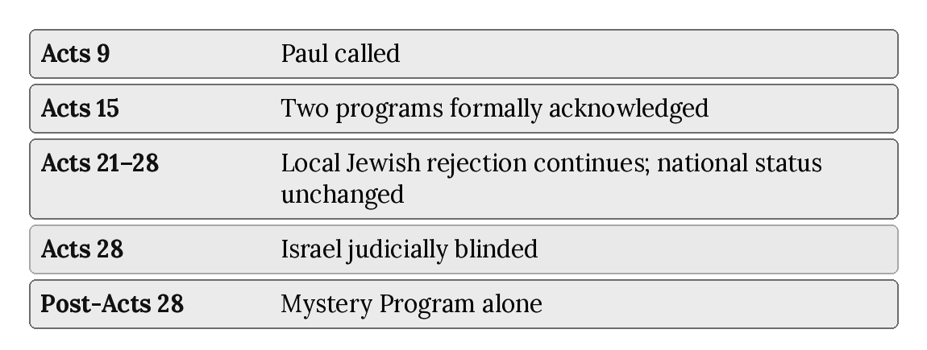
Chapter 4 begins this trajectory at its first marker: Paul’s calling in Acts 9, where the Mystery Program — defined in chapter 2, now formally distinguished from the Prophecy Program in this chapter — actually enters the narrative for the first time. From there, chapters 5 through 21 trace both apostleships in ministry (5–6), their formal recognition of one another (7), the continued operation and eventual judicial cessation of the Prophecy Program’s sign-authentication (8) and audience (9–10), the maturing of Paul’s own churches and doctrine (11–17), and finally the crisis and resolution of Acts 28 itself (18–21), where the overlap this chapter has defined comes to its close.

Chapter Summary
The two-program structure this series is built around is not an inference forced onto ambiguous material. Paul himself describes his apostleship and Peter’s as two divinely energized, formally recognized, audience-divided commissions operating in parallel (Galatians 2:7–9), and every diagnostic category this series uses — audience, authority, covenant, signs, commission, eschatology, dispensation — distinguishes the two programs consistently rather than incidentally. The canonical Two Programs Chart in this chapter fixes that comparison in the form every later chapter and every other book in this series will use without variation. What remains is to trace how these two programs actually interact across the narrative of Acts — beginning, in chapter 4, at the moment the Mystery Program enters the story.

Key Terms
Acts Overlap Model — This series’ name for the thesis that Israel’s Prophecy Program and the Body of Christ’s Mystery Program operate concurrently during Acts 9–28.
Dispensation (oikonomia) — An administration or stewardship; Paul’s own term (Ephesians 3:2) for the distinct economy under which his Gentile ministry operates.
Two Programs Chart — The canonical, eight-row comparison of Israel’s Prophecy Program and the Body of Christ’s Mystery Program established in this chapter and referenced without variation throughout the series (see also Appendix B).

Reflection and Teaching Questions
- In Galatians 2:7–9, what specific details indicate that the division between Peter’s and Paul’s ministries was formal and structural rather than merely a personal difference in calling or emphasis?
- Why does this chapter insist that “two programs” does not mean two unrelated deities or two unrelated Christs, and what does it say instead about the content of faith in each program? What is at stake in keeping that distinction clear?
- Look again at the Two Programs Chart. Which of the eight rows do you find most immediately convincing from Scripture, and which would you want to see argued in more depth? (Chapters 4–21 will take up each in turn.)
- Why might it matter, for reading the rest of Acts well, to fix a chart like this in place before working through the narrative chapter by chapter, rather than deciding the categories passage by passage as they arise?

Chapter 4: The Overlap Begins (Acts 9)
“‘Who are you, lord?’ Saul asked. And the voice replied, ‘I am Jesus, the one you are persecuting!’” — Acts 9:5 (NLT)

Introduction: From Definition to Narrative
Chapter 3 set Israel’s Prophecy Program and the Body of Christ’s Mystery Program side by side as an abstract, systematic comparison — the canonical Two Programs Chart, fixed and ready for use. This chapter asks a different kind of question: where, precisely, in the actual narrative of Acts, does this comparison stop being merely theological architecture and start being observable history? The answer is Acts 9, and the case for treating this chapter as the hinge of the entire book is stronger than a single conversion account might suggest. Acts 9 does not merely narrate Saul’s call. In a single chapter, Luke places Saul’s Damascus road encounter and commissioning (vv. 1–22) directly alongside an account of Peter’s continuing kingdom-pattern healing ministry (vv. 32–43) — Aeneas raised from eight years of paralysis, Dorcas raised from death itself. This is not incidental narrative housekeeping. It is Luke’s own literary structure putting both programs on the page together, in the same chapter, for the first time. This chapter examines both halves in turn, then asks what happens when all seven diagnostic lenses are run across the chapter as a whole.
Acts 9 marks the historical beginning of the Mystery Program through the direct calling and commissioning of Paul by the risen Christ. Subsequent revelation given to Paul does not progressively create the Mystery Program; it progressively unfolds and explains the content of a program already inaugurated at Acts 9. Progressive revelation must therefore be distinguished from progressive program formation. During Acts 9–28, Israel’s Prophecy Program remains nationally operative, and Israel therefore continues to stand in relation to its prophetic kingdom promises and responsibilities. Paul may address Israel concerning its Messiah, Scriptures, prophetic hope, and accountability while ministering within that still-operative setting. Such ministry does not make Paul an administrator of Israel’s Kingdom Commission or place him under the Kingdom Commission. The continued operation of Israel’s Prophecy Program does not require Pauline administration of that program. Acts 9 fixes the beginning of the Mystery Program; it does not require exhaustive disclosure of every Mystery doctrine at Acts 9. From that point the Mystery Program is genuinely operative as a distinct program, while its doctrinal content is progressively unfolded through subsequent revelation to and through Paul. Progressive revelation develops the disclosed content of the program; it does not progressively bring the program itself into existence.

The Damascus Road: Confronted by the Risen Christ
Saul’s introduction in Acts 9 establishes, in a single passage, exactly who is being converted and what he had been doing up to this point:
“Meanwhile, Saul was uttering threats with every breath and was eager to kill the Lord’s followers. So he went to the high priest. He requested letters addressed to the synagogues in Damascus, asking for their cooperation in the arrest of any followers of the Way he found there.” (Acts 9:1–2, NLT)
This is not a peripheral figure being drawn gradually toward faith. Saul is the movement’s most committed and most dangerous opponent, acting with the sanction of the Jerusalem religious authorities, in active pursuit of “the Way” as far as a foreign city. The confrontation that follows is correspondingly abrupt:
“As he was approaching Damascus on this mission, a light from heaven suddenly shone down around him. He fell to the ground and heard a voice saying to him, ‘Saul! Saul! Why are you persecuting me?’ ‘Who are you, lord?’ Saul asked. And the voice replied, ‘I am Jesus, the one you are persecuting! Now get up and go into the city, and you will be told what you must do.’ The men with Saul stood speechless, for they heard the sound of someone’s voice but saw no one! Saul picked himself up off the ground, but when he opened his eyes he was blind. So his companions led him by the hand to Damascus. He remained there blind for three days and did not eat or drink.” (Acts 9:3–9, NLT)
Two details deserve particular attention. First, Jesus identifies Saul’s persecution of the church as persecution of Christ himself — “the one you are persecuting” — establishing an identification between the risen Lord and his body that will become a load-bearing doctrine in Paul’s own later ecclesiology (compare 1 Corinthians 12:12–27, where the church is Christ’s body in an organic, not merely metaphorical, sense). Second, the risen, glorified Christ appears bodily and visibly — the light, the fall to the ground, the resulting blindness — to a man not previously a disciple, in a mode of self-disclosure Paul later insists qualifies as a genuine, if final, resurrection appearance: “Last of all, as though I had been born at the wrong time, I also saw him” (1 Corinthians 15:8, NLT), placed by Paul in the same list as the appearances to Peter, the Twelve, and five hundred believers at once (1 Corinthians 15:5–7). Whatever else Acts 9 will go on to establish about the distinctiveness of Paul’s calling, it begins with an experience Paul places in continuity with, not apart from, the resurrection appearances that founded the apostolic testimony of the Twelve.

Ananias’s Vision and the Threefold Audience of Paul’s Commission
The risen Christ commissions Saul directly. Ananias does not mediate or confer that commission; rather, the Lord sends Ananias as His appointed messenger to confirm Saul’s calling and communicate the divinely assigned scope of his ministry. Ananias, “a believer in Damascus” otherwise unknown to the narrative, receives his own vision:
“The Lord said, ‘Go over to Straight Street, to the house of Judas. When you get there, ask for a man from Tarsus named Saul. He is praying to me right now. I have shown him a vision of a man named Ananias coming in and laying hands on him so he can see again.’ ‘But Lord,’ exclaimed Ananias, ‘I’ve heard many people talk about the terrible things this man has done to the believers in Jerusalem! And he is authorized by the leading priests to arrest everyone who calls upon your name.’ But the Lord said, ‘Go, for Saul is my chosen instrument to take my message to the Gentiles and to kings, as well as to the people of Israel. And I will show him how much he must suffer for my name’s sake.’” (Acts 9:11–16, NLT)
Chapter 2 already drew on verses 15–16 to establish that Paul’s one distinctive commission encompasses a threefold audience — Gentiles, kings, and “the people of Israel.” These audience categories describe the scope of Paul’s ministry; they do not divide his commission or assign him multiple programmatic stewardships. They describe the scope of Paul’s one distinctive Mystery commission, not an assignment of administrative responsibility for Israel’s still-operative Prophecy Program. Here it is worth adding what immediately follows, because it complicates a simplistic before-and-after picture of Acts 9 in a way careful readers should not smooth over:
“So Ananias went and found Saul. He laid his hands on him and said, ‘Brother Saul, the Lord Jesus, who appeared to you on the road, has sent me so that you might regain your sight and be filled with the Holy Spirit.’ Instantly something like scales fell from Saul’s eyes, and he regained his sight. Then he got up and was baptized.” (Acts 9:17–18, NLT)
Saul — the man who will become, on this series’ own framework, the apostle through whom a non-covenantal, water-baptism-free Mystery Program is revealed (chapter 14 will treat the two baptisms fully) — is himself water baptized at the very moment of his own commissioning. This deserves honest acknowledgment rather than silent omission. The resolution is not to deny the text but to keep this chapter’s own thesis in view: Acts 9 marks the entrance of the Mystery Program’s apostolic authority into the narrative, not the instantaneous, full-strength operation of its mature, distinctive practice from the first hour. Saul’s baptism here belongs to the overlap’s earliest moment, when the man who will carry the Mystery is himself baptized in a setting still shaped by Israel’s ongoing prophetic practice — the practice Ananias himself, a believer evidently still operating within Israel’s ongoing prophetic setting, would have expected as a matter of course. Paul’s baptism is reported as written (chapter 14 treats the two baptisms fully); it does not make the apostle of the Gentiles a Prophecy apostle. The fuller disclosure of the mystery, which Paul says was made known through him, unfolds, as the next section shows from Paul’s own testimony, over the years immediately following, not in the initial hours after Ananias’s visit.

Continuity Before Distinctiveness: Saul’s Early Preaching
The same pattern holds for the content of Saul’s earliest public ministry, narrated a few verses later:
“Saul stayed with the believers in Damascus for a few days. And immediately he began preaching about Jesus in the synagogues, saying, ‘He is indeed the Son of God!’ All who heard him were amazed. ‘Isn’t this the same man who caused such devastation among Jesus’ followers in Jerusalem?’ they asked. ‘And didn’t he come here to arrest them and take them in chains to the leading priests?’ Saul’s preaching became more and more powerful, and the Jews in Damascus couldn’t refute his proofs that Jesus was indeed the Messiah.” (Acts 9:19–22, NLT)
Notice the setting and the content: synagogues, a Jewish audience, and a christological claim — “he is indeed the Son of God,” “Jesus was indeed the Messiah” — framed in exactly the messianic, kingdom-idiom vocabulary this series traced in chapter 1 from John the Baptist through Peter’s Acts 3 sermon. Nothing here yet announces the one new man, the heavenly calling, or the dispensation of grace chapter 3 defined as the mystery’s distinctive content. Saul’s earliest ministry, immediately following his commissioning, is audience-specific proclamation to Israel: Jesus is the promised Messiah, the Son of God, argued from the Hebrew Scriptures to a synagogue audience. This is not a contradiction of Saul’s unique calling; it is exactly what this chapter’s thesis predicts. The overlap does not begin with Saul’s first sermon announcing every part of the mystery; the fuller disclosure is made known through him as his ministry unfolds (chapter 5). It begins with a new apostolic authority entering a narrative still shaped by Israel’s prophetic setting, with his commission and his gospel his own from the start.
Paul’s commission never changes: he is the apostle of the Gentiles, and his own gospel is the gospel of the grace of God. When he reasons in the synagogues from Israel’s Scriptures, he proclaims Israel’s Messiah and kingdom hope to Israel, whose prophetic program remained operative until its national suspension at Acts 28. That is audience-specific proclamation, not a second gospel and not a change of commission; it does not make Paul a Prophecy apostle, and it does not make his hearers members of the Body by that message.

Galatians 1:15–18: The Arabia Interval
Paul’s own retrospective account of this period, written years later to the Galatians, confirms this reading directly and adds a detail Acts 9 does not narrate at all:
“But even before I was born, God chose me and called me by his marvelous grace. Then it pleased him to reveal his Son to me so that I would proclaim the Good News about Jesus to the Gentiles. When this happened, I did not rush out to consult with any human being. Nor did I go up to Jerusalem to consult with those who were apostles before I was. Instead, I went away into Arabia, and later I returned to the city of Damascus. Then three years later I went to Jerusalem to get to know Peter, and I stayed with him for fifteen days.” (Galatians 1:15–18, NLT)
Paul’s own chronology separates his commissioning (the Damascus road) from the extended period — three years, by his own count, before even his first meeting with Peter — during which he withdrew “into Arabia.” Acts does not narrate what happened during that interval; Paul’s letters do not describe it in detail either. But its very existence in Paul’s own account confirms this chapter’s central claim: whatever content the mystery would eventually include, as unfolded across the Prison Epistles chapter 2 examined, was not delivered complete and ready for public proclamation in the hours following Ananias’s visit. The overlap begins at a datable moment — Acts 9, the Damascus road — but the Mystery Program’s distinctive content matures across the years that follow, even as, from the very moment of Saul’s calling, a second apostolic authority is already, irreversibly, in the world.

Meanwhile, Unchanged: Peter and the Prophecy Program Continue in the Very Same Chapter
It is easy to read Acts 9 as though its first twenty-two verses were the whole chapter. They are not, and the second half deserves equal weight in establishing this book’s thesis, because it shows Luke himself placing the Prophecy Program’s continuing, unmodified operation directly alongside Saul’s commissioning, within the very same chapter of the very same book:
“Meanwhile, Peter traveled from place to place, and he came down to visit the believers in the town of Lydda. There he met a man named Aeneas, who had been paralyzed and bedridden for eight years. Peter said to him, ‘Aeneas, Jesus Christ heals you! Get up, and roll up your sleeping mat!’ And he was healed instantly. Then the whole population of Lydda and Sharon saw Aeneas walking around, and they turned to the Lord.” (Acts 9:32–35, NLT)
And immediately following:
“There was a believer in Joppa named Tabitha (which in Greek is Dorcas)... About this time she became ill and died... Peter returned with them; and as soon as he arrived, they took him to the upstairs room... But Peter asked them all to leave the room; then he knelt and prayed. Turning to the body he said, ‘Get up, Tabitha.’ And she opened her eyes!... The news spread through the whole town, and many believed in the Lord.” (Acts 9:36–42, NLT, selected)
Run this material through chapter 1’s diagnostic profile and it returns exactly what that chapter would predict: Peter, one of the Twelve, ministering among “the believers” in Jewish towns of Judea, performing sign-miracles — healing a paralytic, raising the dead — in direct continuity with the pattern of Jesus’ own ministry and the pattern already traced through Acts 3. Nothing in this half of the chapter has been altered, diminished, or qualified by Saul’s commissioning a few verses earlier. Luke’s placement of these two accounts back to back, in the same chapter, is the clearest possible narrative confirmation that the arrival of the Mystery Program does not interrupt, pause, or compete with the ongoing operation of the Prophecy Program. Both are simply true, simultaneously, on the same page of the same book — which is precisely what this series means by “overlap.”

Applying the Seven Diagnostic Lenses to Acts 9 as a Whole
Read as a single chapter rather than two isolated stories, Acts 9 produces two distinct diagnostic profiles running concurrently:
Lens | Acts 9:1–22 (Saul) | Acts 9:32–43 (Peter)
Audience | Saul himself; his earliest preaching to Damascus synagogues | Jewish believers in Lydda and Joppa
Apostolic Authority | A new, directly-commissioned apostleship, entering the narrative | The Twelve, continuing unmodified
Covenant | Not yet invoked; content still unfolding (Galatians 1:15–18) | Implicitly kingdom-era; healing ministry in continuity with Jesus’ own
Sign-Gift | Saul’s own blindness and healing — a sign attending his commissioning, not yet a pattern of signs he performs | Signs performed by Peter: healing, raising the dead
Commission | Threefold — Gentiles, kings, and Israel (Acts 9:15) | The kingdom-proclamation ministry continuing from Acts 3
Eschatology | Not yet developed in this passage | Not in view; local, immediate kingdom-pattern ministry
Dispensation | Mystery Program begins at Acts 9, operating alongside the still-active Prophecy Program | Israel’s prophetic/Kingdom administration, unchanged
The chart makes visible what a chapter-by-chapter reading of Acts 9 in isolation from its second half can obscure: this is not a chapter in which one program yields to another. It is a chapter in which a second program begins, at a specific and datable point, while the first continues operating exactly as chapter 1 described it — performed, in this instance, by the same apostle (Peter) using the same category of authenticating sign (healing, raising the dead) in the very same chapter where Saul’s commissioning is narrated.

Why Not Pentecost?
Readers coming from other traditions within dispensational theology will often expect the church, and with it the Body of Christ, to begin at Pentecost (Acts 2) rather than at Saul’s commissioning seven chapters later. This chapter’s placement of the overlap’s beginning at Acts 9 rather than Acts 2 is not incidental, and the difference is worth stating directly rather than leaving as an unexplained departure from more familiar schemes.
Everything traced in chapter 1 about Peter’s Pentecost sermon and his subsequent ministry at Solomon’s Colonnade locates Acts 2 and 3 firmly within Israel’s Prophecy Program, not the Mystery Program chapter 2 described. The audience at Pentecost is explicitly national — “fellow Jews and residents of Jerusalem” (Acts 2:14, NLT) — the sign accompanying the event (tongues, understood by “Jews from every nation” as their own native languages, Acts 2:5–11) authenticates a message to Israel, and Peter’s own explanation of the event roots it in Joel’s prophecy of the last days poured out “upon all people” of Israel (Acts 2:17), not in any previously undisclosed mystery. Nothing in Acts 2 mentions Gentiles, the one new man, a heavenly destiny, or a distinct Pauline apostleship, because — on the timeline this series follows — none of that content yet exists in the narrative. Pentecost empowers the Prophecy Program’s proclamation; it does not introduce a second program alongside it. That introduction, as this chapter has argued at length, does not occur until Acts 9, when an apostolic authority appears that Peter, James, and John did not confer and could not have anticipated, carrying a commission — “to the Gentiles and to kings, as well as to the people of Israel” — with no precedent anywhere in Acts 1–8. Placing the Mystery Program’s beginning at Acts 9 rather than Acts 2 is therefore not a minor chronological adjustment; it is the direct consequence of applying the same seven diagnostic lenses to Acts 2 that this chapter has just applied to Acts 9, and finding that Acts 2 returns a wholly Prophecy Program profile.

Chapter Summary
Acts 9 is the narrative hinge of this entire book: the moment the Mystery Program, defined in chapter 2 and formally distinguished from Israel’s Prophecy Program in chapter 3, actually enters the story of Acts. Saul’s Damascus road encounter, the threefold audience identified through Ananias within his one distinctive commission, his water baptism, and his earliest synagogue preaching all show a new apostolic authority entering a narrative still shaped by Israel’s prophetic setting — the fuller disclosure of the mystery, by Paul’s own testimony in Galatians 1:15–18, unfolding over the years that followed rather than delivered complete in a single hour. And in the same chapter, without interruption or qualification, Peter continues performing kingdom-pattern signs among Jewish believers in Judea. The overlap this whole series is built to explain does not begin as an abstract theological postulate. It begins, concretely, in Acts 9, where both halves of the chapter are equally, simultaneously true.

Key Terms
Damascus Road — The location and event of Saul’s confrontation by the risen Christ (Acts 9:3–9), marking the datable beginning of the overlap between Israel’s Prophecy Program and the Body of Christ’s Mystery Program.
The Arabia Interval — The roughly three-year period (Galatians 1:17–18) between Saul’s commissioning and his first meeting with Peter, during which Paul remained independent of consultation with the Jerusalem apostles while receiving and developing the revelation entrusted to his ministry.
Threefold Audience of Paul’s Commission — The three audience categories named in Acts 9:15 — Gentiles, kings, and the people of Israel — within the scope of Paul’s one distinctive Mystery commission. These audiences do not constitute three commissions or transfer to Paul the Kingdom Commission of the Twelve.

Reflection and Teaching Questions
- Why does this chapter treat Luke’s placement of Peter’s healing ministry (Acts 9:32–43) directly after Saul’s commissioning (Acts 9:1–22), within the same chapter, as significant for the Acts Overlap Model rather than as incidental narrative sequencing?
- Saul is water baptized in Acts 9:18, even though this series associates water baptism with the Prophecy Program rather than the Mystery Program (a distinction chapter 14 will examine fully). How does this chapter explain that detail without contradicting its own thesis?
- What does Galatians 1:15–18 add to the Acts 9 account that Acts itself does not narrate? Why does this matter for understanding the mystery as something that “matured” rather than arriving instantly complete?
- Saul’s earliest preaching (Acts 9:20–22) uses messianic vocabulary addressed to Israel in the synagogues rather than the language of the one new man or the heavenly calling. What does this suggest about how the overlap begins — as an abrupt bifurcation, or as something else?

Diagram: Acts 9 in Two Halves
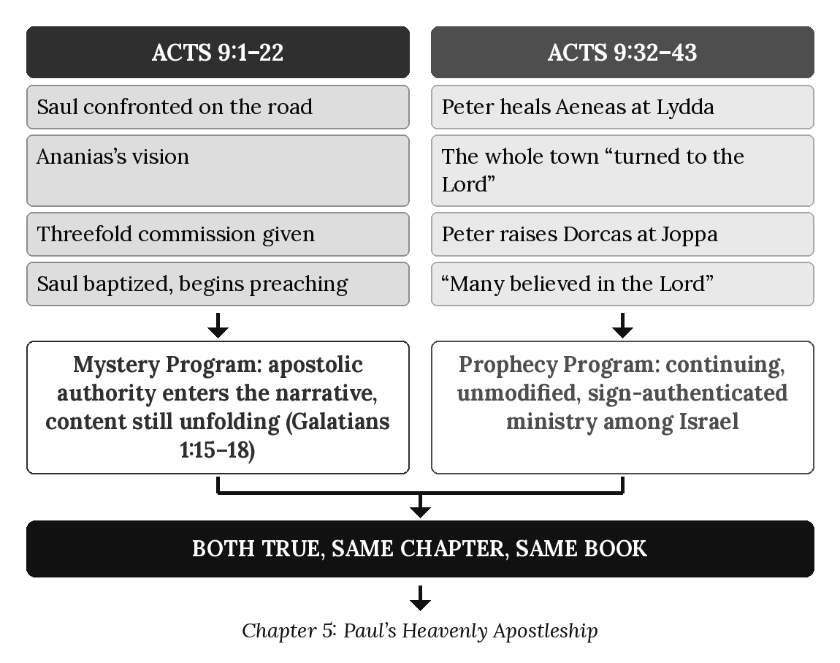

Chapter 5: Paul’s Heavenly Apostleship
“And so, King Agrippa, I obeyed that vision from heaven.” — Acts 26:19 (NLT)

Introduction: An Apostleship of a Different Kind
Chapter 4 established when Paul’s apostolic authority enters the narrative of Acts. This chapter asks a more fundamental question: what kind of apostleship is it? The answer this chapter argues is not merely that Paul received a different assignment — Gentiles rather than Jews — within the same office the Twelve held. It is that Paul’s apostleship is constituted on entirely different grounds than theirs: not earthly companionship with the historical Jesus, but a heavenly commissioning from the glorified Christ; not appointment by human process, but direct, underived calling; not a destiny tied to Israel’s twelve tribes, but a citizenship and a seating already located, in Paul’s own words, “in the heavenly realms.” This is why this chapter, and this series, calls it Paul’s heavenly apostleship — not as a flattering title, but as a technical description of its actual constitutional basis, developed here from Paul’s own most extended self-defenses of his office.

The Earthly Qualification the Twelve Required — and Paul Could Not Meet
The clearest way to see that Paul’s apostleship operates on different grounds than the Twelve’s is to examine, first, what grounds theirs. When the eleven remaining apostles seek a replacement for Judas in Acts 1, the qualifying criterion Peter states is exclusively historical and earthly:
“So now we must choose a replacement for Judas from among the men who were with us the entire time we were traveling with the Lord Jesus — from the time he was baptized by John until the day he was taken from us. Whoever is chosen will join us as a witness of Jesus’ resurrection.” (Acts 1:21–22, NLT)
Apostleship in the Twelve’s own understanding of their own office required continuous, personal, physical companionship with Jesus throughout the entire span of his earthly ministry — from John’s baptism to the ascension. This is not an incidental detail; it is the stated qualifying criterion, applied deliberately to fill a vacancy in a defined, numbered office. And it is matched by an equally earthly destiny promised to that same office. When Peter asks what the Twelve will receive for having left everything to follow Jesus, the answer Jesus gives is concrete, national, and tied to Israel specifically:
“Jesus replied, ‘I assure you that when the world is made new and the Son of Man sits upon his glorious throne, you who have been my followers will also sit on twelve thrones, judging the twelve tribes of Israel.’” (Matthew 19:28, NLT)
Twelve thrones. Twelve tribes. A promise as specific and as earthbound as the Davidic kingdom hope traced in chapter 1. This is the office Paul is measured against — and by its own stated qualification, Paul cannot possibly hold it. He was not a companion of Jesus “from the time he was baptized by John” onward; by his own repeated testimony, he was actively persecuting the church during the relevant period (Acts 9:1–2; Galatians 1:13; Philippians 3:6). If apostleship meant only what Acts 1:21–22 describes, Paul simply could not be an apostle. And yet the New Testament — including Paul’s own writings, examined below, and the Jerusalem apostles’ own recognition in Galatians 2:7–9 (chapter 3) — treats him as unmistakably one. The only coherent resolution is the one this chapter argues at length: Paul’s apostleship is not a late, irregular instance of the Twelve’s earthly office. It is a second kind of apostleship altogether, constituted on different grounds, for a different program.

“Not Appointed by Any Group of People”: Galatians 1:1
Paul states those different grounds explicitly, in the very first verse of a letter written specifically to defend his apostolic authority against challengers:
“This letter is from Paul, an apostle. I was not appointed by any group of people or any human authority, but by Jesus Christ himself and by God the Father, who raised Jesus from the dead.” (Galatians 1:1, NLT)
The contrast Paul draws is total: not “any group of people,” not “any human authority” — categories that would include the Jerusalem apostles themselves, however much Paul respects them — but “Jesus Christ himself and... God the Father.” This is not merely a claim about the ultimate divine origin of all legitimate ministry, true as that would be of the Twelve’s calling as well. It is a specific claim that Paul’s apostleship bypasses the human, historical, communal process by which the Twelve’s office — companionship, witness, communal selection as in Acts 1:23–26 — was constituted. Paul’s apostleship begins with a direct commissioning from the risen and ascended Christ, with no human intermediary in its foundation, exactly as chapter 2 already established regarding the content of his gospel (Galatians 1:11–12).

“As to One Untimely Born”: 1 Corinthians 15:8–10
Paul’s own description of his place among the resurrection witnesses is worth reading closely for what it both claims and concedes:
“Last of all, as though I had been born at the wrong time, I also saw him. For I am the least of all the apostles. In fact, I’m not even worthy to be called an apostle after the way I persecuted God’s church. But whatever I am now, it is all because God poured out his special favor on me — and not without results. For I have worked harder than any of the other apostles; yet it was not I but God who was working through me by his grace.” (1 Corinthians 15:8–10, NLT)
“As though I had been born at the wrong time” translates a single Greek word, ektrōma — literally a miscarriage or untimely birth — which Paul applies to his own apostolic origin with startling self-deprecation. The image captures precisely what the previous section argued from Acts 1:21–22: Paul’s entry into apostleship did not follow the normal gestational course the Twelve’s office required — sustained companionship maturing naturally into commissioned witness. It arrived abruptly, out of season, external to that process entirely. And yet Paul places this “untimely” appearance in the very same list, structurally, as the appearances to Peter, the Twelve, and the five hundred (1 Corinthians 15:5–8) — last, least, most unworthy by his own estimate, but genuinely included. The chapter’s thesis is visible in miniature in these three verses: an apostleship irregular by the Twelve’s own criteria, yet undeniably real, constituted entirely “because God poured out his special favor” rather than through the ordinary channel Acts 1 describes.

Equal in Authority, Different in Kind: 2 Corinthians 11 and 12
When Paul’s authority is directly challenged by rival teachers at Corinth, his defense is equally direct:
“But I don’t consider myself inferior in any way to these ‘super apostles’ who teach such things.” (2 Corinthians 11:5, NLT)
“You have made me act like a fool. You ought to be writing commendations for me, for I am not at all inferior to these ‘super apostles,’ even though I am nothing at all. When I was with you, I certainly gave you proof that I am an apostle. For I patiently did many signs and wonders and miracles among you.” (2 Corinthians 12:11–12, NLT)
Two things in this passage deserve careful, honest handling. First, Paul’s claim is not merely to a different apostleship but to one fully equal in authority — he does not consider himself “inferior in any way” — even though, as this chapter has argued, its grounds are categorically different from the Twelve’s earthly office. Second, Paul explicitly claims to have performed “signs and wonders and miracles” at Corinth as evidence of his own apostleship. During the overlap, Paul’s participation in signs does not create a second apostleship, commission, stewardship, or Prophecy-Program office. His apostleship remains the distinctive Mystery apostleship given directly by the risen Christ, while he ministers within an historical setting in which Israel’s Prophecy Program remains concurrently active. The presence of a sign must therefore be classified by its audience, purpose, revelatory setting, and immediate context — not merely by Paul’s participation in it. The frequency of recorded signs may vary, but their programmatic availability does not progressively diminish before Acts 28; chapter 8 traces their judicial cessation at the national suspension of Israel’s Prophecy Program.

One Apostleship Within a Concurrent Prophetic Setting
Paul may participate in signs and minister to Israel within that prophetic setting without becoming an administrator of Israel’s program: he ministers within Israel’s Prophecy setting without administering Israel’s Prophecy Program. His apostleship, commission, and stewardship remain distinctly Mystery throughout the overlap and beyond Acts 28.

Not the Thirteenth: Why the Matthias Question Doesn’t Apply
Readers who know Acts 1 well sometimes ask whether Paul was, in effect, God’s intended replacement for Judas — with Matthias, chosen by the eleven’s own process in Acts 1:23–26, representing a premature or mistaken human selection that Paul’s later calling implicitly corrects. This chapter’s argument suggests a cleaner answer: the question does not arise, because Paul was never a candidate for that office in the first place. The Twelve’s own criterion (Acts 1:21–22) required continuous companionship with Jesus “from the time he was baptized by John” — a qualification Matthias apparently met and Paul, by his own testimony, categorically did not. If Paul’s apostleship were meant to fill the Twelve’s own numbered office, his evident disqualification under their own stated standard would be a real problem. It is not a problem, on this chapter’s argument, because Paul was never filling that slot. Matthias completes the Twelve as an earthly, historically-qualified apostolic band tied to Israel’s twelve tribes (Matthew 19:28); Paul inaugurates an entirely different apostleship, heavenly in its commissioning, for a program the Twelve’s own criterion was never designed to anticipate. The two offices simply do not compete for the same seat.
Paul’s own preferred self-designation confirms that he understood his office in exactly this distinct, rather than substitutionary, sense:
“I am saying all this especially for you Gentiles. God has appointed me as the apostle to the Gentiles. I stress this...” (Romans 11:13, NLT)
Not “an apostle,” interchangeable with the Twelve, but “the apostle to the Gentiles” — a title with its own defined scope, standing alongside rather than inside the office Peter, James, John, and their nine companions held.

Seated in the Heavenlies
The positive, constructive ground of Paul’s apostleship — as opposed to the negative case built so far from what disqualifies him under Acts 1:21–22 — is stated by Paul himself in terms that supply this chapter’s title:
“For he raised us from the dead along with Christ and seated us with him in the heavenly realms because we are united with Christ Jesus.” (Ephesians 2:6, NLT)
Set this directly against Matthew 19:28’s promise to the Twelve of “twelve thrones, judging the twelve tribes of Israel” — a promise to be fulfilled, per its own terms, “when the world is made new,” on earth, in connection with Israel’s own restored kingdom. Ephesians 2:6 describes an already-accomplished heavenly seating, “with him,” for those united to Christ under the administration Paul describes throughout this letter (chapter 2). The contrast is not a matter of degree — greater or lesser reward — but of category: an earthly throne over Israel’s twelve tribes, promised and future, against a heavenly seating with Christ, already true “in the heavenly realms.” Paul’s own apostleship — heavenly in its commissioning (Acts 26:19, below), underived in its origin (Galatians 1:1), irregular by earthly criteria yet fully authoritative (1 Corinthians 15:8–10; 2 Corinthians 11:5) — is of a piece with the heavenly destiny chapter 13 will examine as belonging to the whole Body of Christ he was commissioned to address.
Paul states the same heavenly orientation as a present reality for all believers united with Christ, not a future hope alone:
“But we are citizens of heaven, where the Lord Jesus Christ lives. And we are eagerly waiting for him to return as our Savior.” (Philippians 3:20, NLT)

The Heavenly Vision Obeyed
Paul’s own summary of his commissioning, given in his defense before King Agrippa, names its source directly and gives this chapter its final confirming term:
“And so, King Agrippa, I obeyed that vision from heaven.” (Acts 26:19, NLT)
Not a vision mediated through the Twelve’s existing structure, not a commissioning that required Peter’s, James’s, or John’s prior authorization (though, as chapter 3 showed from Galatians 2:7–9, they did later recognize it) — a vision “from heaven,” obeyed directly. Every strand this chapter has traced — the earthly qualification Paul could not meet, the underived commissioning of Galatians 1:1, the untimely birth of 1 Corinthians 15:8, the heavenly seating of Ephesians 2:6 — converges in this single phrase. Paul’s apostleship is heavenly at its source, heavenly in its foundation, and heavenly in the destiny it shares with those it was sent to reach.

Applying the Seven Diagnostic Lenses to Galatians 1:1
- Audience — The Galatian churches, defending Paul’s authority to Gentile believers directly.
- Apostolic Authority — Paul’s own, explicitly independent of “any group of people or any human authority” (v. 1).
- Covenant — Not invoked; the claim rests on direct commissioning, not covenantal appointment.
- Sign-Gift — Absent from this specific verse; Paul’s authority claim here rests on the commissioning itself, not an accompanying miracle.
- Commission — The Pauline Commission, grounded in “Jesus Christ himself and... God the Father, who raised Jesus from the dead” (v. 1).
- Eschatology — Implied rather than stated here, but consistent with the heavenly seating of Ephesians 2:6 developed above.
- Dispensation — The administration under which Paul’s entire apostolic self-understanding operates, as chapter 3 named it: the dispensation of grace.
The expressions “Paul’s gospel” and “my gospel” identify Paul’s distinctive stewardship and divinely entrusted message; they do not identify Paul as the source or inventor of that gospel. The risen Christ is the source of the revelation. Paul is its uniquely commissioned apostolic recipient and steward. The Mystery was revealed directly to Paul and then made known by the Spirit to the New Testament apostles and prophets associated with his ministry; the Twelve, as Prophecy apostles, are not thereby made independent recipients or administrators of Paul’s Mystery commission. Paul is the recipient and steward of the Mystery revelation, not its originator.
The threefold audience of Paul’s commission (Gentiles, kings, and the people of Israel; Acts 9:15) describes the scope of Paul’s one distinctive Mystery commission; it neither divides that commission nor assigns Paul administrative responsibility for Israel’s still-operative Prophecy Program. His ministry to Jewish audiences occurs within the historical Acts Overlap, where Israel’s Prophecy Program remains operative alongside his distinct Pauline commission. Paul may announce a divine judgment concerning Israel’s Prophecy Program without being the administrator of that program. At Acts 28, Paul pronounces the divinely authorized judicial verdict marking the national suspension of Israel’s Prophecy Program; God is the One who judicially suspends the program.

Chapter Summary
Paul’s apostleship cannot be understood as a late, somewhat irregular addition to the Twelve’s own office, because it fails the Twelve’s own stated qualification — continuous earthly companionship with Jesus “from the time he was baptized by John” (Acts 1:21–22) — by definition. It must instead be understood as this chapter has argued: a second kind of apostleship, heavenly in its commissioning (Acts 26:19), underived from human appointment (Galatians 1:1), irregular in its timing yet fully authoritative (1 Corinthians 15:8–10; 2 Corinthians 11:5), and oriented toward a heavenly seating (Ephesians 2:6) categorically different from the earthly thrones promised to the Twelve over Israel’s twelve tribes (Matthew 19:28). Paul’s ministry within the overlap also included confirming signs (2 Corinthians 12:12). Their presence does not place Paul under the Kingdom Commission or give him a second programmatic office; they must be interpreted according to audience, purpose, revelatory setting, and immediate context while Israel’s Prophecy Program remains concurrently operative.

Key Terms
Heavenly Apostleship — This series’ term for Paul’s apostolic office, grounded not in earthly companionship with Jesus but in a direct, heavenly commissioning from the risen and glorified Christ (Acts 26:19; Galatians 1:1).
Ektrōma — “Untimely born” (1 Corinthians 15:8); Paul’s own description of his irregular entry into apostleship, outside the process Acts 1:21–22 describes for the Twelve.
Seated in the Heavenly Realms — Paul’s description (Ephesians 2:6) of believers’ present position in Christ, contrasted in this chapter with the Twelve’s promised earthly thrones over Israel (Matthew 19:28).

Reflection and Teaching Questions
- Why does the qualification given in Acts 1:21–22 for replacing Judas make it structurally impossible for Paul to hold the same office as the Twelve — rather than simply making him a late or unusual example of it?
- How does 1 Corinthians 15:8–10 hold together Paul’s self-description as “the least of all the apostles” with his claim to have “worked harder than any of the other apostles”? What does this tension reveal about the grounds of his authority?
- This chapter states that Paul’s confirming signs at Corinth (2 Corinthians 12:12) occur during the concurrent operation of Israel’s Prophecy Program while Paul’s own apostleship, commission, and stewardship remain distinctly Mystery. Why does this distinction prevent Paul’s participation in signs from creating a second Pauline commission or making sign-authentication a defining feature of the Mystery Program? How do audience, purpose, revelatory setting, and immediate context govern the classification of a sign?
- Compare Matthew 19:28 and Ephesians 2:6 directly. What is the difference between a promised earthly throne and an already-accomplished heavenly seating, and why does that difference matter for understanding the destiny of the Body of Christ (a subject chapter 13 will take up fully)?

Chapter 6: Peter’s Circumcision Apostleship
“And I will give you the keys of the Kingdom of Heaven. Whatever you forbid on earth will be forbidden in heaven, and whatever you permit on earth will be permitted in heaven.” — Matthew 16:19 (NLT)

Introduction: The Other Half of the Overlap
Chapter 5 examined Paul’s apostleship on its own terms: heavenly in commissioning, underived in origin, oriented toward a heavenly seating. This chapter turns to examine Peter’s apostleship with the same care, on its own terms, rather than treating it merely as a foil against which Paul’s distinctiveness is measured. Chapter 4 already showed Peter’s kingdom-pattern ministry continuing, unmodified, in the very chapter where Saul is commissioned (Acts 9:32–43). This chapter asks what grounds that ministry — where its authority comes from, what vocabulary it uses of itself, and how far its scope actually extends — so that the comparison built in chapter 3 rests on the same depth of exegesis for both apostleships rather than only one.

The Keys of the Kingdom
Peter’s own apostolic commissioning, unlike Paul’s, comes directly from Jesus during his earthly ministry, in the same Gospel record chapter 1 already drew on for the kingdom’s announcement:
“Now I say to you that you are Peter (which means ‘rock’), and upon this rock I will build my church, and all the powers of hell will not conquer it. And I will give you the keys of the Kingdom of Heaven. Whatever you forbid on earth will be forbidden in heaven, and whatever you permit on earth will be permitted in heaven.” (Matthew 16:18–19, NLT)
A word of care is needed here, because the English word “church” in verse 18 can mislead a reader who has just finished chapter 2’s account of the Mystery Program. The underlying Greek, ekklēsia, means simply “called-out assembly” — a general term used throughout the Greek Old Testament (the Septuagint) for Israel’s own covenant assembly, and used elsewhere in the New Testament for gatherings with no connection whatsoever to Paul’s later technical usage (compare Acts 19:32, 39, 41, where the same word describes a civic assembly in Ephesus). Jesus’ promise to Peter in Matthew 16:18 is not a premature disclosure of the one new man chapter 2 described as “kept secret from the beginning” (Ephesians 3:9) — that would contradict Paul’s own repeated testimony that the mystery was undisclosed until his own commissioning. It is the promise of an assembly built on Peter’s own confession of Jesus as “the Messiah, the Son of the living God” (Matthew 16:16, NLT), governed by Peter’s own binding-and-loosing authority, operating within the kingdom-offer framework chapter 1 traced — the same assembly Peter continues to lead throughout Acts, keys in hand, right through the events this chapter and chapter 4 have already examined.
The “keys” themselves are administrative rather than merely honorific. In first-century usage, to hold the keys of a household or estate was to hold delegated authority to open and shut, admit and exclude, on the owner’s behalf. Peter’s exercise of this authority is visible across Acts: he opens the kingdom’s proclamation to Israel at Pentecost (Acts 2), pronounces binding judgment on Ananias and Sapphira (Acts 5:1–11), and — as chapter 10 will examine in full — is the one through whom the door is first opened to Cornelius. The keys are Peter’s own, personally promised, and they belong to the kingdom administration this chapter is describing, not to the Pauline Commission chapter 5 traced.

The Keys in Use: Ananias and Sapphira
The binding authority of Matthew 16:19 is not left as an abstract promise; Acts shows it exercised, with sobering consequences, within a few chapters:
“Then Peter said, ‘Ananias, why have you let Satan fill your heart? You lied to the Holy Spirit, and you kept some of the money for yourself... You weren’t lying to us but to God!’ As soon as Ananias heard these words, he fell to the floor and died. Everyone who heard about it was terrified.” (Acts 5:3–5, NLT)
Whatever else this severe episode teaches about the seriousness of the early community’s integrity, it demonstrates the “binding” side of Peter’s keys in concrete operation: a pronouncement carrying immediate, divinely-ratified consequence, of a kind this series does not find replicated anywhere in Paul’s own ministry, even amid the church-discipline instructions of his letters (compare 1 Corinthians 5:1–5, where Paul’s remedy is exclusion from fellowship pending repentance, not sudden death). The keys Peter holds administer a kingdom community under kingdom-scale authority — one more thread confirming that his apostleship, examined here on its own terms, operates by different means than Paul’s, not merely toward a different audience.

Apostle to the Circumcision: Confirmed Scope
Chapter 3 already drew on Paul’s own retrospective account of the Jerusalem Council to establish the formal, mutually recognized division of apostolic labor:
“God had given me the responsibility of preaching the Good News to the Gentiles, just as he had given Peter the responsibility of preaching to the Jews.” (Galatians 2:7, NLT; see chapter 3)
What is worth adding here is that Peter’s own writings, composed years into the overlap period this book is tracing, confirm this same scope from his side. The opening address of his first epistle identifies its recipients in unmistakably specific terms:
“This letter is from Peter, an apostle of Jesus Christ. I am writing to God’s chosen people who are living as foreigners in the provinces of Pontus, Galatia, Cappadocia, Asia, and Bithynia.” (1 Peter 1:1, NLT)
“God’s chosen people... living as foreigners” — language that identifies Peter’s audience as the Jewish Diaspora dispersed across Asia Minor, consistent with an apostleship “to the Jews” continuing well past the Jerusalem Council of Acts 15. Whatever occasional exceptions this chapter will address below, Peter’s own settled, ongoing ministry — by his own testimony, this late into the narrative — remains oriented toward Israel, exactly as Galatians 2:7–9 describes it. During the overlap, the circumcision apostleship ministers to Israel under the Prophecy Program, and Paul’s gospel forms the Body; the two operate concurrently and never merge, transfer, or absorb one another.

A Royal Priesthood, a Holy Nation
Peter’s vocabulary for his readers, a few verses later in the same letter, is worth setting directly against the non-covenantal language chapter 2 identified in Paul’s letters:
“But you are not like that, for you are a chosen people. You are royal priests, a holy nation, God’s very own possession. As a result, you can show others the goodness of God, for he called you out of the darkness into his wonderful light. Once you had no identity as a people; now you are God’s people. Once you received no mercy; now you have received God’s mercy.” (1 Peter 2:9–10, NLT)
“A chosen people... royal priests, a holy nation, God’s very own possession” is not incidental phrasing. It echoes, almost word for word, the covenant language God speaks to Israel at Sinai: “you will be my own special treasure... you will be my kingdom of priests, my holy nation” (Exodus 19:5–6, NLT). Peter is not coining new vocabulary for a new, non-covenantal body; he is applying Israel’s own Sinai covenant identity — the vocabulary of the Abrahamic-Davidic-Mosaic stream this series traced in chapter 1 — to his own readers. This is the linguistic signature of the Prophecy Program precisely because it is covenantal language, applied by the apostle to the circumcision, to a Jewish Diaspora audience, using the categories chapter 1 established rather than the “kept secret” categories of chapter 2. Where Paul, addressing Gentiles in Ephesians, coins nearly unprecedented syn- compounds to describe a genuinely new reality (chapter 2), Peter, addressing scattered Israel, reaches for Sinai’s own ancient vocabulary. The contrast is not accidental; it is diagnostic.

Continuing Signs
Chapter 4 already showed Peter’s healing ministry continuing in Acts 9. Earlier still in the narrative, the pattern is established at a scale that makes its kingdom-authenticating character unmistakable:
“The apostles were performing many miraculous signs and wonders among the people. And all the believers were meeting regularly at the Temple in the area known as Solomon’s Colonnade... As a result of the apostles’ work, sick people were brought out into the streets on beds and mats so that Peter’s shadow might fall across some of them as he went by. Crowds came from the villages around Jerusalem, bringing their sick and those possessed by evil spirits, and they were all healed.” (Acts 5:12, 15–16, NLT)
Meeting “at the Temple,” healing multitudes as a matter of course, the sign-gift ministry chapter 1 traced from Jesus’ own earthly ministry continues here at full, undiminished strength — a detail chapter 8’s account of the signs’ continued operation throughout the overlap and judicial cessation at Acts 28 will examine in full. For now, the relevant observation is simple: this is Peter’s apostleship in its most characteristic mode, entirely of a piece with the kingdom-pattern ministry chapter 1 described before Acts 9 had even occurred.

What About Cornelius? A Preview, Not Yet the Full Argument
Honesty requires acknowledging, before this chapter closes, a genuine complication in the otherwise clean picture drawn above: Peter himself, in Acts 10, is the apostle through whom the gospel first reaches a Gentile household, Cornelius and his family — an episode chapter 10 will examine in full as “Gentile Inclusion.” Peter’s own later account of this event, given at the Jerusalem Council, is worth reading here as a preview rather than a full treatment:
“Brothers, you all know that God chose me from among you some time ago to preach to the Gentiles so that they could hear the Good News and believe. God knows people’s hearts, and he confirmed that he accepts Gentiles by giving them the Holy Spirit, just as he did to us. He made no distinction between us and them, for he cleansed their hearts through faith.” (Acts 15:7–9, NLT)
Two things are worth noting now, ahead of chapter 10’s fuller argument. First, Peter himself frames this as a singular, divinely orchestrated exception — “God chose me... some time ago,” referring back to one specific, extraordinary occasion (Acts 10:9–48), not a standing revision of his ongoing apostolic scope. Second, this episode occurs before the Jerusalem Council of Acts 15 itself formally recognizes the Peter-to-the-circumcision, Paul-to-the-Gentiles division (Galatians 2:7–9) — meaning the apostles who lived through both events did not regard Cornelius as having erased that division, or they would hardly have ratified it afterward at that same council. Cornelius functions, on the reading chapter 10 will develop, as a sign to Peter and to the Jerusalem church that Gentile inclusion was coming and was of God — not as the moment Peter’s own ongoing ministry pivoted from Israel to the nations generally. His own epistle, written well after Acts 15, still addresses Diaspora Israel (1 Peter 1:1). The exception proves, rather than dissolves, the rule this chapter has traced.

Applying the Seven Diagnostic Lenses to Matthew 16:18–19
- Audience — Peter and, through him, the assembly built on his confession — within the narrative context, Israel’s own covenant community.
- Apostolic Authority — Peter personally, commissioned directly by Jesus during his earthly ministry, unlike Paul’s post-ascension commissioning (chapter 5).
- Covenant — Implicit continuity with the kingdom-offer framework of chapter 1; the “keys” administer a kingdom already promised to Israel.
- Sign-Gift — Confirmed by Peter’s own subsequent ministry (Acts 5:12–16; 9:32–43), sign-authenticated throughout.
- Commission — The kingdom-proclamation trajectory continuous with Matthew 10 and Matthew 28, not the Pauline Commission of chapter 5.
- Eschatology — Earthly: “the Kingdom of Heaven” (v. 19), the same kingdom chapter 1 traced from Abraham through Peter’s own Acts 3 sermon.
- Dispensation — Israel’s Prophecy Program, prior to and continuing alongside the dispensation of grace given to Paul (chapter 3).

Chapter Summary
Peter’s apostleship, examined on its own terms, is as internally consistent as Paul’s: commissioned directly by the earthly Jesus rather than the ascended Christ, holding delegated kingdom authority (“the keys”), addressing Diaspora Israel in his own epistles using Sinai’s own covenant vocabulary (“royal priests, a holy nation”), and continuing to perform kingdom-authenticating signs at a scale unmatched elsewhere in Acts. The Cornelius episode (Acts 10) complicates a naive version of this picture, and this chapter has deliberately flagged rather than dissolved that complication, leaving its full treatment to chapter 10. What remains clear even so is that Peter’s own retrospective account of Cornelius treats it as a singular exception rather than a redefinition of his ongoing scope — a scope his own late epistle confirms. With both apostleships now examined in depth on their own terms, chapter 7 turns to the moment these two apostleships formally meet and mutually recognize one another: the Jerusalem Council of Acts 15.

Key Terms
Keys of the Kingdom — The delegated binding-and-loosing authority Jesus promises Peter (Matthew 16:19), exercised throughout Acts within the Prophecy Program’s own administration.
Ekklēsia — “Called-out assembly”; the general Greek term underlying “church” in Matthew 16:18, not to be conflated with Paul’s later technical description of the Body of Christ (chapter 2).
Apostle to the Circumcision — Paul’s own description (Galatians 2:7–9) of Peter’s ongoing apostolic scope, confirmed by Peter’s own epistolary address to Diaspora Israel (1 Peter 1:1).

Reflection and Teaching Questions
- Why does this chapter insist that “church” (ekklēsia) in Matthew 16:18 should not be read as an early reference to Paul’s later Body of Christ? What would be lost, doctrinally, by collapsing that distinction?
- Compare 1 Peter 2:9–10 with Ephesians 2:14–16 or Ephesians 3:6 (chapter 2). What does the difference in vocabulary — Sinai’s covenant language versus Paul’s syn- compounds — suggest about the two apostles’ respective audiences and administrations?
- This chapter argues that the Cornelius episode (Acts 10) is a “singular, divinely orchestrated exception” rather than a redefinition of Peter’s ongoing ministry. What evidence, from Peter’s own words in Acts 15:7–9 and his own later epistle, supports that reading? What might a critic say against it?
- Peter’s shadow healing multitudes in Acts 5:12–16 shows the sign-gift ministry at what this chapter calls “full, undiminished strength.” Why does establishing that starting point matter for chapter 8’s argument about the signs continuing throughout the overlap and ceasing in connection with the judicial suspension at Acts 28?

Diagram: Two Apostleships Compared
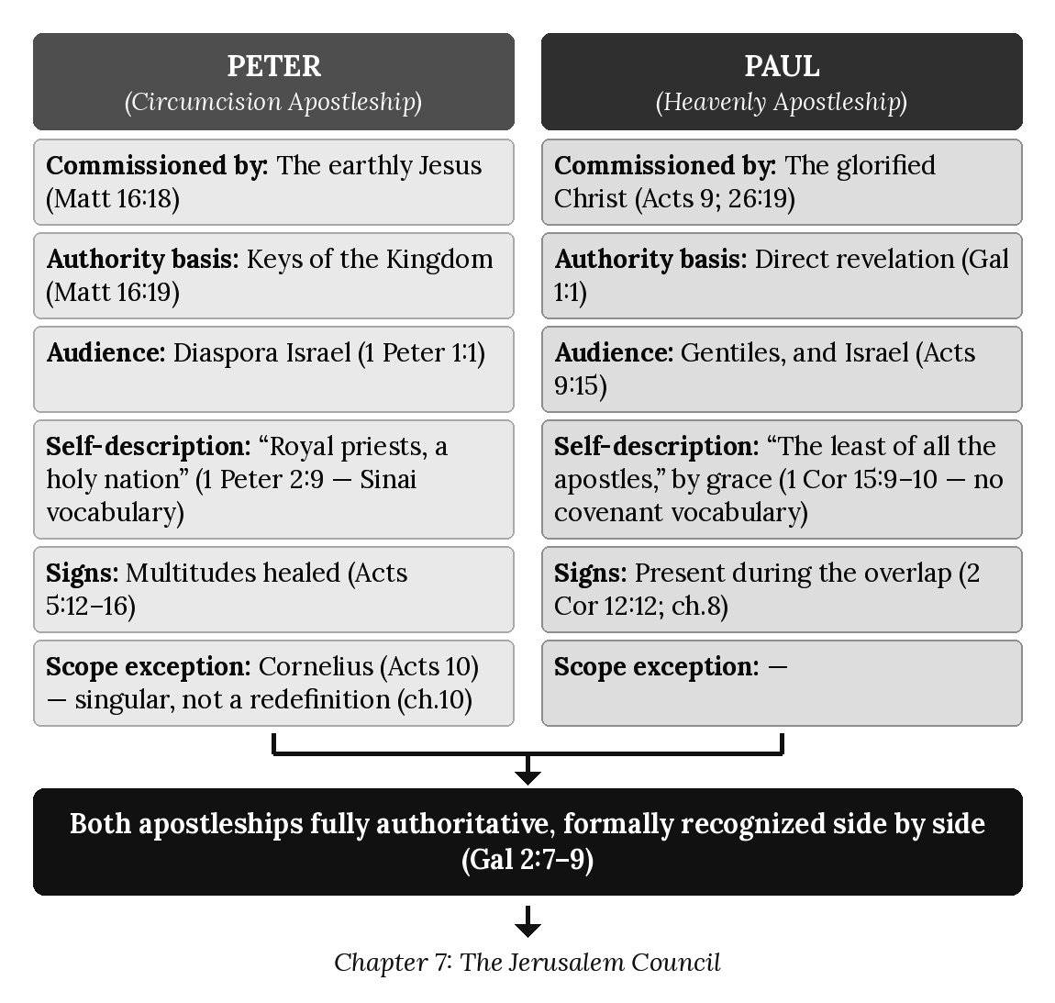

Chapter 7: The Jerusalem Council
“In fact, James, Peter, and John, who were known as pillars of the church, recognized the gift God had given me, and they accepted Barnabas and me as their co-workers. They encouraged us to keep preaching to the Gentiles, while they continued their work with the Jews.” — Galatians 2:9 (NLT)

Introduction: Where Two Apostleships Meet
Chapters 5 and 6 examined Paul’s and Peter’s apostleships separately, each on its own terms. This chapter examines the one moment in Acts where both apostleships, and both apostles, occupy the same room, address the same controversy, and reach a resolution that — as chapter 3 already previewed from Galatians 2:7–9 — formally recognizes rather than dissolves their distinction. The Jerusalem Council of Acts 15 is not a merger of the two programs into one; it is the moment their leaders, meeting together, agree on how the two will coexist. This chapter examines that meeting in full, along with Paul’s own parallel account in Galatians 2, and a sobering coda — the Antioch incident — that shows how easily the boundary this council established could still be blurred, even by the apostles themselves.
The Jerusalem Council is an overlap event. It meets in a setting shaped by Israel’s Prophecy Program, which remained operative, while Paul’s gospel was already in operation. This chapter therefore reports what James, Peter, and Paul each say, and the markers the text itself carries, and it does not assign the council as a whole to a single program.

The Controversy: “Unless You Are Circumcised...”
The council convenes to resolve a specific, urgent dispute that had reached Antioch, the base of Paul’s own Gentile mission:
“While Paul and Barnabas were at Antioch of Syria, some men from Judea arrived and began to teach the believers: ‘Unless you are circumcised as required by the law of Moses, you cannot be saved.’ Paul and Barnabas disagreed with them, arguing vehemently. Finally, the church decided to send Paul and Barnabas to Jerusalem... to talk to the apostles and elders about this question.” (Acts 15:1–2, NLT)
The claim under dispute is not peripheral: “unless you are circumcised... you cannot be saved” asserts that entry into the Mosaic covenant is a precondition of salvation for Gentile believers — precisely the kind of covenantal requirement chapter 3’s Two Programs Chart identifies as belonging to the Prophecy Program, being imposed here on converts under Paul’s own non-covenantal Gentile ministry. When Paul and Barnabas arrive in Jerusalem, the same claim resurfaces from within the Jerusalem church itself:
“But then some of the believers who belonged to the sect of the Pharisees stood up and insisted, ‘The Gentile converts must be circumcised and required to follow the law of Moses.’” (Acts 15:5, NLT)
This is the precise question the rest of the chapter resolves: are Paul’s Gentile converts to be brought under Prophecy Program categories, or does Paul’s own distinct commission (chapter 5) stand on its own terms?

James’s Judgment — and a Careful Distinction
After Peter’s testimony (Acts 15:7–11, previewed in chapter 6) and a report from Paul and Barnabas “about the miraculous signs and wonders God had done through them among the Gentiles” (Acts 15:12, NLT), James — the Jerusalem church’s own leader — delivers the council’s controlling judgment:
“Peter has told you about the time God first visited the Gentiles to take from them a people for himself. And this conversion of Gentiles is exactly what the prophets predicted. As it is written: ‘Afterward I will return and restore the fallen house of David. I will rebuild its ruins and restore it, so that the rest of humanity might seek the Lord, including the Gentiles — all those I have called to be mine.’ ... And so my judgment is that we should not make it difficult for the Gentiles who are turning to God. Instead, we should write and tell them to abstain from eating food offered to idols, from sexual immorality, from eating the meat of strangled animals, and from consuming blood.” (Acts 15:14–20, NLT, selected)
Two features of this judgment deserve careful attention, because a surface reading could seem to complicate chapter 2’s claim that the mystery was “kept secret from the beginning” and unknown to the prophets. First, James explicitly grounds his ruling in prophecy — “this conversion of Gentiles is exactly what the prophets predicted” — citing Amos 9:11–12. This requires the same care given to Ephesians 3:5 and Romans 16:25–26 in chapter 2. James’s proof text speaks of restoring “the fallen house of David” so that Gentiles might “seek the Lord” alongside a restored Israel — Davidic, kingdom-centered language, describing Gentile participation in Israel’s own prophesied restoration (a theme genuinely present in the Old Testament; compare Isaiah 11:10; 60:3). This is not the same claim as Paul’s mystery of the one new man, formed by dissolving the very covenant distinctions Amos 9 presupposes (chapter 2). James is not citing Old Testament proof for Paul’s Gentile mission specifically; he is explaining why Gentiles turning to the Lord in this period, generally, fits a pattern the prophets did anticipate — Gentiles blessed in connection with Israel’s own restoration — without thereby claiming that Paul’s distinct non-covenantal mystery was itself foreseen.
Second, and confirming this reading, the decree’s actual content — abstaining from food offered to idols, sexual immorality, meat of strangled animals, and blood — echoes the Levitical regulations governing resident aliens living among Israel (compare Leviticus 17–18), not a statement of Pauline grace-alone terms. The decree draws on Israel’s own regulations to answer a question raised in that setting: how should Gentiles associated with Jewish communities and synagogues conduct themselves. Tellingly, Paul himself never cites this decree as binding authority in any of his own letters to his own Gentile churches, even when addressing nearly identical issues — his treatment of food offered to idols in 1 Corinthians 8 and 10 argues from entirely different principles (conscience, love, the weaker brother) without once appealing to the Jerusalem decree as settled law. This omission is itself evidence for this chapter’s reading: the decree answers a question arising in Israel’s setting; it does not become the governing law of Paul’s separate Gentile mission.

Paul’s Own Account: “They Had Nothing to Add”
Paul’s own retrospective account of this same meeting, in Galatians 2, confirms both the outcome and, crucially, what was not imposed on his own ministry specifically:
“Then fourteen years later I went back to Jerusalem again... I went there because God revealed to me that I should go. While I was there I met privately with those considered to be leaders of the church and shared with them the message I had been preaching to the Gentiles... And they supported me and did not even demand that my companion Titus be circumcised, though he was a Gentile... And the leaders of the church had nothing to add to what I was preaching.” (Galatians 2:1–3, 6, NLT)
“Nothing to add” — no circumcision requirement, no dietary law, no supplementary condition attached to Paul’s own gospel. Titus, a Gentile companion present at the very meeting, becomes a living test case: if the council had intended to bring Paul’s converts under Prophecy Program requirements, circumcising Titus on the spot would have been the natural demonstration. It does not happen. What follows is the formal recognition chapter 3 already examined:
“Instead, they saw that God had given me the responsibility of preaching the Good News to the Gentiles, just as he had given Peter the responsibility of preaching to the Jews... James, Peter, and John, who were known as pillars of the church, recognized the gift God had given me, and they accepted Barnabas and me as their co-workers. They encouraged us to keep preaching to the Gentiles, while they continued their work with the Jews. Their only suggestion was that we keep on helping the poor, which I have always been eager to do.” (Galatians 2:7–10, NLT)
The only request made of Paul’s own ministry specifically is unrelated to doctrine or covenant requirement: ongoing care for the poor. Read together, Acts 15 and Galatians 2 describe the same event from two vantage points that confirm rather than contradict one another: a decree for Gentiles in Jewish-associated communities generally, framed in Israel’s own terms (James’s judgment), and a separate, formal, unencumbered recognition of Paul’s distinct, non-covenantal Gentile apostleship specifically (Paul’s own account) — exactly the two-track outcome chapter 3’s model predicts.

When the Boundary Blurred: The Antioch Incident
The Jerusalem Council’s resolution did not, by itself, guarantee that the boundary it established would be maintained in practice — and Paul’s very next paragraph in Galatians records a striking failure, involving Peter himself:
“But when Peter came to Antioch, I had to oppose him to his face, for what he did was very wrong. When he first arrived, he ate with the Gentile believers, who were not circumcised. But afterward, when some friends of James came, Peter wouldn’t eat with the Gentiles anymore. He was afraid of criticism from these people who insisted on the necessity of circumcision. As a result, other Jewish believers followed Peter’s hypocrisy, and even Barnabas was led astray by their hypocrisy. When I saw that they were not following the truth of the gospel message, I said to Peter in front of all the others, ‘Since you, a Jew by birth, have discarded the Jewish laws and are living like a Gentile, why are you now trying to make these Gentiles follow the Jewish traditions?’” (Galatians 2:11–14, NLT)
This episode is worth sitting with rather than smoothing over. Peter — the very apostle whose Cornelius experience (Acts 10; chapter 6) and Jerusalem Council testimony (Acts 15:7–11) had helped secure Gentile freedom from Prophecy Program requirements — reverts under social pressure to behavior that, in practice, communicates the opposite: that Gentile believers remain second-class without conformity to Jewish table customs. Paul’s public opposition, “to his face,” is not a challenge to Peter’s genuine apostleship (chapter 6 has already established its full legitimacy on its own terms); it is a defense of the very boundary this chapter has traced, against collapse through inconsistent practice rather than through doctrinal dispute. The lesson for this series’ broader argument is significant: the two-program distinction, even after its formal recognition at Jerusalem, required active, ongoing vigilance to maintain — a pattern this book’s own doctrinal consistency rules are designed to enforce across five volumes for exactly the reason Antioch illustrates within a single afternoon.

A Note on Chronology: Which Jerusalem Visit?
Careful readers of Galatians will know that not every interpreter identifies the Jerusalem visit of Galatians 2:1–10 with the Jerusalem Council of Acts 15. Some argue that Galatians was written before Acts 15 and that its second Jerusalem visit corresponds instead to the earlier famine-relief visit of Acts 11:27–30, making Galatians the earliest of Paul’s letters and placing its argument for Gentile freedom chronologically prior to the council’s formal ruling. This series follows the majority reading — that Galatians 2 and Acts 15 describe the same meeting — both because the content overlaps so closely (the same controversy, the same participants, the same outcome regarding circumcision) and because Galatians 2:9’s language of formal recognition reads most naturally as the culmination, not the prelude, of the dispute Acts 15:1–5 narrates. Readers should know the alternative view exists and does not, in any case, alter this chapter’s central argument: on either chronology, Paul’s own testimony that the Jerusalem leadership added nothing to his gospel and formally recognized his distinct Gentile apostleship stands on its own terms, textually secure regardless of which Acts visit it is paired with.

Applying the Seven Diagnostic Lenses: James’s Decree vs. Paul’s Account
Lens | Acts 15:19–21 (James’s Decree) | Galatians 2:6–10 (Paul’s Account)
Audience | Gentiles in Jewish-associated communities generally | Paul’s own Gentile converts specifically
Apostolic Authority | The Jerusalem church, James presiding | Paul, formally recognized by James, Peter, and John
Covenant | Rooted in Levitical resident-alien categories | Non-covenantal; “nothing to add” to Paul’s gospel
Sign-Gift | Presupposed (Acts 15:12, signs among the Gentiles reported) | Not the basis of the judgment reached
Commission | Israel’s circumcision apostleship, ministering in Israel’s setting | The Pauline Commission, explicitly unencumbered
Eschatology | “Restore the fallen house of David” — earthly, Davidic | Not addressed in this passage; heavenly calling presupposed from chapter 2
Dispensation | Israel’s prophetic/Kingdom administration, still operative in its own programmatic context | The dispensation of grace (chapter 3), confirmed without addition

Chapter Summary
The Jerusalem Council, an overlap event reported here and not assigned to a single program, is the moment Israel’s Prophecy Program and the Body of Christ’s Mystery Program formally meet, in the persons of their respective apostles, and reach a resolution that preserves rather than erases their distinction. James’s judgment, properly read against its own Old Testament citation and its Levitical content, addresses a question arising in Israel’s setting — how Gentiles associated with Israel’s own restoration should conduct themselves — without extending its requirements to Paul’s separate Gentile mission, a point Paul’s own account in Galatians 2 confirms directly: “the leaders of the church had nothing to add to what I was preaching.” The Antioch incident that follows shows how quickly this hard-won boundary could blur even among the apostles themselves, and how directly it had to be defended when it did. Chapter 8 now turns to trace the continued operation of the sign-gift ministry throughout the overlap and to examine its cessation in connection with the judicial suspension of Israel’s Prophecy Program at Acts 28.

Key Terms
Jerusalem Council — The meeting recorded in Acts 15 and Galatians 2, at which the Jerusalem apostles formally recognized Paul’s distinct, unencumbered apostleship to the Gentiles.
The Jerusalem Decree — James’s ruling (Acts 15:19–21) that Gentiles need not be circumcised, but should observe several Levitical-pattern requirements; addressed to Gentiles in Jewish-associated communities generally, not cited by Paul as binding on his own Gentile converts.
The Antioch Incident — Paul’s public rebuke of Peter (Galatians 2:11–14) for withdrawing from table fellowship with Gentile believers under pressure, illustrating how easily the Jerusalem Council’s boundary could be practically compromised even by its own participants.

Reflection and Teaching Questions
- Why does this chapter distinguish between James’s citation of Amos 9 as prophetic support for Gentile inclusion in general, and a claim that Paul’s specific mystery of the one new man was itself prophesied? Is this distinction persuasive, or does it feel like special pleading?
- Paul never cites the Jerusalem decree (Acts 15:20) as binding law in his own letters, even when addressing the same topics (compare 1 Corinthians 8, 10). Why does this chapter treat that omission as significant evidence for its argument?
- What does the Antioch incident (Galatians 2:11–14) suggest about how easily even a formally-recognized theological boundary can be blurred in practice? What parallels might exist for maintaining doctrinal distinctions today?
- Titus, a Gentile, is not compelled to be circumcised at the Jerusalem Council (Galatians 2:3). Why does Paul treat this as significant evidence for his argument, and what would it have meant if the council’s leaders had insisted otherwise?

Diagram: The Jerusalem Council Resolution
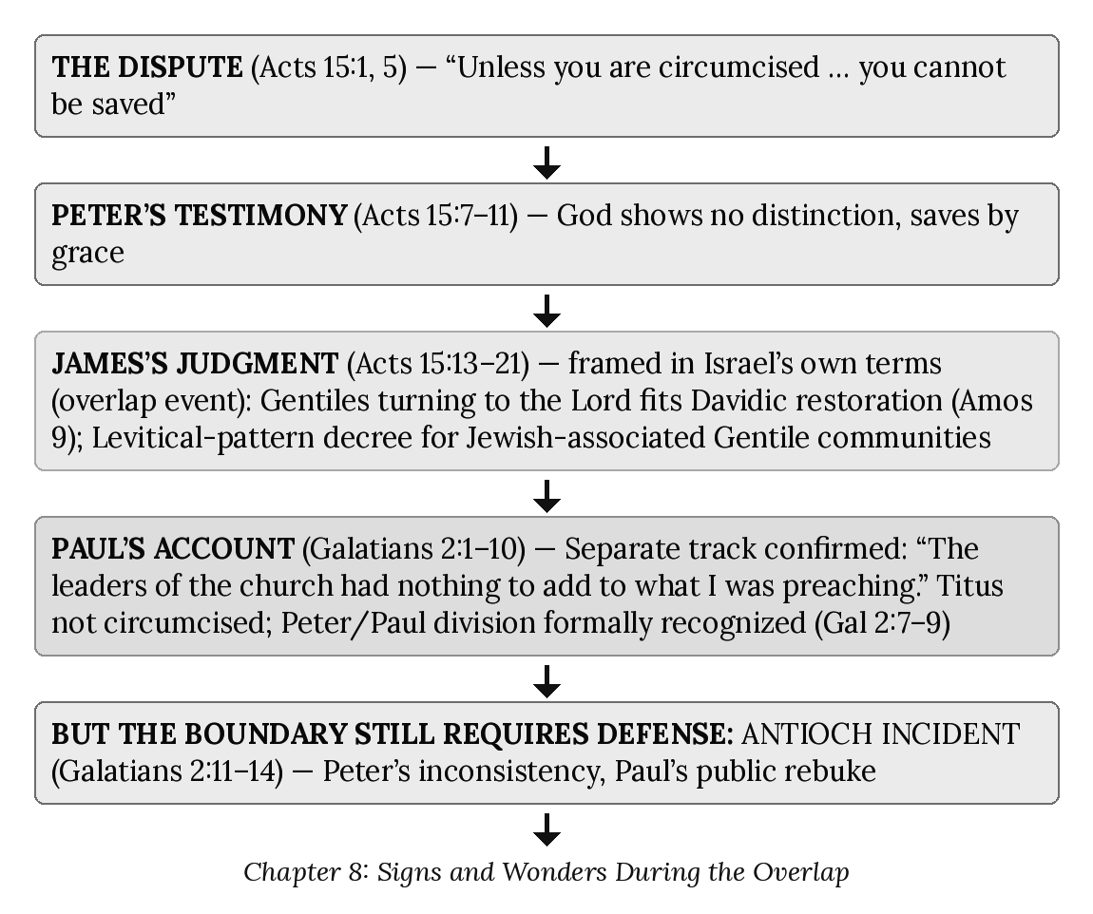

Chapter 8: Signs and Wonders During the Overlap
“So I want you to know that this salvation from God has also been offered to the Gentiles, and they will accept it.” — Acts 28:28 (NLT)

Introduction
Chapters 5 and 6 flagged a complication: Paul performed “signs and wonders and miracles” (2 Corinthians 12:12), and Peter’s sign-ministry operated at full strength as late as Acts 9 — both appearing, at first glance, to stand in tension with chapter 3’s “Signs: Absent” row for the Mystery Program. This chapter resolves that apparent tension by stating and defending the governing rule directly.
Signs and wonders appear in Israel’s Scriptures, in the Gospels, and in the early chapters of Acts as the confirmation of a message given to Israel (chapter 1). Paul’s signs, and those of his companions, belong to the overlap. These are recorded in settings shaped by Israel’s Prophecy Program, which remained operative throughout Acts 9–28 even as the Mystery Program began. Acts 9–28 is the overlap; where Paul or his companions are the ones filled or working signs, this chapter reports the text and does not assign the event to a single program. Paul’s participation does not turn these events into Prophecy Program content, and it does not make them Mystery content; the Mystery Program he was commissioned to reveal is not described in his letters as carrying a sign-gift of its own. The record of signs ends at the boundary of the overlap, Acts 28, where Israel’s Prophecy Program is nationally suspended. What follows traces that pattern across Acts and the epistles, then sets out the judicial logic that fits it.
With the national suspension of Israel’s Prophecy Program at Acts 28, the sign-program associated with Israel ceases programmatically. Signs do not continue into the Mystery Program.

Signs in Paul’s Ministry, Recorded in the Overlap (Acts 13, 14, 16, 19)
The recorded signs in Paul’s ministry occur at full strength throughout the overlap, in settings shaped by Israel’s Prophecy Program, which remained operative. Paul’s participation in them is historical: speaker identity is not program identity. His commission, his gospel, and his apostleship remain those of the apostle of the Gentiles, and the events themselves are reported as written, neither as Prophecy Program content nor as Mystery content.
- Paphos (Acts 13:9–11) — Paul blinds Elymas the sorcerer before the Roman governor: a judgment-sign before a Gentile ruler, reported as written.
- Lystra (Acts 14:8–10) — a man “with crippled feet,” who “had been that way from birth” is healed instantly at Paul’s command, in direct continuity with the healing pattern of chapters 1 and 6.
- Philippi (Acts 16:16–18) — Paul casts out a spirit of divination from an enslaved girl.
- Ephesus (Acts 19:11–12) — “God gave Paul the power to perform unusual miracles”; handkerchiefs and aprons carry healing to the sick.
Each instance is recorded as confirming the message Paul preached in its setting; none is presented in his letters as a permanent feature of his commission (chapter 5).

The Last Recorded Sign: Malta
The final sign-miracle narrated anywhere in Acts occurs at Malta, within Acts 28 itself:
“Paul shook off the snake into the fire and was unharmed... Paul went in and prayed for [Publius’s father], and laying his hands on him, he healed him. Then all the other sick people on the island came and were healed.” (Acts 28:5, 8–9, NLT, selected)
No further sign appears anywhere in Acts after this point.

Silence in the Epistles: The Judicial Boundary Confirmed
After the judicial moment Acts 28 narrates, the epistles report no further sign-miracle — not incidentally, but consistently, and precisely in the passages where a sign-gift would otherwise be expected:
- Philippians 2:25–27 — Epaphroditus “was very distressed... and almost died. But God had mercy on him.” No healing is reported.
- 1 Timothy 5:23 — Paul prescribes wine for Timothy’s chronic stomach ailment, not miraculous healing.
- 2 Timothy 4:20 — “I left Trophimus sick at Miletus.” No healing is reported.
This silence is not incidental. It is the epistolary confirmation of the Acts 28 boundary — the end of the record of signs. Once Israel’s Prophecy Program is nationally suspended (Acts 28:25–28), no sign-miracle is reported in any subsequent letter. Not fading gradually, but ending at the fixed boundary of Acts 28.

Why Cessation, Not Attrition: The Judicial Logic
Signs and wonders are not presented in Scripture as a general spiritual phenomenon; they are tied to the confirmation of a message and to Israel (chapter 1; cf. Hebrews 2:3–4, where signs “confirmed” a message first spoken through the Lord). Paul’s signs, traced above, occur within the overlap, in settings shaped by Israel’s Prophecy Program; they are reported as written and are not assigned to a single program. The Mystery Program he was permanently commissioned to reveal (chapter 2) is not described as carrying a sign-gift of its own. With the national suspension of Israel’s Prophecy Program at Acts 28, the sign-program associated with Israel ceases programmatically. Signs do not continue into the Mystery Program.
This is why Malta’s placement within Acts 28 is decisive. It occurs before the judicial pronouncement later in the same chapter:
“For the hearts of these people are hardened... they cannot turn to me and let me heal them... this salvation from God has also been offered to the Gentiles, and they will accept it.” (Acts 28:27–28, NLT)
Chapters 18 and 19 examine this pronouncement in full as Israel’s judicial blinding — the formal suspension of the Prophecy Program’s active offer. The sequence is exact: Malta precedes the judicial verdict; every instance of silence follows it. The rule is therefore not attrition but judicial cessation: signs remain at full strength for as long as Israel’s Prophecy Program is nationally operative, and no sign is reported once it is suspended.

The Pattern, Summarized
Reference | Approximate Period | Sign-Miracle Present?
Acts 2–5 | Earliest Jerusalem ministry | Yes — abundant (chapters 1, 6)
Acts 13–14 | First missionary journey | Yes — Elymas blinded, lame man healed
Acts 16, 19 | Second/third missionary journeys | Yes — spirit cast out; “unusual miracles”
Acts 28:1–9 | Malta, immediately pre-verdict | Yes — the last recorded sign in Acts
Acts 28:25–28 | Rome | JUDICIAL VERDICT PRONOUNCED
Acts 28:30–31 | Paul’s two years in Rome | None
Philippians, 1–2 Timothy | After Acts 28 | None

Applying the Seven Diagnostic Lenses to Acts 28:1–9
- Audience — Gentile inhabitants of Malta encountering Paul after a shipwreck.
- Apostolic Authority — Paul, the apostle of the Gentiles, in a sign-event recorded in the overlap (chapter 5).
- Covenant — Covenant logic is implicit in the setting; the text reports the healing and does not assign it to a single program.
- Sign-Gift — Present, at full strength — the last recorded instance in Acts.
- Commission — Consistent with the Pauline Commission’s Gentile-inclusive scope (Acts 9:15).
- Eschatology — Not directly addressed.
- Dispensation — Still within the overlap; the judicial verdict of Acts 28:25–28 has not yet been pronounced.

Diagram: Full Strength → Judicial Verdict → Programmatic Cessation
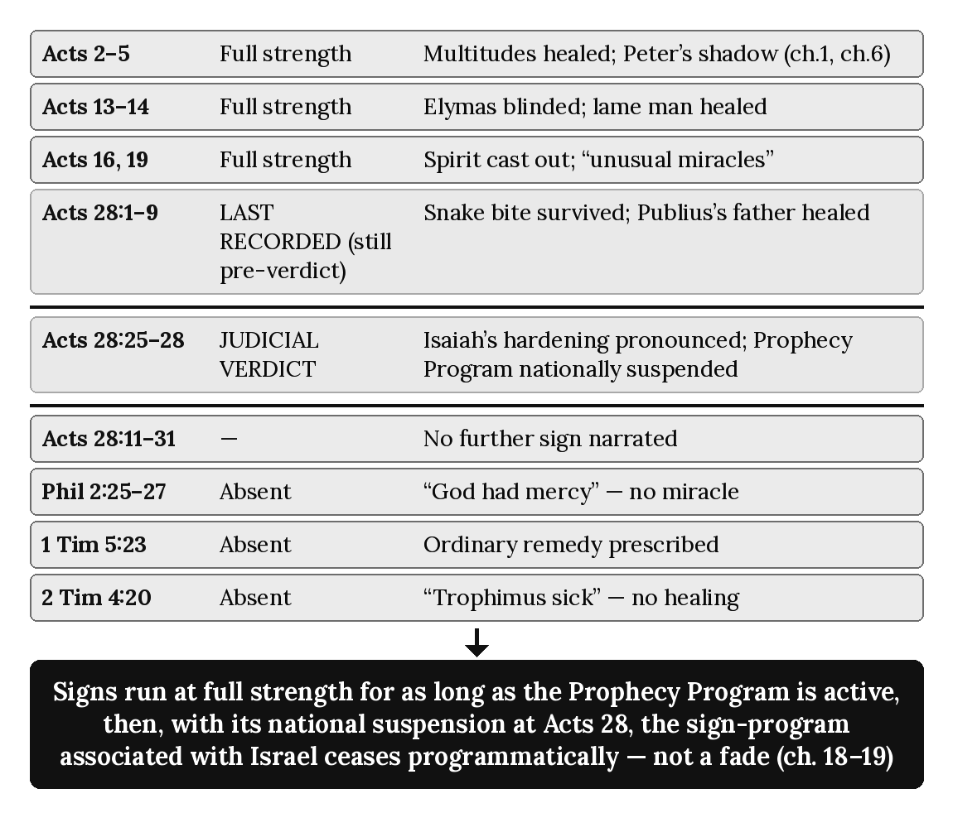

Chapter Summary
Signs and wonders are tied in Scripture to the confirmation of a message given to Israel, and the Mystery Program is not described as carrying a sign-gift of its own. Paul’s signs at Paphos, Lystra, Philippi and Ephesus (Acts 13–14, 16, 19) are overlap phenomena, and the sign at Malta (Acts 28:1–9) is Prophecy Program sign-authentication at full strength; the others are recorded in settings shaped by Israel’s Prophecy Program, which remained operative, and they are reported as written, not assigned to a single program. No sign is reported in any letter written after Acts 28, where Israel’s Prophecy Program is nationally suspended. This is a cessation at a fixed boundary, not a gradual fade: full strength through Malta, no recorded sign after the verdict. Chapter 9 now traces the related development leading to that same verdict — the distinction between repeated local Jewish rejection and the Acts 28 national verdict.

Key Terms
Judicial Cessation of Signs — The non-gradual end of the record of signs at the Acts 28 national suspension of Israel’s Prophecy Program.
Malta (Acts 28:1–9) — The last sign-miracle recorded in Acts, occurring within Acts 28 but before the judicial pronouncement of Acts 28:25–28.

Reflection and Teaching Questions
- Why does this chapter treat the end of the sign-gift as a judicial cessation rather than a gradual fade? What textual evidence demonstrates a programmatic cutoff instead of attrition?
- Why is it doctrinally significant that Malta’s healings (Acts 28:1–9) occur before the judicial pronouncement of Acts 28:25–28 within the same chapter?
- Why does this chapter treat the epistolary silence as doctrinal confirmation of the Acts 28 boundary rather than incidental gaps?
- How does the Prophecy Program/Mystery Program distinction (chapter 3) explain why Paul’s overlap-period signs do not contradict the Mystery Program’s permanent sign-free character?

Chapter 9: Local Jewish Rejection and the National Verdict
“It was necessary that we first preach the word of God to you Jews. But since you have rejected it and judged yourselves unworthy of eternal life, we will offer it to the Gentiles.” — Acts 13:46–47 (NLT)

Introduction
Chapter 8 traced a cutoff at a fixed boundary: the sign-gift operates throughout the overlap and ceases in connection with the judicial suspension of Israel’s Prophecy Program at Acts 28:25–28. This chapter traces a different historical feature: repeated local Jewish rejection during Paul’s ministry while Israel’s national prophetic standing remains unchanged. Pisidian Antioch, Iconium, Thessalonica, Corinth, and Ephesus each record local responses with local ministry consequences. None constitutes a stage in a progressive national setting aside of Israel. Paul continues to address Jewish audiences afterward because Israel’s Prophecy Program remains fully operative throughout Acts 9–28. Acts 28 is categorically different: there the local pattern gives way to the national judicial verdict and suspension of Israel’s Prophecy Program.

Local Rejection at Pisidian Antioch (Acts 13:44–48)
At Pisidian Antioch Paul and Barnabas preach in the synagogue; the following week, almost the entire city gathers to hear them. The Jewish response divides: some believe, while others oppose the message. Paul and Barnabas then announce a turn to the Gentiles in that locality:
“It was necessary that we first preach the word of God to you Jews. But since you have rejected it and judged yourselves unworthy of eternal life, we will offer it to the Gentiles. For the Lord gave us this command when he said, I have made you a light to the Gentiles, to bring salvation to the farthest corners of the earth.” (Acts 13:46–47, NLT)
Two features of this declaration are important. First, Paul addresses the Jews first. Second, the turn to the Gentiles is local, not national: Paul does not conclude that Israel as a nation has been set aside. This synagogue’s rejection produces a local ministry consequence. Paul later enters other synagogues and again addresses Jewish audiences, demonstrating that Israel’s national prophetic standing has not changed. The same distinction governs the earlier rejection scenes throughout this chapter: local Jewish rejection does not equal national Israel rejection. Paul’s synagogue preaching was audience-specific, not commission-specific.

Further Local Rejections: Iconium and Thessalonica
The same kind of divided local response appears at the next two stops:
- Iconium (Acts 14:1–2) — “Paul and Barnabas went to the Jewish synagogue and preached with such power that a great number of both Jews and Greeks became believers” (Acts 14:1, NLT). But again, “some of the Jews... spurned God’s message and poisoned the minds of the Gentiles against Paul and Barnabas” (Acts 14:2, NLT) — belief and rejection running side by side, exactly as at Pisidian Antioch.
- Thessalonica (Acts 17:4–5) — “Some of the Jews who listened were persuaded” (Acts 17:4, NLT), but others, “jealous,” incited a mob against Paul and Silas (Acts 17:5, NLT). The vocabulary itself repeats — belief, then jealousy, then organized opposition — the same three beats struck at Pisidian Antioch and Iconium.
These episodes demonstrate recurring local Jewish opposition, not a progressive change in Israel’s national programmatic status. After them Paul continues to address Jewish audiences elsewhere, because Israel’s Prophecy Program remains fully operative.

Corinth: A Local Turn to the Gentiles (Acts 18:4–6)
At Corinth, the pattern sharpens. Paul is found at the synagogue each Sabbath, “trying to convince the Jews and Greeks alike” (Acts 18:4, NLT), but when the opposition intensifies into open insult, his response goes beyond what he said at Pisidian Antioch:
“But when they opposed and insulted him, Paul shook the dust from his clothes and said, ‘Your blood is upon your own heads — I am innocent. From now on I will go preach to the Gentiles.’” (Acts 18:6, NLT)
The symbolic act and the declaration “I am innocent” mark the seriousness of the Corinthian rejection. Yet the consequence remains local: Paul turns from that opposing synagogue audience to Gentiles in that setting. Corinth has not spoken for the nation, and Paul will again address Jewish audiences afterward. The passage therefore records a local ministry consequence, not another stage in a national setting aside of Israel.
Paul’s practice of reasoning in synagogues on the Sabbath reflects the historical and missionary setting of the Acts Overlap, when Israel’s Prophecy Program remained operative and Jewish audiences assembled on that day. His presence in that setting does not place the Body of Christ under Israel’s Sabbath covenant or make Sabbath observance a requirement of the Mystery Program. The existence of the seventh-day pattern in Scripture does not by itself place the Body of Christ under Israel’s Mosaic Sabbath covenant. Missionary use of a prophetic setting does not transfer that setting’s covenant requirements to the Mystery Program.

Ephesus: Local Hardening and Separation (Acts 19:8–9)
At Ephesus, the pattern’s vocabulary shifts from opposition to hardening:
“Then Paul went to the synagogue and preached boldly for the next three months, arguing persuasively about the Kingdom of God. But some became stubborn, rejecting his message and publicly speaking against the Way. So Paul left the synagogue and took the believers with him.” (Acts 19:8–9, NLT)
“Became stubborn” names settled resistance within this Ephesian audience. Paul responds by withdrawing the disciples and teaching separately. The consequence is significant but local. It does not alter Israel’s national programmatic standing, and it must not be treated as a further stage toward national suspension. Israel’s Prophecy Program remains operative until Acts 28.

Rome: The National Judicial Verdict (Acts 28:17–28)
Every prior rejection examined in this chapter is local — one city, one synagogue or Jewish audience, one ministry setting. Acts 28 is categorically different. After Paul addresses the Jewish leaders at Rome from the law of Moses and the prophets, the response is divided:
“Some were persuaded by the things he said, but others did not believe.” (Acts 28:24, NLT)
At previous locations, divided or hostile Jewish response produced local ministry consequences. At Rome, however, Paul pronounces Isaiah’s judicial words and announces the Gentile consequence in connection with the national boundary:
“The Holy Spirit was right when he said to your ancestors through Isaiah the prophet, ‘Go and say to this people: When you hear what I say, you will not understand. When you see what I do, you will not comprehend. For the hearts of these people are hardened, and their ears cannot hear, and they have closed their eyes — so their eyes cannot see, and their ears cannot hear, and their hearts cannot understand, and they cannot turn to me and let me heal them.’ So I want you to know that this salvation from God has also been offered to the Gentiles, and they will accept it.” (Acts 28:25–28, NLT)
The decisive distinction is not that a local pattern has gradually become national. Rather, Acts 28 introduces a categorically different judicial action. Isaiah’s words are pronounced at the fixed national boundary, and Israel’s Prophecy Program is judicially suspended. Chapters 18 and 19 examine the judicial blinding in full. The earlier local rejections provide historical context, but they do not cumulatively change Israel’s national status or progressively produce the Acts 28 suspension.

Local, Not National: Distinguishing the Earlier Rejections from Acts 28
Acts 13, 14, 17, 18, and 19 record real Jewish rejection and real local ministry consequences, but none changes Israel’s national programmatic standing. The governing distinction is therefore essential: local Jewish rejection is not national Israel rejection, and local ministry consequence is not national programmatic change. Israel’s Prophecy Program remains fully operative throughout the overlap. Acts 28:25–28 is different in category: there the national judicial verdict is pronounced and Israel’s Prophecy Program reaches its suspension point. The earlier events occur in sequence, but sequence must not be converted into a gradual programmatic transition or progressive national suspension.

The Local/National Distinction, Summarized
Reference | Location | Jewish Response
Acts 13:44–48 | Pisidian Antioch | Divided — some believe; leaders slander and oppose; Paul turns to Gentiles locally
Acts 14:1–2 | Iconium | Divided — many believe; others poison Gentile opinion against Paul
Acts 17:1–9 | Thessalonica | Divided — some persuaded; others incite a mob
Acts 18:4–6 | Corinth | Opposition and insult; Paul declares “your blood is upon your own heads”
Acts 19:8–9 | Ephesus | Some become “stubborn”; Paul withdraws with believers
Acts 28:17–28 | Rome | Divided nationally — some persuaded, others not; Isaiah’s hardening pronounced; offer turns to the Gentiles

Applying the Seven Diagnostic Lenses to Acts 28:23–28
- Audience — The local Jewish leaders of Rome, representing, through Isaiah’s address to “your ancestors,” the nation as a whole.
- Apostolic Authority — Paul, exercising his one distinctive Mystery apostleship while addressing Israel within its still-operative prophetic setting during the overlap.
- Covenant — Directly invoked: Isaiah’s prophecy concerns the covenant people’s own hardened response to their own Messiah.
- Sign-Gift — Not present in this scene; the last sign was already narrated at Malta (chapter 8), immediately prior.
- Commission — The kingdom offer under the Kingdom Commission’s own terms, being formally suspended at the national level.
- Eschatology — Israel’s earthly kingdom hope (chapter 1) is not canceled but suspended; chapters 18–19 examine this distinction fully.
- Dispensation — The hinge point itself: Israel’s Prophecy Program is nationally and judicially suspended at Acts 28, ending its concurrent operation alongside the Mystery Program; the Mystery Program continues thereafter as the presently operative program (chapter 21).

Diagram: Local Jewish Rejections and the Acts 28 National Verdict
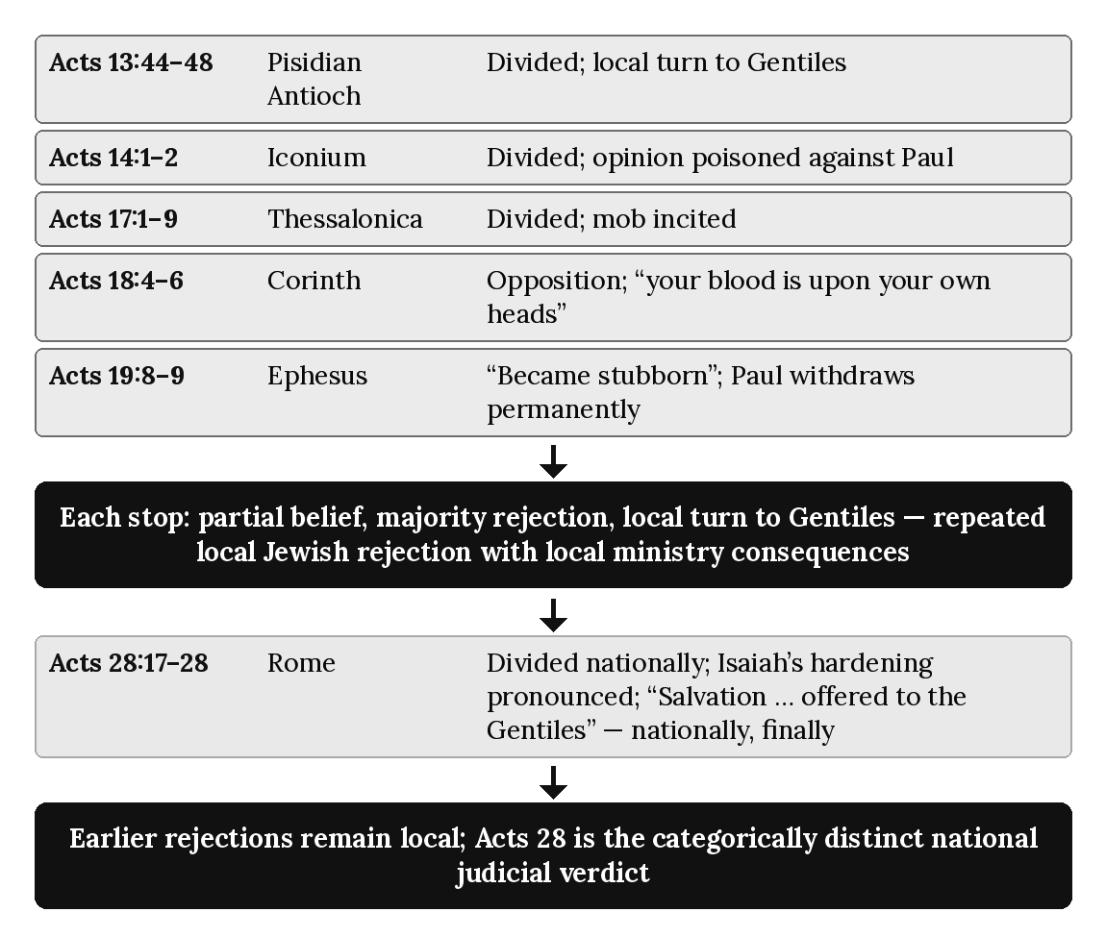

Chapter Summary
Acts records repeated local Jewish rejections during Paul’s ministry at Pisidian Antioch, Iconium, Thessalonica, Corinth, and Ephesus. These episodes have genuine local consequences, including turns to Gentile audiences and separation from opposing synagogue groups, but they do not progressively alter Israel’s national programmatic standing. Paul continues to address Jewish audiences afterward because Israel’s Prophecy Program remains fully operative throughout Acts 9–28. Acts 28 is categorically different: Isaiah’s judicial words are pronounced at the national boundary and Israel’s Prophecy Program is suspended. The controlling distinction is therefore local rejection versus national verdict, not gradual national diminishing.

Key Terms
Local Jewish Rejection — Rejection by a Jewish audience in a particular city or ministry setting, producing a local ministry consequence without changing Israel’s national programmatic standing. Acts 13, 14, 17, 18, and 19 must not be treated as cumulative stages of national suspension.
To the Jew First — Paul’s recurring missionary order during Acts, in which he addresses Jewish audiences first before turning locally to Gentiles. This historical pattern occurs while Israel’s Prophecy Program remains nationally operative but does not assign Paul administrative responsibility for the Kingdom Commission or Israel’s Prophecy Program. (Chapter 9.)
Hardening — Language describing settled resistance in a particular context, as at Ephesus (Acts 19:9), and judicially applied at the Acts 28 national boundary through Isaiah 6. A local use of hardening language must not be treated as a prior stage of national judicial suspension.

Reflection and Teaching Questions
- Why must the local Jewish rejections of Acts 13, 14, 17, 18, and 19 be distinguished from the national judicial verdict of Acts 28:25–28?
- Trace Paul’s responses at Pisidian Antioch, Corinth, and Ephesus. What local ministry consequences follow, and what evidence shows that Israel’s national programmatic standing remains unchanged until Acts 28?
- Why is it significant that at Rome, unlike at every previous city, the divided response of Acts 28:24 leads to a national pronouncement rather than another local turn to the Gentiles?
- How does Paul’s grief in Romans 9:2–3 change how this chapter’s pattern should be taught, even though the pattern itself is traced dispassionately in the text of Acts?

Chapter 10: Gentile Inclusion
“And this is God’s plan: Both Gentiles and Jews who believe the Good News share equally in the riches inherited by God’s children. Both are part of the same body, and both enjoy the promise of blessings because they belong to Christ Jesus.” — Ephesians 3:6 (NLT)

Introduction
Both programs traced in this book include Gentiles. This single fact is the source of one of the most common interpretive errors the Acts Overlap Model exists to correct: the assumption that “Gentiles are included” means the same thing wherever it appears in the New Testament. It does not. The Prophecy Program includes Gentiles as participants in blessing that comes through Israel — a pattern announced centuries earlier and reported at the Jerusalem Council — without making them Israel, placing them in Israel’s covenants, or giving them Israel’s prophetic identity. The Mystery Program includes Gentiles by joining them with believing Jews into a single new entity that did not exist before, a pattern of which Paul says, “God did not reveal it to previous generations” (Ephesians 3:5, NLT). Both are real and scriptural. They are not the same inclusion, and this chapter’s task is to trace each on its own terms before stating the diagnostic rule that keeps them distinct.

Gentile Inclusion Under the Prophecy Program: Cornelius (Acts 10)
The first Gentile inclusion narrated in Acts occurs under Peter’s own authority, not Paul’s. Peter’s vision, Cornelius’s summons, and their meeting in Caesarea culminate in Peter’s own declaration of the principle at work:
“I see very clearly that God shows no favoritism. In every nation he accepts those who fear him and do what is right.” (Acts 10:34–35, NLT)
What follows confirms the principle is not merely stated but enacted: “the Holy Spirit fell upon all who were listening to his message” (Acts 10:44, NLT), to the astonishment of “the Jewish believers who came with Peter” (Acts 10:45, NLT), and Peter orders water baptism for the new Gentile believers (Acts 10:47–48). Every marker of this episode belongs to the Prophecy Program as chapters 1 and 6 have already defined it: Peter’s own apostolic authority exercising it, water baptism administered as the confirming rite, and a Spirit-sign (tongues) matching the same pattern of Acts 2. Cornelius is a genuine, historic first: the first Gentile household to receive the Spirit under Peter’s ministry, a Prophecy Program event inside the overlap (Acts 10–11). It is not, on its own terms, the “one new man” this chapter will trace below from Ephesians.

Acts 15 — An Overlap Event: Two Apostleships Meeting Within Concurrent Programs
Chapter 7 already examined the Jerusalem Council’s outcome — the formal division of apostolic labor between Peter and Paul (Galatians 2:7–9). This chapter’s interest is narrower: the theological basis James gives, in that same council, for why Gentile inclusion belongs where it does. James does not appeal to anything new or hidden; he appeals to the Prophets:
“Afterward I will return and restore the fallen house of David. I will rebuild its ruins and restore it, so that the rest of humanity might seek the Lord, including the Gentiles — all those I have called to be mine. The Lord has spoken —” (Acts 15:16–17, NLT)
The citation is Amos 9:11–12, and its logic is unmistakably Davidic and kingdom-shaped: Gentiles “seek the Lord” as a consequence of Davidic restoration, not as members of a newly created entity. James treats Cornelius’s inclusion (Acts 15:14) as the beginning of exactly this long-promised pattern, not as an isolated anomaly. Gentile blessing in connection with Israel’s restoration, on this accounting, is old news, written by a prophet, now beginning to be fulfilled — the precise opposite of a mystery “kept secret from the beginning of time” (Romans 16:25, a text chapter 2 examined at length). Acts 15 is an overlap event, and this chapter reports James’s argument as he gives it without assigning the council as a whole to a single program.

Gentile Inclusion Under the Prophecy Program: The Olive Tree (Romans 11:17–24)
Paul’s own olive-tree image, addressed to Gentile believers directly, describes Gentile participation in different terms, within Israel’s prophetic line:
“But some of these branches from Abraham’s tree — some of the people of Israel — have been broken off. And you Gentiles, who were branches from a wild olive tree, have been grafted in. So now you also receive the blessing God has promised Abraham and his children, sharing in the rich nourishment from the root of God’s special olive tree. But you must not brag about being grafted in to replace the branches that were broken off. You are just a branch, not the root.” (Romans 11:17–18, NLT)
Paul’s image is about participation, and it carries its own limits. The image is deliberately singular: one tree, one root, with natural branches and wild branches. A wild branch is grafted in among the branches and partakes of the root and its richness, but it does not become a natural branch; the wild branch remains wild, and the natural branches remain natural. Four boundaries govern the reading: the olive tree is Israel’s prophetic blessing, not the Body of Christ; the Gentiles of Romans 11 are prophetic participants, not members of the Body; wild branches are not members of the Body; and grafting changes participation, not identity. Participation is not identity. Blessing is not covenant. Standing is not program membership. Gentiles in Romans 11 do not become Israel, do not enter Israel’s covenants, and do not inherit Israel’s national promises; Paul’s own warning, “You are just a branch, not the root,” is the guard against turning Gentile blessing into identity transfer. Any reading that turns Gentile blessing into identity transfer violates Paul’s warning and collapses the distinction between Israel’s prophetic program and the Mystery. That God “made salvation available to the Gentiles” (Romans 11:11, NLT) means salvation, not covenant membership, not Israel’s name, promises, program, or destiny. Salvation has come to the Gentiles. Israel remains Israel. The Body remains the Body. Program membership is permanent. Identity is fixed by divine program, not by metaphor. Three witnesses — Cornelius’s experience, James’s argument at the Council, and Paul’s olive-tree image — converge on a single pattern: Gentile blessing in connection with Israel’s restoration, not membership in Israel. This is Prophecy-Program Gentile inclusion. Concurrency is operational, not transformational.

Gentile Inclusion Under the Mystery Program: One New People (Ephesians 2:11–19)
Paul describes a second, categorically different inclusion when he writes to Gentile believers at Ephesus. The vocabulary is not grafting into an existing tree but creation of something that did not exist before:
“For Christ himself has brought peace to us. He united Jews and Gentiles into one people when, in his own body on the cross, he broke down the wall of hostility that separated us. He did this by ending the system of law with its commandments and regulations. He made peace between Jews and Gentiles by creating in himself one new people from the two groups.” (Ephesians 2:14–15, NLT)
“Creating... one new people from the two groups” — what this series, following the traditional rendering of the Greek phrase (kainon anthropon), calls the “one new man” — is not the language of branches and roots. Paul does not say Gentiles have been grafted into Israel; he says Christ has created, from Jew and Gentile together, a single new entity neither was before. The result is a status Paul states plainly:
“So now you Gentiles are no longer strangers and foreigners. You are citizens along with all of God’s holy people. You are members of God’s family.” (Ephesians 2:19, NLT)
Not guests admitted to an existing household, but citizens of a newly constituted one. This is not a difference of degree from Cornelius’s inclusion or the olive tree’s grafting; it is a difference of kind.
The same holds for believing Jews. A Jewish member of the Body is Body by identity and a new creation, not Israel by corporate identity; ethnicity is a historical fact with no covenantal or programmatic force once a person is in the Body. Israel remains Israel, and the Body is not Israel.

Gentile Inclusion Under the Mystery Program: The Secret Now Revealed (Ephesians 3:4–6)
Paul states directly, in the same letter, why this second form of inclusion could not have been the subject of Amos’s prophecy or any other prior revelation:
“As you read what I have written, you will understand my insight into this plan regarding Christ. God did not reveal it to previous generations, but now by his Spirit he has revealed it to his holy apostles and prophets. And this is God’s plan: Both Gentiles and Jews who believe the Good News share equally in the riches inherited by God’s children. Both are part of the same body, and both enjoy the promise of blessings because they belong to Christ Jesus.” (Ephesians 3:4–6, NLT)
“God did not reveal it to previous generations” is the exact opposite of Acts 15:16–17’s appeal to Amos — a prophecy given precisely to a previous generation. Chapter 2 already established the technical force of mystērion for this series: not a puzzle solved but a matter “kept secret from the beginning of time” and now disclosed. Ephesians 2–3’s Gentile inclusion meets that definition; Acts 10 and 15’s does not. The same word — “Gentiles” — names two different recipients of two different, simultaneously operating programs.

Two Forms of Inclusion, Not One: The Diagnostic Distinction
The convergence of vocabulary — both programs “include Gentiles” — is exactly what makes this distinction easy to lose and necessary to state plainly. Prophecy-Program Gentile inclusion (Cornelius, Amos 9, the olive tree) operates under apostolic authority vested in Peter and the Twelve, was announced by the Prophets long before Acts, brings Gentiles into blessing connected with Israel’s restoration without admitting them to Israel’s covenants or identity, is confirmed by water baptism and Spirit-sign phenomena of the kind chapter 8 traces, and leaves Israel’s own distinct identity intact — natural branches remain natural, and wild branches remain wild. Mystery-Program Gentile inclusion (Ephesians 2–3) operates under Paul’s distinct apostleship and the Mystery revelation made known through him (chapter 5), was hidden from every previous generation and disclosed only in this era, creates a single new corporate entity, the Body, in which Jew and Gentile alike are members on the same footing — not Israel enlarged and not the olive tree — rather than one being added to the other’s household, and carries no sign-gift or water-baptism requirement of its own (chapters 8 and 14). Reading Ephesians 2’s “one new people” back into Cornelius’s story, or reading Cornelius’s water baptism and kingdom-shaped inclusion into Ephesians, would erase a distinction the text itself insists on maintaining.

The Pattern, Summarized
Feature | Prophecy-Program Inclusion (Acts 10; James’s argument at the Council, Acts 15:14–18; Romans 11) | Mystery-Program Inclusion (Ephesians 2–3)
Authority | Peter and the Twelve | Paul alone
Scriptural basis | Prophesied long ago (Amos 9:11–12) | Hidden from previous generations
Resulting entity | Gentiles blessed in connection with Israel’s restoration; participants, not covenant members | One new people created from Jew and Gentile together
Baptism | Water (Acts 10:47–48) | Not required (chapter 14)
Sign accompaniment | Present (tongues, Acts 10:44–46; chapter 8) | Absent (chapter 3’s chart)
Israel’s identity | Retained; Israel remains Israel, and Gentiles remain Gentiles (wild branches) | The Body is not Israel, and Israel is not the Body; a Jewish member of the Body is Body by identity

Applying the Seven Diagnostic Lenses to Ephesians 2:11–19
- Audience — Gentile believers at Ephesus, addressed directly regarding their new standing.
- Apostolic Authority — Paul, writing under the heavenly apostleship chapter 5 describes.
- Covenant — Deliberately non-covenantal in its basis; not an extension of the Abrahamic or Davidic covenants but a new creation “in Christ.”
- Sign-Gift — Absent; no sign accompanies or authenticates this inclusion, unlike Cornelius’s.
- Commission — The Pauline Commission’s own distinctive content (chapter 12).
- Eschatology — Heavenly, not earthly (chapter 5); the “one new people” shares Christ’s own heavenly seating (Ephesians 2:6).
- Dispensation — The dispensation of grace (chapter 3), operating alongside, not instead of, Israel’s prophetic program’s own Gentile blessing during the overlap.

Diagram: Two Forms of Gentile Inclusion
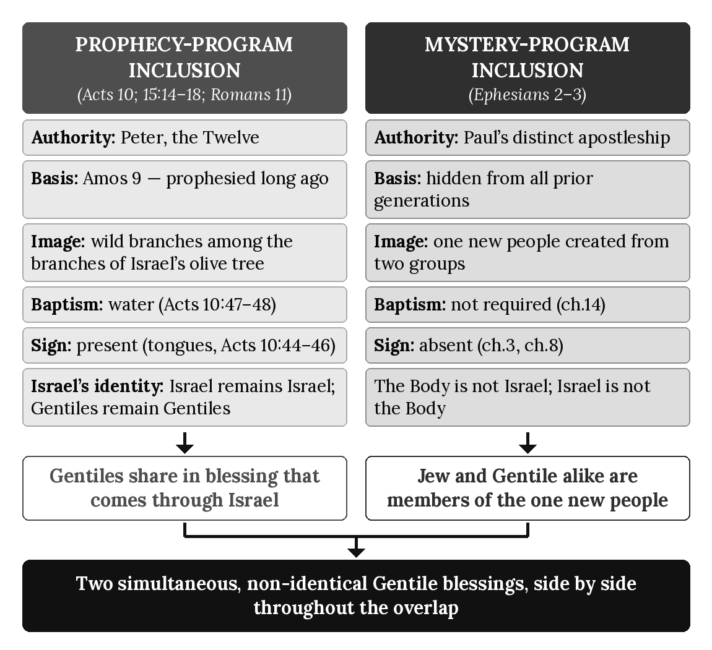

Chapter Summary
Two distinct Gentile inclusions operate simultaneously during the overlap. The Prophecy Program includes Gentiles as participants in the blessing that comes through Israel, without membership in Israel or its covenants — displayed at Cornelius’s household (Acts 10), grounded explicitly in Amos’s prophecy as James argues it at the Council (Acts 15:14–18), and pictured in Paul’s own olive-tree image (Romans 11:17–18). The Mystery Program includes Gentiles differently: not as wild branches among the branches of an existing tree but by the creation of “one new people” from Jew and Gentile together (Ephesians 2:14–15), a pattern Paul states was hidden from every previous generation and revealed through his distinctive apostolic ministry (Ephesians 3:4–6). The two inclusions share a word — Gentiles — but not a mechanism, an authority, a scriptural basis, or a resulting entity. Chapter 11 now turns to the churches Paul planted under this second, Mystery-Program pattern, tracing how “one new people” took shape in practice.

Key Terms
Prophecy-Program Gentile Inclusion — Gentiles blessed in connection with Israel’s restoration, prophesied in the Old Testament (Amos 9:11–12) and seen under Peter’s ministry (Acts 10) and in James’s argument at the Council (Acts 15:14–18); pictured as wild branches among the branches of an olive tree (Romans 11:17–24). It is participation in blessing, not covenant membership, not Israel’s identity, and not the Body.
One New People (“One New Man”) — This series’ term (following the traditional rendering of Ephesians 2:15’s Greek, kainon anthropon; NLT: “one new people”) for the Mystery Program’s form of Gentile inclusion: the creation, in Christ, of a single new corporate entity from Jew and Gentile together, made known as part of the Mystery revealed through Paul (Ephesians 3:4–6).

Reflection and Teaching Questions
- Why does this chapter treat Cornelius’s inclusion (Acts 10) and the “one new people” of Ephesians 2 as two different kinds of Gentile inclusion rather than two accounts of the same event?
- How does Acts 15:16–17’s appeal to Amos 9 — a prophecy Israel already possessed — stand in direct tension with Ephesians 3:5’s claim that “God did not reveal it to previous generations”? Why does this chapter treat that tension as evidence rather than a contradiction to resolve away?
- What is the difference between a wild branch grafted in among the branches of an olive tree (Romans 11:17–18), where participation changes and identity does not, and a “new people” created from two groups (Ephesians 2:15)? Why does this chapter insist the difference is one of kind rather than degree?
- Why does the presence of water baptism and a sign (tongues) at Cornelius’s inclusion, and their absence from Ephesians 2–3’s inclusion, count as diagnostic evidence rather than incidental detail?

Chapter 11: The Pauline Churches
“Christ lives in you. This gives you assurance of sharing his glory.” — Colossians 1:27 (NLT)

Introduction
Chapter 10 established the doctrine: the Mystery Program includes Gentiles not as participants in blessing that comes through Israel but by creating, with believing Jews, “one new people” that did not exist before (Ephesians 2:15). That doctrine did not remain theoretical. It took concrete shape in the actual congregations Paul planted across three missionary journeys — founded by his own preaching, led by structures he himself established, and answerable, in matters of doctrine, to no human authority but his own commission from Christ. This chapter traces that shape historically: how a Pauline church was founded, governed, gathered, and taught. It is deliberately descriptive rather than comparative; chapter 16 will complete the full systematic contrast between this ecclesiology and the Prophecy Program’s own. This chapter’s task is narrower and comes first: to show what Paul actually built.

Founded and Returned To: A Repeating Pattern (Acts 14:21–23)
Paul’s church-planting method is visible in miniature at the close of the first missionary journey:
“After preaching the Good News in Derbe and making many disciples, Paul and Barnabas returned to Lystra, Iconium, and Antioch of Pisidia, where they strengthened the believers. They encouraged them to continue in the faith, reminding them that we must suffer many hardships to enter the Kingdom of God. Paul and Barnabas also appointed elders in every church. With prayer and fasting, they turned the elders over to the care of the Lord, in whom they had put their trust.” (Acts 14:21–23, NLT)
This statement reflects Prophecy-Program encouragement directed to the Jewish believers present in these mixed gatherings. A mixed audience in Acts does not automatically mean the Body of Christ; Paul’s audience-specific language addressed to Jewish hearers must be interpreted within Israel’s still-operative prophetic setting during the Acts Overlap; its presence does not transfer Israel’s Kingdom Commission to Paul or redefine the heavenly hope of the Body of Christ.
This book reads every scene in Acts through four distinct groups, defined in this chapter’s Key Terms; a mixed audience is a physical condition, not a spiritual group.
Four elements recur consistently across Paul’s journeys and form the pattern this chapter traces: proclamation resulting in “many disciples,” a deliberate return to strengthen what preaching alone had started, the appointment of local leadership — “elders in every church,” plural and local, not a single office in Jerusalem — and a formal commendation of that leadership “to the care of the Lord” rather than to any human oversight body. The appointment of elders is Mystery-Program ecclesial practice during the overlap, not Prophecy-Program administration. The pattern is Paul’s own from its first instance; nothing in Acts 14 involves Jerusalem’s approval or the Twelve’s participation.

Answerable to No Human Authority But Christ’s (Galatians 1:8–9; 2:6)
The churches Paul founded were not left to reinterpret his gospel by other authorities after his departure. Paul states the stakes for any competing doctrinal claim in the strongest terms he uses anywhere in his letters:
“Let God’s curse fall on anyone, including us or even an angel from heaven, who preaches a different kind of Good News than the one we preached to you. I say again what we have said before: If anyone preaches any other Good News than the one you welcomed, let that person be cursed.” (Galatians 1:8–9, NLT)
This is not rebellion against Jerusalem but recognition of parallel apostleship; chapter 7 already traced how the Jerusalem Council itself ratified Paul’s Gentile mission as a distinct, parallel apostleship (Galatians 2:7–9), and Paul says so explicitly of that same meeting: “the leaders of the church had nothing to add to what I was preaching” (Galatians 2:6, NLT) — not opposition, but confirmation that nothing needed to be added. The churches Paul planted therefore answer doctrinally to Paul’s own commission (chapter 5’s heavenly apostleship), recognized by Jerusalem but not derived from or supervised by it.

Led by Elders and Overseers, Not the Twelve (Acts 20:17, 28–31)
Paul’s farewell to the Ephesian elders shows this local leadership structure at its fullest description anywhere in Acts. Paul summons the elders (Acts 20:17) and charges them directly:
“So guard yourselves and God’s people. Feed and shepherd God’s flock — his church, purchased with his own blood — over which the Holy Spirit has appointed you as leaders.” (Acts 20:28, NLT)
The authority invoked is the Holy Spirit’s own appointment, not a commission delegated downward from Jerusalem or the Twelve. Paul immediately warns of a specific danger these local leaders — not any centralized body — must guard against:
“I know that false teachers, like vicious wolves, will come in among you after I leave, not sparing the flock. Even some men from your own group will rise up and distort the truth in order to draw a following.” (Acts 20:29–30, NLT)
The entire structure is local, Spirit-appointed, and self-contained: elders appointed within the congregation, entrusted by the Spirit, warned of dangers arising from within their own number, with no appeal in this passage to any higher human court of doctrine beyond Paul’s own teaching, already given and now departing with him.

Built on One Foundation: Paul’s Own Stewardship (1 Corinthians 3:10–11; Colossians 1:25–27)
Paul describes his own relationship to these congregations in terms no other apostle uses of them:
“Because of God’s grace to me, I have laid the foundation like an expert builder. Now others are building on it. But whoever is building on this foundation must be very careful. For no one can lay any foundation other than the one we already have — Jesus Christ.” (1 Corinthians 3:10–11, NLT)
The foundation itself is Christ, but the laying of it — in these specific congregations — is Paul’s own act, by “God’s grace to me.” He states the same stewardship in explicitly mystērion terms, in language chapter 2 already examined for its content and returns to here for its churchward application:
“God has given me the responsibility of serving his church by proclaiming his entire message to you. This message was kept secret for centuries and generations past, but now it has been revealed to God’s people. For God wanted them to know that the riches and glory of Christ are for you Gentiles, too. And this is the secret: Christ lives in you.” (Colossians 1:25–27, NLT)
“The responsibility of serving his church” — singular stewardship, singular apostle — grounds every congregation this chapter has traced in Paul’s own unique commission, not in a delegated fragment of the Twelve’s authority.

Equipped by a Different Set of Gifts (Ephesians 4:11–12)
The offices that sustain these churches after Paul’s own departure are named in a list that includes no reference to the Twelve’s own office:
“Now these are the gifts Christ gave to the church: the apostles, the prophets, the evangelists, and the pastors and teachers. Their responsibility is to equip God’s people to do his work and build up the church, the body of Christ.” (Ephesians 4:11–12, NLT)
“The body of Christ” is this series’ own term (see Appendix F, the Dispensational Glossary) for the Mystery Program’s own people; the gifts listed equip that body specifically, by the same apostle who received the mystery constituting it (Ephesians 3:1–9, chapter 2). The local elders and overseers of Acts 14 and Acts 20 operate within this same gift-structure, not within the Twelve’s Jerusalem-centered office.

Gathered in Homes, Not the Temple
Nothing in Paul’s letters locates these congregations’ worship at the temple or any centralized sanctuary. Believers meet instead in private homes — Paul greets “the church that meets in [Priscilla and Aquila’s] home” at Rome (Romans 16:5, NLT) and again at Ephesus (1 Corinthians 16:19, NLT), and Nympha hosts a congregation at Laodicea in the same way (Colossians 4:15, NLT). This is a structural fact, not yet a doctrinal contrast; chapter 1 already established the temple’s centrality to the Prophecy Program’s own worship, and chapter 16 will take up the full comparison. Noted here, it completes the historical picture: these were local, home-based assemblies, led by locally appointed elders, answerable to Paul’s own apostolic teaching, gathered around no sanctuary at all.

Not a Rival Ecclesiology, Yet Not the Same One
Every feature this chapter has traced — independent founding, elder-led local government, Paul’s own singular stewardship, a distinct set of equipping gifts, home-based gathering — describes a coherent, self-contained pattern of church life. It is not a rival to the Prophecy Program’s own community, still centered on Jerusalem and the temple throughout the overlap (chapters 1, 6); the two operate simultaneously, exactly as chapters 3 and 4 have argued the two programs themselves do. Nor is it a mere variation on the same pattern, awaiting Jerusalem’s oversight once matured. It is the practical, historical shape “one new people” (chapter 10) took wherever Paul preached. Chapter 16 will state the full doctrinal comparison; this chapter has supplied what that comparison will need — the actual, traceable pattern itself.

The Pattern, Summarized
Feature | The Pauline Churches
Founding | Paul’s own preaching, followed by a deliberate return to strengthen (Acts 14:21–23)
Doctrinal authority | Paul’s own commission (Galatians 1:8–9), confirmed but not supervised by Jerusalem (Galatians 2:6)
Local leadership | Elders/overseers appointed within each congregation (Acts 14:23; 20:17, 28)
Foundational role | Paul as “expert builder” and steward of the mystery (1 Corinthians 3:10–11; Colossians 1:25–27)
Equipping offices | Apostles, prophets, evangelists, pastors and teachers (Ephesians 4:11–12)
Gathering place | Private homes (Romans 16:5; 1 Corinthians 16:19; Colossians 4:15)

Applying the Seven Diagnostic Lenses to Acts 20:17–31
- Audience — The elders of the Ephesian church, gathered for Paul’s final address to them.
- Apostolic Authority — Paul’s own, exercised in commissioning local leaders rather than appointing centralized ones.
- Covenant — Not invoked; the charge rests on the Spirit’s appointment and Christ’s purchase of the church “with his own blood” (Acts 20:28), not covenantal succession.
- Sign-Gift — Not present in this scene; the charge is pastoral and administrative, not sign-authenticated.
- Commission — The Pauline Commission’s own structure, sustaining itself through local elders after Paul’s departure.
- Eschatology — Implied rather than stated; the church is “God’s flock,” gathered for a heavenly, not earthly, hope (chapter 5).
- Dispensation — The dispensation of grace (chapter 3), operating through its own leadership structure independent of the Prophecy Program’s.

Diagram: The Pauline Churches
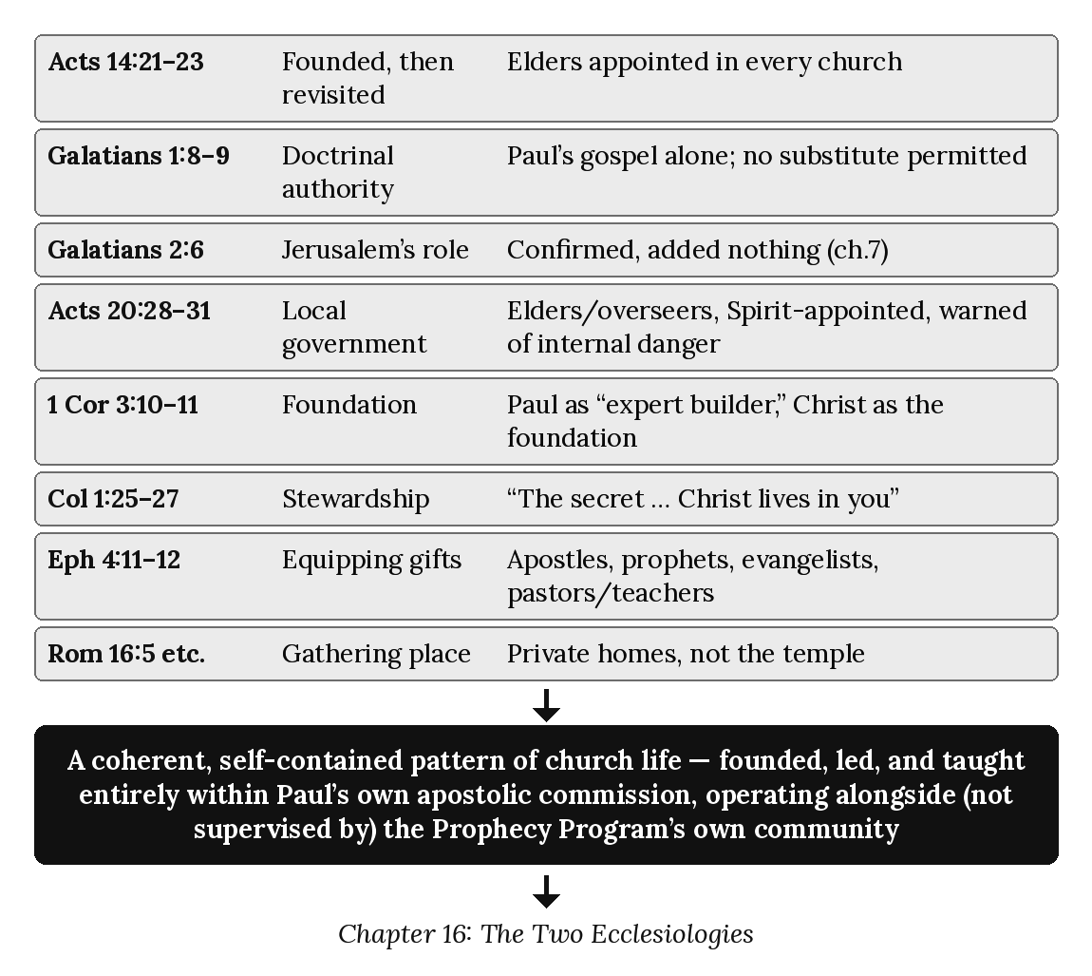

Chapter Summary
The doctrine of “one new people” (chapter 10) took concrete, traceable shape in the congregations Paul planted: founded by his own preaching and revisited to strengthen them (Acts 14:21–23), governed by locally appointed elders answerable to no centralized human authority (Acts 20:17, 28–31), built on Paul’s own singular stewardship of the mystery (1 Corinthians 3:10–11; Colossians 1:25–27), equipped by a distinct set of gifts (Ephesians 4:11–12), and gathered in homes rather than the temple. This pattern is not a rival to the Prophecy Program’s own Jerusalem-centered community; it operates alongside it throughout the overlap, on its own terms. These congregations reflect the Mystery-Program pattern even when Jewish believers are present in the room; mixed audiences in Acts do not erase the program distinctions traced in chapters 3, 4, and 10. During Acts 9–28, Paul carries out his one distinctive Mystery commission while Israel’s Prophecy Program and the Kingdom Commission of the Twelve remain concurrently operative. Historical proximity and interaction do not transfer programmatic jurisdiction. Concurrency explains Paul’s contact with prophetic settings; it does not place his Mystery commission inside the Kingdom Commission. Chapter 12 now turns to the commission structure underlying both patterns of church life — the Kingdom Commission and the Pauline Commission — examining formally the relationship this chapter and chapter 5 have already begun to trace.

Key Terms
Pauline Church — This series’ term for a congregation founded under Paul’s own apostolic commission: locally led by elders/overseers, doctrinally answerable to Paul’s teaching alone, and gathered in homes rather than the temple. Mixed audiences in Acts do not automatically constitute the Body of Christ; the Body is defined by the Mystery revelation, not by physical proximity.
Elder/Overseer (Ephesian Pattern) — The local leadership office Paul appoints in every church he founds (Acts 14:23), charged directly by the Holy Spirit (Acts 20:28) rather than by delegation from Jerusalem or the Twelve.
Four Distinct Groups — This series’ classification of the groups an Acts scene can contain: (1) Jews under the Prophecy Program (the covenant nation, with a prophetic identity, who never become the Body); (2) Gentiles responding to the Mystery Program (non-covenantal, entering the Body upon belief, distinct from Israel); (3) mixed audiences (a physical category only: Jews and Gentiles in the same room, not a program and not a spiritual group, a narrative condition only); and (4) the Body of Christ proper (Jew and Gentile without distinction, with a Mystery identity and a heavenly destiny). Mixed audiences are not a spiritual group but a physical audience condition that must be interpreted correctly during the overlap; “Gentiles responding to the Mystery” names the entry condition, not a separate group overlapping the Body; and unbelieving Israel is not one of the four, because the doctrine concerns programmatic identity, not general anthropology.

Reflection and Teaching Questions
- Why does this chapter treat Paul’s church-planting pattern (Acts 14:21–23) as evidence of a distinct ecclesiology rather than simply a missionary method within the Prophecy Program’s own structure?
- How does Galatians 2:6 — “the leaders of the church had nothing to add to what I was preaching” — support this chapter’s claim that Jerusalem confirmed rather than supervised Paul’s congregations?
- Why does this chapter treat 1 Corinthians 3:10–11 and Colossians 1:25–27 together as evidence of Paul’s singular stewardship, rather than as general statements true of any apostle’s ministry?
- This chapter deliberately defers the full doctrinal comparison between the Pauline churches and the Prophecy Program’s own community to chapter 16. What is gained by tracing the historical pattern first, before making that comparison explicit?

Chapter 12: The Two Commissions
“Therefore, go and make disciples of all the nations, baptizing them in the name of the Father and the Son and the Holy Spirit.” — Matthew 28:19 (NLT)

Introduction
Every chapter of this book has referred to “the Kingdom Commission” and “the Pauline Commission” as the distinct operating commissions of the Prophecy Program and the Mystery Program. This chapter now defines each formally and states precisely how they relate during the Acts Overlap. The two commissions operate concurrently from Acts 9–28, but they are never merged, transferred, or jointly administered by Paul. The Kingdom Commission remains the commission of the Twelve within Israel’s Prophecy Program; the Pauline Commission remains Paul’s one distinctive commission within the Mystery Program. Paul may minister to Israel within its still-operative prophetic setting, but he does not thereby come under, share, or administer the Kingdom Commission.

The Kingdom Commission (Matthew 28:18–20)
The risen Christ delivers this charge to “the eleven disciples” (Matthew 28:16, NLT) — the Twelve’s own office, minus Judas, restored to its full number only after Matthias’s appointment (chapter 5’s “Not the Thirteenth” already examined that appointment on other grounds):
“Jesus came and told his disciples, ‘I have been given all authority in heaven and on earth. Therefore, go and make disciples of all the nations, baptizing them in the name of the Father and the Son and the Holy Spirit. Teach these new disciples to obey all the commands I have given you. And be sure of this: I am with you always, even to the end of the age.’” (Matthew 28:18–20, NLT)
Four features define this commission on its own terms. Its recipients are the Eleven specifically, not Paul, who is not yet called. Its method is water baptism and obedience-based teaching — “baptizing them... Teach these new disciples to obey all the commands,” the same water rite chapter 10 traced at Cornelius’s inclusion. Its scope, “all the nations,” is the Prophecy-Program pattern of Gentile inclusion chapter 10 already distinguished from the Mystery’s “one new people”: nations brought into relationship with Israel’s own kingdom message, not created into a new corporate entity. And its horizon is “the end of the age” — an earthly, temporal marker (chapter 17 will examine this eschatology fully), not the heavenly hope chapter 5 attributed to Paul’s own commissioning.

The Pauline Commission (Acts 26:16–18; Galatians 1:11–12)
Paul’s own commission is a separate, later, and independently sourced event. His account of it, given before Agrippa, states its content directly:
“Now get to your feet! For I have appeared to you to appoint you as my servant and witness. Tell people that you have seen me, and tell them what I will show you in the future. And I will rescue you from both your own people and the Gentiles. Yes, I am sending you to the Gentiles to open their eyes, so they may turn from darkness to light and from the power of Satan to God. Then they will receive forgiveness for their sins and be given a place among God’s people, who are set apart by faith in me.” (Acts 26:16–18, NLT)
No water baptism is commanded here; no obedience-to-commands formula is given. The content is revelatory and forensic — opening eyes, turning from darkness, forgiveness, a place “among God’s people... by faith” — matching precisely the “one new people” doctrine chapter 10 traced in Ephesians.
Paul states the commission’s source with the same bluntness chapter 5 already examined from Galatians 1:1:
“Dear brothers and sisters, I want you to understand that the gospel message I preach is not based on mere human reasoning. I received my message from no human source, and no one taught me. Instead, I received it by direct revelation from Jesus Christ.” (Galatians 1:11–12, NLT)
And he names its recipients specifically, not generally: “I am a special messenger from Christ Jesus to you Gentiles” (Romans 15:16, NLT) — a scope Acts 26:17 already stated (“I am sending you to the Gentiles”) and this series has traced since chapter 5.

Two Commissions, Two Contents
The two commissions share almost nothing beyond their both being described, in English, as a “sending.” Their source differs: the Kingdom Commission is delivered by the resurrected Christ to the gathered Eleven in Galilee; the Pauline Commission is delivered later, separately, to Paul alone, “from no human source” (Galatians 1:12). Their recipients differ: the Twelve’s own office versus Paul’s own office, never merged (chapter 5’s “Not the Thirteenth”). Their method differs: water baptism and command-keeping versus eye-opening, forgiveness, and inclusion “by faith.” Their scope differs: “all the nations” brought into Israel’s kingdom message versus Gentiles specifically drawn into “one new people” (chapter 10). And their horizon differs: “the end of the age,” an earthly terminus, versus the heavenly seating chapter 5 already traced to Ephesians 2:6. Two commissions; two contents; two authorities. Neither is a variant of the other.
This distinction must be stated before the commissions are compared, because each program’s forgiveness structure flows from its own revealed terms. Members of the Body of Christ possess positional forgiveness through Christ’s completed redemptive work. Pauline instruction therefore does not present repeated confession as a mechanism by which a believer repeatedly regains judicial forgiveness or restores membership in Christ. Believers should nevertheless acknowledge sin, judge sinful conduct, seek reconciliation where appropriate, and walk consistently with the grace already bestowed upon them. Confession may express honest acknowledgment of sin; it does not purchase or reactivate the believer’s completed positional forgiveness in Christ. Passages containing conditional confession/forgiveness formulas must be interpreted according to their audience, purpose, and programmatic setting rather than automatically made the controlling soteriological formula for the Body of Christ.

One Apostle, Two Concurrent Programs: Paul’s Distinct Commission During the Overlap
Chapter 5 established that Paul’s apostleship, commission, and stewardship remain distinctly Mystery while he ministers during the concurrent operation of Israel’s Prophecy Program. Paul does not hold, share, or receive any part of the Kingdom Commission. That commission belongs to the Eleven; Paul was neither present at its delivery nor commissioned under it. Paul nevertheless ministers to Israel within its still-operative prophetic setting, reasons from Israel’s Scriptures, proclaims Jesus as Israel’s promised Messiah, and addresses Israel’s kingdom hope without becoming an administrator of Israel’s program. His synagogue preaching, signs, and Jewish-directed ministry must therefore be classified by audience, purpose, revelatory setting, and immediate context. One apostle; one distinctive Pauline commission; multiple audiences during the overlap.

The Pattern, Summarized
Feature | Kingdom Commission (Matthew 28:18–20) | Pauline Commission (Acts 26:16–18; Galatians 1:11–12)
Recipients | The Eleven | Paul alone
Source | The resurrected Christ, in Galilee | Christ, independently, “from no human source”
Method | Water baptism; teaching obedience to commands | Eye-opening, forgiveness, inclusion by faith
Scope | “All the nations” — in connection with Israel’s kingdom message | Gentiles specifically — drawn into “one new people”
Horizon | “The end of the age” (earthly) | Heavenly seating (chapter 5)
Duration | Active through the overlap; suspended at Acts 28 (chapters 8–9) | Permanent; continues beyond Acts 28 within the Mystery Program (chapter 21)
Paul’s relationship | Never held by Paul; it remains operative through the Twelve during the Acts Overlap while Paul carries out his distinct Mystery commission. | Paul’s own distinct apostolic commission

Applying the Seven Diagnostic Lenses to Acts 26:16–18
- Audience — Agrippa’s court, as Paul recounts his own commissioning; the commission’s actual recipients are “the Gentiles” (v. 17).
- Apostolic Authority — Paul’s own, directly from the risen Christ, independent of the Eleven’s prior commissioning.
- Covenant — Not invoked; inclusion is “by faith,” not by covenantal descent or extension.
- Sign-Gift — Not present in the commissioning scene itself, distinguishing it from the Twelve’s own commissioning context.
- Commission — The Pauline Commission’s own founding text.
- Eschatology — Implied heavenly hope, consistent with chapter 5’s “seated... with him in the heavenly realms.”
- Dispensation — The dispensation of grace (chapter 3), inaugurated in this very commissioning.

Diagram: The Two Commissions
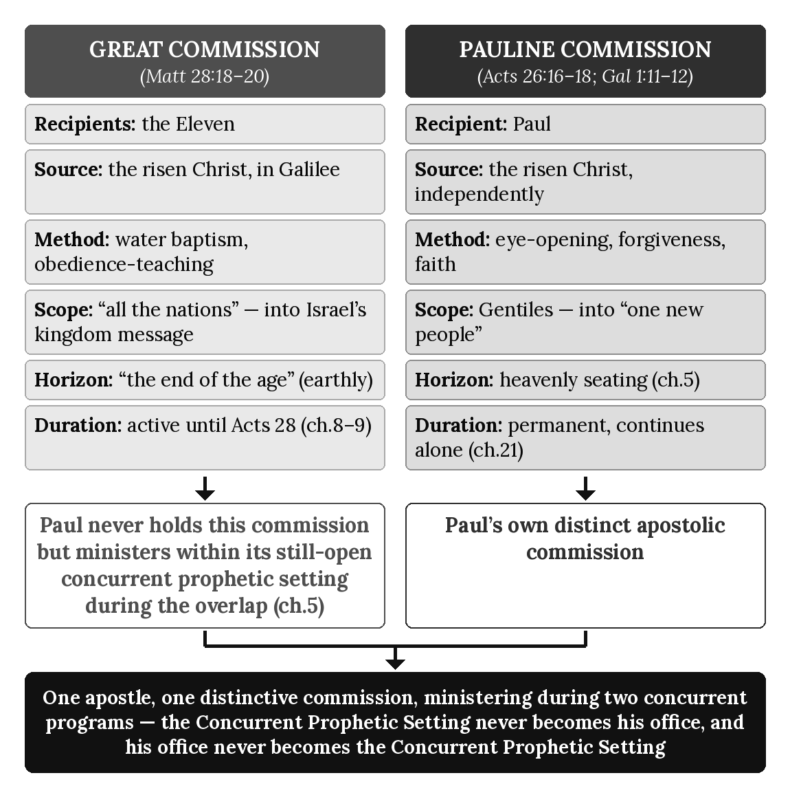

Chapter Summary
The Kingdom Commission (Matthew 28:18–20) and the Pauline Commission (Acts 26:16–18; Galatians 1:11–12) differ in recipients, source, method, scope, horizon, and duration; neither is a variant of the other. Paul never holds the Kingdom Commission — it belongs to the Twelve — but during the Acts Overlap he carries out his one distinctive Mystery commission while Israel’s Prophecy Program remains concurrently operative. His ministry to Jewish audiences occurs within that shared historical period without transferring to him the Kingdom Commission or administrative jurisdiction over Israel’s program. Chapter 13 now turns to the two destinies these commissions respectively serve — the earthly kingdom hope and the heavenly calling — examining formally the eschatological horizon each commission’s recipients actually inherit.

Key Terms
Kingdom Commission — The charge Christ gives the Eleven in Matthew 28:18–20: making disciples of all nations through water baptism and obedience-teaching, serving within Israel’s Prophecy Program until its national judicial suspension at Acts 28.
Pauline Commission — The charge Christ gives Paul independently (Acts 26:16–18; Galatians 1:11–12): opening Gentile eyes and including them, by faith, among God’s people; Paul’s own distinct commission, continuing alone after Acts 28.
Concurrent Prophetic Setting — This chapter’s term for Israel’s Prophecy Program remaining concurrently operative during the Acts Overlap while Paul carries out his distinct Mystery commission (chapter 5) without thereby holding or sharing the Kingdom Commission itself.

Reflection and Teaching Questions
- Why does this chapter insist that Paul carries out his one distinctive Mystery commission while the Kingdom Commission of the Twelve remains concurrently operative rather than saying he “holds” or “shares” that commission? What is lost if that distinction is collapsed?
- Compare the method specified in Matthew 28:19–20 (water baptism, obedience-teaching) with the content of Acts 26:18 (eye-opening, forgiveness, inclusion by faith). Why does this chapter treat the difference as evidence of two distinct commissions rather than two descriptions of the same commissioning?
- How does this chapter’s account of Paul’s ministry to two audiences build on chapter 5’s “One Apostleship Within a Concurrent Prophetic Setting” without implying two Pauline commissions or programmatic stewardships?
- Why must a mixed audience — Jews and Gentiles together in a single synagogue scene — be understood as each hearer remaining within the program that actually addresses them, rather than as evidence that the two commissions’ recipients have merged?

Chapter 13: The Two Destinies
“Since you have been raised to new life with Christ, set your sights on the realities of heaven, where Christ sits in the place of honor at God’s right hand.” — Colossians 3:1 (NLT)

Introduction
Chapter 1 identified Israel’s destiny as earthly; chapter 5 identified Paul’s own destiny as heavenly, traced from Ephesians 2:6 and Philippians 3:20. Both treatments were necessary at the time but partial: chapter 1 was establishing the Prophecy Program’s covenantal shape generally, and chapter 5 was establishing Paul’s own apostleship specifically. Neither chapter formalized destiny as its own doctrine, with its own governing rule for who inherits which destiny and why. This chapter does that directly, drawing on fresh textual support alongside what those chapters already established, and states the rule precisely: destiny is assigned by program membership, not by ethnicity. A Jewish believer incorporated into the Mystery Program’s “one new people” (chapter 10) inherits the heavenly destiny with every Gentile believer beside him; a Gentile who participates in Israel’s blessing (chapter 10) does not thereby become Israel or inherit Israel’s national promises. The line runs between the programs, not between the peoples.

The Prophecy Program’s Earthly Destiny: “Restore Our Kingdom” (Acts 1:6–7)
The clearest statement of the Prophecy Program’s earthly expectation comes not from the Twelve’s opponents but from the Twelve themselves, in the last exchange before the ascension:
“So when the apostles were with Jesus, they kept asking him, ‘Lord, has the time come for you to free Israel and restore our kingdom?’ He replied, ‘The Father alone has the authority to set those dates and times, and they are not for you to know.’” (Acts 1:6–7, NLT)
The question presupposes a real, national, earthly restoration — Israel freed, the kingdom restored — and Jesus’s reply corrects only the timing, “those dates and times,” not the premise itself. Had the expectation been mistaken in substance rather than merely premature in timing, this is where a correction belonged; none is given. The earthly kingdom hope chapter 1 already traced from the Davidic covenant is here reaffirmed by Christ himself, at the very threshold of the book of Acts this whole series examines.

The Prophecy Program’s Earthly Destiny: Thrones and the Whole Earth (Matthew 19:28; Matthew 5:5)
Two further texts specify what this earthly restoration includes. Chapter 5 already examined the first for what it reveals about the Twelve’s own office:
“Jesus replied, ‘I assure you that when the world is made new and the Son of Man sits upon his glorious throne, you who have been my followers will also sit on twelve thrones, judging the twelve tribes of Israel.’” (Matthew 19:28, NLT)
This chapter’s interest is not the office but the destiny: twelve thrones, over twelve tribes, when “the world is made new” — governance, specifically over Israel, located on a renewed earth. The same earthly scope extends beyond the Twelve to the wider Prophecy-Program hope:
“God blesses those who are humble, for they will inherit the whole earth.” (Matthew 5:5, NLT)
“The whole earth” is inherited, not evacuated for a heavenly alternative. The Prophecy Program’s destiny is consistently, specifically earthly: a renewed world, a restored Israel, thrones and inheritance located exactly where the covenant promises (chapter 1) said they would be.

The Mystery Program’s Heavenly Destiny: Every Spiritual Blessing (Ephesians 1:3; 2:6)
Paul opens the letter that most fully develops the Mystery (chapters 2, 10) by naming its destiny in its very first blessing:
“All praise to God, the Father of our Lord Jesus Christ, who has blessed us with every spiritual blessing in the heavenly realms because we are united with Christ.” (Ephesians 1:3, NLT)
“In the heavenly realms” is not a future hope alone but a present location of blessing, “because we are united with Christ” — union, not covenant descent (chapter 10’s diagnostic distinction), is the basis. Chapter 5 already traced the same letter’s fuller statement of this destiny — “seated... with him in the heavenly realms” (Ephesians 2:6) — as the ground of Paul’s own apostleship; here it stands as the ground of the whole Mystery Program’s destiny, for every believer incorporated into “one new people,” Jew and Gentile alike.

The Mystery Program’s Heavenly Destiny: Already Hidden, Not Yet Revealed (Colossians 3:1–4; Philippians 3:20)
Paul states this heavenly orientation as a present reordering of priorities, not a distant hope deferred to the end of an earthly age:
“Since you have been raised to new life with Christ, set your sights on the realities of heaven, where Christ sits in the place of honor at God’s right hand. Think about the things of heaven, not the things of earth. For you died to this life, and your real life is hidden with Christ in God. And when Christ, who is your life, is revealed to the whole world, you will share in all his glory.” (Colossians 3:1–4, NLT)
“Hidden with Christ in God” — already true, not merely promised — matches the present-tense citizenship chapter 5 already drew from Philippians 3:20: “we are citizens of heaven... eagerly waiting for him to return.” The Mystery Program’s destiny is inaugurated now and consummated at Christ’s appearing, but it is heavenly in both phases; no stage of it relocates to the earthly inheritance Matthew 5:5 and Matthew 19:28 describe.

Two Destinies, Not One Postponed Into the Other
Two interpretive errors are equally available here, and this chapter rejects both. The first collapses the Prophecy Program’s earthly promises into the Mystery Program’s heavenly ones — treating “inherit the whole earth” and “restore our kingdom” as figures of speech for a heavenly reality Israel never actually receives on its own terms. Acts 1:6–7 forecloses this reading directly: Christ corrects the Twelve’s timing, not their expectation of an actual, earthly restoration. The second error runs the opposite direction, treating the Mystery Program’s heavenly destiny as a temporary holding pattern — an interim spiritual blessing pending an eventual transfer into the earthly kingdom once it arrives. Colossians 3:1–4 forecloses this reading just as directly: the heavenly destiny is where “your real life is hidden,” now, and what is “revealed” at Christ’s appearing is that same hidden life in glory — not a relocation to an earthly inheritance never in view for the Mystery Program’s own people. These are two destinies for two programs, not one destiny told twice or postponed from one into the other. And per this series’ governing rule (chapter 11’s clarification), destiny follows program membership, never ethnicity or narrative proximity: a Gentile who participates in Israel’s blessing (chapter 10) does not become Israel or inherit Israel’s national promises; a Jewish believer incorporated into the Mystery’s “one new people” inherits the heavenly destiny with every Gentile believer in the Body of Christ. No hearer inherits a destiny merely by birth or by presence in a mixed narrative scene; each inherits the destiny of the program that actually includes him.

The Pattern, Summarized
Feature | Prophecy Program’s Earthly Destiny | Mystery Program’s Heavenly Destiny
Location | The renewed earth (Matthew 5:5; 19:28) | The heavenly realms (Ephesians 1:3; 2:6)
Basis | Covenant promise (Abrahamic, Davidic — chapter 1) | Union with Christ (chapter 10)
Governance | Twelve thrones over twelve tribes (Matthew 19:28) | Not tribal or national; “one new people” (chapter 10)
Present status | Awaited; “not for you to know” the timing (Acts 1:7) | Already true; “hidden with Christ” now (Colossians 3:3)
Consummation | The kingdom restored, “when the world is made new” | Christ “revealed,” glory shared (Colossians 3:4)
Assigned by | Prophecy-Program membership (Israel; Gentile participants in its blessing do not become Israel) | Mystery-Program membership (Jew or Gentile in the Body)

Applying the Seven Diagnostic Lenses to Acts 1:6–7
- Audience — The apostles themselves, asking their own question about Israel’s own restoration.
- Apostolic Authority — The Twelve, addressing the risen Christ directly before his ascension.
- Covenant — Directly presupposed; “restore our kingdom” only makes sense against the Davidic covenant (chapter 1).
- Sign-Gift — Not present in this exchange; the question is about timing, not authentication.
- Commission — Immediately followed by the Kingdom Commission’s own restatement (Acts 1:8), tying this destiny to that commission (chapter 12).
- Eschatology — The passage’s entire subject: an awaited, undated, earthly restoration.
- Dispensation — Still pre-Pentecost, prior to the overlap’s own beginning (chapter 4); the Prophecy Program’s expectation predates the Mystery entirely.

Diagram: The Two Destinies
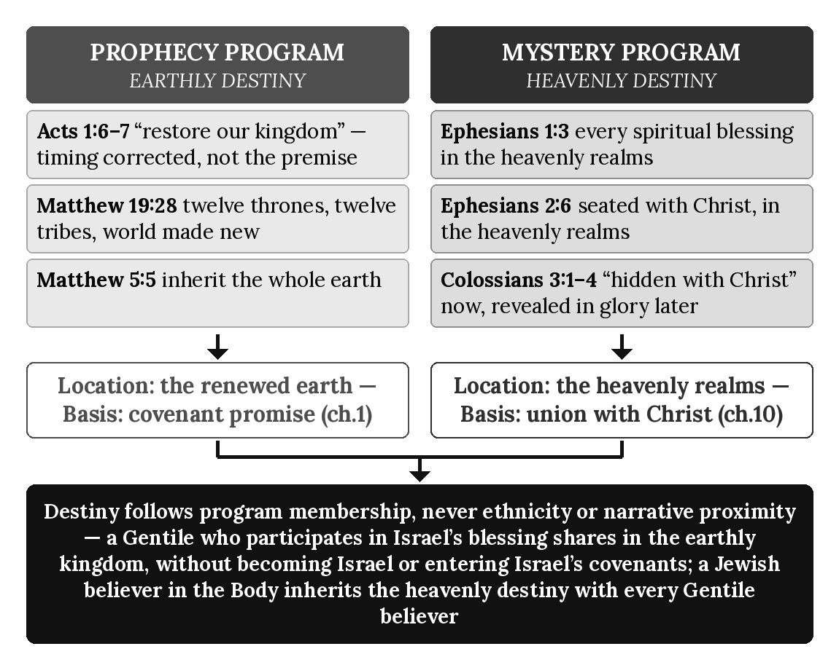

Chapter Summary
The Prophecy Program’s destiny is earthly: a restored Israel, twelve thrones over twelve tribes, the whole earth inherited, exactly as the Twelve themselves expected at the ascension (Acts 1:6–7) and Christ never corrected. The Mystery Program’s destiny is heavenly: every spiritual blessing already located “in the heavenly realms” (Ephesians 1:3), a life already “hidden with Christ” and awaiting only its full revealing (Colossians 3:1–4). Neither destiny collapses into or is postponed into the other, and both are assigned by program membership rather than ethnicity — a rule that governs every subsequent chapter’s use of “earthly” and “heavenly” language. Chapter 14 now turns to the two baptisms that mark entry into each program, examining how water baptism and Spirit baptism respectively signify the destiny each recipient has already been assigned.

Key Terms
Earthly Destiny — The Prophecy Program’s own destiny: a restored, national Israel governing a renewed earth under Davidic and Abrahamic covenant promise (Acts 1:6–7; Matthew 5:5; 19:28).
Heavenly Destiny — The Mystery Program’s own destiny: every spiritual blessing located in the heavenly realms, already true by union with Christ and fully revealed at his appearing (Ephesians 1:3; 2:6; Colossians 3:1–4).
Destiny Assignment Rule — This series’ governing principle (stated in chapter 13, building on chapter 11’s warning against reading mixed audiences as one): destiny is assigned strictly by program membership, never by ethnicity or by mere presence in a mixed narrative scene.

Reflection and Teaching Questions
- Why does this chapter treat Christ’s reply in Acts 1:7 as a correction of timing only, and not as evidence that the earthly kingdom expectation itself was mistaken?
- How does Colossians 3:3’s “your real life is hidden with Christ in God” function as evidence against reading the heavenly destiny as a temporary stage before an eventual earthly inheritance?
- Why does this chapter insist that destiny is assigned by program membership rather than ethnicity? What error would result from assigning destiny by ethnicity instead?
- Compare Matthew 5:5’s “inherit the whole earth” with Ephesians 1:3’s “every spiritual blessing in the heavenly realms.” Why does this chapter treat these as two distinct destinies rather than two descriptions of the same inheritance?

Chapter 14: The Two Baptisms
“But we have all been baptized into one body by one Spirit, and we all share the same Spirit.” — 1 Corinthians 12:13 (NLT)

Introduction
Water baptism has appeared throughout this book without yet receiving its own formal treatment: at Pentecost (chapter 1), at Cornelius’s household (chapter 10), and in the Kingdom Commission’s own method (chapter 12). Spirit baptism has appeared only in passing, embedded in this series’ definition of the Body of Christ. This chapter formalizes both as a single doctrine of entry: water baptism marks entry into the Prophecy Program’s community; Spirit baptism marks entry into the Mystery Program’s “one new people” (chapter 10). The two are not variant forms of one rite but two distinct acts, belonging to two distinct programs — and, exactly as chapter 12 traced for the two commissions, one apostle practices the first while defining the second, without contradiction, because he carries out his one distinctive Mystery commission while Israel’s Prophecy Program remains concurrently operative during the Acts Overlap.

Water Baptism Under the Prophecy Program: Pentecost’s Command (Acts 2:38)
Peter’s own instruction to his Pentecost audience — Jews, gathered “from every nation” (Acts 2:5, chapter 1) — states water baptism’s place in the Prophecy Program directly:
“Each of you must repent of your sins and turn to God, and be baptized in the name of Jesus Christ for the forgiveness of your sins. Then you will receive the gift of the Holy Spirit.” (Acts 2:38, NLT)
Water baptism here is commanded, tied to forgiveness, and followed by the Spirit’s gift as a consequence — the same sign-pattern chapter 8 traced elsewhere in the Prophecy Program’s own authentication. This differs in kind from the incorporative, unseen baptism this chapter will trace below from 1 Corinthians 12:13: Acts 2:38 describes a physical rite, commanded of a specific audience, tied to a specific national moment.

Water Baptism Continuing Through the Overlap: Cornelius and Ephesus (Acts 10:47–48; 19:1–5)
Chapter 10 already traced Peter’s order for water baptism at Cornelius’s household (Acts 10:47–48) as a marker of Prophecy-Program inclusion. The same rite continues, as reported at Ephesus, deep into the overlap, at Ephesus:
“‘Did you receive the Holy Spirit when you believed?’ he asked them. ‘No,’ they replied, ‘we haven’t even heard that there is a Holy Spirit.’ ‘Then what baptism did you experience?’ he asked. And they replied, ‘The baptism of John.’ Paul said, ‘John’s baptism called for repentance from sin. But John himself told the people to believe in the one who would come later, meaning Jesus.’ As soon as they heard this, they were baptized in the name of the Lord Jesus.” (Acts 19:1–5, NLT)
Paul does not treat these disciples’ incomplete baptism as a matter of indifference; the disciples’ incomplete baptism is answered with the same water rite Peter commanded at Pentecost. Water baptism, on this evidence, remains historically operative within Israel’s prophetic/Kingdom setting during the Acts Overlap, not a rite confined to the Twelve or to the earliest chapters of Acts.

Paul’s Own Water Baptism: Even the Apostle of the Mystery (Acts 22:16)
Paul himself received this same rite, at his own conversion, from Ananias:
“What are you waiting for? Get up and be baptized. Have your sins washed away by calling on the name of the Lord.” (Acts 22:16, NLT)
This occurs at the beginning of Paul’s apostleship (Acts 9; chapter 4), when the Mystery Program has begun while Israel’s Prophecy Program remains fully operative. Paul’s own water baptism is therefore not evidence that water baptism belongs to the Mystery Program. It reflects the still-active prophetic environment in which his calling occurs, exactly as the Acts Overlap Model predicts.

Spirit Baptism Under the Mystery Program: One Body (1 Corinthians 12:13)
Paul describes a second, categorically different baptism when he addresses the Mystery Program’s own entity directly:
“Some of us are Jews, some are Gentiles, some are slaves, and some are free. But we have all been baptized into one body by one Spirit, and we all share the same Spirit.” (1 Corinthians 12:13, NLT)
This baptism is not commanded, administered, or witnessed as a physical event; it is stated as an already-accomplished fact — “we have all been baptized” — the single act by which Jew and Gentile alike become “one body,” the same entity chapter 10 traced from Ephesians 2:15’s “one new people.” No water is mentioned, no minister is named, no date or location is given, because the baptism in view is not a repeatable observable rite but the incorporative act itself.

Spirit Baptism as the Body’s Only Baptism (Ephesians 4:4–5)
Paul states the singularity of this baptism explicitly when describing the Body of Christ’s unity:
“For there is one body and one Spirit, just as you have been called to one glorious hope for the future. There is one Lord, one faith, one baptism.” (Ephesians 4:4–5, NLT)
“One baptism” — not two, not water alongside Spirit — matches the Mystery Program as chapter 3 defined it: no water-baptism requirement of its own. The Body of Christ’s single baptism is the Spirit baptism of 1 Corinthians 12:13; nothing in Ephesians adds a second, physical rite to it.

Two Baptisms, One Apostle: Applying the Concurrent-Programs Doctrine
Paul was himself water-baptized (Acts 22:16) and the Ephesian disciples were baptized “in the name of the Lord Jesus” (Acts 19:5), the text reporting the baptism without naming the baptizer. Paul writes, under his distinct commission, that the Body of Christ he was raised up to reveal has only “one baptism” — the Spirit’s (Ephesians 4:5). Water baptism’s presence in the narrative must be distinguished from the commission Paul possesses. Its presence does not place Paul under the Kingdom Commission, transfer that commission to him, or make water baptism part of his distinctive Mystery commission. Water baptism belongs to Israel’s prophetic/Kingdom setting and remains historically present during the Acts Overlap while that program remains concurrently operative. Spirit baptism belongs to Paul’s distinct commission itself, exercised the moment anyone — Jew or Gentile — is joined to the Body Paul was sent to reveal. Which baptism marks a given person’s entry depends, as chapter 13’s destiny-assignment rule already established, on which program actually includes them — never on which rite happens to appear in a given narrative scene, and never on ethnicity. A Gentile blessed in connection with Israel’s restoration (chapter 10) receives water baptism as Cornelius did; a Jewish believer incorporated into the Mystery’s one body receives the same Spirit baptism as every Gentile believer beside him.

The Pattern, Summarized
Feature | Water Baptism (Prophecy Program) | Spirit Baptism (Mystery Program)
Nature | Physical rite, administered and witnessed | Incorporative act, unseen and unrepeated
Command | “Be baptized... for the forgiveness of your sins” (Acts 2:38) | Not commanded; stated as accomplished fact (1 Corinthians 12:13)
Administered by | Peter and the Twelve (Acts 2:38; 10:47–48); at Ephesus the baptism is reported without naming the baptizer (Acts 19:1–5) | Christ himself, by the Spirit, at incorporation
Result | Forgiveness; the Spirit’s gift follows as sign (chapter 8) | “One body” — Jew and Gentile united (chapter 10)
Count in its own program | One of several markers alongside signs, temple, covenant (chapter 3’s chart) | The Body’s only baptism (Ephesians 4:5)
Paul’s relationship | Received it (Acts 22:16); at Ephesus the baptism is reported without naming the baptizer (Acts 19:5) | Its own commission’s content; not something Paul administers as a rite

Applying the Seven Diagnostic Lenses to 1 Corinthians 12:13
- Audience — The Corinthian church, addressed as already-incorporated members of one body.
- Apostolic Authority — Paul’s own, teaching the Mystery Program’s own doctrine of unity.
- Covenant — Not invoked; unity rests on the Spirit’s own act, not covenantal descent.
- Sign-Gift — Distinguished from sign phenomena; the surrounding chapter (1 Corinthians 12) discusses spiritual gifts, but this baptism itself is not a sign-event like Acts 2 or Acts 10.
- Commission — The Pauline Commission’s own content (chapter 12).
- Eschatology — Consistent with the heavenly destiny chapter 13 traced; “one body” shares one heavenly hope, not a national restoration.
- Dispensation — The dispensation of grace (chapter 3), in which this baptism operates exclusively.

Diagram: The Two Baptisms
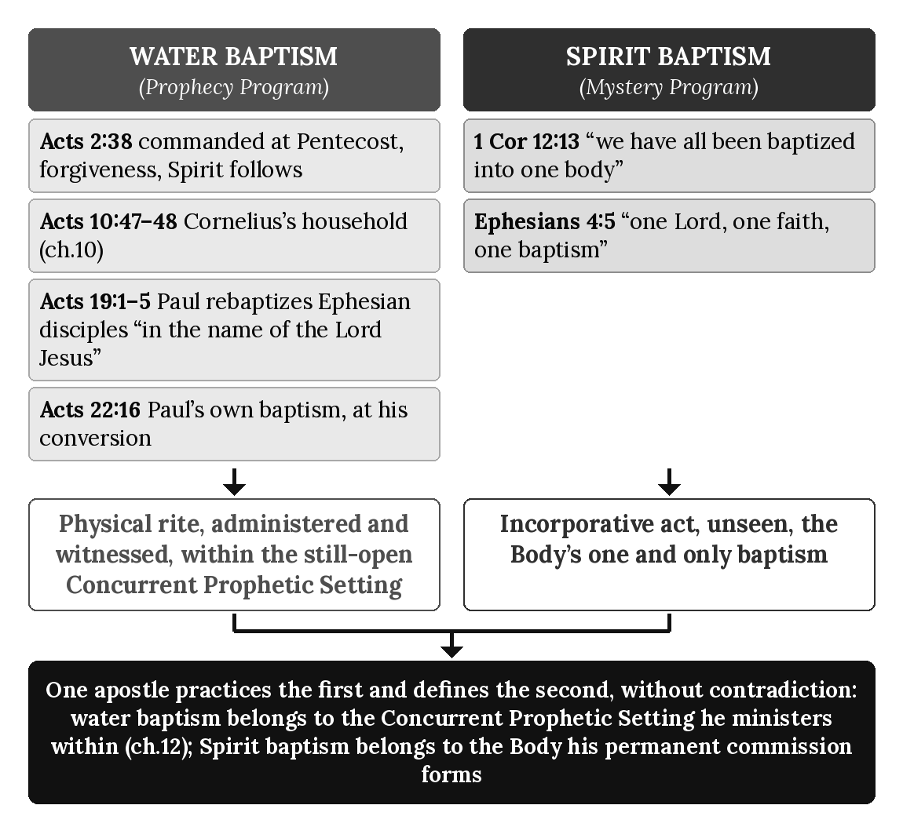

Chapter Summary
Water baptism marks entry into the Prophecy Program’s community — commanded at Pentecost (Acts 2:38), administered at Cornelius’s household (Acts 10:47–48), reported again at Ephesus, without naming the baptizer (Acts 19:1–5), and received by Paul himself at his own conversion (Acts 22:16). Spirit baptism marks entry into the Mystery Program’s one body — an unseen, incorporative act (1 Corinthians 12:13) that is the Body of Christ’s only baptism (Ephesians 4:5). Paul ministers within the Concurrent Prophetic Setting during the overlap (chapter 12) while Spirit baptism, the second, belongs to his distinct commission’s content; which baptism marks a given person’s entry depends on program membership alone, never ethnicity or narrative setting (chapter 13). Chapter 15 now turns to the two justifications these baptisms respectively accompany, examining how forgiveness under the Prophecy Program and justification by faith under the Mystery Program are grounded differently.

Key Terms
Water Baptism — The Prophecy Program’s own physical rite of entry, commanded at Pentecost (Acts 2:38), continuing throughout the overlap (Acts 10:47–48; 19:1–5), and administered even to Paul himself (Acts 22:16).
Spirit Baptism — The Mystery Program’s own incorporative act, by which Jew and Gentile alike are joined into “one body” (1 Corinthians 12:13); the Body of Christ’s only baptism (Ephesians 4:5), not accompanied by any water rite of its own.

Reflection and Teaching Questions
- Why does this chapter treat Paul’s own water baptism (Acts 22:16) as confirmation of its argument rather than a complication for it?
- How does Ephesians 4:5’s “one baptism” support this chapter’s claim that Spirit baptism, not water baptism, is the Body of Christ’s defining rite?
- Why does the water baptism reported at Ephesus (Acts 19:1–5), long after Paul’s own conversion and commissioning and without the baptizer being named, not count as evidence that water baptism belongs to the Mystery Program after all?
- How does the Concurrent-Programs Doctrine from chapter 12 resolve the apparent tension between the water baptism reported in Acts and Paul’s teaching that the Body has only one, non-water baptism?

Chapter 15: The Two Justifications
“So we are made right with God through faith and not by obeying the law.” — Romans 3:28 (NLT)

Introduction
Chapter 14 traced water baptism’s link to forgiveness under the Prophecy Program and Spirit baptism’s link to incorporation under the Mystery Program. Behind each baptism stands a distinct doctrine of what actually makes a person right with God, and this chapter states both directly — including the sharpest apparent contradiction anywhere in this series’ source texts: James writes, “we are shown to be right with God by what we do, not by faith alone” (James 2:24, NLT); Paul writes, “we are made right with God through faith and not by obeying the law” (Romans 3:28, NLT). Read as addressing the same audience under the same program, these two statements cannot both stand. This chapter does not soften either one. It identifies, per this series’ governing diagnostic method (chapter 3’s Seven Lenses; chapter 11’s mixed-audience rule), which program and which audience each apostle actually addresses, and shows that once correctly diagnosed, both statements are true, exactly as written, of the programs they each describe.
One rule governs everything in this chapter. Salvation is always by faith and never by merit, in every program; but the content of faith is what God revealed within that program. Before the Cross, salvation operated within Israel’s prophetic program: Abraham believed what God revealed to Abraham, Moses what God revealed to Moses, and David what God revealed to David. Their faith rested on the revelation given to them, accompanied by obligations appropriate to Israel’s program — not on Pauline revelation, and not on the finished work of Christ, which had not yet been revealed to them. The Body is saved by believing Pauline revelation, the gospel of the grace of God, through faith alone, apart from Israel’s covenantal obligations. Repentance, baptism, covenant fidelity, and readiness for the kingdom belong to Israel’s prophetic setting; they are not meritorious grounds of salvation, they are not Pauline faith-alone doctrine, and they never transfer to the Body. Pauline faith-alone doctrine is likewise never read backward onto Israel’s prophetic era. This chapter states the content of faith for each program and does not state one saving formula or a saving ground shared between them.

The Prophecy Program’s Forgiveness: Faith Accompanied by Repentance, Baptism, and Works (Acts 2:38; James 2:17, 24)
Chapter 14 already traced Peter’s Pentecost command — repentance and water baptism “for the forgiveness of your sins” (Acts 2:38) — as the Prophecy Program’s own entry point. James, writing later, states the same program’s ongoing standard for a right standing with God, addressed to a named and specific audience:
“This letter is from James, a slave of God and of the Lord Jesus Christ. I am writing to the ‘twelve tribes’ — Jewish believers scattered abroad. Greetings!” (James 1:1, NLT)
Not “to all believers everywhere,” but to the twelve tribes specifically — the same Prophecy-Program audience chapter 1 defined at the outset of this book. Writing to that audience, James states his doctrine of justification without qualification:
“So you see, faith by itself isn’t enough. Unless it produces good deeds, it is dead and useless.” (James 2:17, NLT)
“So you see, we are shown to be right with God by what we do, not by faith alone.” (James 2:24, NLT)
James does not say faith is unnecessary; he says faith alone, unaccompanied by deeds, does not justify — a standard coherent within Israel’s own prophetic setting (chapter 1), where faith has always been accompanied by obedience appropriate to Israel’s program, not bare intellectual assent. The works James calls for are the evidence and expression of a living faith in that setting; they are not offered as a meritorious ground of salvation, and they are not a requirement for the Body.

The Mystery Program’s Justification: By Faith Apart From Works (Romans 3:28; Galatians 2:16; Ephesians 2:8–9)
Paul states the Mystery Program’s own doctrine of justification to a different audience, in terms that admit no covenantal works at all:
“So we are made right with God through faith and not by obeying the law.” (Romans 3:28, NLT)
“Yet we know that a person is made right with God by faith in Jesus Christ, not by obeying the law. And we have believed in Christ Jesus, so that we might be made right with God because of our faith in Christ, not because we have obeyed the law. For no one will ever be made right with God by obeying the law.” (Galatians 2:16, NLT)
The repetition in Galatians 2:16 — three clauses making the same point — signals how deliberately Paul excludes law-keeping from justification’s ground, not merely from its beginning. Ephesians states the same doctrine as a gift rather than an achievement:
“God saved you by his grace when you believed. And you can’t take credit for this; it is a gift from God. Salvation is not a reward for the good things we have done, so none of us can boast about it.” (Ephesians 2:8–9, NLT)
Paul states the content of the Body’s faith in the gospel he preached: “Christ died for our sins, just as the Scriptures said. He was buried, and he was raised from the dead on the third day, just as the Scriptures said” (1 Corinthians 15:3–4, NLT; see 15:1–4). That is the message the Body believes, and believing it is the whole of the Body’s entry into a right standing with God.
“Not a reward for the good things we have done” stands in direct verbal tension with James’s “not by faith alone” — unless, as the next section argues, the two statements are addressed to two different programs.

Two Messages, Not One Contradiction: Resolving James and Paul
James 2:24 and Romans 3:28 are not reconciled by softening either verse’s plain sense; they are reconciled by correctly diagnosing their respective audiences and programs, exactly as chapter 11’s mixed-audience rule requires for any text in this period. James writes “to the twelve tribes... Jewish believers scattered abroad” (James 1:1) — Israel’s own audience, addressed in its own prophetic setting (chapter 1), where faith is accompanied by obligations appropriate to Israel’s program. Paul writes to Gentile and Jewish believers alike within the Mystery Program’s “one new people” (chapter 10), a body constituted by a revelation of which Paul says “God did not reveal it to previous generations” (Ephesians 3:5, NLT) and therefore never under the framework James addresses. The Body is saved by believing Pauline revelation, the gospel of the grace of God, through faith alone, apart from the works of the law — Paul’s own point in Galatians 2:16 and Romans 3:28. James is not contradicting Paul; he has no occasion to address Pauline faith-alone doctrine, because he is not writing to the audience that doctrine describes. Paul is not contradicting James’s statement that a living faith produces works; he is describing a different program, with a different content of faith. In both programs faith is the means and merit is excluded; what differs is what has been revealed to the believer and the setting in which that faith lives. This chapter therefore states two contents of faith in two programs — not one doctrine of justification stated twice and contradicted once, and not one saving ground shared by both.

The Pattern, Summarized
Feature | Prophecy-Program Forgiveness (Acts 2:38; James) | Mystery-Program Justification (Romans; Galatians; Ephesians)
Audience | “The twelve tribes... scattered abroad” (James 1:1) | “One new people,” Jew and Gentile (chapter 10)
Content of faith and accompanying requirements | Faith in what God revealed to Israel, with repentance, water baptism, and a working faith as program requirements, not merit (Acts 2:38; James 2:17, 24) | Faith alone in the gospel of the grace of God, apart from works of the law (Romans 3:28; Galatians 2:16)
Covenantal framework | Yes — Israel’s own covenants (chapter 1) | No — “not a reward,” a gift (Ephesians 2:8–9)
Role of works | Evidence that faith is genuine, not dead (James 2:17) | Excluded from the ground; no boasting (Ephesians 2:9)
Governing text | James 2:24 | Romans 3:28

Applying the Seven Diagnostic Lenses to James 2:24
- Audience — “The twelve tribes... scattered abroad” (James 1:1), the Prophecy Program’s own audience, not the Mystery’s “one new people.”
- Apostolic Authority — James, writing within the Jerusalem leadership chapter 7 already located under Peter’s own apostolic circle, not under Paul’s commission.
- Covenant — Directly presupposed; James’s standard of a working faith reflects Israel’s own covenantal expectation (chapter 1).
- Sign-Gift — Not directly invoked in this passage.
- Commission — Israel’s Prophecy Program under the Kingdom Commission, not the Pauline Commission (chapter 12).
- Eschatology — Consistent with the earthly destiny chapter 13 traced for this same audience.
- Dispensation — The Prophecy Program’s own dispensation, operating on its own covenantal terms throughout the overlap.

Diagram: The Two Justifications
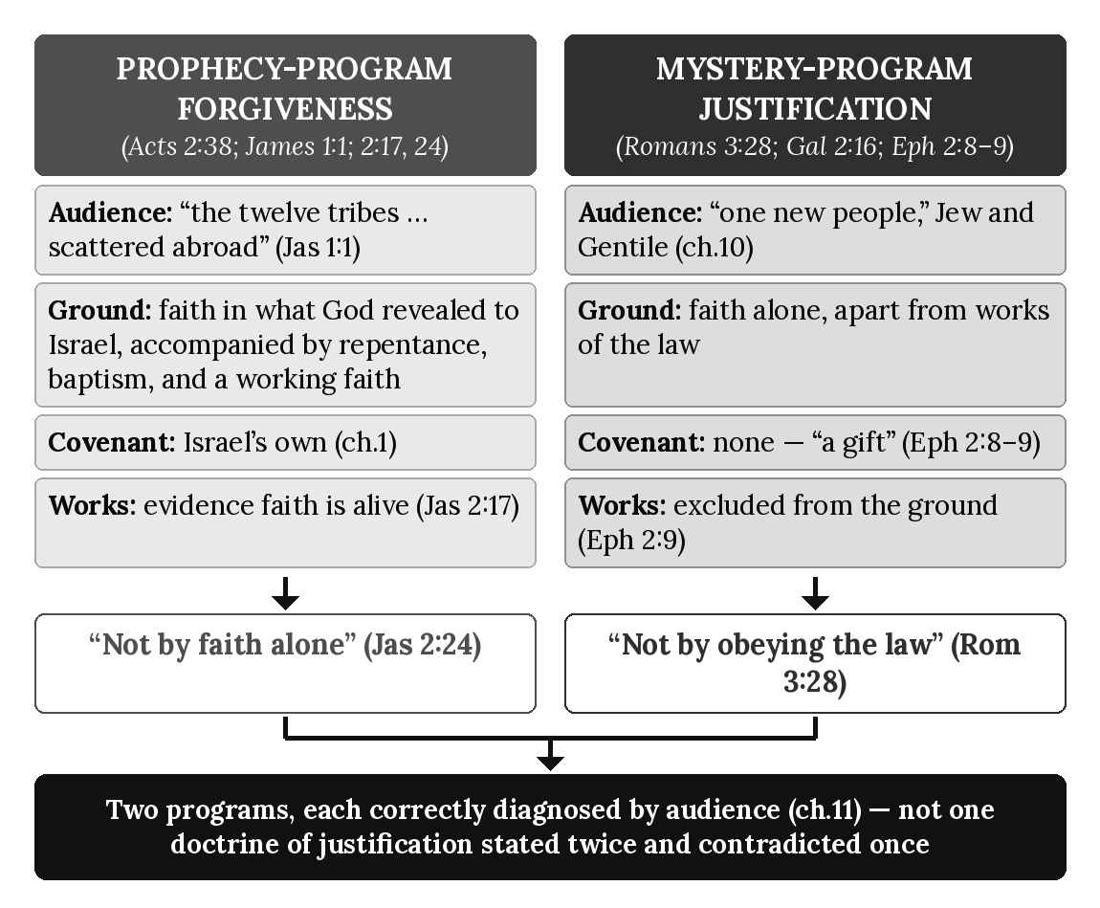

Chapter Summary
In Israel’s prophetic setting, forgiveness and a right standing are tied to faith in what God revealed to Israel, accompanied by repentance, water baptism, and a working faith that produces deeds (Acts 2:38; James 2:17, 24), addressed to “the twelve tribes... scattered abroad” (James 1:1). These are program requirements, not meritorious grounds, and they never transfer to the Body. In the Mystery Program, a person is made right with God by believing the gospel of the grace of God through faith alone, apart from any works of the law, a gift rather than a reward (Romans 3:28; Galatians 2:16; Ephesians 2:8–9), addressed to the “one new people” chapter 10 already traced. Faith is the means in both; the content of faith differs; and this book states no saving ground shared between them. James 2:24 and Romans 3:28 are not competing doctrines of the same justification; they are accurate statements about two different programs, correctly distinguished once their audiences are diagnosed. Chapter 16 now turns to the two ecclesiologies these programs respectively produce, completing the systematic comparison chapter 11 deferred: the Prophecy Program’s own community alongside the Pauline churches already traced.

Key Terms
Prophecy-Program Forgiveness — Forgiveness and a right standing in Israel’s prophetic setting: faith in what God revealed to Israel, accompanied by repentance and water baptism (Acts 2:38) and by a living, working faith (James 2:17, 24), addressed to “the twelve tribes... scattered abroad” (James 1:1). These are program requirements, not grounds of merit, and they never transfer to the Body.
Mystery-Program Justification — The Body is made right with God by believing Pauline revelation, the gospel of the grace of God, through faith alone, apart from any works of the law, a gift rather than a reward (Romans 3:28; Galatians 2:16; Ephesians 2:8–9), addressed to the Body’s “one new people” (chapter 10).

Reflection and Teaching Questions
- Why does this chapter refuse to soften either James 2:24 or Romans 3:28 in order to harmonize them, choosing instead to diagnose their audiences?
- How does James 1:1’s address to “the twelve tribes... scattered abroad” function as the decisive diagnostic clue for reading James 2:24 correctly?
- Why does Ephesians 2:8–9’s “not a reward for the good things we have done” stand in direct tension with James 2:24’s “not by faith alone” if both are read as addressing the same program — and how does this chapter’s resolution avoid that tension?
- James 2:17 says faith without deeds “is dead and useless.” How can this chapter affirm that statement fully for the Prophecy Program’s own audience while still affirming Ephesians 2:9’s exclusion of works from the Mystery Program’s justification?

Chapter 16: The Two Ecclesiologies
“And the church is his body; it is made full and complete by Christ, who fills all things everywhere with himself.” — Ephesians 1:22–23 (NLT)

Introduction
Chapter 11 traced the Pauline churches’ government, teaching, and stewardship in detail, but explicitly deferred one question: how does that pattern relate to the Jerusalem community Acts describes from its opening chapter, and are they, doctrinally, the same kind of thing? Chapter 15 closed by naming this chapter directly as the place where that comparison would be completed. The obstacle is vocabulary: the New Testament uses a single word — ekklēsia, rendered “church” — for both the gathered Jerusalem believers of Acts 2:47 and the entity Paul calls Christ’s own body in Ephesians 1:22–23. A shared word has repeatedly been read as a shared institution, producing the same collapse this book has diagnosed at every other point: Prophecy-Program categories imported into the Mystery, or Mystery-Program categories retrojected onto Israel’s own assembly. This chapter applies the series’ diagnostic method to the word itself, states each program’s own ecclesiology in full, and shows that “church” names two distinct realities, correctly identified once their governing texts are read on their own terms.

The Prophecy Program’s Own Community: Jerusalem’s Assembly (Acts 2:41–47)
Luke’s first description of the postresurrection believing community is a single, localized, temple-centered assembly, formed at Pentecost under the Twelve’s own authority:
“Those who believed what Peter said were baptized and added to the church that day — about 3,000 in all. All the believers devoted themselves to the apostles’ teaching, and to fellowship, and to sharing in meals (including the Lord’s Supper), and to prayer.” (Acts 2:41–42, NLT) The expression “breaking bread” is not by itself a technical designation for the Lord’s Supper. Its meaning must be determined by audience, setting, purpose, and immediate context. Some passages may describe ordinary meals or fellowship, while passages containing explicit Pauline doctrinal instruction concerning the Lord’s Supper must be interpreted on their own terms. Narrative participation must be distinguished from explicit apostolic instruction. Shared terminology does not establish identical programmatic function. This distinction does not by itself decide the separate question of the Lord’s Supper’s present observance.
This community shares its meals, its possessions, and — decisively — its worship location with the rest of believing Israel:
“They worshiped together at the Temple each day, met in homes for the Lord’s Supper, and shared their meals with great joy and generosity — all the while praising God and enjoying the goodwill of all the people. And each day the Lord added to their fellowship those who were being saved.” (Acts 2:46–47, NLT)
Every marker here belongs to the Prophecy Program as this book has already defined it: daily worship at the Jerusalem Temple (chapter 1’s covenant foundation, still standing and still honored), teaching drawn exclusively from “the apostles” — the Twelve, under Peter’s own circumcision apostleship (chapter 6) — and a membership formed by water baptism (chapter 14) added to a single, geographically fixed assembly. This is not a loosely descriptive account of “the early church” in some generic sense; it is the Prophecy Program’s own community, governed by its own apostles (chapter 7’s Jerusalem Council), practicing its own covenant, and continuing within the still-operative Prophecy Program even as Israel’s cumulative national rejection develops across Acts.

The Mystery Program’s Own Ecclesia: The Body of Christ (Ephesians 1:22–23; Colossians 1:18; 1 Corinthians 12:27)
Paul describes a second entity that shares Luke’s word for “church” but none of the Jerusalem assembly’s defining marks. Writing of Christ’s own headship, he states:
“God has put all things under the authority of Christ and has made him head over all things for the benefit of the church. And the church is his body; it is made full and complete by Christ, who fills all things everywhere with himself.” (Ephesians 1:22–23, NLT)
Colossians states the same relationship in nearly identical terms:
“Christ is also the head of the church, which is his body. He is the beginning, supreme over all who rise from the dead. So he is first in everything.” (Colossians 1:18, NLT)
And Paul states the same reality from the standpoint of its own members. Writing to a congregation, he describes not a single local gathering but the entity that gathering belongs to:
“All of you together are Christ’s body, and each of you is a part of it.” (1 Corinthians 12:27, NLT)
Nothing here is local, temple-centered, or geographically bounded. “The church” in these three texts is not the Jerusalem assembly’s counterpart in another city; it is a single body, with Christ himself — not the Twelve, not James, not any earthly apostolic council — as its immediate head. Membership is by Spirit baptism (chapter 14), not by addition to a Jerusalem-based roll; unity is grounded in incorporation into Christ (chapter 10’s “one new people”), not in shared Temple attendance or shared possession of Israel’s covenants.

One Word, Two Realities: Why “Church” Does Not Name One Ecclesiology (Ephesians 2:19–22)
The apparent difficulty is that Paul also calls the local congregations he founded — the Pauline churches chapter 11 already traced, with their elders, overseers, and house gatherings — by this same word, “church.” This has repeatedly been read as evidence that the Jerusalem assembly and the Pauline congregations are simply the same kind of community in different cities. They are not, and the same diagnostic method already applied to commissions (chapter 12), baptisms (chapter 14), and justification (chapter 15) resolves the difficulty the same way: by audience and program, not by vocabulary. The Jerusalem assembly of Acts 2:47 is the Prophecy Program’s own local, visible form — Jewish believers, gathered under apostolic authority the Twelve hold, worshiping at Israel’s own Temple. The Pauline congregations chapter 11 described are themselves the visible, local gatherings of a different entity entirely: not a second Prophecy-Program outpost, but local expressions of the one Body of Christ, whose universal, non-local reality Paul describes directly:
“So now you Gentiles are no longer strangers and foreigners. You are citizens along with all of God’s holy people. You are members of God’s family. Together, we are his house, built on the foundation of the apostles and the prophets. And the cornerstone is Christ Jesus himself. We are carefully joined together in him, becoming a holy temple for the Lord. Through him you Gentiles are also being made part of this dwelling where God lives by his Spirit.” (Ephesians 2:19–22, NLT)
This “holy temple,” “carefully joined together,” is not the Jerusalem Temple of Acts 2:46 relocated; it is a different structure altogether — built on the apostles and prophets of the Mystery Program, not the Twelve, not Old Testament prophets, but the foundational ministers God raised up alongside Paul to confirm and distribute the revelation of the Mystery (Ephesians 3:5) — indwelt by the Spirit rather than located at a single address, and including Gentiles as full “citizens” and “members,” never as guests admitted into Israel’s own household. Applying this book’s Four Distinct Groups doctrine to the term itself: the Jerusalem assembly belongs to the first group, Jews under the Prophecy Program; the Pauline congregations are local gatherings of the fourth group, the Body of Christ, and must never be read — as chapter 11 already warned regarding their mixed audiences — as a second Prophecy-Program community merely because Luke and Paul share one Greek word for both. One word; two ecclesiologies; correctly distinguished, as always, by asking which program, which apostolic authority, and which covenantal relationship to Israel each text actually describes.

The Pattern, Summarized
Feature | Prophecy-Program Community (Acts 2:41–47) | Mystery-Program Ecclesia (Ephesians 1:22–23; Colossians 1:18)
Founding text | Acts 2:41–47 | Ephesians 1:22–23; Colossians 1:18; 1 Corinthians 12:27
Membership basis | Water baptism, added to a local roll (Acts 2:41) | Spirit baptism, incorporation into Christ (chapter 14)
Governing authority | The Twelve, Peter’s circumcision apostleship (chapter 6) | Christ himself as head; Paul’s own commission (chapter 12)
Geographic center | Jerusalem, the Temple (Acts 2:46) | None — “fills all things everywhere” (Ephesians 1:23)
Covenantal relationship to Israel | Direct continuation of Israel’s own covenants (chapter 1) | None of its own; “God did not reveal it to previous generations” (chapter 2’s citation of Ephesians 3:5)
Local visible form | The Jerusalem assembly itself | The Pauline congregations (chapter 11)

Applying the Seven Diagnostic Lenses to Acts 2:47’s “Church”
- Audience — Jews “added” to a Jerusalem-based fellowship, the same audience chapter 1 defined for the Prophecy Program from the outset.
- Apostolic Authority — The Twelve’s own teaching (Acts 2:42), under Peter’s circumcision apostleship, not Paul’s commission.
- Covenant — Directly continuous with Israel’s covenants; daily Temple worship (Acts 2:46) presupposes the covenant relationship chapter 1 traced.
- Sign-Gift — “Many miraculous signs and wonders” performed by the apostles (Acts 2:43), the same authenticating pattern chapter 8 already traced for the Prophecy Program.
- Commission — Israel’s Prophecy Program under the Kingdom Commission (chapter 12), administered by the Twelve themselves.
- Eschatology — Consistent with the earthly destiny chapter 13 traced; this community awaits the kingdom Acts 1:6–7 describes, not a heavenly hope.
- Dispensation — The Prophecy Program’s own dispensation, still fully active at this point in Acts (chapter 3).

Diagram: The Two Ecclesiologies
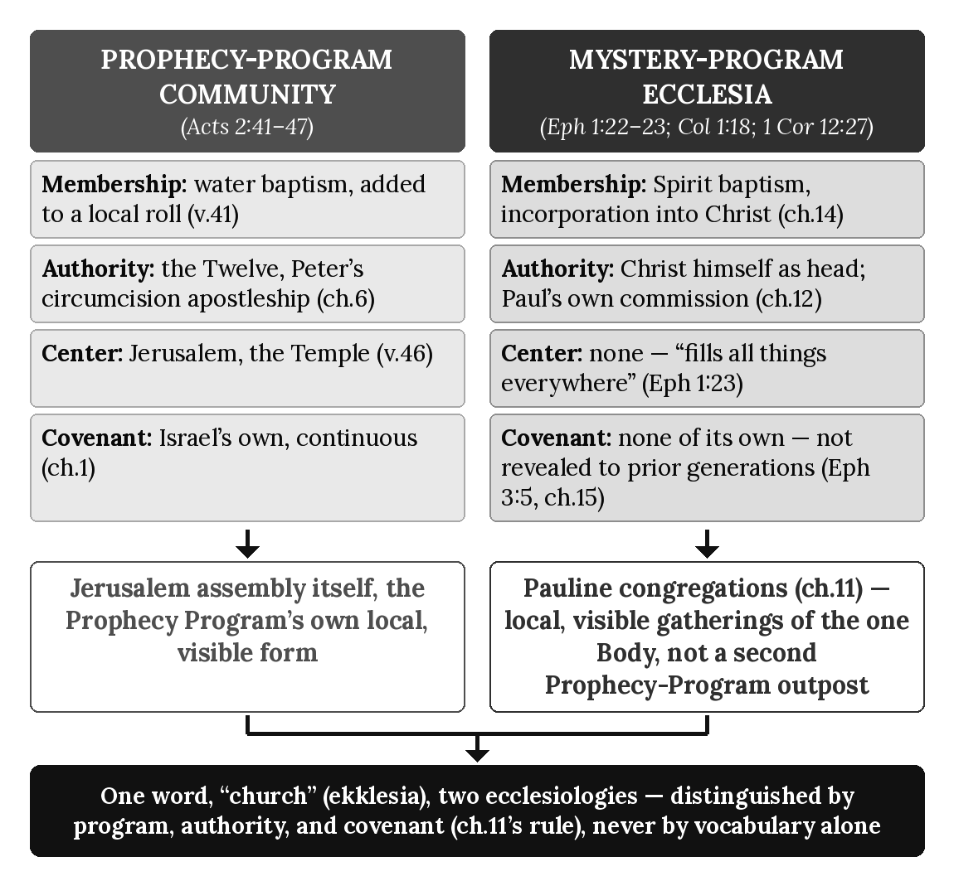

Chapter Summary
The Prophecy Program’s own community is the Jerusalem assembly of Acts 2:41–47: Jewish believers added by water baptism to a single, Temple-centered fellowship, taught by the Twelve under Peter’s own circumcision apostleship, and continuous with Israel’s own covenants. The Mystery Program’s own ecclesia is the Body of Christ Paul describes in Ephesians 1:22–23, Colossians 1:18, and 1 Corinthians 12:27: a single, non-local entity headed directly by Christ, entered by Spirit baptism, and built as a “holy temple” of its own (Ephesians 2:19–22) with no covenantal relationship to Israel of its own. The Pauline congregations chapter 11 already traced are not a second Prophecy-Program community but this Body’s own local, visible gatherings — resolving the terminological difficulty of one Greek word, ekklēsia, naming two distinct realities across the New Testament. Chapter 17 now turns to the two eschatologies these two ecclesiologies respectively anticipate, tracing how each community’s future hope follows directly from the destiny already assigned to it in chapter 13.

Key Terms
Prophecy-Program Community — The Jerusalem assembly of Acts 2:41–47: Jewish believers added by water baptism to a single, Temple-centered fellowship, taught by the Twelve, and continuous with Israel’s own covenants.
Mystery-Program Ecclesia — The Body of Christ described in Ephesians 1:22–23, Colossians 1:18, and 1 Corinthians 12:27: a single, non-local entity headed directly by Christ, entered by Spirit baptism, whose local, visible gatherings are the Pauline congregations chapter 11 traced.

Reflection and Teaching Questions
- Why does the shared use of the word “church” for both the Jerusalem assembly and the Body of Christ not, by itself, establish that they are the same kind of community?
- How does Acts 2:46’s picture of daily Temple worship function as a diagnostic marker identifying the Jerusalem assembly as the Prophecy Program’s own community?
- In what sense are the Pauline congregations of chapter 11 the Body of Christ’s own “local, visible form” rather than a second, separate ecclesiology alongside the Jerusalem assembly and the Body?
- How does Ephesians 2:19–22’s picture of a Spirit-indwelt “holy temple” differ from the Jerusalem Temple of Acts 2:46, and why does this difference matter for correctly identifying which ecclesiology a given New Testament text describes?

Chapter 17: The Two Eschatologies
“For the Lord himself will come down from heaven with a commanding shout, with the voice of the archangel, and with the trumpet call of God. First, the believers who have died will rise from their graves. Then, together with them, we who are still alive and remain on the earth will be caught up in the clouds to meet the Lord in the air. Then we will be with the Lord forever.” — 1 Thessalonians 4:16–17 (NLT)

Introduction
Chapter 13 traced two destinies, earthly and heavenly; chapter 16 traced two ecclesiologies, Israel’s own assembly and the Body of Christ. Both chapters pointed forward to the same unfinished question: what future event does each program actually await, and on what terms? This chapter states both directly. Israel’s own future is a restoration, announced centuries in advance and explicitly conditioned on national repentance. The Body’s own future is an event Paul himself calls a secret — unconditioned, unannounced anywhere in the Old Testament, and governed by none of the signs that mark Israel’s own prophetic timeline. Read as the same event described twice, these two pictures generate real confusion — a shared trumpet, an apparently doubled “coming.” Read through this book’s governing diagnostic method, they are two distinct hopes, belonging to two distinct programs, each stated in full on its own terms.

The Prophecy Program’s Own Future: Israel’s Restoration, Announced and Conditioned (Acts 3:19–21)
Peter’s own sermon at the Temple states the Prophecy Program’s future hope directly, in terms drawn entirely from Israel’s own prophetic expectation, and explicitly conditioned on a national response:
“Now repent of your sins and turn to God, so that your sins may be wiped away. Then times of refreshment will come from the presence of the Lord, and he will again send you Jesus, your appointed Messiah. For he must remain in heaven until the time for the final restoration of all things, as God promised long ago through his holy prophets.” (Acts 3:19–21, NLT)
Every marker here belongs to the Prophecy Program as this book has traced it from the outset. The hope is national (“repent,” addressed to Israel, chapter 1’s own covenant people), conditioned (“so that... then”), explicitly grounded in prior prophecy (“as God promised long ago through his holy prophets,” matching the pattern chapter 2 already distinguished from the Mystery’s own unprophesied content), and earthly in its object — the Messiah’s own return to a restored earthly order, not a heavenly gathering. This is the same restoration of the kingdom to Israel the apostles themselves asked after in Acts 1:6, and which chapter 13 already traced from Matthew 19:28’s promise of twelve thrones. Peter does not describe an imminent, sign-free event; he describes a return conditioned on Israel’s own national repentance, positioned within a prophetic timeline stretching back, on his own words, to “his holy prophets.”

The Mystery Program’s Own Future: The Body’s Own Secret (1 Thessalonians 4:16–17; 1 Corinthians 15:51–52)
Paul describes a second future event, addressed not to Israel but to the Body of Christ chapter 16 already traced, in terms that share none of Acts 3:19–21’s conditions:
“For the Lord himself will come down from heaven with a commanding shout, with the voice of the archangel, and with the trumpet call of God. First, the believers who have died will rise from their graves. Then, together with them, we who are still alive and remain on the earth will be caught up in the clouds to meet the Lord in the air. Then we will be with the Lord forever.” (1 Thessalonians 4:16–17, NLT)
Paul names this event’s own category explicitly when he restates it to the Corinthians, using the very vocabulary chapter 2 already traced for the Mystery Program as a whole:
“But let me reveal to you a wonderful secret. We will not all die, but we will all be transformed! It will happen in a moment, in the blink of an eye, when the last trumpet is blown. For when the trumpet sounds, those who have died will be raised to live forever. And we who are living will also be transformed.” (1 Corinthians 15:51–52, NLT)
“A wonderful secret” renders the same Greek term, mystērion, chapter 2 traced through Romans 16:25, Colossians 1:26, and Ephesians 3:9 — content “kept secret from the beginning,” disclosed for the first time through Paul, never previously spoken by Israel’s own prophets. Nothing in either passage conditions this event on repentance, national or otherwise; nothing dates it against a prophetic timeline; nothing places it after signs. It is stated as an unconditioned certainty, addressed to “we who are still alive,” gathering the Body — not to a restored earth, but “to meet the Lord in the air,” matching the heavenly destiny chapter 13 already traced from Ephesians 2:6 and Philippians 3:20.

Two Timelines, Not One Coming Doubled: Resolving Acts 3 and 1 Thessalonians 4
The apparent difficulty is a shared vocabulary of comings and restoration, read as though Acts 3:19–21 and 1 Thessalonians 4:16–17 must describe a single event under two descriptions. They do not, and the same diagnostic method already applied to commissions, baptisms, justification, and ecclesiology resolves the difficulty the same way: by audience, condition, and prophetic status, not by surface vocabulary. Acts 3:19–21 describes a conditioned, prophesied, national event — Israel’s Messiah returning to an earth restored to the terms “God promised long ago through his holy prophets,” reachable only after the repentance Peter’s own sermon calls for. First Thessalonians 4:16–17 and 1 Corinthians 15:51–52 describe an unconditioned, unprophesied, and — on Paul’s own explicit word — secret event, gathering the Body to meet the Lord in the air rather than settling the Lord on a restored earth. Chapter 2’s own argument applies here without modification: content genuinely “kept secret from the beginning” cannot be the same content Israel’s prophets announced “long ago,” because the entire force of Paul’s own language is that the Body’s hope was not among the things those prophets spoke. Acts 3:19–21 anticipates Israel’s prophetic restoration; the trumpet language belongs to Revelation 11’s Prophecy-Program sequence, not to Peter’s offer. Two comings are not one coming doubled. They are the Prophecy Program’s own prophesied, conditioned restoration and the Mystery Program’s own unprophesied, unconditioned gathering — correctly distinguished, as always, once their governing texts are read on their own terms rather than merged by their shared vocabulary of comings and arrivals. Through these two eschatologies, God in Christ completes His cosmic purpose — restoring the earth through Israel’s prophesied kingdom and reordering the heavenly realms through the Body’s unprophesied gathering.

Where the Body Is Not: Revelation, Daniel’s Seventieth Week, and the Day of the Lord
This book reads Revelation’s prophetic scenes, Daniel’s seventieth week, and the Day of the Lord as belonging to Israel’s prophetic program. The Body of Christ is absent from them. The Body’s hope is the unprophesied gathering Paul calls a secret, “to meet the Lord in the air” (1 Thessalonians 4:17), and it carries no place in Israel’s timeline of judgment and restoration. This book neither reads the Body into Revelation’s scenes nor reads Revelation’s scenes onto the Body.

The Male Child of Revelation 12:5
Revelation 12 pictures a woman who gives birth to “a son who was to rule all nations with an iron rod,” and the child is “caught up to God and to his throne” before the dragon can devour him (Revelation 12:5, NLT). This book identifies the male child as the 144,000 — Israel’s sealed firstfruits company — and not as the individual person of Jesus Christ. Three controls support the reading.
First, the verb. The word translated “caught up” is harpazō, the verb Scripture uses for the removal of a living company (1 Thessalonians 4:17; 2 Corinthians 12:2); the New Testament describes Christ’s own ascension with a different verb (Acts 1:9). Second, the narrative. The child’s sudden removal in Revelation 12:5 and the sudden, already-gathered appearance of the 144,000 with the Lamb on Mount Zion in Revelation 14:1–5 read as one company shown at two points within a single vision. Third, the rule. The rod-of-iron authority given the child (Revelation 12:5, quoting Psalm 2:9) is extended to overcomers in company with Christ (Revelation 2:26–27), so it is not reserved to Christ alone.
This identification does not diminish Christ’s own future rule; it distinguishes the protection and vindication of the firstfruits company from the Messiah’s own person and office. Nor does it place the Body in the scene: the removal of 1 Thessalonians 4:17 is the Body’s gathering, and the removal of Revelation 12:5 is Israel’s firstfruits company. A shared verb does not make two companies one, and program membership is permanent.

The Pattern, Summarized
Feature | Prophecy-Program Eschatology (Acts 3:19–21) | Mystery-Program Eschatology (1 Thessalonians 4:16–17; 1 Corinthians 15:51–52)
Audience | Israel, called to national repentance | The Body of Christ (chapter 16)
Condition | Conditioned — “repent... so that... then” | Unconditioned — stated as certainty
Prophetic status | Prophesied “long ago through his holy prophets” | A “secret,” unprophesied (chapter 2)
Destination | Messiah returns to a restored earth | The Body caught up “to meet the Lord in the air”
Signs | Positioned within Israel’s own prophetic timeline | No preceding signs named
Governing text | Acts 3:19–21 | 1 Thessalonians 4:16–17; 1 Corinthians 15:51–52

Applying the Seven Diagnostic Lenses to 1 Corinthians 15:51–52
- Audience — The Corinthian church, part of “we who are still alive,” the Body of Christ (chapter 16), not Israel under the Kingdom offer.
- Apostolic Authority — Paul’s own, disclosing his own commission’s content (chapter 2’s mystery).
- Covenant — Not invoked; the event is not tied to any covenant promise made to Israel.
- Sign-Gift — Not a sign-event; no preceding miraculous authentication is described or required.
- Commission — The Pauline Commission’s own content (chapter 12), disclosed to no one before Paul.
- Eschatology — The heavenly destiny chapter 13 traced, gathering the Body to meet Christ in the air, not to an earthly throne.
- Dispensation — The dispensation of grace (chapter 3), in which this “wonderful secret” is first revealed.

Diagram: The Two Eschatologies
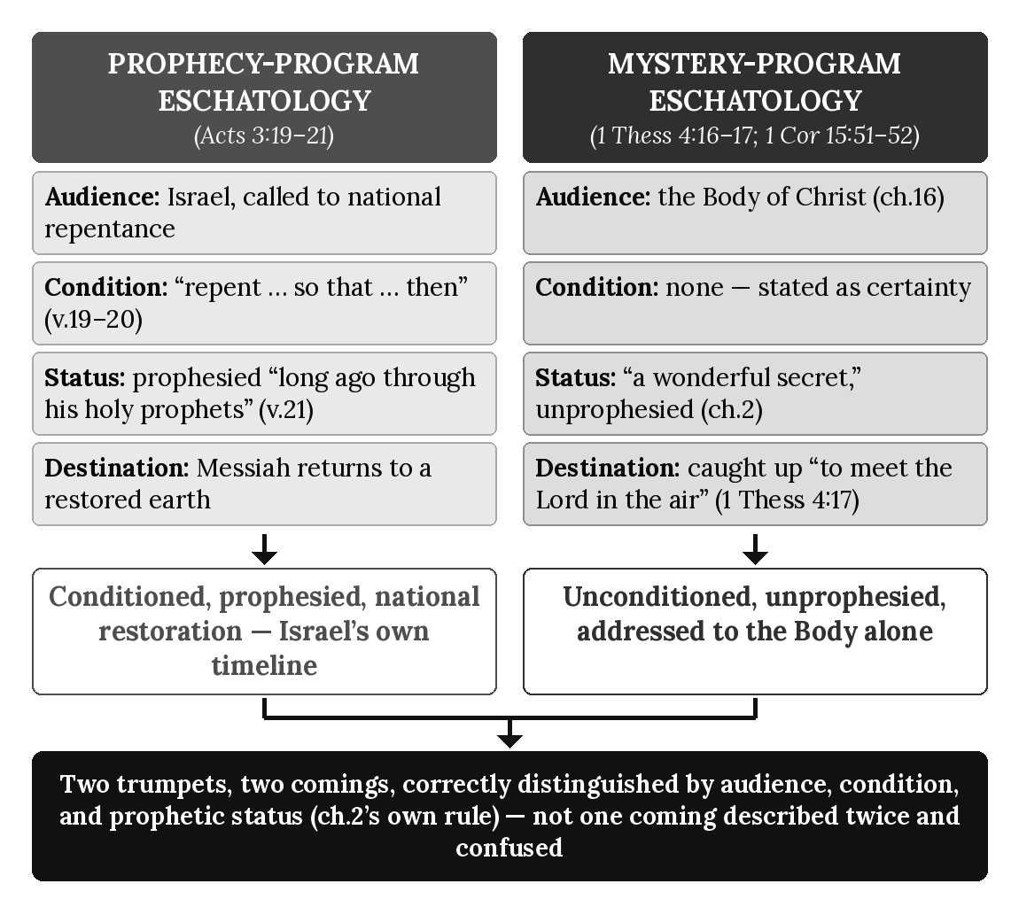

Chapter Summary
The Prophecy Program’s own future is Israel’s restoration: conditioned on national repentance, prophesied “long ago through his holy prophets,” and culminating in the Messiah’s return to a restored earth (Acts 3:19–21) — the same hope chapter 13 already traced as Israel’s earthly destiny. The Mystery Program’s own future is the Body’s own gathering: unconditioned, unprophesied, and explicitly named “a wonderful secret” (1 Corinthians 15:51), catching the Body up “to meet the Lord in the air” (1 Thessalonians 4:17) rather than settling it on a restored earth. The two are not one event described in two vocabularies but two distinct hopes, distinguished by audience, condition, and prophetic status exactly as chapter 2 first established for the Mystery as a whole. Revelation, Daniel’s seventieth week, and the Day of the Lord belong to Israel’s prophetic program, and the Body is absent from them; the male child of Revelation 12:5 is the 144,000, Israel’s sealed firstfruits company, and not the person of Christ. Chapter 18 now turns to the moment these two ongoing programs meet their sharpest crisis within Acts itself: Paul’s final appeal to the Jewish leaders at Rome and the judicial verdict Acts 28 records against the nation’s continued unbelief.

Key Terms
Prophecy-Program Eschatology — Israel’s own future hope: a conditioned, prophesied restoration culminating in the Messiah’s return to a restored earth (Acts 3:19–21), following the earthly destiny chapter 13 traced.
Mystery-Program Eschatology — The Body of Christ’s own future hope: an unconditioned, unprophesied gathering to meet the Lord in the air (1 Thessalonians 4:16–17), explicitly named “a wonderful secret” (1 Corinthians 15:51) rather than a fulfillment of Israel’s own prophetic timeline.
The Male Child (Revelation 12:5) — This book’s identification of the child caught up to God and his throne as the 144,000, Israel’s sealed firstfruits company, and not the individual person of Christ; supported by the verb harpazō, by the child’s removal in Revelation 12:5 and the company’s appearance in Revelation 14:1–5 as one company at two points, and by the rod-of-iron authority shared with overcomers (Revelation 2:26–27). (Chapter 17.)

Reflection and Teaching Questions
- Why does Acts 3:19–21’s condition — “repent... so that... then” — function as a decisive diagnostic marker distinguishing it from 1 Thessalonians 4:16–17’s unconditioned promise?
- How does 1 Corinthians 15:51’s “a wonderful secret” connect this chapter’s argument back to chapter 2’s definition of the Mystery as content “kept secret from the beginning”?
- Why does this chapter treat the shared vocabulary of comings in Acts 3:19–21 and the trumpet language of 1 Thessalonians 4:16 / 1 Corinthians 15:52 as insufficient grounds for identifying the two passages as the same event?
- How does the destination named in each passage — a restored earth (Acts 3:21) versus “the clouds... in the air” (1 Thessalonians 4:17) — reinforce the destiny-assignment rule chapter 13 established?
- Why does this chapter place the Body outside Revelation’s scenes, and how do the three controls (the verb harpazō, the child’s removal and the company’s appearance read as one company, and the shared rod-of-iron authority) support identifying the male child of Revelation 12:5 as the 144,000 rather than the person of Christ?

Chapter 18: The Acts 28 Crisis
“I asked you to come here today so we could get acquainted and so I could explain to you that I am bound with this chain because I believe that the hope of Israel — the Messiah — has already come.” — Acts 28:20 (NLT)

Introduction
Chapter 9 already traced repeated local Jewish rejection and the Acts 28 national verdict to its national terminus at Rome, quoting in full the divided response of Acts 28:24 and the verdict of Acts 28:25–28. This chapter does not repeat that ground. It examines the crisis surrounding that verdict: the meeting that leads up to it, still conducted as audience-specific proclamation of Prophecy-Program truth to Israel within its still-operative prophetic setting even from custody, and the two-year silence that follows it, in which Luke’s narrative simply stops. Both halves of this crisis — the last appeal and the abrupt ending — bear directly on this book’s architecture, and neither has yet been examined on its own terms.

Paul’s Approach to Rome’s Jewish Leaders: Still “To the Jew First” (Acts 28:17–22)
Paul’s first act on arriving at Rome, still a prisoner awaiting Caesar’s hearing, is to summon the city’s Jewish leadership — not Gentile officials, not the believers already present in Rome (whom his own letter to the Romans addresses), but “the local Jewish leaders” (Acts 28:17, NLT):
“Three days after Paul’s arrival, he called together the local Jewish leaders. He said to them, ‘Brothers, I was arrested in Jerusalem and handed over to the Roman government, even though I had done nothing against our people or the customs of our ancestors.’” (Acts 28:17, NLT)
Paul states his own self-understanding of his imprisonment in terms drawn entirely from Israel’s own hope, not from the Mystery he has spent this book’s earlier chapters describing:
“I asked you to come here today so we could get acquainted and so I could explain to you that I am bound with this chain because I believe that the hope of Israel — the Messiah — has already come.” (Acts 28:20, NLT)
“The hope of Israel” is chapter 1’s own vocabulary, not chapter 2’s. Even in chains, at the empire’s capital, at the very edge of the overlap, Paul continues to present himself to Israel’s leaders on Israel’s own prophetic terms. This is not a second programmatic role for Paul. It is his one distinctive Mystery apostleship ministering within Israel’s still-operative prophetic setting. Paul’s synagogue preaching was audience-specific, not commission-specific: “the hope of Israel” is the vocabulary of that address and does not change his commission or his gospel. The leaders’ reply is cautious rather than hostile, setting up the appointed day chapter 9 already narrated in full: the daylong exposition from the law of Moses and the prophets, the divided response, and Isaiah’s pronounced verdict (Acts 28:23–28).

The Verdict, in Brief
Chapter 9 has already traced this verdict’s own place within Israel’s gradual, cumulative national hardening, quoting Acts 28:24–28 in full and applying the Seven Diagnostic Lenses directly to it. This chapter does not re-argue that ground; it takes the verdict as settled and turns to what has not yet been examined — what happens immediately after it, in the same chapter of Acts, in the same house, within the same passage that close the book.

The Silence That Follows: Two Years, No Further Verdict (Acts 28:30–31)
Luke’s narrative does not end with the verdict of Acts 28:28. It continues for two more verses, describing two more years, and then stops entirely:
“For the next two years, Paul lived in Rome at his own expense. He welcomed all who visited him, boldly proclaiming the Kingdom of God and teaching about the Lord Jesus Christ. And no one tried to stop him.” (Acts 28:30–31, NLT)
This is, on its face, a genuine complication for this book’s own argument, and it is addressed directly rather than passed over: if the Prophecy Program is judicially suspended at Acts 28:28, why does Paul continue “proclaiming the Kingdom of God” for two more years, to “all who visited him”? The resolution follows the same diagnostic method this book has applied throughout. What occurs at Acts 28:28 is the judicial suspension of Israel’s Prophecy Program in its present administration. This suspension brings the Acts overlap to its close. It does not cancel Israel’s covenants, erase prophetic truth, or prevent Paul from teaching the Kingdom of God as revealed doctrine. Acts 28:30–31 therefore does not extend the overlap beyond Acts 28:28: Paul may continue audience-specific proclamation of Prophecy-Program truth while the program to which that truth belongs is no longer operating alongside the Mystery Program. This is not Kingdom administration, not a Kingdom Commission, and not a renewed offer.

Why Acts Ends Here: The Narrative Boundary and the Mystery Program’s Own Voice
Luke gives no account of Paul’s trial before Caesar, no report of acquittal or execution, no closing summary of the church’s condition — the book simply stops, mid-situation, after “no one tried to stop him.” Read against this book’s own architecture, that abrupt ending is not an accident of incomplete history; it reflects Acts’ own designed scope. Acts is, from Pentecost onward, the narrative of the Prophecy Program’s own offer to Israel unfolding in real time — announced (chapter 1), extended through the Twelve, then carried alongside the Mystery through the overlap this whole book has traced, and finally suspended, nationally, at Acts 28:28. Once that narrative arc reaches its divinely appointed Acts 28 boundary, Acts has no further account of Israel’s nationally operative Prophecy Program to narrate, and Luke closes the book at exactly the point that arc concludes — not at the point Paul’s own life concludes, which lay years in the future. What continues past this point is not Acts’ own narrative but the Mystery Program’s own literary voice: the letters this same two-year Roman imprisonment produced — Ephesians, Philippians, Colossians, and Philemon, the traditional “Prison Epistles” — carry the Mystery’s fullest content (chapter 2’s “one new man,” chapter 13’s heavenly destiny, chapter 16’s ecclesiology) forward without any further need of Acts’ own narrative framework. Chapter 21 will trace what this means for the Mystery Program operating, from this point forward, entirely on its own.

The Pattern, Summarized
Feature | Before Acts 28:28 | After Acts 28:28
Kingdom offer to Israel | Open, national, presented “the Jew first” (chapter 3) | Suspended, nationally (chapter 9)
Paul’s proclamation to Israel | Audience-specific proclamation of Prophecy-Program truth to Israel in its still-operative setting | Continues as audience-specific proclamation, not a renewed offer (Acts 28:30–31)
Audience of Paul’s teaching | Synagogues, Jewish leaders corporately | “All who visited him” — individuals, any background
Acts’ own narrative | Carries the Prophecy Program’s unfolding story | Has no further Prophecy-Program story to tell; the book ends
The Mystery Program’s own voice | Carried through Paul’s mid-Acts epistles (chapter 2) | Carried forward independently through the Prison Epistles

Applying the Seven Diagnostic Lenses to Acts 28:30–31
- Audience — “All who visited him” — no longer Israel corporately through her own leaders, but individuals of any background.
- Apostolic Authority — Paul’s own, now exercised entirely outside any synagogue setting or national appeal.
- Covenant — Kingdom content taught as true revealed doctrine, no longer extended as a live national offer (chapter 9’s verdict already marked the national judicial suspension of Israel’s Prophecy Program).
- Sign-Gift — Absent; the last sign was already narrated at Malta, prior to Rome (chapter 8).
- Commission — Paul’s own distinct commission (chapter 12), now unaccompanied by the concurrent operation of Israel’s Prophecy Program that chapters 5 and 12 traced.
- Eschatology — Both destinies remain true (chapter 13); Israel’s Prophecy Program is nationally and judicially suspended, while its covenants, promises, and eventual prophetic fulfillment remain intact (chapter 19 examines this distinction fully).
- Dispensation — The Mystery Program’s own dispensation, now operating without the Prophecy Program’s national offer running alongside it (chapter 21).

Diagram: The Acts 28 Crisis
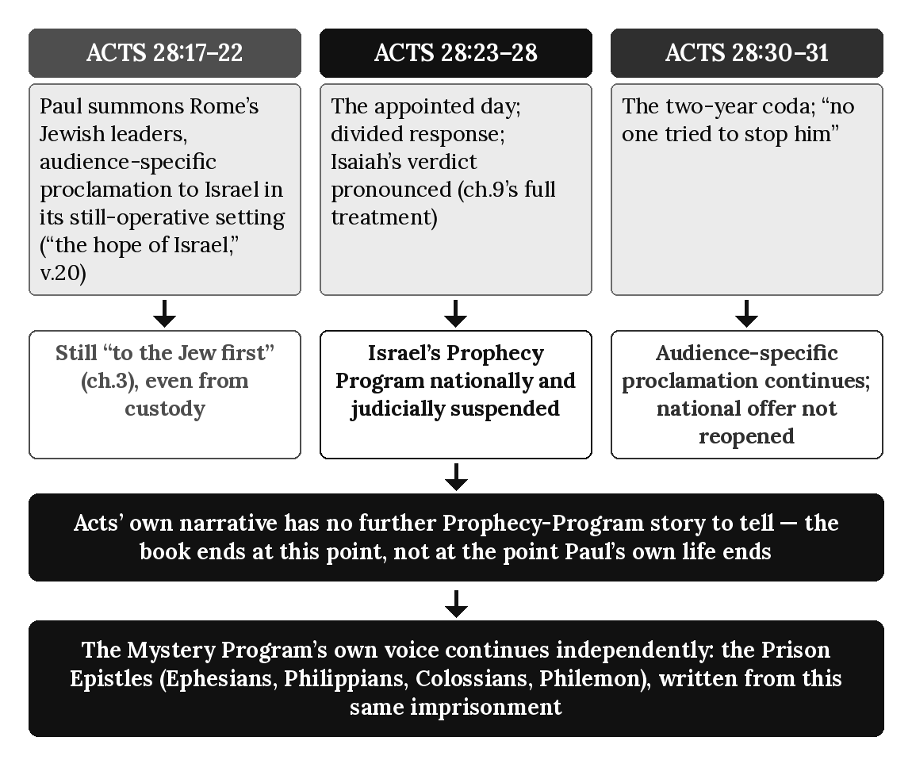

Chapter Summary
Paul’s approach to Rome’s Jewish leaders (Acts 28:17–22) continues his Jewish-first ministry within Israel’s still-operative prophetic setting, presented even from custody in relation to “the hope of Israel.” The verdict that follows (Acts 28:24–28), already examined fully in chapter 9, marks the national judicial suspension of Israel’s Prophecy Program. What this chapter has added is the crisis that surrounds it on both sides: an appeal that is audience-specific proclamation of Prophecy-Program truth to Israel within its still-operative prophetic setting, and a two-year coda (Acts 28:30–31) in which Paul continues audience-specific proclamation of Prophecy-Program truth to individual visitors without reversing the national judicial suspension of Israel’s Prophecy Program marked by the Acts 28 verdict. Acts itself ends at this point because the prophetic narrative traced by Luke has reached its divinely appointed Acts 28 boundary — not because Israel’s covenants or future prophetic fulfillment have terminated, and not because Paul’s own ministry has ended. Chapter 19 now examines the judicial blinding this verdict pronounces in full doctrinal depth, tracing its scope, its duration, and its relationship to Israel’s future restoration already anticipated in chapter 17.

Key Terms
The Rome Appeal — Paul’s summons of the local Jewish leaders on his arrival at Rome (Acts 28:17–22), as audience-specific proclamation of Prophecy-Program truth to Israel within its still-operative prophetic setting (chapter 3), presented even from custody in the vocabulary of “the hope of Israel.”
The Two-Year Coda — This chapter’s term for Acts 28:30–31, the narrative’s closing description of Paul’s continued teaching after Israel’s Prophecy Program is nationally and judicially suspended, distinguishing ongoing audience-specific proclamation of Prophecy-Program truth from a renewed national offer.

Reflection and Teaching Questions
- Why does Paul’s language in Acts 28:20 — “the hope of Israel” — matter for showing that his approach to Rome’s Jewish leaders remains audience-specific proclamation of Prophecy-Program truth to Israel within its still-operative prophetic setting even from custody, rather than a renewed offer or an act of Kingdom administration?
- How does this chapter distinguish Paul’s continued proclamation of “the Kingdom of God” (Acts 28:31) from a reactivation of Israel’s nationally suspended Prophecy Program? Is this distinction persuasive on the text’s own terms?
- Why does this chapter treat Acts’ abrupt ending after Acts 28:31 as evidence of the book’s own designed scope rather than as an accident of incomplete history?
- In what sense do the Prison Epistles (Ephesians, Philippians, Colossians, Philemon) “continue” the story Acts leaves unfinished, even though they are not part of Acts’ own narrative?

Chapter 19: The Judicial Blinding
“For God’s gifts and his call can never be withdrawn.” — Romans 11:29 (NLT)

Introduction
Chapter 9 traced repeated local Jewish rejection and the Acts 28 national verdict to its national terminus, and chapter 18 examined the crisis surrounding the verdict Isaiah’s own words pronounce at Acts 28:26–27. Neither chapter examined the verdict’s own doctrinal shape: how total is this blinding, how long does it last, and does it cancel the promises chapter 1 traced from Abraham forward? This chapter answers each question in turn, from Paul’s own fullest treatment of the subject, and shows that the judicial blinding pronounced at Rome is real, but neither total, permanent, nor covenant-canceling.

The Verdict, Restated in Brief (Acts 28:26–27)
Chapters 9 and 18 have already quoted Isaiah’s words in full as Paul applies them at Rome — hardened hearts, closed eyes, ears that cannot hear — and traced their place within Israel’s national pattern and the crisis surrounding it. This chapter takes that verdict as established and turns to Paul’s own fuller explanation of what it means, written some years before in his letter to the Romans but addressing precisely this same national condition.

Real, But Not Total: A Remnant Remains (Romans 11:1–2, 5)
Paul opens his own extended treatment of Israel’s condition by foreclosing the most severe possible misreading of the verdict:
“I ask, then, has God rejected his own people, the nation of Israel? Of course not! I myself am an Israelite, a descendant of Abraham and a member of the tribe of Benjamin. No, God has not rejected his own people, whom he chose from the very beginning.” (Romans 11:1–2, NLT)
Paul’s own example is the argument: an Israelite, chosen “from the very beginning,” and — on this book’s own terms — an apostle of the Mystery rather than evidence against Israel’s own election. He then names the pattern’s own theological category:
“It is the same today, for a few of the people of Israel have remained faithful because of God’s grace — his undeserved kindness in choosing them.” (Romans 11:5, NLT)
“A few of the people of Israel” renders what the underlying Greek names directly as a remnant — a technical category chapter 1’s own prophets already knew (Isaiah’s own “remnant will return,” Isaiah 10:21–22). The judicial blinding pronounced at Acts 28:26–27 is national and corporate; it has never meant, on Paul’s own testimony, that no individual Israelite believes. A remnant, chosen by grace, remains throughout — Paul himself the standing proof.

Purposeful and Temporary: “Until the Full Number of Gentiles Comes to Christ” (Romans 11:25–27)
Paul states the blinding’s own scope and duration together, using language that requires care alongside chapter 2’s own definition:
“I want you to understand this mystery, dear brothers and sisters, so that you will not feel proud about yourselves. Some of the people of Israel have hard hearts, but this will last only until the full number of Gentiles comes to Christ. And so all Israel will be saved. As the Scriptures say, ‘The one who rescues will come from Jerusalem, and he will turn Israel away from ungodliness.’ ‘And this is my covenant with them, that I will take away their sins.’” (Romans 11:25–27, NLT)
Paul’s own word here is “mystery,” the same English rendering chapter 2 traced from mystērion — but this is not the Mystery Program’s own technical content chapter 2 defined and this book has traced ever since. That content is the one new man, Jew and Gentile fused into a single body with no covenantal distinction (chapter 2), never spoken by Israel’s prophets. This mystery is a different disclosure entirely: the specific mechanism and timing of Israel’s own partial, temporary hardening, stated in terms — “the full number of Gentiles,” “all Israel will be saved” — that presuppose rather than replace the covenantal framework chapter 1 traced, and that Paul explicitly grounds in Israel’s own prophets a verse later (“as the Scriptures say”). The two mysteries share a word; they do not share a referent, and this chapter’s own argument depends on keeping them distinct exactly as chapter 15 kept “the twelve tribes” and “one new people” distinct despite James and Paul sharing vocabulary. What Paul does disclose newly is the word “some” — “some of the people of Israel,” not all — and the word “until” — a bounded, temporary condition, not a permanent state, lasting precisely as long as it takes for “the full number of Gentiles” to come in, after which “all Israel will be saved.”

Irrevocable Promises: The Blinding Does Not Cancel the Covenant (Romans 11:28–29)
Paul closes this section of his own argument by stating directly that the hardening, however real, changes nothing about the covenant promises themselves:
“Many of the people of Israel are now enemies of the Good News, and this benefits you Gentiles. Yet they are still the people he loves because he chose their ancestors Abraham, Isaac, and Jacob. For God’s gifts and his call can never be withdrawn.” (Romans 11:28–29, NLT)
“Can never be withdrawn” states in Paul’s own terms exactly what chapter 1 traced as covenantal: the Abrahamic, Davidic, and New Covenant promises are not annulled by Israel’s national hardening, any more than they were annulled by Israel’s earlier failures under the Law. The blinding suspends the offer’s present national administration (chapter 9’s own verdict); it does not touch the promises’ own future certainty, which chapter 17 already traced as Israel’s own coming eschatological hope.

Reconciling National Blinding with Individual Response: Applying the Four Distinct Groups Doctrine
The apparent difficulty is holding together a real, pronounced national judgment (Acts 28:26–27) with Paul’s own insistence that individual Israelites continue believing throughout and after it (Romans 11:1–5). The judicial suspension operates at the national and programmatic level; it does not erase believing Israelites. Israel’s remnant remains Israel’s prophetic believing company; it never becomes the Body, and the Body never becomes the remnant. During Acts 9–28 the remnant remains Israel’s prophetic believing company, and the Body remains the Mystery new creation. They coexist historically but never merge in identity, membership, calling, covenant, gospel, hope, or destiny. Concurrency is operational, not transformational. Anyone saved under Paul’s gospel from Acts 9 onward, Jew or Gentile, is Body from the moment of belief; after Acts 28, only newly saved individuals enter the Body, because the membership of Prophecy saints was already fixed and does not relocate. Individual Israelites remain free to believe, and those who are newly saved in the present administration enter the Body on the same terms as Gentiles.

Four Boundaries on Reading Romans 11
Romans 9–11 is addressed to Israel and concerns Israel, and this book reads it in that setting; it is not a passage on how the Body is saved. Romans 11 explains Israel’s prophetic condition and what Gentile salvation means in relation to that condition. It does not define the origin, identity, or membership of the Body. Four boundaries govern the reading: the olive tree is Israel’s prophetic blessing, not the Body of Christ; the Gentiles of Romans 11 are prophetic participants, not members of the Body; wild branches are not members of the Body; and grafting changes participation, not identity. That God “made salvation available to the Gentiles” (Romans 11:11, NLT) means salvation, not covenant membership, Israel’s name, Israel’s promises, Israel’s program, or Israel’s destiny. Participation is not identity. Blessing is not covenant. Standing is not program membership. Gentile participation in Romans 11 does not confer Israel’s identity, promises, or program membership. Salvation has come to the Gentiles. Israel remains Israel. The Body remains the Body. Program membership is permanent. Romans 11:25 is content belonging to Israel’s prophetic program that is occurring while the Mystery administration runs, and it is read inside these boundaries.

The Pattern, Summarized
Feature | The Blinding’s Scope | What Remains True
Level | National and corporate (Acts 28:26–27; chapter 9) | Individual Israelites remain free to believe (Romans 11:1–2)
Extent | “Some,” not all (Romans 11:25) | A remnant, chosen by grace, continues (Romans 11:5)
Duration | “Until the full number of Gentiles comes to Christ” (Romans 11:25) | Bounded, not permanent
Covenant status | Present national administration suspended (chapter 9) | “God’s gifts and his call can never be withdrawn” (Romans 11:29)
Future outcome | — | “All Israel will be saved” (Romans 11:26); Israel’s own restoration (chapter 17)
Individual response | — | Remains within Israel’s own believing company; no individual is barred by the national verdict. Anyone saved under Paul’s gospel is in the Body of Christ (chapter 5); the remnant and the Body never merge.

Applying the Seven Diagnostic Lenses to Romans 11:25–27
- Audience — Israel, with Gentile readers observing the argument (v. 25’s stated purpose is to warn them against pride toward Israel). Participation is not identity. Gentile participation in Romans 11 does not confer Israel’s identity, promises, or program membership.
- Apostolic Authority — Paul’s own, disclosing further detail of Israel’s own condition, not the Mystery Program’s own content.
- Covenant — Directly invoked and reaffirmed: “this is my covenant with them” (v. 27), Israel’s own covenant, not annulled.
- Sign-Gift — Not addressed in this passage.
- Commission — Not the subject here; the passage concerns Israel’s national standing, not apostolic office.
- Eschatology — Earthly and future: “all Israel will be saved,” the same restoration chapter 17 traced from Acts 3:19–21.
- Dispensation — Spans both: the present hardening belongs to the current interval; the promised resolution belongs to the Prophecy Program’s own future restoration.

Diagram: The Judicial Blinding
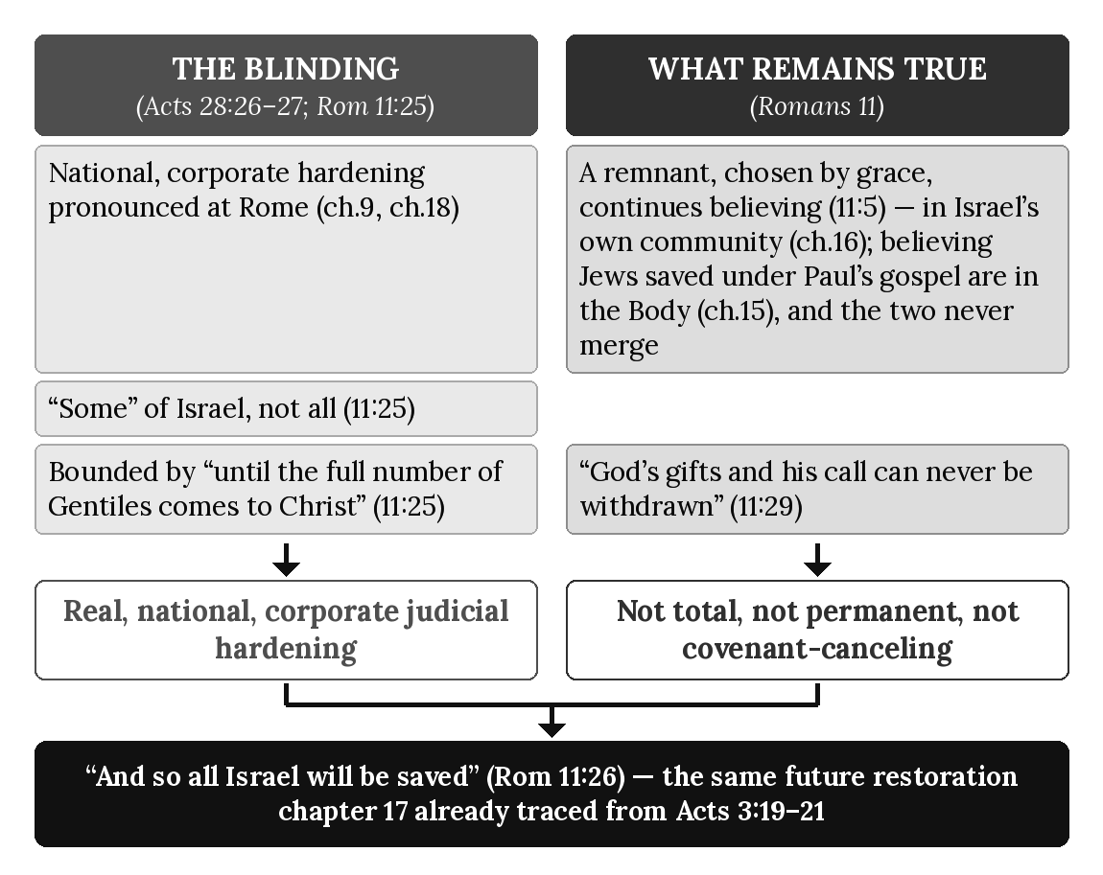

Chapter Summary
The judicial blinding Isaiah’s words pronounce at Rome (Acts 28:26–27) is real, but Paul’s own extended treatment in Romans 11 qualifies it in three ways this chapter has traced: it is partial, not total — “some” of Israel, with a believing remnant continuing throughout (Romans 11:1–2, 5); it is temporary, not permanent — bounded by “until the full number of Gentiles comes to Christ,” after which “all Israel will be saved” (Romans 11:25–26); and it leaves the covenant promises themselves untouched — “God’s gifts and his call can never be withdrawn” (Romans 11:29). Applying this book’s Four Distinct Groups doctrine, the blinding operates at the national, corporate level chapter 9’s verdict addressed, never at the level of any individual’s freedom to believe; a newly saved Israelite enters the Body on the same terms as any Gentile, while Israel’s remnant remains Israel’s remnant and never becomes the Body. Chapter 20 now turns to what these two chapters together mean for the overlap itself: the moment at which the Prophecy Program’s active operation, not merely its national offer, comes to its own formal end.

Key Terms
The Judicial Blinding — The national, corporate hardening Isaiah’s words pronounce over Israel at Acts 28:26–27, real but partial, temporary, and non-covenant-canceling, as Romans 11 qualifies it.
Israel’s Remnant — Paul’s own term (Romans 11:5) for individual Israelites who continue believing throughout the blinding, chosen by grace, standing alongside — never in tension with — the nation’s own corporate hardening; Israel’s prophetic believing company, which never becomes the Body.

Reflection and Teaching Questions
- Why does Paul’s own example as “an Israelite” (Romans 11:1, NLT) function as evidence against reading the judicial blinding as total?
- How does this chapter distinguish the “mystery” Paul names in Romans 11:25 from the Mystery Program’s own technical content chapter 2 defined, even though both use the same English word?
- Why does “until the full number of Gentiles comes to Christ” (Romans 11:25) matter for showing that the blinding is bounded rather than permanent?
- How does this chapter’s application of the Four Distinct Groups doctrine explain how a real national hardening and genuine individual Jewish belief can both be true at the same time, without contradiction?

Chapter 20: The Overlap Ends
“So I want you to know that this salvation from God has also been offered to the Gentiles, and they will accept it.” — Acts 28:28 (NLT)

Introduction
Chapter 3 previewed a trajectory: two programs, formally distinguished and traced in concurrent operation from Paul’s calling (chapter 4) through the maturing of his own churches and doctrine (chapters 11–17), arriving finally at “the crisis and resolution of Acts 28 itself... where the overlap this chapter has defined comes to its close.” Chapters 8, 9, 18, and 19 have each traced one strand of that closing — the sign-gift’s judicial cessation, Israel’s national rejection and verdict, the crisis surrounding the verdict, and the verdict’s own qualified scope. This chapter does not add a new strand. It gathers the threads already traced and states, formally and in one place, exactly what ends at this boundary, exactly what does not, and exactly where the boundary itself falls.

What Ends: The Overlap’s Active, Dual-Track Operation
Four distinct things close at this boundary, each already traced in its own chapter and gathered here as a single, formal statement:
- The sign-gift’s active ministry. Chapter 8 traced Prophecy Program sign-authentication at full strength through Malta (Acts 28:1–9) and its ending, categorically and at once, at the Acts 28 boundary, where the Prophecy Program’s own administration is nationally suspended — a judicial cutoff, not a gradual fade. With the national suspension of Israel’s Prophecy Program at Acts 28, the sign-program associated with Israel ceases programmatically. Paul’s other signs and those of his companions in Acts 9–28 are overlap-context signs, not Mystery-Program signs, and are reported as written in settings shaped by Israel’s Prophecy Program and are not assigned to a single program (chapter 8).
- The Prophecy Program’s national, corporate offer to Israel. Chapter 9 traced repeated local Jewish rejection and the Acts 28 national verdict from Pisidian Antioch to Rome; chapter 18 traced the appeal that precedes the formal boundary; chapter 19 confirmed that Acts 28 judicially suspends the Prophecy Program’s present administration without canceling the underlying covenant promises.
- Paul’s ministry within Israel’s still-operative prophetic setting. Chapters 5 and 12 establish that Paul’s apostleship, commission, and stewardship remain distinctly Mystery throughout the overlap even while he ministers to Israel within its Prophecy setting. At Acts 28, Israel’s Prophecy Program reaches its national judicial suspension point. What changes is Israel’s national programmatic status, not the identity of Paul’s commission. His one distinctive Mystery commission continues beyond the boundary.
- Acts’ own two-track narrative. Chapter 18 already traced why Luke’s book ends where it does: Acts carries the unfolding story of Israel’s nationally operative Prophecy Program, and once that narrative reaches its divinely appointed Acts 28 boundary, the book has no further account of that nationally operative program to narrate.

What Does Not End: The Promises, the Remnant, and the Future
Three things chapter 19 already established remain untouched by this boundary, and are restated here as part of the same formal accounting:
- The covenant promises themselves. “God’s gifts and his call can never be withdrawn” (Romans 11:29, NLT; chapter 19). What is nationally suspended at Acts 28 is the present operation of Israel’s Prophecy Program; its covenants, promises, and future fulfillment remain intact.
- The believing remnant. Chapter 19 traced Israel’s remnant continuing as Israel’s prophetic believing company throughout and after this boundary (chapter 19), never barred by the national verdict. Jews who are saved under Paul’s gospel, as Paul was, are members of the Body, which is not Israel and is not the remnant (chapter 5).
- Israel’s own future restoration. Chapter 17 traced this hope from Acts 3:19–21; chapter 19 traced its own bounded timetable from Romans 11:25–27 — “until the full number of Gentiles comes to Christ... and so all Israel will be saved.” The boundary this chapter names is not this hope’s cancellation but the interval its own fulfillment still awaits.

Naming the Boundary Precisely
This book has stated from the outset that “Acts 28 is the official, fixed boundary.” This chapter states what that rule means with the precision the preceding nineteen chapters now make possible: the boundary is not a span of time, a gradual transition, or a symbolic marker, but the specific pronouncement of Acts 28:25–28, in which Paul, quoting Isaiah, pronounces the divinely authorized judicial verdict marking the national suspension of Israel’s Prophecy Program and states plainly, “this salvation from God has also been offered to the Gentiles, and they will accept it.” Everything this chapter has called “ending” ends at that pronouncement; everything it has called “continuing” continues past it without interruption. The two-year coda that follows (Acts 28:30–31; chapter 18) does not extend the boundary or reopen it; it demonstrates what remains true on the other side of it — Prophecy-Program truth still taught as audience-specific proclamation, individuals still free to believe, the Mystery Program’s own voice still active, all without a national offer’s administration to run alongside it.
The same shift is visible in Paul’s own later correspondence. Writing from the same imprisonment that produces Acts’ own silence, he reports the gospel’s continued spread in terms that carry none of the earlier missionary pattern’s own vocabulary — no synagogue, no “the Jew first,” no local turn to the Gentiles after local rejection:
“And I want you to know, my dear brothers and sisters, that everything that has happened to me here has helped to spread the Good News. For everyone here, including the whole palace guard, knows that I am in chains because of Christ. And because of my imprisonment, most of the believers here have gained confidence and boldly speak God’s message without fear.” (Philippians 1:12–14, NLT)
“The whole palace guard,” “most of the believers here,” “God’s message” spoken “without fear” — an undivided report, addressed to no national audience and shaped by no synagogue-first pattern, exactly the single-track voice chapter 21 will trace as the Mystery Program’s own unaccompanied operation.

The Pattern, Summarized
Element | Before Acts 28:28 (During the Overlap) | After Acts 28:28 (Boundary Crossed)
Sign-gift ministry | Active, full strength through Malta (chapter 8) | Ceases programmatically at Acts 28 (chapter 8)
Kingdom offer to Israel | Open, national, “the Jew first” (chapter 3, 9) | Suspended, nationally (chapter 9, 18)
Paul’s ministry within Israel’s prophetic setting | Active alongside his permanent commission (chapter 5, 12) | With Israel’s Prophecy Program nationally suspended, the Acts Overlap ends
Acts’ own narrative | Carries the Prophecy Program’s unfolding story | Has no further Prophecy-Program story to tell; the book ends (chapter 18)
Covenant promises | In force | Still in force, unchanged (chapter 19)
The believing remnant | Prophecy Program only | Prophecy Program only, unchanged (chapter 19)
Israel’s future restoration | Anticipated | Still anticipated, on its own bounded timetable (chapter 17, 19)
The Mystery Program’s own operation | Alongside the Prophecy Program | Operating alone (chapter 21)

Applying the Seven Diagnostic Lenses to the Overlap’s Own Boundary
- Audience — Before: Israel corporately, addressed through her own leaders, alongside individual Gentile and Jewish believers in the Mystery. After: no further national audience; only individuals, of any background, addressed as in Philippians 1:12–14.
- Apostolic Authority — Before Acts 28: Peter’s circumcision apostleship and Paul’s distinct Mystery apostleship operate within the same concurrent historical setting. After Acts 28: Israel’s Prophecy Program is nationally suspended; Paul’s distinct Mystery commission continues.
- Covenant — Before: actively administered as a national offer. After: still true and future (chapter 19), but not presently administered.
- Sign-Gift — Before: recorded at full strength, in settings shaped by Israel’s Prophecy Program. After: absent; with the national suspension of Israel’s Prophecy Program at Acts 28, the sign-program associated with Israel ceases programmatically (chapter 8).
- Commission — Before: Israel’s Prophecy Program and the Pauline Commission operate concurrently. After: Israel’s Prophecy Program is nationally suspended while the Pauline Commission continues.
- Eschatology — Before: both destinies anticipated, one nearer in its own administration. After: both destinies still anticipated; only the Kingdom’s present national program, not its future hope, has closed.
- Dispensation — Before Acts 28: two distinct divine programs operate concurrently — Israel’s Prophecy Program and the Mystery Program under Paul’s stewardship. After Acts 28: Israel’s Prophecy Program is nationally and judicially suspended, while the Mystery Program continues.

Diagram: The Overlap’s End
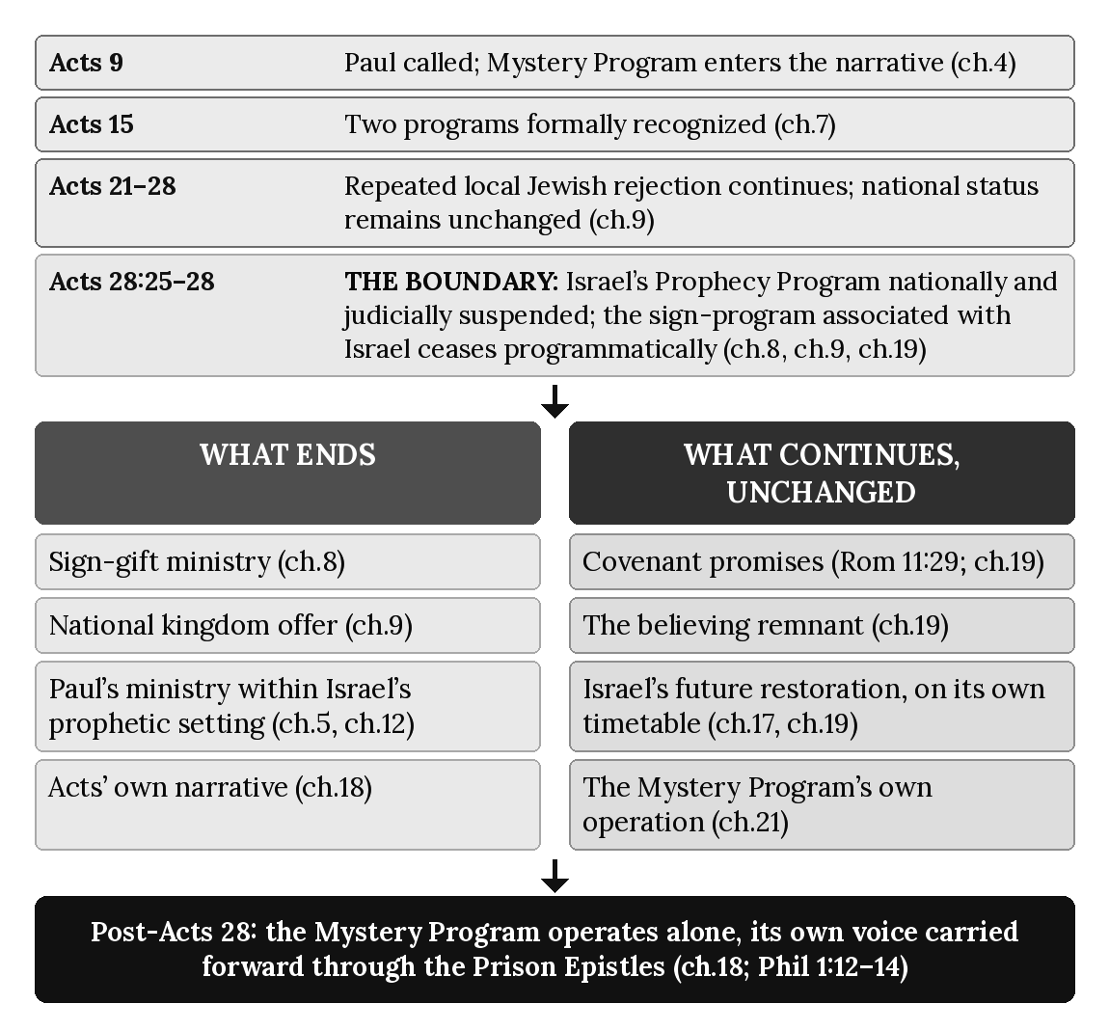

Chapter Summary
At the single pronouncement of Acts 28:25–28, four historical conditions reach their Acts-period boundary: the sign-authentication ministry associated with Israel’s prophetic setting ceases (chapter 8); Israel’s Prophecy Program is nationally and judicially suspended (chapter 9); its concurrent operation alongside Paul’s Mystery ministry ends (chapters 5 and 12); and Acts reaches the boundary of its Prophecy-Program narrative (chapter 18). Three realities remain intact: the covenant promises themselves, Israel’s believing remnant, and Israel’s future restoration on its bounded timetable (chapters 19 and 17). This is what this book’s own consistency rule — “Acts 28 is the official, fixed boundary” — means with precision: a specific pronouncement, not a gradual transition, after which the overlap this book has traced since chapter 4 gives way to a single program operating alone, its own voice already visible in Paul’s own later correspondence (Philippians 1:12–14). Chapter 21 now examines that single-program operation directly: the Mystery Program, alone, on its own terms, for the remainder of this age.

Key Terms
The Overlap’s Boundary — This book’s own term for the specific pronouncement of Acts 28:25–28, at which the sign-authentication ministry associated with Israel’s prophetic setting ceases and Israel’s Prophecy Program is nationally and judicially suspended, bringing its concurrent operation alongside Paul’s Mystery ministry to an end, while the covenant promises, the believing remnant, and Israel’s future restoration remain unaffected.
Solo Operation — This book’s term for the Mystery Program’s own condition after the boundary: continuing exactly as before in its own content and commission (chapters 2, 5, 12), but no longer running alongside an actively administered Prophecy Program.

Reflection and Teaching Questions
- Why does this chapter insist that four specific things end at Acts 28:25–28 rather than describing the boundary as a single, undifferentiated “end of the overlap”?
- How does distinguishing what ends from what does not end (chapter 19’s own qualifications) protect this book’s argument from being misread as teaching that God has abandoned Israel?
- Why does Philippians 1:12–14’s report — no synagogue, no “the Jew first,” no local turn to the Gentiles — function as evidence that the Mystery Program’s own voice has already shifted to solo operation by the time this letter is written?
- In what sense is “Acts 28 is the official, fixed boundary” (this book’s own consistency rule) now more precise, after this chapter, than it was when first stated in chapter 3’s preview?

Chapter 21: The Mystery Program Alone
“Now all glory to God, who is able, through his mighty power at work within us, to accomplish infinitely more than we might ask or think. Glory to him in the church and in Christ Jesus through all generations forever and ever! Amen.” — Ephesians 3:20–21 (NLT)

Introduction
Chapter 20 named the boundary and stated, formally, what closes there and what does not. This chapter, the last of Book 1’s twenty-one-chapter core, describes what remains: the Mystery Program, operating alone, exactly as chapters 2, 5, 12, 14, 15, 16, and 17 have already defined it, but no longer running alongside an actively administered Prophecy Program. Nothing in this chapter is new doctrine. It is this book’s own argument, stated one final time as a single, integrated present reality rather than as one half of a concurrent pair — the condition this book’s readers themselves currently stand within, this present interval, until Israel’s Prophecy Program resumes according to God’s preserved covenants, promises, and prophetic timetable on the far side of the boundary chapter 20 named.

One Commission After the Overlap (Building on Chapter 12)
Chapter 12 formalized the distinction between the commission Paul possesses and the prophetic setting in which he sometimes ministers. Paul’s commission remains distinctly Mystery throughout Acts 9–28. Chapter 20 traced Israel’s Prophecy Program to its national judicial suspension at Acts 28. What remains after that boundary is the continued operation of the Mystery Program and Paul’s one distinctive commission; Israel’s future prophetic promises remain intact and await their future fulfillment.
“This means that anyone who belongs to Christ has become a new person. The old life is gone; a new life has begun! And all of this is a gift from God, who brought us back to himself through Christ. And God has given us this task of reconciling people to him. For God was in Christ, reconciling the world to himself, no longer counting people’s sins against them. And he gave us this wonderful message of reconciliation. So we are Christ’s ambassadors; God is making his appeal through us. We speak for Christ when we plead, ‘Come back to God!’” (2 Corinthians 5:17–20, NLT)
“Anyone who belongs to Christ” — not a nation, not a synagogue audience distinguished from a Gentile one, but a single, undifferentiated address. “The message of reconciliation” is not a replacement commission invented for this interval; it is the Pauline Commission chapter 12 already defined (Acts 26:16–18; Galatians 1:11–12), now operating without the concurrent operation of Israel’s Prophecy Program that had run alongside it throughout the overlap.

One Door, No Longer Two: How Anyone Is Saved Today
A question this book’s readers will themselves have — what becomes of an individual who wishes to believe in the present interval this chapter describes, whether Jew or Gentile — follows directly from chapter 20’s own accounting rather than requiring new doctrine. Chapter 14 traced two doors of entry operating concurrently during the overlap: water baptism within Israel’s prophetic setting, and Spirit baptism, the Mystery Program’s own incorporative act. Chapter 20 established that, with Israel’s Prophecy Program nationally suspended, the setting in which water baptism functioned nationally during the overlap is no longer concurrently operative. Anyone newly saved in this interval is saved as Paul’s gospel describes, and enters the Body at the moment of belief:
“God saved you by his grace when you believed. And you can’t take credit for this; it is a gift from God. Salvation is not a reward for the good things we have done, so none of us can boast about it.” (Ephesians 2:8–9, NLT)
This is a narrower claim than it may seem, and this book states it as such. The Body is saved by belief alone in the gospel Paul preached — that Christ died for our sins, was buried, and was raised on the third day (1 Corinthians 15:1–4) — and that belief is the whole of the Body’s entry. It does not erase the distinction between Israel and the nations; chapters 13 and 17 traced two destinies that remain fully distinct and fully future. Nor does it move anyone from one program to another: the membership of Prophecy saints was fixed before Acts 28 and does not relocate, and only individuals who are newly saved enter the Body. A newly saved Israelite enters the Body on the same terms as a newly saved Gentile — not because Israel’s promises have been canceled (chapter 19’s own irrevocability), but because the present administration of salvation is Paul’s gospel alone.

Romans 10:9–13 Is Read in Israel’s Setting
Romans 9–11 is addressed to Israel and concerns Israel, and this book reads it in that setting; it is not a passage on how the Body is saved. Romans 10:9–10, which joins confession with the mouth to belief in the heart, is Israel’s covenantal salvation formula, drawn from Deuteronomy 30:14, which Paul quotes in Romans 10:8. Confession in that formula is Israel’s covenantal expression, and it is no part of the Body’s salvation. Romans 10:12–13, with its quotation of Joel 2:32, stays in that same setting and is not used here as a passage on how the Body is saved. The Body is saved by belief alone in the gospel Paul preached (1 Corinthians 15:1–4; Ephesians 2:8–9). Repentance, baptism, covenant fidelity, and confession, as program requirements, never transfer to the Body.

The Body’s Own Ecclesiology, Continuing Alone (Building on Chapter 16)
The Pauline congregations chapter 16 traced as the Body of Christ’s own local, visible form continue exactly as chapter 16 described them — headed by Christ, entered by Spirit baptism, governed by elders and overseers (chapter 11), gathered wherever believers are found rather than at a single geographic center. What does not continue in the same national capacity is the Jerusalem assembly’s own corporate administration (chapter 16’s Prophecy-Program community), consistent with chapter 20’s own accounting; Israel’s remnant remains Israel’s prophetic believing company and does not become the Body (chapter 19), while individuals who are newly saved in this interval enter the Body, without altering the Body’s own single ecclesiology for this interval.

The Body’s Own Future, Unshaken (Building on Chapter 17)
Nothing this chapter has traced touches the Body’s own hope. The unconditioned, unprophesied gathering chapter 17 described from 1 Thessalonians 4:16–17 and 1 Corinthians 15:51–52 remains exactly as stated — undiminished by the boundary chapter 20 named, unaffected by the single-door administration this chapter has described, awaited by the Body precisely as Paul himself awaited it while writing from the very imprisonment chapters 18 and 20 traced. This is the note this book’s twenty-one-chapter core closes on: the Mystery Program, operating alone, still watching for the same gathering it has watched for since chapter 17 first stated its terms.

What This Means for Israel’s Own Future (Building on Chapters 17 and 19)
This chapter’s “alone” is temporal, not final. Chapter 19 already traced the boundary’s own bounded timetable — “until the full number of Gentiles comes to Christ... and so all Israel will be saved” (Romans 11:25–26) — and chapter 17 already traced the restoration awaiting Israel on the far side of that timetable (Acts 3:19–21). Nothing in this chapter’s description of the present interval revises either. When the interval this chapter describes reaches its own appointed end, Israel’s Prophecy Program resumes according to God’s preserved covenants, promises, and prophetic timetable, and Israel’s own national restoration proceeds exactly as this book’s earlier chapters have already traced it — a hope this book affirms as fully as it affirms the Mystery Program’s own present, unaccompanied operation.

The Pattern, Summarized
Feature | During the Overlap (Chapters 4–20) | The Mystery Program Alone (This Interval)
Commission in operation | Pauline Commission ministering within Israel’s concurrent prophetic setting (chapter 12) | Pauline Commission alone — “the message of reconciliation” (2 Corinthians 5:18–20)
Door of entry | Water baptism (Concurrent Prophetic Setting) and Spirit baptism (Mystery), concurrently (chapter 14) | Belief alone in the gospel Paul preached, with Spirit baptism, for Jew and Gentile alike (1 Corinthians 15:1–4; Ephesians 2:8–9)
Ecclesiology in national operation | The Jerusalem assembly and the Pauline congregations, both active (chapter 16) | The Pauline congregations continue; the Jerusalem assembly’s national administration does not (chapter 20)
The Body’s own future hope | Anticipated, unconditioned (chapter 17) | Unchanged — still anticipated, still unconditioned
Israel’s own future hope | Anticipated, on its own timetable (chapter 17, 19) | Unchanged — still anticipated, still on its own timetable

Applying the Seven Diagnostic Lenses to 2 Corinthians 5:17–20
- Audience — “Anyone who belongs to Christ” — no national distinction, no synagogue-first pattern, addressed without qualification.
- Apostolic Authority — Paul’s own distinct commission (chapter 12), now unaccompanied by any concurrent operation of Israel’s Prophecy Program.
- Covenant — Not invoked; reconciliation is offered on the Mystery Program’s own non-covenantal terms (chapter 15).
- Sign-Gift — Absent; consistent with the programmatic cessation of the sign-program associated with Israel at Acts 28 (chapter 8).
- Commission — The Pauline Commission’s own content, stated here in its final, unaccompanied form.
- Eschatology — The heavenly destiny (chapter 13) and imminent gathering (chapter 17), both unaffected by this interval’s own administrative shape.
- Dispensation — The dispensation of grace, operating alone (chapter 20), for the duration of this present interval.

Diagram: The Mystery Program Alone
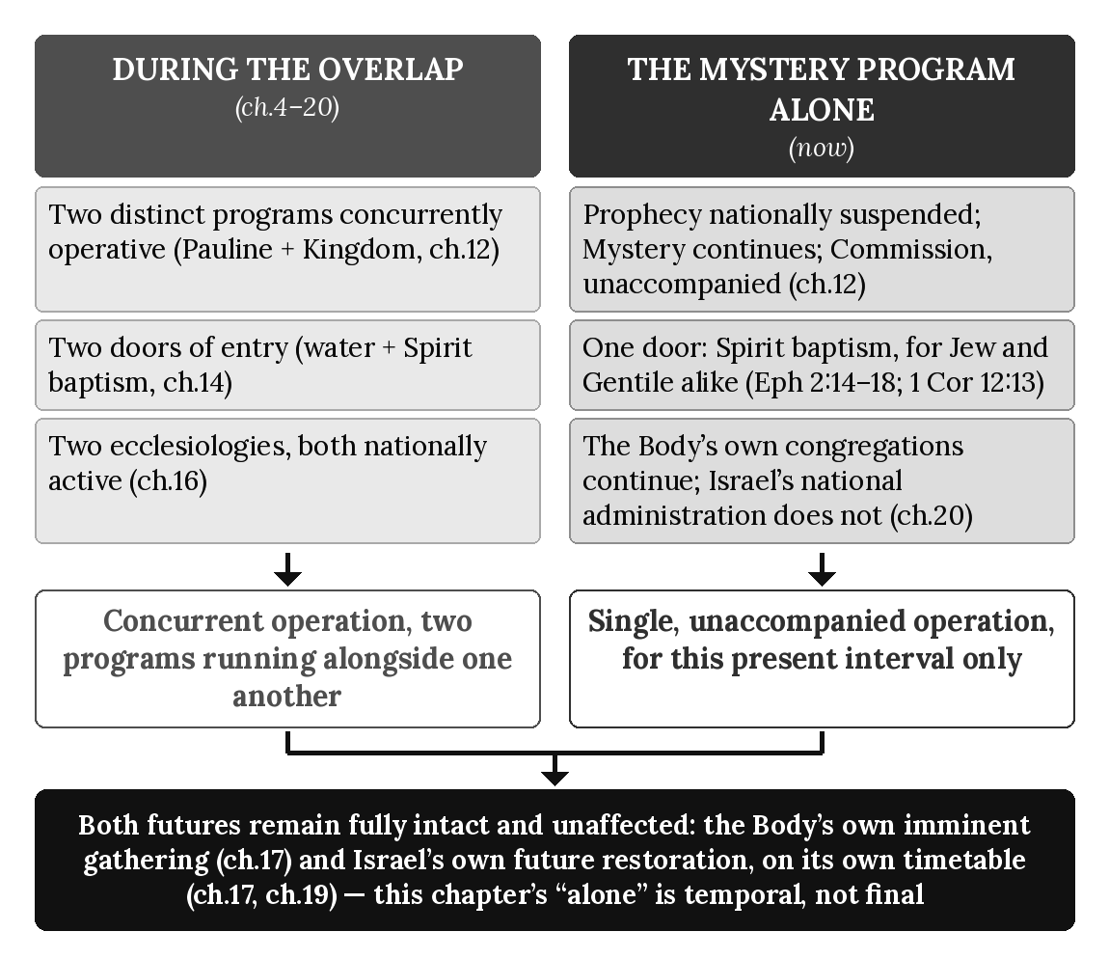

Chapter Summary
The Mystery Program operates alone, for this present interval, in every respect this chapter has traced: one commission, the Pauline Commission’s own “message of reconciliation” (2 Corinthians 5:17–20), unaccompanied by any concurrent operation of Israel’s Prophecy Program; one door of entry, belief alone in the gospel Paul preached, open to Jew and Gentile alike on identical terms (1 Corinthians 15:1–4; Ephesians 2:8–9); one ecclesiology in national operation, the Body’s own Pauline congregations (chapter 16). Both futures this book has traced remain fully intact: the Body’s own imminent, unconditioned gathering (chapter 17), and Israel’s own future restoration, bounded but certain, awaiting the timetable chapter 19 already named. This closes Book 1’s twenty-one-chapter core argument. What follows are the Appendices (A–U), each a reference tool drawn from the material this book has already established rather than a new doctrinal claim, and, beyond this volume, the remaining four books of this series — including Book 4’s own exegetical deep dive into the Mystery Program this final chapter has just described operating on its own.

Key Terms
This Present Interval — This book’s own term for the period beginning at the boundary chapter 20 named, in which the Mystery Program operates alone, without the concurrent national operation of Israel’s Prophecy Program, until Israel’s Prophecy Program resumes according to God’s prophetic timetable (chapter 19).
The Single Door — This chapter’s term for the Mystery Program’s own entry terms — Spirit baptism by faith alone (chapters 14–15) — as the sole presently operating administration of entry for Jew and Gentile alike, without implying any cancellation of Israel’s own distinct future hope (chapter 19).

Reflection and Teaching Questions
- Why does this chapter insist that nothing in it is new doctrine, but rather this book’s own prior argument “stated one final time as a single, integrated present reality”?
- How does the single-door doctrine avoid claiming that Israel’s own distinct future hope has been canceled, even while claiming that Jew and Gentile presently enter by the same door?
- In what sense is the Mystery Program’s operation “alone” a temporal condition rather than this book’s final word on Israel’s own future, according to this chapter’s closing section?
- Looking back across chapters 12 through 21, how does 2 Corinthians 5:17–20’s “message of reconciliation” gather up the Two Commissions, Two Baptisms, Two Justifications, Two Ecclesiologies, and Two Eschatologies this book has traced into a single, coherent present mission?

Appendix A: Acts Timeline

The Canonical Five-Marker Timeline
Every chapter in this book ultimately locates itself against one of five fixed markers, first stated in chapter 3’s own preview and repeated throughout this book:
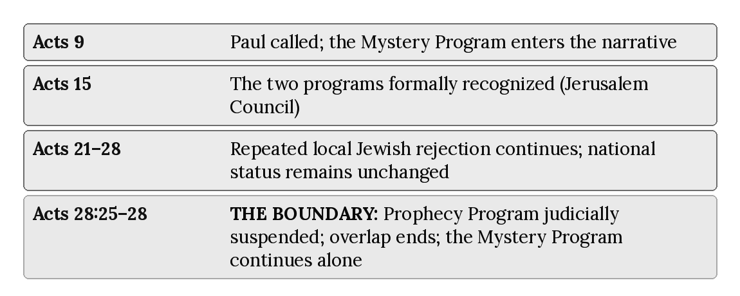

The Full Timeline
The table below expands this five-marker spine into every scene this book has actually cited, in narrative order, tagged by which program each scene belongs to and cross-referenced to the chapter that treats it. “Kingdom” marks a scene belonging to Israel’s Prophecy Program; “Mystery” marks a scene belonging to the Body of Christ’s Mystery Program; “Overlap” marks a scene in which both programs are directly in view at once. A scene tagged “Overlap (sign)” records one of Paul’s signs in an overlap-context setting, not a Mystery-Program sign; the sign at Malta is tagged “Kingdom” as Prophecy Program sign-authentication at full strength.
Reference | Event | Program | Chapter(s)
Acts 1:6–8 | The apostles ask about restoring the kingdom to Israel; Jesus answers without denying the hope, only its timing | Kingdom | 1, 9, 18
Acts 1:21–26 | Matthias chosen to complete the Twelve, qualified by continuous earthly companionship with Jesus | Kingdom (contrast) | 5
Acts 2:5–11 | Pentecost: Jews “from every nation” gathered in Jerusalem | Kingdom | 1
Acts 2:38 | Peter’s command: repent and be baptized “for the forgiveness of your sins” | Kingdom | 1, 14
Acts 2:41–47 | The Jerusalem assembly formed: water baptism, apostles’ teaching, daily Temple worship | Kingdom | 16
Acts 3:1–10 | Peter and John heal the lame man at the Temple gate | Kingdom | 8 (sign pattern)
Acts 3:19–21 | Peter’s offer: national repentance, followed by “times of refreshment” and the Messiah’s return | Kingdom | 1, 17, 18
Acts 5:1–16 | Ananias and Sapphira; the apostles’ own sign-authenticated ministry continues | Kingdom | 6, 8
Acts 8:26–39 | Philip and the Ethiopian eunuch | Kingdom | 3 (lens example)
Acts 9:1–22 | Paul’s conversion on the Damascus road; the Mystery Program enters the narrative | Overlap begins | 4
Acts 9:15–16 | Ananias’s vision; the threefold commission — before Gentiles, kings, and the people of Israel | Mystery | 4
Acts 9:20–22 | Paul’s early preaching, continuous in method with existing synagogue practice | Overlap | 4
Acts 9:32–43 | Peter’s continuing Kingdom ministry (Aeneas, Dorcas) — “meanwhile, unchanged” | Kingdom | 4, 6
Acts 10:9–48 | Cornelius’s household: a Prophecy Program event inside the overlap, with Gentile blessing in connection with Israel’s restoration | Kingdom | 6, 10
Acts 11:27–30 | The famine-relief visit to Jerusalem (chronology note relevant to Galatians 2) | Overlap | 7
Acts 13:9–11 | Paul strikes Elymas blind at Paphos | Overlap (sign; overlap-context, not Mystery-Program) | 8
Acts 13:44–48 | Pisidian Antioch: the pattern of partial belief, majority rejection, and a local turn to the Gentiles begins | Kingdom | 9
Acts 14:1–2 | Iconium: the pattern repeats | Kingdom | 9
Acts 14:8–10 | Healing of the man lame from birth at Lystra | Overlap (sign; overlap-context, not Mystery-Program) | 8
Acts 14:21–23 | Paul and Barnabas appoint elders in every Pauline church | Mystery | 11
Acts 15:1–21 | The Jerusalem Council: the two apostleships formally recognize one another | Overlap | 7
Acts 16:16–18 | The slave girl with a spirit of divination, at Philippi | Overlap (sign; overlap-context, not Mystery-Program) | 8
Acts 17:1–9 | Thessalonica: the pattern continues | Kingdom | 9
Acts 18:4–6 | Corinth: “your blood is upon your own heads” | Kingdom | 9
Acts 19:1–5 | The Ephesian disciples are baptized “in the name of the Lord Jesus” | Kingdom | 14
Acts 19:8–9 | Ephesus: “some became stubborn” — hardening named explicitly | Kingdom | 9
Acts 19:11–12 | “Unusual miracles” at Ephesus | Overlap (sign; overlap-context, not Mystery-Program) | 8
Acts 20:17–31 | Paul’s farewell to the Ephesian elders | Mystery | 11
Acts 22:16 | Paul’s own water baptism, recounted before the Jerusalem crowd | Kingdom | 14
Acts 26:16–19 | Paul’s defense before Agrippa; the Pauline Commission’s own terms stated in full | Mystery | 5, 12
Acts 28:1–9 | Malta: the last sign recorded in Acts | Kingdom (Prophecy Program sign-authentication, full strength) | 8
Acts 28:17–22 | Paul summons Rome’s Jewish leaders, still “the Jew first,” even from custody | Kingdom | 18
Acts 28:23–28 | The appointed day; the divided response; Isaiah’s verdict pronounced — THE BOUNDARY | Kingdom (closing) | 9, 18, 19, 20
Acts 28:30–31 | The two-year coda: Paul teaches all who visit him; Acts’ own narrative ends | Mystery (alone) | 18, 20, 21

Notes on This Timeline
This timeline does not add any event to Acts beyond what the twenty-one chapters have already cited and dated. Its purpose is navigational: a reader working through a specific chapter’s Scripture citations can locate that citation’s place in the larger Acts narrative at a glance, and a reader working through Acts itself can locate which chapter of this book treats any given scene.
Two entries deserve a note on their program tag. Acts 10:9–48 (Cornelius) is tagged Kingdom rather than Mystery, following chapter 10’s own argument: every marker of that episode — Peter’s own apostolic authority, water baptism as the confirming rite, and a Spirit-sign matching Pentecost’s own pattern — belongs to Israel’s prophetic line — a Prophecy Program event inside the overlap, in which Gentiles are blessed in connection with Israel’s restoration (Amos 9; Romans 11’s olive tree) — not to the Mystery Program’s later, categorically different “one new people” (Ephesians 2–3), which this timeline locates instead at Acts 9’s own opening and in Paul’s own subsequent ministry. Acts 9:20–22 is tagged Overlap rather than Mystery outright, following chapter 4’s own argument that Paul’s earliest preaching is continuous with existing practice before the Mystery’s fuller content is later given to him.

Appendix B: Two Programs Chart

The Canonical Two Programs Chart (Chapter 3)
Chapter 3 states directly that its own summary chart “is the version chapters 5 through 21 and Appendix B will cite.” It is reproduced here unchanged, exactly as chapter 3 established it, as this appendix’s own foundation:
 | Israel’s Prophecy Program | Body of Christ’s Mystery Program
Covenant status | Covenantal | Non-covenantal
Destiny | Earthly | Heavenly
Scope | National | Universal
Authority | The Twelve | Paul
Baptism | Water | Spirit
Signs | Present throughout the overlap; judicially ceases at Acts 28 | Absent
Temple | Central | Not applicable
Commission | Kingdom Commission | Pauline Commission

Extending the Chart: Three Rows Chapter 3 Could Not Yet State
Chapter 3 was written before chapters 12 through 17 had argued their own material in full, so its own chart already anticipates Destiny (fully argued in chapter 13), Baptism (chapter 14), and Commission (chapter 12) without duplication here. Three further comparison dimensions — justification, ecclesiology, and eschatology — were established later, in chapters 15 through 17, and were not yet part of chapter 3’s own chart. They are added here, in the same format, each drawn directly from its own chapter’s “Pattern, Summarized” table:
 | Israel’s Prophecy Program | Body of Christ’s Mystery Program
Justification (content of faith) | Faith in what God revealed to Israel, with repentance, water baptism, and a working faith as program requirements, not merit (Acts 2:38; James 2:17, 24; chapter 15) | Faith alone in the gospel of the grace of God, apart from works of the law (Romans 3:28; Galatians 2:16; chapter 15)
Ecclesiology | The Jerusalem assembly, entered by water baptism, Temple-centered (Acts 2:41–47; chapter 16) | The Body of Christ, entered by Spirit baptism, with no geographic center (Ephesians 1:22–23; chapter 16)
Eschatology | A conditioned, prophesied restoration, culminating in the Messiah’s return to a restored earth (Acts 3:19–21; chapter 17) | An unconditioned, unprophesied gathering to meet the Lord in the air (1 Thessalonians 4:16–17; chapter 17)

The Full Master Chart
Combined, the eleven rows chapters 1 through 17 have established form a single reference chart — the complete comparative shape of the Acts Overlap Model in one place:
Category | Israel’s Prophecy Program | Body of Christ’s Mystery Program
Covenant status | Covenantal | Non-covenantal
Destiny | Earthly | Heavenly
Scope | National | Universal
Authority | The Twelve | Paul
Baptism | Water | Spirit
Signs | Present throughout the overlap; judicially ceases at Acts 28 | Absent
Temple | Central | Not applicable
Commission | Kingdom Commission | Pauline Commission
Justification | Faith accompanied by repentance, baptism, and works | Faith alone
Ecclesiology | The Jerusalem assembly | The Body of Christ
Eschatology | Conditioned, prophesied restoration | Unconditioned, unprophesied gathering

Notes on This Chart
This appendix introduces no comparison not already fully argued in its own chapter. Each row’s chapter citation in the tables above points to the chapter where the claim is exegeted in full — this chart is a navigational summary, not an independent argument, and should be read alongside Appendix S (Program Separation Map), which states the assignment rule governing each of these categories, and Appendix F (Dispensational Glossary), which defines each term used here.
On the Signs row: With the national suspension of Israel’s Prophecy Program at Acts 28, the sign-program associated with Israel ceases programmatically.

Appendix C: Acts Overlap Diagram

What “Overlap” Means
Chapter 3 was careful to name this period an overlap rather than a transition: “Both programs operate simultaneously. Both sets of apostles minister. Both commissions are active. Both messages appear. Both audiences are addressed. Both sets of signs appear throughout the overlap. Both destinies are preached. Both ecclesiologies exist in parallel.” Nothing about Acts 9 through 28 is one program dissolving into another; it is two programs, each fully itself, operating at once — a relationship this book’s twenty-one chapters have traced in exegetical detail and this appendix now presents as a single navigational picture.

The Canonical Diagram
This diagram is reproduced exactly as it first appears in this book, unchanged, because every later citation of it matches its canonical version:

Walk-Through: Acts 9 — Paul Called
Paul’s own conversion on the Damascus road (Acts 9:1–22) is the point at which the Mystery Program first enters the narrative of Acts. It does not displace the Prophecy Program, which chapter 4 traces continuing in the very same chapter through Peter’s own ongoing ministry (Acts 9:32–43) — “meanwhile, unchanged.” This marker begins the overlap; it does not end anything. (Chapter 4.)

Walk-Through: Acts 15 — Two Programs Formally Acknowledged
At the Jerusalem Council, the two apostleships recognize one another directly rather than merging: Peter and James affirm Paul’s own distinct, unencumbered apostleship to the Gentiles, while James’s own ruling addresses a Prophecy-Program question specific to Gentiles in Jewish-associated communities. This is the overlap’s own formal, mutual acknowledgment — two programs, two apostleships, operating in parallel with each other’s knowledge and consent. (Chapter 7.)

Walk-Through: Acts 21–28 — Local Rejection Continues; National Status Unchanged
Across this span, Acts records repeated local Jewish rejection at Pisidian Antioch, Iconium, Thessalonica, Corinth, and Ephesus. These events are genuine and consequential in their local settings, but they do not progressively narrow Israel’s national programmatic standing. Paul continues to address Jewish audiences afterward. Acts 28 alone marks the categorically distinct national judicial verdict and suspension of Israel’s Prophecy Program. (Chapter 9.)

Walk-Through: Acts 28 — Israel Judicially Blinded
At Rome, the pattern traced above reaches its national and final form: Paul’s appeal to the local Jewish leaders (Acts 28:17–22), the appointed day’s divided response (Acts 28:23–24), and Isaiah’s own words pronounced as verdict (Acts 28:25–28) — the boundary this entire book treats as fixed. What closes here is real and specific: the sign-gift’s active ministry, the Prophecy Program’s national administration, and the concurrent prophetic setting within which Paul had ministered to Israel while retaining his one distinctive Mystery commission. What does not close is equally specific: the covenant promises, the believing remnant, and Israel’s own future restoration, each still fully intact on the far side of this marker. (Chapters 18, 19, 20.)

Walk-Through: Post-Acts 28 — The Mystery Program Alone
Past this boundary, the Mystery Program continues operating on its own terms — the same commission, the same entry by faith, the same congregations, the same imminent hope it held throughout the overlap — but no longer running alongside an actively administered Prophecy Program. This is a temporal condition, not a final word: when the interval this marker begins reaches its own appointed end, Israel’s Prophecy Program resumes according to God’s preserved covenants, promises, and prophetic timetable, and Israel’s own restoration proceeds on the timetable chapters 17 and 19 have already traced. (Chapter 21.)

Notes on This Diagram
This appendix adds no marker to this book’s own canonical diagram and no claim beyond what the book’s own chapters have already argued in full. Its purpose is to give the diagram — often cited in isolation throughout this book — its own fuller annotation in one place, for readers who want the diagram’s five marker labels expanded into their governing argument without paging back through twenty-one chapters to find it. Appendix A’s fuller timeline and Appendix R’s diagnostic flowchart both build on the same five markers from a different angle: Appendix A supplies every cited scene in narrative order; Appendix R supplies a step-by-step procedure for classifying a passage not yet covered by either.

Appendix D: Signs & Wonders Diagnostic

The Diagnostic Checklist
Chapter 8 established the governing rule: Paul’s signs are overlap phenomena, recorded in settings shaped by Israel’s Prophecy Program and reported as written, present at full strength throughout the overlap, then absent from the record after Acts 28 rather than fading gradually. With the national suspension of Israel’s Prophecy Program at Acts 28, the sign-program associated with Israel ceases programmatically. Four questions, drawn directly from that chapter’s own argument, diagnose any sign-event in Acts or the epistles:
- Does this event occur before or after Acts 28:25–28? Before: recorded in a setting shaped by Israel’s Prophecy Program, reported as written and not assigned to a single program. After: no sign-event is recorded anywhere in Acts or the epistles — the absence itself is the diagnostic (chapter 8).
- Who performs it, and under what authority? Every sign in Acts is performed by the Twelve, their associates, or Paul, recorded in settings shaped by Israel’s Prophecy Program (chapters 6, 8) — never offered as evidence of the Mystery Program’s own content, which chapter 2 established as revelation-based rather than sign-based.
- What does it authenticate? A sign in Acts is recorded as confirming the message preached in its setting (chapter 1’s pattern), not personal piety, general spiritual power, or, on its own, any doctrine belonging to the Mystery.
- Does its absence, where a sign would otherwise be expected, confirm the boundary? Chapter 8 traced three post-Acts-28 passages where a miracle is narratively anticipated and conspicuously withheld — itself diagnostic evidence for the judicial cessation, not merely a gap in the record.

Catalog: Every Sign or Wonder Cited in This Book
Reference | Event | Diagnosis | Chapter(s)
Acts 2:43 | “Many miraculous signs and wonders” performed by the apostles at Pentecost | Kingdom, full strength | 1, 16
Acts 3:1–10 | The lame man healed at the Temple gate | Kingdom, full strength | 1, 8 (pattern)
Acts 5:1–11 | Ananias and Sapphira | Kingdom, judgment-sign | 6, 8
Acts 5:12–16 | “Many miraculous signs and wonders”; Peter’s own shadow brings healing | Kingdom, full strength | 6, 8
Acts 9:32–35 | Aeneas healed at Lydda | Kingdom, full strength | 4, 6
Acts 9:36–42 | Dorcas raised at Joppa | Kingdom, full strength | 4, 6
Acts 10:44–46 | The Spirit falls on Cornelius’s household; tongues | Kingdom, inclusion-sign | 6, 10
Acts 13:9–11 | Elymas blinded at Paphos | Overlap-context sign, reported as written (Paul); not a Mystery-Program sign | 8
Acts 14:8–10 | The man lame from birth healed at Lystra | Overlap-context sign, reported as written (Paul); not a Mystery-Program sign | 8
Acts 16:16–18 | A spirit of divination cast out at Philippi | Overlap-context sign, reported as written (Paul); not a Mystery-Program sign | 8
Acts 19:11–12 | “Unusual miracles” at Ephesus | Overlap-context sign, reported as written (Paul); not a Mystery-Program sign | 8
Acts 28:1–9 | Malta: the snakebite survived, Publius’s father and others healed | Kingdom: Prophecy Program sign-authentication at full strength, the last recorded sign in Acts | 8
Acts 28:25–28 | Isaiah’s verdict pronounced | Not a sign-event — the boundary itself | 8, 18, 19, 20
Philippians 2:25–27 | Epaphroditus’s illness; “God had mercy” | Absent — confirms the boundary | 8
1 Timothy 5:23 | Timothy’s chronic stomach ailment | Absent — confirms the boundary | 8
2 Timothy 4:20 | “I left Trophimus sick at Miletus” | Absent — confirms the boundary | 8

Notes on This Diagnostic
Every diagnosis in this catalog restates a conclusion chapter 8 already argued in full; this appendix organizes rather than extends that argument, so a reader encountering a new sign-event elsewhere in Acts or the epistles can apply the four-question checklist directly rather than re-deriving chapter 8’s own reasoning. Two rows deserve a brief flag. Acts 5:1–11 (Ananias and Sapphira) is tagged a judgment-sign rather than a healing-sign — its authenticating force lies in the severity of the consequence, not in restoration, but it belongs to the same Prophecy-Program pattern chapter 6 traces from Peter’s own authority. Acts 10:44–46 (Cornelius) is tagged an inclusion-sign, following chapter 10’s own argument that this episode’s tongues match Pentecost’s own pattern (Acts 2) rather than introducing a second, Mystery-Program sign-gift; see Appendix A’s own note on this same passage.

Appendix E: Paul vs. Peter Authority Map

The Two Apostleships, Side by Side
Chapters 5 and 6 examined Paul’s and Peter’s apostleships in full, each on its own terms, before chapter 3’s summary chart and chapter 6’s own closing diagram set them side by side. This appendix reproduces that comparison as a single reference table, adding one dimension — commission — that chapter 12 supplied after chapters 5 and 6 were already written:
Feature | Peter’s Circumcision Apostleship | Paul’s Heavenly Apostleship
Commissioning source | The earthly Jesus, before the cross (Matthew 16:18–19) | The glorified, ascended Christ (Acts 9; 26:19)
Basis of authority | Delegated: “the keys of the Kingdom of Heaven” (Matthew 16:19) | Direct revelation, underived: “from no human source” (Galatians 1:11–12)
Commission | The Kingdom Commission (Matthew 28:18–20) — water baptism, obedience-teaching | The Pauline Commission (Acts 26:16–18) — eye-opening, forgiveness, inclusion by faith
Scope / audience | Diaspora Israel, “the Jews” (Galatians 2:7; 1 Peter 1:1) | The Gentiles, and Israel during the Acts Overlap (Romans 15:16; Acts 26:17)
Self-description | “Royal priests, a holy nation” — Sinai’s own covenant vocabulary (1 Peter 2:9–10) | “The least of all the apostles”... “as though I had been born at the wrong time” (1 Corinthians 15:8–10)
Relationship to signs | Full strength throughout: multitudes healed by his own shadow (Acts 5:12–16) | Recorded in the overlap, in settings shaped by Israel’s Prophecy Program; reported as written, not assigned to a single program (2 Corinthians 12:11–12; Appendix D)
Scope exception | Cornelius (Acts 10) — a singular, divinely orchestrated exception, not a redefinition of his ongoing ministry (Acts 15:7–9) | None on the Gentile side; the exception runs the other direction — his synagogue ministry to Jews, audience-specific and not commission-specific (Acts 13:46)
Destiny in view | Earthly: “twelve thrones, judging the twelve tribes of Israel” (Matthew 19:28) | Heavenly: “seated... with him in the heavenly realms” (Ephesians 2:6)
Duration | Active throughout the overlap; the Concurrent Prophetic Setting’s own administration suspended at Acts 28 (chapters 8–9, 18–20) | Permanent; continues beyond Acts 28 within the Mystery Program (chapter 21)
Both apostleships are fully authoritative — Paul does not consider himself “inferior in any way” to the Jerusalem apostles (2 Corinthians 11:5) — and both are formally, mutually recognized at the Jerusalem Council (Galatians 2:7–9; chapter 7). The comparison above states two apostleships equal in authority and simultaneous in time, not one superseding the other.

Authority Lines Plotted Against the Acts Timeline
Chapter 6’s own diagram sets the two apostleships side by side as a static comparison. This diagram instead plots both authority lines against the same five markers Appendix A uses to organize the entire book, showing where each apostleship is active, and where the two lines run alongside one another rather than in sequence:
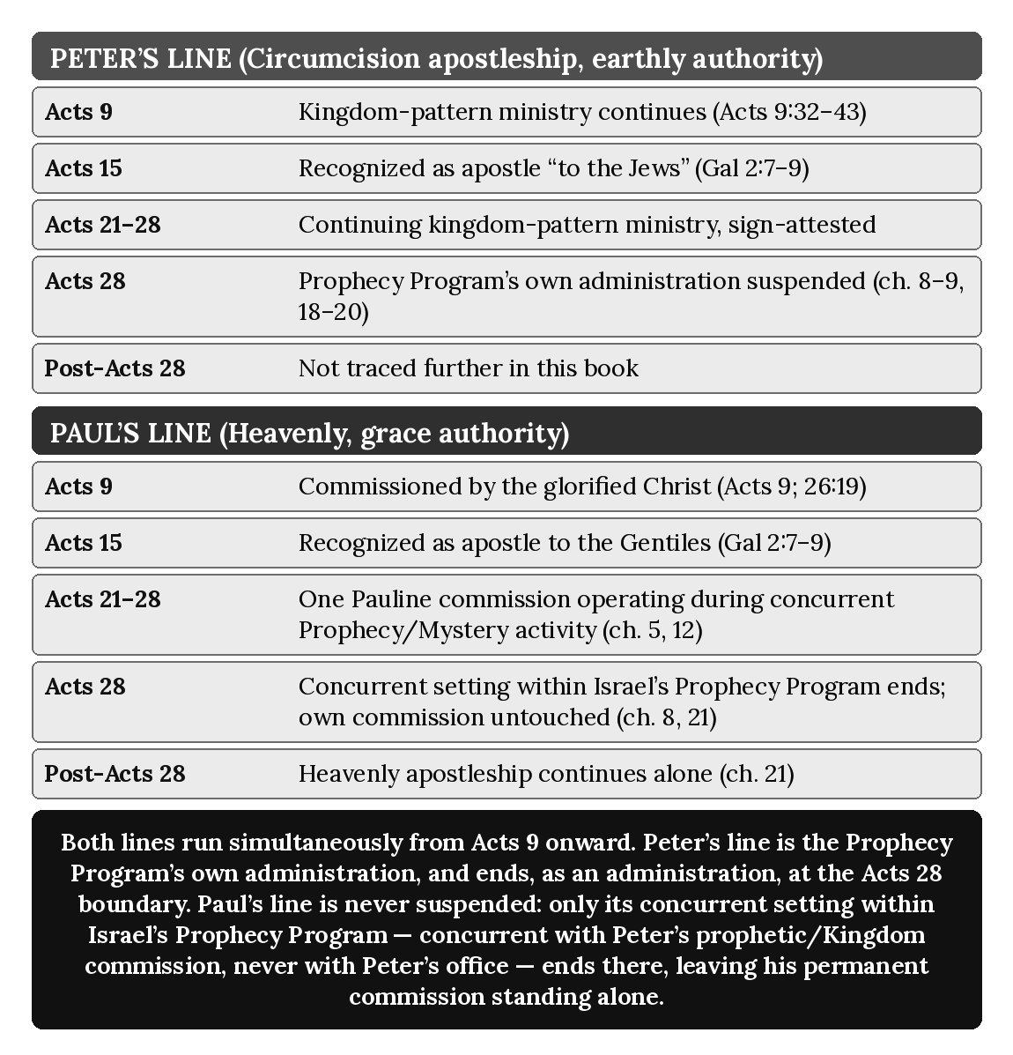

Notes on This Map
This appendix introduces no claim about either apostleship beyond what chapters 5, 6, and 12 have already argued. Peter’s line is not traced beyond Acts 28 because this book does not trace his ministry that far; what occurs at Acts 28 is the national judicial suspension of Israel’s Prophecy Program, not a claim about Peter’s person. Paul’s line continues because his apostleship, commission, and stewardship remain distinctly Mystery. During Acts 9–28 he may minister within Israel’s still-operative prophetic setting without administering that program. Acts 28 changes Israel’s national programmatic status; it does not terminate a supposed second Pauline role.

Appendix F: Dispensational Glossary

Note on This Glossary
Every term below is drawn verbatim from a chapter’s own “Key Terms” section (chapters 1–21); no new term or definition is introduced here. Entries are filed alphabetically by their main word, ignoring a leading “The” or “This” (so, for example, “The Jerusalem Decree” files under J, and “This Present Interval” files under P). Two consolidations are made openly. First, chapter 2 defines “The One New Man” and chapter 10 later defines the fuller term “One New People (‘One New Man’)” covering the same reality from the same Greek phrase (kainon anthropon, Ephesians 2:15); rather than list the same doctrine twice under two headwords, this glossary merges them into a single entry citing both chapters. Second, chapter 2’s “Dispensation of Grace” and chapter 3’s “Dispensation (oikonomia)” define the same administration and are merged likewise. Cross-references (“See also,” “Not to be confused with”) have been added between paired or easily conflated terms; every cross-reference points to a distinction each chapter involved has already argued in full.

Glossary
Abrahamic Covenant — The unconditional covenant (Genesis 12, 15, 17) promising Abraham’s descendants a nation, a land, and a mediating blessing to the world. (Chapter 1.)
Acts Overlap Model — This series’ name for the thesis that Israel’s Prophecy Program and the Body of Christ’s Mystery Program operate concurrently during Acts 9–28. (Chapter 3.)
Antioch Incident — Paul’s public rebuke of Peter (Galatians 2:11–14) for withdrawing from table fellowship with Gentile believers under pressure, illustrating how easily the Jerusalem Council’s boundary could be practically compromised even by its own participants. (Chapter 7.)
Apostle to the Circumcision — Paul’s own description (Galatians 2:7–9) of Peter’s ongoing apostolic scope, confirmed by Peter’s own epistolary address to Diaspora Israel (1 Peter 1:1). See also Heavenly Apostleship, Keys of the Kingdom. (Chapter 6.)
Arabia Interval — The roughly three-year period (Galatians 1:17–18) between Saul’s commissioning and his first meeting with Peter, during which Paul remained independent of consultation with the Jerusalem apostles while receiving and developing the revelation entrusted to his ministry. (Chapter 4.)
Concurrent Prophetic Setting — Chapter 12’s term for Israel’s Prophecy Program remaining concurrently operative during the Acts Overlap while Paul carries out his distinct Mystery commission without thereby holding or sharing the Kingdom Commission itself. (Chapter 12; see chapter 5.)
Damascus Road — The location and event of Saul’s confrontation by the risen Christ (Acts 9:3–9), marking the datable beginning of the overlap between Israel’s Prophecy Program and the Body of Christ’s Mystery Program. (Chapter 4.)
Davidic Covenant — The covenant (2 Samuel 7) promising David an eternal dynasty, throne, and kingdom, fulfilled ultimately in the Messiah. (Chapter 1.)
Destiny Assignment Rule — This series’ governing principle (stated in chapter 13, building on chapter 11’s warning against reading mixed audiences as one): destiny is assigned strictly by program membership, never by ethnicity or by mere presence in a mixed narrative scene. See also Earthly Destiny, Heavenly Destiny. (Chapter 13.)
Direct Revelation — Paul’s own description of how he received the mystery: “not based on mere human reasoning... from no human source... by direct revelation from Jesus Christ” (Galatians 1:11–12). (Chapter 2.)
Dispensation (oikonomia) / Dispensation of Grace — An administration or stewardship; Paul’s own term (Ephesians 3:2) for the distinct economy under which his Gentile ministry and the mystery operate, apart from the kingdom-offer administration of chapter 1. (Chapters 2 and 3.)
Earthly Destiny — The Prophecy Program’s own destiny: a restored, national Israel governing a renewed earth under Davidic and Abrahamic covenant promise (Acts 1:6–7; Matthew 5:5; 19:28). See also Heavenly Destiny. (Chapter 13.)
Ekklēsia — “Called-out assembly”; the general Greek term underlying “church” in Matthew 16:18, not to be conflated with Paul’s later technical description of the Body of Christ. (Chapter 6; see chapter 2.)
Ektrōma — “Untimely born” (1 Corinthians 15:8); Paul’s own description of his irregular entry into apostleship, outside the process Acts 1:21–22 describes for the Twelve. (Chapter 5.)
Elder/Overseer (Ephesian Pattern) — The local leadership office Paul appoints in every church he founds (Acts 14:23), charged directly by the Holy Spirit (Acts 20:28) rather than by delegation from Jerusalem or the Twelve. (Chapter 11.)
Four Distinct Groups — This series’ classification of the groups an Acts scene can contain: (1) Jews under the Prophecy Program (the covenant nation, with a prophetic identity, who never become the Body); (2) Gentiles responding to the Mystery Program (non-covenantal, entering the Body upon belief, distinct from Israel); (3) mixed audiences (a physical category only: Jews and Gentiles in the same room, not a program and not a spiritual group, a narrative condition only); and (4) the Body of Christ proper (Jew and Gentile without distinction, with a Mystery identity and a heavenly destiny). Mixed audiences are not a spiritual group but a physical audience condition that must be interpreted correctly during the overlap; “Gentiles responding to the Mystery” names the entry condition, not a separate group overlapping the Body; and unbelieving Israel is not one of the four, because the doctrine concerns programmatic identity, not general anthropology. (Chapter 11.)
Hardening — The vocabulary Acts 19:9 first applies locally at Ephesus (“became stubborn”) and Isaiah’s prophecy applies nationally at Acts 28:26–27; a settled resistance distinct from simple disagreement or delay. Not to be confused with Judicial Cessation of Signs, which is tied to Acts 28 and the national suspension of the Prophecy Program, and is categorical and instantaneous rather than gradual. (Chapter 9.)
Heavenly Apostleship — This series’ term for Paul’s apostolic office, grounded not in earthly companionship with Jesus but in a direct, heavenly commissioning from the risen and glorified Christ (Acts 26:19; Galatians 1:1). See also Apostle to the Circumcision, Keys of the Kingdom. (Chapter 5.)
Heavenly Destiny — The Mystery Program’s own destiny: every spiritual blessing located in the heavenly realms, already true by union with Christ and fully revealed at his appearing (Ephesians 1:3; 2:6; Colossians 3:1–4). See also Earthly Destiny. (Chapter 13.)
Israel’s Remnant — Paul’s own term (Romans 11:5) for individual Israelites who continue believing throughout the blinding, chosen by grace, standing alongside — never in tension with — the nation’s own corporate hardening; Israel’s prophetic believing company, which never becomes the Body. (Chapter 19.)
Jerusalem Council — The meeting recorded in Acts 15 and Galatians 2, at which the Jerusalem apostles formally recognized Paul’s distinct, unencumbered apostleship to the Gentiles. (Chapter 7.)
Jerusalem Decree — James’s ruling (Acts 15:19–21) that Gentiles need not be circumcised, but should observe several Levitical-pattern requirements; addressed to Gentiles in Jewish-associated communities generally, not cited by Paul as binding on his own Gentile converts. (Chapter 7.)
Judicial Blinding — The national, corporate hardening Isaiah’s words pronounce over Israel at Acts 28:26–27, real but partial, temporary, and non-covenant-canceling, as Romans 11 qualifies it. Not to be confused with Judicial Cessation of Signs: one is Israel’s national response, the other is the end of the sign-program associated with Israel; both occur at the same Acts 28 boundary but are argumentatively distinct (see chapter 8’s own caution). (Chapter 19.)
Judicial Cessation of Signs — The programmatic, non-gradual end of Prophecy-Program sign-authentication, caused by the Acts 28 judicial suspension of that program: with the national suspension of Israel’s Prophecy Program at Acts 28, the sign-program associated with Israel ceases programmatically. See also Local Jewish Rejection and the National Verdict, Judicial Blinding, and Appendix D. (Chapter 8.)
Keys of the Kingdom — The delegated binding-and-loosing authority Jesus promises Peter (Matthew 16:19), exercised throughout Acts within the Prophecy Program’s own administration. (Chapter 6.)
Kingdom Commission — The charge Christ gives the Eleven in Matthew 28:18–20: making disciples of all nations through water baptism and obedience-teaching, serving within Israel’s Prophecy Program until its national judicial suspension at Acts 28. See also Pauline Commission. (Chapter 12.)
Local Jewish Rejection and the National Verdict — The distinction between recurring local Jewish rejection with local ministry consequences and the categorically different Acts 28 national judicial suspension. Earlier local rejections do not progressively alter Israel’s national programmatic standing. (Chapter 9.)
The Male Child (Revelation 12:5) — This book’s identification of the child caught up to God and his throne as the 144,000, Israel’s sealed firstfruits company, and not the individual person of Christ; supported by the verb harpazō, by the child’s removal in Revelation 12:5 and the company’s appearance in Revelation 14:1–5 as one company at two points, and by the rod-of-iron authority shared with overcomers (Revelation 2:26–27). (Chapter 17.)
Malta (Acts 28:1–9) — The last sign-miracle recorded in Acts, occurring within Acts 28 but before the judicial pronouncement of Acts 28:25–28. (Chapter 8.)
Mystery (mystērion) — A sacred secret: content deliberately hidden throughout previous revelation and disclosed for the first time at a specific point in redemptive history, as distinct from prophecy, which announces in advance what will later be recognized as fulfilled. (Chapter 2.)
Mystery-Program Ecclesia — The Body of Christ described in Ephesians 1:22–23, Colossians 1:18, and 1 Corinthians 12:27: a single, non-local entity headed directly by Christ, entered by Spirit baptism, whose local, visible gatherings are the Pauline congregations chapter 11 traced. See also Prophecy-Program Community. (Chapter 16.)
Mystery-Program Eschatology — The Body of Christ’s own future hope: an unconditioned, unprophesied gathering to meet the Lord in the air (1 Thessalonians 4:16–17), explicitly named “a wonderful secret” (1 Corinthians 15:51) rather than a fulfillment of Israel’s own prophetic timeline. See also Prophecy-Program Eschatology. (Chapter 17.)
Mystery-Program Justification — The Body is made right with God by believing Pauline revelation, the gospel of the grace of God, through faith alone, apart from any works of the law, a gift rather than a reward (Romans 3:28; Galatians 2:16; Ephesians 2:8–9), addressed to the Body’s “one new people.” See also Prophecy-Program Forgiveness. (Chapter 15; see chapter 10.)
New Covenant (Israel’s) — The covenant (Jeremiah 31:31–34) made explicitly “with the people of Israel and Judah,” promising an internalized law and a permanently secured national relationship with God; not to be confused with the non-covenantal Mystery Program. (Chapter 1; see chapter 2.)
One New People (“One New Man”) — This series’ term (following the traditional rendering of Ephesians 2:15’s Greek, kainon anthropon; NLT: “one new people”) for the Mystery Program’s form of Gentile inclusion: the creation, in Christ, of a single new corporate entity from Jew and Gentile together, made known as part of the Mystery revealed through Paul (Ephesians 2:14–16; 3:4–6). Contrast Prophecy-Program Gentile Inclusion. (Chapters 2 and 10.)
Overlap’s Boundary — This book’s own term for the specific pronouncement of Acts 28:25–28, at which the sign-authentication ministry associated with Israel’s prophetic setting ceases and Israel’s Prophecy Program is nationally and judicially suspended, bringing its concurrent operation alongside Paul’s Mystery ministry to an end, while the covenant promises, the believing remnant, and Israel’s future restoration remain unaffected. (Chapter 20.)
Pauline Church — This series’ term for a congregation founded under Paul’s own apostolic commission: locally led by elders/overseers, doctrinally answerable to Paul’s teaching alone, and gathered in homes rather than the temple. Mixed audiences in Acts do not automatically constitute the Body of Christ; the Body is defined by the Mystery revelation, not by physical proximity. (Chapter 11.)
Pauline Commission — The charge Christ gives Paul independently (Acts 26:16–18; Galatians 1:11–12): opening Gentile eyes and including them, by faith, among God’s people; Paul’s own distinct commission, continuing alone after Acts 28. See also Kingdom Commission. (Chapter 12.)
Present Interval — This book’s own term (“this present interval”) for the period beginning at the boundary chapter 20 named, in which the Mystery Program operates alone, without the concurrent national operation of Israel’s Prophecy Program, until Israel’s Prophecy Program resumes according to God’s prophetic timetable. (Chapter 21; see chapter 19.)
Prophecy-Program Community — The Jerusalem assembly of Acts 2:41–47: Jewish believers added by water baptism to a single, Temple-centered fellowship, taught by the Twelve, and continuous with Israel’s own covenants. See also Mystery-Program Ecclesia. (Chapter 16.)
Prophecy-Program Eschatology — Israel’s own future hope: a conditioned, prophesied restoration culminating in the Messiah’s return to a restored earth (Acts 3:19–21), following the earthly destiny chapter 13 traced. See also Mystery-Program Eschatology. (Chapter 17.)
Prophecy-Program Forgiveness — Forgiveness and a right standing in Israel’s prophetic setting: faith in what God revealed to Israel, accompanied by repentance and water baptism (Acts 2:38) and by a living, working faith (James 2:17, 24), addressed to “the twelve tribes... scattered abroad” (James 1:1). These are program requirements, not grounds of merit, and they never transfer to the Body. See also Mystery-Program Justification. (Chapter 15.)
Prophecy-Program Gentile Inclusion — Gentiles blessed in connection with Israel’s restoration, prophesied in the Old Testament (Amos 9:11–12) and seen under Peter’s ministry (Acts 10) and in James’s argument at the Council (Acts 15:14–18); pictured as wild branches among the branches of an olive tree (Romans 11:17–24). Participation in blessing, not covenant membership, not Israel’s identity, not the Body. Contrast One New People (“One New Man”). (Chapter 10.)
Rome Appeal — Paul’s summons of the local Jewish leaders on his arrival at Rome (Acts 28:17–22), as audience-specific proclamation of Prophecy-Program truth to Israel within its still-operative prophetic setting (chapter 3), presented even from custody in the vocabulary of “the hope of Israel.” (Chapter 18.)
Seated in the Heavenly Realms — Paul’s description (Ephesians 2:6) of believers’ present position in Christ, contrasted with the Twelve’s promised earthly thrones over Israel (Matthew 19:28). (Chapter 5.)
Single Door — Chapter 21’s term for the Mystery Program’s own entry terms — Spirit baptism by faith alone — as the sole presently operating administration of entry for Jew and Gentile alike, without implying any cancellation of Israel’s own distinct future hope. (Chapter 21; see chapters 14–15, 19.)
Solo Operation — This book’s term for the Mystery Program’s own condition after the boundary: continuing exactly as before in its own content and commission, but no longer running alongside an actively administered Prophecy Program. (Chapter 20; see chapters 2, 5, 12.)
Spirit Baptism — The Mystery Program’s own incorporative act, by which Jew and Gentile alike are joined into “one body” (1 Corinthians 12:13); the Body of Christ’s only baptism (Ephesians 4:5), not accompanied by any water rite of its own. See also Water Baptism. (Chapter 14.)
Threefold Audience of Paul’s Commission — The three audience categories named in Acts 9:15 — Gentiles, kings, and the people of Israel — within the scope of Paul’s one distinctive Mystery commission. These audiences do not constitute three commissions or transfer to Paul the Kingdom Commission of the Twelve. (Chapter 4.)
To the Jew First — Paul’s recurring missionary order during Acts, in which he addresses Jewish audiences first before turning locally to Gentiles. This historical pattern occurs while Israel’s Prophecy Program remains nationally operative but does not assign Paul administrative responsibility for the Kingdom Commission or Israel’s Prophecy Program. (Chapter 9.)
Two Programs Chart — The canonical, eight-row comparison of Israel’s Prophecy Program and the Body of Christ’s Mystery Program established in chapter 3 and referenced without variation throughout the series. See Appendix B for the chart, extended. (Chapter 3.)
Two-Year Coda — Chapter 18’s term for Acts 28:30–31, the narrative’s closing description of Paul’s continued teaching after Israel’s Prophecy Program is nationally and judicially suspended, distinguishing ongoing audience-specific proclamation of Prophecy-Program truth from a renewed national offer. (Chapter 18.)
Water Baptism — The Prophecy Program’s own physical rite of entry, commanded at Pentecost (Acts 2:38), continuing throughout the overlap (Acts 10:47–48; 19:1–5), and administered even to Paul himself (Acts 22:16). See also Spirit Baptism. (Chapter 14.)

Notes on This Glossary
This appendix defines no term beyond what its own originating chapter already stated; every definition above is reproduced from that chapter’s “Key Terms” section, condensed only by removing repeated framing language (“this chapter’s term for...” retained only where the chapter itself used it as part of the definition). Two disclosures already made above are worth restating together here. First, the merge of chapter 2’s “The One New Man” and chapter 10’s “One New People (‘One New Man’)” into a single entry reflects that both chapters are naming the same doctrine at two different points in the book’s argument, not two different doctrines. Second, “Judicial Blinding” (chapter 19, Israel’s national response) and “Judicial Cessation of Signs” (chapter 8, the sign-gift’s own end) share the word “judicial” and the Acts 28 boundary but name two distinct effects of that one boundary, each argued on its own terms in its own chapter; a reader is directed to both entries’ cross-references rather than to a single merged one, since — unlike the One New Man/One New People pair — these remain two separate doctrines, not one doctrine under two names.

Appendix G: Baptisms Comparison

The Canonical Comparison (Chapter 14)
Chapter 14 established the two baptisms as a single doctrine of entry, not two variant forms of one rite. Its own “Pattern, Summarized” table is reproduced here unchanged, as this appendix’s own foundation:
Feature | Water Baptism (Prophecy Program) | Spirit Baptism (Mystery Program)
Nature | Physical rite, administered and witnessed | Incorporative act, unseen and unrepeated
Command | “Be baptized... for the forgiveness of your sins” (Acts 2:38) | Not commanded; stated as accomplished fact (1 Corinthians 12:13)
Administered by | Peter and the Twelve (Acts 2:38; 10:47–48); at Ephesus the baptism is reported without naming the baptizer (Acts 19:1–5) | Christ himself, by the Spirit, at incorporation
Result | Forgiveness; the Spirit’s gift follows as sign (chapter 8) | “One body” — Jew and Gentile united (chapter 10)
Count in its own program | One of several markers alongside signs, temple, covenant (chapter 3’s chart) | The Body’s only baptism (Ephesians 4:5)
Paul’s relationship | Received it (Acts 22:16); at Ephesus the baptism is reported without naming the baptizer (Acts 19:5) | Its own commission’s content; not something Paul administers as a rite

Catalog: Every Baptism Reference Cited in This Book
Reference | Event or Statement | Type | Program | Chapter(s)
Acts 2:38 | Peter commands repentance and water baptism “for the forgiveness of your sins” at Pentecost | Water | Kingdom | 1, 14
Acts 10:44–46 | The Spirit falls on Cornelius’s household before their water baptism — a confirming sign, not the baptism itself | Sign accompanying water baptism | Kingdom | 8, 10, 14
Acts 10:47–48 | Peter orders Cornelius’s household baptized in water | Water | Kingdom | 10, 14
Acts 19:1–5 | The Ephesian disciples are baptized “in the name of the Lord Jesus,” correcting their incomplete, John’s-baptism-only status | Water | Kingdom | 14
Acts 22:16 | Ananias instructs Paul himself to “be baptized... have your sins washed away” | Water | Kingdom | 4, 14
1 Corinthians 12:13 | “We have all been baptized into one body by one Spirit” | Spirit | Mystery | 10, 14
Ephesians 4:4–5 | “One Lord, one faith, one baptism” — the Body’s singular baptism, stated without a second, water-based rite alongside it | Spirit | Mystery | 14
1 Corinthians 15:1–4; Ephesians 2:8–9 | The Body is saved by belief alone in the gospel Paul preached — the one door of entry for anyone newly saved in the present interval | Spirit (no water rite named) | Mystery | 21

Notes on This Catalog
This appendix adds no baptism doctrine beyond what chapter 14 already argued; the comparison table above is chapter 14’s own, reproduced unchanged, and the catalog below it gathers every baptism-related citation appearing anywhere else in the book — chapters 1, 4, 8, 10, and 21 — into the single reference table chapter 14’s own scope did not attempt to be. One entry deserves a brief flag: Acts 10:44–46 is cataloged as a sign accompanying Cornelius’s water baptism (Acts 10:47–48), not as a baptism event in its own right — the tongues speech there confirms Gentile inclusion under the Prophecy Program (chapters 8, 10; Appendix D), and should not be read as a separate instance of the Spirit baptism 1 Corinthians 12:13 describes, which is a permanent incorporative act rather than an accompanying sign. Readers assigning a given reference to either baptism in isolation, apart from either program’s own history in Acts, should consult Appendix S (Program Separation Map).

Appendix H: Justification Comparison

The Canonical Comparison (Chapter 15)
Chapter 15 resolved the sharpest apparent contradiction in this series’ source texts — James 2:24 against Romans 3:28 — by diagnosing audience and program rather than softening either verse. Its own “Pattern, Summarized” table is reproduced here, expanded by one row (Applicable Diagnostic Lens) drawn from the same chapter’s own Seven Lenses application to James 2:24:
Feature | Prophecy-Program Forgiveness (Acts 2:38; James) | Mystery-Program Justification (Romans; Galatians; Ephesians)
Audience | “The twelve tribes... scattered abroad” (James 1:1) | “One new people,” Jew and Gentile (chapter 10)
Content of faith and accompanying requirements | Faith in what God revealed to Israel, with repentance, water baptism, and a working faith as program requirements, not merit (Acts 2:38; James 2:17, 24) | Faith alone in the gospel of the grace of God, apart from works of the law (Romans 3:28; Galatians 2:16)
Covenantal framework | Yes — Israel’s own covenants (chapter 1) | No — “not a reward,” a gift (Ephesians 2:8–9)
Role of works | Evidence that faith is genuine, not dead (James 2:17) | Excluded from the ground; no boasting (Ephesians 2:9)
Governing text | James 2:24 | Romans 3:28
Deciding lens (chapter 3) | Audience — James 1:1’s address settles the diagnosis before verse 24 is even read | Audience — Ephesians 2:11–13’s “you Gentiles” and chapter 10’s “one new people” settle it likewise

Worked Example: Applying the Method to James 2:14–16
Chapter 15 diagnosed James 2:24 in full; this appendix extends the same method, verse by verse, to the three verses immediately preceding it — James’s own illustration, not previously worked through in the chapter itself:
“What good is it, dear brothers and sisters, if you say you have faith but don’t show it by your actions? Can that kind of faith save anyone? Suppose you see a brother or sister who has no food or clothing, and you say, ‘Good-bye and have a good day; stay warm and eat well’ — but then you don’t give that person any food or clothing. What good does that do?” (James 2:14–16, NLT)
Applying the audience-diagnosis method chapter 15 established:
- Audience first. “Dear brothers and sisters” continues the address James 1:1 already fixed: “the twelve tribes... Jewish believers scattered abroad.” Nothing in verses 14–16 reopens that address to a different audience; the illustration that follows is addressed to the same Prophecy-Program readers as verse 24.
- “Can that kind of faith save anyone?” is a rhetorical question about a specific kind of faith — bare verbal profession, unaccompanied by any action — not a general claim that faith itself, of any kind, fails to save. This matches chapter 15’s own reading of verse 17 (“faith by itself isn’t enough... it is dead and useless”): the object of James’s criticism is a dead, actionless faith, not faith as such.
- The illustration’s content is deliberately concrete and communal — food, clothing, a “brother or sister” in need — matching the covenantal, community-facing ethic Israel’s own law already required (compare Deuteronomy 15:7–8) and which chapter 1 traced as native to the Prophecy Program’s own covenantal framework, not an ethic imported from outside it.
- The conclusion is the same one chapter 15 already reached for verse 24: James is stating the standard of Israel’s own prophetic setting — a working faith that produces real, visible deeds — to the audience that standard has always governed. Nothing in verses 14–16 addresses, qualifies, or contradicts the Mystery Program’s justification by faith alone (Romans 3:28; Ephesians 2:8–9), because that program’s own “one new people” (chapter 10) is simply not the audience these verses have in view.
The worked example confirms chapter 15’s method rather than testing it against a harder case: once James 1:1’s address is taken seriously as the passage’s controlling fact, verses 14–16 read as the same doctrine as verse 24, stated earlier in the same argument, to the same readers.

Notes on This Comparison
This appendix adds no doctrine beyond chapter 15’s own argument; the table above is chapter 15’s own, expanded by a single row already implicit in that chapter’s Seven Lenses section, and the worked example applies chapter 15’s stated method rather than introducing a new one. Readers wanting the full resolution of James 2:24 against Romans 3:28 — including the “two messages, not one contradiction” argument this appendix assumes throughout — should read chapter 15 itself; this appendix summarizes and extends rather than replaces that argument.

Appendix I: Ecclesiology Comparison

The Canonical Comparison (Chapter 16)
Chapter 16 resolved the terminological difficulty of one Greek word, ekklēsia, naming two distinct realities — the Jerusalem assembly and the Body of Christ — by diagnosing program, authority, and covenant rather than vocabulary alone. Its own “Pattern, Summarized” table is reproduced here unchanged, as this appendix’s own foundation:
Feature | Prophecy-Program Community (Acts 2:41–47) | Mystery-Program Ecclesia (Ephesians 1:22–23; Colossians 1:18)
Founding text | Acts 2:41–47 | Ephesians 1:22–23; Colossians 1:18; 1 Corinthians 12:27
Membership basis | Water baptism, added to a local roll (Acts 2:41) | Spirit baptism, incorporation into Christ (chapter 14)
Governing authority | The Twelve, Peter’s circumcision apostleship (chapter 6) | Christ himself as head; Paul’s own commission (chapter 12)
Geographic center | Jerusalem, the Temple (Acts 2:46) | None — “fills all things everywhere” (Ephesians 1:23)
Covenantal relationship to Israel | Direct continuation of Israel’s own covenants (chapter 1) | None of its own; “God did not reveal it to previous generations” (chapter 2’s citation of Ephesians 3:5)
Local visible form | The Jerusalem assembly itself | The Pauline congregations (chapter 11)

Extending the Comparison: Church Government Specifically
Chapter 16’s table states governing authority — the Twelve versus Christ and Paul’s commission — but does not itself detail governing structure: who actually leads a given local gathering day to day, and by what appointment. Chapters 7 and 11 each supply that detail for their own community, though neither chapter set the two side by side. This table does:
Feature | Jerusalem Assembly’s Government | Pauline Congregations’ Government
Top-level authority | The Twelve, holding the keys of the kingdom (Matthew 16:19; chapter 6), Peter presiding in the earliest chapters of Acts | Christ as head of the Body (Ephesians 1:22–23); Paul’s own commission as the churches’ doctrinal authority (Galatians 1:8–9)
Local officers | “Apostles and elders” together, a body that appears by name once the Jerusalem church has matured (Acts 15:2, 6, 22–23) | Elders/overseers, plural, appointed in every congregation (Acts 14:23)
Mode of appointment | Not narrated in detail; the “elders” appear alongside “the apostles” as an already-functioning body by Acts 15, without an account of their own installation | Directly by the Holy Spirit, at the moment of appointment, through Paul and Barnabas (Acts 20:28)
Scope of authority | A single, centralized body, addressed collectively by the wider church for a matter (circumcision) affecting Gentiles across many cities (Acts 15:2) | Local and congregational; each church’s elders shepherd that congregation only, with no centralized court above them besides Paul’s own teaching (Acts 20:28–31)
Relationship between levels | Elders operate under and alongside the Twelve’s own apostolic authority, in the same city, at the same meetings (Acts 15:6, 22) | Elders operate under Paul’s commission but with no Twelve-level office positioned above them in their own congregation; Paul himself departs and does not remain as a resident authority (Acts 20:25, 29–31)
The Jerusalem assembly, unlike the Pauline congregations, is never shown as governed by elders alone; every reference to its “elders” (Acts 15:2, 6, 22–23) places them explicitly alongside “the apostles” — a combined apostolic-and-eldership structure appropriate to a single, centralized, Temple-based community. The Pauline congregations, by contrast, are governed by elders/overseers exclusively at the local level, answerable to Paul’s own commission but with no resident Twelve-equivalent office in any city he did not personally remain in. This difference in structure follows directly from the difference in kind chapter 16 already established: one centralized community with an emerging council beneath the Twelve; many local, self-contained congregations, each directly Spirit-appointed and doctrinally answerable to one absent apostle’s teaching alone.

Notes on This Comparison
This appendix introduces no doctrine beyond what chapters 7, 11, and 16 have already argued; the base table is chapter 16’s own, reproduced unchanged, and the government table draws its content entirely from chapter 7’s account of the Jerusalem Council’s “apostles and elders” and chapter 11’s account of the Pauline pattern, set side by side for the first time. One honest limit is worth stating plainly: Acts never narrates how the Jerusalem elders were themselves appointed, in the way it narrates Paul’s appointment of elders at Acts 14:23 and Acts 20:28; this table reports that silence rather than filling it with a speculative account, consistent with this book’s own rule against introducing content its cited texts do not themselves supply.

Appendix J: Eschatology Comparison

The Canonical Comparison (Chapter 17)
Chapter 17 resolved the apparent doubling of a shared vocabulary of comings and restoration into two distinct hopes, distinguished by audience, condition, and prophetic status rather than surface language. Its own “Pattern, Summarized” table is reproduced here unchanged, as this appendix’s own foundation:
Feature | Prophecy-Program Eschatology (Acts 3:19–21) | Mystery-Program Eschatology (1 Thessalonians 4:16–17; 1 Corinthians 15:51–52)
Audience | Israel, called to national repentance | The Body of Christ (chapter 16)
Condition | Conditioned — “repent... so that... then” | Unconditioned — stated as certainty
Prophetic status | Prophesied “long ago through his holy prophets” | A “secret,” unprophesied (chapter 2)
Destination | Messiah returns to a restored earth | The Body caught up “to meet the Lord in the air”
Signs | Positioned within Israel’s own prophetic timeline | No preceding signs named
Governing text | Acts 3:19–21 | 1 Thessalonians 4:16–17; 1 Corinthians 15:51–52

A Row Not Added: The Intermediate State
A reader might expect one further row here addressing the intermediate state — what happens between death and each program’s own future event. This book does not add it. Neither chapter 13 nor chapter 17 cites any text on the condition of the dead prior to resurrection or gathering — no treatment of Philippians 1:23, 2 Corinthians 5:6–8, or any comparable passage appears anywhere in this book. Chapter 13’s “hidden with Christ in God” (Colossians 3:3) describes the Mystery Program’s present heavenly status for the living, not a doctrine of what happens to a believer between death and Christ’s appearing, and no comparable Prophecy-Program text is cited in chapter 13 or chapter 17 either. Adding a row on this subject would require introducing exegetical content this book has not itself argued, and this appendix introduces no new doctrine. The row is omitted; a future volume in this series is the appropriate place to take up the intermediate state on its own terms, with its own textual support argued in full rather than asserted here as a bare comparison-table entry.

Notes on This Comparison
This appendix adds no eschatological claim beyond chapter 17’s own argument; the table above is chapter 17’s own, reproduced unchanged. Declining to add an intermediate-state row is a decision about what this book has and has not argued, not a new position on the intermediate state itself, on which this book remains silent by design.

Appendix K: Commission Comparison

The Canonical Comparison (Chapter 12)
Chapter 12 formalized the two commissions as distinct in recipients, source, method, scope, horizon, and duration, then stated Paul’s own relationship to each: never holding the Kingdom Commission, while carrying out the Pauline Commission as his own distinctive charge during the concurrent operation of Israel’s Prophecy Program. Its own “Pattern, Summarized” table is reproduced here, extended by one closing row:
Feature | Kingdom Commission (Matthew 28:18–20) | Pauline Commission (Acts 26:16–18; Galatians 1:11–12)
Recipients | The Eleven | Paul alone
Source | The resurrected Christ, in Galilee | Christ, independently, “from no human source”
Method | Water baptism; teaching obedience to commands | Eye-opening, forgiveness, inclusion by faith
Scope | “All the nations” — in connection with Israel’s kingdom message | Gentiles specifically — drawn into “one new people”
Horizon | “The end of the age” (earthly) | Heavenly seating (chapter 5)
Duration | Active through the overlap; suspended at Acts 28 (chapters 8–9) | Permanent; continues beyond Acts 28 within the Mystery Program (chapter 21)
Paul’s relationship | Never held by Paul; it remains operative through the Twelve during the Acts Overlap while Paul carries out his distinct Mystery commission. | Paul’s own distinct apostolic commission
Final status after Acts 28 | With Israel’s Prophecy Program nationally suspended, the Acts Overlap ends — chapter 20’s third item in “What Ends”: the concurrent operation of Israel’s Prophecy Program alongside Paul’s distinctive Mystery ministry is no longer concurrently operative, though the commission’s own future reopening (chapter 19) is not foreclosed | Continues exactly as before, unaccompanied — chapter 20’s “Solo Operation,” governing the “Single Door” of Spirit baptism by faith alone for Jew and Gentile alike (chapter 21)

Bridging to Solo Operation
The added row states, in this table’s own terms, the same Acts 28 boundary chapters 20 and 21 already traced in full. Before Acts 28:25–28, Israel’s Prophecy Program and the Kingdom Commission of the Twelve remain concurrently operative while Paul carries out his own distinct apostolic commission. At Acts 28, the Prophecy Program’s present administration is judicially suspended; Paul’s ministry within Israel’s prophetic setting therefore ends, while his distinct apostleship continues within the Mystery Program. The Kingdom Commission is not canceled: its future prophetic fulfillment remains intact.

Notes on This Comparison
This appendix introduces no new commission doctrine; the base table is chapter 12’s own, and the closing row restates, in table form, conclusions chapters 19 through 21 have each already argued in full — chapter 20’s fourfold “What Ends” accounting and chapter 20’s “Solo Operation” and chapter 21’s “Single Door” terms specifically. Readers wanting the full argument for why Israel’s Prophecy Program is nationally suspended without its promises being canceled should consult chapter 20 directly; this appendix summarizes that argument’s conclusion rather than repeating its case.

Appendix L: Audience Diagnostic Worksheets

Purpose
Every chapter in this book models the same method on an already-identified passage: chapter 3’s “Applying the Seven Lenses to a New Case” (Philip and the Ethiopian eunuch, Acts 8:26–39) and every subsequent chapter’s “Applying the Seven Diagnostic Lenses to...” section. This appendix extracts that method as a reusable tool — a blank worksheet a reader or teacher can fill in for any Acts or epistle passage not already treated in the book — followed by two fully worked examples on passages this book has not yet lensed anywhere else.

The Blank Worksheet
Passage: _______________________________________________
1. Audience. Who is directly addressed or affected in this passage? Is the audience Israel specifically (chapter 1), Gentiles specifically or Jew-and-Gentile-united (chapter 2), or a Gentile already standing within Israel’s own covenant orbit (chapter 3’s “God-fearer” category)?
2. Apostolic Authority. Who exercises authority in this passage — the Twelve or their delegated agents (Prophecy Program, chapter 6), Paul or his own co-workers acting under his commission (Mystery Program, chapter 5), or someone not yet clearly aligned with either?
3. Covenant. Does this passage invoke, presuppose, or depend on one of Israel’s own covenants (Abrahamic, Davidic, New — chapter 1), or is it silent on covenantal grounds, consistent with the Mystery’s non-covenantal basis (chapter 2)?
4. Sign-Gift. Is a sign, wonder, or miraculous confirmation present, absent, or simply not addressed in this passage? Prophecy-Program presence and its judicial cessation are cataloged in Appendix D. With the national suspension of Israel’s Prophecy Program at Acts 28, the sign-program associated with Israel ceases programmatically.
5. Commission. Does this passage reflect Israel’s Prophecy Program under the Kingdom Commission (water baptism, obedience-teaching, kingdom proclamation — chapter 12) or the Pauline Commission’s own content (eye-opening, forgiveness, inclusion by faith)?
6. Eschatology. Does the passage anticipate an earthly, prophesied restoration (chapter 13, chapter 17) or a heavenly, unprophesied hope — or does it not address eschatology at all?
7. Dispensation. Does this passage operate within Israel’s prophetic/Kingdom administration, within the dispensation of grace under Paul’s stewardship, or is the governing administration not identifiable from the passage itself?
Diagnosis: Weigh all seven answers together — no single lens, including audience, is decisive by itself (chapter 3’s own caution, confirmed by its Ethiopian eunuch example). State which program the passage belongs to, and note any lens that pointed the other direction.

Worked Example 1: The Unnamed Preachers at Antioch (Acts 11:19–21)
“Meanwhile, the believers who had been scattered during the persecution after Stephen’s death traveled as far as Phoenicia, Cyprus, and Antioch of Syria. They preached the word of God, but only to Jews. However, some of the believers who went to Antioch from Cyprus and Cyrene began preaching to the Gentiles about the Lord Jesus. The power of the Lord was with them, and a large number of these Gentiles believed and turned to the Lord.” (Acts 11:19–21, NLT)
This passage might look, at first glance, like an early instance of the Mystery Program’s own Gentile inclusion, occurring apart from any of the Twelve and — chronologically — after Paul’s own commissioning in Acts 9. Running the full diagnostic gives a more precise result.
- Audience. Gentiles at Antioch, previously unreached — but reached in the immediate narrative aftermath of Cornelius’s own inclusion, just reported to and approved by the Jerusalem church in the verses directly preceding this passage (Acts 11:1–18).
- Apostolic Authority. Unnamed believers from Cyprus and Cyrene — not the Twelve directly, but also not Paul, who has not yet arrived; Barnabas is sent afterward by the Jerusalem church specifically to investigate and confirm what has happened (Acts 11:22), placing this activity under Jerusalem’s own oversight.
- Covenant. Not directly invoked in this passage’s own wording, but framed by its immediate context as an extension of the very precedent (Cornelius, Acts 10) that chapter 10 identified as Gentile blessing in connection with Israel’s restoration.
- Sign-Gift. “The power of the Lord was with them” is stated generally, without a specific sign-event named — unlike Cornelius’s own tongues (Acts 10:44–46; Appendix D).
- Commission. Paul’s own distinctive ministry at Antioch does not begin until several verses later, when “Barnabas went on to Tarsus to look for Saul” and brought him back (Acts 11:25–26). Everything in verses 19–21 itself precedes that arrival.
- Eschatology. Not addressed in this passage.
- Dispensation. Occurring before Paul’s own arrival at Antioch, this activity extends the Prophecy Program’s own expanding pattern — Cornelius’s precedent, applied by unnamed disciples and confirmed by Jerusalem’s own delegate — rather than exercising the Pauline Commission specifically.
Diagnosis. Four of the seven lenses point to Prophecy-Program Gentile inclusion; the remaining lenses are not addressed in this passage. This is the same result chapter 3’s own worked example reached for the Ethiopian eunuch, for a related reason: apparent Gentile inclusion, on its own, is not yet evidence of the Mystery Program specifically, which chapter 10 ties to Paul’s own distinct revelation of “one new people” rather than to Gentile inclusion as such. Antioch becomes the base of Paul’s own distinctive Gentile ministry only in the verses that follow this passage, once he himself arrives.

Worked Example 2: Apollos and the Baptism He Did Not Yet Know (Acts 18:24–26)
“Meanwhile, a Jew named Apollos, an eloquent speaker who knew the Scriptures well, had arrived in Ephesus from Alexandria in Egypt. He had been taught the way of the Lord, and he taught others about Jesus with an enthusiastic spirit and with accuracy. However, he knew only about John’s baptism. When Priscilla and Aquila heard him preaching boldly in the synagogue, they took him aside and explained the way of God even more accurately.” (Acts 18:24–26, NLT)
- Audience. Apollos himself, and by extension the synagogue congregation at Ephesus he addresses — a Jewish setting.
- Apostolic Authority. Priscilla and Aquila, named elsewhere in this book (chapter 11) as hosts of a Pauline congregation, correcting Apollos’s teaching — acting within Paul’s own commission’s sphere, not the Twelve’s.
- Covenant. Not directly at issue; Apollos’s own teaching about Jesus is already affirmed as accurate (“with accuracy”). His gap is specifically baptismal, not covenantal.
- Sign-Gift. Not mentioned in this passage.
- Commission. Apollos “knew only about John’s baptism” — the same incomplete state chapter 14 already traced for the twelve Ephesian disciples Paul himself later meets (Acts 19:1–5), in the same city, likely close in time to this very episode.
- Eschatology. Not addressed.
- Dispensation. The correction is administered by Paul’s own associates, within the present dispensation of grace at Ephesus, even though the specific content corrected — baptismal completeness — belongs to chapter 14’s water-baptism material rather than to any point of Mystery-Program doctrine as such.
Diagnosis. This passage does not fit either program’s pattern as a simple membership case; it is a correction case, and the worksheet’s value here is showing that clearly. Apollos is not being brought from one program into another — nothing in the text suggests he was outside the Prophecy Program’s own audience or needed inclusion into “one new people.” He is a Prophecy-Program teacher, doctrinally accurate about Jesus, whose knowledge of water baptism itself was incomplete (John’s baptism only, not baptism “in the name of the Lord Jesus” — chapter 14), corrected by Paul’s own co-workers. Read alongside Acts 19:1–5 (chapter 14; Appendix G), this passage is best understood as that same episode’s near-contemporary counterpart: the same gap, in the same city, addressed by different hands.

Notes on This Appendix
Both worked examples reach diagnostic conclusions not stated anywhere else in this book; unlike every prior appendix in this suite, this appendix does apply the method to new textual ground rather than only reproducing prior chapters’ own conclusions. This is by design and stated plainly here: the whole purpose of a diagnostic worksheet is to be usable on passages the book itself has not already resolved, and Appendix L’s two worked examples model that use rather than merely restating settled material. Readers should treat both diagnoses as reasoned applications of this book’s established method, not as canonical additions to the doctrinal chapters 1 through 21 have already fixed; a diagnosis reached here could, in principle, be revisited without disturbing anything the main text has established.

Appendix M: Pauline Epistles Timeline

Purpose
This book has cited all thirteen Pauline epistles at various points, but never placed them together against a single timeline. This appendix does that, distinguishing letters written during the overlap this book has traced from letters written at or after its Acts 28 boundary — the same distinction chapters 18, 20, and 21 have already argued from individual letters (especially the Prison Epistles), now shown for the whole corpus at once. This appendix and Appendix A (Acts Timeline) are meant to be read together: Appendix A places narrated scenes on the timeline; this appendix places the letters, several of which fall outside any scene Acts itself narrates.

The Timeline
Epistle | Approximate Date | Acts-Timeline Placement | Overlap Status
Galatians | c. AD 49 | Shortly after the Jerusalem Council (Acts 15), early in the second missionary journey | During the overlap
1 Thessalonians | c. AD 50–51 | Corinth, second missionary journey (Acts 18) | During the overlap
2 Thessalonians | c. AD 51 | Corinth, shortly after 1 Thessalonians (Acts 18) | During the overlap
1 Corinthians | c. AD 53–54 | Ephesus, third missionary journey (Acts 19) | During the overlap
2 Corinthians | c. AD 55–56 | Macedonia, third missionary journey (Acts 20) | During the overlap
Romans | c. AD 57 | Corinth, close of the third missionary journey (Acts 20) | During the overlap
Ephesians | c. AD 60–62 | Not narrated in Acts; written during the imprisonment Acts 28:30–31 records | After the boundary (Prison Epistle)
Philippians | c. AD 60–62 | Not narrated in Acts; same imprisonment | After the boundary (Prison Epistle)
Colossians | c. AD 60–62 | Not narrated in Acts; same imprisonment | After the boundary (Prison Epistle)
Philemon | c. AD 60–62 | Not narrated in Acts; same imprisonment | After the boundary (Prison Epistle)
1 Timothy | c. AD 62–64 | Not narrated in Acts; after a release from the Acts 28:30–31 imprisonment this book’s own timeline does not itself narrate | After the boundary (Pastoral Epistle)
Titus | c. AD 62–64 | Not narrated in Acts; same period as 1 Timothy | After the boundary (Pastoral Epistle)
2 Timothy | c. AD 66–67 | Not narrated in Acts; a final, later Roman imprisonment | After the boundary (Pastoral Epistle)
Six letters fall during the overlap this book has traced from chapter 4 onward; seven fall after the Acts 28 boundary chapter 20 named — four from the imprisonment Acts 28:30–31 itself records, three from a later period Acts does not narrate at all.

Note on Galatians’s Placement
Chapter 7 already resolved this book’s own reading of Galatians 2 as describing the Jerusalem Council of Acts 15 (the majority scholarly view), against a minority position that identifies that same passage with the earlier famine-relief visit of Acts 11:27–30 and dates the letter correspondingly earlier. This appendix’s placement of Galatians follows chapter 7’s own settled reading and does not reargue it; readers wanting the case for either chronology should consult chapter 7’s own “A Note on Chronology” section.

Note on the Prison Epistles’ Provenance: A Load-Bearing Disclosure
Every other dating question in this appendix is a matter of approximate scholarly consensus that does not affect this book’s own argument either way. This one is different, and deserves a more careful flag than any other note in these appendices so far. Chapters 18, 20, and 21 build their central claim — that the Mystery Program’s own literary voice continues, alone, immediately on the far side of the Acts 28 boundary — specifically on the traditional identification of Ephesians, Philippians, Colossians, and Philemon as written from the Roman imprisonment Acts 28:30–31 itself records. This is the majority position, historically and among most conservative and dispensational interpreters, and it draws support from details within the letters themselves: Ephesians 6:20’s “ambassador in chains,” Philippians 1:13’s “the whole palace guard” and 4:22’s “those in Caesar’s household,” and the general absence of any indication of a different location. It is not, however, the only position scholarship holds. A minority of interpreters, going back at least a century, have proposed an Ephesian imprisonment (inferred from 2 Corinthians 1:8–11 and 1 Corinthians 15:32, though Acts itself narrates no such imprisonment there) for some or all of these letters, particularly Philippians; others have proposed a Caesarean imprisonment (Acts 23–26) instead of, or prior to, a Roman one. Unlike chapter 7’s Galatians question, which “does not, in any case, alter this chapter’s central argument,” this dating question is load-bearing for this book: if any of the four Prison Epistles were written from a different imprisonment, at a different point relative to Acts 28:25–28, chapters 18 through 21’s specific claims about what those letters demonstrate on “this side” of the boundary would need re-examination. This book follows the traditional Roman placement throughout, consistently and by design; this note exists so that a reader relying on chapters 18–21’s argument knows exactly which chronological commitment that argument depends on, rather than encountering it as an unstated assumption.

Notes on This Timeline
This appendix introduces no new content about any individual letter beyond what chapters 2, 18, 20, and 21 have already cited from it; its contribution is arranging all thirteen letters on one timeline for the first time. Readers cross-referencing specific verses from the Prison and Pastoral Epistles already cataloged elsewhere in this book — the sign-silence texts of Philippians 2:25–27, 1 Timothy 5:23, and 2 Timothy 4:20 — should consult Appendix D, whose own dating of those three letters as “after the boundary” is identical to and consistent with this appendix’s own placement.

Appendix N: Local Jewish Rejection and the National Verdict Chart

The Canonical Pattern (Chapter 9)
Chapter 9 traced repeated local Jewish rejections from Pisidian Antioch through Ephesus and distinguished them from the categorically different national judicial verdict at Rome. The earlier episodes have local ministry consequences but do not progressively alter Israel’s national programmatic standing. Its summary table is reproduced here, extended by one column for readers using this appendix as a teaching aid:
Reference | Location | Jewish Response | Modern Location
Acts 13:44–48 | Pisidian Antioch | Divided — some believe; leaders slander and oppose; Paul turns to Gentiles locally | Near Yalvaç, in the Isparta province of Turkey
Acts 14:1–2 | Iconium | Divided — many believe; others poison Gentile opinion against Paul | Konya, Turkey
Acts 17:1–9 | Thessalonica | Divided — some persuaded; others incite a mob | Thessaloniki, Greece
Acts 18:4–6 | Corinth | Opposition and insult; Paul declares “your blood is upon your own heads” | Corinth (Korinthos), Greece
Acts 19:8–9 | Ephesus | Some become “stubborn”; Paul withdraws with believers | Near Selçuk, in the İzmir province of Turkey
Acts 28:17–28 | Rome | Divided nationally — some persuaded, others not; Isaiah’s hardening pronounced; offer turns to the Gentiles | Rome, Italy

The Canonical Diagram (Chapter 9)
Chapter 9’s own diagram is reproduced here exactly as it stands, unchanged, per this book’s own consistency rule that diagrams match their canonical versions exactly:

Notes on This Chart
This appendix adds no claim beyond chapter 9’s local/national distinction. The table and diagram summarize repeated local Jewish rejections while preserving Israel’s unchanged national programmatic standing until the judicial suspension at Acts 28. Readers wanting the fuller argument should consult chapter 9 directly.

Appendix O: Acts 28 Judicial Blinding Analysis

A Note Before Beginning
Every earlier appendix has restated, reorganized, or lightly extended material this book’s twenty-one chapters already argued in full, apart from the worked examples of Appendix L. This appendix is different: it traces the citation history of Isaiah 6:9–10 across all four of its New Testament uses, three of which — Matthew 13:14–15, Mark 4:11–12, and John 12:37–40 — are not quoted or discussed anywhere else in this book. The material below is offered as support for chapter 19’s own argument, not as a replacement for or addition to it; nothing in chapter 19’s doctrine of the judicial blinding depends on this appendix, and chapter 19 is unchanged whether or not a reader consults this one.

Isaiah 6:9–10: The Prophet’s Own Commissioning
The words Paul quotes at Rome originate in Isaiah’s own commissioning as a prophet, centuries before Christ. When Isaiah receives his call to prophesy, God tells him in advance what response his message will meet:
“And he said, ‘Yes, go, and say to this people, “Listen carefully, but do not understand. Watch closely, but learn nothing.” Harden the hearts of these people. Plug their ears and shut their eyes. That way, they will not see with their eyes, nor hear with their ears, nor understand with their hearts and turn to me for healing.’” (Isaiah 6:9–10, NLT)
The prophecy is given to Isaiah as a warning about his own audience’s response, not as a description of a single moment. This is the text all four New Testament citations traced below draw from, each applying it afresh to a specific audience, at a specific point in the unfolding story this book has traced from the Gospels through Acts.

The Four New Testament Citations, in Narrative Order
1. Matthew 13:14–15 — Jesus, to his disciples, explaining the crowds’ response to the parables (Galilee, mid-ministry).
“This fulfills the prophecy of Isaiah that says, ‘When you hear what I say, you will not understand. When you see what I do, you will not comprehend. For the hearts of these people are hardened, and their ears cannot hear, and they have closed their eyes — so their eyes cannot see, and their ears cannot hear, and their hearts cannot understand, and they cannot turn to me and let me heal them.’” (Matthew 13:14–15, NLT)
Jesus speaks these words privately, to his own disciples, as an explanation of why he teaches the crowds in parables rather than plain speech (Matthew 13:10–13). The citation here describes a present, ongoing condition among “these people” — the crowds following Jesus in Galilee — but functions as pedagogical explanation, addressed to insiders, about outsiders. It is not yet a pronouncement made to the crowds’ own face.
2. Mark 4:11–12 — Jesus, to the Twelve and others, in the same teaching context.
“He replied, ‘You are permitted to understand the secret of the Kingdom of God. But I use parables for everything I say to outsiders, so that the Scriptures might be fulfilled: “When they see what I do, they will learn nothing. When they hear what I say, they will not understand. Otherwise, they will turn to me and be forgiven.”’” (Mark 4:11–12, NLT)
Mark records what is very likely the same episode Matthew records, addressed to the same private audience — “the twelve disciples and... the others who were gathered around” (Mark 4:10) — for the same purpose. One difference is worth noting rather than smoothing over: Mark’s own rendering closes with “turn to me and be forgiven” where Matthew’s and Acts’ citations read “let me heal them.” Both renderings translate the same underlying Isaiah text; the NLT’s translators have rendered Mark’s own briefer Greek phrasing with different English words than Matthew’s fuller citation, not evidence of a different Old Testament source. Mark’s citation, like Matthew’s, is explanatory and private — the same function, the same moment, substantially the same content.
3. John 12:37–40 — The narrator, commenting on Israel’s unbelief despite Jesus’ signs (Jerusalem, the close of Jesus’ public ministry).
“But despite all the miraculous signs Jesus had done, most of the people still did not believe in him. This is exactly what Isaiah the prophet had predicted: ‘LORD, who has believed our message? To whom has the LORD revealed his powerful arm?’ But the people couldn’t believe, for as Isaiah also said, ‘The Lord has blinded their eyes and hardened their hearts — so that their eyes cannot see, and their hearts cannot understand, and they cannot turn to me and have me heal them.’” (John 12:37–40, NLT)
This citation differs from the first two in three ways. First, it is not spoken by Jesus but supplied by John himself, as the Gospel’s own narratorial comment. Second, it responds directly to unbelief despite “all the miraculous signs Jesus had done” — the sign-gift’s own authenticating function, the same pattern chapter 8 traces through Acts, already meeting resistance even during Jesus’ own earthly ministry. Third, it falls at the very close of Jesus’ public ministry (John 12 precedes the Passion narrative), making it a summary verdict on the whole of that ministry’s reception, not an explanation of one teaching method as in Matthew and Mark.
4. Acts 28:26–27 — Paul, to the Jewish leaders at Rome, as a direct pronouncement (the close of Acts).
“‘Go and say to this people: When you hear what I say, you will not understand. When you see what I do, you will not comprehend. For the hearts of these people are hardened, and their ears cannot hear, and they have closed their eyes — so their eyes cannot see, and their ears cannot hear, and their hearts cannot understand, and they cannot turn to me and let me heal them.’” (Acts 28:26–27, NLT)
Chapters 9, 18, and 19 have already examined this citation in full. What this appendix adds is its place at the end of a sequence: unlike the three citations before it, this one is spoken directly to the audience it describes — “the local Jewish leaders” themselves (Acts 28:17) — not reported privately to disciples (Matthew, Mark) or supplied by a narrator after the fact (John). It is the only one of the four delivered as a direct verdict, face to face, to the very people it concerns.

The Trajectory: From Private Explanation to Public Verdict
Citation | Speaker | Addressed To | Function | Point in the Story
Matthew 13:14–15 | Jesus | The disciples, privately | Explains the crowds’ misunderstanding of the parables | Early-to-mid public ministry
Mark 4:11–12 | Jesus | The Twelve and others, privately | Same explanation, same occasion | Early-to-mid public ministry
John 12:37–40 | The narrator (John) | The Gospel’s own reader | Summarizes Israel’s unbelief despite Jesus’ signs | The close of Jesus’ public ministry
Acts 28:26–27 | Paul | The Jewish leaders at Rome, directly | Pronounces the verdict to its own subjects | The close of Acts’ own narrative
Read in this order, the same prophecy is invoked four times with increasing directness and increasing finality: first as private pedagogical explanation, then as the Gospel narrator’s own retrospective summary over the whole of Jesus’ public ministry, and finally as Paul’s own direct pronouncement to the nation’s own representatives at the close of Acts. This is not four unrelated uses of a common proof text; it is the same specific prophecy, tracking the same specific pattern of national unbelief, at four points along a single continuous story — Jesus’ own Galilean ministry, the close of his public ministry in Jerusalem, and finally Paul’s own ministry at the empire’s capital.

What This Supports in Chapter 19’s Argument
Chapter 19 argues that the judicial blinding pronounced at Acts 28:26–27 is real but not novel — the terminus of a pattern, not an isolated act unconnected to what preceded it (a claim chapter 9 already made from Israel’s own city-by-city response across Acts). This appendix supplies a second, independent line of support for that same claim: Isaiah’s own words about hardened hearts and closed eyes were not first invoked at Rome. Jesus himself applied them to describe Israel’s unbelief in Galilee; John applied them to summarize Israel’s unbelief at the very end of Jesus’ public ministry. Paul’s own citation at Rome is the last of four, not the first and only instance of this specific prophecy being applied to Israel’s response to her own Messiah. This supports, without needing to alter, chapter 19’s own qualifications: none of the four citations, including Paul’s, describes every individual Israelite as unable to believe — Jesus taught crowds that included believers, John’s own Gospel names individual believers even among the rulers (John 12:42, immediately following this appendix’s own citation), and chapter 19 has already traced the remnant Paul’s own life embodies. The pattern these four citations trace is corporate and repeated, not individually exhaustive at any of its four occurrences.

Notes on This Appendix
This appendix’s own exegetical content — the citation history of Matthew 13:14–15, Mark 4:11–12, and John 12:37–40, and the trajectory table connecting all four citations — does not appear anywhere else in this book and is offered as this appendix’s own contribution, clearly marked as such. It does not alter, extend, or qualify chapter 19’s own doctrine of the judicial blinding; it supports that doctrine with a second body of textual evidence chapter 19 did not itself need to establish its case. Readers wanting the full doctrinal argument — that the blinding is real, partial, temporary, and non-covenant-canceling — should read chapter 19 directly; this appendix is supplementary to, not a substitute for, that chapter’s own case.

Appendix P: Teaching Modules

Purpose
This appendix proposes an eight-session curriculum built entirely from material already in this book. Each session groups two to four chapters under one teaching session, with a short summary of what that session covers and three to four discussion questions selected — not newly written — from those chapters’ own existing “Reflection and Teaching Questions” sections. No question below has been altered from its original chapter; each is reproduced verbatim, with its own chapter cited.

Session 1: Two Programs, Named and Defined (Chapters 1–3)
This opening session lays the foundation the rest of the book builds on: Israel’s Prophecy Program (chapter 1), the Body of Christ’s Mystery Program (chapter 2), and the formal, seven-category comparison between them (chapter 3), culminating in the canonical Two Programs Chart that governs every later chapter’s own use of these terms.
- Why is it significant that the Abrahamic covenant is unconditional while the Mosaic covenant is conditional? How does this distinction protect Israel’s future kingdom hope from being nullified by Israel’s national disobedience? (Chapter 1.)
- Why does the distinction between “prophesied in advance” and “kept secret from the beginning” matter for how we interpret Old Testament silence about the church? What would it mean to get this distinction backward? (Chapter 2.)
- Ephesians 2:14–16 describes “one new people from the two groups” rather than Gentiles being added to Israel’s existing covenant identity. Why does this distinction matter for keeping Israel’s program and the Body of Christ’s program doctrinally separate? (Chapter 2.)
- Why does this chapter insist that “two programs” does not mean two unrelated deities or two unrelated Christs, and what does it say instead about the content of faith in each program? What is at stake in keeping that distinction clear? (Chapter 3.)

Session 2: Where the Overlap Begins (Chapters 4–7)
This session traces the overlap from its datable beginning at Paul’s calling (chapter 4), through both apostleships examined on their own terms (chapters 5–6), to the moment those two apostleships formally meet and recognize one another at the Jerusalem Council (chapter 7).
- Why does this chapter treat Luke’s placement of Peter’s healing ministry (Acts 9:32–43) directly after Saul’s commissioning (Acts 9:1–22), within the same chapter, as significant for the Acts Overlap Model rather than as incidental narrative sequencing? (Chapter 4.)
- Why does the qualification given in Acts 1:21–22 for replacing Judas make it structurally impossible for Paul to hold the same office as the Twelve — rather than simply making him a late or unusual example of it? (Chapter 5.)
- Why does this chapter insist that “church” (ekklēsia) in Matthew 16:18 should not be read as an early reference to Paul’s later Body of Christ? What would be lost, doctrinally, by collapsing that distinction? (Chapter 6.)
- Why does this chapter distinguish between James’s citation of Amos 9 as prophetic support for Gentile inclusion in general, and a claim that Paul’s specific mystery of the one new man was itself prophesied? Is this distinction persuasive, or does it feel like special pleading? (Chapter 7.)

Session 3: Signs and Audience During the Overlap (Chapters 8–10)
This session traces two matters converging on the same Acts 28 boundary: the sign-gift’s judicial cessation (chapter 8) and the distinction between repeated local Jewish rejection and the Acts 28 national verdict (chapter 9), then examines Gentile inclusion under both programs side by side (chapter 10).
- Why does this chapter treat the end of the sign-gift as a judicial cessation rather than a gradual fade? What textual evidence demonstrates a programmatic cutoff instead of attrition? (Chapter 8.)
- Why does this chapter insist that repeated local Jewish rejection and the Acts 28 national verdict (this chapter) and the sign-gift’s cessation (chapter 8) must not be read through each other’s logic, even though both converge at Acts 28:25–28? (Chapter 9.)
- Why does this chapter treat Cornelius’s inclusion (Acts 10) and the “one new people” of Ephesians 2 as two different kinds of Gentile inclusion rather than two accounts of the same event? (Chapter 10.)

Session 4: The Shape of Paul’s Ministry (Chapters 11–13)
This session moves from Israel’s own story to the concrete, historical shape “one new people” took wherever Paul preached: the Pauline churches (chapter 11), the two commissions underlying both patterns of church life (chapter 12), and the two destinies those commissions respectively serve (chapter 13).
- Why does this chapter treat Paul’s church-planting pattern (Acts 14:21–23) as evidence of a distinct ecclesiology rather than simply a missionary method within the Prophecy Program’s own structure? (Chapter 11.)
- Why does this chapter insist that Paul carries out his one distinctive Mystery commission while the Kingdom Commission of the Twelve remains concurrently operative rather than saying he “holds” or “shares” that commission? What is lost if that distinction is collapsed? (Chapter 12.)
- Why does this chapter insist that destiny is assigned by program membership rather than ethnicity? What error would result from assigning destiny by ethnicity instead? (Chapter 13.)

Session 5: Entry and Standing (Chapters 14–15)
This session examines how a person enters each program and how each program grounds a right standing with God: the two baptisms (chapter 14) and the two justifications (chapter 15), including this book’s resolution of James 2:24 against Romans 3:28.
- Why does this chapter treat Paul’s own water baptism (Acts 22:16) as confirmation of its argument rather than a complication for it? (Chapter 14.)
- How does the Concurrent-Programs Doctrine from chapter 12 resolve the apparent tension between the water baptism reported in Acts and Paul’s teaching that the Body has only one, non-water baptism? (Chapter 14.)
- Why does this chapter refuse to soften either James 2:24 or Romans 3:28 in order to harmonize them, choosing instead to diagnose their audiences? (Chapter 15.)
- How does James 1:1’s address to “the twelve tribes... scattered abroad” function as the decisive diagnostic clue for reading James 2:24 correctly? (Chapter 15.)

Session 6: Community and Hope (Chapters 16–17)
This session completes the systematic comparison chapter 11 deferred, examining the two ecclesiologies that share the word “church” (chapter 16) and the two eschatologies each community actually awaits (chapter 17).
- Why does the shared use of the word “church” for both the Jerusalem assembly and the Body of Christ not, by itself, establish that they are the same kind of community? (Chapter 16.)
- How does Ephesians 2:19–22’s picture of a Spirit-indwelt “holy temple” differ from the Jerusalem Temple of Acts 2:46, and why does this difference matter for correctly identifying which ecclesiology a given New Testament text describes? (Chapter 16.)
- Why does Acts 3:19–21’s condition — “repent... so that... then” — function as a decisive diagnostic marker distinguishing it from 1 Thessalonians 4:16–17’s unconditioned promise? (Chapter 17.)
- How does 1 Corinthians 15:51’s “a wonderful secret” connect this chapter’s argument back to chapter 2’s definition of the Mystery as content “kept secret from the beginning”? (Chapter 17.)

Session 7: The Crisis at Rome (Chapters 18–19)
This session examines the overlap’s sharpest crisis: Paul’s final appeal to the Jewish leaders at Rome and Acts’ own abrupt ending (chapter 18), then the book’s fuller doctrinal treatment of the judicial blinding that pronouncement produces (chapter 19).
- Why does this chapter treat Acts’ abrupt ending after Acts 28:31 as evidence of the book’s own designed scope rather than as an accident of incomplete history? (Chapter 18.)
- In what sense do the Prison Epistles (Ephesians, Philippians, Colossians, Philemon) “continue” the story Acts leaves unfinished, even though they are not part of Acts’ own narrative? (Chapter 18.)
- Why does Paul’s own example as “an Israelite” (Romans 11:1, NLT) function as evidence against reading the judicial blinding as total? (Chapter 19.)
- How does this chapter’s application of the Four Distinct Groups doctrine explain how a real national hardening and genuine individual Jewish belief can both be true at the same time, without contradiction? (Chapter 19.)

Session 8: The Overlap Ends, the Mystery Continues (Chapters 20–21)
This closing session states formally what ends and what does not end at the Acts 28 boundary (chapter 20), then examines the Mystery Program’s own single-commission operation for the remainder of this age (chapter 21) — the note this book’s twenty-one-chapter core closes on.
- Why does this chapter insist that four specific things end at Acts 28:25–28 rather than describing the boundary as a single, undifferentiated “end of the overlap”? (Chapter 20.)
- How does distinguishing what ends from what does not end (chapter 19’s own qualifications) protect this book’s argument from being misread as teaching that God has abandoned Israel? (Chapter 20.)
- How does the single-door doctrine avoid claiming that Israel’s own distinct future hope has been canceled, even while claiming that Jew and Gentile presently enter by the same door? (Chapter 21.)
- Looking back across chapters 12 through 21, how does 2 Corinthians 5:17–20’s “message of reconciliation” gather up the Two Commissions, Two Baptisms, Two Justifications, Two Ecclesiologies, and Two Eschatologies this book has traced into a single, coherent present mission? (Chapter 21.)

Notes on This Curriculum
This appendix writes no new discussion question and states no doctrine beyond what its cited chapters already argue; its own contribution is the session groupings, the session summaries, and the selection of which existing questions best anchor each session’s discussion. A teacher or small-group leader is free to substitute any of a session’s unused questions from the chapters’ own full lists, or to expand a session across two meetings where a group wants more time — this eight-session structure is a suggested default, not a fixed requirement.

Appendix Q: Diagnostic Lenses Reference Sheets

Purpose
This appendix distills chapter 3’s Seven Diagnostic Lenses into a compact, two-sided quick-reference card — the same seven categories every “Applying the Seven Diagnostic Lenses to...” section in this book has used, now presented on their own, apart from any single chapter’s argument, for use alongside Appendix L’s worksheets or in ordinary reading and teaching.

Side One: Lenses 1–4
1. Audience. Definition: Israel’s Prophecy Program addresses Israel specifically; the Mystery Program addresses Gentiles specifically, and beyond them, Jew and Gentile united without distinction (chapter 3). Ask: Who is directly addressed in this passage — Israel specifically, or Gentiles / Jew-and-Gentile-united? Worked example: James 1:1 addresses “the twelve tribes... scattered abroad” — the Prophecy Program’s own audience, the decisive clue chapter 15 uses to read James 2:24 correctly.
2. Apostolic Authority. Definition: The Prophecy Program is governed by the Twelve, with Peter holding the keys of the kingdom; the Mystery Program is governed by Paul’s independent apostleship (chapter 3). Ask: Who exercises authority in this passage — the Twelve (or Peter) acting under the keys of the kingdom, or Paul acting under his own direct commissioning? Worked example: Matthew 16:18–19 rests on Peter personally, commissioned directly by Jesus during his earthly ministry — the ground chapter 6 traces for his entire circumcision apostleship.
3. Covenant. Definition: The Prophecy Program is thoroughly covenantal, resting on the Abrahamic, Davidic, and New Covenant promises; the Mystery Program is non-covenantal, its content “kept secret from the beginning” rather than promised in advance (chapter 3). Ask: Does this passage invoke or presuppose one of Israel’s own covenants, or is it silent on covenantal grounds? Worked example: Acts 26:16–18, Paul’s own commissioning, invokes no covenant at all — inclusion is “by faith,” not by covenantal descent or extension, as chapter 12 notes in its own Seven Lenses application.
4. Sign-Gift. Definition: The Prophecy Program is characterized by signs and wonders authenticating the kingdom message; the Mystery Program rests on revelation rather than accompanying sign (chapter 3; see also Appendix D). Ask: Is a sign or wonder present, absent, or simply not addressed in this passage? Worked example: 1 Corinthians 15:51–52’s “wonderful secret” is not a sign-event; no preceding miraculous authentication is described or required, as chapter 17 notes in its own Seven Lenses application.

Side Two: Lenses 5–7, and How to Use This Card
5. Commission. Definition: The Prophecy Program operates under the Kingdom Commission, given to the Twelve; the Mystery Program operates under the Pauline Commission, given to Paul as his distinct apostolic commission (chapter 3; see also Appendix K). Ask: Does this passage belong programmatically to Israel’s Prophecy Program under the Kingdom Commission (water baptism, obedience-teaching), or to the Mystery Program under Paul’s distinctive commission (eye-opening, forgiveness, inclusion by faith)? Worked example: Acts 28:23–28 addresses Israel within its still-operative prophetic setting and culminates in the divinely authorized national judicial verdict of Acts 28:25–28; Paul’s role in pronouncing that verdict does not make him an administrator of the Kingdom Commission.
6. Eschatology. Definition: The Prophecy Program promises an earthly destiny, culminating in a restored earth; the Mystery Program promises a heavenly calling (chapter 3; see also Appendix J). Ask: Does this passage anticipate an earthly, prophesied restoration, or a heavenly, unprophesied hope? Worked example: Acts 1:6–7’s exchange between the apostles and Christ is, in chapter 13’s own words, “the passage’s entire subject: an awaited, undated, earthly restoration.”
7. Dispensation. Definition: The Prophecy Program operates under the prophetic/Kingdom administration operative for Israel; the Mystery Program operates under what Paul explicitly names “the special responsibility of extending his grace” — the dispensation of grace (chapter 3; Ephesians 3:2). Ask: Does this passage operate within Israel’s prophetic/Kingdom administration, within the dispensation of grace under Paul’s stewardship, or is the governing administration not identifiable from the passage itself? Worked example: Galatians 1:1 operates entirely within “the dispensation under which Paul’s entire apostolic self-understanding operates,” as chapter 5’s own Seven Lenses application states it.
How to use this card. No single lens is decisive by itself — chapter 3’s own worked example (the Ethiopian eunuch, Acts 8:26–39) reached a Prophecy-Program diagnosis on six of seven lenses despite an audience question that might, considered alone, have suggested otherwise. Run all seven before concluding; where they disagree, the audience lens is usually the place to look most carefully first, but never the place to stop. Appendix L’s blank worksheet applies this same card to any passage of a reader’s own choosing.

Notes on This Card
This appendix states no new lens, definition, or diagnostic question; every definition above is chapter 3’s own, and every worked example is drawn from an “Applying the Seven Diagnostic Lenses to...” section already present in a specific chapter, cited by chapter. Its own contribution is compression: the same seven categories, detached from any single chapter’s argument, formatted for quick reference rather than sequential reading.

Appendix R: Overlap Flowchart

Purpose
Appendix C’s Acts Overlap diagram plots the overlap’s five narrative markers against the Acts timeline. Appendix L’s worksheets walk a reader through all seven diagnostic lenses for a single chosen passage. This appendix is a third, different tool: a step-by-step decision tree that classifies any given Acts passage into the Prophecy Program, the Mystery Program, or — where both groups are physically present in one scene — a mixed audience requiring chapter 11’s own disambiguation rule and this book’s Four Distinct Groups doctrine (defined in chapter 11). Where Appendix L asks a reader to weigh all seven lenses together, this appendix offers a faster, branching path to the same destination for the most common cases, starting from audience alone.

The Flowchart
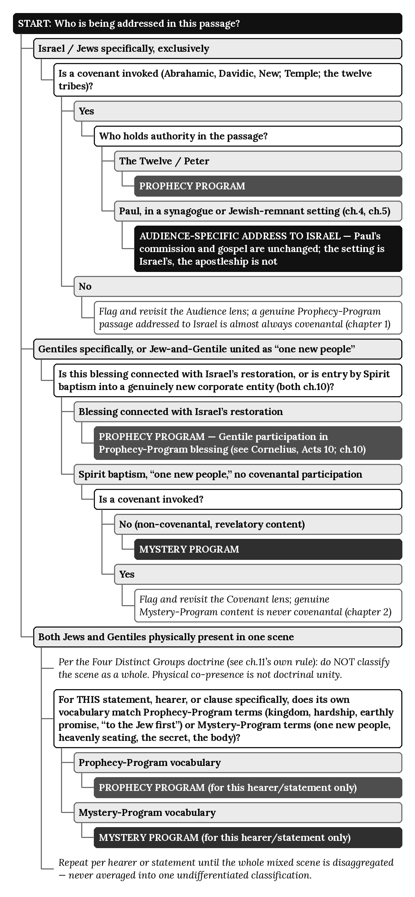

Worked Trace: Acts 14:21–23
Chapter 11 already cites this passage without walking it through the flowchart explicitly; this trace makes that reasoning visible step by step.
“After preaching the Good News in Derbe and making many disciples, Paul and Barnabas returned to Lystra, Iconium, and Antioch of Pisidia, where they strengthened the believers. They encouraged them to continue in the faith, reminding them that we must suffer many hardships to enter the Kingdom of God. Paul and Barnabas also appointed elders in every church.” (Acts 14:21–23, NLT)
Step 1 — Who is being addressed? These are the newly founded congregations of Paul’s first missionary journey — mixed gatherings, as chapter 9’s pattern (Jews and interested Gentiles together in and around the synagogue) has already traced for these very cities. Branch: both Jews and Gentiles physically present in one scene.
Step 2 — Apply the Four Distinct Groups doctrine. Do not classify the whole scene as the Body of Christ merely because Gentiles are present alongside Jewish believers; a mixed audience is a physical condition only, and each statement is classified by the group it addresses (chapter 11).
Step 3 — Isolate the specific statement. “We must suffer many hardships to enter the Kingdom of God.” Its vocabulary is “hardships” and “the Kingdom of God” — Prophecy-Program categories, not “one new people” or “heavenly seating.”
Step 4 — Classify this statement only. PROPHECY PROGRAM — this specific encouragement is directed to the Jewish believers present in the gathering, under the Prophecy Program’s own still-active offer, exactly as chapter 11 states: “Paul’s audience-specific language addressed to Jewish hearers must be interpreted within Israel’s still-operative prophetic setting during the Acts Overlap; its presence does not transfer Israel’s Kingdom Commission to Paul or redefine the heavenly hope of the Body of Christ.”
Step 5 — Note what the flowchart does not resolve. The elder-appointment that follows in the same passage (“Paul and Barnabas also appointed elders in every church”) is a governance fact, not itself an audience statement; it is Mystery-Program ecclesial practice during the overlap, not Prophecy-Program administration; chapter 11 and Appendix I trace that structure separately. The flowchart classifies statements by content, not every clause in a narrated scene.

Notes on This Flowchart
This appendix introduces no new doctrine; every branch terminates in a classification chapter 3’s Seven Lenses, chapter 10’s Gentile-inclusion distinction, chapter 11’s mixed-audience rule, or this book’s Four Distinct Groups doctrine has already established. Its own contribution is sequencing those existing rules into a faster path for the two most common cases — a single-audience passage, and a mixed-audience scene — while still directing a reader to the fuller seven-lens method (Appendix Q; Appendix L) whenever a branch’s own “Flag and revisit” instruction is reached. This flowchart is a shortcut through settled doctrine, not a substitute for it.

Appendix S: Program Separation Map

The Master Rule
From chapter 12 onward, this book has applied one governing principle to every doctrine it compares: assignment follows program membership, never ethnicity, and never mere physical presence in a mixed narrative scene. Chapter 13 states this first, as a named rule, crediting its own clarification to chapter 11’s earlier warning against reading mixed audiences as doctrinally unified:
Destiny Assignment Rule — This series’ governing principle (stated in chapter 13, building on chapter 11’s warning against reading mixed audiences as one): destiny is assigned strictly by program membership, never by ethnicity or by mere presence in a mixed narrative scene. (Chapter 13, Key Terms.)
Every doctrine this book compares — baptism, justification, ecclesiology, eschatology, commission, and destiny itself — applies some version of this same rule. Appendix B’s own chart states what each program’s content is; this appendix states how a reader determines which content applies to a given person or passage.

The Map
Doctrine | Governing Assignment Rule | Source
Destiny | Assigned strictly by program membership, never by ethnicity or mere presence in a mixed scene. A Gentile who participates in Israel’s blessing does not become Israel or inherit Israel’s national promises; a Jewish believer in the Body is Body by identity, not Israel, and inherits the heavenly destiny with every Gentile believer. | Chapter 13
Baptism | Which baptism marks a person’s entry depends on which program actually includes them — never on which rite happens to appear in a given narrative scene, and never on ethnicity. | Chapter 14
Justification | Assigned by correctly diagnosing the text’s own audience and program — James addresses “the twelve tribes... scattered abroad” under the Prophecy Program’s own covenantal terms; Paul addresses the Mystery’s “one new people” under no covenantal terms at all. A reader is never free to apply one program’s ground of justification to the other program’s audience. | Chapter 15
Ecclesiology | Assigned by which program’s own revelation and entry rite actually constituted the community — water baptism under the Twelve (Kingdom) or Spirit baptism under Christ’s own headship (Mystery) — never by the shared word “church” alone, and never by whether Gentiles happen to be present in a given congregation’s room. | Chapter 16
Eschatology | Assigned by audience, condition, and prophetic status of the governing text, which in turn follows the destiny already assigned under chapter 13’s own rule. A text’s shared vocabulary of comings or arrivals is never itself the assignment criterion. | Chapter 17
Commission | Assigned by which commission’s own recipients include the person in view — the Twelve under the Kingdom Commission, or Paul alone under the Pauline Commission. Paul’s own ministry within the Concurrent Prophetic Setting during the overlap does not transfer the Kingdom Commission’s recipients into his own commission, and does not transfer his own commission’s recipients into Israel’s Prophecy Program. | Chapter 12

Worked Note: The Remnant (Chapter 19)
Chapter 19 applies this same master rule to its hardest case: individual Israelites in relation to the national judicial blinding of Acts 28:26–27. The judicial suspension at Acts 28 does not erase Israelites who belonged to the believing Kingdom remnant during the overlap, nor does it cancel Israel’s future promises. It does, however, end the Prophecy Program’s present administration. In the present post-Acts-28 administration, newly saved Jews enter the Body of Christ on the same basis as newly saved Gentiles; Israel’s believing remnant keeps its identity as Israel and its place in Israel’s prophetic believing company.

Notes on This Map
This appendix introduces no new assignment rule; each row states, in compact form, a principle chapters 12 through 17 and 19 have each already argued from their own texts. Its own contribution is collecting six separately-stated rules into a single lookup table, organized by doctrine rather than by program, so a reader asking “how is X assigned” finds a direct answer with its source, rather than searching six chapters for the same underlying logic stated six different ways. Readers wanting a program’s own content rather than its assignment rule should consult Appendix B; readers wanting to classify a specific passage should consult Appendix R’s flowchart or Appendix L’s worksheets, both of which apply the rules this appendix maps.

Appendix T: Hermeneutical Rules for Acts

Purpose
Twenty-one chapters and nineteen prior appendices have each argued a piece of this book’s model from its own text or table. This appendix does something none of them has done: it states the model’s own governing rules directly, as a numbered list a reader can hold in mind while reading Acts on their own, each rule paired with the chapter where this book first argued it. Nothing here is new; every rule restates, in compact and general form, an argument this book has already made from Scripture.

The Rules
1. Never blend the two programs. Israel’s Prophecy Program and the Body of Christ’s Mystery Program remain two structurally distinct programs for the entire span in which both operate — sharing the same God and the same Lord Jesus Christ, yet never sharing identical content, audiences, or authority, and never merging into a single hybrid entity with blended terms, blended destinies, or blended entry rites. Chapter 3 states this as the book’s own first diagnostic chart; chapter 2 grounds it in the Mystery’s own status as a previously undisclosed program rather than a development of Israel’s covenants. Source: Chapter 3; Chapter 2.
2. Mixed audiences are physical, not doctrinal. A scene in Acts where Jews and Gentiles are both present — a synagogue, a mixed congregation, a missionary crowd — is a narrative fact about who occupies the same physical space. It is never, on that fact alone, evidence that the two groups have been fused into “the Body of Christ” or into any other single doctrinal category. The Body is constituted by the Mystery revelation and entered by Spirit baptism, not by shared presence in a room. This book recognizes four distinct groups rather than two blended ones: (1) Jews under the Prophecy Program, the covenant nation, who never become the Body; (2) Gentiles responding to the Mystery Program, who are non-covenantal and enter the Body upon belief (this names the entry condition, not a separate group overlapping the Body); (3) mixed audiences, a physical category only, neither a program nor a spiritual group; and (4) the Body of Christ proper, Jew and Gentile without distinction. Unbelieving Israel is not one of the four, because the doctrine concerns programmatic identity, not general anthropology. Source: Chapter 11; Four Distinct Groups doctrine.
3. Acts is the overlap — two complete and distinct programs operating concurrently, not one program transitioning into another. The Prophecy Program is already operative when Acts opens. The Mystery Program begins at Acts 9. Both operate concurrently through Acts 28, neither merging into nor developing out of the other. Local Jewish rejection recurs historically during this period without progressively altering Israel’s national status, but the Prophecy Program itself does not gradually diminish. At Acts 28 the Prophecy Program is judicially suspended, bringing the overlap to its fixed boundary, while the Mystery Program continues. Source: Chapter 3, “Terminological Note: Overlap, Not Transition.”
4. Acts 28 is the fixed, official boundary. Paul’s pronouncement of Isaiah’s judicial hardening to the Jewish leaders in Rome (Acts 28:25–28) is the dated, textual event that closes the overlap’s active operation. It is not a symbolic marker a reader may relocate earlier or later to suit a given passage; every rule in this appendix that depends on “before” or “after” the overlap depends on this fixed point specifically. Source: Chapter 18; Chapter 20.
5. Paul’s signs are overlap phenomena, reported and not assigned. Paul’s fillings, signs, and miraculous events, and those of his companions, are recorded in settings shaped by Israel’s Prophecy Program, which remained operative throughout Acts 9–28 even as the Mystery Program began. Paul’s participation does not convert them into Prophecy Program content and does not make them Mystery content; speaker identity is not program identity. With the national suspension of Israel’s Prophecy Program at Acts 28, the sign-program associated with Israel ceases programmatically, and signs do not continue into the Mystery Program. No sign is reported in any letter Paul writes after Acts 28. That is not a natural fade or gradual attrition; it coincides with the pronouncement that closes the overlap under Rule 4. The local Jewish rejections of chapter 9 do not change Israel’s national status progressively, and the end of the recorded signs is not a gradual change either; the two patterns must never be read as one and the same kind of change. Source: Chapter 8; Chapter 19; Appendix D.
6. Destiny and doctrine are assigned by program membership, never by ethnicity. Once a passage or a person is correctly diagnosed as belonging to one program or the other, every doctrine this book has compared — destiny, baptism, justification, ecclesiology, eschatology, commission — follows that program membership, never the person’s ethnic identity and never their mere physical presence in a mixed narrative scene. A Gentile who participates in Israel’s blessing does not thereby become Israel or inherit Israel’s national promises; a Jewish believer in the Body is Body by identity, not Israel, and inherits the same heavenly hope as any Gentile believer. Paul’s own life is the standing proof: ethnically “an Israelite” (Romans 11:1, NLT), and doctrinally the Mystery’s own apostle. Source: Chapter 13, Destiny Assignment Rule; Appendix S.
7. Luke’s narrative compression must never override the underlying program distinction. Acts frequently narrates a mixed scene as one continuous episode — one sermon, one crowd, one congregation — for straightforward literary and historical reasons. That compression is Luke’s method of telling the story; it is never itself a doctrinal claim that the two programs present in the scene have merged. A single verse, and even a single statement within a single verse, may need to be disaggregated by audience before its doctrinal content can be correctly assigned, exactly as Rule 2 requires. Source: Chapter 11; Four Distinct Groups doctrine.

Notes on This Appendix
This appendix introduces no new doctrine and no new exegesis; each rule restates an argument already made in full, from its own text, by the chapter cited beside it. Its own contribution is compression: seven rules, each short enough to hold in mind while reading Acts, replacing the need to recall the full argument of chapters 2, 3, 8, 9, 11, 13, 18, 19, and 20 individually. Readers wanting the fuller reasoning behind any single rule should consult the chapter cited; readers wanting to apply these rules to a specific passage should consult Appendix R’s flowchart or Appendix L’s worksheets, both of which operationalize the same rules stated here.

Appendix U: How This Architecture Resolves the Historical Confusions

Introduction: Why So Many Systems Collapse the Programs
Across church history, most interpretive systems have struggled with the book of Acts, the relationship between Israel and the Church, and the apparent contradictions between Jesus’ instructions and Paul’s. These struggles arise from one root problem:
They collapse the Bible’s two programs into one.
When the Prophecy Program and the Mystery Program are merged, every doctrine becomes unstable:
- commissions blur
- destinies merge
- baptisms confuse
- eschatology flattens
- mixed audiences mislead
- Israel’s promises spiritualize
- the Body’s hope postpones
- Paul appears to contradict himself
This appendix identifies the major historical confusions and shows how the architecture presented in this book resolves each one cleanly, without forcing Scripture to contradict itself.

1. Confusion #1 — Merging the Two Programs
Error: Treating Israel and the Body of Christ as one continuous people.
Result: Israel’s earthly promises get spiritualized; the Body’s heavenly promises get postponed.
Resolution:
- Chapter 3 — The Two Programs
- Chapter 10 — Gentile Inclusion
- Chapter 13 — The Two Destinies

2. Confusion #2 — Collapsing the Two Commissions
Error: Treating Matthew 28 and Acts 26 as the same commission.
Result: Water baptism gets imported into the Body; obedience-teaching gets imported into grace.
Resolution:
- Chapter 12 — The Two Commissions
- Chapter 14 — The Two Baptisms

3. Confusion #3 — Flattening the Overlap
Error: Treating Acts as a single program.
Result: Paul appears inconsistent; signs appear random; baptisms appear mixed.
Resolution:
- Chapter 5 — Paul’s Heavenly Apostleship
- Chapter 12 — The Two Commissions
- Chapter 14 — The Two Baptisms

4. Confusion #4 — Misassigning the Destinies
Error: Treating earthly and heavenly destinies as the same inheritance.
Result: Israel loses its kingdom; the Body loses its heavenly hope.
Resolution:
- Chapter 13 — The Two Destinies

5. Confusion #5 — Merging Water and Spirit Baptism
Error: Treating water baptism as the Body’s rite.
Result: Ephesians 4:5 becomes incoherent; 1 Corinthians 12:13 gets minimized.
Resolution:
- Chapter 14 — The Two Baptisms

6. Confusion #6 — Misreading Mixed Audiences
Error: Treating synagogue scenes as unified churches.
Result: Kingdom instructions get applied to the Body; Mystery instructions get applied to Israel.
Resolution:
- Chapter 11 — The Pauline Churches
- Chapter 12 — The Two Commissions
- Chapter 13 — The Two Destinies

7. Confusion #7 — Spiritualizing Israel
Error: Treating Israel’s promises as metaphors for the Church.
Result: Matthew 19:28 and Acts 1:6–7 lose their literal meaning.
Resolution:
- Chapter 1 — The Prophetic Foundation
- Chapter 13 — The Two Destinies

8. Confusion #8 — Postponing Heaven
Error: Treating the heavenly destiny as temporary until the earthly kingdom arrives.
Result: Colossians 3:1–4 becomes incoherent; Philippians 3:20 loses its present-tense force.
Resolution:
- Chapter 13 — The Two Destinies

Conclusion: Why This Architecture Works
This architecture resolves every historical confusion because it restores the Bible’s own boundaries:
- Two Programs
- Two Commissions
- Two Destinies
- Two Baptisms
- Two Ecclesiologies
- Two Eschatologies
- One Apostle During Two Concurrent Programs
- One Body with One Baptism
- One Kingdom with One Restoration
When these boundaries are honored, Scripture becomes coherent, consistent, and architecturally stable — exactly as God revealed it.

Selected Bibliography
This bibliography records the works consulted in preparing this book, including its Bible translations and reference tools and a selection from the wider field of biblical studies. Listing a work does not claim dependence on it, agreement with it, doctrinal alignment with it or direct citation of it. The list shows the reader the ground over which the book was worked and where to read further.

Bible Translation
The Holy Bible, New Living Translation. Carol Stream, IL: Tyndale House Publishers, 1996, 2004, 2015. All Scripture quotations in this book are from this translation unless otherwise indicated.

Biblical Reference Works
Aharoni, Yohanan, and Michael Avi-Yonah. The Macmillan Bible Atlas. Rev. ed. New York: Macmillan, 1977.
Brown, Francis, S. R. Driver, and Charles A. Briggs. The Brown-Driver-Briggs Hebrew and English Lexicon. Peabody, MA: Hendrickson Publishers. First published 1906.
Smith, Jerome H., ed. The New Treasury of Scripture Knowledge. Nashville: Thomas Nelson, 1992.
Strong, James. The Exhaustive Concordance of the Bible. Nashville: Abingdon Press, 1890.
Thayer, Joseph Henry. A Greek-English Lexicon of the New Testament. New York: American Book Company, 1889.
Vine, W. E. Vine’s Expository Dictionary of New Testament Words. London: Oliphants, 1940.

Historical and Theological Background: Dispensational History and Pauline Studies
Baker, Charles F. A Dispensational Theology. Grand Rapids: Grace Publications, 1971.
Bullinger, E. W. The Companion Bible. London: Oxford University Press, 1922.
Chafer, Lewis Sperry. Systematic Theology. 8 vols. Dallas: Dallas Seminary Press, 1947–1948.
Ryrie, Charles C. Dispensationalism. Chicago: Moody Press, 1965. Rev. ed., 1995.
Scofield, C. I. The Scofield Reference Bible. New York: Oxford University Press, 1909.
Stam, Cornelius R. Things That Differ. Germantown, WI: Berean Bible Society, 1951.
Welch, Charles H. Dispensational Truth. London: The Berean Publishing Trust, 1957.

Acts, the Early Church, and Jewish Background
Bruce, F. F. The Book of the Acts. Grand Rapids: Eerdmans, 1954.
Josephus, Flavius. The Works of Josephus. Translated by William Whiston. Peabody, MA: Hendrickson Publishers, 1987. Whiston’s translation first published 1737.
Marshall, I. Howard. Acts. Tyndale New Testament Commentaries. Downers Grove, IL: InterVarsity Press, 1980.
Polhill, John B. Acts. New American Commentary. Nashville: Broadman & Holman, 1992.

Old Testament Covenants and Prophetic Structure
Beale, G. K. A New Testament Biblical Theology. Grand Rapids: Baker Academic, 2011.
Hamilton, Victor P. Handbook on the Pentateuch. 2nd ed. Grand Rapids: Baker Academic, 2005.
Kaiser, Walter C., Jr. The Messiah in the Old Testament. Grand Rapids: Zondervan, 1995.
Walton, John H. Ancient Near Eastern Thought and the Old Testament. Grand Rapids: Baker Academic, 2006.

The New Testament’s Use of the Old Testament
Beale, G. K., and D. A. Carson, eds. Commentary on the New Testament Use of the Old Testament. Grand Rapids: Baker Academic, 2007.
Hays, Richard B. Echoes of Scripture in the Gospels. Waco, TX: Baylor University Press, 2016.
Hays, Richard B. Echoes of Scripture in the Letters of Paul. New Haven: Yale University Press, 1989.

General Biblical Studies
Carson, D. A. New Testament Commentary Survey. 6th ed. Grand Rapids: Baker Academic, 2007.
Fee, Gordon D., and Douglas Stuart. How to Read the Bible for All Its Worth. 4th ed. Grand Rapids: Zondervan, 2014. First published 1981.
Longman, Tremper, III, and Raymond B. Dillard. An Introduction to the Old Testament. 2nd ed. Grand Rapids: Zondervan, 2006.

