

hal-00990007, version 1 - 13 May 2014
A Grammatical
Approach to Data-centric
Case Management in a
Distributed Collaborative
Environment
ISRN INRIA/RR--8528--FR+ENG
ISSN 0249-6399
Eric Badouel, Loïc Hélouët, Georges-Edouard Kouamou, Christophe
Morvan
RESEARCH
REPORT
N° 8528
May 2014
Project-Team SUMO

hal-00990007, version 1 - 13 May 2014
A Grammatical Approach to Data-centric
Case Management in a Distributed
Collaborative Environment
hal-00990007, version 1 - 13 May 2014
Eric Badouel∗ , Loïc Hélouët† , Georges-Edouard Kouamou‡ ,
Christophe Morvan §
Project-Team SUMO
Research Report n° 8528 — May 2014 — 32 pages
Abstract:This paper presents a purely declarative approach to artifact-centric case manage-
ment systems, and a decentralization scheme for this model. Each case is presented as a tree-like
structure; nodes bear information that combines data and computations. Each node belongs to a
given stakeholder, and semantic rules govern the evolution of the tree structure, as well as how data
values derive from information stemming from the context of the node. Stakeholders communicate
through asynchronous message passing without shared memory, enabling convenient distribution.
Key-words: Active Documents, Business Artifacts, Case Management, Attribute Grammars
∗
†
‡
§
Inria and Lirima
Inria
ENSP and Lirima
UniversitÃ© Paris-Est and Inria
RESEARCH CENTRE
RENNES – BRETAGNE ATLANTIQUE
Campus universitaire de Beaulieu
35042 Rennes Cedex

Une approche grammaticale de la gestion de dossiers dans
un environement collaboratif distribué
Résumé : Nous introduisons un modèle déclaratif de système de gestion de dossiers à base
d’artefacts ainsi qu’un schéma de distribution de ce modèle. Chaque dossier a une structure
arborescente dont les moeuds combinent données et calculs. Chaque noeud est sous la respon-
sabilité d’un unique utilisateur et des règles sémantiques régissent les évolutions du document
ainsi que le calcul de la valeur des attributs des noeuds. Les utilisateurs communiquent de façon
asynchrone par échange de messages, et sans mémoire partagée, ce qui facilite la distribution du
modèle.
Mots-clés : documents actifs, artefacts, gestion de dossiers, grammaires attribuées
hal-00990007, version 1 - 13 May 2014

A Grammatical Approach to Data-centric Case Management
3
1
Introduction
Traditional Case Management Systems rely on workﬂow models. The emphasis is put on the
orchestration of activities involving humans (the stakeholders) and software systems, in order to
achieve some global objective. In this context, stress is often put on control and coordination of
the tasks required for the realization of a particular service. Such systems are usually modeled
using centralized and state-based formalisms like automata, Petri nets or statecharts. They can
also be directly speciﬁed with dedicated notations like BPEL [22] or BPMN 1 .
A drawback of existing workﬂow formalisms is that data exchanged during the processing of a
task play a secondary role when not simply ignored. However, data can be tightly connected with
control ﬂows and should not be overlooked. Actually, data contained in a request may inﬂuence
its processing; conversely diﬀerent decisions during the treatment of a case may produce distinct
output-values.
Similarly, stakeholders are frequently considered as second class citizens in workﬂow systems:
they are modeled as plain resources, performing speciﬁc tasks for a particular case, like machines
in assembly lines. As a result, workﬂow systems are ideal to model ﬁxed production schemes
in manufactures or organizations, but can be too rigid to model open architectures where the
evolving rules and data require more ﬂexibility.
On the other hand, data-centric workﬂow systems, proposed by IBM [21, 12, 5], put stress on
the exchanged documents, the so-called Business Artifacts, also known as business entities with
lifecycles. An artifact is a document that conveys all the information concerning a particular
case from its inception in the system until its completion. It contains all the relevant information
about the entity together with a lifecycle that models its possible evolutions through the busi-
ness process. Several variants presenting the life cycle of an artifact by an automaton, a Petri
net [17], or logical formulas depicting legal successors of a state [5] have been proposed. However,
even these variants remain state-based centralized models in which stakeholders are second class
citizens.
Recently, Guard-Stage-Milestone (GSM), a declarative model of the lifecycle of artifacts has
been introduced [13, 6]. This model deﬁnes Guards, Stages and Milestones to control the en-
abling, enactment and completion of (possibly hierarchical) activities. The GSM lifecycle meta-
model has been adopted as a basis of the OMG standard Case Management Model and Notation
(CMMN). The GSM model allows for dynamic creation of subtasks (the stages), and handles
data attributes. Furthermore, guards and milestones attached to stages provide declarative de-
scriptions of tasks inception and termination. However, interaction with users are modeled as
incoming messages from the environment, or as events from low-level (atomic) stages. In this
way, users do not contribute to the choice of a workﬂow for a process. The semantics of GSM
models is given in terms of global snapshots. Events can be handled by all stages as soon as they
are produced, and guard of a stage can refer to attributes of distant stages. Thus this model is
not directly executable on a distributed architecture.
This paper introduces a distributed and declarative model for Case Management called Guarded
Attribute Grammars (GAG for short), which is both data-centric, user-driven, and provides a
convenient way to handle distribution. GAGs are collections of semantic rules that describe how
to produce data from inputs provided by the environment. They are a variant of attribute gram-
mars [16, 23]. Their notation is reminiscent of uniﬁcation grammars, and is inspired by the work
of Deransart and Maluszynski [8] relating attribute grammars with deﬁnite clause programs.
In this declarative model, the lifecycle of artifacts is left implicit. Artifacts under evaluation
can be seen as incomplete structured documents, i.e., trees with open nodes corresponding to
parts of the document that remain to be completed. Each open node is attached intentional data,
1 www.bpmn.org
hal-00990007, version 1 - 13 May 2014
RR n° 8528
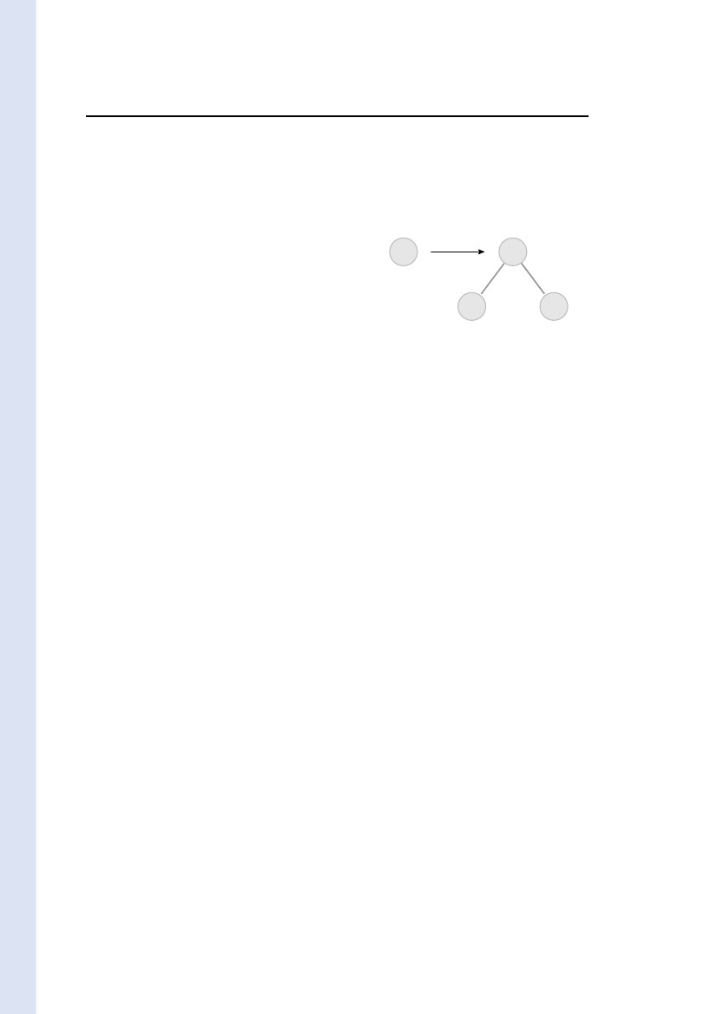
4
Badouel & al.
i.e., an expression for the piece of information to be substituted to the node. The evolution of an
artifact is governed by the stakeholder’s decisions (choosing a particular action amongst those
which are enabled at a given moment, inputing data,...), and by application of the semantic rules
to update artifacts (by reﬁning open nodes). Cases reach completion when they do not contain
open nodes. An artifact is thus a structured document with some active parts. This notion of
active documents is close to the model of Active XML introduced by Abiteboul et al. [1] which
consists of semi-structured documents with embedded service calls.
The paper is organized as follows. After an informal introduction to our grammatical ap-
proach to case management in Section 2 we introduce the model of guarded attribute grammars
that underpins the approach by presenting successively its syntax (Section 3), its behaviour
(Section 4) and by giving some illustrative examples (Section 5). The deployment of a guarded
attribute grammar on a distributed asynchronous architecture is studied in Section 6. Soundness
of guarded attribute grammars is touched upon in Section 7. An assessment of the model and
future research directions are given in conclusion.
hal-00990007, version 1 - 13 May 2014
2
A Grammatical Approach to Case Management
This section introduces a grammatical notation for case management which will be described
more formally in the subsequent two sections.
Throughout the paper, the term case designates a concrete instance of a given business
process. We use the editorial process of an academic journal as a running example to illustrate
the various notions and notations. A case for this example is the editorial processing of a
particular article submitted to the journal.
The case is handled by various actors involved in the process, called stakeholders, namely the
editor in chief, an associate editor and some referees. We associate each case with a document,
called an artifact, that collects all the information related to the case from its inception in the
process until its completion. When the case is closed this document constitutes a full history of
all the decisions that led to its completion.
We interpret a case as a problem to be solved, that can be completed by reﬁning it into
sub-tasks using business rules. This notion of business rule can be modelled by a production
P : s0 ← s1 · · · sn expressing that task s0 can be reduced to subtasks s1 to sn . If several
productions with the same left-hand side s0 exist then the choice of a particular production
corresponds to a decision made by some designated stakeholder. For instance, there are two
possible immediate outcomes for a submitted article: either it is validated by the editor in chief
and it enters the evaluation process of the journal or it is invalidated because its topic or format
is not adequate. This initial decision can be reﬂected by the two following productions:
validate : Proposed_submission ← Submission
invalidate : Proposed_submission ←
If P is the unique production having s0 in its left-hand side, then there is no real decision to
make and such a rule is interpreted as a logical decomposition of the task s0 into substasks s1
to sn . Such a production will be automatically triggered without human intervention.
Accordingly, we model an artifact as a tree whose nodes are sorted. We write X :: s to indicate
that node X is of sort s. An artifact is given by a set of equations of the form X = P (X1 , . . . , Xn ),
stating that X :: s is a node labeled by production P : s ← s1 · · · sn and with successor nodes
X1 :: s1 to Xn :: sn . In that case node X is said to be a closed node deﬁned by equation
X = P (X1 , . . . , Xn ) (we henceforth assume that we do not have two equations with the same
left-hand side). A node X :: s deﬁned by no equation (i.e. that appears only in the right hand
side of an equation) is an open node. It corresponds to a pending task s.
Inria
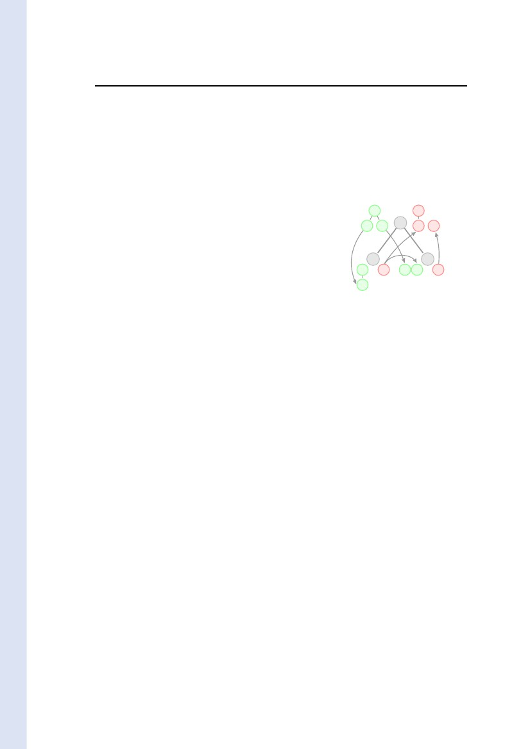
A Grammatical Approach to Data-centric Case Management
5
The lifecycle of an artifact is implicitly given by a set of productions:
1. The artifact initially associated with a case is reduced to a single open node.
2. An open node X of sort s can be reﬁned by choosing a production
P : s ← s1 . . . sn that ﬁts its sort.
s
s
P
s1
?
?
sn
The open node X becomes a closed node X =
P (X1 , . . . , Xn ) under the decision of applying
production P to it. In doing so the task s
associated with X is replaced by n subtasks s1
to sn and new open nodes X1 :: s1 to Xn :: sn
are created accordingly.
?
3. The case has reached completion when its associated artifact is closed, i.e. it no longer
contains open nodes.
hal-00990007, version 1 - 13 May 2014
However, plain context-free grammars do not model the interactions and data exchanged
between the various tasks associated with open nodes. To overcome this problem, we attach
additional information to open nodes using attributes. Each sort s ∈ S comes equipped with a
set of inherited attributes and a set of synthesized attributes. Values of attributes are given by
terms over a ranked alphabet. Recall that such a term is either a variable or an expression of
the form c(t1 , . . . , tn ) where c is a symbol of rank n, and t1 , . . . , tn are terms. In particular a
constant c, i.e. a symbol of rank 0, will be identiﬁed with the term c( ). We will denote by var(t)
the set of variables used in term t.
Deﬁnition 2.1 (Forms). A form of sort s is an expression
F = s(t1 , . . . , tn ) u1 , . . . , um
where t1 , . . . , tn (respectively u1 , . . . , um ) are terms over a ranked alphabet —the alphabet of
attribute’s values— and a set of variables var (F ). Terms t1 , . . . , tn give the values of the
inherited attributes and u1 , . . . , um the values of the synthesized attributes) attached to
form F .2 Def. 2.1
From now on, we consider productions where sorts are replaced by forms of the corresponding
sorts. More precisely, a production is of the form
s0 (p1 , . . . , pn ) u1 , . . . , um
← s1 (t1 , . . . , tn1 ) y1 , . . . , ym1
···
(k)(k)(k)(k)
sk (t1 , . . . , tnk ) y1 , . . . , ymk
( )
(1)
(1)
(1)
(1)
(1)
where the pi ’s, the uj ’s, and the tj ’s are terms and the yj ’s are variables. The forms in the right-
hand side of a production are service calls, namely they are forms F = s(t1 , . . . , tn ) y1 , . . . , ym
where the synthesized positions are (distinct) variables y1 , . . . , ym (i.e., they are not instantiated).
The rationale is that we invoke a service by ﬁlling in the inherited positions of the form (the
entries) and by indicating the variables that expect to receive the results returned by the service
(the subscriptions).
Any open node is now attached to a service call. The corresponding service is supposed
to (i) construct the tree that will reﬁne the open node and (ii) compute the values of the
synthesized attributes (i.e., it should return the subscribed values). A service is enacted by
RR n° 8528
( )

6
Badouel & al.
applying productions. More precisely, a production such as the one given in formula (1) can apply
in an open node X when its left-hand side matches with the service call s0 (d1 , . . . , dn ) y1 , . . . , ym
attached to node X. For that purpose the terms pi ’s are used as patterns that should match the
corresponding data di ’s. When the production applies, new open nodes are created and they are
respectively associated with the forms (service calls) in the right-hand side of the production.
The values of uj ’s are then returned to the corresponding variables yj ’s that had subscribed to
these values. For instance applying production
P : s0 (a(x1 , x2 )) b(y1 ), y2 ← s1 (c(x1 )) y1 s2 (x2 , y1 ) y2
a
s0
?
b
y1
y2
s2
?
hal-00990007, version 1 - 13 May 2014
to a node associated with service call s0 (a(t1 , t2 )) y1 , y2
gives rise to the substitution x1 = t1 and x2 = t2 . The
two newly-created open nodes are respectively associated
with the service calls s1 (c(t1 )) y1 and s2 (t2 , y1 ) y2 and
the values b(y1 ) and y2 are substituted to the variables y1
and y2 respectively.
?
P
x1
s1
?
x2
c
x1
?
x2 y1
?
y1
y2
The precise deﬁnitions are given in the next section. For the moment, let us illustrate the
notations on our running example. A stakeholder has a speciﬁc role in the editorial process: he
can be an author, the editor in chief, an associate editor or a referee. Each role is associated
with a set of services and a set of productions explaining how each service is provided. For
instance an associate editor provides the service Submission(article) decision consisting in
returning an editorial decision about an article submitted to the journal. We emphasize the fact
that production MakeDecision(decision ) : Decide(report 1 , report 2 ) decision ← has a parameter
decision, that is used to enter new data in the case. Parameters are a convenient way to avoid
speciﬁng a production for each allowed parameter. A parametric production can be equivalently
replaced by several non-parametric productions when its parameters range over a ﬁnite set of
values. The corresponding productions are listed in Table 1.
Table 1: Acting as an associate Editor
DecideSubmission : Submission(article) decision ←
Evaluate(article) report 1
Evaluate(article) report 2
Decide(report 1 , report 2 ) decision
MakeDecision(decision ) : Decide(report 1 , report 2 ) decision ←
AskReview(reviewer ) : Evaluate(article) report ←
WaitReport(answer , article) report
Call(reviewer , ToReview(article) answer )
CaseNo msg : WaitReport(No(msg), article) report ←
Evaluate(article) report
CaseYes msg : WaitReport(Yes(msg, report ), article) report ←
The ﬁrst two productions mean that an associate editor makes an editorial decision about a
submitted paper on the basis of the evaluation reports produced by two diﬀerent referees. He can
ask a report from a reviewer through an invocation of the external service ToReview(article) answer .
The productions that govern the actions of a reviewer are given in Table 2.
One can group the productions of Table 1 and Table 2 using an additional parameter reviewer
to make as many disjoint copies of the speciﬁcation given in Table 2 as there are individuals
Inria
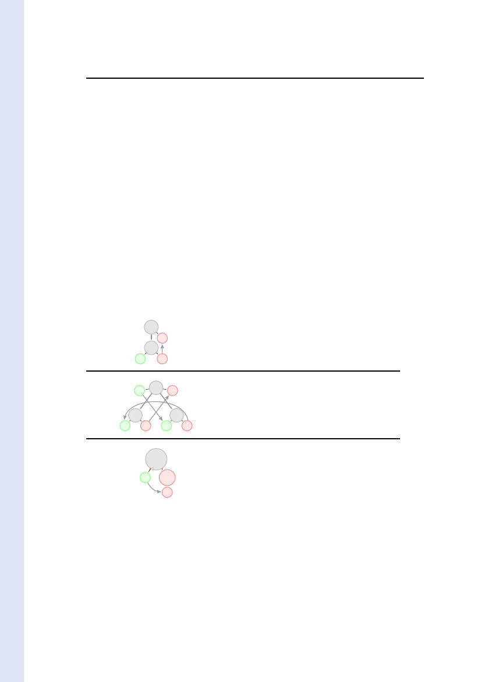
A Grammatical Approach to Data-centric Case Management
7
Table 2: Acting as a reviewer
Decline(msg) : ToReview(article) No(msg) ←
Accept(msg) : ToReview(article) Yes(msg, report ) ← Review(article) report
MakeReview(report ) : Review(article) report ←
playing the role of a referee. The resulting set of productions (where call to external services have
been eliminated) is given in Table 3. Similarly one has as many instances of the productions in
Table 3: Making a decision on a submitted paper
DecideSubmission : Submission(article) decision ←
Evaluate(article) report 1
Evaluate(article) report 2
Decide(report 1 , report 2 ) decision
MakeDecision(decision ) : Decide(report 1 , report 2 ) decision ←
AskReview(reviewer ) : Evaluate(article) report ←
WaitReport(answer , article) report
ToReview(reviewer , article) answer
Decline(msg) reviewer: ToReview(reviewer , article) No(msg) ←
Accept(msg) reviewer: ToReview(reviewer , article) Yes(msg, report ) ←
Review(reviewer , article) report
MakeReview(report ) reviewer: Review(reviewer , article) report ←
CaseNo msg : WaitReport(No(msg), article) report ←
Evaluate(article) report
CaseYes msg : WaitReport(Yes(msg, report ), article) report ←
hal-00990007, version 1 - 13 May 2014
Table 1 as there are associate editors in the editorial board. In the complete (ﬂat) speciﬁcation
one should therefore add an additional parameter associateEditor to distinguish between all
associate editors. If the speciﬁcation is large and contains many diﬀerent roles the resulting
global grammar can be quite complex. Yet, it is still possible to build an equivalent monolithic
grammar without external service calls.
The above speciﬁcation uses production schemes rather than plain productions. Therefore
the actual productions of the grammar are instances of these productions schemes where speciﬁc
values are substituted to the parameters. Replacing all parameters by their possible values to
obtain plain productions in a systematic way results in a guarded attribute grammar (deﬁned
in Section 3) with an inﬁnite set of productions. However, at least in the above example, the
parameters of the productions correspond either to a speciﬁc role in the process or to some kind
of data (a message, a report, a decision) whose precise value has no impact on the behavior of
the system. Therefore one can abstract this speciﬁcation by identifying all individuals playing
the same role and by representing each type of data by a corresponding constant so that one can
obtain a ﬁnite guarded attribute grammar with the same behavior.
3
The Syntax of Guarded Attribute Grammars
Attribute grammars, introduced by Donald Knuth in the late sixties [16], have been instrumental
in the development of syntax-directed transformations and compiler design. More recently this
RR n° 8528
8
Badouel & al.
model has been revived for the speciﬁcation of structured document’s manipulations mainly
in the context of web-based applications. The expression grammareware has been coined in
[15] to qualify the tools for the design and customization of grammars and grammar-dependent
softwares. One such interesting tool is the UUAG system developped by Swierstra and his group.
They relied on purely functional implementations of attribute grammars [14, 25, 2] to build a
domain speciﬁc languages (DSL) as a set of functional combinators derived from the semantic
rules of an attribute grammar [26, 25, 24]. We intend to adapt this construction to the model of
guarded attribute grammars introduced in this paper.
An Attribute grammar is obtained from an underlying grammar by associating each sort
s with a set Att(s) of attributes —which henceforth should exist for each node of the given
sort— and by associating each production P : s ← s1 . . . sn with semantic rules describing the
functional dependencies between the attributes of a node labelled P (hence of sort s) and the
attributes of its successor nodes (of respective sorts s1 to sn ).
We use a non-standard notation for attribute grammars, inspired from [7, 8]. Let us introduce
this notation on an example before proceeding to the formal deﬁnitions.
hal-00990007, version 1 - 13 May 2014
Example 3.1 (Flattening of a binary tree). Our ﬁrst illustration is the classical example of the
attribute grammar that computes the ﬂattening of a binary tree, i.e., the sequence of the leaves
read from left to right. The semantic rules are usually presented as shown in Table 4. The sort bin
Table 4: Flattening of a binary tree
X :: root
Root
x
?
Nil
?
x
Root : X :: root ← X1 :: bin
where X · s = X1 · s
X1 · h = Nil
X :: bin
x
?
Fork
y
?
z
?
y
x
?
?
z
Fork : X :: bin ← X1 :: bin X2 :: bin
where X · s = X1 · s
X1 · h = X2 · s
X2 · h = X · h
X :: bin
Leaf a
x
?
Consa
Leaf a : X :: bin ←
where X · s = Consa (X · h)
x
of binary trees has two attributes: the inherited attribute h contains an accumulating parameter
and the synthesized attribute s eventually contains the list of leaves of the tree appended to the
accumulating parameter. Which we may write as t · s = ﬂatten(t) ++t · h, i.e., t · s = ﬂat (t, t · h)
where ﬂat (t, h) = ﬂatten(t) ++h. The semantics rules stem from the identities:
ﬂatten(t)=ﬂat(t, N il)
ﬂat (Fork(t1 , t2 ), h)=ﬂat(t1 , ﬂat(t2 , h))
ﬂat(Leaf a , h)=Consa (h)
Inria

A Grammatical Approach to Data-centric Case Management
9
We present the semantics rules of Table 4 using the following syntax:
Root :root () x ← bin(N il) x
Fork :bin(x) y ← bin(z) y bin(x) z
Leaf a : bin(x) Consa (x) ←
The syntactic categories of the grammar, also called its sorts, namely root and bin are associated
with their inherited attributes (given as a list of arguments: (t1 , . . . , tn )) and their synthesized
attributes (the co-arguments: u1 , . . . , um ). A variable x is an input variable, denoted as x? , if it
appears in an inherited attribute of the left-hand side or in a synthesized attribute of the right-
hand side. It corresponds to a piece of information stemming respectively from the context of the
node or from the subtree rooted at the corresponding successor node. These variables should be
pairwise distinct. Symmetrically a variable is an output variable, denoted as x! , if it appears in
a synthesized attribute of the left-hand side or in an inherited attribute of the right-hand side.
It corresponds to values computed by the semantic rules and send respectively to the context of
the node or the subtree rooted at the corresponding successor node. Indeed, if we annotate the
occurrences of variables with their polarity (input or output) one obtains:
Root :root () x! ← bin(N il) x?
Fork :bin(x? ) y ! ← bin(z ! ) y ? bin(x! ) z ?
Leaf a : bin(x? ) Consa (x! ) ←
And if we draw an arrow from the (unique) occurrence of x? to the (various) occurrences of x!
for each variable x to witness the data dependencies then the above rules correspond precisely to
the three ﬁgures shown on the left-hand side of Table 4.2 Exple 3.1
Guarded attribute grammars extend the traditional model of attribute grammars by allowing
patterns rather that plain variables (as it was the case in the above example) to represent the
inherited attributes in the left-hand side of a production. Patterns allow the semantic rules to
process by case analysis based on the shape of some of the inherited attributes, and in this way
to handle the interplay between the data (contained in the inherited attributes) and the control
(the enabling of productions).
Deﬁnition 3.2 (Guarded Attribute Grammars). Given a set of sorts S with ﬁxed inherited
and synthesized attributes. A guarded attribute grammar is a set of productions P : F0 ←
F1 · · · Fk where the Fi :: si are forms. The inherited attributes of left-hand side F0 are called
the patterns of the production. The values of synthesized attributes in the right-hand side are
variables. These occurrence of variables together with the variables occurring in the patterns are
called the input occurrences of variables. We assume that each variable has at most one
input occurrence.2 Def. 3.2
The well-formedness conditions of GAGs express that every output is deﬁned in terms of the
inputs. We will often refer to this correspondences as the semantic rules. More precisely, the
inputs are associated with (distinct) variables and the value of each output is given by a term
using these variables.
Each variable can have several occurrences. First it should appear once as an input and it
may also appear in several occurrences within some output term. The corresponding occurrence
is respectively said to be in an input or in an output position. One can deﬁne the following
transformation on productions whose eﬀect is to annotate each occurrence of a variable so that
x? (respectively x! ) stands for an occurrence of x in an input position (resp. in an output
RR n° 8528
hal-00990007, version 1 - 13 May 2014
10
Badouel & al.
position).
!(F0 ← F1 · · · Fk ) = ?(F0 ) ←!(F1 ) · · ·!(Fk )
?(s(t1 , . . . tn ) u1 , . . . um ) = s(?(t1 ), . . .?(tn )) !(u1 ), . . .!(um )
!(s(t1 , . . . tn ) u1 , . . . um ) = s(!(t1 ), . . .!(tn )) ?(u1 ), . . .?(um )
?(c(t1 , . . . tn )) = c(?(t1 ), . . .?(tn ))
!(c(t1 , . . . tn )) = c(!(t1 ), . . .!(tn ))
?(x) = x?
!(x) = x!
The conditions stated in Deﬁnition 3.2 say that in the labelled version of a production each vari-
able occurs at most once in an input position, i.e., that {?(F0 ), !(F1 ), . . . , !(Fk )} is an admissible
labelling of the set of forms in P according to the following deﬁnition.
Deﬁnition 3.3 (Link Graph). A labelling in {?, !} of the variables var (F ) of a set of forms
F is admissible if the labelled version of a form F ∈ F is given by either !F or ?F and each
variable has at most one occurrence labelled with ?. The occurrence x? identiﬁes the place where
the value of variable x is deﬁned and the occurrences of x! identify the places where this value is
used. The link graph associated with an admissible labelling of a set of forms F is the directed
graph whose vertices are the occurrences of variables with an arc from v1 to v2 if these vertices
are occurrences of a same variable x, labelled ? in v1 and ! in v2 . This arc, depicted as follows,
x
?
x
hal-00990007, version 1 - 13 May 2014
means that the value produced in the source vertex v1 should be forwarded to the target vertex
v2 . Such an arc is called a data link.2 Def. 3.3
4
The Behaviour of Guarded Attribute Grammars
Attribute grammars are applied to input abstract syntax trees. These trees are usually produced
by some parsing algorithm during a previous stage. The semantic rules are then used to decorate
the node of the input tree by attribute values. In our setting the generation of the tree and its
evaluation using the semantic rules are intertwined since the input tree represents an artifact
under construction. An artifact is thus an incomplete abstract syntax tree which contains closed
and open nodes. A closed node is labelled by the production that was used to create it. An
open node is associated with a form that contains all the needed information for its further
reﬁnements. The information attached to an open node consists of the sort of the node and the
current value of its attributes. The synthesized attributes of an open node are undeﬁned and are
thus associated with variables.
Deﬁnition 4.1 (Conﬁguration of a Guarded Attribute grammar). A conﬁguration Γ of a
guarded attribute grammar is an S-sorted set of nodes X ∈ nodes(Γ) each of which is associated
with a deﬁning equation in one of the following form where var (Γ) is a set of variables associated
with Γ:
Closed node: X = P (X1 , . . . , Xk ) where P : s ← s1 . . . sk is a production of the underlying
grammar and X :: s, and Xi :: si for 1 ≤ i ≤ k. Production P is the label of node X and
nodes X1 to Xn are its successor nodes.
Open node: X = s(t1 , . . . , tn ) x1 , . . . , xm where X is of sort s and t1 , . . . , tk are terms with
variables in var (Γ) that represents the values of the inherited attributes of X, and x1 , . . . , xm
are variables in var (Γ) associated with its synthesized attributes.
Inria
A Grammatical Approach to Data-centric Case Management
11
Each variable in var (Γ) occurs at most once in a synthesized position. Otherwise stated !Γ =
{!F | F ∈ Γ } is an admissible labelling of the set of forms occurring in Γ.2 Def. 4.1
In order to specify the eﬀect of applying a production at a given node of a conﬁguration
(Deﬁnition 4.4) we ﬁrst recall some notions about substitutions.
Recall 4.2 (on Substitutions). We identify a substitution σ on a set of variables {x1 , . . . , xk },
called the domain of σ, with a system of equations
{xi = σ(xi ) | 1 ≤ i ≤ k }
The set of variables of σ, deﬁned by var(σ) = 1≤i≤k var(σ(xi )), is disjoint from the domain of σ.
Conversely a system of equations {xi = ti | 1 ≤ i ≤ k } deﬁnes a substitution σ with σ(xi ) = ti
if it is in solved form, i.e., none of the variables xi appears in some of the terms tj . In
order to transform a system of equations E = {xi = ti | 1 ≤ i ≤ k } into an equivalent system
xi = tj | 1 ≤ j ≤ m in solved form one can iteratively replace an occurrence of a variable xi in
one of the right-hand side term tj by its deﬁnition ti until no variable xi occurs in some tj . This
process terminates when the relation xi xj ⇔ xj ∈ var(σ(xi )) is acyclic. One can easily verify
that, under this assumption, the resulting system of equation SF (E) = {xi = ti | 1 ≤ i ≤ n } in
solved does not depend on the order in which the variables xi have been eliminated from the
right-hand sides. When the above condition is met we say that the set of equations is acyclic
and that it deﬁnes the substitution associated with its solved form.2 Recall 4.2
The composition of two substitutions σ, σ is denoted by σσ and deﬁned by σσ = {x =
tσ |x = t ∈ σ}. Similarly, we let Γσ denote the conﬁguration obtained from Γ by replacing the
deﬁning equation X = F of each open node X by X = F σ.
We now deﬁne more precisely when a production is enabled at a given open node of a conﬁg-
uration and the eﬀect of applying the production. First note that variables of a production are
formal parameters which scope is limited to the production. They can injectively be renamed
in order to avoid clashes with variables names appearing in a conﬁguration. Therefore we shall
always assume that the set of variables of a production P is disjoint from the set of variables of a
conﬁguration Γ when applying production P at a node of Γ. As informally stated in the previous
section, a production P applies at an open node X when its left-hand side s(p1 , . . . , pn ) u1 , . . . um
matches with the deﬁnition X = s(d1 , . . . , dn ) y1 , . . . , ym , i.e., the service call attached to X in
Γ.
First, the patterns pi should match with the data di according to the usual pattern matching
given by the following inductive statements
match(c(p1 , . . . , pk ), c (d1 , . . . , dk )) with c = c fails
k
match(c(p1 , . . . , pk ), c(d1 , . . . , dk )) =i=1 match(pi , di )
match(x, d) = {x = d}
where the sum σ =i∈1..k σi when alli=1 σi of substitutions σi is deﬁned and equal to
substitutions σi are deﬁned and associated with disjoint sets of variables. Note that since no
variable occurs twice in the whole set of patterns pi , the various substitutions match(pi , di ), when
deﬁned, are indeed concerned with disjoint sets of variables. Note also that match(c(), c()) = ∅.
Deﬁnition 4.3. A form F = s(p1 , . . . , pn ) u1 , . . . um matches with a service call
F = s(d1 , . . . , dn ) y1 , . . . , ym (of the same sort) when
1. the patterns pi ’s matches with the data di ’s, deﬁning a substitution σin =
RR n° 8528
1≤i≤n
k
hal-00990007, version 1 - 13 May 2014
match(ti , di ),
12
Badouel & al.
2. the set of equations {yj = uj σin | 1 ≤ j ≤ m } is acyclic and deﬁnes a substitution σout .
The resulting substitution σ = match(F, F ) is given by σ = σout ∪ σin σout .
2 Def. 4.3
Deﬁnition 4.4 (Applying a Production). Let P = F ← F1 . . . Fk be a production, Γ be a
conﬁguration, and X be an open node with deﬁnition X = s(d1 , . . . , dn ) y1 , . . . , ym in Γ. We
assume that P and Γ are deﬁned over disjoint sets of variables. We say that P is enabled in X
and write Γ[P/X , if the left-hand side of P matches with the deﬁnition of X. Then applying
production P at node X transforms conﬁguration Γ into Γ , denoted as Γ[P/X Γ , where:
Γ
=
∪
∪
{X = P (X1 , . . . , Xk )}where X1 , . . . , Xk
{X1 = F1 σ, . . . , Xk = Fk σ}
{X = F σ | (X = F ) ∈ Γ ∧ X = X }
are new nodes added to Γ
where σ = match(F, X).
2 Def. 4.4
hal-00990007, version 1 - 13 May 2014
Thus the ﬁrst eﬀect of applying production P to an open node X is that X becomes a closed
node with label P and successor nodes X1 to Xk . The latter are new nodes added to Γ . They
are associated respectively with the instances of the k forms in the right-hand side of P obtained
by applying substitution σ to these forms. The deﬁnitions of the other nodes of Γ are updated
using substitution σ (or equivalently σout ). This update has no eﬀect on the closed nodes because
their deﬁning equations in Γ contain no variable.
We conclude this section with two results justifying Deﬁnition 4.4. Namely, Proposition 4.5
states that if P is a production enabled in a node X0 of a conﬁguration Γ with Γ[P/X0 Γ then
Γ is a conﬁguration, i.e., applying P cannot create a variable with several input occurrences.
And Proposition 4.7 shows that the substitution σ = match(F, X) resulting from the matching
of the left-hand side F = s(p1 , . . . , pn ) u1 , . . . , um of a production P with the deﬁnition X =
s(d1 , . . . , dn ) y1 , . . . , ym of an open node X is the most general uniﬁer of the set of equations
{pi = di | 1 ≤ i ≤ n } ∪ {yj = uj | 1 ≤ j ≤ m }.
Proposition 4.5. If production P is enabled in an open node X0 of a conﬁguration Γ and
Γ[P/X0 Γ then Γ is a conﬁguration.
Proof. Let P = F ← F1 . . . Fk with left-hand side F = s(p1 , . . . , pn ) u1 , . . . um and X0 =
s(d1 , . . . , dn ) y1 , . . . , ym be the deﬁning equation of X0 in Γ. Since the values of synthesized
attributes in the forms F1 , . . . , Fk are variables (by Deﬁnition 3.2) and since these variables
are unaﬀected by substitution σin the synthesized attribute in the resulting forms Fj σin are
variables. The substitutions σin and σout substitute terms to the variables x1 , . . . , xk appearing
to the patterns and to the variables y1 , . . . , ym respectively. Since xi appears in an input position
in P , it can appear only in an output position in the forms !(F1 ), . . .!(Fk ) and thus any variable
of the term σin (xi ) will appear in an output position in !(Fi σin ). Similarly, since yi appears in an
input position in the form !(s(u1 , . . . , un ) y1 , . . . , ym ), it can only appear in an output position
in !(F ) for the others forms F of Γ. Consequently any variable of the term σout (yi ) will appear
in an output position in !(F σout ) for any equation X = F in Γ with X = X0 . It follows that the
application of a production cannot produce new occurrences of a variable in an input position
and thus there cannot exist two occurrences x? of a same variable x in Γ .2 Prop. 4.5
2
Thus applying an enabled production deﬁnes a binary relation on conﬁgurations.
Deﬁnition 4.6. A conﬁguration Γ is directly accessible from Γ, denoted by Γ[ Γ , whenever
Γ[P/X Γ for some production P enabled in node X of conﬁguration Γ. Furthermore, a conﬁgu-
ration Γ is accessible from conﬁguration Γ when Γ[∗ Γ where [∗ is the reﬂexive and transitive
closure of relation [ .2 Def. 4.6
Inria
A Grammatical Approach to Data-centric Case Management
13
Recall that a substitution σ uniﬁes a set of equations E if tσ = t σ for every equations
t = t in E. A substitution σ is more general than a substitution σ if σ = σσ for some
substitution σ . If a system of equations has a some uniﬁer, then it has (up to an bijective
renaming of the variables in σ) a most general uniﬁer. In particular a set of equations of the
form {xi = ti | 1 ≤ i ≤ n } has a uniﬁer if and only if it is acyclic. In this case, the corresponding
solved form is its most general uniﬁer.
Proposition 4.7. If the left-hand side F = s(p1 , . . . , pn ) u1 , . . . , um of a production P matches
with the deﬁnition X = s(d1 , . . . , dn ) y1 , . . . , ym of an open node X then the substitution
σ = match(F, X) is the most general uniﬁer of the set of equations {pi = di | 1 ≤ i ≤ n } ∪
{yj = uj | 1 ≤ j ≤ m }.
In order to prove Proposition 4.7 we ﬁrst recall some fact about uniﬁcation.
Recall 4.8 (on Uniﬁcation). We consider sets E = E? E= containing equations of two kinds.
?
An equation in E? , denoted as t = u, represents a uniﬁcation goal whose solution is a substitution
σ such that tσ = uσ, i.e., substitution σ uniﬁes terms t and u. E= contains only equations of the
form x = t where variable x occurs only there, i.e., we do not have two equations with the same
variable in their left-hand side and such a variable cannot either occur in any right-hand side of
an equation in E= . A solution to E is any substitution σ whose domain is the set of variables
occurring in the right-hand sides of equations in E= such that the compound substitution made
?
of σ and the set of equations {x = tσ | x = t ∈ E= } uniﬁes terms t and u for any equation t = u
in E? . Two systems of equations are said to be equivalent when they have the same solutions. A
uniﬁcation problem is a set of such equations with E= = ∅, i.e., it is a set of uniﬁcation goals.
On the contrary E is said to be in solved form if E? = ∅, thus E deﬁnes a substitution which, by
deﬁnition, is the most general solution to E. Solving a uniﬁcation problem E consists in ﬁnding
an equivalent system of equations E in solved form. In that case E is a most general uniﬁer
for E.
Martelli and Montanari Uniﬁcation algorithm [18] proceeds as follows. We pick up non de-
terministically one equation in E? and depending on its shape apply the corresponding transfor-
mation:
1. c(t1 , . . . , tn ) = c(u1 , . . . , un ): replace it by equations t1 = u1 , . . . , t1 = u1 .
2. c(t1 , . . . , tn ) = c (u1 , . . . , um ) with c = c : halt with failure.
3. x = x: delete this equation.
4. t = x where t is not a variable: replace this equation by x = t.
5. x = t where x ∈ var(t): replace this equation by x = t and substitute x by t in all other
equations of E.
6. x = t where x ∈ var(t) and x = t: halt with failure.
The condition in (5) is the occur check. Thus the computation fails either if the two terms of
an equation cannot be uniﬁed because their main constructors are diﬀerent or because a potential
solution of an equation is necessarily an inﬁnite tree due to a recursive statement detected by the
occur check. System E obtained from E by applying one of these rules, denoted as E ⇒ E ,
is clearly equivalent to E. We iterate this transformation as long as we do not encounter a
failure and some equation remains in E? . It can be proved that all these computations terminate
RR n° 8528
?
?
?
?
?
?
?
?
?
hal-00990007, version 1 - 13 May 2014
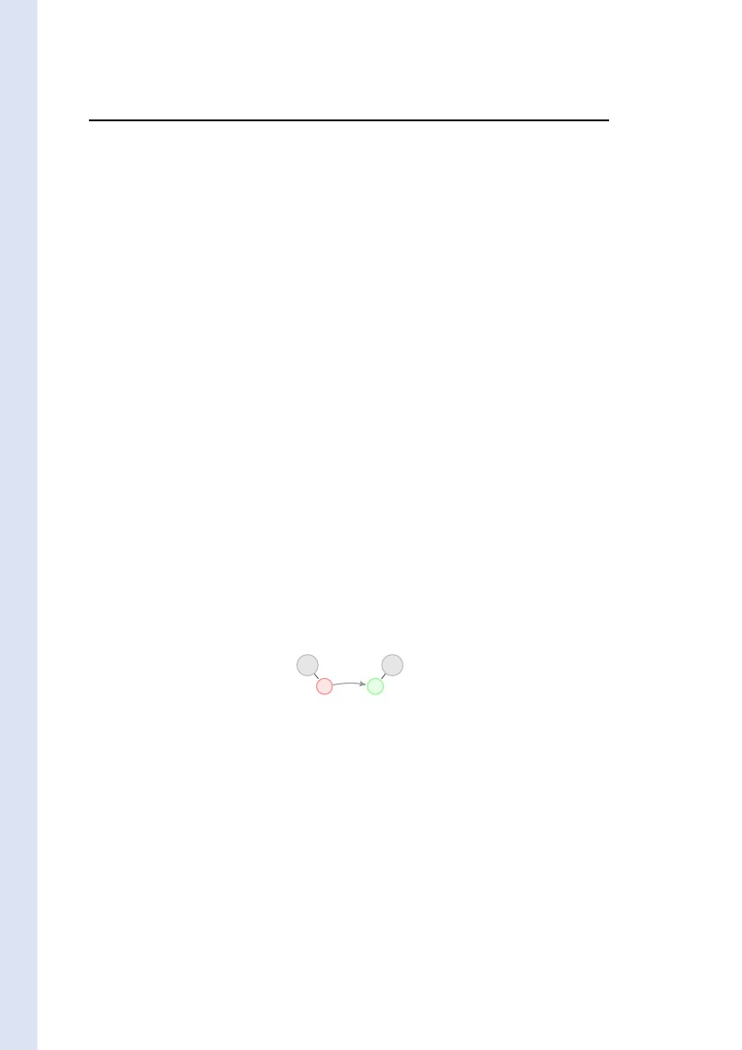
14
Badouel & al.
and either the original uniﬁcation problem E has a solution (a uniﬁer) and every computation
terminates (and henceforth produces a solved set equivalent to E describing a most general uniﬁer
of E) or E has no uniﬁer and every computation fails. We let
σ = mgu({ti = ui | 1 ≤ i ≤ n }) iﬀ
ti = u i | 1 ≤ i ≤ n
?
⇒∗ σ
2 Recall 4.8
Note that (5) and (6) are the only rules that can be applied to solve a uniﬁcation problem
of the form yi = ui | 1 ≤ i ≤ n , where the yi are distinct variables. The most general uniﬁer
exists when the occur check always holds, i.e., rule (5) always applies. The computation amounts
to iteratively replacing an occurrence of a variable yi in one of the right-hand side term uj
by its deﬁnition ui until no variable yi occurs in some uj . This process terminates precisely
when the relation yiyj ⇔ yj ∈ ui is acyclic. When this condition is met we say that
the set of equations {yi = ui | 1 ≤ i ≤ n } is acyclic and we say that it deﬁnes the substitution
σ = mgu({yi = ui | 1 ≤ i ≤ n }).
Proof of Proposition 4.7.
If a production P of left-hand side s(p1 , . . . , pn ) u1 , . . . um is triggered in node X0 deﬁned by
X0 = s(d1 , . . . , dn ) y1 , . . . , ym then by Deﬁnition 4.4
pi = di | 1 ≤ i ≤ n
?
?
hal-00990007, version 1 - 13 May 2014
∪ yj = u j | 1 ≤ j ≤ m
?
⇒∗ σin ∪ yj = uj σin | 1 ≤ j ≤ m
?
using only the rules (1) and (5). Now
σin ∪ yj = uj σin | 1 ≤ j ≤ m
?
⇒∗ σin ∪ mgu {yj = uj σin | 1 ≤ j ≤ m }
by applying iteratively rule (5) if the set of equations {yj = uj σin | 1 ≤ j ≤ m } satisﬁes the
occur check. Then σin + σout ⇒∗ σ again by using rule (5).2 Prop. 4.7
2
Note that the converse does not hold. Namely, one shall not deduce from Proposition 4.7
that the relation Γ[P/X0 Γ is deﬁned whenever the left-hand side lhs(P ) of P can be uniﬁed
with the deﬁnition def(X0 , Γ) of X0 in Γ with
Γ
= {X0 = P (X1 , . . . , Xk )} where X1 , . . . , Xk
∪ {X1 = F1 σ, . . . , Xk = Fk σ}
∪ {X = F σ | (X = F ) ∈ Γ ∧ X = X0 }
are nodes added to Γ
where σ = mgu(lhs(P ), def(X0 , Γ)) is the corresponding most general uniﬁer. Indeed, when
unifying s(d1 , . . . , dn , y1 , . . . , ym ) with s(p1 , . . . , pn , u1 , . . . , um ) one may generate an equation of
the form x = t where x is a variable in an inherited data di and t is an instance of a corresponding
subterm in the associated pattern pi . This would correspond to a situation where information
is sent to the context of a node through one of its inherited attribute! Otherwise stated some
parts of the pattern pi are actually used to ﬁltered out the incoming data value di while some
other parts of the same pattern are used to transfert synthesized information to the context.
As already mentioned, an artifact is reﬁned by applying a production at one of its open node.
However we also need means to initiate cases. To this extent, we deﬁne interfaces for GAGs,
that describe how services can initialize new artifacts.
Inria
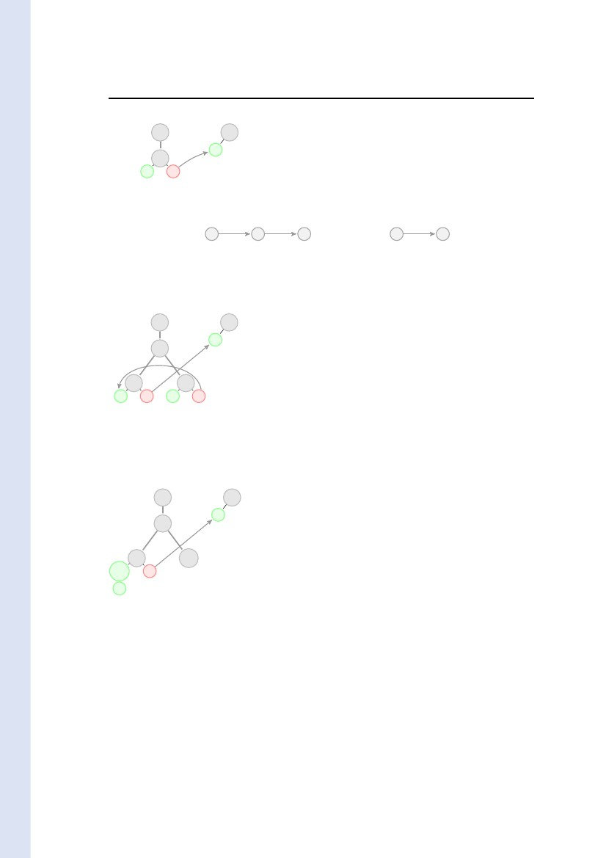
A Grammatical Approach to Data-centric Case Management
15
Deﬁnition 4.9. The interface of a guarded attribute grammar is given by a subset I of forms
F = s(t1 , . . . , tn ) x1 , . . . , xm , called its services where the synthesized positions are (distinct)
variables x1 , . . . , xm . The invocation of the service produces a new artifact reduced to a single
open node deﬁned by F , it is associated with initial conﬁguration
Γ0 = {X0 = s(t1 , . . . , tn ) x1 , . . . , xm }
An accessible conﬁguration of a guarded attribute grammar is a conﬁguration accessible from
one of its initial conﬁgurations.2 Def. 4.9
Example 4.10. The attribute grammar for the ﬂattening of a binary tree (Example 3.1) can be
presented as a guarded attribute grammar with the following productions:
Fork :
Leaf a :
bin(x) y ←bin(z) y bin(x) z
bin(x) Consa (x) ←
hal-00990007, version 1 - 13 May 2014
together with service Init x = bin(N il) x whose invocation creates a new binary tree and expects
for the list of its leaves. In comparison with Example 3.1 we avoid the construction of the artiﬁcial
node Root whose sole purpose was to initialize the inherited attribute of the tree at its root.
2 Exple 4.10
5
Some Examples
In this section we illustrate the behaviour of guarded attribute grammars with three examples.
Example 5.1 describes an execution of the attribute grammar of Example 3.1. The speciﬁca-
tion in Example 3.1 is actually an ordinary attribute grammar because the inherited attributes
in the left-hand sides of productions are plain variables. This example shows how data are lazily
produced and send in push mode through attributes. It also illustrates the role of the data links
and their dynamic evolutions.
Example 5.2 illustrates the role of the guards by describing two processes acting as corou-
tines. The ﬁrst process sends forth a list of values to the second process and it waits for an
acknowledgement for each message before sending the next one.
Example 5.3 justiﬁes the role of the occur check.
Example 5.1 (Example 3.1 continued). Let us consider the attribute grammar of Example 3.1
and the initial conﬁguration Γ0 = {X0 = root () x , Y0 = toor (x) } shown next
X0 :: root
?
?
x
x
?
Y0 :: toor
The annotated version !Γ0 = {!F | F ∈ Γ0 } of conﬁguration Γ0 is
!Γ0 = X0 = root () x? , Y0 = toor (x! )
The data link from x? to x! says that the list of the leaves of the tree —that will stem from node
X0 — to be synthesized at node X0 should be forwarded to the inherited attribute of Y0 .
This tree is not deﬁned in the intial conﬁguration Γ0 . One can start developping it by ap-
plying production Root : root () u ← bin(N il) u at node X0 :: root . Actually the left-hand
side root() u of production Root matches with the deﬁnition root () x of X0 with σin = ∅ and
σout = {x = u}. Hence Γ0 [Root/X0 Γ1 where the annotated conﬁguration !Γ1 is given in Fig-
ure 1. Note that substitution σout = {x = u} replaces the data link (x? , x! ) by a new link (u? , u! )
with the same target and whose source has been moved from the synthesized attribute of X0 to
the synthesized attribute of X1 :
RR n° 8528
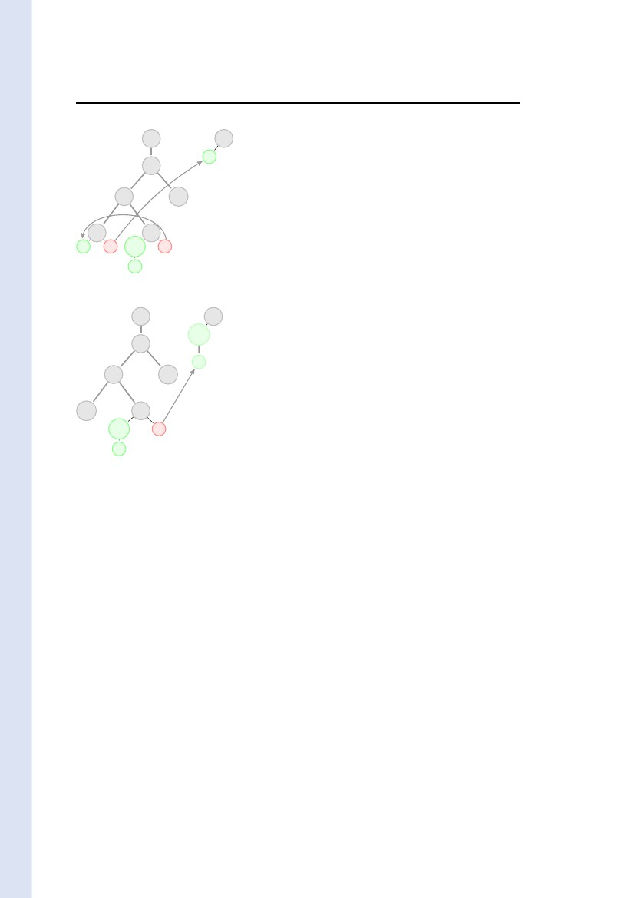
16
Badouel & al.
X0 :: root
Root
u
?
Y0 :: toor
X1 :: bin
Nil
?
?
u
X0 = Root(X1 )
X1 = bin(Nil) u?
Y0 = toor (u! )
Figure 1: Conﬁguration Γ1
u
?
x
u
x
u
[σout
?
u
The tree may be further reﬁned by applying production Fork : bin(x) y ← bin(z) y bin(x) z
at node X1 :: bin since its left-hand side bin(x) y matches with the deﬁnition bin(Nil) u of X1
with σin = {x = N il} and σout = {u = y}. Hence Γ1 [Fork/X1 Γ2 where !Γ2 is given in Figure 2.
hal-00990007, version 1 - 13 May 2014
X0 :: root
Root
y
Fork
?
Y0 :: toor
?
z
?
y
Nil
?
?
z
X0
X1
X11
X12
Y0
= Root(X1 )
= Fork(X11 , X12 )
= bin(z ! ) y ?
= bin(N il) z ?
= toor (y ! )
Figure 2: Conﬁguration Γ2
Production Leaf c : bin(x) Consc (x) ← applies at node X12 since its left-hand side bin(x) Consc (x)
matches with the deﬁnition bin(N il) z of X12 with σin = {x = N il} and σout = {z = Consc (Nil)}.
Hence Γ2 [Leaf c /X12 Γ3 where the annotated conﬁguration !Γ3 is given in Figure 3. As a result of
X0 :: root
Root
y
Fork
?
Y0 :: toor
?
Consc
Nil
?
y
Leaf c
X0
X1
X11
X12
Y0
= Root(X1 )
= Fork(X11 , X12 )
= bin(Consc (Nil)) y ?
= Leaf c
= toor (y ! )
Figure 3: Conﬁguration Γ3
substitution σout = {z = Consc (Nil)} the value Consc (Nil) is transmitted through the link (z ? , z ! )
and this link disappears.
Production Fork : bin(x) u ← bin(z) u bin(x) z may apply at node X11 since its left-hand
side bin(x) u matches with the deﬁnition bin(Consc (Nil)) y of X11 with σin = {x = Consc (Nil))}
and σout = {y = u}. Hence Γ3 [Fork/X1 Γ4 with conﬁguration ?Γ4 given in Figure 4.
Production Leaf a : bin(x) Consa (x) ← applies at node X111 since its left-hand side bin(x) Consa (x)
matches with the deﬁnition bin(z) u of X111 with σin = {x = z} and σout = {u = Consa (z)}.
Hence Γ4 [Leaf a /X111 Γ5 with conﬁguration !Γ5 given in Figure 5. Using substitution σout =
Inria
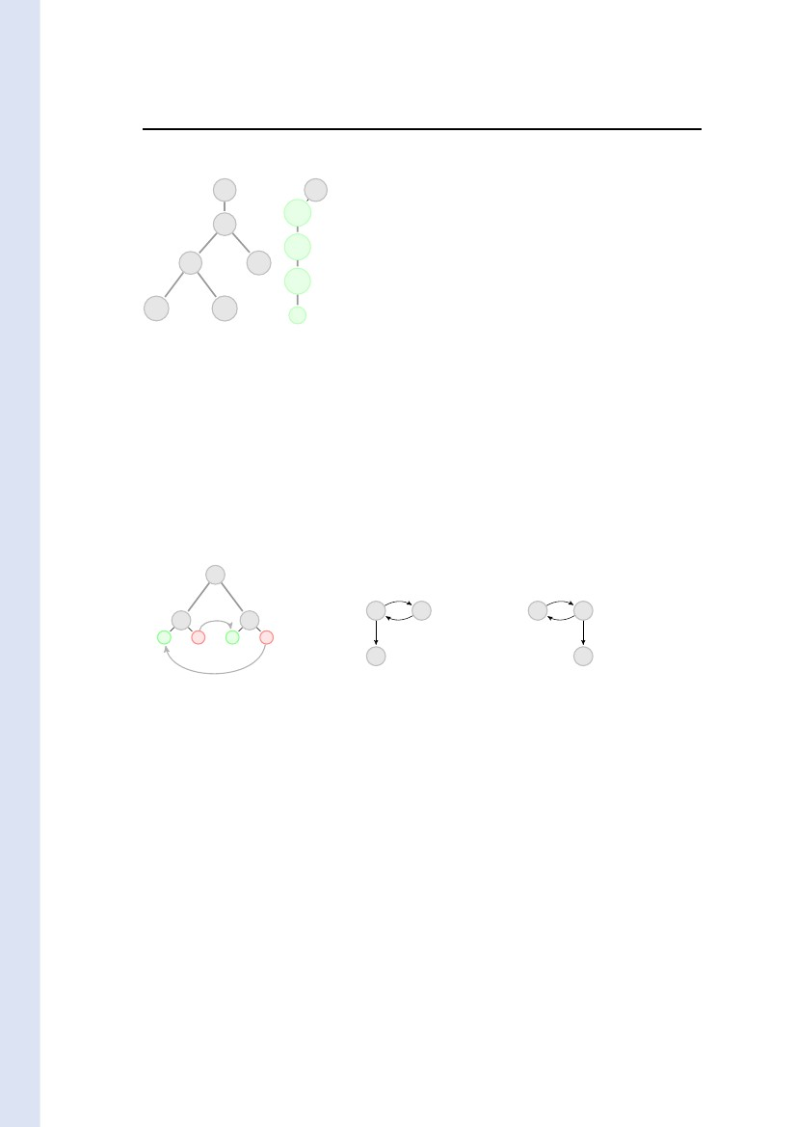
A Grammatical Approach to Data-centric Case Management
17
X0 :: root
Root
u
Fork
?
Y0 :: toor
Fork
Leaf c
?
z
?
u
Nil
Consc
?
?
z
X0
X1
X11
X111
X112
X12
Y0
= Root(X1 )
= Fork(X11 , X12 )
= Fork(X111 , X112 )
= bin(z!) u?
= bin(Consc (Nil)) z?
= Leaf c
= toor (u!)
Figure 4: Conﬁguration Γ4
X0 :: root
Root
Consa
Fork
z
Fork
Leaf c
?
Y0 :: toor
hal-00990007, version 1 - 13 May 2014
Leaf a
Consc
?
z
?
X0
X1
X11
X111
X112
X12
Y0
= Root(X1 )
= Fork(X11 , X12 )
= Fork(X111 , X112 )
= Leaf a
= bin(Consc (Nil)) z ?
= Leaf c
= toor (Consa (z ! ))
Nil
Figure 5: Conﬁguration Γ5
{u = Consa (z)} the data Consa (z) is transmitted through the link (u? , u! ) which, as a result, dis-
appears. A new link (z ? , z ! ) is created so that the rest of the list, to be synthesized in node X112
can later be forwarded to the inherited attribute of Y0 .
Finally one can apply production Leaf b : bin(x) Consa (x) ← at node X112 since its left-hand
side matches with the deﬁnition bin(Consc (Nil)) z of X112 with σin = {x = Consc (Nil)} and
σout = {z = Consb (Consc (Nil))}. Therefore Γ5 [Leaf b /X112 Γ6 with conﬁguration !Γ6 given in
Figure 6. Now the tree rooted at node X0 is closed —and thus it no longer holds attributes—
and the list of its leaves has been entirely forwarded to the inherited attribute of node Y0 . Note
that the recipient node Y0 could have been reﬁned in parallel with the changes of conﬁgurations
just described.2 Exple 5.1
The above example shows that data links are used to transmit data in push mode from a
source vertex v (the input occurrence x? of a variable x) to some target vertex v (an output
occurrence x! of the same variable). These links (x! , x? ) are transient in the sense that they
disappear as soon as variable x gets deﬁned by the substitution σout induced by the application
of a production in some open node of the current conﬁguration. If σout (x) is a term t, not
reduced to a variable, with variables x1 , . . . , xk then vertex v is reﬁned by the term t[x! /xi ]i
and new vertices vi —associated with these new occurrences of xi in an output position— are
created. The original data link (x? , x! ) is replaced by all the corresponding instances of (x? , x! ).ii
Consequently, a target is replaced by new targets which are the recipients for the subsequent
pieces of information (maybe none because no new links are created when t contains no variable).
RR n° 8528
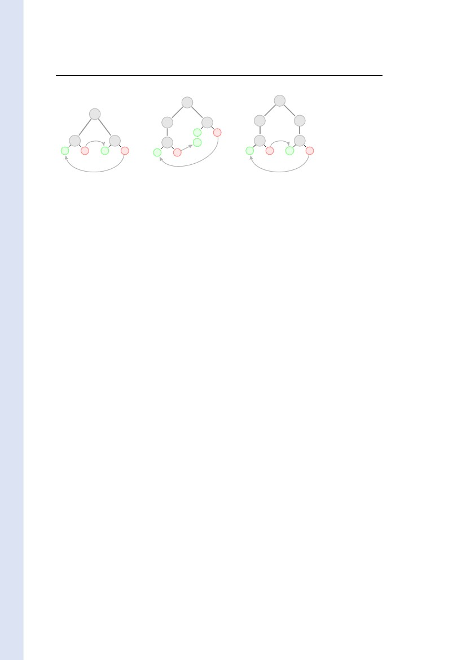
18
Badouel & al.
X0 :: root
Root
Y0 :: toor
?
Consa
Fork
Consb
Fork
Leaf c
Consc
X0
X1
X11
X111
X112
X12
Y0
= Root(X1 )
= Fork(X11 , X12 )
= Fork(X111 , X112 )
= Leaf a
= Leaf b
= Leaf c
= toor (Consa (Consb (Consc (Nil))))
Leaf a
Leaf b
Nil
Figure 6: Conﬁguration Γ6
If the term t is a variable y then the link (x? , x! ) is replaced by the link (y ? , y ! ) with the same
target and whose source, the (unique) occurrence x? of variable x, is replaced by the (unique)
occurrence y ? of variable y. Therefore the direction of the ﬂow of information is in both cases
preserved: Channels can be viewed as “generalized streams” (that can fork or vanish) through
which information is pushed incrementally.
Example 5.2. Figure 7 shows a guarded attribute grammar that represents two coroutines com-
municating through lazy streams. Each process alternatively sends and receives data. More
precisely the second process send an acknowlegment (a b message) upon reception of a message
send by the left process. Initially or after reception of an acknowlegment of its previous message
the left process can either send a new message or terminate the communication.
hal-00990007, version 1 - 13 May 2014
!a
q1
?
x
?
y
!b
q2
q1
?a
−
q2
?stop
q2
?
y
?
x
q1
!stop
?b
−
: q0 ← q1 (x) y q2 (y) x
!a : q1 (x) a(y) ← q2 (x) y
?b : q2 (b(x)) y ← q1 (x) y
!stop : q1 (x) stop ←
!b : q1 (y) b(x) ← q2 (y) x
?a : q2 (a(y)) x ← q1 (y) x
?stop : q2 (stop) y ←
Figure 7: Coroutines with lazy streams
Production !a : q1 (x ) a(y ) ← q2 (x ) y
applies at node X1 of the conﬁguration
Γ1 = X = X1 X2 , X1 = q1 (x) y , X2 = q2 (y) x
shown on the left of Figure 8 because its left-hand side q1 (x ) a(y ) matches with the deﬁnition
q1 (x) y of X1 with σin = {x = x} and σout = {y = a(y )}. One obtains the conﬁguration
Γ2 = X = X1 X2 , X1 =!a(X11 ), X2 = q2 (a(y )) x , X11 = q2 (x) y
shown on the middle of Figure 8. Production ?a : q2 (a(y)) x ← q1 (y) x applies at node X2
of Γ2 because its left-hand side q2 (a(y)) x matches with the deﬁnition q2 (a(y )) x of X2 with
σin = {y = y } and σout = {x = x }. One obtains the conﬁguration
Γ3 = X = X1 X2 , X1 =!a(X11 ), X2 =?a(X21 ), X11 = q2 (x ) y , X21 = q1 (y ) x
Inria
A Grammatical Approach to Data-centric Case Management
19
q2
!a
q1
?
x
y
?
q2
a
y
?
x
?
x
!a
q1
?
y
?a
q1
?
?
y
?
x
q2
?
?
?
x
?
y
x
y
Figure 8: Γ1 [!a/X1 Γ2 [?a/X2 Γ3
shown on the right of Figure 8. The corresponding acknowlegment may then be send and received
leading to conﬁguration
Γ5 = Γ ∪ X111 = q1 (x) y , X211 = q2 (y) x
hal-00990007, version 1 - 13 May 2014
where Γ = {X = X1 X2 , X1 =!a(X11 ), X2 =?a(X21 ), X21 =!b(X211 ), X11 =?b(X111 )}. The process on
the left may decide to end the communication by applying production !stop : q1 (x ) stop ← at
X111 with σin = {x = x} and σout = {y = stop} leading to conﬁguration
Γ6 = Γ ∪ X111 =!stop, X211 = q2 (stop) x
The reception of this message by the process on the right corresponds to applying production
?stop : q2 (stop) y ← at X211 with σin = ∅ and σout = {x = y} leading to conﬁguration
Γ7 = Γ ∪ {X111 =!stop, X211 =?stop}
Note that variable x appears in an input position in Γ6 and has no corresponding output occurrence.
This means that the value of x is not used in the conﬁguration. When production ?stop is ﬁred in node
X211 variable y is substituted to x. Variable y has an output occurrence in production ?stop and no
input occurence meaning that the corresponding output attribute is not deﬁned by the semantic rules. As
a consequence this variable simply disappears in the resulting conﬁguration Γ7 . If variable x was used
in Γ6 then the output occurrences of x would have been replaced by (output occurrences) of variable y
which will remain undeﬁned (no value will be substituted to y in subsequent transformations) until these
occurrences of variables may possibly disappear.2 Exple 5.2
We say that a production P is triggered in node X if substitution σin is deﬁned, i.e., the
patterns pi match the data di . As shown by the following example one can usually suspect an
error in the speciﬁcation when a triggered transition is not enabled due to the fact that the
system of equations {yj = uj σin | 1 ≤ j ≤ m } is cyclic.
Example 5.3. Let us consider the guarded attribute grammar given by the following productions:
P :
Q:
R:
s0 ( ) ← s1 (a(x)) x
s1 (y) a(y)←
s2 (a(z))←
s2 (x)
Applying production P0 in node X0 of conﬁguration Γ0 = {X0 = s0 ( ) } leads to conﬁguration
Γ1 = {X0 = P (X1 , X2 ); X1 = s1 (a(x)) x ; X2 = s2 (x) }
Production Q is triggered in node X1 with σin = {y = a(x)} but the occur check fails because
variable x occurs in a(y)σin = a(a(x)). Alternatively, we could drop the occur check and instead
RR n° 8528
20
Badouel & al.
adapt the ﬁxed point semantics for attribute evaluation deﬁned in [3, 19] in order to cope with
inﬁnite data structures. More precisely we could let σout be deﬁned as the least solution of the
system of equations {yi = uj σin | 1 ≤ j ≤ m } —assuming these equations are guarded, i.e., that
there is no cycle of copy rules in the link graph of any accessible conﬁguration—. In that case
the inﬁnite tree aω is substituted to variable x and the unique maximal computation associated
with the grammar is given by the inﬁnite tree P (Q, Rω ). In Deﬁnition 4.4 we have chosen to
restrict ourself to ﬁnite data structures which seems a reasonable assumption in view of the nature
of systems we want to model. The occur check is used to avoid recursive deﬁnitions of attribute
values. The given example, whose most natural interpretation is given by ﬁxed point computation,
should in that respect be considered as ill-formed. And indeed this guarded attribute grammar is
not sound (a notion presented in Section 7) because the conﬁguration Γ is not closed (it still
contains open nodes), hence it represents a case that is not terminated. However it is a terminal
conﬁguration since it enables no production.2 Exple 5.3
6
hal-00990007, version 1 - 13 May 2014
Distribution of a Guarded Attribute Grammar
The fact that triggered productions are not enabled can also impact the distributability of a
grammar as shown by the following example.
Example 6.1. Let us consider the GAG with the following productions:
P : s( )← s1 (x) y s2 (y) x
Q : s1 (z) a(z) ←
R : s2 (u) a(u) ←
Production P is enabled in the conﬁguration Γ0 = {X0 = s( ) } with Γ0 [P/X0 Γ1 where Γ1 =
{X0 = P (X1 , X2 ); X1 = s1 (x) y , X2 = s2 (y) x }. In conﬁguration Γ1 productions Q and R are
enabled in nodes X1 and X2 respectively with
Γ1 [Q/X1 Γ2 where Γ2 = {X0 = P (X1 , X2 ); X1 = Q, X2 = s2 (a(x)) x }
Γ1 [R/X2 Γ3 where Γ3 = {X0 = P (X1 , X2 ); X1 = s2 (a(y)) y , X2 = R}
Now production R is triggered but not enabled in node X2 conﬁguration Γ2 because of the cyclicity
of {x = a(a(x))}. Similarly, production Q is triggered but not enabled in node X3 conﬁguration
Γ3 . There is a conﬂict between the application of productions R and Q in conﬁguration Γ1 , which
makes this speciﬁcation non-implementable in case nodes X1 and X2 have distinct locations.
2 Exple 6.1
6.1
Input Enabled Guarded Attribute Grammars
Substitution σin , given by pattern matching, is monotonous w.r.t. incoming information and thus
it causes no problem for a distributed implementation of a model. However substitution σout is
not monotonous since it may become undeﬁned when information coming from a distant location
makes the match of output attributes a cyclic set of equations, as illustrated by example 6.1.
Deﬁnition 6.2. A guarded attribute grammar is input-enabled if every production that is
triggered in an accessible conﬁguration is also enabled.2 Def. 6.2
We call the substitution induced by a sequence Γ[∗ Γ the corresponding composition of the
various substitutions associated respectively with each of the individual steps in the sequence. If
X is an open node in both Γ and Γ , i.e., no productions are applied at X in the sequence, then
we get X = s(d1 σ, . . . , dn σ) y1 , . . . , ym ∈ Γ where X = s(d1 , . . . , dn ) y1 , . . . , ym ∈ Γ and σ is
the substitution induced by the sequence.
Inria
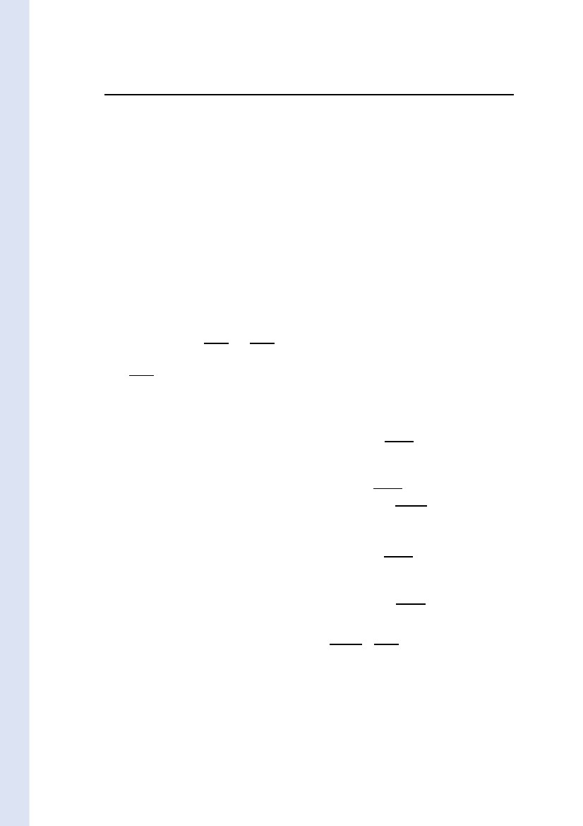
A Grammatical Approach to Data-centric Case Management
21
Proposition 6.3 (Monotony). Let Γ be an accessible conﬁguration of an input-enabled GAG,
X = s(d1 , . . . , dn ) y1 , . . . , ym ∈ Γ and σ the substitution induced by some sequence starting from
Γ. Then Γ[P/X Γ implies Γσ[P/X Γ σ.
Proof of Proposition 6.3.
Direct consequence of Deﬁnition 3.2 due to the fact that
1. match(p, dσ) = match(p, d)σ, and
2. mgu({yj = uj σ | 1 ≤ j ≤ m }) = mgu({yj = uj | 1 ≤ j ≤ m })σ.
The former is trivial and the latter follows by induction on the length of the computation of the
most general uniﬁer (relation ⇒∗ using rule (5) only). Note that the assumption that the guarded
attribute grammar is input-enabled is crucial because in the general case it could happen that the
set {yj = uj σin | 1 ≤ j ≤ m } satisﬁes the occur check whereas the set {yj = uj (σin σ) | 1 ≤ j ≤ m }
does not satisfy the occur check.2 Prop. 6.3
2
hal-00990007, version 1 - 13 May 2014
Proposition 6.3 is instrumental for the distributed implementation of guarded attribute gram-
mars. Namely it states that new information coming from a distant asynchronous location re-
ﬁning the value of some input occurrences of variables of an enabled production do not prevent
from applying that production. Thus a production that is locally enabled can freely be applied
regardless of information that might further reﬁne the current local conﬁguration. It means
that conﬂict arises only from the existence of two distinct productions enabled in the same open
node. Hence the only form of non-determinism corresponds to the decision of a stakeholder to
apply one particular production among those enabled in a conﬁguration. This is expressed by
the following conﬂuence property.
Corollary 6.4. Let Γ be an accessible conﬁguration of an input enabled GAG. If Γ[P/X Γ1 and
Γ[Q/Y Γ2 with X = Y then Γ2 [P/X Γ3 and Γ1 [Q/Y Γ3 for some conﬁguration Γ3 .
Note that, by Corollary 6.4, the artifact contains a full history of the case in the sense that one
can reconstruct from the artifact the complete sequence of applications of productions leading
to the resolution of the case (up to the commutation of independent elements in the sequence).
We might have considered a more symmetrical presentation in Deﬁnition 3.2 by allowing
patterns for synthesized attributes in the right-hand sides of productions with the eﬀect of
creating forms in a conﬁguration with patterns in their co-arguments. These patterns express
constraints on synthesized values. This extension could be acceptable as long as one sticks
to purely centralized models. However, as soon as one wants to distribute the model on an
asynchronous architecture, one cannot avoid such a constraint to be further reﬁned due to a
transformation occurring in a distant location. Then the monotony property (Proposition 6.3)
is lost: a locally enabled production can later be disabled when a constraint on a synthesized
value gets a reﬁned value. This is why we required synthesized attributes in the right-hand side
of a production to be given by plain variables in order to prohibit the expression of constraints
on synthesized values.
It is diﬃcult to verify input-enabledness as the whole set of accessible conﬁgurations are
involved in this condition. Nevertheless one can ﬁnd a suﬃcient condition for input enabledness,
similar to the strong non-circularity of attribute grammars [4], that can be checked by a simple
ﬁxed-point computation.
Deﬁnition 6.5. Let s be a sort of a guarded attribute grammar with n inherited attributes and
m synthesized attributes. We let (j, i) ∈ SI(s) where 1 ≤ i ≤ n and 1 ≤ j ≤ m if exists
X = s(d1 , . . . , dn ) y1 , . . . , ym ∈ Γ where Γ is an accessible conﬁguration and yj ∈ di . If P is a
RR n° 8528

22
Badouel & al.
production with left-hand side s(p1 , . . . , pn ) u1 , . . . , um we let (i, j) ∈ IS(P ) if exists a variable
x ∈ var(P ) such that x ∈ var(di ) ∩ var(uj ). The guarded attribute grammar G is said to be
acyclic if for every sort s and production P whose left-hand side is a form of sort s the graph
G(s, P ) = SI(s) ∪ IS(P ) is acyclic.2 Def. 6.5
Proposition 6.6. An acyclic guarded attribute grammar is input-enabled.
Proof. Suppose P is triggered in node X with substitution σin such that yj ∈ ui σin then (i, j) ∈
G(s, P ). Then the fact that occur check fails for the set {yj | 1 ≤ j ≤ m } entails that one can
ﬁnd a cycle in G(s, P ).2 Prop. 6.6
2
Relation SI(s) still takes into account the whole set of accessible conﬁgurations. The following
deﬁnition provides an overapproximation of this relation given by a ﬁxed point computation.
Deﬁnition 6.7. The graph of local dependencies of a production P : F0 ← F1 · · · F is the
directed graph GLD(P ) that records the data dependencies between the occurrences of attributes
given by the semantics rules. We designate the occurrences of attributes of P as follows: we
let k(i) (respectively k j ) denote the occurrence of the ith inherited attribute (resp. the j th
synthesized attribute) in Fk . If s is a sort with n inherited attributes and m synthesized attributes
we deﬁne the relations IS(s) and SI(s) over [1, n] × [1, m] and [1, m] × [1, n] respectively as the
least relations such that :
1. SI(s) = SI(s) if s is an axiom, i.e., it is given by the set of pairs (j, i) such that yj ∈ var(di )
for some service F = s(d1 , . . . , dn ) y1 , . . . , ym of sort s in the interface of the guarded
attribute grammar.
2. For every production P : F0 ← F1 · · · F where form Fi is of sort si and for every k ∈ [1, ]
(j, i)
(k j , k(i)) ∈ GLD(P )k
⊆ SI(sk )
hal-00990007, version 1 - 13 May 2014
where graph GLD(P )k is given as the transitive closure of
GLD(P ) ∪ (0 j , 0(i))
∪ (k (i), k j )
(j, i) ∈ SI(s0 )
k ∈ [1, ], k = k, (i, j) ∈ IS(sk )
3. For every production P : F0 ← F1 · · · F where form Fi is of sort si
(i, j) (0(i), 0 j ) ∈ GLD(P )0
⊆ IS(s0 )
where graph GLD(P )0 is given as the transitive closure of
GLD(P ) ∪ (k(i), k j )
k ∈ [1, ], (i, j) ∈ IS(sk )
The guarded attribute grammar G is said to be strongly-acyclic if for every sort s and production
P whose left-hand side is a form of sort s the graph G(s, P ) = SI(s) ∪ IS(P ) is acyclic.
2 Def. 6.7
Proposition 6.8. A strongly-acyclic guarded attribute grammar is acyclic and hence input-
enabled.
Inria

A Grammatical Approach to Data-centric Case Management
23
Proof. The proof is analog to the proof that a strongly non-circular attribute grammar is non-
circular and it goes as follows. We let (i, j) ∈ IS(s) when var(di σ) ∩ var(yj σ) = ∅ for some
form F = s(d1 , . . . , dn ) y1 , . . . , ym of sort s and where σ is the substitution induced by a ﬁring
sequence starting from conﬁguration {X = F }. Then we show by induction on the length of the
ﬁring sequence leading to the accessible conﬁguration that IS(s) ⊆ IS(s) and SI(s) ⊆ SI(s).
2 Prop. 6.8
2
Note that the following two inclusions are strict
strongly-acyclic GAGs
acyclic GAGs
input enabled GAGs
Indeed the reader may easily check that the guarded attribute grammar
A(x) z ← B(a(x, y)) y, z
B(a(x, y)) x, y ←
hal-00990007, version 1 - 13 May 2014
is acyclic but not strongly-acyclic. Attribute grammars arising from real situations are almost
always strongly non-circular so that this assumption is not really restrictive. Similarly we are
conﬁdent that most of the guarded attribute grammars that we shall use in practise will be input-
enabled and that most of the input-enabled guarded attribute grammars are in fact strongly-
acyclic. Thus most of the speciﬁcations are distributable and most of those can be proved so by
checking the strong non-circularity condition.
is cyclic and input-enabled whereas guarded
 A(x) z
A(x) z
B(x, y)
attribute grammar with productions
← B(y, x) z, y
← B(x, y) y, z
x, y ←
6.2
Distribution of an Input Enabled Guarded Attribute Grammar
The principle of a distribution of a GAG on a set of locations is as follows: Each location maintains
a local conﬁguration, and subscribes to results provided by other locations. Productions are
applied locally. When variables are given a value by a production, the location that computed
this value sends messages to the locations that subscribed to this value. Messages are simply
equations deﬁning the value of a particular variable. Upon reception of a messages, a subscriber
updates its local conﬁguration, and may in turn produce new messages.
More formally, a GAG can be distributed by specifying a partition S = 1≤ ≤p S of the set
of sorts. The projections Γ , called the local conﬁgurations associated with sites S , are deﬁned
as follows. Each site S has a namespace ns(S ) used for the nodes X whose sorts are in S
and for the variables x representing attributes of these nodes but also for references to variables
belonging to distant sites (subscriptions). Hence we have name generators that produce unique
identiﬁers for each newly created variable for each site. For each equation X = P (X1 , . . . , Xn )
with X :: s and Xi :: si we insert equation X = P (X 1 , . . . , X n ) in Γ where s ∈ S and variable
X i is Xi if si ∈ S or is a new variable in the namespace of S if si ∈ S with = . In the latter
case we add equation X i = Xi in Γ . Similarly for each equation X = s(t1 , . . . , tn ) y1 , . . . , ym
in Γ we add equation X = s(t1 , . . . , tn ) y 1 , . . . , ym in Γ where s ∈ S and t is obtained by
replacing each variable x in term t by x where variable x is x if x :: s with s ∈ S else is
a new variable in the namespace of S . In the latter case one adds equation x = x, called a
subscription, to Γ . Similarly for the variables yj . Hence a local conﬁguration contains the
RR n° 8528

24
Badouel & al.
usual equations associated with their closed and open nodes (and containing only local variables)
together with equations of the form X = Y and y = x where x and X are local names and y and
Y belongs to distant sites. Clearly the global conﬁguration can be recovered as Γ = Γ1 ⊕ · · · ⊕ Γn
where operator ⊕ consists in taking the union of the systems of equations given as arguments
and simplifying the resulting system by elimination of the copy rules: we drop each equation of
the form X = Y (respectively y = x) and replace each occurrence of X by Y (resp. of y by x).
Therefore the global conﬁguration Γ may be identiﬁed with the vectors of local conﬁgurations
(Γ1 , . . . , Γp ).
P /X
Each production can then be locally applied: we write Γ −→ Γ when application of pro-
M
duction P at node X results in a new conﬁguration Γ and the sending of a set of messages
M.
P /X
More formally, Γ −→ Γ when X = s(t1 , . . . , tn ) y1 , . . . , ym ∈ Γ and P = F ← F1 · · · Fk is
M
a production whose left-hand side matches with X and
Γ
=
∪
∪
∪
=
∪
∪
{X = P (X1 , . . . , Xk )}where X1 , . . . , Xk are new names in ns(S )
{Xi = Fi σ | Xi :: si and si ∈ S }
{X = F σ | (X = F ) ∈ Γ ∧ X = X }
{y = yj σ | (y = yj ) ∈ Γ and yj σ is a variable }
{Xi = Fi σ | Xi :: si and si ∈ S }
{y = yj σ | (y = yj ) ∈ Γ and yj σ not a variable }
Mσ
hal-00990007, version 1 - 13 May 2014
M
where σ = match(F, X), and σ is the relativization of σ to location , it generates a set of
messages Mσ . This relation means that applying production P at X in site S generates messages
M send to distant sites. The reception of a message may generate new messages and is described
mby relation Γ −→ Γ where
M
= then Γ =1. If m = {X = s(t1 , . . . , tn ) y1 , . . . , yq } with X ∈ ns(S ), s ∈ S with
Γ ∪ X = s(t1 , . . . , tn ) y 1 , . . . , y q ∪ {yj = yj | 1 ≤ j ≤ q } where X, the variables x for
x ∈ var(ti ) and the variables y j are new names in ns(S ) and t = t[x/x], and M =
{x = x | x ∈ var(ti ) 1 ≤ i ≤ n } ∪ X = X .
2. If m = {x = t} with x ∈ ns(S ) then Γ = Γ [x = t[y/y]] where y are new names in ns(S )
associated with the variables y in t and M = {y = y | y ∈ var(t) }.
3. If m = (X = Y ) with X ∈ ns(S ) then Γ = Γ ∪ {X = Y } and M = ∅.
4. If m = (y = x) with x ∈ ns(S ) then Γ = Γ ∪ {y = x} and M = ∅.
The global dynamics of the system can then be derived as follows, where e stands for P/X
or a message m:
ee1. If Γ −→ Γ then Γ =⇒ Γ with Γ = Γ for = .
M
M
2. If
Γ =⇒ Γ
M
e
and
Γ =⇒ Γ
M
m
for m ∈ M then
Γ
M \{m}∪M
=⇒
e
Γ
Input-enabled GAGs possess useful properties with respect to distribution, namely messages
consumptions and application of productions commute, as shown in the following proposition:
Proposition 6.9. For an input-enabled guarded attribute grammar:
1. If
Γ =⇒ Γ
M
P /X
then there exists a substitution σM such that
Γ =⇒ Γ σM .
∅
P /X
Inria

A Grammatical Approach to Data-centric Case Management
25
2. Γ[P/X Γ if and only if
3. Let
Γ =⇒ Γ1
M1
P1 /X1
Γ =⇒ Γ
∅
P /X
and
Γ =⇒ Γ2
M2
P2 /X2
with X1 = X2 . One can assume w.l.o.g that M1 and M2 have
hal-00990007, version 1 - 13 May 2014
no common variables (the name generator chooses diﬀerent names for the new variables in
both cases). Then the diagram below , wheredenotes messages consumption commutes.
m Γ QQQQmmm
QQQP2 /X2P1 /X1 mmm
QQQmm
QQQmmm M1M2
QQQmmm
(/o /o /o / Γ2 σMo o/ o/ o/ Γ1 vmΓ1 σM1
PPP2
n Γ2n
PPP P /XnP1 /X1 nnn2PPP 2nnM1 P1 /X1M2 P2 /X2
PPPnnnM1M2nPPP
'wnnn
Γ3Γ1 )i )iu5 Γ2
)i )i )iu5 u5 u5O
)i )i )i
u5 u5
O
)i )i )i
u5 u5 u5
u5O
)i )u u5 u5
Γ3 (σM1 ∪ σM2 )
= Γ2 σM1 = Γ1 σM2
Intuitively, proposition 6.9 and in particular (3) mean that distribution does not aﬀect the
global behavious of an input-enabled GAG.
Proof of Proposition 6.9.
We ﬁrst prove (1): whenever
P /X
P /X
M
Γ =⇒ Γ
then there exists a substitution σM such that
Γ =⇒ Γ σM .
∅
P /X
Let us assume that Γ =⇒ Γ , and examine how consuming messages in M = {m1 , . . . , mq } aﬀects
M
Γ . Messages can be of several kinds :
• if mi = (y = x) ( or mi = (X = Y ) ) then consuming the message results in adding an
equation σmi = {y = x} (resp. σmi = {X = Y }) to the local conﬁguration that receives
this message, and generates no new message.
• if mi = {x = t}, then consumption of the message results in production of new variables,
and a new (ﬁnite) set of messages Mi that are all of the form {¯ = y} and can theny
be consumed without producing new messages by the location that has subscribed to this
value. We can denote by σi the substitution that replaces every x in the local conﬁguration
that receives mi .
• if mi is of the form {X = s(t1 , . . . , tn ) < y1 , . . . , yn >}, then consuming mi results in
adding new equations to the local conﬁguration that receives it, and generating a set of
¯
messages Mi = {mi,1 , mi,q }, that are of the form {¯ = y} and {X = X} and can hence bey
consumed by the location that will receive them without generating new messages.
These observations show that, after application of a production, message consumption is a ﬁnite
m|M |M|M |P /XM1m1process. We have Γ =⇒ Γ =⇒ Γ1 =⇒ Γ1 . . . =⇒ Γ|M | =⇒ Γ|M |
M
M1
∅
M|M |
∅
Now, the diﬀerence between each Γi and Γi is a set of subscriptions, that are appended to
some local conﬁgurations, and erased during the step. Therefore, the global conﬁgurations Γi
and Γi are identical. Similarly, we have Γ1 = Γ σm1 , and Γi = Γi−1 σmi for every i ∈ [2, |M |].
Hence, the substitution σM = σm1 . . . σ|M| is such that Γ σM = Γ|M| . Hence
Γ =⇒ Γ σM .
∅
P /X
We now give a proof for (2). We have to establish the following equivalence: Γ[P/X Γ
P /XP /X
if and only if Γ =⇒ Γ . First, whenever Γ =⇒ Γ , then, by deﬁnition, Γ[P/X Γ . Conversely,
∅
∅
RR n° 8528
26
Badouel & al.
Γ[P/X Γ implies the existence of and M such that Γ
Γ1 = Γ
for
= ). Hence, by (1) we have
P /X
∅
P /X
M
−→ Γ1 .
Thus, by deﬁnition Γ
P /X
M
=⇒ Γ1
(with
Γ =⇒ Γ1 σM .
Note that productions applications
are deterministic, and messages consumption too. Hence, it suﬃces to prove Γ := Γ1 σM to
obtain the desired result. In fact the nodes replacement performed to obtain Γ and Γ1 are
identical, since the same production is applied at the same node. Let us denote by Γ[ P/X] the
conﬁguration obtained by replacement of X. We have to show the equality Γ = Γ[ P/X]σ =
Γ[ P/X]σl σM , where σ is the usual substitution applied during production application, σl is
the substitution resulting from applying production locally to Γl , and σM is the substitution
obtained by consumption of messages in M . Now, one can notice that all substitutions in
σM replace a variable y by a term t whenever y is a subscription to some value produced
in Γl . The eﬀect is exactly the same as applying σ at nodes that diﬀer from X in Γ. As
additional subscription generated by messages consumption is not considered in the product, we
have Γ = Γ[ P/X]σ = Γ[ P/X]σl σM .
The last statement, (3), expresses the commutativity of the following diagram:
hal-00990007, version 1 - 13 May 2014
m Γ QQQQmmm
QQQP2 /X2P1 /X1 mmm
QQQm
QQQmmm 1M2
QQQmmm M
vmm(
Γ2 /o /o /o / Γ2 σM2Γ1 σM1 o o/ o/ o/ Γ1 PP
PPP
nnn
PPP /X2P1 /X1 nnnP2
PPPnnM1 P1 /X1M2 P2 /X2
PPP
nnnM1M2
n
P'wnnn
Γ3Γ1 )i )iΓ2
u5 u5
)i )i )iOu5 u5 u5
)i )i )iu5 u5O
)i )i )i
u5 u5 u5O
)i )u u5 u5
Γ3 (σM1 ∪ σM2 )
= Γ2 σM1 = Γ1 σM2
We ﬁrst consider the commutativity of the center:
Γ =⇒ Γ1 =⇒ Γ3
M1
M2
P1 /X1
P2 /X2
commutes into
Γ =⇒ Γ2 =⇒ Γ3 .
M2
M1
P2 /X2
P1 /X1
This follows directly from the properties of input-enabled grammars: Γ3 is simply Γ where
1both open nodes X1 and X2 have been replaced respectively by the closed nodes X1 = P1 (Y11 , . . . , Ym )
and X2 = P2 (Y12 , . . . , Yk2 ) (since M1 and M2 have no common variables they are unaﬀected by
each other).
Let us consider the left hand-side of the diagram. From (1), we have that Γ
P1 /X1
M1
/ Γ1 /o /o /o / Γ1 σM1 .
And by (2), this implies that Γ[P1 /X1 Γ1 σM1 . Using Proposition 6.3, and the fact that Γ1 [P2 /X2 Γ1 ,
P2 /Xwhe have that P2 is triggered and enabled in Γ1 σM1 . Hence, Γ1 σM1 =⇒ 2 Γ1 . Using again Propo-
M2
sition 6.3, conﬁguration Γ1 is simply Γ3 σM1 .
Furthermore, from (1), we have that: Γ1 σM1
P2 /X2
M2
/ Γ /o /o /o / Γ σM2 , since Γ = Γ3 σM1 , we111
have: Γ1 σM2 = Γ3 σM1 σM2 . By a symmetric argument, we obtain: Γ2 σM1 = Γ3 σM2 σM1 . Since
these substitutions have disjoint support, we have σM1 σM2 = σM2 σM1 = σM1 ∪ σM2 . Thus, we
have: Γ3 σM1 σM2 = Γ3 σM2 σM1 = Γ3 σM1 ∪ σM2 .
Finally Γ3 /o /o /o / Γ3 (σM1 ∪ σM2 ) follows from the deﬁnitions of σM1 and σM2 .
2 Prop. 6.9
2
Inria
A Grammatical Approach to Data-centric Case Management
27
7
Soundness
A speciﬁcation is sound if every case can reach completion no matter how its execution started.
Deﬁnition 7.1. Let a guarded attribute grammar be given with its interface (Deﬁnition 4.9).
A case is an instanciation c = s(t1 σ, . . . , tn σ) x1 , . . . , xm of a service s(t1 , . . . , tn ) x1 , . . . , xm
where σ is a substitution such that var(ti )σ ⊆ {x1 , . . . , xm }. Stated otherwise a case is, but for the
variables with a synthesized value, a closed instance of a service. It means that it is a service call
which already contains all the information coming from the environment of the guarded attribute
grammar. A conﬁguration is closed if it contains only closed nodes. A guarded attribute grammar
is sound if a closed conﬁguration is accessible from any conﬁguration Γ accessible from the initial
conﬁguration Γ0 (c) = {X0 = c} associated with a case c.2 Exple 7.1
Let γ denote the set of conﬁgurations accessible from the initial conﬁguration of some case.
We consider the ﬁnite sequences (Γi )0<i≤n and the inﬁnite sequences (Γi )0<i<ω of conﬁgurations
in γ such that Γi [ Γi+1 . A ﬁnite and maximal sequence is said to be terminal, i.e., a terminal
sequence leads to a conﬁguration that enables no production. Soundness can the be rephrased
by the two following conditions.
1. Every terminal sequence leads to a closed conﬁguration.
2. Every conﬁguration on an inﬁnite sequence also belongs to some terminal sequence.
Soundness can unfortunately be proved indecidable by a simple encoding of Minsky machines.
Proposition 7.2. Soundness of guarded attribute grammar is undecidable.
Proof. We consider the following presentation of the Minsky machines. We have two registers
r1 and r2 holding integer values. Integers are encoded with the constant zero and the unary
operator succ. The machine is given by a ﬁnite list of instructions instr i for i = 1, . . . , N of one
of the three following forms
1. INC(r,i): increment register r and go to instruction i.
2. JZDEC(r,i,j): if the value of register r is 0 then go to instruction i else decrement the
value of the register and go to j.
3. HALT: terminate.
We associate such a machine with a guarded attribute grammar whose sorts corresponds bijec-
tively to the lines of the program, (i.e., S = {s1 , . . . , sN }) with the following encoding of the
program instructions by productions:
1. If instr k = INC(r1 , i) then add production
Inc(k, 1, i) : sk (x, y) ← si (succ(x), y)
2. If instr k = INC(r2 , i) then add production
Inc(k, 2, i) : sk (x, y) ← si (x, succ(y))
3. If instr k = JZDEC(r1 , i, j) then add the productions
Jz(k, 1, i) : sk (zero, y) ← si (zero, y)
Dec(k, 1, j) : sk (succ(x), y) ← sj (x, y)
RR n° 8528
hal-00990007, version 1 - 13 May 2014
28
Badouel & al.
4. If instr k = JZDEC(r2 , i, j) then add the productions
Jz(k, 2, i) : sk (x, zero) ← si (x, zero)
Dec(k, 2, j) : sk (x, succ(y)) ← sj (x, y)
5. If instr k = HALT then add production
Halt(k) : sk (x, y) ←
Since there is a unique maximal ﬁring sequence from the initial conﬁguration Γ0 = {X0 = s1 (zero, zero)}
the corresponding guarded attribute grammar is sound if and only if the computation of the cor-
responding Minsky machine terminates.2 Prop. 7.2
2
8
hal-00990007, version 1 - 13 May 2014
Conclusion
To conclude we assess our model and highlight some research directions.
8.1
Assessment of the model
In a nutshell the model of GAGs provides a modular, declarative, user-centric, data-driven, dis-
tributed and reconﬁgurable model of case management.
Concurrency. The lifecycle of a business artifact is implicitly represented by the grammar
productions. A production decomposes a task into new subtasks and speciﬁes constraints between
their attributes in the form of the so-called semantic rules. The subtasks may then evolve
independently as long as the semantic rules are satisﬁed. The order of execution, which may
depend on value that are computed during process execution, need not (and cannot in general)
be determined statically. For that reason, GAGs allow as much concurrency as needed. In
comparison, models in which the lifecycle of artifacts are represented by ﬁnite automata constrain
concurrency among tasks in an artiﬁcial way.
Modularity. The GAG approach also facilitates a modular description of business processes.
For instance when a referee has accepted to produce a report, one need not care about the sub-
process dedicated to the actual production of the report. In the example depicted on Table 3,
making a review report was modeled by a single production, but one can imagine similar sit-
uations where computing some synthesized information is given by a large set of rules used to
collect and assemble information arising from various sources. However, following a top-down ap-
proach, one simply introduces an attribute in which this report should eventually be synthesized
and delegate the actual production of the expected outcome to an additional set of rules. The
identiﬁcation of the diﬀerent roles involved in the business process also contributes to enhance
modularity. Finally, some techniques borrowed from attribute grammars, like descriptional com-
position [10, 11], decomposition by aspects [30, 29] or higher-order attribute grammars [28], may
also contribute to better modular designs.
Reconﬁguration. The workﬂow can be reconﬁgured at run time: New business rules (pro-
ductions of the grammar) can be added to the system without disturbing the current cases. By
contrast, run time reconﬁguration of workﬂows modeled by Petri nets (or similar models) is a
Inria
A Grammatical Approach to Data-centric Case Management
29
complex issue [20, 9]. One can also add “macro productions” corresponding to speciﬁc compo-
sitions of productions. For instance if the Editor-in-chief wants to handle the evaluation of a
paper, he can decide to act as an associate editor and as a referee for this particular submission.
However, this means forwarding the corresponding case to himself as an associate editor and
then asking himself as a referee if he is willing to write a report. A more direct way to model
this decision is to encapsulate these steps in a compound macro production that bypasses the
intermediate communications. More generally compound rules can be introduced for handling
unusual behaviors that deviates from the nominal workﬂow.
Logged information. When a case is terminated, the corresponding artifact collects all rel-
evant information of its history. Nodes are labeled by instances of the productions that have
lead to the completion of the case. Henthforth, they record the decisions (the choices among the
allowed productions) together with information associated with these decisions. In the case of
the editorial process, a terminated case contains the names of the referees, the evaluation reports,
the editorial decision, etc. A terminated case is a tree whose branches reﬂect causal dependencies
among subactivities used to solve a case, while abstracting from concurrent subactivities. The
temporary information stored by the attributes attached to open nodes no longer exist when the
case has reached completion. Closing nodes eliminates temporary information without resorting
to any complex mechanism of distributed garbage collection. The artifacts can be collected in
a log which may be used for the purpose of process mining [27] either for process discovery
(by inferring a GAG from a set of artifacts using common patterns in their tree structure) or
for conformance checking (by inspection of the logs produced during simulations of a model or
executions of an actual implementation).
Distribution. Guarded attributed grammars can easily be implemented on a distributed ar-
chitecture without complex communication mechanisms (shared memory, FIFO channels,...).
Stakeholders in a business process own open nodes, and communicate asynchronously with other
stakeholders via messages. Moreover there are no edition conﬂicts since each part of an artifact
is edited by the unique owner of the corresponding node.
hal-00990007, version 1 - 13 May 2014
8.2
Further works.
We plan to design prototypes to analyze and implement a GAG description together with the
required support tools (editor, parser, checker, simulators ...) and to concentrate on the following
research directions:
Applicability. We intend to develop some representative case studies to check applicability
and limitations of the model. The ﬁrst case study is a (simpliﬁed) distributed distance learning
system, for which a GAGs implementation may have several advantages w.r.t. traditional solu-
tions. First, since it does not rely on a client/server architecture, it should behave better in a
degraded environment (when Internet connection is not always available). Most of the activity of
the stakeholders are oﬄine and the communication between them takes place upon avaibility of
Internet connection. Second, the declarative decomposition of learning activities which does not
impose a particular execution order together with the modularity of the model should provide
more ﬂexibility in the description of the learning processes. The second case study is a reporting
system (e.g. semi-automatic synthesis of dashboards). The grammar can reﬂect the structure
of the report, the identiﬁcation of the stakeholders and their respective contributions lead to a
distributed version of the grammar. Finally the semantic rules implement the automatic assem-
bly of the reports. We obtain a “write things once” principle: once data are collected in some
RR n° 8528
30
Badouel & al.
synthesized position they can be used wherever they are needed. GAGs should hence reduce
the workload of stakeholders: as the largest part of activity reports collect information that is
already available somewhere, and can be extracted automatically by a GAG.
Structuring the workspace of a stakeholder: Active Workspaces. One can rely on
the technique presented in [26] to extract a domain speciﬁc language from the subgrammar
associated with a stakeholder according to the role(s) he plays in the system. The grammar may
then contribute to structure the workspace of a stakeholder: Procedural parts of the artifacts
given by the semantic rules encode and encapsulate technical know-hows that the end user may
safely ignore. Each stakeholder manipulates documents in a familiar syntax using notations
adapted to his domain of expertise (the DSL derived from the semantic rules). This can be
important for enabling end-users with low level computer literacy to take part in the business
process.
Soundness. Soundness is a crucial issue of case management systems: it guarantees that a case
has a way to reach completion from any accessible conﬁguration. Unsurprisingly soundness of
GAGs in undecidable. We are looking for recursive subclasses of GAGs with decidable soundness.
hal-00990007, version 1 - 13 May 2014
References
[1] Serge Abiteboul, Omar Benjelloun, Ioana Manolescu, Tova Milo, and Roger Weber. Active
xml: A data-centric perspective on web services. In BDA’02, 2002.
[2] Kevin Backhouse. A functional semantics of attribute grammars. In Tools and Algorithms
for the Construction and Analysis of Systems, TACAS, volume 2280 of Lecture Notes in
Computer Science, pages 142–157. Springer, 2002.
[3] Laurian M. Chirica and David F. Martin. An order-algebraic deﬁnition of knuthian seman-
tics. Mathematical Systems Theory, 13:1–27, 1979.
[4] Bruno Courcelle and Paul Franchi-Zannettacci. Attribute grammars and recursive program
schemes i and ii. Theor. Comput. Sci., 17:163–191 and 235–257, 1982.
[5] Elio Damaggio, Alin Deutsch, and Victor Vianu. Artifact systems with data dependencies
and arithmetic. ACM Trans. Database Syst., 37(3):22, 2012.
[6] Elio Damaggio, Richard Hull, and Roman Vaculín. On the equivalence of incremental and
ﬁxpoint semantics for business artifacts with guard-stage-milestone lifecycles. Inf. Syst.,
38(4):561–584, 2013.
[7] Pierre Deransart and Jan Maluszynski. Relating logic programs and attribute grammars.
J. Log. Program., 2(2):119–155, 1985.
[8] Pierre Deransart and Jan Maluszynski. A grammatical view of logic programming. MIT
Press, 1993.
[9] Clarence A. Ellis and Karim Keddara. Ml-dews: Modeling language to support dynamic
evolution within workﬂow systems. Computer Supported Cooperative Work, 9(3/4):293–333,
2000.
[10] Harald Ganzinger. Increasing modularity and language-independency in automatically gen-
erated compilers. Sci. Comput. Program., 3(3):223–278, 1983.
Inria
A Grammatical Approach to Data-centric Case Management
31
[11] Harald Ganzinger and Robert Giegerich. Attribute coupled grammars. In SIGPLAN Sym-
posium on Compiler Construction, pages 157–170. ACM, 1984.
[12] Richard Hull. Artifact-centric business process models: Brief survey of research results
and challenges. In OTM 2008, volume 5332 of Lecture Notes in Computer Science, pages
1152–1163. Springer, 2008.
[13] Richard Hull, Elio Damaggio, Riccardo De Masellis, Fabiana Fournier, Manmohan Gupta,
Fenno Terry Heath, Stacy Hobson, Mark H. Linehan, Sridhar Maradugu, Anil Nigam,
Piyawadee Noi Sukaviriya, and Roman Vaculín. Business artifacts with guard-stage-
milestone lifecycles: managing artifact interactions with conditions and events. In Fifth
ACM International Conference on Distributed Event-Based Systems, DEBS 2011, pages
51–62. ACM, 2011.
[14] Thomas Johnsson. Attribute grammars as a functional programming paradigm. In Func-
tional Programming Languages and Computer Architecture, FPCA, volume 274 of Lecture
Notes in Computer Science, pages 154–173. Springer, 1987.
hal-00990007, version 1 - 13 May 2014
[15] Paul Klint, Ralf Lämmel, and Chris Verhoef. Toward an engineering discipline for gram-
marware. ACM Transaction on Software Engineering Methodologies, 14(3):331–380, 2005.
[16] Donald E. Knuth. Semantics of context free languages. Mathematical System Theory,
2(2):127–145, 1968.
[17] Niels Lohmann and Karsten Wolf. Artifact-centric choreographies. In Service-Oriented Com-
puting - 8th International Conference, ICSOC 2010, San Francisco, CA, USA, December
7-10, 2010., pages 32–46, 2010.
[18] Alberto Martelli and Ugo Montanari. An eﬃcient uniﬁcation algorithm. ACM Trans.
Program. Lang. Syst., 4(2):258–282, 1982.
[19] Brian H. Mayoh. Attribute grammars and mathematical semantics. SIAM J. Comput.,
10(3):503–518, 1981.
[20] Giorgio De Michelis and Clarence A. Ellis. Computer supported cooperative work and Petri
nets. In Advanced Course on Petri Nets, Dagstuhl 1996, volume 1492 of Lecture Notes in
Computer Science, pages 125–153. Springer, 1998.
[21] A. Nigam and N. S. Caswell. Business artifacts: An approach to operational speciﬁcation.
IBM Syst. J., 42:428–445, July 2003.
[22] OASIS. Web services business process execution language. Technical report, OASIS, 2007.
http://docs.oasis-open.org/wsbpel/2.0/OS/wsbpel-v2.0-OS.pdf.
[23] Jukka Paakki. Attribute grammar paradigms - a high-level methodology in language imple-
mentation. ACM Computing Surveys, 27(2):196–255, 1995.
[24] João Saraiva and S. Doaitse Swierstra. Generating spreadsheet-like tools from strong at-
tribute grammars. In Generative Programming and Component Engineering, GPCE 2003,
volume 2830 of Lecture Notes in Computer Science, pages 307–323. Springer, 2003.
[25] João Saraiva, S. Doaitse Swierstra, and Matthijs F. Kuiper. Functional incremental attribute
evaluation. In Compiler Construction, CC 2000, volume 1781 of Lecture Notes in Computer
Science, pages 279–294. Springer, 2000.
RR n° 8528

32
Badouel & al.
[26] S. Doaitse Swierstra, Pablo R. Azero Alcocer, and João Saraiva. Designing and implementing
combinator languages. In Advanced Functional Programming, pages 150–206, 1998.
[27] Wil M. P. van der Aalst. Process Mining - Discovery, Conformance and Enhancement of
Business Processes. Springer, 2011.
[28] Harald Vogt, S. Doaitse Swierstra, and Matthijs F. Kuiper. Higher-order attribute gram-
mars. In PLDI, pages 131–145, 1989.
[29] Eric Van Wyk. Implementing aspect-oriented programming constructs as modular language
extensions. Sci. Comput. Program., 68(1):38–61, 2007.
[30] Eric Van Wyk, Oege de Moor, Kevin Backhouse, and Paul Kwiatkowski. Forwarding in
attribute grammars for modular language design. In Compiler Construction, ETAPS 2002,
Grenoble, France, pages 128–142, 2002.
hal-00990007, version 1 - 13 May 2014
Inria
hal-00990007, version 1 - 13 May 2014
RESEARCH CENTRE
RENNES – BRETAGNE ATLANTIQUE
Campus universitaire de Beaulieu
35042 Rennes Cedex
Publisher
Inria
Domaine de Voluceau - Rocquencourt
BP 105 - 78153 Le Chesnay Cedex
inria.fr
ISSN 0249-6399

