**Difference of Double slit and Photoelectric**

The photoelectric effect is a phenomenon that involves the release of a particle that is electrically charged from within a material. This happens when the material absorbs electromagnetic radiation. The effect that occurs is normally called ejection of electrons which is sourced from a metal once the light tends to fall on it. In a broader definition, the radiant energy produced may be visible, infrared, ultraviolet light, gamma rays, or X-rays. The material involved may be liquid gas or even solid while the particles which are released can be atoms that are electrically charged-ions-and or electrons. From the video, the solid material is used to describe the concept of the photoelectric effect. Photoelectric was a phenomenon that was important in the development of physics which is modern due to the question that was raised concerning the nature of light which was at long last solved by Albert Einstein.

From the videos, both photoelectric effects experiment and double-slit experiment are displayed. In the first video the experiment there is demonstrating a photoelectric effect that involves the use of; Zinc plate metal which is scraped on both sides and two sources of light which ultraviolet light source and the normal lamb and lastly a piece of rod. The plate must be negatively charged through the induction process. For this to happen the rod should be positively charged through rubbing with a piece of cloth. This is shown below in this caption.

*Rubbing the rod to make*

*it positively charged*

When the rod is placed directly on top of the plate, there some changes realized. When the normal lamb is used nothing happens. But when the UV light is used there are changes realized. The reason behind this is that the UV light is discharging electrons from the zinc plate which is negatively charged hence giving the results realized. This is shown below

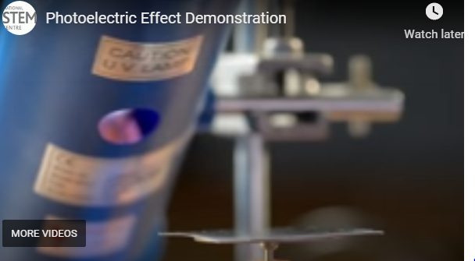  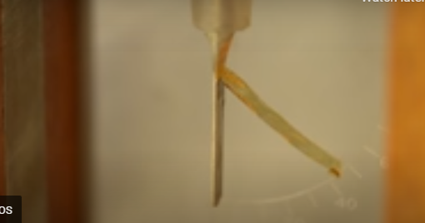

Ultraviolet light before introducing UV after UV light

On the other hand double slit is an experiment that is demonstrated by an outcome of unparalleled strangeness. This is where a particle of matter which little tends to have something of a wave of them. And this suggests that the act of observing a particle tends to have behavior that has a dramatic effect. Below captions shows what happens to the particles. According to Einstein, he described light to be made of a wave of particles.

*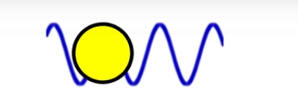light as a wave of particle*

He also went ahead and described wave to be like a behavior. This is shown below.

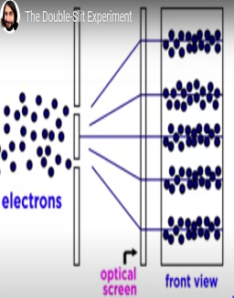

*Behavior portrayed by a wave of light*

*Through two slits.*

This is as a result of individual electrons passing through the slits hence diverging to form the above structure. The behavior of the light electron

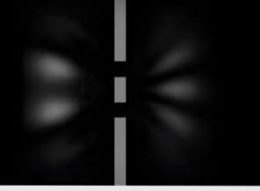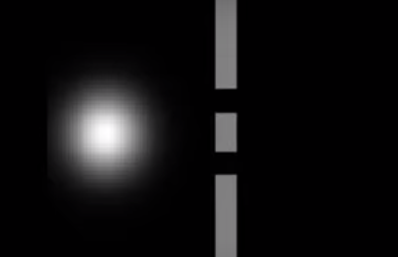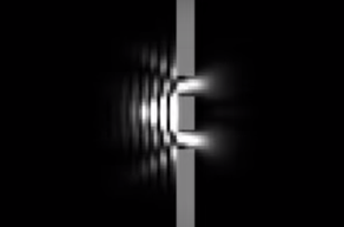

*Behavior portrayed by a single wave electron.*

In conclusion, as seen from the video, light is a concept which many people cannot understand hence tend to give a varying view about what they think is true about it.