**Thomas Radioactive Cone**

The history of Thomas Radioactive Cone stands out to belong to the 20th century. Thomas Cone is categorized among device categories referred to as emanators. The Thomas Cone was placed in one to two gallons of water. This was used to infuse Radon with water and which is a radioactive gas. A 4.5" cone was standard and included close to seventy grams of carnotite ore as the source of Radon. The collection of ORAU incorporates a 2.25” tall smaller than the other one. It is argued that the large cones were marketed to farmers as they used them in water troughs for animals, but there is limited evidence on this prospect. Regarding the mold size as offered by Earl Pribble estate, 5.5” could be the enlisted height of these cones.

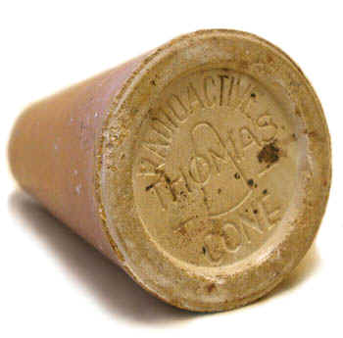

**Fig 1: Thomas radioactive cones**

Thomas Cone was named after R.W. Thomas. It was produced around 1935 in Los Angeles. The key factor contributing to this date was the registration of the Thomas Cone Trade Mark in 1935. It was during World War II when R.W. Thomas died. This made the company be shifted to Earl T. Pribble, located in Lubbock, Texas. Pribble took over the production of cones through the 1950s and into the early 1960s. Some molds and stamps help in the production of Thomas Radioactive Cone. The original molds for producing Thomas cones were present around the 1960s and 1970s. This was taken away by the State of Texas from the original area of manufacturing these cones, Lubbock. The survival of the other molds is not yet identified.

Some steps have been used in processing the Thomas Cone. For instance, cement is mixed with sand to come up with a damp mixture. Both hammer and mold are filled with the damp mixture until they are bonded. A depression is produced at the center of the mixture using a cone-shaped hammer. The uranium ore is hammered. More of the cement mixture is poured into the cone. The Thomas Cone logo is stamped at the very end of the cone. Lastly, the cone is removed and left out to harden into a stone block.

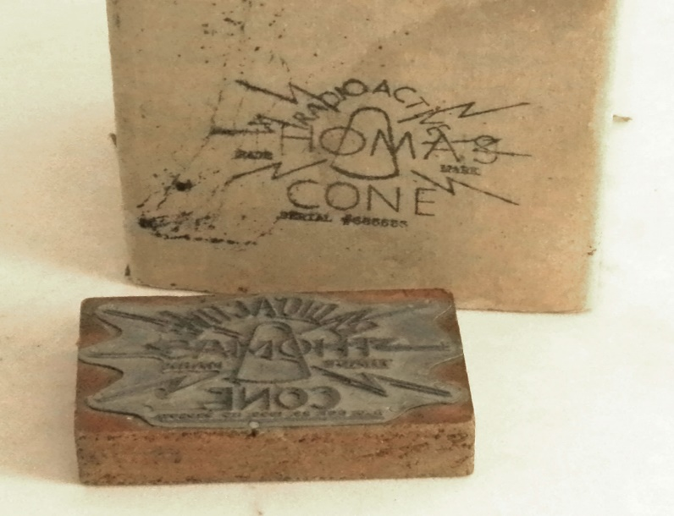

Fig. 1: Thomas Cone stamp stone.

Upon placing Thomas Cone in 3 or 4 water gallons within twelve hours, it guarantees that it charges it with radioactivity of Radon. With all this, health, wealth, and happiness, it is assumed that health is there. Wealth can be valueless when health is not considered of great value.

**Thomas Radioactive Cone impact on human health**

Radiation is known to have health impacts on human lives. Exposure to radioactivity has increased risks of cancer throughout human life. Survivors of this exposure have their lives significantly affected. Children also experience more risks of these risks than the older population as they are induced to radiation. Such radiations, be they in high or low doses, negatively impact the cardiovascular system and other non-related cancer diseases. Detecting genetic effects of radiations on children could be identified in their growth and development. The living cells of individuals are affected as their genetic material is damaged. Since the body cells are responsible for repairing the body cells, their failure to dead cells exposes more risks of cancerous effects. The other known effects of radiation on human health are acute radiation syndrome and skin burns. This is likely to be contributed by atomic bomb impacts.

**References**

Kamiya, K., Ozasa, K., Akiba, S., Niwa, O., Kodama, K., Takamura, N., ... & Wakeford, R. (2015). Long-term effects of radiation exposure on health. *The Lancet*, *386*(9992), 469-478.

Eisenbud, M., & Gesell, T. F. (1997). *Environmental radioactivity from natural, industrial and military sources: from natural, industrial and military sources*. Elsevier.