* 1. ML Web Server Description
* This server takes post requests containing an image and classifies it as paper, rock or scissors. The model is trained using the dataset from <https://storage.googleapis.com/laurencemoroney-blog.appspot.com/rps.zip>. The web server uses the flask and requests libraries and runs on localhost port 80..
  1. Testing the Web Server and Clients
* Navigate terminals to folder Sy_Assignment5
* Change environment to “deeplearning” using “activate deeplearning” in order to use machine learning libraries. *Unless libraries are in another environment. For example, “(base)”
* How to run server:
  1. In one terminal run “python app.py”
* How to run clients:
  1. In another terminal run “python client.py”
  2. Then run “python client.py paper1.png”
  3. Then run “python client.py rock1.png”
  4. Then run “python client.py scissors1.png”
  5. Screen Captures of Test Run

Server:

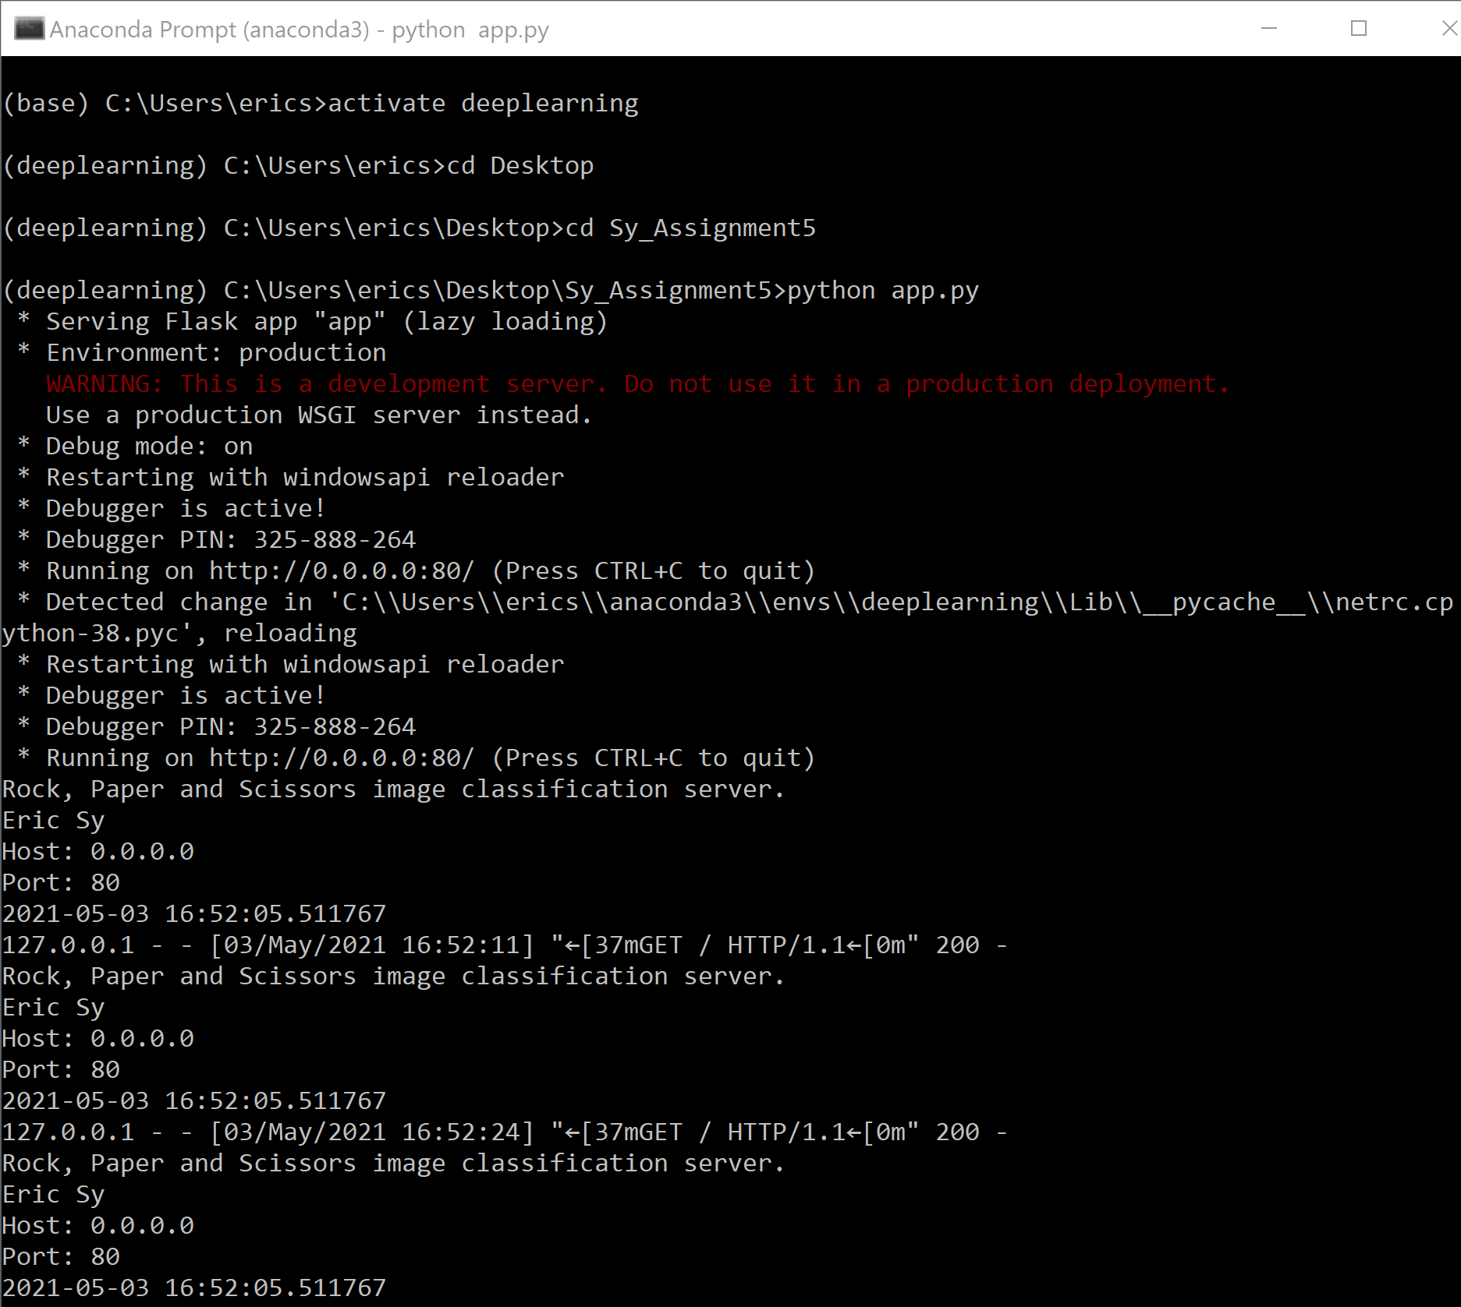

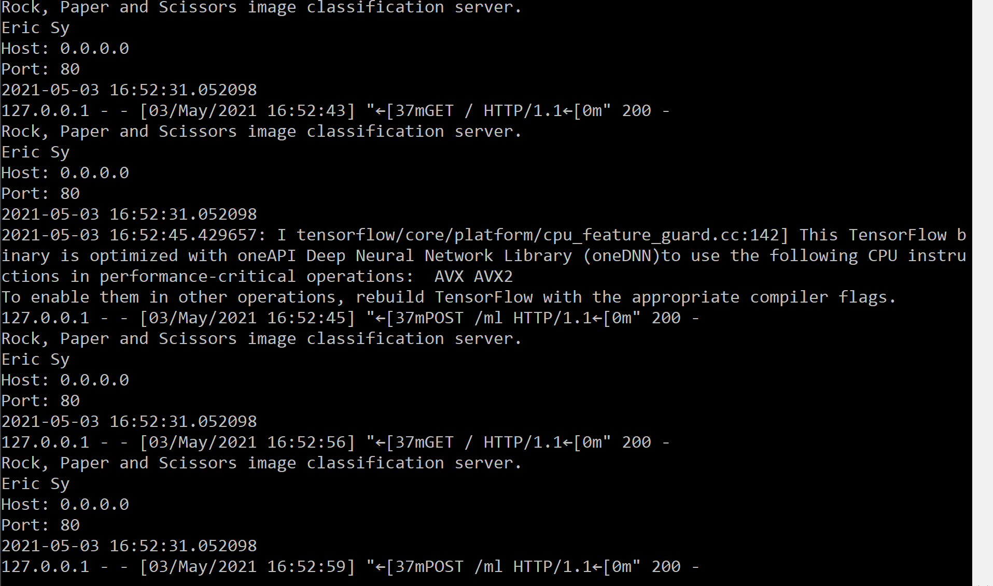

Client:

