

Computers in Biology and Medicine 156 (2023) 106739
Contents lists available at ScienceDirect

Computers in Biology and Medicine
journal homepage: www.elsevier.com/locate/compbiomed

Deep reinforcement learning-based propofol infusion control for anesthesia:  A feasibility study with a 3000-subject dataset
Won Joon Yun ª, MyungJae Shin ^{c}, Soyi Jung ^{b,∗}, JeongGil Ko ^{d,∗}, Hyung-Chul Lee ^{e,∗},
Joongheon Kim ^{a,∗}
a School of Electrical Engineering, Korea University, Seoul 02841, Republic of Korea
b Department of Electrical and Computer Engineering, Ajou University, Suwon 16499, Republic of Korea
c Mofl Inc., Daejeon 50499, Republic of Korea
d School of Integrated Technology, Yonsei University, Seoul 03722, Republic of Korea
e Seoul National University College of Medicine & Seoul National University Hospital, Seoul 03080, Republic of Korea

A R T I C L E I N F O A B S T R A C T

Keywords:
Deep reinforcement learning Automated drug control computing Healthcare IT
In this work, we present a deep reinforcement learning-based approach as a baseline system for autonomous propofol infusion control. Specifically, design an environment for simulating the possible conditions of a target patient based on input demographic data and design our reinforcement learning model-based system so that it effectively makes predictions on the proper level of propofol infusion to maintain stable anesthesia even under dynamic conditions that can affect the decision-making process, such as the manual control of remifentanil by anesthesiologists and the varying patient conditions under anesthesia. Through an extensive set of evaluations using patient data from 3000 subjects, we show that the proposed method results in stabilization in the anesthesia state, by managing the bispectral index (BIS) and effect-site concentration for a patient showing varying conditions.

Introduction

Advances in deep learning systems, along with their capability to understand complex underlying system features, have motivated the application of such systems to address various healthcare-related chal- lenges [1]. Deep neural networks are especially well-suited to tackle complex problems related to dosage and interface control for different clinical practice purposes [2,3]. Receiving noticeable attention, the field of automated propofol control for supporting effective (yet safe) anesthesia, introduces challenges that match the capabilities of deep learning-based prediction models. Specifically, for clinical protocols such as total intravenous anesthesia (TIVA) used for general anesthesia and procedural sedation, where drugs such as propofol and remifen- tanil are commonly applied, controlling the dosage to assure that the subject (or the patient) remains at a target bispectral index (BIS) is important [4].
Generally, specialized physicians, and anesthesiologists, take the role of drug infusion control during general anesthesia to prevent any incidents and to make sure that the subject is in a stable anesthetic state throughout the operation. This is incredibly important given that improper administration of drug dosage can lead to intraoperative
awareness or hemodynamic instability during operations [5]. Anesthe- siologists take into account many different factors from the patient, including lean body mass, central blood volume, and demographic data when computing the proper dose of drugs for a target patient. However, while is a routine process for skilled anesthesiologists, there is no golden rule on how different factors should be amalgamated to offer an ideal case for patients with different needs. Furthermore, the fact that drugs used for anesthesia have a rapid elimination property and a narrow safety margin, makes decisions even more challenging.
To address such issues, a number of previous works have put effort into designing approaches for propofol dosage suggestions. Specifically, target controlled infusion (TCI) is a commonly used drug infusion control algorithm targeting to suggest specific dosages on a per-subject-basis using a pharmacokinetic (PK) or pharmacodynamic (PD) model [6,7]. With larger datasets, Lee et al. proposed a machine learning model for predicting the impact of drug dosage [8] and Moore et al. ex- ploited a reinforcement learning model for drug infusion control [9]. Unfortunately, the practical applicability of these approaches is still limited given that they do not consider the full diversity of population characteristics (due to limited subject size) or lack the consideration

∗ Corresponding authors.
E-mail addresses: ywjoon95@korea.ac.kr (W.J. Yun), mjshin.cau@gmail.com (M. Shin), sjung@ajou.ac.kr (S. Jung), jeonggil.ko@yonsei.ac.kr (J. Ko), vital@snu.ac.kr (H.-C. Lee), joongheon@korea.ac.kr (J. Kim).
https://doi.org/10.1016/j.compbiomed.2023.106739
Received 12 August 2022; Received in revised form 26 November 2022; Accepted 1 March 2023
Available online 3 March 2023
0010-4825/© 2023 Elsevier Ltd. All rights reserved.

Table 1
List of abbreviations.

Abbreviation Description

BIS Bispectral index
DNN Deep neural network
DRL Deep reinforcement learning
GAE Generalized advantage estimation
LSTM Long–short term memory
LOWESS Locally weighted scatterplot smoothing
MDAPE Median absolute performance error
MDP Markov decision process
MDPE Mean performance error
PD Pharmacodynamic
PE Performance error
PK Pharmacokinetic
PPF Propofol
PPO Proximal policy optimization
RL Reinforcement learning
RFTN Remifentanil
TCI Target controlled infusion
TIVA Total intravenous anesthesia

of inheritance relationships between anesthetic and analgesic drugs. To cope with these issues, in the early days of the deep learning era, deep reinforcement learning (DRL) and imitation learning have made successful control in dose control [10,11]. Humbert et al. presented a decision support policy that assists the anesthesiologists’ infusion of drugs to maintain the optimal hypnotic depth, using only observable information (e.g., heart rate, blood pressure, respiratory rate) [10]. However, a simplified discrete action (e.g., reduce, stay, or increase drug dose) is applied without actual drug dosage prediction. In addi- tion, such DRL or imitation learning-based solution does not consider the demonstration for anesthesiologists. As the explainability and these issues are important in the dose control [12], Schamberg et al. propose continuous control on propofol infusion while using Shapley additive explanations for explainability [13]. Even if it shows improvement, only one type of drug delivery is considered.
Spurred by these trends, this paper presents a novel deep reinforce- ment learning (DRL)-based infusion control system that addresses the limitations of previous work. The main challenge in incorporating and DRL model for drug infusion control is the fact that the states of the model are difficult to properly define given the dynamic nature of the human nerve system. For this, we integrate outputs from the PK/PD model, the de facto model used for understanding the drug–human interactions, to the DRL model. As a result, our proposed system takes into consideration the synergistic effect of anesthetic and analgesic drugs and is designed to handle intra- and inter-subject variations in the propofol effect. Furthermore, given that remifentanil infusion is done manually by anesthesiologists, our system is designed to interact and adapt to such unknown (or difficult-to-predict) external behavior. Note that such anesthesiologists-machine interactions are essential, but are something that has not been deeply considered in previous literature. For this, we formulate and present a patient dynamics model for propofol and remifentanil infusion, which is the basis of a system design for accurate predictions of per-subject effects in anesthesia. Using large- scale clinical open-source data collected from 3000 surgical patients who underwent general surgery between June 2016 and September 2016 at the Seoul National University Hospital, Korea, we showcase the effectiveness of our approach in stabilizing the BIS level of a patient and drug concentration under various realistic scenarios [14]. These findings lead to the design of an explainable agent to assist anes- thesiologists in understanding and effectively reacting to emergency situations, without compromising the high stabilization performance. The list of abbreviations is presented in Table 1.
Contributions: The contributions made in this work can be summa- rized in three-fold:

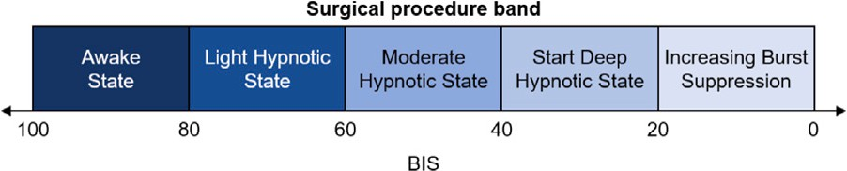

/ig. 1. BIS band to indicate a desired depth of hypnosis.

- We develop a realistic patient simulator based on the PK/PD model, with which we train model-free reinforcement learning agents for propofol dose control. To the best of our knowledge, this is the first patient simulator that captures the combined effects of propofol and remifentanil for capturing the dynamics of patients.
- We propose an explainable RL method for the BIS stabilization and BIS level prediction, which leads physicians to understand how the RL agent makes optimal action-decision.
- Via extensive evaluations with real clinical data collected from 3000 surgical patients who underwent general surgery between June 2016 and September 2016, we make our scheme to the first successful application of DRL-based propofol infusion control under the unexpected external infusion of remifentanil.
Organization: The rest of this paper is organized as follows. Section 2 presents the related work; Section 3 summarizes the patient dynamic models for propofol and remifentanil infusion. Section 4 introduces the proposed deep reinforcement learning-based infusion control, and Section 5 evaluates the performance. Lastly, Section 6 concludes this paper.

Related work

  - Measure of hypnosis

To measure the brain activity and the desired depth of hypnosis, the BIS is often employed as shown in Fig. 1. A value of 100–90 corresponds to a fully awake state. The level of 90–60 and 60–40 indicate light and moderate hypnosis levels, respectively. The level of deep hypnotic state (40–20) and increasing burst suppression (20– 0) is significantly dangerous. In the standard sedation practice, the anesthesiologist manually adjusts the propofol and remifentanil infu- sion based on the BIS. Prior work showed that BIS not only controls the depth of sedation but also reduces the adverse events associated with sedatives, particularly hypotension, desaturation, and bradypnea, by making it possible to reduce the dose of these drugs [15,16]. TCI using a computer-assisted infusion pump is introduced to calculate the appropriate drug administration based on the BIS level [17]. TIVA using TCI of propofol is widely used for anesthesia and sedation. To improve the efficacy of the treatment and the safety of the patient, research on the discrepancy between predicted BIS and measured BIS during TIVA has increasing attention [8,18].

  - Closed-loop control of hypnosis

In particular, DRL has recently made exciting progress and has demonstrated remarkable performance in control tasks. Previous re- search has shown the possibility of reinforcement learning (RL) algo- rithms for drug infusion control [9]. However, their RL method ignores the synergism of anesthetic and analgesic drugs, limiting its practical applicability in the real world.
There has been a number of previous efforts related to machine learning targeting clinical applications, including medical concept learning [19,20], pattern classification [21], and predictive health- care [22]. Especially, in specific domains of anesthesia, automated

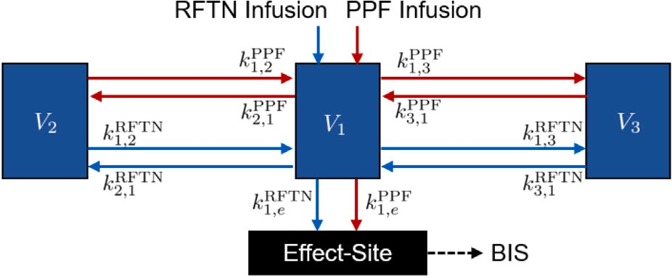

/ig. 2. Compartmental model of the patient under PPF and RFTN.
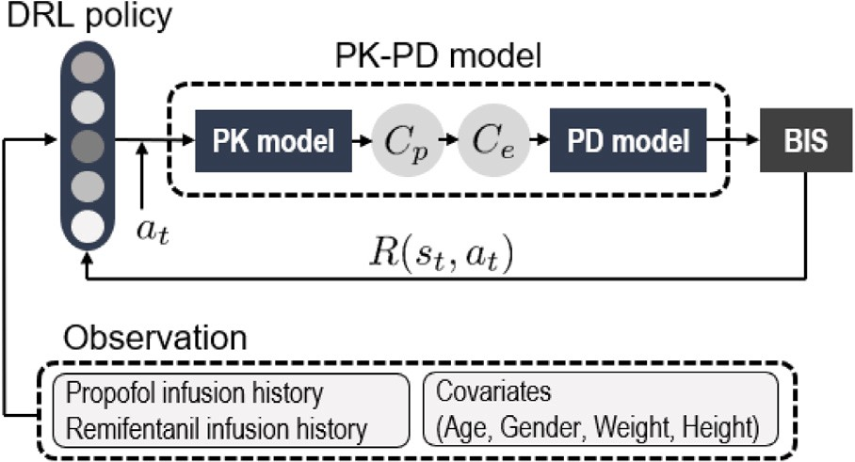

/ig. 3. Overall system structure.

anesthesia techniques guided by machine learning schemes have at- tracted attention given their capability to understand multi-modal inputs. One representative previous research is done by Puri et al. [23], in which the authors compared the performance between a closed-loop automated controller and the manual propofol infusion in terms of BIS. The result showed that the automated controller presented the desired performance in maintaining the BIS around a target of 50 in typical working conditions. Based on the closed-loop feedback control model,
process, the goal is to maintain the desired level of BIS using the drug combinations. By achieving pre-defined target effect-site concentrations (𝐶𝑒) of propofol and remifentanil, respectively, where the 𝐶𝑒 targets of propofol and remifentanil is related to the degree of hypnosis [27,28], we target to control the BIS level for stable anesthesia. As a result of this infusion process, a BIS can be predicted via three-component PK and PD models [29,30], where PK models describe the distribution of drugs within the human body and PD models characterize the blood concentration of the drugs and dose effects.
We configure the PK/PD model-based realistic patient simulation model to train the model-free reinforcement learning agent. In the PK/PD model, the interaction between propofol and remifentanil is considered additive, leading to BIS impact. Note that the proposed pa- tient simulator assumes a three-compartmental pharmacokinetic model depicted in Fig. 2, and the components are interconnected with the mass flux exchange results achieved as follows:
𝑥̂1(𝑡) = − [𝑘10 + 𝑘12 + 𝑘13] 𝑥1(𝑡) + 𝑘21𝑥2(𝑡) +
𝑘₃₁𝑥₃(𝑡) + 𝑢(𝑡), (1)
𝑥̂2(𝑡) = 𝑘12𝑥1(𝑡) − 𝑘21𝑥2(𝑡), (2)
𝑥̂3(𝑡) = 𝑘13𝑥1(𝑡) − 𝑘31𝑥3(𝑡), (3)
where 𝑥𝑖(𝑡) [mg] denotes the quantity of the drug over time for each component 𝑉𝑖, ∀𝑖 ∈ {1, 2, 3} and 𝑉₁ denotes the primary central com-
ponent blood. The peripheral components that exchange the drug with blood are denoted as 𝑉₂ and 𝑉₃, respectively. Specifically, 𝑉₂ represents fast dynamic components (e.g., muscles), and 𝑉₃ represents slow dy- namics components (e.g., fat) in the human body. The infusion rate of anesthetic drugs (i.e., propofol and remifentanil) into the primary central component is denoted as 𝑢(𝑡) mg∕min . The parameters 𝑘𝑖𝑗 for
≠
[ ]
𝑖 𝑗 denote the drug transfer rate from the 𝑖th to the 𝑗th component.
Finally, parameters 𝑘𝑖𝑗 of the patients depends on the gender, height (cm), mass (kg), and age (year). Based on such definitions, the lean body mass (lbm) is computed as follows:

the automated administration of drugs (i.e., propofol, remifentanil, and rocuronium) showed the maintenance of a target BIS, the workload reduction during the induction period, and faster recovery times during
𝑙𝑏𝑚

𝑙𝑏𝑚

male
= 1.1 ⋅ 𝑤𝑒𝑖𝑔ℎ𝑡 − 128 ⋅ 𝑤𝑒𝑖𝑔ℎ𝑡 , (4)
ℎ𝑒𝑖𝑔ℎ𝑡
= 1.07 ⋅ 𝑤𝑒𝑖𝑔ℎ𝑡 − 148 ⋅ 𝑤𝑒𝑖𝑔ℎ𝑡 . (5)

general anesthesia [24]. These researches showed that closed-loop-
female

ℎ𝑒𝑖𝑔ℎ𝑡

based automated systems can be a plausible solution for real scenarios. However, there are still issues regarding the fact that all automated con- trollers should ensure robustness across the diverse patient population and case spectrum. Some previous work has put effort into addressing these issues and improving patient-specific outcomes [25,26]. Follow- ing the closed-loop modeling concept, applying reinforcement learning simplified the previously proposed models, allowing more accurate anesthesia operations in complex conditions with small workloads [9]. These previous efforts form the basis of our approach in which we also apply a reinforcement learning-based technique for adaptive propofol infusion control. (see Figs. 3 and 5).

Patient dynamics model for propofol and remifentanil infusion in anesthesia
Our proposed system for autonomous propofol infusion control con- sists of two main phases: (1) human dynamics modeling and (2) deep reinforcement learning-based propofol dose prediction. In this section, we introduce how our system models the per-patient characteristics based on propofol and remifentanil infusion histories and personal
Once obtaining the lbm, the three-component model for propofol introduced in Schnider et al. [27] is used; thus, the parameters are calculated by means of the following parametric relations:
𝑉 𝑜𝑙^{PPF} = ℎ1, (6)
1
𝑉 𝑜𝑙^{PPF} = ℎ − ℎ (𝑎𝑔𝑒 − ℎ ), (7)
2 2 3 4
𝑉 𝑜𝑙^{PPF} = ℎ5, (8)
3
𝐶^{PPF} = ℎ6 + ℎ7(𝑤𝑒𝑖𝑔ℎ𝑡 − ℎ8) − ℎ9(𝑙𝑏𝑚 − ℎ10) +
𝑙1
ℎ11(ℎ𝑒𝑖𝑔ℎ𝑡 − ℎ12), (9)
𝐶^{PPF} = ℎ13 − ℎ14(𝑎𝑔𝑒 − ℎ15), (10)
𝑙2
𝐶^{PPF} = ℎ16, (11)
𝑙3
PPF
𝐶
𝑘^{PPF} = ^{𝑙1} , (12)
10 𝑉 𝑜𝑙PPF
1
𝐶PPF

𝑘^{PPF} = ^{𝑙2} , (13)
1

demographic data.
We start by presenting a mathematically formulated PD of propofol and remifentanil infusion in anesthesia in the form of a simulation
12 𝑉 𝑜𝑙PPF
𝐶PPF

𝑘^{PPF} = ^{𝑙3} , (14)
1

model. This dynamic model, which simulates an intraoperative patient simulator, is used to train the reinforcement learning agent in a safe
off-line manner. Typically, to achieve stable anesthesia status, a mix-
13 𝑉 𝑜𝑙PPF
𝐶PPF

𝑘^{PPF} = ^{𝑙2} , (15)
2

ture of drugs such as propofol and remifentanil are applied. In this
21 𝑉 𝑜𝑙PPF

PPF
𝐶
𝑘^{PPF} = ^{𝑙3} , (16)
31 𝑉 𝑜𝑙PPF
3
𝑘^{PPF} = ℎ17. (17)
𝑒0
Given the complex nature of the human body dynamics, we agree that modeling such complexity using a simple PK/PD model as above can be limited in many ways. Nevertheless, we note that the PK/PD model is still considered (and used in practice as) the de facto for

Similarly, we exploit the three-component model by Minto et al.
[28] for remifentanil with the following parameters:
𝑉 𝑜𝑙^{RFTN} = 𝑓1 −𝑓2(𝑎𝑔𝑒 − 𝑓17)+𝑓3(𝑙𝑏𝑚 − 𝑓18), (18)
1
𝑉 𝑜𝑙^{RFTN} = 𝑓4 −𝑓5(𝑎𝑔𝑒 − 𝑓17)+𝑓6(𝑙𝑏𝑚 − 𝑓18), (19)
2
𝑉 𝑜𝑙^{RFTN} = 𝑓 , (20)
understanding drug reactions for patients. Thus, to present a scheme that is suitable and persuasive enough for practical use in today’s clinical environments, we keep the PK/PD model but also note that substituting this modeling approach with other methods can also be possible.

Adaptive infusion control using deep reinforcement learning

3 7

𝐶^{RFTN} = 𝑓8 − 𝑓9(𝑎𝑔𝑒−𝑓17)+𝑓10(𝑙𝑏𝑚−ℎ18), (21)
𝑙1
𝐶^{RFTN} = 𝑓11 − 𝑓12(𝑎𝑔𝑒 − 𝑓17), (22)
𝑙2
𝐶^{RFTN} = 𝑓13 − 𝑓14(𝑎𝑔𝑒 − 𝑓17), (23)
𝑙3
We emphasize once more that the goal of this paper is to propose the baseline of an automated anesthesia control system in which a trained deep reinforcement learning agent controls the propofol infu- sion rate to keep BIS in a safe range during surgical operations. To do so, it is important to take into account different dynamic exter-

𝑘RFTN =
10

𝑘RFTN =
12

𝑘RFTN =
13

𝑘RFTN =
21
RFTN
𝑙1
𝐶

𝑉 𝑜𝑙RFTN
1
RFTN
𝐶
𝑙2

𝑉 𝑜𝑙RFTN
1
RFTN
𝐶
𝑙3

𝑉 𝑜𝑙RFTN
1
RFTN
𝐶
𝑙2

𝑉 𝑜𝑙RFTN
2

, (24)

, (25)

, (26)

, (27)
nal factors, such as the unexpected remifentanil infusion initiated by the anesthesiologist. In fact, taking into consideration the unexpected remifentanil infusion rate is important as in real surgical operations, anesthesiologists make subjective decisions on the expected pain level of patients and dynamically control the amount of remifentanil to be injected. However, this is challenging to accommodate in the training phase of a reinforcement learning model, given that such subjective clinical decisions cannot be predicted with high accuracy. Therefore, in this work, we take the remifentanil infusion history based on previous surgical data and select a random value in the training phase. We note that the target remifentanil infusion levels (in the training phase) are selected from surgical cases where the target BIS is set to 50, and for each training episode, we impose the model to select different (random)

RFTN
𝐶
𝑘^{RFTN} = ^{𝑙3} , (28)
31 𝑉 𝑜𝑙RFTN
3
remifentanil infusion levels to account for real-world variations. Using the following subsections, we discuss details on the design of the deep reinforcement learning agent used in our proposed system.

𝑘^{RFTN} = 𝑓15 − 𝑓16(𝑎𝑔𝑒 − 𝑓17), (29)
𝑒0

where 𝑉 𝑜𝑙 [l] represents the volume of each component 𝑉 . 𝑘 and 𝑘
  - Reinforcement learning formulation

𝑖 𝑖 10 𝑒0

denote the rate of drug metabolism and the rate of drug removal from
[ ]
the effect-site component, respectively. 𝐶𝑙𝑖 L∕min is the clearance
We now formalize the adaptive infusion control problem as a Markov decision process (MDP), with state space 𝑆 ∈ R^{𝑛}, action space

of the 𝑖th component, and the concentration of each component is
obtained by dividing the respective volume by the per-component drug quantity. Therefore, the plasma concentration of the drug is computed as 𝐶𝑝(𝑡) = 𝑥1(𝑡)∕𝑉 𝑜𝑙1. With this, the relationship between the plasma and the effect-site is expressed as a first-order function as,
𝑥̂𝑒(𝑡) = −𝑘𝑒0𝑥𝑒(𝑡) + 𝑘1𝑒𝑥̂1(𝑡). (30)
𝐴 ∈ R, environment £, and a set of possible target BIS values . We do so given that the goal of this work is to present a fully closed-loop system for adaptive infusion control. The start target value is set to 50 and the target BIS value can be updated during the surgery based on the expertise and experiences of the physician. The reward 𝑅 ∶ 𝑆×𝐴× → R depends on the current target BIS value and state. Therefore, given

Here, 𝑥𝑒

is the quantity of drug in the effect-site. 𝑘

1𝑒
and 𝑘

𝑒0
a target BIS value 𝑔𝑡 and the current state 𝑠𝑡, the policy distribution
over an action is defined as 𝜋𝜃 (𝑎 ∣ 𝑠𝑡, 𝑔𝑡). The probability of a 𝑇 -step

denote the transfer rate of the drug from the primary component to the effect-site component and the transfer rate of drug removal from the
trajectory is defined as follows:

effect-site component, respectively [31]. Finally, 𝐶𝑒
for both propofol
𝑃 (𝜏 ∣ 𝜋 ) ≜ 𝜌(𝑠 )
𝑇∏−1
𝑃 (𝑠
∣ 𝑠 , 𝑎 )𝜋 (𝑎 ∣ 𝑠 , 𝑔 ). (33)

and remifentanil can be obtained as follows:
𝜃 0

𝑡=0
𝑡+1
𝑡 𝑡 𝜃 𝑡 𝑡 𝑡

𝐶̂𝑒(𝑡) = 𝑘𝑒0(𝐶𝑝(𝑡) − 𝐶𝑒(𝑡)). (31)
This is to account for the fact that transitions of adaptive infusion

In our proposed simulation model, we consider the BIS level as the sole measurement of hypnotic depth, which is essentially a result of the propofol–remifentanil interactions based on the aforementioned relations. The BIS of a patient under anesthesia is represented on a scale of [0:100], where 0 indicates that the patient does not have cerebral activity, and 100 denotes that the patient is fully awake. Thus, given the component concentrations of each drug, an expected BIS is computed as follows:
control and the policy are stochastic factors, where 𝜌(𝑠₀) is the distri- bution of starting state 𝑠₀. Then, the expected return (𝜋𝜃 ) is defined as
J (𝜋𝜃 ) = 𝑃 (𝜏 ∣ 𝜋𝜃 )𝑅(𝜏) = E𝜏∼𝜋𝜃 [𝑅(𝜏)] , (34)
J
∫
𝜏
where trajectory 𝜏 is a sequence of states and actions. Given this, the goal is to learn a policy that maximizes the expected return (𝜋 ) when the agent takes action according to policy 𝜋𝜃 . Here, the value function
𝜃
J

( 𝐶̂^{PPF}(𝑡)
𝐶̂RFTN(𝑡) )−1.43
is defined as:
[ ]

𝐵𝐼𝑆(𝑡) = 98.0 ⋅
1 + 𝑒 + 𝑒
+ 𝜖, (32)
[ ] 𝑡=∑𝑇 −1 |

4.47
19.3
𝑉 (𝑠𝑡, 𝑔𝑡) = E 𝑅𝑡 = E
𝛾^{𝑡}𝑟𝑡| 𝑠𝑡, 𝑔𝑡
. (35)

where 𝜖 denotes Gaussian noise. In many surgical scenarios, the desired target BIS value is 50. While not perfect, the BIS value should remain within a safe range (typically 40–60) under the supervision of an anesthesiologist.
𝑡=0 |
With this baseline definition of the MDP, we now introduce the configurations for the deep reinforcement learning model by defining its states, actions, and rewards.

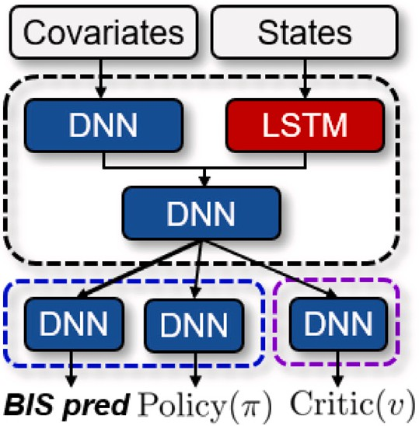
- State Definition: To define the DRL model’s states, we define four different raw states of propofol and remifentanil infusion control at a time slot 𝑡 as follows: (1) BIS history, (2) propofol infusion history, (3) remifentanil infusion history, and (4) demographic data (age, gender, weight, and height). To alleviate the perturbation of measurement noise, we smooth the BIS via locally weighted scatterplot smoothing
(LOWESS) [32]; and use the smoothed BIS as a control input 𝐵𝐼𝑆^{hist} .
smooth
From the smoothed BIS history, we compute two control inputs: (i)
error

𝐵𝐼𝑆hist
slope
and (ii) 𝐵𝐼𝑆^{hist} . First, the difference between the previous

BIS value and the current BIS value at each time 𝑡 is computed as control inputs as follows:

𝐵𝐼𝑆^{hist} (𝑡) = 𝐵𝐼𝑆^{hist}
(𝑡) − 𝐵𝐼𝑆^{hist}
(𝑡 − 1). (36)

slope
smooth
smooth

Here, 𝐵𝐼𝑆^{hist} allows the agent to observe the magnitude of change, as well as its direction of change. Second, the difference between the current BIS value and the target BIS value at each time 𝑡 is calculated as follows:
slope
/ig. 4. The proposed model architecture. It represents a variant of the LSTM along with predictions on the estimated BIS level after a given time from the time of infusion.

  - Agent model design for infusion learning

𝐵𝐼𝑆^{hist} (𝑡) = 𝐵𝐼𝑆^{hist}
(𝑡) − 𝐵𝐼𝑆^{hist}
(𝑡). (37)

error
smooth
target
The deep reinforcement learning model discussed until now can be

Given the target BIS, 𝐵𝐼𝑆^{hist}
error
allows the agent to observe the
represented in the form of an agent. Specifically, the agent learns the

magnitude of difference and direction between the target BIS and the current BIS value. These control inputs serve as the estimation of the hypnosis level in the state space of the agent. Applying such smoothing and the slope has also been proven to be effective in previous literature as well [9]. From the infusion history, two control inputs are computed:
(i) 𝑃 𝑃 𝐹 ^{hist} and (ii) 𝑅𝐹 𝑇 𝑁^{hist}. The first term, 𝑃 𝑃 𝐹 ^{hist}, denotes the
optimal actions for adaptive infusion control so that the stability of hypnotic depth is maintained during surgery. Although some DRL stud- ies have achieved the aforementioned objectives (refer to Section 5), it still remains how an agent makes an action decision. Due to the neural networks’ black-box nature, physicians hesitate to use DRL. To cope with this, we design an agent that learns how it makes infusion

acc
acc
acc

cumulative dose of propofol infused during the specific time window
𝑊 , and is calculated as follows:
∑𝑡
𝑃 𝑃 𝐹 ^{hist}(𝑡) = 𝑃 𝑃 𝐹 ^{hist}(𝑖), (38)
acc
𝑖=𝑡−𝑊

Furthermore, the latter term, 𝑅𝐹 𝑇 𝑁^{hist}, denotes the cumulative dose of remifentanil infused during a time window 𝑊 , and is it is computed as follows:
acc
∑𝑡
𝑅𝐹 𝑇 𝑁^{hist}(𝑡) = 𝑅𝐹 𝑇 𝑁^{hist}(𝑖). (39)
acc
𝑖=𝑡−𝑊
Thus, the state of the proposed MDP at time slot 𝑡 is defined as 𝑠 ≜
}
{
control by predicting the BIS level, and this will lead physicians to understand better why a given infusion rate is selected from the deep learning model, which in some cases is refused to be used in clinical applications.
Fig. 4 illustrates the neural network architecture. As Fig. 4 shows, the time series data (denoted as ‘‘states’’ in the figure) 𝑠𝑡 is used as input to LSTM, and other demographic data (denoted as ‘‘covariates’’ in the
figure) are passed through a DNN.
First of all, when 𝑠𝑡 is input to the LSTM, the process is straightfor- ward. The LSTM encoder takes 𝑠𝑡−𝑊 ∶𝑡 as its input and learns the internal representation of recent anesthesia history. The output of the encoder is the encoded representation of the input time series data.
Second, the covariates are fed into the DNN, and the encoded rep-

hist
hist
hist
hist
hist
hist
𝑡
hist
resentations from the time series and covariate data are concatenated.

𝐵𝐼𝑆 , 𝐵𝐼𝑆slope, 𝐵𝐼𝑆error, 𝑃 𝑃 𝐹 , 𝑃 𝑃 𝐹 acc , 𝑅𝐹 𝑇 𝑁 , 𝑅𝐹 𝑇 𝑁acc . Finally, since the demographic data is independent of time, this de-
mographic data is provided to the agent separately with no dependency on 𝑠𝑡.
- Action Definition: For defining actions, the agent decides on a
target propofol infusion rate as an action for adaptive infusion control, considering the anesthesiologist-controlled remifentanil infusion rates. The agent selects an action every 10 s (i.e., the propofol infusion rate changes every 10 s), based on the current state 𝑠𝑡 and target BIS value. Given a maximum infusion rate of 500 ml∕h, the maximum possible doses of propofol and remifentanil over 10 s are 27.8 mg and 27.8 μg, respectively. Thus, the action at time 𝑡 is defined as 𝑎 ∈ R, 0 𝑎 27.7.
≤ ≤
The DNN layers that process the policy and critic each receive the concatenated representation as input to compute the final output.
Lastly, notice the additional DNN layer in the final step. As briefly mentioned, this DNN is responsible for making additional predictions on the expected BIS level of the patient after a given amount of time past the propofol injection. This DNN model in the architecture takes input from the actions 𝑎 and is trained to make predictions on BIS-level changes after 𝜏 seconds. This add-on to the LSTM offers anesthesiolo- gists explanations of the decision in a human-readable format. Applying such an additional network to the overall architecture has been proven to offer improved performance in previous work [33] and in our case,
we conjecture such improvements (discussed in Section 5).

𝑡 𝑡

- Reward Definition: Given a current state 𝑠𝑡 and the target BIS
𝑔𝑡 in each unit time 𝑡, the agent takes action 𝑎𝑡, which results is a reward in the deep reinforcement learning model. The reward 𝑟𝑡 includes important characteristics of the adaptive infusion control pro-
cess. Specifically, the reward function is defined as

  - Training procedure
In this section, we design our proposed objective function to obtain a well-performed agent and training procedure. First of all, we adopt the proximal policy optimization (PPO) with generalized advantage

𝑅(𝑠𝑡, 𝑎𝑡) = |
1 , (40)
|
estimation (GAE) and value loss as RL trainer [34,35]. The loss function

|𝑔𝑡 − 𝐵𝐼𝑆(𝑡 + 1)| + 𝛼
for RL trainer is expressed as follows:

where 𝐵𝐼𝑆(𝑡) is the current BIS, and 𝛼 determines the maximum value G
∑𝑇
PPO
Val

of 𝑟𝑡. The reward function allows the agent to continuously increase the stability of the hypnotic depth without excessive BIS fluctuations
_{RL}(𝜃) =
𝑡=1
𝑡
[𝑐1 ⋅G_{𝑡} (𝜃)+𝑐2 ⋅G_{𝑡} (𝜃)]+𝑐3 ⋅‖𝜃‖₂, (41)

during surgery.
s.t. 𝐿^{PPO}(𝜃) = min(𝜁𝐴̂𝑡, 𝑐𝑙𝑖𝑝(𝜁, 1 − 𝜖, 1 + 𝜖)𝐴̂𝑡), (42)

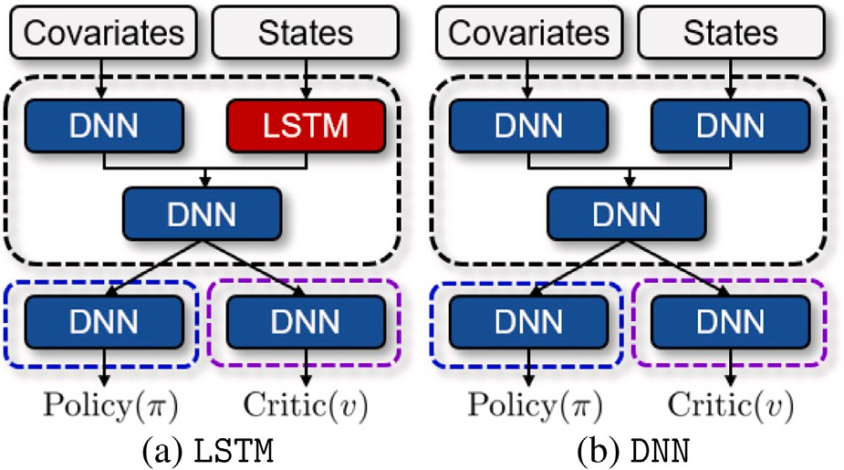
Algorithm 1: Adaptive propofol infusion control learning algorithm for anesthesia
1 Initialize the agent parameter 𝜃;

2 Gather dataset Q
𝑎𝑐𝑡𝑢𝑎𝑙 ;

3 Initialize the patient simulator as the proposed simulator in Section 3;
4 for (iter= 1, ⋯ , 𝐸) do
5 Initialize the replace buffer 5;
6 Sample a remifentanil history R/TN^{hist} from Q ;
𝑎𝑐𝑡𝑢𝑎𝑙

7 Replace the remifentanil history of patient simulator to R/TN^{hist};
8 for (t= 1, ⋯ , 𝑇 − 1) do
9 The policy network generates the mean value 𝜇 and the variance 𝜎²;
10 With the probability density function of the Gaussian
2 1 − (𝑎𝑡 −𝜇)2

/ig. 5. Model architecture comparison. (a) and (b) represent an architecture of an
LSTM-based model and a DNN-based model, respectively.

distribution 𝑓 (𝑎𝑡 ∣ 𝜇, 𝜎 ) = √
propofol infusion rate (𝑎𝑡 );
𝑒
2𝜋𝜎2
2𝜎2 , the agent samples a

11 Store transitions ⟨𝑠𝑡, 𝑎𝑡, 𝑟𝑡, 𝑠𝑡+1 ⟩ to replay buffer 5;
12 Update 𝜃 by applying (49);

to verify the performance of our proposed adaptive propofol infusion

control in anesthesia (c.f., Section 3). The infusion control performance
is evaluated using a number of metrics, and we start by presenting the data, and metrics and then discussing the simulation results.

𝐿^{Val}(𝜃) = ‖𝑅𝑡 − 𝛾𝑉 (𝑠𝑡)‖, (43)
𝑡
∞
∫
𝐻(𝑎𝑡) = 𝑎𝑡 log₂(𝑎𝑡)𝑑𝑎𝑡, (44)
−∞
where, 𝜁 = 𝜋(𝑎𝑡 ∣ 𝑠𝑡)∕𝜋𝑜𝑙𝑑 (𝑎𝑡 ∣ 𝑠𝑡), (45)
Dataset: A large-scale clinical open-source data collected from surgi- cal patients who underwent general surgery between June 2016 and September 2016 is used as the main dataset [14]. The data contains basic information and vital signs of surgical patients, such as nonin- vasive blood pressure, BIS, propofol, and remifentanil target-controlled
infusion information. To obtain a better model, we process the data in

𝐴̂𝑡 =
∑𝑇

𝑘=𝑡
[(𝛾𝜆)𝑘−
𝑡(𝑟𝑡 + 𝛾𝑉 (𝑠𝑡+1) − 𝑉 (𝑠𝑡))], (46)
the following steps:
- We remove the data that the recording time is less than two

𝑎 ∼  (𝜇 , 𝜎²
𝑡 𝜋(𝑠 )
), (47)

hours.

𝑡 𝜋(𝑠𝑡 )

where 𝜁 shows the ratio of the current policy 𝜋 to the previous policy
𝜋𝑜𝑙𝑑 , and 𝐴̂𝑡 represents GAE [35]. In addition, 𝜖, 𝑐1, 𝑐2, and 𝑐³ are train parameters. Moreover, 𝜆 and 𝛾 stand for GAE parameters, respectively. Second, we additionally design the agent to predict the BIS level. We define a loss function as a mean-squared error between the next step of the BIS level and a prediction, which cann be expressed as follows:
- We remove the data that the initial BIS is less than 80 or the terminating BIS is less than 70.
- We replace missing values with the latest values.
- We split the dataset into a train set, validation set, and test set with the ratio of 0.7, 0.2, and 0.1, respectively.
Comparison Techniques: To benchmark our proposed model, we com-

G_{Pred}(𝜃) = 1 ⋅
𝑇 − 1
𝑇∑−1

𝑡=1

|𝐵𝐼𝑆(𝑡 + 1) − 𝐵𝐼𝑆

pred

(𝑡) ². (48)
|
pare our model to different deep learning models in the reinforcement learning process. Specifically, we take two widely-used deep learning models, e.g., DNN-based model architecture (named DNN [36]) and

Then, the final form of the loss function is as follows:
RL
Pred
G
LSTM-based model architecture (named LSTM [37]). Our proposed

Train
(𝜃; 5) = G
(𝜃) + G
(𝜃) (49)
model (named LSTM+Pred) is available to predict the BIS level so that it provides a better understanding of why a given infusion rate is

The loss function is updated at every episode, and we introduce the training procedure as presented in Algorithm 1.
- (Lines 1–3) We initialize the parameters of an agent. We prepare the dataset (refer to Section 5) and PK/PD model (refer to Section 3).
actual
Q
- (5Lines 5–7) For every episode 𝑖𝑡𝑒𝑟, we initialize the replay buffer
actual
and the history of remifentanil injection 𝐑𝐅𝐓𝐍hist ∈ Q .
- (Lines 9–11) For every step 𝑡, the agent obtains continuous action from Gaussian distribution 𝑓 (𝑎𝑡|, 𝜇, 𝜎²), where 𝜇 and 𝜎² denote mean and variance, respectively. Note that the Gaussian distribu- tion is derived from its policy. After that, propofol is infused into the patent model and obtains next state 𝑠𝑡+1. Then we store the
selected from the deep learning model, which in some cases is refused to be used in clinical applications due to their black-box nature (i.e., DNN and LSTM). The model architectures and hyperparameters used in this paper are described in Appendix B. In addition, we compare our model to the anesthesiologists’ dosage histories from VitalDB [14] and Schnider’s method [27] which is widely used in anesthesiology.
Performance Metrics: As the core performance metric, we focus on the difference between the actual/target BIS of a patient and the ex- pected BIS produced by our system. We define the median performance error (MDPE) and median absolute performance error (MDAPE) as the following.
First, we define 𝐵𝐼𝑆target as 50, and the instantaneous performance
error (PE) is defined as,

transition set ⟨𝑠𝑡, 𝑎𝑡, 𝑅(𝑠𝑡, 𝑎𝑡), 𝑠𝑡+1⟩ to replay buffer 5.
- (Line 12) We update the agent parameters 𝜃 with replay buffer 5
𝑃 𝐸 = 100 ⋅
𝐵𝐼𝑆

smooth
– 𝐵𝐼𝑆

target

. (50)

and (49).
Repeating the aforementioned process 𝐸 times, we obtain a well- performed agent.

Performance evaluation

In this section, we compare the performance of a human expert and the three proposed models. We utilized the proposed simulator
𝐵𝐼𝑆target
Using this, we can define an MDPE indicating the control bias observed from a patient as,
𝑀𝐷𝑃 𝐸 = median(𝑃 𝐸). (51)
Finally, the MDAPE reflects the accuracy of the controller, and we define this as,
𝑀𝐷𝐴𝑃 𝐸 = median(|𝑃 𝐸|). (52)

Table 2
BIS stabilization performance when 𝐵𝐼𝑆target = 50.
MDPE/MDAPE | Average | Max | Min | Std
Expert (Anesthesiologist) | −18.72/23.24 | 12.59/47.35 | −47.35/6.59 | 8.88/6.82
Expert (Schnider et al. [27]) | −48.26/48.82 | 16.68/71.02 | −71.02/16.55 | 10.28/9.47
LSTM | −5.35/5.50 | 0.01/20.52 | −20.52/0.01 | 9.14/3.64
DNN | −3.51/3.58 | −1.65/20.52 | −20.51/1.65 | 3.00/3.04
LSTM+Pred | −0.38/2.45 | 3.75/20.82 | −20.81/0.09 | 3.90/3.25
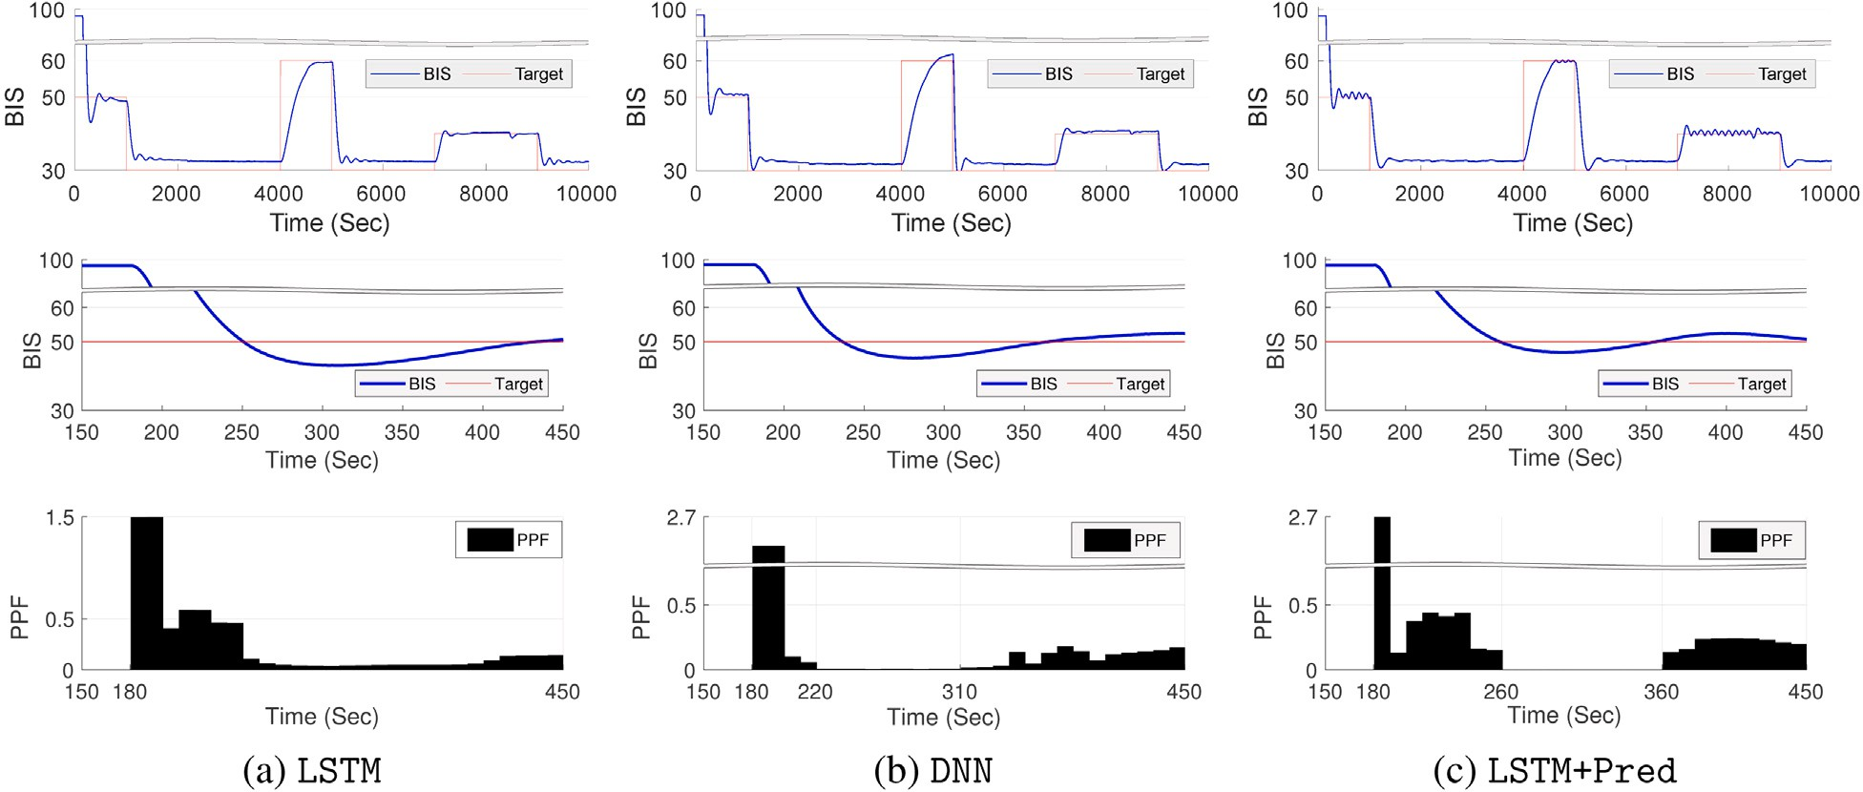

/ig. 6. (First & second row) The red curve depicts an arbitrary target BIS sequence, and the three blue curves depict the BIS levels observed as an outcome of the control of three different trained agents at two different time scales. (third row) Propofol infusion controls of the agents.

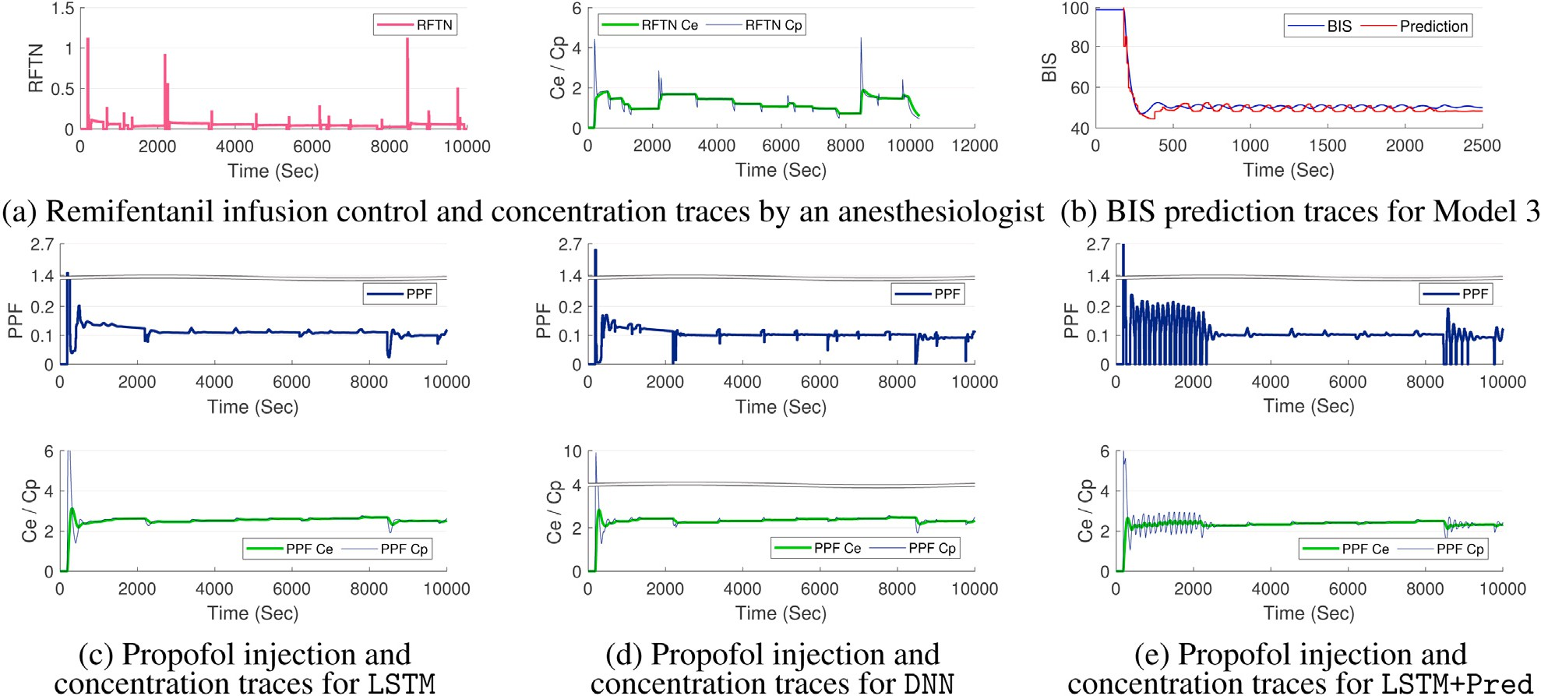

/ig. 7. (a) Sample remifentanil infusion controls of the expert and the changes of the Plasma Concentration (𝐶𝑝 ) and Effect-Site Concentration (𝐶𝑒 ) as a result of the control.
(b) BIS level predicted by our trained agent. (c, d, e) Sample propofol infusion controls of three different trained agents and the changes of the Plasma Concentration (𝐶𝑝 ) and Effect-Site Concentration (𝐶𝑒 ) as a result of the control.

Thus, as MDAPE reaches 0, the adaptive infusion control operation will show a stable performance towards the target BIS. In previous literature that exploit similar performance metrics, MDPE and MDAPE reflected stable systems when 0 ± 5.0 and 7.5, respectively. In addition, PK, PD, and the interaction parameters used for adaptive infusion control simulations are presented in Appendix A.
≤
  - Target 50 maintenance infusion control

Table 2 presents the infusion control performance for different test cases. Specifically, we test for five different cases, wherein the first, we compute the MDPE and MDAPE for BIS data collected from a real surgical environment (with manual control by an experienced

Table 3
Performance comparison by infusion control frequency.

Update Interval | Average MDPE/MDAPE | Std
10 s | −0.38/2.45 | 3.9/3.25
5 s | −0.21/1.32 | 3.26/3.16
1 s | −0.18/1.12 | 2.98/2.97

anesthesiologist), and in the second, the input doses from such a real environment are used as input for the BIS estimation model proposed by Schnider et al. [27], and then the three remaining cases are for the DNN, LSTM, and LSTM+Predpresented in Fig. 4. The results in Table 2 show that even an experienced anesthesiologist with more than 10 years of experience showed very high errors in predicting the BIS level with drug injection. Unfortunately, this is also evidence that some form of propofol and remifentanil infusion control is needed to improve anesthesia quality in operation rooms today. Performance from a textbook state-of-the-art approach by Schnider et al. [27] is also disappointing, given the high errors that exceed the tolerable stability bounds.
Fortunately, the results from our proposed deep reinforcement learning model shed light on such current-day limitations. As the results for our three proposed models in Table 2 show, the average cases for the DNNand LSTM+Pred cases fall within the target error bounds. For LSTM, the MDAPE is less than 7.5, but the MDPE slightly exceeds the target stability level. Nevertheless, our prediction-based BIS results show superior performance over manual and traditional BIS estimation methods. We emphasize that the data from the same set of patients are used in the evaluation process. A surprising observation to make from the data is the improvement in performance for the LSTM+Pred model. Compared to LSTMand DNN, we see a dramatic improvement. As briefly mentioned earlier, we conjecture this to be an effect of integrating the future BIS prediction into the reinforcement learning process for propofol infusion control. Since the loss function can utilize the input from the additional DNN, more accurate estimations on propofol infusion can be effectively made.

  - Safety of infusion control

To prevent patients from waking from anesthetic states, the effect- site concentration (𝐶𝑒) and plasma concentration (𝐶𝑝) should maintain a certain level throughout a target duration. As discussed earlier, the infusion of propofol and remifentanil causes changes to 𝐶𝑝 (at heart), which leads to delayed changes in 𝐶𝑒 (measured at the brain), and this is what initiates diversions in the BIS values. Naturally, the decay in
𝐶𝑒 indicates that the patient is waking from anesthesia. Thus, as it is important to reach the target BIS level, it is equally important to consider and maintain the changes in concentrations closely. Specif- ically, clinical literature suggests that an effect-site concentration of less than 2.0 ± 0.9 can cause a patient to wake from anesthesia [38]. Fig. 7(a) presents the remifentanil infusion patterns (RFTN plots) and the resulting 𝐶𝑒 and 𝐶𝑝 measurements (RFTN 𝐶𝑒 and RFTN 𝐶𝑝 plots) for remifentanil performed by an anesthesiologist during a 10,000- second time frame. Notice that the anesthesiologist injects remifentanil as the concentration diverges far from 2.0. In Figs. 7 (c), (d), and (e) we present the propofol injection patterns (top; PPF plots) and the corresponding 𝐶𝑒 and 𝐶𝑝 measurements for propofol (bottom). The results suggest that all three models we test successfully maintain a 2.0- level and systematically inject additional doses when the concentration shows a drop. These results together suggest that our proposed deep reinforcement learning-based approach for propofol infusion control can effectively maintain the anesthesia state of patients.

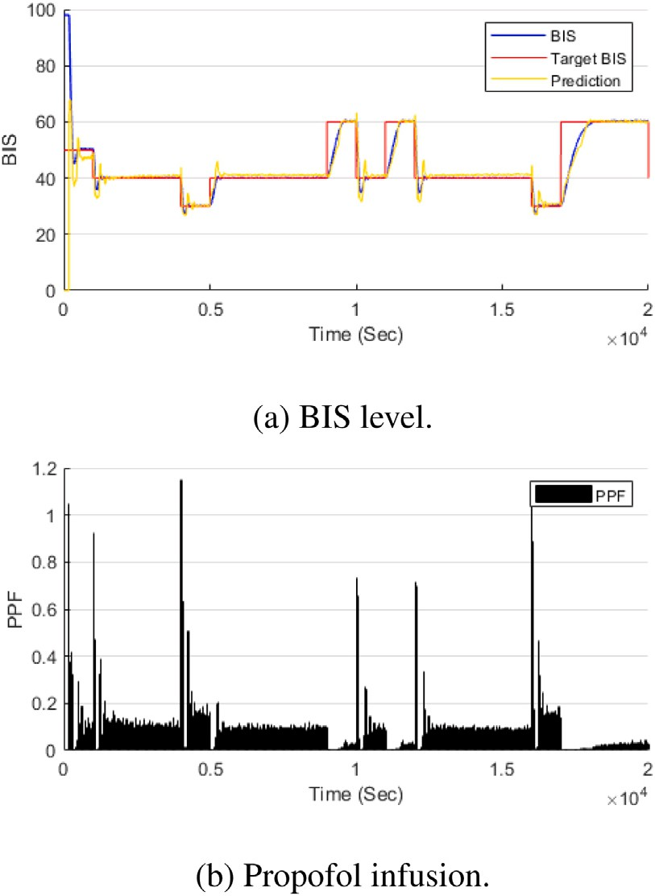

/ig. 8. Propofol infusion control in long-horizon task.

  - Explainability

Fig. 7(b) presents a timeline comparison for the resulting BIS from LSTM+Predwith the actual observed BIS. As mentioned, the LSTM+Pred model adds a special DNN to present explainable evidence on why a target propofol dose is selected from the agent. Specifically, it outputs the expected BIS level of the patient once the suggested propofol dose is injected. While our model shows higher fluctuation levels, compared to the ground truth, we can see from Fig. 7(b) that the BIS predictions are highly accurate (the largest difference observed is 3 BIS units, which is marginal). Thus, this suggests that our model is capable of offering some level of explainability on its propofol infusion control decisions to anesthesiologists.

  - Target change infusion control

Experiments until now are performed under the assumption that the system should configure a target BIS of 50. However, we now examine the flexibility of the proposed propofol infusion control system towards different (and changing) BIS levels. Fig. 6 presents experimental results for such a test case, where we dynamically change the target BIS from 50 to 30 and then to 60, 30, 40, and 30. This change request takes place during a 10,000-sec time frame. The pink ‘‘Target’’ plots on the topmost figures of the three model cases show this dynamic target BIS change. In the figure, the topmost plot also presents the resulting BIS from our three models. Note that the data from the first 150 s are needed as input of the model; thus, accurate BIS tracking is not made in this timeframe. Nevertheless, once given the inputs, we can see the BIS accurately tracking the target levels (with a short delay). We further analyze this short delay using the figures in the middle, where we show how the models converge to a target BIS. As the three middle plots of Fig. 6 show, all three models successfully track the target within a short period of time. Given that a typical surgery takes up to multiple hours, this small delay is negligible in most cases. Among the three, LSTM+Predshows the fastest convergence to the target BIS. Finally, the bottom-most plots in Fig. 6 present the actual propofol infusion

decisions made by the three models for the convergence experiment. We can see delayed correlations in which when more propofol is injected, we see a drop in BIS (deeper hypnotic state), and suppressing propofol increases the BIS.

  - Optimally control

We examine how the accuracy metrics, MDPE and MDAPE change with respect to different update intervals. Experiments until now used an update interval of 10 s as recommended by anesthesiologists, but this is actually a human-centered limitation given that it is not prac- tical for anesthesiologists to make decisions faster than this interval. However, with automated systems as proposed in this work, there are chances to control the propofol infusion at a more fine-grain time scale. Thus, we test for shorter update intervals (i.e., 1 and 5 s) and observe the average MDPE and MDAPE for these cases. The results presented in Table 3 indicate that a shorter interval allows for more sensitive control over propofol infusion, which leads to higher accuracy in meeting the target BIS level. This is a very promising result that with the clinical adoption of automated systems for propofol infusion control, more safe and stable anesthesia can be conducted during surgical operations.

  - Achievement in long-horizon

It is known that RL-based control suffers from a long horizon due to a lack of exploration. To verify whether the proposed control method successfully works or not, we conduct experiments in 2 × 104 second in- fusion control without additional model training. Fig. 8 shows infusion control by our LSTM+Pred. Even if the target BIS value changes and the control time is relatively long, the BIS level follows the target BIS value. In addition, the ability for the next-time slot of BIS prediction does not diverge as shown in Fig. 8(a). In the propofol infusion aspect, the amount of propofol dosage shows adaptive change corresponding to the target BIS level updates. That is our LSTM+Predpresents not only BIS stabilization in the long horizon but also provides a reasonable explanation for its control.

Concluding remarks

While maintaining a stable anesthetic state is important in pre- serving the safety of patients under surgical operations, even for the experienced anesthesiologist, this is a challenging task given the dy- namics of various patient- and situation-related factors. This work presents a deep reinforcement learning-based approach for assisting propofol and remifentanil infusion control for stable anesthesia. For this, we design a PK/PD-based dynamic patient simulator to train the agent with per-patient factors effectively and propose a deep reinforce- ment learning agent for proper propofol infusion control under the in-operation dynamics. Extensive evaluations using real-patient data collected from 3000 patients suggest that the proposed deep reinforce- ment learning-based approach with different baseline deep learning models can effectively make dynamic suggestions on the propofol infusion rate to maintain a stable BIS level and drug concentration. Although our results and system design experiences shared in this work comprehensively suggest that DRL-based infusion control can contribute towards safer anesthesia control-related clinical practices of today, we have not conducted DRL-based infusion control in a real patient, which is our future research direction.

Declaration of competing interest

The authors declare that they have no known competing finan- cial interests or personal relationships that could have appeared to influence the work reported in this paper.
Table A.4
The PK, PD, and interaction parameters used for adaptive infusion control simulation with propofol.

Parameter Values Parameter Values

Propofol |  | Schnider |  | Remifentanil |  | Minto
ℎ1 |  | 4.27 |  | 𝑓1 |  | 5.1
ℎ2 |  | 18.9 |  | 𝑓2 |  | 0.0201
ℎ3 |  | 0.391 |  | 𝑓3 |  | 0.072
ℎ4 |  | 53 |  | 𝑓4 |  | 9.82
ℎ5 |  | 238 |  | 𝑓5 |  | 0.0811
ℎ6 |  | 1.89 |  | 𝑓6 |  | 0.108
ℎ7 |  | 0.0456 |  | 𝑓7 |  | 5.42
ℎ8 |  | 77 |  | 𝑓8 |  | 2.6
ℎ9 |  | 0.0681 |  | 𝑓9 |  | 0.0162
ℎ10 |  | 59 |  | 𝑓10 |  | 0.0191
ℎ11 |  | 0.0264 |  | 𝑓11 |  | 2.05
ℎ12 |  | 177 |  | 𝑓12 |  | 0.030
ℎ13 |  | 1.29 |  | 𝑓13 |  | 0.076
ℎ14 |  | 0.024 |  | 𝑓14 |  | 0.00113
ℎ15 |  | 53 |  | 𝑓15 |  | 0.595
ℎ16 |  | 0.836 |  | 𝑓16 |  | 0.007
ℎ17 |  | 0.456 |  | 𝑓17 |  | 40
 |  |  |  | 𝑓18 |  | 55

Table B.5
Hyper-parameters used for neural network models.

Hyper-Parameters | Values | Hyper-Parameters | Values
LSTM |  | DNN
LSTM cell dimension | 3 | States DNN | 128
Covariate DNN | 1 | Covariate DNN | 1
Concate DNN | 128 | Concate DNN | 128
Pi DNN | 1 | Pi DNN | 1
Value DNN | 128 | Value DNN | 128
Hyper-Parameters | Values | Hyper-Parameters | Values
LSTM+Pred Train
LSTM cell dimension | 3 | Training epoch | 106
Covariate DNN | 1 | PPO loss coeff. | 1
Concate DNN | 128 | Value loss coeff. | 0.1
Pi DNN | 1 | Prediction loss coeff. | 0.1
Value DNN | 128 | Learning rate | 0.001
Prediction DNN 1 | 128 | L2 regularizer | 0.001
Prediction DNN 2 | 1 | Optimizer | Adam

Acknowledgements

This work was supported by the National Research Foundation of Korea (NRF) grant funded by the Korea government (MSIT) (No. NRF-2020R1C1C1014905), the Ministry of Science and ICT’s ITRC Pro- gram supervised by IITP (IITP-2021-2020-0-01461), and the National Research Foundation of Korea (2022R1A2C2004869).

Appendix A. Parameters for PK/PD model

The PK, PD, and interaction parameters used for adaptive infusion control simulations are presented in Table A.4.

Appendix B. Techniques

Comparison Setup: When applying the DNN for time series data input, since typical DNNs cannot process time series input data, we revise the input using the following process.
- Take 𝐵𝐼𝑆(𝑡), the BIS value at time 𝑡.
- Let 𝐵𝐼𝑆^{mean} denote the average slope of the BIS over 𝑊 seconds.
slope
- 𝐵𝐼𝑆error(𝑡) denotes the difference between the current BIS and the target BIS at time 𝑡.
- 𝑃 𝑃 𝐹 last is the infusion rate of propofol at time 𝑡−1 and 𝑅𝐹 𝑇 𝑁last
is the infusion rate of remifentanil at time 𝑡 − 1.

- Thus, a state in the DNN-based model is defined as
{
[19] T. Bai, B. Egleston, R. Bleicher, S. Vucetic, Medical concept representation

𝑠 ≜
mean

hist

hist
learning from multi-source data, in: IJCAI, 2019.

_{𝑡} 𝐵𝐼𝑆(𝑡), 𝐵𝐼𝑆slope , 𝐵𝐼𝑆error(𝑡), 𝑃 𝑃 𝐹 last , 𝑃 𝑃 𝐹 acc , 𝑅𝐹 𝑇 𝑁last , 𝑅𝐹 𝑇 𝑁acc .
}

Hyper-Parameters Setup: Table B.5 denotes the default values of hyper-parameters of three models.

References

- D. Ravì, C. Wong, F. Deligianni, M. Berthelot, J. Andreu-Perez, B. Lo, G.-Z. Yang, Deep learning for health informatics, IEEE J. Biomed. Health Inform. 21
(1) (2016) 4–21.
- Q. Sun, M.V. Jankovic, J. Budzinski, B. Moore, P. Diem, C. Stettler, S.G. Mougiakakou, A dual mode adaptive basal-bolus advisor based on reinforcement learning, IEEE J. Biomed. Health Inform. 23 (6) (2018) 2633–2641.
- C. Zhou, Y. Jia, M. Motani, Optimizing autoencoders for learning deep rep- resentations from health data, IEEE J. Biomed. Health Inform. 23 (1) (2018) 103–111.
- G.E. Van Poucke, L.J. Bravo, S.L. Shafer, Target controlled infusions: targeting the effect site while limiting peak plasma concentration, IEEE Trans. Biomed. Eng. 51 (11) (2004) 1869–1875.
- T. Monk, B. Weldon, Anesthetic depth is a predictor of mortalityit’s time to take the next step, Anesthesiology 112 (2010) 1070–1072.
- S. Shafer, K. Gregg, Algorithms to rapidly achieve and maintain stable drug concentrations at the site of drug effect with a computer-controlled infusion pump, J. Pharmacokinet. Biopharm. 20 (1992) 147–169.
- B. Marsh, M. White, N. Morton, G. Kenny, Pharmacokinetic model driven infusion of propofol in children, Br. J. Anaesth. 67 (1991) 41–48.
- H.-C. Lee, H.-G. Ryu, E.-J. Chung, C.-W. Jung, Prediction of bispectral index during target-controlled infusion of propofol and remifentanil, Anesthesiology 128 (3) (2018) 492–501.
- B. Moore, L. Pyeatt, V. Kulkarni, P. Panousis, K. Padrez, A. Doufas, Reinforcement learning for closed-loop propofol anesthesia: a study in human volunteers, J. Mach. Learn. Res. 15 (1) (2014) 655–696.
- P. Humbert, C. Dubost, J. Audiffren, L. Oudre, Apprenticeship learning for a predictive state representation of Anesthesia, IEEE Trans. Biomed. Eng. 67 (7) (2020) 2052–2063.
- M. Shin, J. Kim, Joint behavioral cloning and reinforcement learning method for propofol and remifentanil infusion in anesthesia, in: Proc. IEEE International Conference on Information Networking, ICOIN, Jeju Island, South Korea, 2021,
pp. 849–852.
- E. Tjoa, C. Guan, A survey on explainable artificial intelligence (XAI): Toward medical XAI, IEEE Trans. Neural Netw. Learn. Syst. 32 (11) (2021) 4793–4813, http://dx.doi.org/10.1109/TNNLS.2020.3027314.
- G. Schamberg, M. Badgeley, B. Meschede-Krasa, O. Kwon, E.N. Brown, Con- tinuous action deep reinforcement learning for propofol dosing during general anesthesia, Artif. Intell. Med. 123 (2022) 102227.
- H.-C. Lee, C.-W. Jung, Vital Recorder—a free research tool for automatic recording of high-resolution time-synchronised physiological data from multiple anaesthesia devices, Sci. Rep. 8 (2018) 1527.
- B. Guignard, C. Coste, C. Menigaux, M. Chauvin, Reduced isoflurane consumption with bispectral index monitoring, Acta Anaesthesiol. Scand. 45 (3) (2001) 308–314.
- C. Rosow, P.J. Manberg, Bispectral index monitoring, Anesthesiol. Clin. N. Am. 19 (4) (2001) 947–966.
- J.M. Ehrenfeld, M. Cannesson, Monitoring Technologies in Acute Care Environments, Springer, 2014.
- I. Martín-Mateos, J.M. Pérez, J.R. Morales, J. Gómez-González, Adaptive phar- macokinetic and pharmacodynamic modelling to predict propofol effect using BIS-guided anesthesia, Comput. Biol. Med. 75 (2016) 173–180.
- L. Song, C. Cheong, K. Yin, W. Cheung, B. Fung, J. Poon, Medical concept embedding with multiple ontological representations, in: IJCAI, 2019, pp. 4613–4619.
- J. Neill, D. Bollegala, A. Radford, P. Noble, Tick parasitism classification from noisy medical records, in: IJCAI Workshop on CEUR, Vol. 2429, 2019, pp. 30–34.
- E. Choi, C. Xiao, W. Stewart, J. Sun, Mime: Multilevel medical embedding of electronic health records for predictive healthcare, in: NeurIPS, 2018, pp. 4547–4557.
- G. Puri, A. Jayant, M. Tsering, M. Dorje, M. Tashi, Closed loop anaesthesia at high altitude (3505 m above sea level): Performance characteristics of an indigenously developed closed loop anaesthesia delivery system, Indian J. Anaesth. 56 (3) (2012).
- T. Hemmerling, E. Arbeid, M. Wehbe, S. Cyr, R. Taddei, C. Zaouter, Evaluation of a novel closed-loop total intravenous anaesthesia drug delivery system: a randomized controlled trial, Br. J. Anaesth. 110 (6) (2013) 1031–1039.
- C. Ionescu, R. De Keyser, B. Torrico, T. De Smet, M. Struys, J. Normey-Rico, Robust predictive control strategy applied for propofol dosing using BIS as a controlled variable during anesthesia, IEEE Trans. Biomed. Eng. 55 (9) (2008) 2161–2170.
- G. Puri, P. Mathew, I. Biswas, A. Dutta, J. Sood, S. Gombar, S. Palta, M. Tsering,
P. Gautam, A. Jayant, et al., A multicenter evaluation of a closed-loop anesthesia delivery system: a randomized controlled trial, Anesth. Analg. 122 (1) (2016) 106–114.
- T. Schnider, C. Minto, P. Gambus, C. Andresen, D. Goodale, S. Shafer, E. Youngs, The influence of method of administration and covariates on the pharmacokinetics of propofol in adult volunteers, Anesthesiology 88 (5) (1998) 1170–1182.
- C. Minto, T. Schnider, T. Egan, E. Youngs, H. Lemmens, P. Gambus, V. Billard,
J. Hoke, K. Moore, D. Hermann, et al., Influence of age and gender on the pharmacokinetics and pharmacodynamics of remifentanil. I. Model development, Anesthesiology 86 (1) (1997) 10–23.
- C. Minto, T. Schnider, Contributions of PK/PD modeling to intravenous anesthesia, Clin. Pharm. Ther. 84 (1) (2008) 27–38.
- T. Bouillon, J. Bruhn, L. Radulescu, C. Andresen, T. Shafer, C. Cohane, S. Shafer, Pharmacodynamic interaction between propofol and remifentanil regarding hyp- nosis, tolerance of laryngoscopy, bispectral index, and electroencephalographic approximate entropy, Anesthesiology 100 (6) (2004) 1353–1372.
- T. Schnider, C. Minto, S. Shafer, P. Gambus, C. Andresen, D. Goodale, E. Youngs, The influence of age on propofol pharmacodynamics, Anesthesiology 90 (6) (1999) 1502–1516.
- W. Cleveland, Robust locally weighted regression and smoothing scatterplots, J. Amer. Statist. Assoc. 74 (368) (1979) 829–836.
- P. Mirowski, M. Grimes, M. Malinowski, K. Hermann, K. Anderson, D. Teplyashin,
K. Simonyan, A. Zisserman, R. Hadsell, et al., Learning to navigate in cities without a map, in: NeurIPS, 2018, pp. 2419–2430.
- J. Schulman, F. Wolski, P. Dhariwal, A. Radford, O. Klimov, Proximal policy optimization algorithms, 2017, arXiv:1707.06347.
- J. Schulman, P. Moritz, S. Levine, M. Jordan, P. Abbeel, High-dimensional continuous control using generalized advantage estimation, 2015, arXiv preprint arXiv:1506.02438.
- V. Mnih, K. Kavukcuoglu, D. Silver, A. Graves, I. Antonoglou, D. Wierstra, M.A. Riedmiller, Playing atari with deep reinforcement learning, CoRR abs/1312.5602, 2013.
- M.J. Hausknecht, P. Stone, Deep recurrent Q-learning for partially observable MDPs, in: AAAI Fall Symposia, Arlington, VA, USA, 2015, pp. 29–37.
- H. Iwakiri, N. Nishihara, O. Nagata, T. Matsukawa, M. Ozaki, D. Sessler, Indi- vidual effect-site concentrations of propofol are similar at loss of consciousness and at awakening, Anesth. Analg. 100 (1) (2005) 107.

