INDIA’S AGRICULTURE CROP PRODUCTION ANALYSIS (1997-2021)

INTRODUCTION

* 1. Overview:

An agriculture practice followed by Indian farmers

to grow and produce crops to use as food and fibre.

* 1. Purpose:

Agriculture in India is important for the development

Of the industrial sector and for trading purpose.

PROBLEM DEFINITION & DESIGN THINKING

2.1 Empathy map:

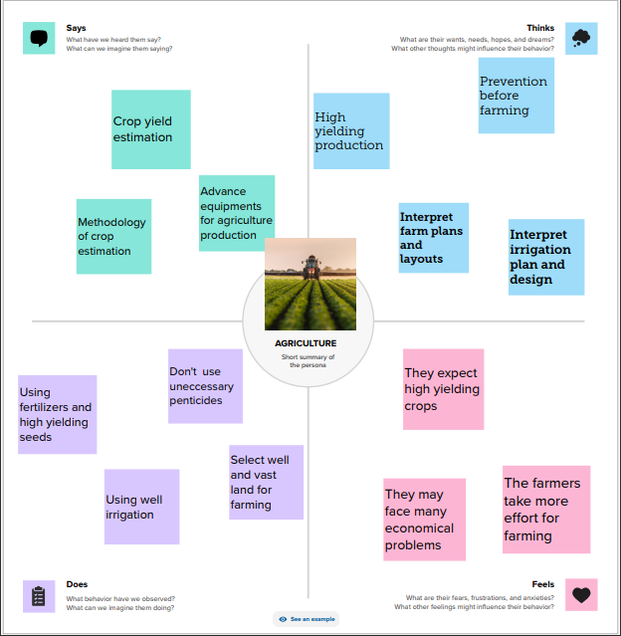

2.2 Ideation & Brainstorming Map:

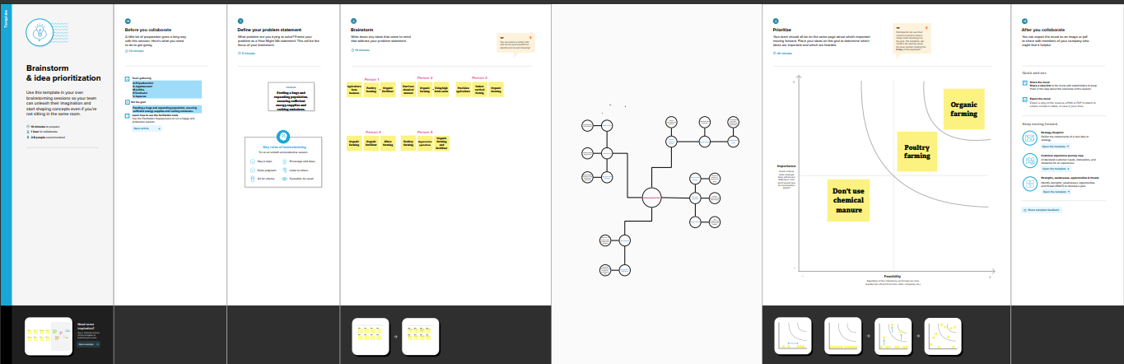

RESULT

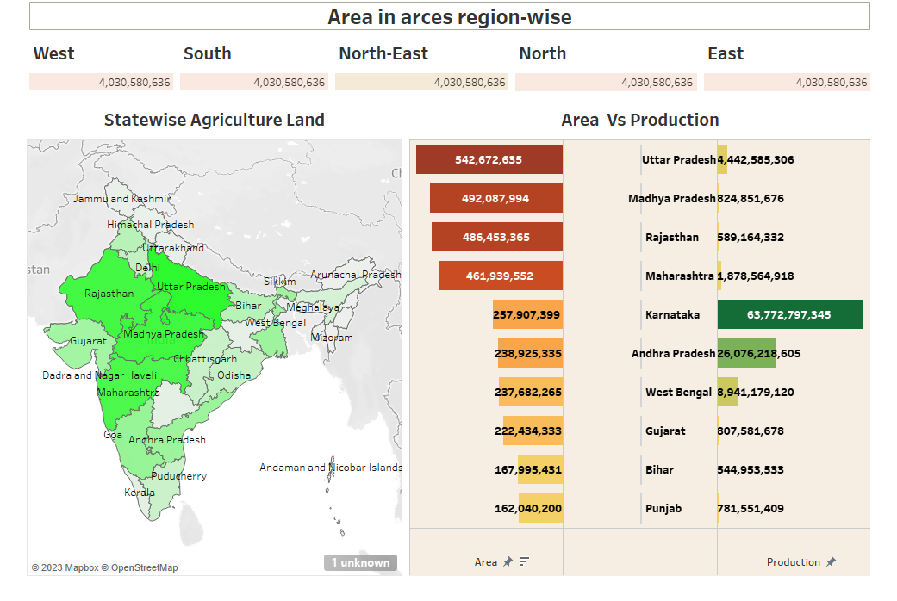

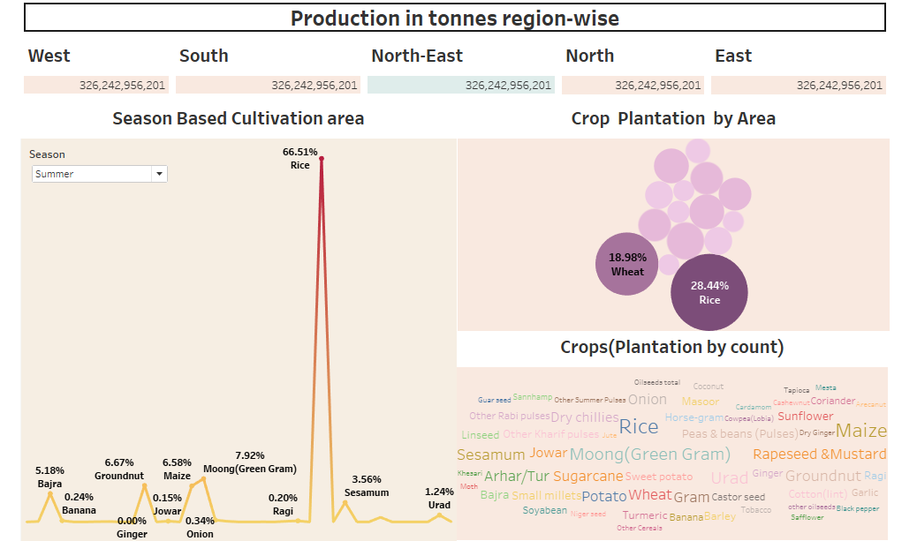

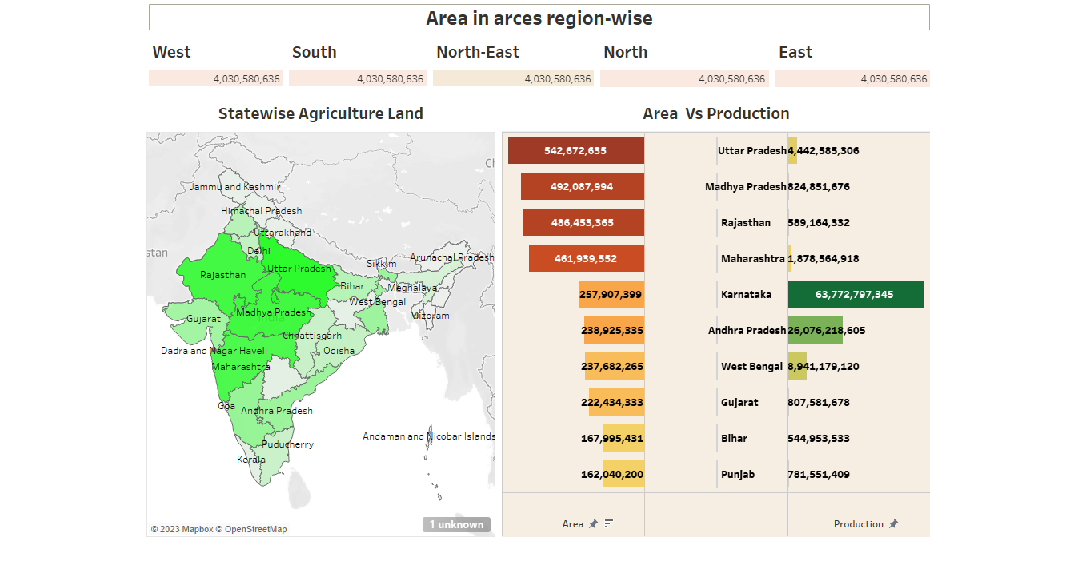



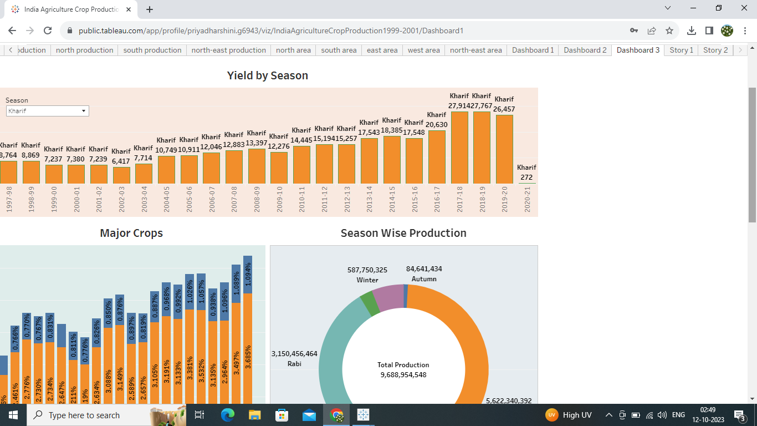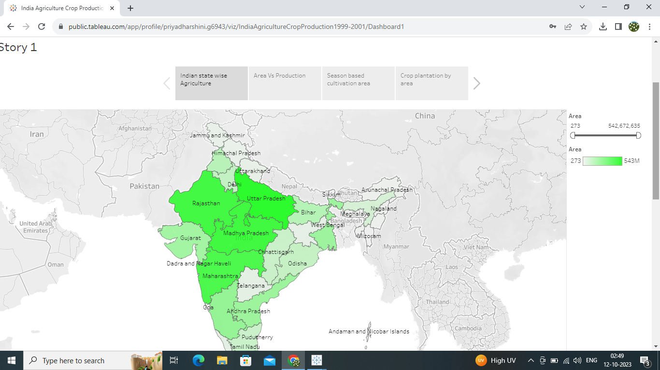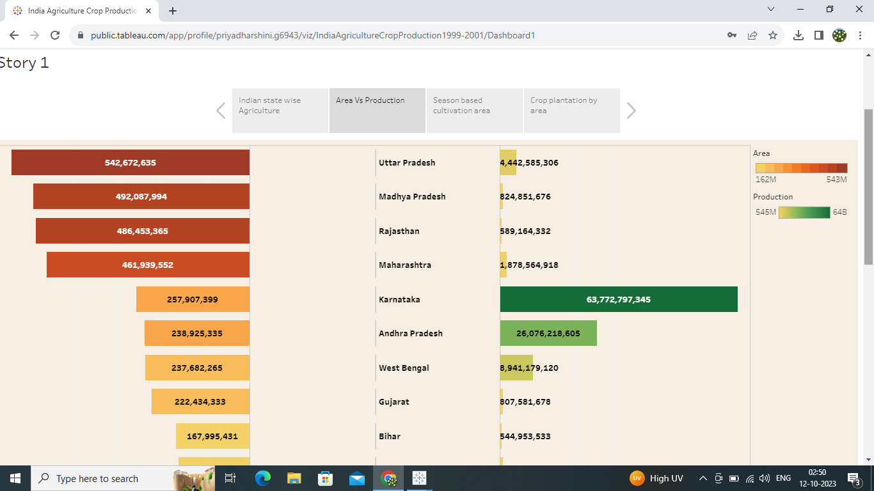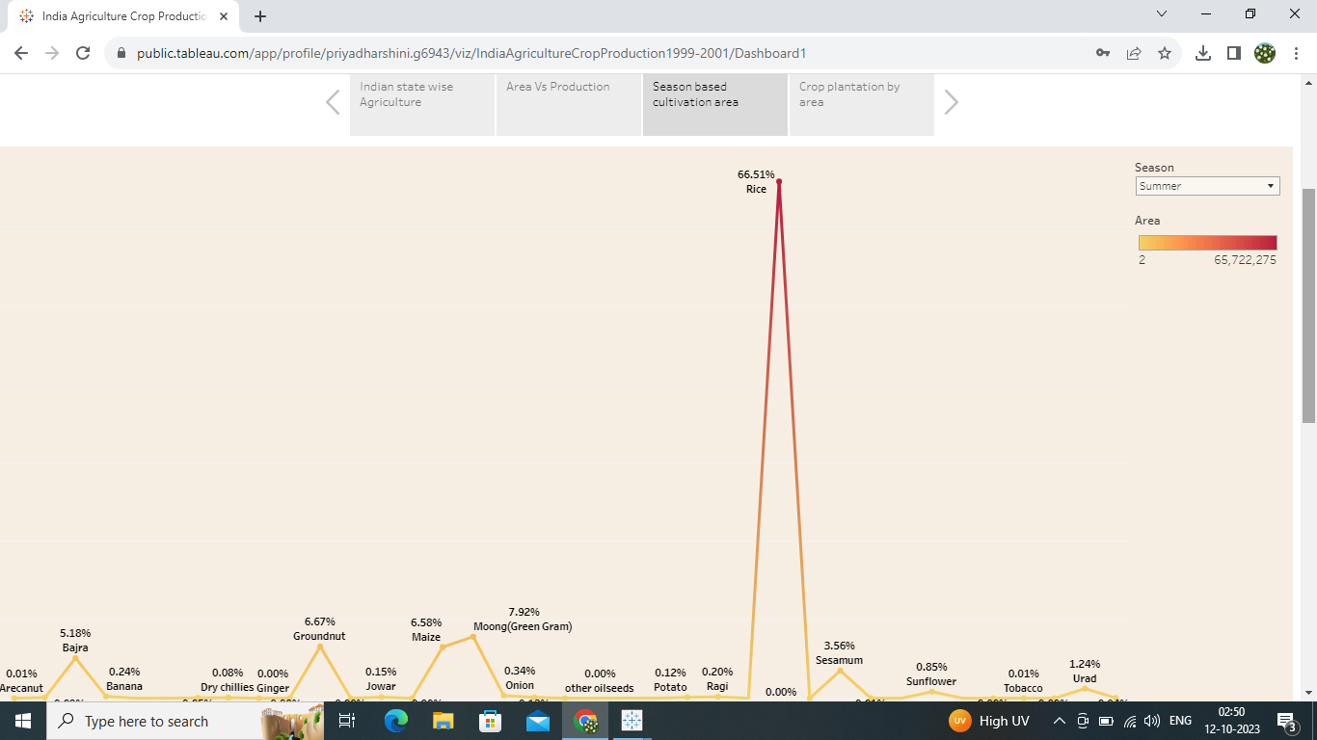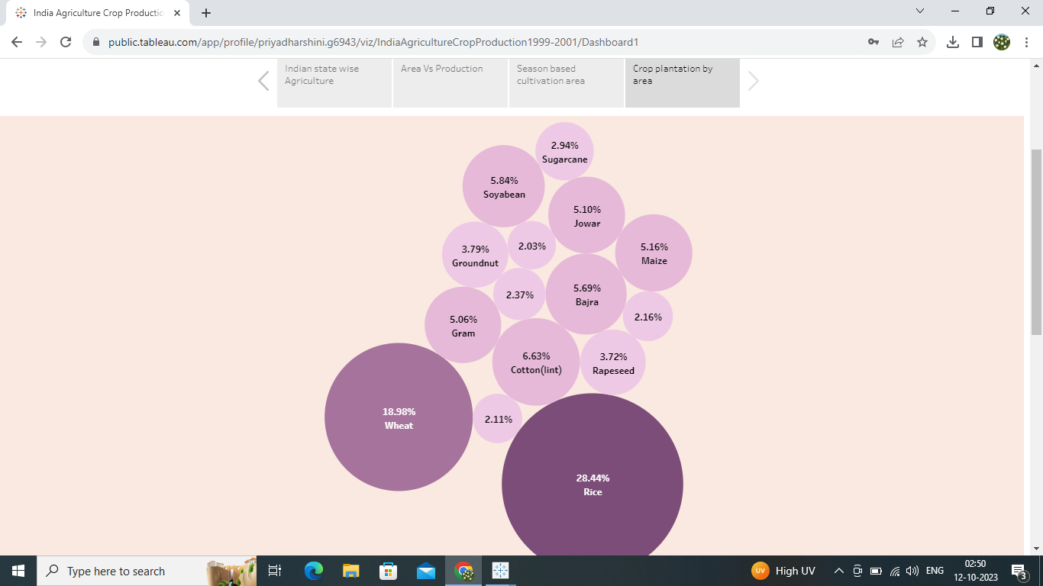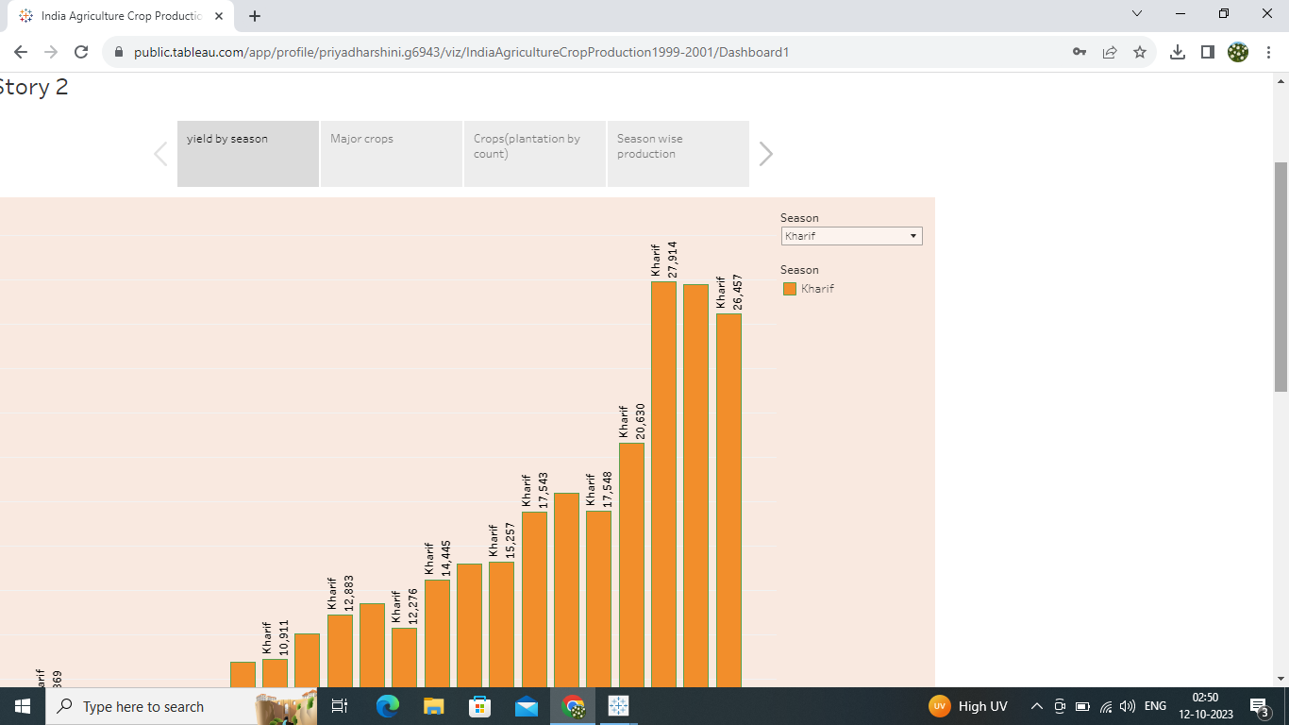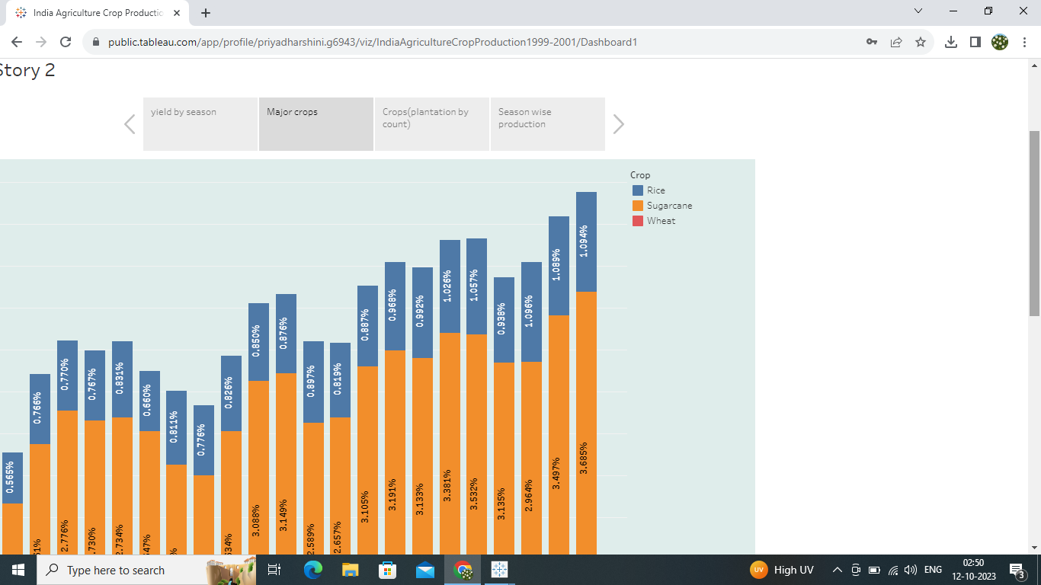

ADVANTAGES AND DISADVANTAGES

ADVANTAGES : India is the second largest producer of wheat and rice, the world's major food staples. India is currently the world's second largest producer of several dry fruits, agriculture-based textile raw materials, roots and tuber crops, pulses, farmed fish, eggs, coconut, sugarcane and numerous vegetables.

DISADVANTAGES: Erosion of soil by heavy rain, floods, insufficient vegetation cover etc., reduces farm productivity. Inadequate irrigation facilities and poor management of water resources have led to a great decline in agricultural productivity.

APPLICATION

Agricultural Applications means applications relating to (i) cultivating, characterizing or modifying soil; (ii) producing, growing, improving, protecting, treating or modifying crops or forest products; (iii) raising, harvesting, improving, protecting, treating or modifying livestock, poultry, fish or shellfish.

CONCLUSION

The Indian economy is an agro-economy and depends highly on the agricultural sector. Despite just supporting the Indian Economy, the agricultural sector also supports the industrial sector and international trade in imports and exports.

FUTURE SCOPE

There will be more of vertical and urban farming and there will also be efforts in long term to find new areas for production like barren deserts and seawater. Hydroponic farming, which is a soil-less, water-based farming operation, that may even be done in a tiny space is going to pick up the pace