[多策略集中执行实现](http://blog.csdn.net/jingshuaizh/article/details/42396177)

分类： [java spring](http://blog.csdn.net/jingshuaizh/article/category/475063)2015-01-04 18:49 12人阅读 [评论](http://blog.csdn.net/jingshuaizh/article/details/42396177#comments)(0) [收藏](javascript:void(0);) [编辑](http://write.blog.csdn.net/postedit/42396177) [删除](javascript:void(0);)

[java spring](http://www.csdn.net/tag/java%20spring)

应用场景：有很多策略或者check逻辑，他们之间没有联系，但是需要根据某一些给定条件执行

实现：

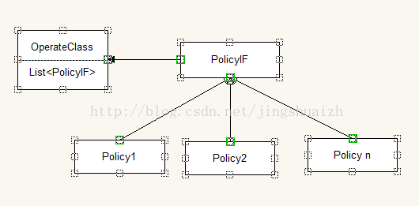

Spring配置文件

将实现了PolicyIF 的 bean 配置到执行类 的List 中，执行类的逻辑只需要逐个执行就可以了.

**[html]** [view plaincopy](http://blog.csdn.net/jingshuaizh/article/details/42396177)

1. **<?xml** version="1.0" encoding="UTF-8"**?>**
2. **<beans** xmlns="http://www.springframework.org/schema/beans"
3. xmlns:xsi="http://www.w3.org/2001/XMLSchema-instance" xmlns:aop="http://www.springframework.org/schema/aop"
4. xmlns:tx="http://www.springframework.org/schema/tx"
5. xsi:schemaLocation="http://www.springframework.org/schema/tx http://www.springframework.org/schema/tx/spring-tx-2.0.xsd
6. http://www.springframework.org/schema/beans http://www.springframework.org/schema/beans/spring-beans-2.0.xsd
7. http://www.springframework.org/schema/aop http://www.springframework.org/schema/aop/spring-aop-2.0.xsd"
8. default-lazy-init="true"**>**
10. **<bean** id="operatorClass" class="com.jason.pattern.OperatorClass"**>**
11. **<property** name="policyList"**>**
12. **<list>**
13. **<ref** bean="ploicyCheck1" **/>**
14. **<ref** bean="ploicyCheck2" **/>**
15. **<ref** bean="ploicyCheck3" **/>**
16. **</list>**
17. **</property>**
18. **</bean>**
20. **<bean** id="ploicyCheck1"
21. class="com.jason.pattern.ploicy.Policy1" **/>**
22. **<bean** id="ploicyCheck2"
23. class="com.jason.pattern.ploicy.Policy2" **/>**
24. **<bean** id="ploicyCheck3"
25. class="com.jason.pattern.ploicy.Policy3" **/>**
27. **</beans>**

**[java]** [view plaincopy](http://blog.csdn.net/jingshuaizh/article/details/42396177)

1. **package** com.jason.pattern;
3. **import** java.util.List;
5. **import** org.springframework.context.ApplicationContext;
6. **import** org.springframework.context.support.ClassPathXmlApplicationContext;
7. **import** com.jason.pattern.ploicy.*;
8. **public** **class** OperatorClass {
9. **private** List<PolicyIF> policyList;
11. **public** List<PolicyIF> getPolicyList() {
12. **return** policyList;
13. }
15. **public** **void** setPolicyList(List<PolicyIF> policyList) {
16. **this**.policyList = policyList;
17. }
19. **public** **static** **void** main(String [] agrs){
20. ApplicationContext context = **new** ClassPathXmlApplicationContext("file:C:\\2task\\Code\\SpringAOP\\src\\applicationContext.xml");
21. OperatorClass operatorClass = (OperatorClass) context.getBean("operatorClass");
22. System.out.println("policyList.size " + operatorClass.getPolicyList().size());
23. **for**(**int** i=0;i<operatorClass.getPolicyList().size();i++){
24. operatorClass.getPolicyList().get(i).excute("parameter");
25. }
26. }
27. }

[source code](http://download.csdn.net/detail/jingshuaizh/8326063)

http://download.csdn.net/detail/jingshuaizh/8326063