
Corporate Administrative Procedures Template

Create script for Account creation – Procedures

Approved By:
Category:
Approval Date: May 23, 2015
Effective Date: May 23, 2015
Revision Date:
Review Date:

1. Application
Service Desk Analysts use the Active Directory Module for Windows Powershell, Exchange Management Shell, Enterprise Directory Services (EDS), and Marval our request tracking tool.

Note: Requires
- One Time Install:
  - .Net Framework 4,
  - Powershell 3,
  - Token created by Brian McDonald while remote accessing to the pc while user is logged in with ADM account. One token per user per pc. Token saved in C:\temp\donotdelete.txt
  - Netapp extension: \\dc1fap003\ito\isd\CSB\ITSSWiki\SD\Tools\NetApp\
- Scripts Location: \\dc1fap003\ito\isd\CSB\ITSSWiki\sd\nta\scripts\EDS\Create\scripts\
- Xtraction data simplified: http://cmad109/Xtraction/Login.aspx?ReturnUrl=%2fXtraction%2f
  - Only Ron Guilbeault and Suzanne Groulx have this capability. We are running consecutive licenses. Login using your city\login and password.
- Exchange Management Shell: Create a desktop shortcut and go into the properties and change the “Start In” path to the above link.
- Active Directory Module: Create a desktop shortcut and go into the properties and change the “Start In” path to the above link.

2. Procedure Description
Basic account creation is done in EDS. The Service Desk NT Admin group finalize the setup of the accounts using the information provided in the ARF.

3. SLA
- Accommodation Request Form (ARF) is to be completed on or before the date they are scheduled. See ARF section found in the NT Admin Group - Objectives and Responsibilities documentation for details on scheduling.

3. Hiring Manager
- The Hiring Manager uses the instructions found on Requests for space accommodation, moves and IT connectivity to complete appropriate documentation. There is a list of exceptions. This can be found in ARF documentation.
Note:
- Human Resources (HR/Payrolls) takes up to 10 days to complete the Employee Transaction documentation. HR must have updated the employee's SAP record to Hired. Overnight EDS receives the record.
  - The ARF type B is submitted to Telecom. Telecom requires 10 working days notice. They create the Marval SRQ and assign it to SD_NTA_EDS group queue. This type of ARF is done on the due date.
  - The ARF type A is approved by the Manager and Marval automatically creates the tickets and assigneds them to SD_NTA_EDS group queue. The SD_NTA_EDS ARFs are checked daily against EDS. On or before the due date all active ARFs are completed by SD_NTA_EDS group.

4. How a network account gets activated

4.1. Automatic Disabled
- Employees paid through payrolls (EMP): The account end date is controlled through the Manager Info tab. This information is downloaded from SAP to EDS overnight. If the end date needs to be changed the Manager can go to Ozone > Manager tab.
- Employees not paid through payrolls (NCE): The account create is controlled by the http://ARF due date which is submitted by the Manager. The NT Admin team will manually created the EDS record using the information found in the http://ARF.

4.2. Manual Request

4.2.1. Manager

4.3.1. NT Admin
5.6 xtraction data simplified
- Link: http://cmad109/Xtraction/Login.aspx?ReturnUrl=%2fXtraction%2f
- Login using your City Account and password. (Only Ron Guilbeault and Suzanne Groulx are presently setup to run this).
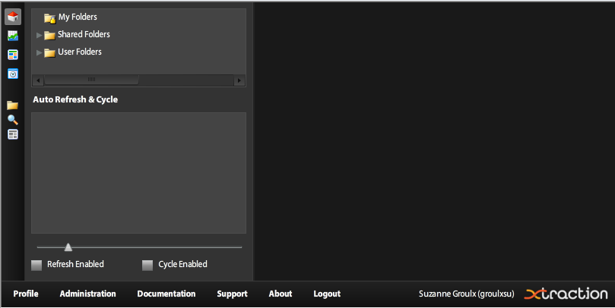
- Select SHEDULED TASK icon . This will open all the automated scheduled tasks. IMPORTANT: be careful to only run the ones that are assigned to your group.
- In this case right click on SD – Active Accounts EDS and select Run Task. This was setup to send the report to >CS - ITS - TI - CSS - NT Admins distribution list in Excel format as an attachment.
Don’t forget to log out of the xtraction data simplified application (bottom left).

Monitoring/Contraventions

Responsible Computing Policy
Signed Network Account Request Form:
Account Owner Declaration:
I, the undersigned, acknowledge that I have read and understood the City of Ottawa “Responsible Computing Policy”. Furthermore, I understand that any violation of the aforementioned Policies may result in disciplinary action.
During the course of my duties, I understand that I may have access to sensitive corporate or personal information. I undertake not to disclose any sensitive information to unauthorized individuals. Furthermore, I understand that any violation of confidentiality policies may result in disciplinary action.

References

n/a

Legislative and Administrative Authorities

n/a

Definitions

n/a

Keyword Search

Specify all relevant key words in this document which are to be added to the keyword subject index. Avoid using terms found in the procedures title.

Enquiries

Portfolio Coordinator,
IT Client Supp. Serv. (Service Desk)
Change Mgmt & IT Support Srvc Unit
Client Services Branch
Information Technology Services Dept.
City Operations Portfolio
TEL: 613-580-2424, ext. 26758

Appendices

n/a

