
Corporate Administrative Procedures Template

disable script for disables – Procedures

Approved By: Chad Yach
Category:
Approval Date: March 11, 2015
Effective Date: March 11, 2015
Revision Date:
Review Date:

1. Application
Service Desk Analysts use the Active Directory Module for Windows Powershell, Exchange Management Shell, Enterprise Directory Services (EDS), and Marval our request tracking tool.

Note: Requires
- One Time Install:
  - .Net Framework 4,
  - Powershell 3,
  - Token created by Brian McDonald while remote accessing to the pc while user is logged in with ADM account. One token per user per pc. Token saved in C:\temp\donotdelete.txt
  - Netapp extension: \\dc1fap003\ito\isd\CSB\ITSSWiki\SD\Tools\NetApp\
- Scripts Location: \\dc1fap003\ito\isd\CSB\ITSSWiki\sd\nta\scripts\EDS\Disables\scripts\
- Exchange Management Shell: Create a desktop shortcut and go into the properties and change the “Start In” path to the above link.
- Active Directory Module: Create a desktop shortcut and go into the properties and change the “Start In” path to the above link.

2. Procedure Description
Sometimes the Service Desk receives a request to delete or disabled an account. The policy is to remove the access groups, give the supervisor the contents of the home share folder for three months.

3. SLA
- 1 Working Days

4. How a network account gets disable

4.1. Automatic Disabled
- Employees paid through payrolls (EMP): The account end date is controlled through the Manager Info tab. This information is downloaded from SAP to EDS overnight. If the end date needs to be changed the Manager can go to Ozone > Manager tab > My Employee Automated Leave Request.
- Employees not paid through payrolls (NCE): The account disable is controlled by the http://ARF end date which is submitted by the Manager. The NT Admin team will have manually created the EDS record using the information found in the http://ARF.
When an account becomes disabled automatically in EDS the EDS system will automatically disabled the account in AD and send an email to Marval call tracking tool. Marval will automatically configure and populate the following information into the Marval SRQ:
- Client: Former Manager's name. If not found: New Client.
- Funct-sympt: Access Mgmt | Deactiv/Suspend | Email/NT-Reg | _
- Category: _ | _ | _ | _
- Assignee: SD_NTA_EDS
- Notify Client: Via: Email, Using: smtp email address.
- Description: ***Network Account Disabled*** - FULL NAME – LOGIN ID
- Schedule Start: One (1) working day.

4.2. Manual Request

4.2.1. Manager
- Sends an e-mail to the ServDeskCorp@ottawa.ca with subject line Open Call including the following information:
  - Recipient name.
  - Present NT Login ID.
  - End Date

4.3. Service Desk Phones
- Service Desk Phones group will ensure the required information is completed.
- Check in employee's EDS record to ensure the request is coming from the appropriate Hiring Supervisor.
- Change the following within the 'Marval SQR'':
  - Client: Former Manager's name.
  - Funct-sympt: Access Mgmt | Deactiv/Suspend | Email/NT-Reg | _
  - Category: _ | _ | _ | _
  - Assignee: SD_NTA_EDS
  - Notify Client: Via: Email, Using: smtp email address.
  - Description: ****Network Account Disabled**** - FULL NAME – LOGIN ID
  - Schedule Start: One (1) work day.

4.3.1. NT Admin
Because the request came in manually the account will need to be disabled in EDS. EDS will not send an email to Marval to create a SRQ.
- Follow the documentation found in EDS - Disable Record documentation.

5. Disable Date
The Disable Marval Requests are put in the SD_NTA_EDS group queue every morning. The report is run by the Marval system at 10 a.m. in the morning. The disable process is started by the NTAdmin analyst in the afternoon of the day the Marval SRQ comes in to the SD_NTA_EDS group queue.

5.1. Marval
The following steps will ensure all Marval SRQ have a manager’s name in the Client field.
- Disabled – New Client: Double click on My Work List
  - Right click on Assignee and select Include > SD_NTA_EDS
  - Right click on Funct-sympt and select Include > AccessMgmt,Deactiv/Suspend,Email/NT-Reg,_
  - Right click on Client and select Include > New Client
  - Double click on the first record.
Note: If none of the record has a Client: New Client skip to step 7.
- Look at the History note to see if the name of the former manager is included. If it is update the Client field with this name. When the former manager's name in not included in the history notes area then do the following steps:
  - Use EDS and locate the disabled employee's record to identify the former supervisor.
  - In the record select View Audit Logs.
  - Find the most recent EDS.SUPERVISOR_POSITION change and copy the Old Value position #.
  - Click on the Account Administration link and paste the position # in the Search for field.
    - If the record does not show up with a supervisor's name use the Ozone Org Structure to try to find existing supervisor for the vacant supervisor position.
    - You can also use the notes in the EDS record to trace down the name of the former employee’s supervisor using previous requests.
- Status: New
- Click on the Update button.
- In the Select window select yes.
- In the Update window select yes.
Note:
- Every morning a report is automatically sent to the >CS - ITS - TI - CSS - NT Admins” distribution list. The report includes any requests that are in SD_NTA_EDS group queue and have the function key AccessMgmt | Deactiv/Suspend | Email/NT-Reg | _
- Only one Analyst can work on the disabled report at a time.
- Ensure you eliminate the records that have the word HOLD at the beginning of the description.
- Disabled - New: Double click on My Work List
  - Right click on Assignee and select SD_NTA_EDS
  - Right click on Funct-sympt and select Include > AccessMgmt,Deactiv/Suspend,Email/NT-Reg,_
  - Right click on Status and select New.
  - Double click on the first record.
  - Select the disabled account login ID found in the Description field.
- Open EDS.

5.2. EDS
- Search for the EDS record using the Login ID.
- Check EDS to ensure the account has not been re-activated by another member of the group.
- Active: If the account is active (see sample bellow)
  - Update the Marval SRQ to Status: Completed
  - Paste a copy of the following fields from EDS record as proof in Resolution Text.
  - Marval # that reactivated the account.
  - EDS Id:
  - Type: EMP
  - Is active:
  - Terminated:
  - Termination Date:
  - First Name:
  - Initial:
  - Last Name:
- Inactive: If the account is inactive (sample bellow) in the EDS Record:
  - Select Edit Notes link.
  - Select Create a new note.
    - Title: M###### - Disabled
    - Message: M####### - Disabled
    - Click on the Save button.
Sample Active accounts:
- Is Active: True, Terminated: False, Has Network Account: True
- Is Active: True, Terminated: False, Position Type: Pooled, Has Network Account: True
Sample of Disabled Accounts:
- Is Active: True, Terminated: True, Position: 99999999
- Is Active: False, Terminated: False, Position: 99999999
- Is Active: True, Terminated: False, Has Network Account: False
- Is Active: True, Terminated: False, Position Type: Pooled, Has Network Account: False

5.3. ADUC
Sometimes a ADM account has been create for a client but there is no record in EDS. You can use the Xtraction Scheduled Export – Disabled Accounts EDS report to check if any of the following types of account exist. Check the following domains to see if the disabled employee has a:
- City: city\adm-loginID
- A: A\adm-loginID
IMPORTANT: If the account is disabled and the account has A\ADM, A\SVC, CITY\ADM, CITY\SVC account associated to it use the instructions found in A and City Domain Admin and Service - Administration Accounts to disable these administrative accounts.
5.4. Marval Request
- Take the Marval Requests listed and place them in your personal queue. In the history note add: Disabled scripts in progress. Then place the request in WIP.
5.5. EDS record
- Go to the matching EDS record and add a note: M####: Disabled scripts in progress.
6.1. Preparing the database
This procedure will walk you through the steps of disabling and account using scripts. If you follow everything in order, you will be able to batch disable multiple accounts at the same time.
- Take a copy of the Xtraction Scheduled Export – Disabled Accounts EDS. Save a copy of this report on your desktop. The report will show all the disables and their supervisor’s login ID.
- Delete all rows that have dates higher than today’s date and any lines that don’t have the wording “***Network Account Disabled*** - “ in column b.

Before
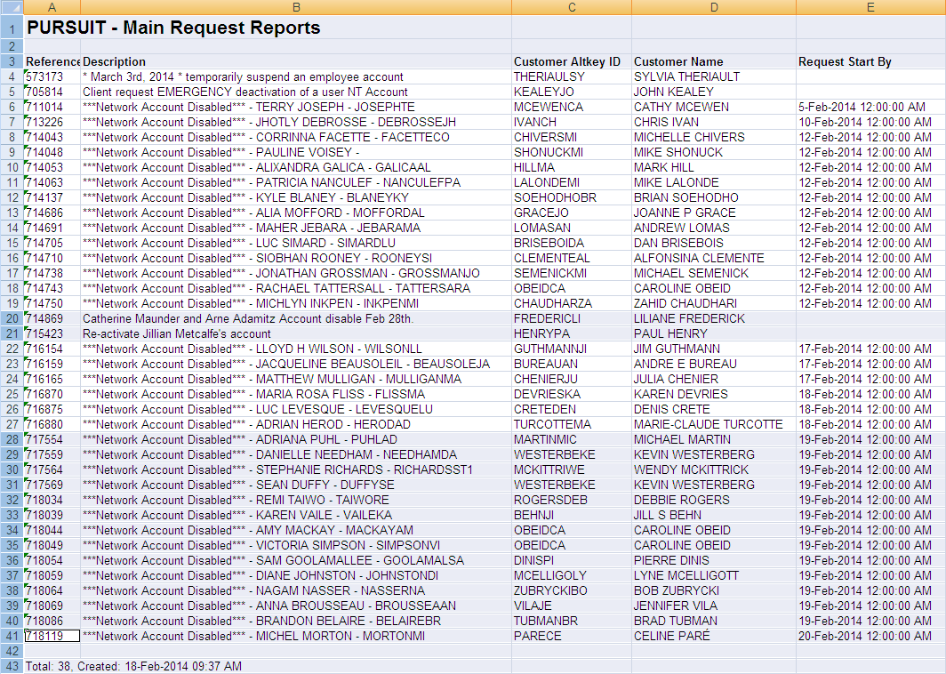

After
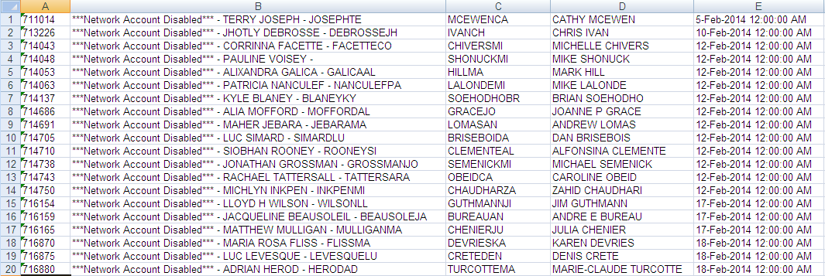

- Select the column that show the date and time (column E) and delete it.

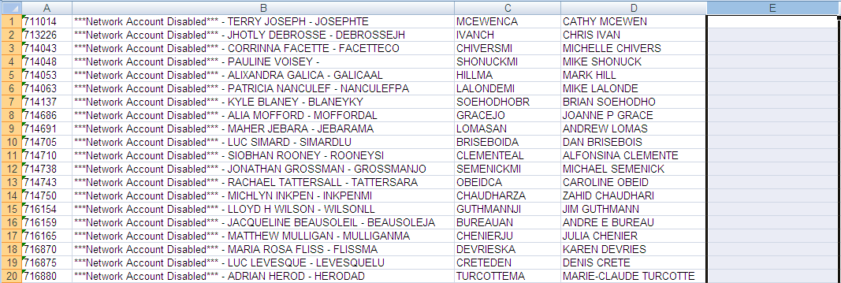

- While in the Menus bar go the Find and Replace (end of the bar).
  - Find What: ***Network Account Disabled*** - (space-space) (copy from spreadsheet to get the exact results).
  - Replace with: leave this field empty.
  - Replace All (Once done, make sure there are no spaces in from of each names).

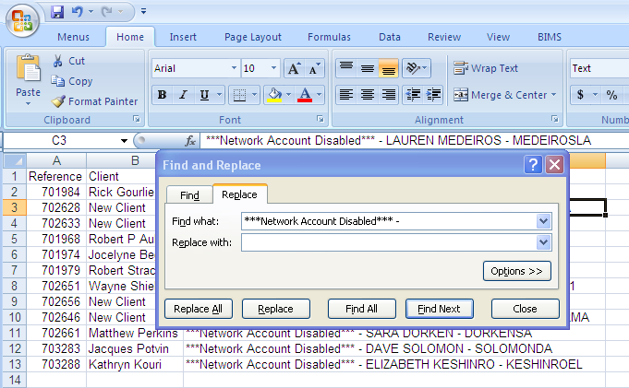

- Replace any French characters with the capital letter with no accent. (e.g.: all “é” for the letter “E” (alt130))
- Select File, Save As, Report.csv (csv comma delimited) on your desktop. Press save when prompted. Close file.
- Select file and right click on it, select Open With, Notepad.
  - Replace all “ - “ (space-space) with a value of “,” (coma).
  - Save the document (csv).
  - Re-open it using Excel.
  - Select cell A1 to cell E (last record) and copy it to clipboard.
  - Open the Excel spreadsheet called Updates.xlsx from the script folder (\\dc1fap003\ito\isd\CSB\ITSSWiki\sd\nta\scripts\EDS\Disables\CSV\) and select cell A2 only and select Paste Special and select All from list and ok.
  - Now select the entire first empty row (In our snapshot it will be line 20) to the last one at line 1000, right click and select Clear Content then right click again and select Delete. This will ensure we only have lines with data we entered for our scripts that we will run later.
  - SaveAs Updates.csv (ensure the document is kept open).
  - Start Active Directory Module for Windows PowerShell.

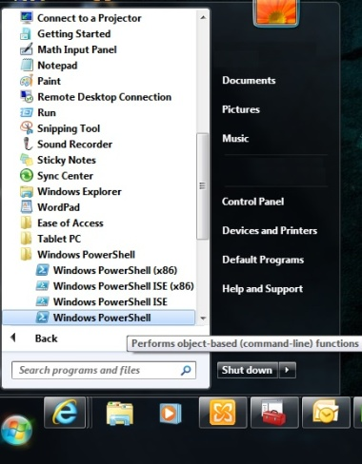

- Run ./ HomeFolders (A log file will open with your results at the end of each scripts you run. This will give you the folder size and the share path.)
- In the Homefolders.csv file that is open, copy all data under the homedirectory and Size column except for first line with header.

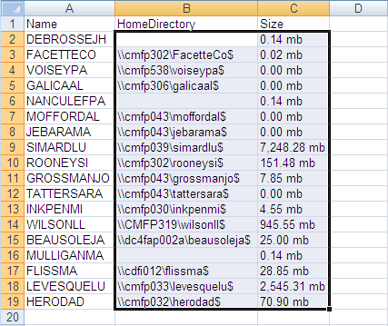

In your Updates.csv, select cell F2, right click and select paste, ok.

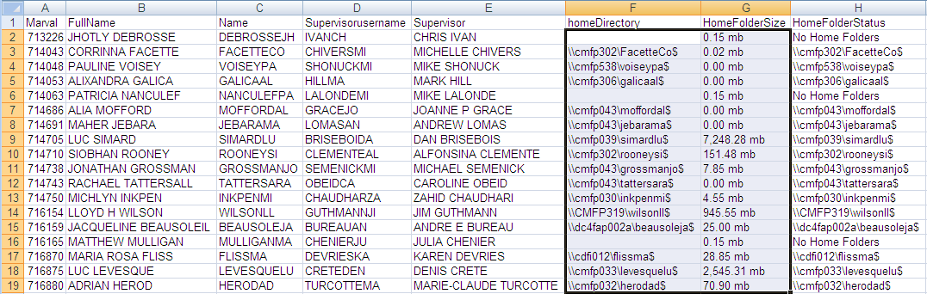

- You will automatically see the other columns auto populate for when you close your call later on. Save Updates.csv and overwriting the existing one once again.
- In Active Directory Module for Windows PowerShell type ./Groups, press Enter and wait till you see text file called Groups.txt showing your logs. Minimize it.
- Start the Exchange Management Shell tool.

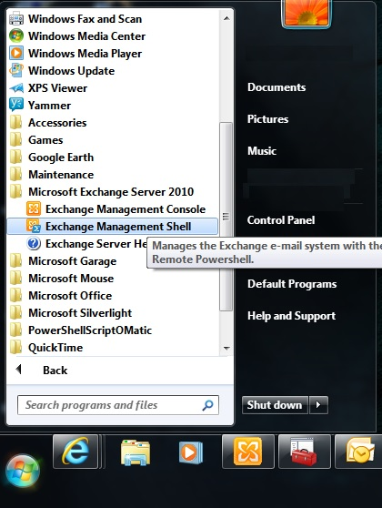
- Type ./Exchange press Enter and wait till you see text file called Exchange.txt showing your logs. Minimize it. (This might take a long time). This is a record of all the work that was done in the mailboxes. Close the Exchange Management Shell tool
- In Active Directory Module for Windows PowerShell window type./CreateRemoteDirectory, press enter. This script will create a folder for each of the listed disabled account and assign the appropriate rights automatically including the manager. Once completed you will see a text file called CreateRemoteDirectory.txt. This will show you the log of the command. You can close it. There is no need to copy this.
- Type “./RoboCopyAdmin” and wait till you see the robocopy.txt file. (This will take a while. Might want to run this script before leaving at the end of the day or early in the morning). Close this file.
- Once done, type “./CreateDisabledShare” and press yes when prompted. You will see the CreateDisabledShare.txt file. Close PowellShell and open it again.
- Once done, type “./RemoveHomeShare”. This will remove the home. You will see the removehomeshare.txt file. Close PowellShell and open it again.
- Once done, type “./DeleteHomeDirectory”. This will delete the home directories. You will see the deletehomedirectory.txt file
- Once you are done, you will need to maximize your Groups.txt and Exchange.txt log or open it from the logs folder.
- Open Marval and EDS and start the pasting info from both txt files for selected users with a subject line of “M(call number) Disabled”.
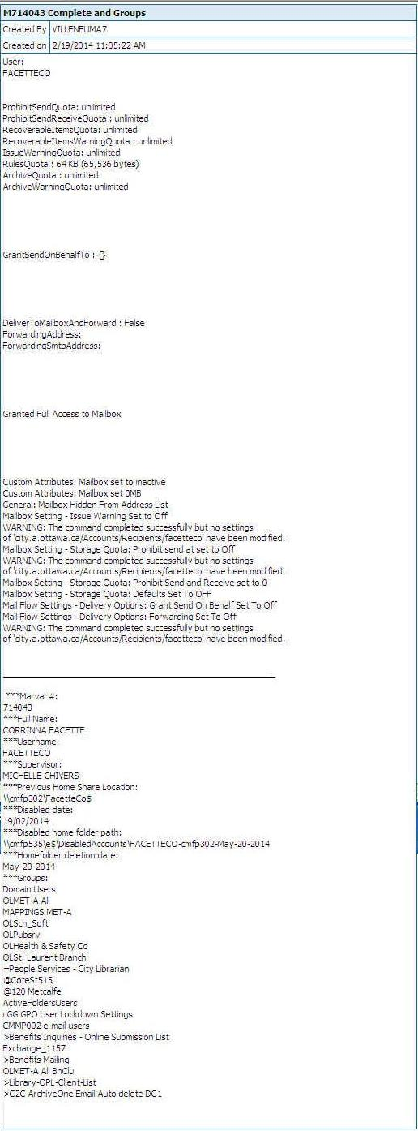

- Copy Updates.csv found in the \\dc1fap003\ito\isd\CSB\ITSSWiki\SD\NTA\Scripts\EDS\Disables\CSV\
- Paste Updates.csv in the \\dc1fap003\ito\isd\CSB\ITSSWiki\SD\NTA\Scripts\EDS\Disables\logs\ today’s date folder. Do not overwrite any existing “Updates.csv” that you find in the folder. Rename this one to Updates_#.csv.

Monitoring/Contraventions

Responsible Computing Policy
Signed Network Account Request Form:
Account Owner Declaration:
I, the undersigned, acknowledge that I have read and understood the City of Ottawa “Responsible Computing Policy”. Furthermore, I understand that any violation of the aforementioned Policies may result in disciplinary action.
During the course of my duties, I understand that I may have access to sensitive corporate or personal information. I undertake not to disclose any sensitive information to unauthorized individuals. Furthermore, I understand that any violation of confidentiality policies may result in disciplinary action.

References

n/a

Legislative and Administrative Authorities

n/a

Definitions

n/a

Keyword Search

Specify all relevant key words in this document which are to be added to the keyword subject index. Avoid using terms found in the procedures title.

Enquiries

Portfolio Coordinator,
IT Client Supp. Serv. (Service Desk)
Change Mgmt & IT Support Srvc Unit
Client Services Branch
Information Technology Services Dept.
City Operations Portfolio
TEL: 613-580-2424, ext. 26758

Appendices

n/a

